CHEMICAL ENGINEERING TRANSACTIONS  VOL. , 2023 | A publication of
The Italian Association
of Chemical Engineering
Online at www.cetjournal.it

Guest Editor: Sauro Pierucci
Copyright © 2023, AIDIC Servizi S.r.l.
ISBN 978-88-95608-98-3; ISSN 2283-9216

Impact of Wetting Time on the Discharge Capacity of Li-O₂ Batteries
Jean Felipe Leal Silva, Thayane Carpanedo de Morais Nepel, Gustavo Doubek, Rubens Maciel Filho
Advanced Energy Storage Division – Center for Innovation on New Energies (AES/CINE), School of Chemical Engineering, University of Campinas (UNICAMP). Rua Michel Debrun, s/n, Campinas, SP, Brazil, ZIP code 13083-841.
jefelipe@outlook.com; jeanf@unicamp.br
The increasing adoption of solar and wind power for electricity production has spurred new projects for the development of cost-competitive energy storage technologies. Among the various promising options, Li-O₂ batteries deserve special attention because of their potential high specific energy, which might lead to decreased manufacturing and installation costs. Regarding the manufacturing costs, one of the steps with the most impact on manufacturing time is the wetting process, which might take days to complete. Improving this process has been crucial to reduce manufacturing costs and increase battery performance for lithium-ion batteries. This work provides an assessment of the impact of time of the wetting process on the performance of Li-O₂ batteries. Li-O₂ batteries were assembled using an O₂ electrode based on carbon paper. The separator membrane and the O₂ electrode were immersed in the electrolyte solution for 1 h, 3 h, 9 h, 27 h, and 81 h, and deep discharge trials were performed for each case. The capacity of the battery was measured and compared to the standard assembly procedure, in which the battery is assembled with electrolyte and left to rest for 72 h. After discharge, the electrodes were analyzed via scanning electron microscopy to identify the impact of electrolyte filling of the O₂ electrode on the distribution of the discharge product over its surface. The results demonstrate the importance of investigating this process step in the manufacturing of batteries to ensure better performance of Li-O₂ batteries.
  - Introduction
According to recent reports, wind and solar power have become the most cost-competitive electricity sources in many regions across the globe (Lazard, 2020). However, despite costing less than other conventional, fossil fuel-based electricity sources, the wide adoption of wind and solar power for electricity production faces the resistance of grid operators because of their intermittent nature (Zalzar et al., 2020). Large-scale energy storage is one of the main solutions proposed to mitigate the effects of intermittency in electricity supply (Andresen et al., 2014). Therefore, affordable energy storage technologies must be developed to be used in cost-competitive hybrid power systems (Varbanov et al., 2019). Among the possible technologies being developed for energy storage, Li-O₂ batteries deserve special attention because their potentially high specific energy might lead to decreased installation costs for large-scale energy storage systems (Leal Silva et al., 2021a).
Research fields in the development of Li-O₂ batteries include electrode and/or electrolyte stability and properties, battery cycle life, mass transport, and catalysis (Mahne et al., 2017; Tan et al., 2017; Leal Silva et al., 2022). In the investigation of electrode and electrolyte behavior, the wetting of the electrode has been shown as a very important step in the manufacturing of lithium-ion batteries because of the floor space required to perform this activity in the factory and its impact on the final quality of the product (Wood et al., 2015). Currently, a typical electrode wetting process for a lithium-ion battery might be divided into three wetting steps, each one followed by 1–2 formation cycles of up to 24 h each (Wood et al., 2019). The impact of the wetting time on the performance of Li-O₂ batteries has not been thoroughly discussed in the literature yet because of the early stage of development of this technology. Nevertheless, the topic is clearly of high importance for Li-O₂ batteries because careful control of wettability in Li-O₂ batteries ensures better battery performance (Wang et al., 2020a). This occurs because wettability impacts the delivery of reactants (Li⁺ and O₂) to reaction sites of the porous electrode (Sauter et al., 2020). Moreover, incomplete wetting compromises battery lifetime and safety (Lagadec et al., 2018).
Many properties influence the wettability of the electrode. For the electrolyte, properties such as viscosity and surface tension deserve special attention. As for the electrode itself, properties such as surface area, morphology, porous structure, and surface chemistry are the most important (Carvalho et al., 2020; Davoodabadi et al., 2020; Xu et al., 2009). Nevertheless, time is also an important variable as shown by the manufacturing methods developed by the lithium-ion industry (Wood et al., 2019). Therefore, studies for different combinations of materials are required to provide a general view of the problem of wetting time for Li-O₂ batteries. Bearing all this in mind, this work presents an assessment of the impact of wetting time on the specific capacity of Li-O₂ batteries. The glass microfiber filter used as the separator membrane and the carbon paper used as the O₂ electrode were immersed in the electrolyte for different lengths of time, and the batteries were assembled and tested thereafter. The results demonstrate the importance of this step to ensure the high specific capacity of these batteries, and they represent a reference in the standards for battery assembly in the research and development of Li-O₂ batteries.
  - Methodology
    - Electrodes and battery assembly
The O₂ electrodes were made of carbon paper (TGP-H-060, Toray) and the separators were made of glass microfiber filter (GF/A, Whatman). Both materials were cut into discs of 16 mm. The discs were left to dry overnight in an oven at 80 °C and then left to rest inside the glovebox workstation (Ar atmosphere, H₂O<10 ppm, O₂<10 ppm, MBraun MB10, M. BRAUN Inertgas-Systeme GmbH) for 24 h. The electrolyte solution containing 0.1 mol L⁻¹ lithium perchlorate (LiClO₄, ≥99.99% trace metal basis, Sigma-Aldrich) in dimethylsulfoxide (DMSO, ≥99.9%, Sigma-Aldrich) was prepared inside the glovebox workstation. The water content of the electrolyte was measured via coulometric Karl Fischer titration (852 Titrando Metrohm AG, Switzerland).
The O₂ electrodes and separator membranes were immersed in electrolyte solution inside a Petri dish that was sealed using Parafilm M and kept inside the glovebox workstation during different wetting times: 1, 3, 9, 27, and 81 h, chosen in a geometric progression. The same was carried out for the standard time of 72 h. After the wetting time has passed, the battery was assembled inside a testing cell using a Li foil (Tob Machine, 99.99%), the separator membrane, the O₂ electrode, and a stainless-steel current collector/spring assembly. In this process, the electrode and separator were removed from the electrolyte solution using tweezers and the excess liquid was drawn off by touching the discs to the sidewall of the Petri dish. After assembly, the testing cell was closed and immediately removed from the glovebox workstation. Then, the cell was purged to remove Ar and filled with 3 bar of pure O₂ to work in a closed pressurized system.
    - Deep discharge and analysis
Galvanostatic deep discharge was performed on an Arbin Laboratory Battery Testing System (LBT21084, Arbin Instruments LLC, USA). The battery rested for 30 min under O₂ pressure before discharge was initiated at 50 μA. After the cut-off potential of 2.2 V was reached, the battery was purged with N₂ and the battery was disassembled inside the glovebox workstation. The deep discharge tests were performed in duplicate for each resting time. The total discharge capacity was normalized by the average mass of carbon paper of electrodes of 16 mm in diameter. The morphology of the discharge product was analyzed via scanning electron microscopy (SEM, Quattro S, Thermo Fischer Scientific Inc., US) at 10 kV at a working distance of ~10 mm by using a secondary electron detector.
  - Results and Discussion
    - Results of discharge capacity
Figure 1 shows the increase in the specific capacity of the battery as the wetting time increases. It is possible to observe that the largest increase in capacity occurs from 9 to 27 h, thus indicating that a higher wetting time is more desirable. A possible cause for this problem is that a wetting time lower than 27 h was not enough to promote the formation of the triple-phase interface, fundamental to the proper delivery of reactants (Li⁺ and O₂) to reaction sites (Carvalho et al., 2020). The wetting time of 81 h provided a similar result compared to 27 h (inside their error margin), despite the large increase in wetting time. Therefore, a resting time in the range of 27–81 h yields satisfactory results. Moreover, this result indicates the importance of reporting this information on research papers as some works report resting times ranging from 1 h to 8 h (Dong et al., 2018; Hu et al., 2015; Oh et al., 2013), which is not enough. Figure 2 presents the discharge profile of all tested batteries. Instabilities in the potential drop were observed for all cases, and this problem was already observed in other trials using carbon paper as the O₂ electrode (Schwenke et al., 2015). It is important to mention that these results reflect the effect of wetting time in both electrode and membrane in a situation of excess electrolyte.

Figure 1: Average specific capacity for each wetting time

Figure 2: Discharge profile of batteries for each wetting time: a) 1 h, b) 3 h, c) 9h, d) 27 h, e) 81 h, and f) 72 h (standard condition). The red and brown lines indicate different tests of the duplicate.
    - Morphology of discharge product
Figure 3 shows the morphology of the discharge product for the different wetting times considered in this study. For the smallest time, 1 h (Figure 3a, left), it is possible to observe low amounts of discharge product and that it is not well distributed over the surface of the carbon fibers. A closer look (Figure 3a, right) shows that in this case, the discharge product deposits mostly as a thin film over the surface of the carbon fibers. This thin film is observed as the initial deposition of the discharge product in many other systems (Dou et al., 2021; Lau and Archer, 2015) and might have been observed here as the final form of the film of discharge product because of the small discharge capacity. On the other hand, as the discharge progresses further, more product is deposited into the surface of the O₂ electrode. This was the case for the batteries with larger wetting times. For instance, the formation of a discharge product film with many crystals of toroidal shape is observed for a wetting time of 9 h (Figure 3c). Besides that, many agglomerates of discharge product were already visible for this discharge time. These results indicate that the wetting times of 1 h and 3 h are insufficient for efficient use of the electrode.
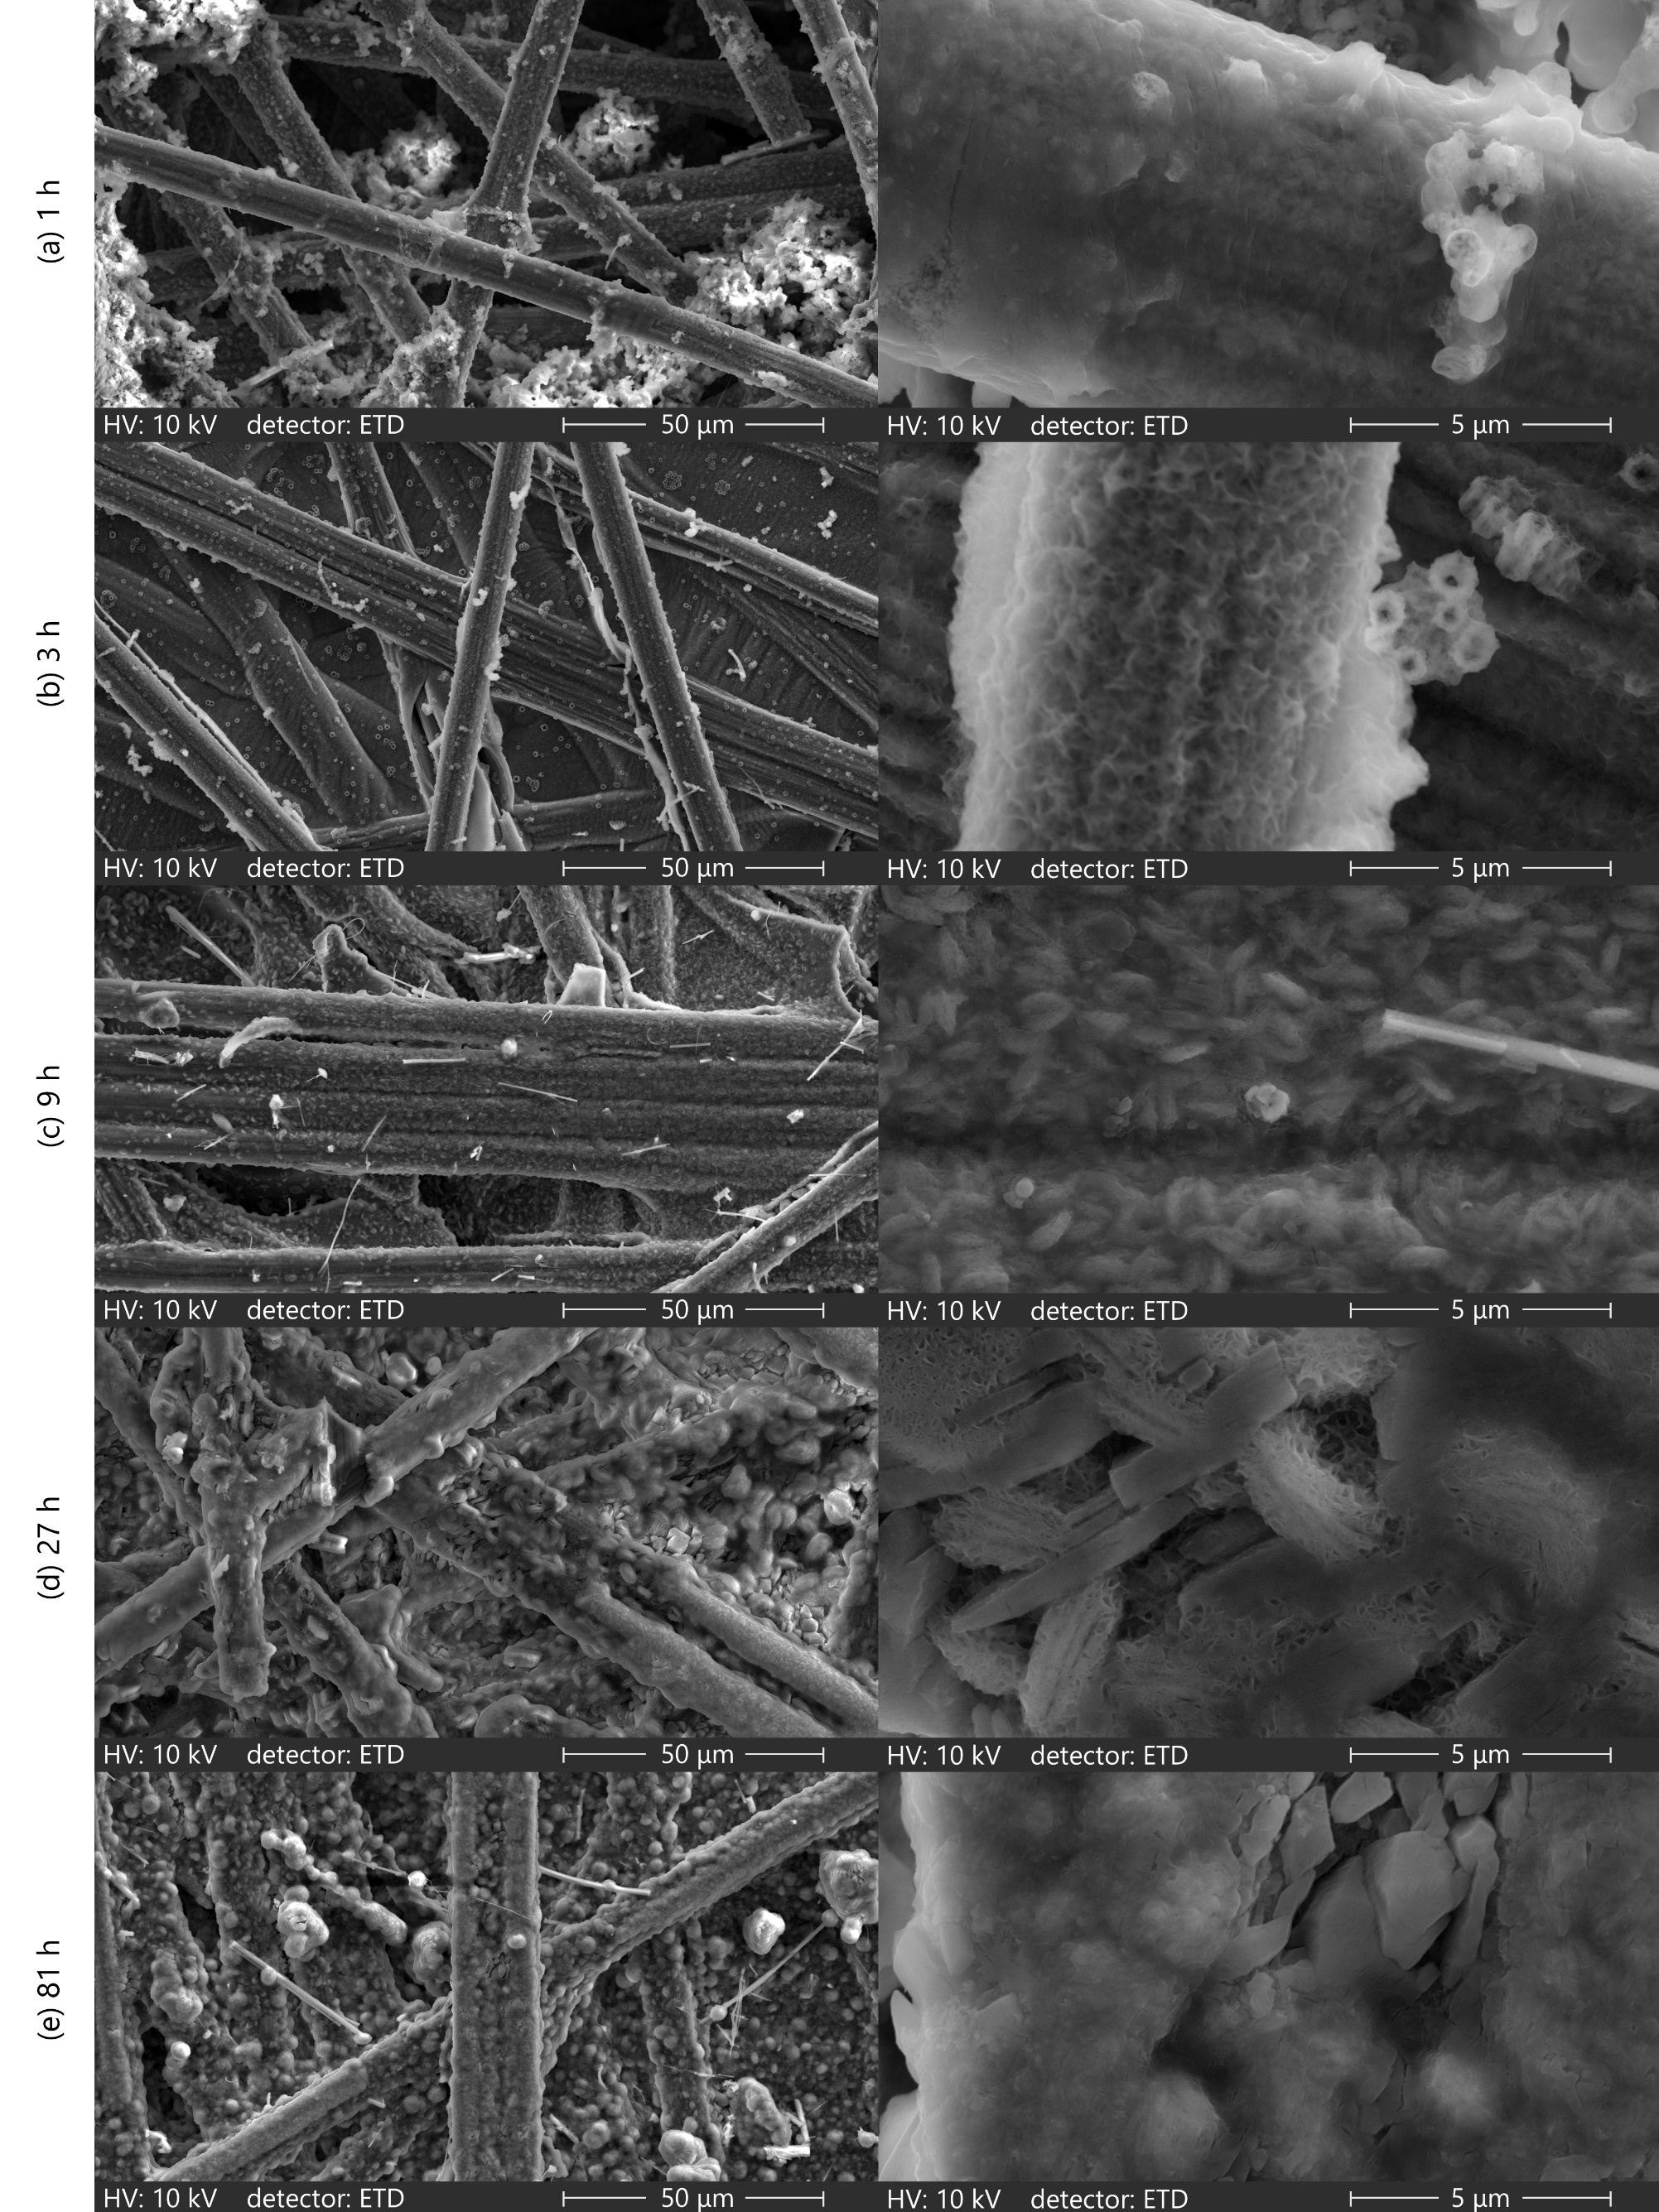 Figure 3: Morphology of discharge product of Li-O₂ batteries with different wetting times: a) 1 h, b) 3 h, c) 9 h, d) 27 h, and e) 81 h; the image on the right shows a 10× zoom of the center of the image on the left
Figure 3d and Figure 3e show that a sufficiently long wetting time, higher than 27 h, allows the electrode to discharge to a point where the surface becomes fully covered with large crystals of Li₂O₂, thus producing batteries with high specific capacity. The shape of these crystals is very similar to the shape of other crystals of Li₂O₂ reported in the literature, which is expected since the electrolyte contains 94 ppm of water according to results of Karl-Fischer titration, and no LiOH formation is expected in these conditions (Aetukuri et al., 2015; Schwenke et al., 2015; Yang et al., 2016). Many of these crystals present a toroidal shape, and some of these shapes are covered by a layer of platelet-like crystals. This morphology leads to a less resistive layer of discharge product and helps the battery to last longer before reaching the cut-off potential (Sahapatsombut et al., 2013). However, despite these results indicating that a longer wetting process leads to increase capacity, it is important to mention that O₂ is a limiting reactant in a homogeneous medium made of liquid (Silva et al., 2022). Therefore, other studies should also evaluate the impact of wetting time on electrodes with more lyophobic conditions as they have better discharge capacity when compared to lyophilic electrodes (Wang and Li, 2018), and these studies should include the effect of additives in the electrolyte solution, such as water (Leal Silva et al., 2021b) or redox mediators (Wang et al., 2020b), which play a crucial role in battery performance.
  - Conclusion
Li-O₂ batteries represent the next frontier in the development of electrochemical energy storage devices because their high theoretical energy density might lead to decreased manufacturing costs. Currently, research and development efforts on these batteries are focused on the search for new, stable materials to provide high-performance electrodes. One important variable related to both the research stage and the manufacturing of batteries is the wetting time, which has a direct influence on the performance of the battery. This work presented an analysis of the impact of wetting time on the specific capacity of Li-O₂ batteries. According to discharge capacity results, wetting times of 27 h and 81 h presented similar results compared to the current standard of 72 h, thus indicating that increasing the wetting time beyond 27 h does not yield a great increase in capacity when using carbon paper as the O₂ electrode and a dimethylsulfoxide-based electrolyte. Analysis of the morphology of the discharge product showed that the low capacity observed in low wetting times might be a consequence of insufficient reactants for the deep discharge to continue. Therefore, wetting times of 1 h or 3 h must be avoided. In addition, for wetting times of 27 or 81 h, a mixture of toroids and platelet-like crystals was observed, which are structures that decrease the electronic resistance of the layer of the discharge product. It should be noted that these tests considered carbon paper as the O₂ electrode and a dimethylsulfoxide-based electrolyte; other tests should also consider other electrode materials and different electrolyte compositions to draw more general conclusions regarding the wetting time for Li-O₂ batteries. Nevertheless, they demonstrate the importance of this step to achieve the full potential of electrode materials.
Acknowledgments
The authors gratefully acknowledge the support from FAPESP (the Sao Paulo Research Foundation, Grant Numbers 2017/11958-1, 2018/16663-2), Shell, the strategic importance of the support given by ANP (Brazil’s National Oil, Natural Gas, and Biofuels Agency) through the R&D levy regulation, and the Coordenação de Aperfeiçoamento de Pessoal de Nível Superior - Brasil (CAPES) - Finance Code 001.
References
Aetukuri, N.B., McCloskey B.D., García J.M., Krupp L.E., Viswanathan V., Luntz A.C., 2015, Solvating Additives Drive Solution-Mediated Electrochemistry and Enhance Toroid Growth in Non-Aqueous Li–O₂ Batteries, Nature Chemistry, 7(1):50–56.
Andresen, G.B., Rodriguez R.A., Becker S., Greiner M., 2014, The Potential for Arbitrage of Wind and Solar Surplus Power in Denmark, Energy, 76:49–58.
Carvalho, V.S., Miranda A.N., Nunes W.G., Costa L.H., Pascon A.M., Rodella C.B., Zanin H., Doubek G., 2020, Radially Ordered Carbon Nanotubes Performance for Li-O₂ Batteries: Pre-Treatment Influence on Capacity and Discharge Products, Catalysis Today, 348:299–306.
Davoodabadi A., Jin C., Wood D.L., Singler T.J., Li J., 2020, On Electrolyte Wetting through Lithium-Ion Battery Separators, Extreme Mechanics Letters 40:100960.
Dong Q., Yao X., Zhao Y., Qi M., Zhang X., Sun H., He Y., Wang D., 2018, Cathodically Stable Li-O₂ Battery Operations Using Water-in-Salt Electrolyte, Chem, 4(6):1345–58.
Dou Y., Wang X. G., Wang D., Zhang Q., Wang C., Chen G., Wei Y, Zhou Z., 2021, Tuning the Structure and Morphology of Li₂O₂ by Controlling the Crystallinity of Catalysts for Li-O₂ Batteries, Chemical Engineering Journal, 409:128145.
Hu X., Zhu Z., Cheng F., Tao Z., Chen J., 2015, Micro-Nano Structured Ni-MOFs as High-Performance Cathode Catalyst for Rechargeable Li–O₂ Batteries, Nanoscale, 7(28):11833–40.
Lagadec M.F., Zahn R., Wood V., 2018, Characterization and Performance Evaluation of Lithium-Ion Battery Separators, Nature Energy, 2018 4:1 4(1):16–25.
Lau S., Archer L.A., 2015, Nucleation and Growth of Lithium Peroxide in the Li-O₂ Battery., Nano Letters, 15(9):5995–6002.
Lazard, 2020, Lazard’s Levelized Cost of Energy Analysis – Version 14.0, New York, US.
Leal Silva J.F., Doubek G., Maciel Filho R., 2021a, Impact of the Catalytic Activity of Carbon Nanotubes in the Performance of Li-O₂ Batteries, Chemical Engineering Transactions, 86:499–504.
Leal Silva J.F., Ignácio G.E., Doubek G., Nepel T.C.M., Maciel Filho R., 2021b, Dry Solvents for Batteries: Equilibrium Study of Water Adsorption from Dimethyl Sulfoxide using 3A Zeolite, Chemical Engineering Transactions, 86:1093-1098.
Leal Silva J.F., Policano M.C., Tonon G.C., Anchieta C.G., Doubek G., Maciel Filho R., 2022, The potential of hydrophobic membranes in enabling the operation of lithium-air batteries with ambient air, Chemical Engineering Journal Advances, 11, 100336.
Mahne N., Fontaine O., Thotiyl M.O., Wilkening M., Freunberger S.A., 2017, Mechanism and Performance of Lithium-Oxygen Batteries-a Perspective, Chemical Science, 8(10):6716–29.
Oh D., Qi J., Lu Y.C., Zhang Y., Shao-Horn Y., Belcher A.M., 2013, Biologically Enhanced Cathode Design for Improved Capacity and Cycle Life for Lithium-Oxygen Batteries, Nature Communications, 4(1):1–8.
Sahapatsombut U., Cheng H, Scott K., 2013, Modelling the Micro–Macro Homogeneous Cycling Behaviour of a Lithium–Air Battery, Journal of Power Sources, 227:243–53.
Sauter C., Zahn R., Wood V., 2020, Understanding Electrolyte Infilling of Lithium-Ion Batteries, Journal of The Electrochemical Society, 167(10):100546.
Schwenke, K.U., Metzger M., Restle T., Piana M., Gasteiger H.A., 2015, The Influence of Water and Protons on Li₂O₂ Crystal Growth in Aprotic Li-O₂ Cells, Journal of The Electrochemical Society, 162(4):A573–84.
Silva J.F.L., Doubek G., Maciel Filho R., 2022, Gas diffusion channels in Li-O2 batteries: a comparison of wet and flooded electrodes, in: Montastruc, L., Negny, S.B.T.-C.A.C.E. (Eds.), 32 European Symposium on Computer Aided Process Engineering. Elsevier, pp. 361–366.
Tan P., Jiang H.R., Zhu X.B., An L., Jung C.Y., Wu M.C., Shi L., Shyy W., Zhao T.S., 2017, Advances and Challenges in Lithium-Air Batteries, Applied Energy, 204:780–806.
Varbanov P.S., Walmsley T.G., Klemeš J.J., Seferlis P., Jiang Y., Kang L., Liu Y., 2019, Impacts of Supply-Demand Characteristics on Optimal Configuration of Energy Storage System with Multiple Types of Batteries, Chemical Engineering Transactions, 76:1117–22.
Wang F., Li X., 2018, Effects of the Electrode Wettability on the Deep Discharge Capacity of Li–O₂ Batteries, ACS Omega, 3(6):6006–12.
Wang F., Li X., Hao X., Tan J., 2020a, Review and Recent Advances in Mass Transfer in Positive Electrodes of Aprotic Li-O₂ Batteries, ACS Applied Energy Materials, 3(3):2258–70.
Wang H., Wang X.,Li M., Zheng L., Guan D., Huang X., Xu J., Yu J., 2020b, Porous Materials Applied in Nonaqueous Li–O2 Batteries: Status and Perspectives, Advanced Materials, 32, 2002559.
Wood D.L., Li J., An S.J., 2019, Formation Challenges of Lithium-Ion Battery Manufacturing, Joule, 3(12):2884–88.
Wood D.L., Li J., Daniel C., 2015, Prospects for Reducing the Processing Cost of Lithium-Ion Batteries, Journal of Power Sources, 275:234–42.
Xu W., Xiao J., Zhang J., Wang D., Zhang J.G., 2009, Optimization of Nonaqueous Electrolytes for Primary Lithium/Air Batteries Operated in Ambient Environment, Journal of The Electrochemical Society, 156(10):A773.
Yang C., Wong R.A., Hong M., Yamanaka K., Ohta T., Byon H.R., 2016, Unexpected Li₂O₂ Film Growth on Carbon Nanotube Electrodes with CeO₂ Nanoparticles in Li-O₂ Batteries, Nano Letters, 16(5):2969–74.
Zalzar S., Bompard E., Purvins A., Masera M., 2020, The Impacts of an Integrated European Adjustment Market for Electricity under High Share of Renewables, Energy Policy, 136:111055.

