|  |  |
| --- | --- |
| cetlogo ***CHEMICAL ENGINEERING TRANSACTIONS***  ***VOL. , 2023*** | A publication of  aidiclogo_grande |
| The Italian Association  of Chemical Engineering  Online at www.cetjournal.it |
| Guest Editors: Sauro Pierucci, Jiří Jaromír Klemeš  Copyright © 2023, AIDIC Servizi S.r.l.  **ISBN** 978-88-95608-98-3; **ISSN** 2283-9216 | |

**Pesticides Removal From Wastewater Using a Pilot-scale Photocatalytic Reactor**

Wanda Navarraa\*, Olga Saccoa, Vincenzo Vaianob, Vincenzo Vendittoa

a Department of Chemistry and Biology “A. Zambelli”, and INSTM Research Unit, University of Salerno, Via Giovanni Paolo II, 132, 84084 Fisciano (SA), Italy

b Department of Industrial Engineering, University of Salerno, Via Giovanni Paolo II 132, 84084 Fisciano (SA), Italy

wnavarra@unisa.it

Today, the increase in agricultural practices leads to pesticide pollution, which has become a threat to both water sources and humans. Various techniques to degrade pesticides have been used, but heterogeneous photocatalysis in presence of semiconductor nanoparticles has proven to be more efficient because it can degrade many persistent organic compounds. However, for practical and industrial applications, it is necessary to immobilize the photocatalyst on the surface or within macroscopic supports to avoid the post-treatment step to separate the photocatalyst in powder form from the treated water at the end of the process.

In this work, monolithic polymer/photocatalyst composite aerogels based on syndiotactic polystyrene (sPS) and two different photocatalysts, N-doped TiO2 (NdT) and ZnO/NdT, were prepared to obtain easily recoverable materials for cost-saving processes. The aerogels were tested in the degradation of two target pesticides, atrazine (ATZ) and thiacloprid (THI), using a pilot-scale photoreactor. The experimental data showed a pollutant degradation higher than 90% after 180 min for ATZ and over 90% after 60 min of irradiation for THI. These results indicate that the heterogeneous photocatalytic process based on composite aerogels could be an efficient technology for pesticide degradation.

* 1. Introduction

The intensification of agricultural practices due to the increase in food demand has enabled the development and increasing use of pesticides, which became an integral part of modern agriculture (Abdelhameed et al., 2023; Reddy and Kim, 2015). Although, pesticides’ presence in the environment has become a concern for its potentially harmful effect on various compartments, especially for water sources and humans (Abdel Rasoul et al., 2008; Abdelhameed et al., 2023; Caldas et al., 1999; Reddy and Kim, 2015; Tang et al., 2021). In fact, pesticides are identified as some of the most dangerous and persistent compounds (Reddy and Kim, 2015) and, due to their highly recalcitrant nature, cannot be removed using conventional wastewater processes, for example, adsorption and bioremediation (Reddy and Kim, 2015). In the adsorption process, pesticides are only transferred from one phase to another generating wastes which require additional steps and costs for disposal (Ahmed et al., 2011). Biodegradation is not suitable for natural environmental media such as air and soil (Reddy and Kim, 2015) and sometimes leads to the generation of by-products more toxic than parent compounds.

As an alternative approach to conventional wastewater treatment, advanced oxidation processes, such as heterogeneous photocatalysis (De Almeida et al., 2019), have been extensively studied because of their high potential in the degradation of pesticides (Reddy and Kim, 2015). The use of semiconductors, like N-doped TiO2 (NdT) (Di Valentin et al., 2007; Sacco et al., 2012a) and ZnO/NdT (ZNT) (Navarra et al., 2022a; Tian et al., 2009) has demonstrated promising results for the degradation of pesticide to less hazardous substances through the generation of strongly oxidizing species, such as hydroxyl radical. Photocatalytic processes for pesticide degradation in laboratory set-up are commonly studied in slurry photoreactor with suspended powder. On an industrial scale, this can be a disadvantage because keeping the powder in suspension in a large body is energy intensive. Furthermore, the use of photocatalysts in powder form requires an additional step during the process to recover the catalyst and reuse it (Iervolino et al., 2019).

A practical solution to these issues could be to embed the photocatalysts within the highly porous polymeric matrix, such as syndiotactic polystyrene (sPS) aerogels. Recently, several works have proven that composite aerogels based on sPS and photocatalysts (sPS/photocatalyst aerogels) are more efficient in the degradation of persistent organic pollutants than powder photocatalysts. Polymer aerogels minimize aggregation phenomena between photocatalyst particles and allow an easy recovery of catalytic material from the treated water (Daniel et al., 2020; Navarra et al., 2022b; Sacco et al., 2019).

In this work, sPS/based composite aerogels were prepared with N-doped TiO2 (NdT) and ZnO/NdT as photocatalysts and tested in photocatalytic degradation processes of two model pesticides, atrazine (ATZ) a persistent pollutant (Jablonowski et al., 2011) and thiacloprid (THI) (Sousa et al., 2019), a contaminant of emerging concern, using a pilot-scale photoreactor.

* 1. Materials and methods
     1. Photocatalysts preparation

N-doped TiO2 (NdT) photocatalyst was prepared by sol-gel method using ammonia as a nitrogen source and titanium isopropoxide, according to the procedure developed by Sacco et al.(Sacco et al., 2012b). The ZnO/NdT photocatalyst (at 30 wt% of ZnO) (30ZNT) was prepared following the procedure reported by Navarra et al. (Navarra et al., 2022a). NdT and ZnO were added to an aqueous solution of 2-propanol and the solution was heated at 80 °C until the 30ZNT photocatalyst powder was obtained. The composites aerogel/photocatalyst sPS/NdT and sPS/30ZNT were prepared using sPS pellets and NdT or 30ZNT photocatalyst. The polymer and the photocatalysts were dispersed in CHCl3 inside hermetically sealed test tubes and heated at 100 °C until complete polymer solubilization. The polymer/solvent and polymer/ photocatalyst weight ratio are reported in Table 1. The tubes were subsequently cooled to room temperature to form a gel. The solvent was extracted from the gels using supercritical CO2 at T=40 °C and P= 20 MPa with an ISCO SFX 220 extractor, and the relative monolithic composite aerogels were obtained after 4h (Daniel et al., 2020; Navarra et al., 2022b; Sacco et al., 2019, 2018).

Table 1: sPS/solvent and sPS/photocatalysts weight ratios for aerogels composite sPS/NdT and sPS/30ZNT preparation

|  |  |  |
| --- | --- | --- |
| **Samples** | **sPS/solvent**  **(w/w)** | **sPS/catalysts**  **(w/w)** |
| sPS/NdT | 5/95 | 90/10 |
| sPS/30ZNT | 5/95 | 95/5 |

* + 1. Photocatalysts characterization

The BET method was used to evaluate the specific surface area of the photocatalyst by making dynamic N2 adsorption measurements at -196 °C, using a Nova Quantachrome 4200e analyzer.

X-ray diffraction (XRD) patterns were carried out with an automatic Bruker D2 Advance diffractometer, with reflection geometry and nickel-filtered Cu-Kα radiation. The intensities of XRD patterns were not corrected for polarization and Lorentz factors, to allow easier comparison with most literature data. The acquisition interval range was between 2θ = 5° and 90°, scanning with a step size of 0.0303° and an acquisition time of 0.200 s per point.

* + 1. Photocatalytic activity tests

For the lab-scale photocatalytic experiments, a pyrex cylindrical photoreactor (ID = 2.5 cm, h = 25 cm) equipped with an air distributor device (Qair = 150 cm3/min, at standard T and pP), using 75 mL of ATZ aqueous solution (initial concentration:100 µg/L), a dosage of 4 g/L for sPS/NdT aerogel (corresponding to 0.4 g/L of NdT dosage). The solution was mixed using an external recirculation system based on the use of a peristaltic pump (Watson Marlow 120s). UV-A (emission: 365 nm; nominal power 10 W) LEDs strips (NewOralight) were wrapped around the external surface of the Pyrex reactor for the irradiation of test solutions. Before the photocatalytic experiment, the system was kept in the dark for 60 min to reach the adsorption equilibrium of ATZ in the composite aerogel and then irradiated for 180 min.

The pilot-scale reactor used for the experiments is schematized in Figures 1a and 1b. It consists of a stainless-steel body with two UV-A lamps inside with emission at 365 nm and nominal power of 80 W operating in batch mode. The peristaltic pump and the tank are connected by suitable hoses, with internal and external diameters of 3.6 and 6.4 mm, respectively.

The photocatalytic degradations experiments were performed using 20 L of an aqueous solution of ATZ and THI (initial concentration 100 µg/L), with a dosage of 0.025 g/L of sPS/NdT or sPS/30ZNTcomposite aerogels and a recirculation flow rate of 2 L/min

*Figure 1:* Pilot-scale photoreactor used for ATZ and THI photocatalytic degradation. (a) Schematic representation of the pilot-scale reactor. (b) photograph of the pilot-scale reactor.

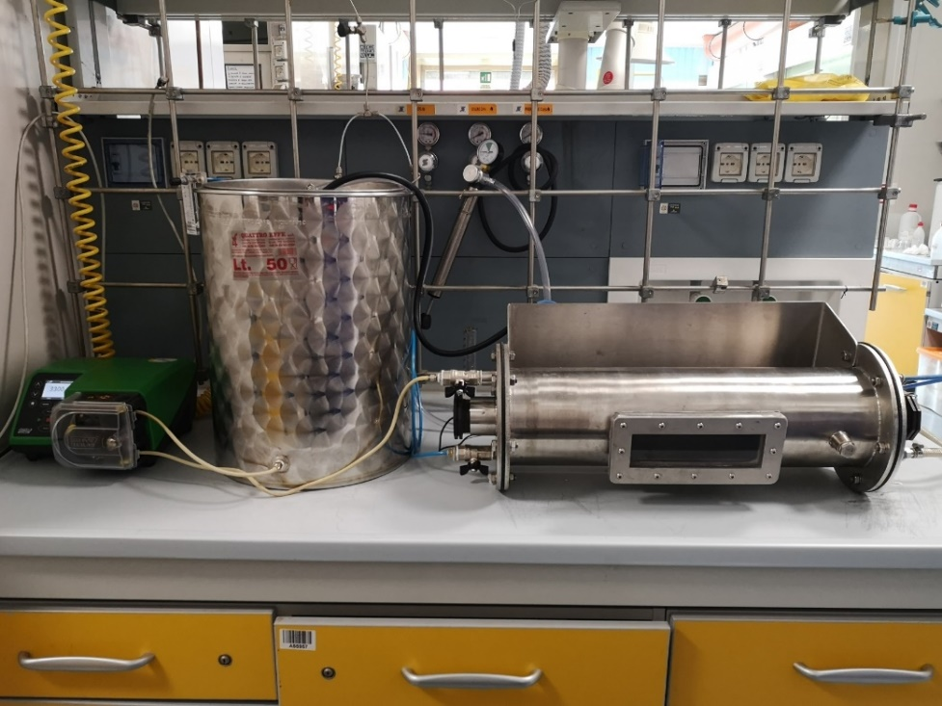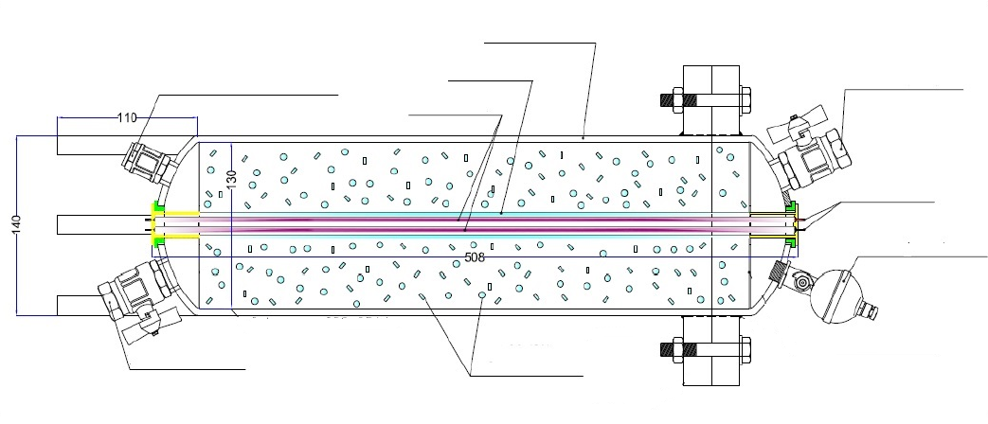

**Air inlet valve**

**Valve ½’’**

**Valve ½’’**

**UV lamp**

**Polymeric composite**

**sPS/photocatalyst**

**(a)**

**(b)**

At regular times, 2 mL of the solution was collected and filtered. ATZ and THI were determined by using HPLC UltiMate 3000 Thermo Scientific system equipped with DAD detector, binary pump, column thermostat and automatic sample injector with 100 µL loop. A C18 reversed-phase column (Luna 5u, 150 mm × 4.6 mm i.d., pore size 5µm, Phenomenex). The mobile phase consisted of an acetonitrile/water mixture (70/30 v/v). The flow rate was 1 mL/min, and injection volume and detection wavelength were, 80 µL and 223 nm for ATZ (Franco et al., 2022) and 40 µL and 242 nm for THI (Mancuso et al., 2021), respectively.



*Figure 2:* (a) ATZ chromatogram at a concentration of 100 µg/L. Retention time: 2.94 min (b) THI chromatogram at a concentration of 100 µg/L. Retention time: 2.04 min

Figures 2a and 2b shows the chromatograms of the ATZ and THI, respectively. The concentrations of ATZ and THI were obtained by interpolation with the least squares with R2 equal to 0.998 and 0.993. (For ATZ: slope= 12.5 ± 0.4 and intercept= 0.31 ± 0.22; THI: slope= 3.1±0.18 and intercept= 0.11 ± 0.10).

* 1. Results and discussion
     1. Photocatalysts characterization

The values of the specific surface area (SSA) of the aerogels sPS/NdT and sPS/30ZNT are reported in Table 2. The SSA values are 350 and 270 m2/g for sPS/NdT and sPS/30ZNT, respectively, in agreement with those reported for similar sPS-based composites (Daniel et al., 2020; Navarra et al., 2022b).

X-ray diffraction patterns of sPS/NdT and sPS/30ZNT aerogels are shown in Figure 3 and compared with the catalysts in powder form. Both the aerogels presented the XRD patterns typical of the sPS aerogel in δ form (2θ in the range 8.3°-23.6°). For the sPS/NdT aerogel, there are the typical reflections of the NdT powder catalyst, with the main XRD patterns observed at 2θ = 25.3 and 48°, typical of TiO2 in the anatase phase. sPS/30ZNT aerogel evidenced reflexes typical of both the NdT powder catalyst and ZnO in the wurtzite phase (2θ = 31.9, 34.6 and 36.6°).



*Figure 3:* X-ray diffraction patterns of powder catalysts (NdT and 30ZNT) and composite aerogel (sPS/NdT and sPS/30ZNT). a.u. = Arbitrary Unit.

* + 1. Photocatalytic activity tests

Few studies are reported in the literature on the degradation of pesticides with pilot-scale photoreactors under UV irradiation. In this work, the photocatalytic results of ATZ degradation under UV-A irradiation in the lab-scale and pilot-scale photoreactor with the composite aerogels sPS/NdT and sPS/30ZNT are presented in Figures 4a and 4b.



Figure 4: ATZ photocatalytic degradation with a) sPS/NdT and (b) sPS/30ZNT composite aerogel under UV irradiation using the lab-scale and pilot-scale photoreactor. ATZ initial concentration: 100 µg/L. Aerogel dosage 4 g/L for lab-scale and 0.025 for pilot-scale photoreactor.

The photocatalytic experiments carried out in the pilot-scale reactor led to better activities than those performed on the lab-scale. In the pilot-scale setting ATZ degradation of 94% was reached after 180 min for both samples. Yang et al. (Yang et al., 2018) analyzed the ATZ degradation under VUV/UV irradiation in a pilot-scale reactor, and reported an ATZ degradation of 74%, lower than those found in this study.

In contrast, in lab-scale configuration, ATZ degradation was 40% for the sPS/NdT and 70% for the sPS/30ZNT, respectively. The improved performance may be due to the different light intensity distribution within the two reactor configurations, which inevitably influences the overall pollutant degradation efficiency (Pareek et al., 2008). Indeed, photocatalytic reactions are highly dependent on light intensity as it affects the amount of light absorbed by the catalyst (Ahmed et al., 2011).

The photocatalytic performances of sPS/NdT and sPS/30ZNT were also evaluated for the degradation of THI, a pesticide listed among the contaminants of emerging concern (Sousa et al., 2019), using the pilot-scale photocatalytic reactor (Figure 5).



*Figure 5:* THI photocatalytic degradation under UV irradiation using the pilot-scale photoreactor with the composite aerogel and sPS/NdT and sPS/30ZNT. ATZ initial concentration: 100 µg/L. C0 and C, concentration at t = 0 and t min, respectively.

The degradation curves showed that the photocatalytic composites are also able to degrade THI in a very short reaction time. In detail, after 30 min of irradiation, the THI degradation reached a percentage value of 92% and 85% for sPS/NdT and sPS/30ZNT aerogels, respectively. The results obtained from the ATZ and THI degradation processes with the pilot-scale reactor highlighted that these catalytic materials could be interesting for a subsequent scale-up of the process.

* 1. Conclusions

In this work, NdT and 30ZNT photocatalysts were embedded in the porous sPS aerogel matrix to form monolithic sPS/NdT and sPS/30ZNT composite aerogels. The photocatalytic activity of the samples was assessed against two persistent pesticides, ATZ and THI, using a pilot-scale photoreactor operating in batch mode. Both aerogels showed good photocatalytic performance for the degradation of the two target pollutants. In detail, the ATZ degradation was 94% was for both the photocatalytic aerogels. Whereas the THI degradation performances were 92 and 85% for the sPS/NdT and sPS/30ZNT aerogels, respectively. The experimental results underlined the good photocatalytic properties of both sPS/NdT and sPS/30ZNT in the removal of pesticides, highlighting their possible use for a subsequent process scale-up.

Acknowledgment

This research work was carried out in partnership with COGEI company and was funded by MIUR (POR FESR CAMPANIA 2014/2020 - O.S.1.1 - RIS3, grant number: B63D18000600007). The authors wish to thank Maria Grazia Napoli and Ivano Immediata for their technical support in chemical analysis.

References

Abdel Rasoul, G.M., Abou Salem, M.E., Mechael, A.A., Hendy, O.M., Rohlman, D.S., Ismail, A.A., 2008. Effects of occupational pesticide exposure on children applying pesticides. NeuroToxicology 29, 833–838. https://doi.org/10.1016/j.neuro.2008.06.009

Abdelhameed, R.M., Darwesh, O.M., El-Shahat, M., 2023. Titanium-based metal-organic framework capsulated with magnetic nanoparticles: Antimicrobial and photocatalytic degradation of pesticides. Microporous and Mesoporous Materials 112543. https://doi.org/10.1016/j.micromeso.2023.112543

Ahmed, S., Rasul, M.G., Brown, R., Hashib, M.A., 2011. Influence of parameters on the heterogeneous photocatalytic degradation of pesticides and phenolic contaminants in wastewater: A short review. Journal of Environmental Management 92, 311–330. https://doi.org/10.1016/j.jenvman.2010.08.028

Caldas, E.D., Coelho, R., Souza, L.C.K.R., Silva, S.C., 1999. Organochlorine Pesticides in Water, Sediment, and Fish of Paranoá Lake of Brasilia, Brazil. Bulletin of Environmental Contamination and Toxicology 62, 199–206. https://doi.org/10.1007/s001289900860

Daniel, C., Navarra, W., Venditto, V., Sacco, O., Vaiano, V., 2020. 4 - Nanoporous polymeric aerogels–based structured photocatalysts for the removal of organic pollutant from water under visible or solar light, in: Sacco, O., Vaiano, V. (Eds.), Visible Light Active Structured Photocatalysts for the Removal of Emerging Contaminants. Elsevier, pp. 99–120. https://doi.org/10.1016/B978-0-12-818334-2.00004-3

De Almeida, L.N.B., Lenzi, G.G., Pietrobelli, J., Dos Santos, O.A.A., 2019. Degradation of Caffeine by Heterogeneous Photocatalysis Using Tio2 Impregnated with Fe and Ag. Chemical Engineering Transactions 74, 1531–1536.

Di Valentin, C., Finazzi, E., Pacchioni, G., Selloni, A., Livraghi, S., Paganini, M.C., Giamello, E., 2007. N-doped TiO 2: Theory and experiment. Chemical Physics 339, 44–56. https://doi.org/10.1016/j.chemphys.2007.07.020

Franco, P., Navarra, W., Sacco, O., De Marco, I., Mancuso, A., Vaiano, V., Venditto, V., 2022. Photocatalytic degradation of atrazine under visible light using Gd-doped ZnO prepared by supercritical antisolvent precipitation route. Catalysis Today 397–399, 240–248. https://doi.org/10.1016/j.cattod.2021.09.025

Iervolino, G., Zammit, I., Vaiano, V., Rizzo, L., 2019. Limitations and Prospects for Wastewater Treatment by UV and Visible-Light-Active Heterogeneous Photocatalysis: A Critical Review. Topics in Current Chemistry 378, 7. https://doi.org/10.1007/s41061-019-0272-1

Jablonowski, N.D., Schäffer, A., Burauel, P., 2011. Still present after all these years: persistence plus potential toxicity raise questions about the use of atrazine. Environmental Science and Pollution Research 18, 328–331.

Mancuso, A., Navarra, W., Sacco, O., Pragliola, S., Vaiano, V., Venditto, V., 2021. Photocatalytic Degradation of Thiacloprid Using Tri-Doped TiO2 Photocatalysts: A Preliminary Comparative Study. Catalysts 11. https://doi.org/10.3390/catal11080927

Navarra, W., Ritacco, I., Sacco, O., Caporaso, L., Farnesi Camellone, M., Venditto, V., Vaiano, V., 2022a. Density Functional Theory Study and Photocatalytic Activity of ZnO/N-Doped TiO2 Heterojunctions. J. Phys. Chem. C 126, 7000–7011. https://doi.org/10.1021/acs.jpcc.2c00152

Navarra, W., Sacco, O., Daniel, C., Venditto, V., Vaiano, V., Vignati, D.A.L., Bojic, C., Libralato, G., Lofrano, G., Carotenuto, M., 2022b. Photocatalytic degradation of atrazine by an N-doped TiO2/polymer composite: catalytic efficiency and toxicity evaluation. Journal of Environmental Chemical Engineering 10, 108167. https://doi.org/10.1016/j.jece.2022.108167

Pareek, V., Chong, S., Tadé, M., Adesina, A.A., 2008. Light intensity distribution in heterogenous photocatalytic reactors. Asia-Pacific Journal of Chemical Engineering 3, 171–201. https://doi.org/10.1002/apj.129

Reddy, P.V.L., Kim, K.-H., 2015. A review of photochemical approaches for the treatment of a wide range of pesticides. Journal of Hazardous Materials 285, 325–335. https://doi.org/10.1016/j.jhazmat.2014.11.036

Sacco, O., Stoller, M., Vaiano, V., Ciambelli, P., Chianese, A., Sannino, D., 2012a. Photocatalytic Degradation of Organic Dyes under Visible Light on N-Doped TiO2 Photocatalysts. International Journal of Photoenergy 2012. https://doi.org/10.1155/2012/626759

Sacco, O., Stoller, M., Vaiano, V., Ciambelli, P., Chianese, A., Sannino, D., 2012b. Photocatalytic Degradation of Organic Dyes under Visible Light on N-Doped Photocatalysts. International Journal of Photoenergy 2012, e626759. https://doi.org/10.1155/2012/626759

Sacco, O., Vaiano, V., Daniel, C., Navarra, W., Venditto, V., 2019. Highly Robust and Selective System for Water Pollutants Removal: How to Transform a Traditional Photocatalyst into a Highly Robust and Selective System for Water Pollutants Removal. Nanomaterials 9. https://doi.org/10.3390/nano9111509

Sacco, O., Vaiano, V., Daniel, C., Navarra, W., Venditto, V., 2018. Removal of phenol in aqueous media by N-doped TiO2 based photocatalytic aerogels. Materials Science in Semiconductor Processing 80, 104–110. https://doi.org/10.1016/j.mssp.2018.02.032

Sousa, J.C.G., Ribeiro, A.R., Barbosa, M.O., Ribeiro, C., Tiritan, M.E., Pereira, M.F.R., Silva, A.M.T., 2019. Monitoring of the 17 EU Watch List contaminants of emerging concern in the Ave and the Sousa Rivers. Science of The Total Environment 649, 1083–1095. https://doi.org/10.1016/j.scitotenv.2018.08.309

Tang, F.H.M., Lenzen, M., McBratney, A., Maggi, F., 2021. Risk of pesticide pollution at the global scale. Nature Geoscience 14, 206–210. https://doi.org/10.1038/s41561-021-00712-5

Tian, J., Wang, J., Dai, J., Wang, X., Yin, Y., 2009. N-doped TiO2/ZnO composite powder and its photocatalytic performance for degradation of methyl orange. Surface and Coatings Technology 204, 723–730. https://doi.org/10.1016/j.surfcoat.2009.09.028

Yang, L., Li, M., Li, W., Jiang, Y., Qiang, Z., 2018. Bench- and pilot-scale studies on the removal of pesticides from water by VUV/UV process. Chemical Engineering Journal 342, 155–162. https://doi.org/10.1016/j.cej.2018.02.075