CHEMICAL ENGINEERING TRANSACTIONS  VOL. , 2023 | A publication of
The Italian Association
of Chemical Engineering
Online at www.cetjournal.it

Guest Editor: Sauro Pierucci
Copyright © 2023, AIDIC Servizi S.r.l.
ISBN 978-88-95608-98-3; ISSN 2283-9216

The Hydrothermal Carbonization Process for Waste Valorisation: a Study on the Effect of Process Conditions on the Yield and Properties of Hydrochars from Municipal Solid Waste
Federica Barontini^{a,d}*, Sandra Vitolo^{a,d}, Riccardo Gori^{b,d}, Leonello Trivelli^{c}, Monica Puccini^{a,d}
ªDipartimento di Ingegneria Civile e Industriale, Università di Pisa, Largo Lucio Lazzarino 2, 56122 Pisa, Italy.
^{b}Dipartimento di Ingegneria Civile e Ambientale, Università di Firenze, via S. Marta 3, 50139 Firenze, Italy.
^{c}Scapigliato S.r.l., Loc.Scapigliato, SR 206, 57016 Rosignano Marittimo (Livorno), Italy.
^{d}Consorzio Interuniversitario Nazionale per la Scienza e Tecnologia dei Materiali (INSTM), via Giusti 9, 50121 Firenze, Italy.
federica.barontini@unipi.it
Hydrothermal carbonization (HTC) has received considerable attention in recent years for its potential to process heterogeneous organic wastes with high moisture contents. Unlike other thermochemical processes, HTC does not require drying of the feedstock as a pre-treatment. Performed in aqueous conditions at moderate temperatures under autogenous pressure, HTC produces a carbon rich solid phase, referred to as hydrochar, which can be directly used as a solid fuel, or it can be better exploited for new applications. In the present work the potential valorization by HTC of a waste stream from mechanical biological treatment of mixed municipal solid waste, namely the under-sieve fraction from the mechanical treatment stage, was explored. This stream does not have any potential for material recovery, and it is usually landfilled after aerobic biostabilization.
HTC tests were carried out in a laboratory-scale reactor. The joint effect of different process parameters on the yield and physicochemical properties of the hydrochar produced was investigated. The design of experiments (DoE) / response surface methodology (RSM) approach was used for the analysis of the influence of temperature, time and solid load on the mass yield and properties of hydrochar. Quantitative relationships between responses and process parameters were determined. The results obtained demonstrated the feasibility of HTC for mixed municipal solid waste, suggesting HTC as a promising alternative treatment path to current waste management.
  - Introduction
Global production of municipal solid waste (MSW) is increasing constantly in last years. A considerable amount of the total waste which is not suitable for recycling is incinerated or landfilled, posing severe environmental concerns. The increasing need to safely dispose of waste together with the need to find new renewable energy alternatives to fossil fuels has promoted the investigation for more efficient and reliable technologies for waste energy exploitation and conversion towards valuable materials.
Hydrothermal carbonization (HTC) has received considerable attention in recent years for its potential to process heterogeneous organic wastes (Libra et al., 2011). Performed in aqueous conditions at moderate temperatures (ranging from 180 °C to 300 °C) under autogenous pressure, HTC produces a carbon rich solid phase, referred to as hydrochar (Kambo and Dutta, 2015). Hydrochar can be directly used as a solid fuel, or it can be better exploited for new applications, such as for carbon dioxide sequestration, and for wastewater treatment (Maniscalco et al., 2020). Indeed, its condensed carbon structure and moderate porosity make hydrochar attractive as a feedstock for the production of materials such as catalysts, adsorbents, and activated carbons (Tekin et al., 2014). Unlike thermochemical processes such as combustion, pyrolysis and gasification, HTC does not require drying of the feedstock as a pre-treatment. This makes HTC applicable to a wide variety of carbonaceous wastes with varying but high moisture contents, including agricultural residues (Pavlovic et al., 2013), sewage sludge (Tasca et al., 2019), and the organic fraction of MSW (Lucian et al., 2018).
In many European countries, mixed MSW is commonly sent to a mechanical biological treatment (MBT) plant with the aim of generating a stream with improved combustible characteristics which can be classified as Solid Recovered Fuel. The mechanical treatment stage of mixed MSW generates a second waste stream, that is generally separated on a size basis by industrial sieving equipment, i.e., an under-sieve fraction, which is a fraction with high moisture content containing different materials such as residual food waste, paper and cardboard, plastics, metals, inert. This stream (named MBT-USF in the following) does not have any potential for material recovery, and it is usually aerobically biostabilized before being landfilled.
In the present study the application of HTC to MBT-USF was proposed, as a potential path for the recovery and valorisation of this waste stream. MBT-USF was provided by a waste management company located in Tuscany (Italy). HTC tests were carried out in a laboratory-scale reactor. The joint effect of different process parameters on the yield and physicochemical properties of the hydrochar produced was investigated. The design of experiments (DoE) / response surface methodology (RSM) approach was used for the analysis of the influence of temperature, time and solid load on the mass yield and properties of hydrochar.
  - Materials and Methods
    - Materials
MBT-USF (Figure 1a) was provided by Scapigliato S.r.l., a waste management company located in Tuscany.
The sample was milled using a Retsch SM 100 cutting mill, with the aid of liquid nitrogen, to reduce the dimensions below 4 mm. The moisture content of the milled sample was 39.4 wt %. Proximate analysis, ultimate analysis and heating value determination were performed following the methodologies briefly described herein. Volatile Matter (VM), Fixed Carbon (FC) and Ash content, i.e., proximate analysis, were determined by thermogravimetric (TG) analysis using a TA Instruments Q-500 thermobalance. Ultimate analysis was carried out with a LECO TruSpec CHN Elemental Analyzer, the oxygen content was evaluated by difference. A LECO AC-500 Calorimeter was used for heating value determination, according to EN 14918 test method. The results of material characterization are reported in Table 1.
    - Hydrothermal Carbonization
Hydrothermal carbonization experiments were carried out in a 300 mL AISI 316 stainless-steel PARR 4566 reactor, equipped with a mechanical agitator, an electric heating system, a thermocouple, a pressure gauge, and a pressure transducer (Figure 1b). The reactor temperature was controlled by a Parr 4848 Process Controller. HTC experimental tests were performed at different reaction temperatures (190–250 °C), reaction times (60–240 min), and solid content of the feedstock (5–25 wt %), according to the randomized design matrix obtained by DoE-RSM design. For each test the milled sample was mixed with water to reach the required solid content value. The mixture of solid and liquid products obtained at the end of the HTC test was recovered from the reaction vessel and the solid fraction was separated by vacuum filtration. The solid product (hydrochar) was dried at 105 °C for 12 hours, weighed and stored for characterization. Proximate analysis, ultimate analysis and heating value determination of hydrochar samples were performed following the same methodologies described for feedstock characterization.
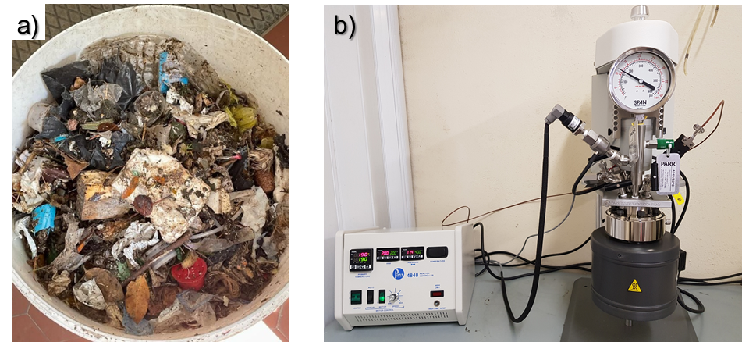
Figure 1: a) MBT-USF; b) experimental equipment used for HTC tests.
Table 1: Results of feedstock characterization (on a dry basis)
VM [wt %] | FC [wt %] | Ash [wt %] | C [wt %] | H [wt %] | N [wt %] | O [wt %] | HHV [MJ/kg]
55.66 | 4.89 | 39.45 | 29.42 | 3.96 | 1.17 | 26.00 | 12.50
    - Design of Experiments – Response Surface Methodology
HTC tests were planned according to the Design of Experiments (DoE) method, under the Response Surface Methodology (RSM) approach. The Design Expert 11 software was used to carry out DoE/RSM procedures. Temperature (A), reaction time (B), and solid content (C), were selected as independent variables. Table 2 shows the levels selected for the process variables. The experimental design was performed according to a three factorial face centered design, with six axial points and six replicates at the central point. The experimental sequence was randomized with the aim to reduce the effects of uncontrolled factors.
The responses selected to assess the HTC process performance were the following: hydrochar yield (Y), carbon yield (C yield), hydrochar H/C atomic ratio, hydrochar O/C atomic ratio, hydrochar ash content, hydrochar higher heating value (HHV), energy densification (ED), and energy recovery efficiency (ERE). Hydrochar yield (Y), carbon yield (C yield), energy densification (ED), and energy recovery efficiency (ERE) were defined as reported in Eqs(1)–(4).
$$Y=\frac{mass of dry hydrochar}{mass of dry feedstock}∙100$$ | (1)
$$C yield=Y∙\frac{C content of dry hydrochar}{C content of dry feedstock}∙100$$ | (2)
$$ED=\frac{{HHV}_{dry hydrochar}}{{HHV}_{dry feedstock}}$$ | (3)
$$ERE=Y∙\frac{{HHV}_{dry hydrochar}}{{HHV}_{dry feedstock}}$$ | (4)
Table 2: Independent variables: name, units and levels
Factor | Low level (-1) | High level (+1)
A: Temperature [°C] | 190 | 250
B: Time [min] | 60 | 240
C: Solid content [wt %] | 5 | 25

  - Results and Discussion
The most significant parameters that influence thermochemical conversion processes are temperature and residence time. Both these parameters influence the physicochemical characteristics of chars produced. To characterize HTC operating conditions and compare hydrochars obtained with different temperature and residence time, a severity factor f was introduced in the literature (Funke and Ziegler, 2010):
$$f=50∙t^{0.2}∙e^{-\frac{3500}{T}}$$ | (5)
where t is the duration of the thermochemical treatment (s) and T is the temperature (K). An enhanced process severity is related to a higher temperature and/or major residence time.
The results of HTC runs performed on MBT-USF were evaluated as a function of process severity. The results obtained for hydrochar yield, carbon yield, hydrocar heating value, and energy recovery efficiency (ERE) are shown in Figure 2 for different values of the feedstock solid content used in experimental tests.
HTC treatments carried out at higher severity show decreasing hydrochar yield (Figure 2a). Indeed, under hydrothermal conditions, the carbonization involves the degradation and re-organization of biomass polymers into an aqueous phase and therefore a mass loss is expected mainly from solubilisation of reaction intermediates and inorganic components of the biomass; a minor loss is due to the release of carbon dioxide in the gaseous phase due to decarboxylation reactions. This mass loss increases with temperature and reaction time. However, for severity values higher than 0.35, a slight increase in hydrochar yield is observed, since re-condensation reactions occur at higher temperatures and prolonged reaction times.
A decrease of carbon yield with severity is observed up to a severity value of roughly 0.3 (Figure 2b). As severity increases, the increase of the hydrochar carbon content does not compensate the decrease of char mass yield. For higher f values, the carbon yield increases: the re-condensation of a carbonaceous matrix increasingly richer in carbon takes place at higher temperatures and reaction times.
The results in Figure 2c indicate that the heating value of the produced hydrochar in low severity operating conditions is much higher than the feedstock HHV (Table 1). During HTC the degradation of hemicellulose (a component present in the organic fraction of municipal solid waste), occurs at relatively low temperatures (about 180 °C); hence, the removal of hemicellulose from the feedstock leads to an increase in energy density. As severity increases, the carbon transformation into soluble products results in an initial decrease of hydrochar HHV. With a further increase of process severity, the enhancement of the carbon content of the solid matrix together with the decrease of the oxygen content become more significant, so, hydrochar HHV increases. The energy densification (ED) obviously exhibits the same trend of hydrochar HHV.
Since an increase of severity produces also variations in hydrochar mass yield, the performance of the HTC process is better evaluated by the energy recovery efficiency (ERE). The results obtained for ERE (Figure 2d) show a trend similar to those of hydrochar yield and HHV, with maximum values of ERE for low severity operating conditions.
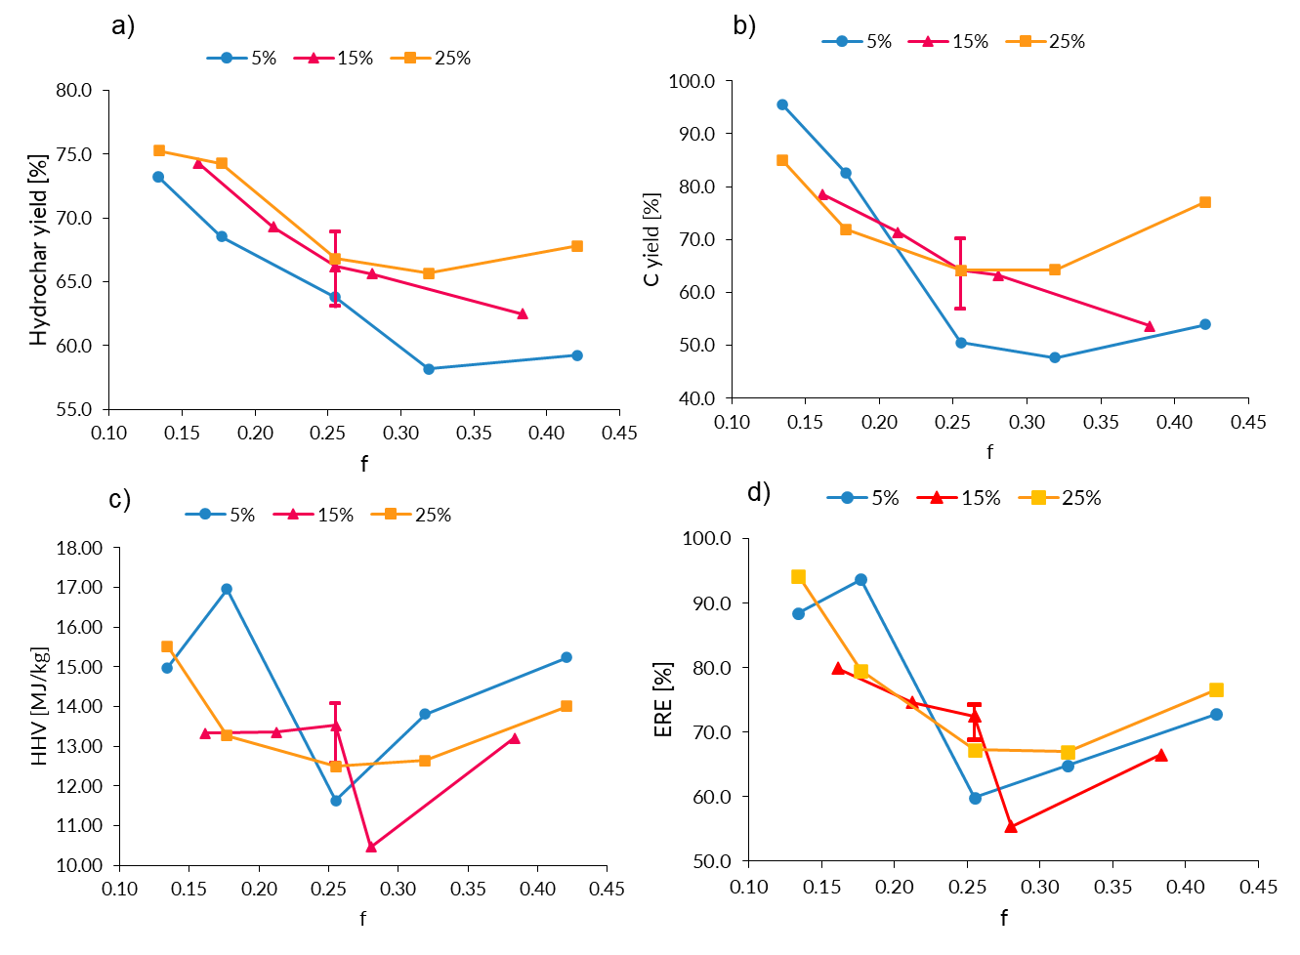
Figure 2: Effect of process severity and solid content of the feedstock on hydrochar yield (a), carbon yield (b), hydrochar higher heating value (c), and energy recovery efficiency (d).
The influence of temperature, time and solid load on the mass yields and properties of the hydrochar produced was further analyzed by the response surface methodology (RSM) approach. The effect of the key operative parameters, namely, temperature, reaction time, and solid content, on the target responses, as well as the influence of their interaction, was investigated, with the aim to provide insight into the choice of the operating conditions required to fit the desired application.
The results of the RSM analysis on selected test responses are reported and discussed next.
The following mathematical model was obtained for hydrochar yield:
$$y=67.04-5.22A+2.69C$$ | (6)
The Analysis of Variance (ANOVA) (Table 3) revealed that temperature and solid content are significant process variables (p value < 0.05), while the lack-of-fit is not significant (p value > 0.1), denoting good predictivity of the model. The model is linear and time is not significant. The relationship between process parameters and responses may be graphically represented by three-dimensional response surface plots. Figure 3 shows the response surfaces of the hydrochar yield as a function of temperature and time for different values of the solid content. It can be observed the hydrochar yield increases with increasing solid content and decreasing temperature.
The mathematical model obtained for carbon yield is reported in Eq(7):
$$y=63.30-11.70A-1.51B+3.21C+5.64AB+7.61AC+7.98B^{2}$$ | (7)
Figure 4 shows the response surfaces of the carbon yield as a function of temperature and time as the solid content varies. The carbon yield is higher for lower temperatures and shorter reaction times. It can also be noted that for high solid content the process severity does not significantly affect carbon yield (Figure 4c).
Table 3: ANOVA results and model statistics for hydrochar yield response
Source | Sum of Squares | df | Mean Square | F-value | p-value
Model | 345.42 | 2 | 172.71 | 40.58 | < 0.0001 | significant
A – Temperature | 272.92 | 1 | 272.92 | 64.13 | < 0.0001
C – Solid content | 72.50 | 1 | 72.50 | 17.04 | 0.0007
Residual | 72.35 | 17 | 4.26
Lack of Fit | 54.02 | 12 | 4.50 | 1.23 | 0.4381 | not significant
Pure Error | 18.33 | 5 | 3.67
Cor Total | 417.77 | 19
Fit Statistics
R² | 0.8268
Adjusted R² | 0.8064
Predicted R² | 0.7549

The following mathematical model was obtained for energy recovery efficiency (ERE):
$$y=68.44-8.81A-9.63B+3.38AB+9.88A^{2}+10.65A^{2}B$$ | (8)
The corresponding three-dimensional response surface plot is shown in Figure 5. Temperature and time are significant process variables, while ERE does not depend on the solid content. As evident from Eq(8) and Figure 5, the energy recovery efficiency is higher for lower temperatures and shorter reaction times.
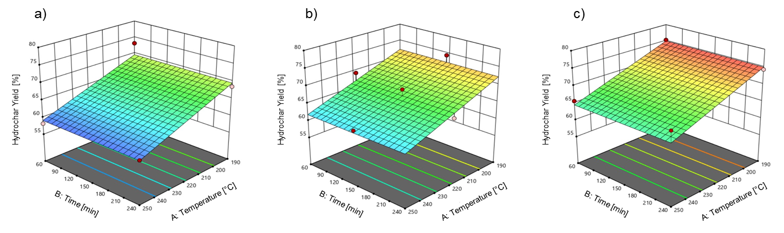
Figure 3: 3D response surface graphs obtained by RSM for hydrochar yield as a function of temperature and time; (a) 5 wt % solid content, (b) 15 wt % solid content, (c) 25 wt % solid content.
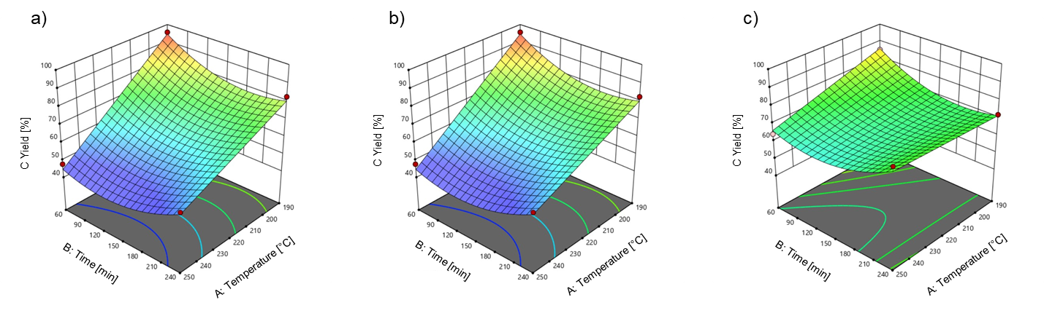
Figure 4: 3D response surface graphs obtained by RSM for carbon yield as a function of temperature and time; (a) 5 wt % solid content, (b) 15 wt % solid content, (c) 25 wt % solid content.
An optimization of the ERE response was carried out by referring to the parametric model obtained. The optimization of the HTC process was performed with the aim of identifying the optimum set of input parameters to the process which maximizes the energy recovery efficiency. By setting this objective, the software provided the following operative conditions: 190 °C reaction temperature and 60 min reaction time (ERE does not depend on solid load). Two validation tests were conducted in these conditions, using two different values of solid load (5 wt % and 25 wt %). For both runs, the measured responses were within the ranges predicted by the model.
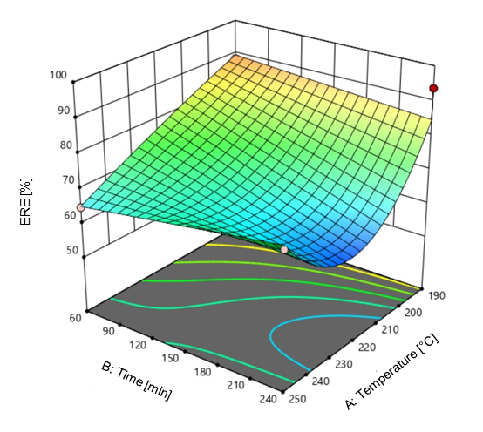
Figure 5: 3D response surface graph obtained by RSM for energy recovery efficiency (ERE) as a function of temperature and time.
  - Conclusions
In the present work the potential valorization by HTC of a waste stream, the wet fraction mechanically separated from mixed MSW or under-sieve fraction, was explored. The influence of temperature, time and solid load on the mass yields and properties of the hydrochar produced was investigated by the design of experiments (DoE) / response surface methodology (RSM) approach. Quantitative relationships between responses and process parameters were determined.
The results obtained demonstrated the feasibility of HTC for mixed municipal solid waste, suggesting HTC as a promising alternative treatment path to current waste management. Hydrothermal carbonization can play an innovative role in waste treatment and valorisation. Transforming municipal solid waste into a renewable fuel would mitigate environmental issues associated with landfilling, while providing a renewable energy source. Further potential applications of the hydrochar produced will be investigated, such as fertilizer for soil amendment in agriculture, filler in composite materials, and adsorbent for gas and liquid contaminants removal.
Acknowledgments
The authors wish to thank Scapigliato S.r.l. for their financial support.
References
Funke A., Ziegler F., 2010, Hydrothermal carbonization of biomass: a summary and discussion of chemical mechanisms for process engineering, Biofuels Bioprod. Biorefining 4, 160–177.
Kambo H., Dutta A., 2015, A comparative review of biochar and hydrochar in terms of production, physico-chemical properties and applications, Renew. Sustain. Energy Rev. 45, 359–378.
Libra J.A., Ro K.S., Kammann C., Funke A., Berge N.D., Neubauer Y., Titirici M.-M., Fühner C., Bens O., Kern J., Emmerich K.-H., 2011, Hydrothermal carbonization of biomass residuals: a comparative review of the chemistry, processes and applications of wet and dry pyrolysis, Biofuels 2, 71–106.
Lucian M., Volpe M., Gao L., Piro G., Goldfarb J.L., Fiori L., 2018, Impact of hydrothermal carbonization conditions on the formation of hydrochars and secondary chars from the organic fraction of municipal solid waste, Fuel, 233, 257–268.
Maniscalco M.P., Volpe M., Messineo A., 2020, Hydrothermal Carbonization as a Valuable Tool for Energy and Environmental Applications: A Review, Energies, 13, 4098.
Pavlovic I., Knez Z., Skerget M., 2013, Hydrothermal reactions of agricultural and food processing wastes in sub- and supercritical water: a review of fundamentals, mechanisms, and state of research, J. Agric. Food Chem. 61, 8003–8025.
Tasca A.L., Puccini M., Gori R., Corsi I., Raspolli Galletti A.M., Vitolo S., 2019, Hydrothermal carbonization of sewage sludge: a critical analysis of process severity, hydrochar properties and environmental implications, Waste Management, 93, 1–13.
Tekin K., Karagöz S., Bektas S., 2014, A review of hydrothermal biomass processing, Renew. Sustain. Energy Rev. 40, 673–687.

