A Contribution Towards Supply Chain Sustainability

Ana Paula Barbosa-Póvoa
Centre for Management Studies, Instituto Superior Técnico, Universidade de Lisboa, Portugal

Today organization's long-term success is built not only on profitability but also on its contribution to society. Being supply chain keystones in any organisation, the management of such systems considering sustainability goals is essential. Though being supply chains complex systems in nature, the incorporation of environmental and social goals simultaneously with the traditional supply chain goal, profit, adds more complexity to the associated decision-making process. To support such a process the use of adequate process system engineering tools is a prerequisite. In this talk, the characteristics of such tools are discussed and their development to inform the design and planning of a sustainable supply chain is addressed, where the solution of real base case examples is discussed. Perspectives in the area are presented and important existing challenges identified, which may push research in sustainable supply chains.

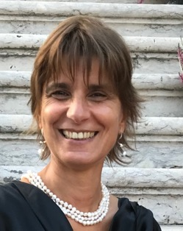

Ana Barbosa-Póvoa is a Full Professor in Operations and Logistics, at the Engineering and Management Department of Instituto Superior Técnico (IST), University of Lisbon. She holds a PhD from the Imperial College of Science Technology and Medicine, and her research focus is on developing a comprehensive understanding of complex problems in supply chains and operations management, supported by novel and sound engineering systems models and techniques. Sustainability, resilience, uncertainty, and risk in the design and planning of supply chains are among her main research addressed domains. Ana has created and coordinates the research group in Operations Management and Logistics (OpLog) at the Centre for Management Studies of IST. Her research has led to several national and international awards. She is a member of the Computer Aided Process Engineering Working Party of the European Federation of Chemical Engineers and a founder member of the Euro Working Group in Sustainable Supply Chains of the European Association of Operational Research Societies (EURO) – where she is currently part of the coordination team. She is an editor of the Computers and Chemical Engineering Journal and a member of the editorial boards of the European Journal of Operational Research and International Journal of Production Economics. She is the vice-president for education of the EURO - European Association of Operational Research Societies.

