CHEMICAL ENGINEERING TRANSACTIONS  VOL. , 2023 | A publication of
The Italian Association
of Chemical Engineering
Online at www.cetjournal.it

Guest Editor: Sauro Pierucci
Copyright © 2023, AIDIC Servizi S.r.l.
ISBN 978-88-95608-98-3; ISSN 2283-9216

Evaluation of Adsorption Process in a Molecular Sieve for Anhydrous Ethanol Production Using Facilities of Aspen Adsim
Yann M. Pinterich and Maria R. Wolf Maciel
Laboratory of Development of Separation Processes (LDPS), School of Chemical Engineering, University of Campinas, Brazil
wolf@unicamp.br
Anhydrous ethanol has several applications in industrial segments, besides being used as an additive to gasoline. Due to the formation of the azeotrope between ethanol and water, complex separation processes must be used to obtain anhydrous ethanol, such as extractive distillation, azeotropic distillation or molecular sieve adsorption. Among these processes, molecular sieve adsorption has the advantage of not requiring the addition of a solvent, which can enable a very high degree of purity for the product and avoids a solvent recovery step. This type of adsorption process can be performed using a hydrophilic adsorbent with pore diameter capable of selectively adsorbing water molecules and not ethanol molecules. Through dynamic process simulations, profiles of mole fractions of ethanol and water in the bed, the variation of the product composition with time and sensitivity analyses were evaluated. The adsorption phenomenon, the molecular sieves mechanism and the use of software for the simulation of chemical processes were demonstrated. The simulations reached very satisfactory results for the process. The base case simulation reached 91.3 % mass purity for the complete simulation of the batch process lasting 5000 s. Limiting the simulation to 2337 s, the mass purity was 99.3 %, while the recovery was 100.0 % and the productivity was 3.40 L/h/kg of adsorbent. This purity achieved meets the criteria for the use of ethanol as a gasoline additive. Column diameter and feed flow rate were the variables that most impacted the results in the sensitivity study.
  - Introduction
In the 1970s, during the oil crises, the National Alcohol Program (Pró-Álcool) was created in Brazil, in which it began to study fuels of vegetable origin alternative to gasoline derived from petroleum, with emphasis on the production of ethanol from sugar cane, a technique that prevails in the country until the present (Silva, 2022) with success. Therefore, it was regulated by Resolution N° 1 of 2015 of the Interministerial Council for Sugar and Alcohol (CIMA) that anhydrous ethanol in Brazil composes the formulation of regular gasoline, in a mixture of 27 % for regular gasoline and 25 % for premium gasoline, with a minimum ethanol mass fraction of 0.993 (National Agency of Petroleum, Natural Gas and Biofuels, 2015). For other countries, the minimum fraction of ethyl alcohol may vary according to local regulations, as shown in Table 1.
Table 1: Specifications of anhydrous ethanol to be mixed with gasoline. From Fontana et al. (2021).
Local | Minimum ethanol content |  | Maximum water content |  | Regulation
 | % mass | % volume | % mass | % volume
Brazil | 99.3 | 98.0 | 0.7 | - | ANP Nº 19 (2015)
USA | - | 92.1 | 1.26 | 1.0 | ASTM D4806-16 (2016)
Europe | 98.7 | - | 0.3 | - | EM 15376:2014 (2014)

It is known that ethanol and water form an azeotropic mixture in an ethanol fraction of 0.8952 molar or 0.9562 mass at atmospheric pressure and a temperature of 78.2 °C (Walas, 1985). The azeotropic point shows that the mole fraction of ethanol in the vapor and liquid phase are the same. Thus, in order to obtain anhydrous ethanol, some additional technique is needed besides to traditional distillation, such as extractive or azeotropic distillation, pervaporation and molecular sieve adsorption, which is the object of study of this work.
The phenomenon of adsorption consists of the mass transfer of one or more components, called adsorbates, from a fluid phase to the surface of a solid phase, called adsorbent. For adsorption columns, there is usually a fixed bed in which a continuous flow of fluid is maintained through the bed filled with adsorbent, which retains the adsorbate, separating it from the fluid phase until the moment when the adsorbent becomes saturated and separation is no longer possible. After saturation, it is necessary to perform desorption to regenerate the solid phase. This process is done physically, since the adsorption on molecular sieves is carried out through physisorption, characterized by weak intermolecular bonds (of van der Waals) (Ruthven, 1984).
Molecular sieves are porous solid materials that have the ability to selectively separate compounds in a mixture. The micropores present in its structure capture the molecules of one of the components of the mixture by adsorption, while the molecules of the other component do not change. A type of molecular sieve commonly used in industrial processes are zeolites 3A, characterized by a porous crystalline structure of aluminosilicates (Braga, 2016). The vast majority of this type of molecular sieve is hydrophilic - except when the zeolite goes through the dealumination process that makes it hydrophobic (Müller, 2017) -, which favors the capture of water molecules in relation to those of ethanol. Furthermore, 3A zeolites, whose nomenclature refers to the diameter of their pores, in this case 3 Å, greatly favors the dehydration of ethanol, since the water molecule has a diameter of 2.8 Å while that of ethanol has 4.4 Å.
The adsorption process with molecular sieves is more advantageous than other ethanol dehydration processes, such as azeotropic distillation and extractive distillation that use, respectively, cyclohexane and monoethyleneglycol as solvents. As there is no addition of a solvent to separate water from ethanol, molecular sieves minimize contamination of the final product, providing better quality ethanol, in addition to not requiring a subsequent solvent recovery step (Abdala, 2017). As a result, the process using molecular sieves has less energy expenditure and lower steam consumption (Huang et al., 2008), since it operates in the vapor phase, not needing to condense the hydrated ethanol at the exit of the upstream distillation column.
Technologically speaking, it is important to spend as little energy as possible in the ethanol production process to reduce bagasse consumption, increasing the potential for second-generation ethanol production. This is because sugarcane bagasse is used to generate energy and steam used in the ethanol process. The unit operation that requires the most energy in anhydrous ethanol production is the extractive or azeotropic distillation process, which are the most used processes in large scale ethanol plants in Brazil. The challenge then is to have a robust adsorption process that allows the product to reach the desired concentration.
Thus, the objective of this work was to emphasize the importance of this separation technology in the downstream process showing more clearly its implementation on Aspen Adsim Simulator, taking into account the adsorption process in molecular sieve for the production of anhydrous ethanol. This procedure is not much present in the open literature. Furthermore, adsorption process having as dehydrating agent zeolite beads demands much less kg steam/L ethanol when compared to conventional separation processes.
  - Methodology
In order to make simulations possible through simple adsorption on molecular sieves for a batch regime, the Aspen Adsim package of the Aspen simulator was used, in which the adsorbent used was zeolite 3A, already consolidated for this type of application (Simo, 2009; Fonseca, 2011).
Table 2: Operating parameters of the adsorbent column based on Fonseca (2011)
Parameter | Value
H_{b} - Bed length (m) | 7.3
D_{b} - Inner diameter of the bed (m) | 2.4
ℰ_{i} - Bed porosity (m³ voids/m³ bed) | 0.5098
R_{p} - Adsorbent particle radius (m) | 1.785‧10⁻³
ℰ_{p} - Particle porosity (m³ voids/m³ bed) | 0.2869
RHOs - Adsorbent solid density (kg/m³) | 2254

For the simulation, it was considered that the hydrous ethanol feed stream was 3000 kmol/h with a mole fraction of ethanol equal to 0.8 (lesser than the azeotrope). The simulation aims to adsorb the water present in the feed, producing anhydrous ethanol at the exit of the column, with a mass fraction of ethanol in the product of 0.993, which meets the minimum specifications for ethanol in European countries, the United States and Brazil, according to Table 1. On the other hand, the minimum mass fraction of water does not meet European requirements, which must be lesser than 0.003. The conditions for feeding the bed in the gaseous phase were 440.15 K temperature and 3.79 bar pressure, according to Fonseca (2011).
The operating parameters used were proposed by Fonseca (2011), as shown in Table 2. The parameters of the Langmuir isotherm model used are shown in Table 3, as well as the mass transfer coefficients adopted.
Table 3: Mass transfer coefficients and parameters of the Langmuir isotherm based on Fonseca (2011)
Parameter | Value
MTC Ethanol – Mass transfer coefficient (1/s) | 0
MTC Water – Mass transfer coefficient (1/s) | 1.03‧10⁻³
IP (1, Ethanol) Parameter 1 of the isotherm for ethanol | 0
IP (1, Water) Parameter 1 of the isotherm for water | 0.1489
IP (2, Ethanol) Parameter 2 of the isotherm for ethanol | 0
IP (2, Water) Parameter 2 of the isotherm for water | 19.11
  - Results and discussions
Considering the explained methodology, the batch process of anhydrous ethanol production by simple adsorption in molecular sieve was simulated using the Aspen Adsim software. The simulations were considered in a batch regime in order to evaluate the behavior of the proposed model, its main characteristics and the capacity of the process to selectively adsorb water.
    - Base case simulation
Inserting the considerations present in Tables 2 and 3, relevant curves are generated for the study of the process. Evaluating the mole fraction of water in the product stream at the column outlet over time, the system breakthrough curves are obtained (Figure 1). Furthermore, it can also compare the evolution of the profile of the mole fraction of ethanol and water along the column at different simulation times, as shown in Figure 2.
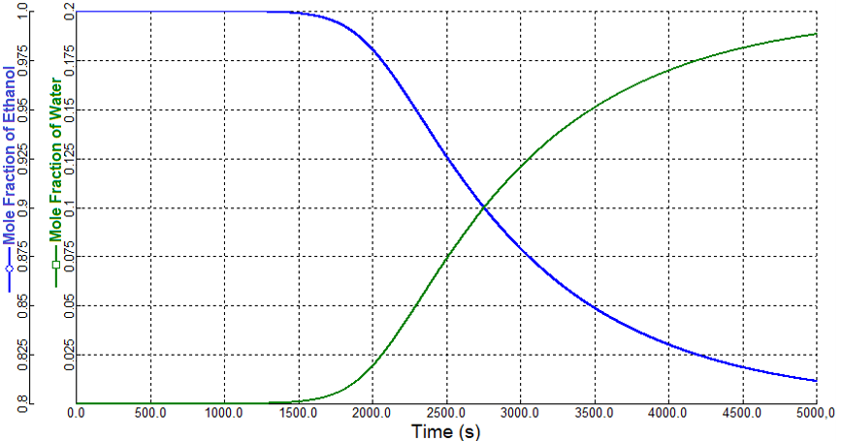
Figure 1: Breakthrough curve of the adsorption process with molecular sieve
From the results found, it is possible to notice the effect of the phenomenon of selective adsorption occurring along the adsorbent column, given that the mole fraction of water in the product stream is smaller than in the feed stream. On the other hand, with the passage of time, the concentration of water (adsorbate) gradually increases in the product stream, as evidenced in Figure 1 by the breakthrough curve. From the breakthrough point, the bed starts to become saturated and the capacity of the bed to adsorb water decreases.
Through Figure 2, it is observed that the base of the adsorption column (region close to the feed stream) is saturated faster than the other regions of the bed, which gradually increase the amount of adsorbed water until they saturate. This fact is observed since the upper part of the column receives a flow partially enriched in ethanol, while the base receives hydrated ethanol from the feed.
Calculating the process performance indicators, 91.3 % mass purity was obtained for the complete simulation lasting 5000 seconds. However, limiting the simulation to just 2337 seconds, the mass purity was 99.3 %, while the recovery was 100.0 % and the productivity 3.40 L/h/kg of adsorbent. The purity achieved meets the criteria for use as a gasoline additive (Table 1). The high recovery of ethanol indicates that the adsorbent bed retains only water molecules during its operation, allowing the passage of ethanol. The productivity obtained is considerably lower than those obtained in other studies in the literature, such as Fonseca (2011). However, the present work considers a batch regime with the bed operating only once, contrary to the study by Fonseca (2011), which presented a cyclic regime. The benefits of batch processes consist of the possibility of easily controlling and limiting the operating time of the process and, consequently, the purity and productivity achieved. Furthermore, there is no ethanol lost in the purge step, as occurs in the cyclic regime.

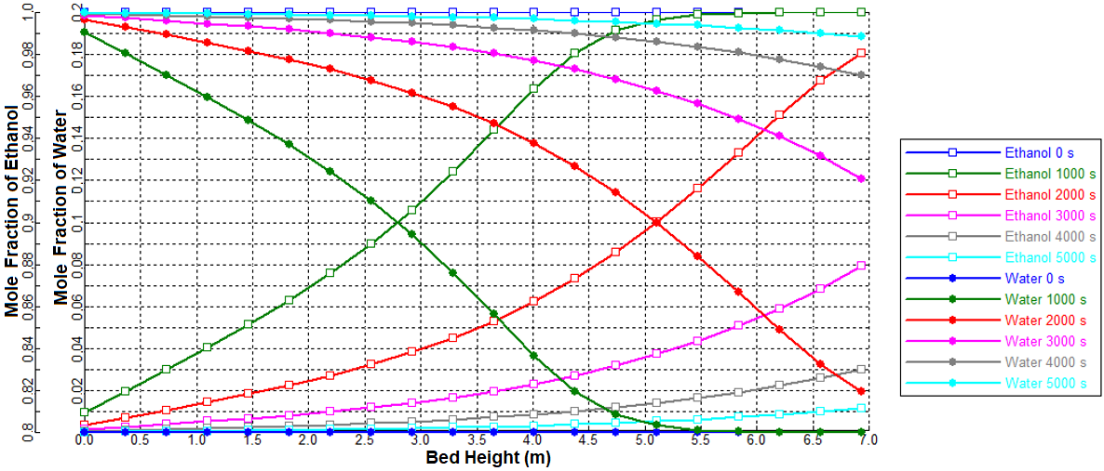
Figure 2: Column profile at different times
    - Sensitivity analysis
New simulations were performed for the sensitivity analysis, varying the parameters by +10 % and -10 % (except for diameter and porosity, which were evaluated at +10 % and +20 %). The total simulation time was 5000 s, calculating in this period the productivity of the adsorbent and the final purity reached by the batch. As it is necessary for ethanol to have a mass purity greater than 99.3 % to be used as a gasoline additive (Table 1), the performance indicators were also calculated considering the simulation until the time when the batch mass purity is equal to 99.3 %, which can be considered the breakthrough time (Seader, 1998). For all simulations, recovery was 100 %, which indicates that the column does not retain ethanol molecules.
According to Figure 3a, the greater the feed flow rate, the lower the final purity achieved by the process, since there is a greater amount of solute passing through the adsorbent bed, which decreases the residence time of water molecules, which will be less retained by the zeolites in the column, increasing the water concentration at the end of the batch. On the other hand, with a higher flow rate, productivity increases due to the increase in the amount of final product and the breakthrough time decreases, as the bed saturates more quickly.
The results shown in Figure 3b show that a higher adsorption pressure provides greater purity, justified by the adsorption isotherms. The inverse process occurs in the desorption step using the Pressure Swing Adsorption technique. The productivity changes little with pressure variation, remaining around 5.23 L/h/kg of adsorbent for the simulation up to mass purity of 99.3% and 4.80 L/h/kg of adsorbent for the complete simulation. Breakthrough time increases with pressure, as the adsorption capacity of the bed is greater.
The temperature (Figure 3c), contributes negatively to the purity because of the adsorption isotherms. The higher the temperature, the smaller the amount of adsorbed solute, as it happens in the desorption step by the Temperature Swing Adsorption technique. Breakthrough time and productivity are little impacted, remaining 5.23 and 4.80 L/h/kg for the productivity of 99.3% mass purity and for the final productivity, respectively.
The results in Figure 3d show that the higher the initial concentration of water, the lower the final purity, since there is a greater amount of solute for the same amount of adsorbent, which saturates faster, increasing the amount of solute in the final solution. Productivity decreases with increasing concentration, since it is directly proportional to the mole fraction of ethanol in the final solution, because high initial water concentration values ​​lead to a lower quality of ethanol, in addition to reducing the breakthrough time, since it favours the driving force of adsorption, saturating the bed more quickly.
As an important bed designer parameter, column diameter had the greatest impact on performance indicators (Figure 3e). Increasing the diameter favours purity, because a larger column has more adsorbents and greater adsorption capacity. In addition, the velocity inside the column decreases for the same flow rate, which increases the contact time of the solute with the adsorbent, favouring adsorption. However, a bed with larger dimensions,
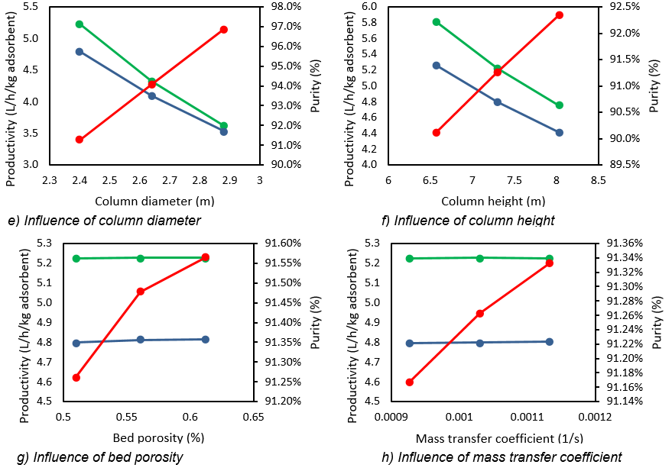
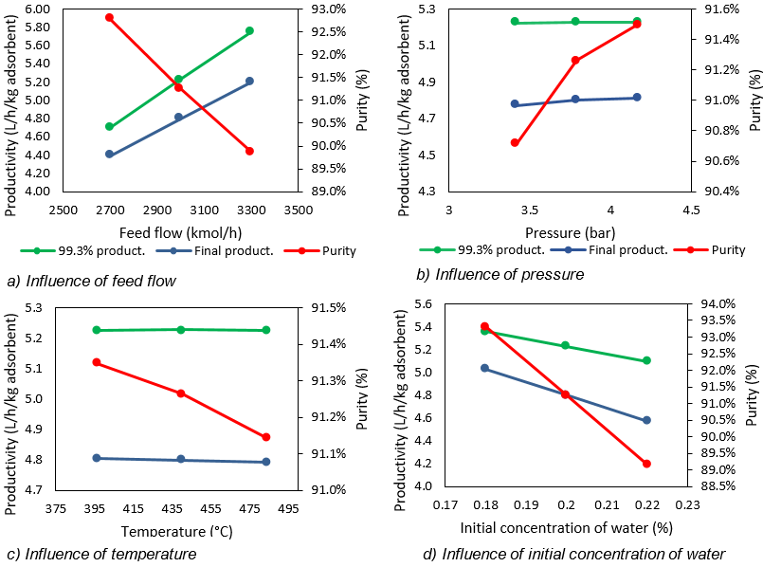
Figure 3: Sensitivity analysis of variables in performance indicators

greater is the amount of adsorbent for the same feed flow rate, which decreases the productivity. The bed saturation time increases due to the higher adsorption capacity.
Bed height has similar effects on performance indicators to bed diameter (Figure 3f). A higher bed height produces higher purity ethanol due to the higher amount of adsorbent and adsorption capacity. Productivity is disadvantaged because of the increase in adsorbent volume for the same flow rate. The breakthrough time increases the larger the bed.
The increase in porosity favours purity (Figure 3g), since there is greater contact with the adsorbent and has a slight influence on productivity. The breakthrough time increases little with the increase in porosity, since better contact with the adsorbent favours the adsorption process, taking longer for the bed to saturate.
The effects of mass transfer coefficient (MTC) on performance indicators are found in Figure 3h, where a slight increase in purity is observed with the increase in MTC, since it provides an adsorption process more effective. Regarding productivity, it is observed that this variable is subtly impacted in a positive way. With increasing MTC, the adsorption process is more efficient, increasing the time required for the bed to saturate.
For the simulation to obtain good results, as it is a batch process, it is necessary to be aware of the simulation operating time and the breakthrough time, since operating in times greater than the breakthrough point will result in ethanol with lower purity and quality. The isotherm parameters adopted also impact the final results, as they contribute to the interaction of molecules with the adsorbent bed and with the profiles in the column. Other values ​​found in the open literature must be evaluated to verify the process performance and this should be carried out in the simulation environment. This is barely found in the literature and this information is important because industrial data (design details and operating values) are usually not available.
  - Conclusions
The simulations were able to purify ethanol to be used as an additive to gasoline, according to the regulations of the countries, proving the efficiency of the adsorption process in molecular sieves. The effects of the different system variables were evaluated through sensitivity analysis, in which it was possible to verify that the variables with the greatest impact on the results and performance indicators are the column diameter and the feed flow rate, while the ones with the lowest impact are the temperature and the mass transfer coefficient.
Acknowledgments
The authors would like to grant #2015/20630-4 São Paulo Research Foundation (FAPESP); to grant # 313952/2020-5 CNPq and to PIBIC/CNPq.
References
Abdala, T. O., 2017, Comparative analysis of anhydrous ethanol production processes (in Portuguese), Federal University of Uberlândia, Brazil.
Braga, V. G. P., 2016, Production of molecular sieves (zeolites) as an alternative for ethanol dehydration (in Portuguese), Revista Científica Semana Acadêmica, Brazil, v. 1, n. 97.
Interministerial Council for Sugar and Alcohol, 2015, CIMA Resolution Nº 1, de 03.04.2015, Brazil, <www.jusbrasil.com.br/diarios/87237712/dou-secao-1-06-03-2015-pg-17> accessed 02.13.2023.
Fonseca, N. A. A., 2011, Simulation of the adsorption process psa for separation of ethanol-water mixtures (in Portuguese) (Master’s thesis), University of Campinas, Brazil.
Fontana, M., 2021, Comparative evaluation of processes for obtaining hydrated anhydrous bioethanol of the 1st and 2nd generations using the rate-based model (in Portuguese) (Master’s thesis), University of Campinas, Brazil.
Huang, H.-J., Ramaswamy, S., Tschirner, U., Ramarao, B., 2008, A review of separation technologies in current and future biorefineries, Separation and purification technology, Elsevier, v. 62, n. 1, p. 1-21.
Müller, J. M., 2017, The influence of the desaluminization process on the structure, acidity and catalytic properties of zeolites (in Portuguese) (Doctoral dissertation), University of Brasília, Brazil.
National Agency of Petroleum, Natural Gas and Biofuels, 2015, ANP Resolution Nº 19, of 4.15.2015, Brazil.
Ruthven, D. M., 1984, Principles of adsorption and adsorption processes, John Wiley & Sons.
Seader, J. D., Henley, E. J., Roper, D. K., 1998, Separation Process Principles, Wiley New York, v. 25.
Silva, G. R., 2022, Sugar cane in ethanol production (in Portuguese), UNINTER International University Center, Brazil.
Simo, M., Sivashanmugam, S., Brown, C. J., Hlavacek, V., 2009, Adsorption/desorption of water and ethanol on 3A zeolite in near-adiabatic fixed bed, Industrial & Engineering Chemistry Research, ACS Publications, v. 48, n. 20, p. 9247-9260.
Walas, S. M., 1985, Phase Equilibria in Chemical Engineering, Butterworth Publishers, Stoneham, USA.

