|  |  |
| --- | --- |
| cetlogo ***CHEMICAL ENGINEERING TRANSACTIONS***  ***VOL. xxx, 2025*** | A publication of  aidiclogo_grande |
| The Italian Association  of Chemical Engineering  Online at www.cetjournal.it |
| Guest Editors: Fabrizio Bezzo, Flavio Manenti, Gabriele Pannocchia, Almerinda di Benedetto  Copyright © 2025, AIDIC Servizi S.r.l. **ISBN** 979-12-81206-17-5; **ISSN** 2283-9216 | |

Computational Fluid Dynamics Investigation on Transplantation Anastomoses

Filippos F. Karageorgosa, Georgios Tsoulfasa, Aleck H. Alexopoulosb,\*

aDepartment of Transplantation Surgery, Center for Research and Innovation in Solid Organ Transplantation, Aristotle University School of Medicine, 54642 Thessaloniki, Greece

bChemical Process & Energy Resources Institute, 6th km Harilaou-Thermi rd., P.O. Box 60361, 57001, Thessaloniki, Greece

aleck@certh.gr

A surgical technique, known as hepatic artery patch, is applied in the anastomosis of the hepatic artery to minimize complications such as hepatic artery thrombosis (HAT). This surgical technique is used when there is a diameter size difference in the two connected arteries. Computational fluid dynamics (CFD) is a tool for solving problems including various phenomena (e.g., fluid flow, mass transfer, heat transfer) (Raman et al., 2018). Moreover, CFD has a wide range of applications from turbomachinery design and aerodynamics of aircrafts to food industry, drug delivery and even more (Raman et al., 2018; Kiparissides et al., 2018). There is limited data from the viewpoint of CFD studying the HAT problem and how it can be reduced or prevented. Herein, the hepatic artery anastomosis using hepatic artery patch is studied. For this, the geometric characteristics, such as the diameter of the connection that the patch should have, in relation to the blood inlet and outlet artery (i.e., the recipient’s blood vessel diameter, the donor’s blood vessel diameter), are studied. In addition, pulsatile flow with various assumed heart rates inside and outside the normal range are considered together with a Carreau model for blood rheology (Zouggari et al., 2018). The CFD solver, ANSYS, has been used to generate the simulation results. It is known that ANSYS is appropriate to simulate complex geometries (Papadimitriou et al., 2011). Solutions are obtained over a span of at least three flow pulses. In the literature wall shear stress and blood velocity are associated with thrombosis and plaque formation (Reorowicz et al., 2022). The simulation results are compared with clinical studies from the literature on the risk of thrombosis.

* 1. Introduction

A solid organ transplantation (e.g., liver transplantation, kidney transplantation) includes a series of steps to be completed during surgery such as blood vessel anastomoses. In liver transplantation there is a number of blood vessel anastomoses that need to be completed before the transplantation surgery can be completed and the graft can function properly (Cohn et al., 2012). Some of these anastomoses include the hepatic artery anastomosis and the portal vein anastomosis. As in every surgery there may be complications in the postoperative period. The hepatic artery thrombosis (HAT) (Pareja et al., 2010) is a common postoperative complication of the liver transplantation.

* + 1. General Information on Liver Transplantation

The first successful liver transplant was performed in July 1967 by a surgical team led by Dr Thomas Starzl (Zarrinpar and Busuttil, 2013, Karageorgos et al., 2024). Since then, these interventions have expanded significantly and a total of 34,694 liver transplants were performed globally in 2021 (Terrault et al., 2023). During liver transplantation the following vascular anastomoses must be performed: the piggy-back inferior vena cava anastomosis; the portal vein anastomosis; the hepatic artery anastomosis; the bile duct anastomosis.

Non-occlusive and steno-occlusive diseases are the two main types of hepatic artery complications (Cizman and Saad, 2023). The term "steno-occlusive disease" refers to a group of conditions including hepatic artery kinks, stenosis, and thrombosis. Arteriovenous fistulae, arterial rupture, pseudoaneurysms, and non-occlusive hepatic artery hypoperfusion syndrome are all referred to as non-occlusive arterial disease. HAT is the most frequent vascular complication that follows after liver transplantation, occurring in 2–12% of cases (i.e., 694-4164 cases per year) (Katyal et al., 2000). Hepatic artery stenosis is the second most frequent vascular complication following liver transplantation that occurs in ≤5% of transplants (Katyal et al., 2000).

* + 1. Hepatic Artery Anastomosis and Dimensions

In liver transplant surgeries the recipient and donor arteries undergo an anastomosis, where the initial diameter and length of the arteries, together with other factors that differ from patient to patient, determine the level of anastomosis on both the donor and recipient sides. Hepatic graft arterialization is often accomplished by end-to-end anastomosis between the recipient hepatic artery and the small Carrel patch of the graft's celiac trunk (CT) on the CT itself (Todo et al., 1987). One preferred site for the end-to-end anastomosis is the recipient gastroduodenal artery (GDA) bifurcation at the common hepatic artery (CHA) (see Figure 1) (Todo et al., 1987). To choose an appropriate recipient for anastomosis, the GDA and the proper hepatic artery (PHA) are split to form a patch (see Figure 1). Similar applications include the take-off of the splenic artery (SA) from the CT or the bifurcation of the RHA and LHA at the PHA. Additionally, suitable spots include the CT and CHA (Todo et al., 1987). Regarding the dimensions of the anatomical elements from literature the dimension and the length of the CHA are in Table 1 and Table 2.

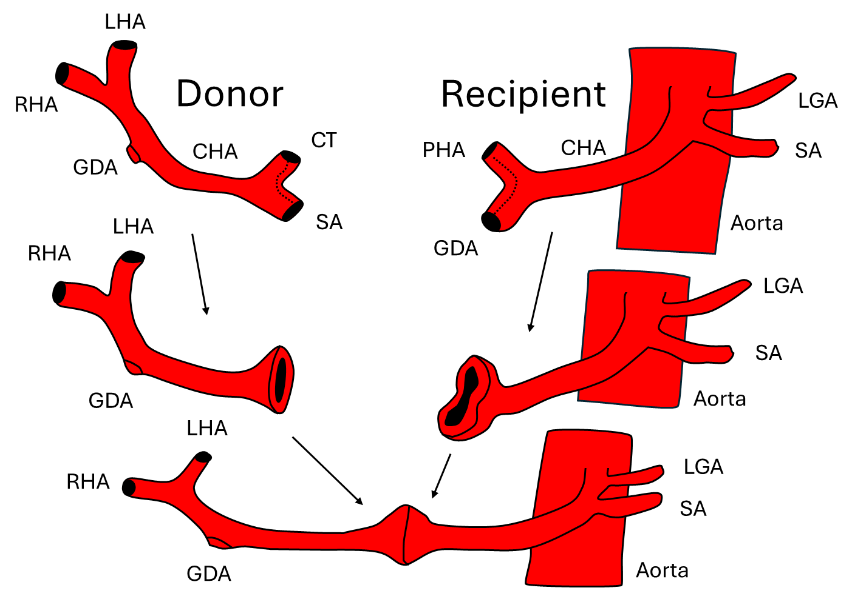

*Figure 1: Arterial tree of the donor and the recipient to create a patch in the anastomosis of the common hepatic arteries (CHA). LHA: Left hepatic artery; RHA: right hepatic artery; GDA: Gastroduodenal artery; CT: Coeliac trunk; SA:* *Splenic artery; PHA: Proper hepatic artery; CHA: Common hepatic artery; LGA: Left gastric artery .*

Table 1: Anatomical dimensions of the common hepatic artery from Singh et al., 2014.

|  |  |  |  |
| --- | --- | --- | --- |
| Dimensions | Men | Female | Both sexes average |
| Diameter range (mm) | 3-9 | 2-8 | 5.1 |
| Mean diameter (mm) | 5.4 | 5.2 | - |

Table 2: Anatomical dimensions of the common hepatic artery from Saldarriaga et al., 2023.

|  |  |
| --- | --- |
| Dimensions | Value |
| Diameter (mm) | 5.2 |
| Length (mm) | 26.7 |

* + 1. Scope of the Study

This study aims to examine 3 simplified cases of hepatic arterial anastomoses using Computational Fluid Dynamics (CFD) and extract conclusions for further study.

* 1. Materials and Methods

Three cases were simulated using the CFD software Fluent (ANSYS Inc.). These cases are: Case I (Vessel – Anastomosis – Vessel = 5mm-12mm-5mm), Case II (Vessel – Anastomosis – Vessel = 4mm-12mm-6mm), and Case III (Vessel – Anastomosis – Vessel = 6mm-12mm-4mm) (see Figure 2). The CFD model assumed axial rotational symmetry, employed a domain discretization of about 140,000-150,000 elements in each of the three cases (see Figure 3) and employed a Carreau viscosity for blood (see equation 1).

|  |  |
| --- | --- |
| $$μ=μ_{∞}+\left(μ_{0}-μ_{∞}\right){\left(1+{\left(λ\dot{γ}\right)}^{2}\right)}^{\frac{n-1}{2}}$$ | (1) |

The parameters used in the simulation were the following (Zouggari et al., 2018): Fluid density ρb = 1060 kg/m3, time constant λ = 3.3, power index n = 0.36, zero shear viscosity μ0= 0.056 kg/m-s, infinite shear viscosity μ∞= 0.0035 kg/m-s. For the boundary condition at the inlet to the domain a user-defined function having the function shown in Figure 4 was used. In addition, the physiological parameters of the pulse were: Heart rate = 75 bpm (a value in the normal heart rate window); Peak velocity = 1.0 m/s (Iranpour et al., 2016); Lowest velocity = 0.2 m/s with the assumption of resistive index (RI) at 0.80. A pressure boundary condition at the domain outlet of 13332 Pa = 100 mmHg (i.e., the mean of 80 mmHg and 120 mmHg) was employed and 3 consecutive pulses were considered for each simulation. Here since this study is a preliminary study of a deeper analysis to come only three consecutive pulses were simulated.

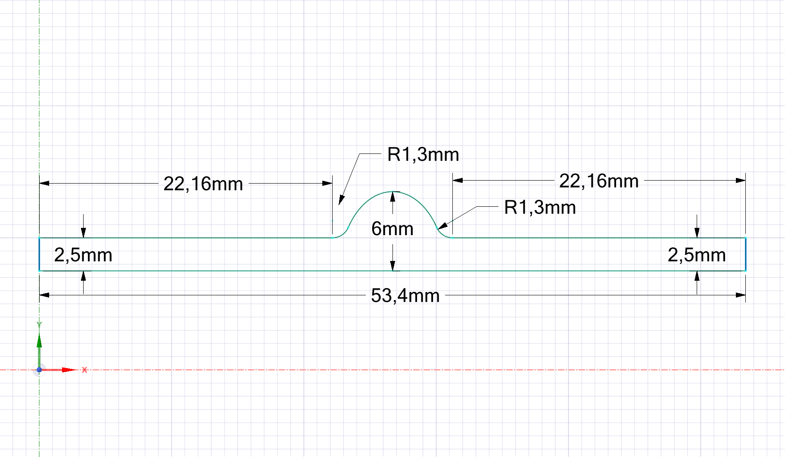

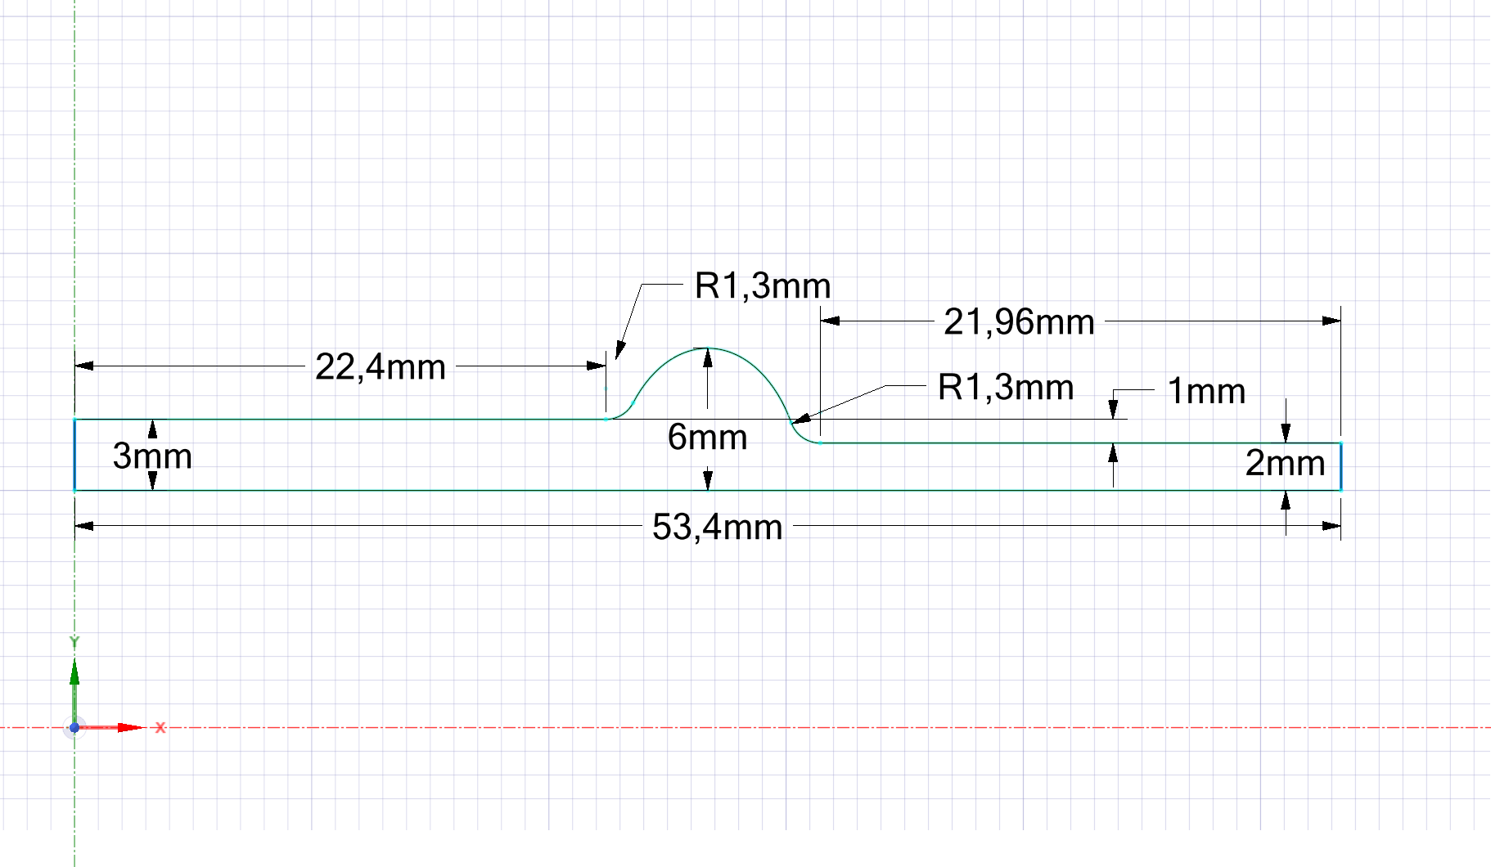

*Figure 2: Dimensions for the three cases used in the simulations. On top is Case I, on the bottom left is Case II and on the bottom right is Case III.*

*Figure 3: Mesh of the anastomosis on the left side (approximately 140,000 cells were used) and detail of the denser mesh near the edge on the right side.*



*Figure 4: Plot of blood velocity profile for one heartbeat. In total three heartbeats were used in the simulations.*

* 1. Results and Discussion

Literature studies generally associate thrombosis and plaque formation with i) Wall shear stress; ii) Blood velocity. The safe levels of the wall shear stress and the blood velocity have not yet been clearly established. According to Malek et al., (1999), hemodynamic shear stress has a significant role in determining the phenotype and function of endothelial cells and also claim that the shear stress of >1.5 Pa = 15 dyne/cm2 (i.e., arterial-level) induces endothelial quiescence and an atheroprotective gene expression profile. Finally, they state that low shear stress (<0.4 Pa = 4 dyne/cm2) that is prevalent at atherosclerosis-prone sites, stimulates an atherogenic phenotype (Malek et al., 1999). Cheng et al., (2006) states that where shear stress is low (i.e., <1.5 N/m2=1.5 Pa in humans), like the inner curvatures of coronary arteries, atherosclerotic plaque development preferentially occurs. In the work of Reorowicz, et al., (2022) it is noted that for human arteries, the upper limit of the healthy range of wall shear stress is roughly 7 Pa. Malek et al., (1999), recommend >7 Pa high shear thrombosis occurs.

In addition, in cases of relatively low blood velocity, thrombosis and blood stagnation may develop, which can result in clots forming between the aneurysm and the stent (Reorowicz, et al., 2022). In Reorowicz, et al., (2022) there are more than one values of the limit of blood stagnation. Specifically, they report that blood stagnation occurs when blood velocity drops below 0.001 m/s from literature values (Reorowicz, et al., 2022). Moreover, in their produced work the blood stagnation can be defined as the region where the blood velocity does not exceed 0.01 m/s (Reorowicz, et al., 2022). For all these reasons, the current results focus on: i) Blood velocity under 0.01 m/s; ii) Wall Shear ≥7 Pa and ≤1 Pa.

*Results regarding wall shear*

In all Cases (i.e., I, II, III) there are areas on the wall of the anastomoses where the wall shear stress is ≤1 Pa during the whole simulation (i.e., in all 3 pulses). Specifically, in Case I before and after the anastomosis there are large areas with wall shear ≥7 Pa in the peak of blood velocity (data not shown). In Case II before and after anastomosis (in a small area) there are areas with wall shear ≥7 Pa in the peak of blood velocity (data not shown). In addition, in Case III before and after anastomosis there are areas with wall shear ≥7 Pa in the peak of blood velocity (data not shown). Moreover, in Case III there is an area after anastomosis where there is wall shear ≥7 Pa during the whole simulation (i.e., all 3 pulses).

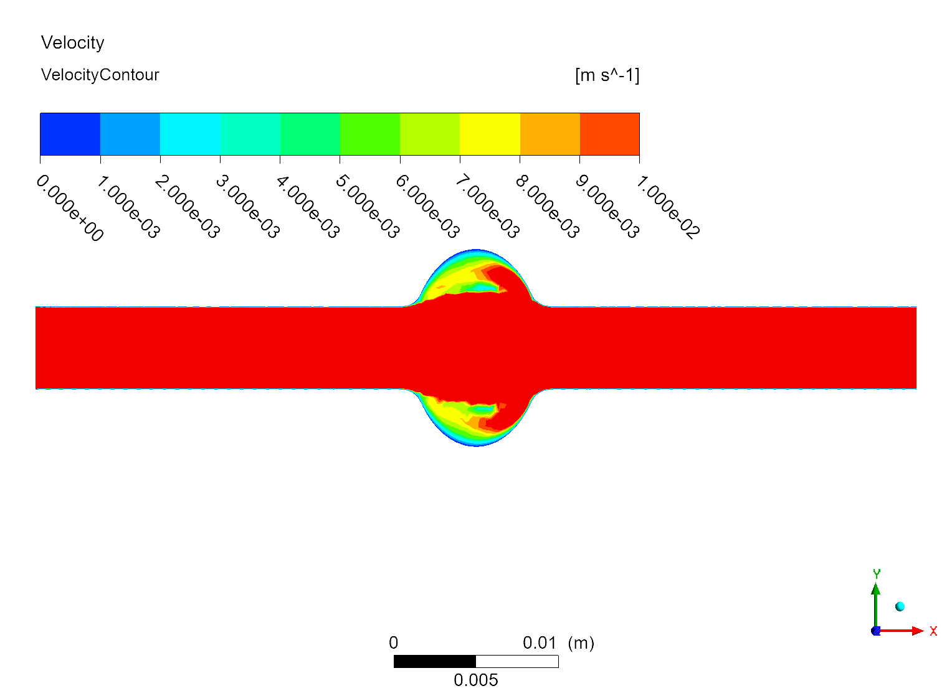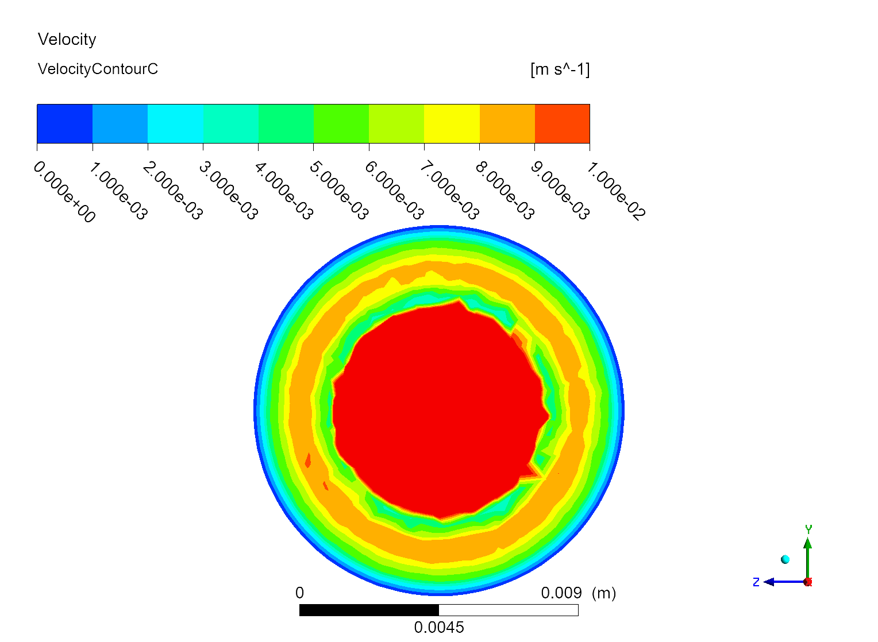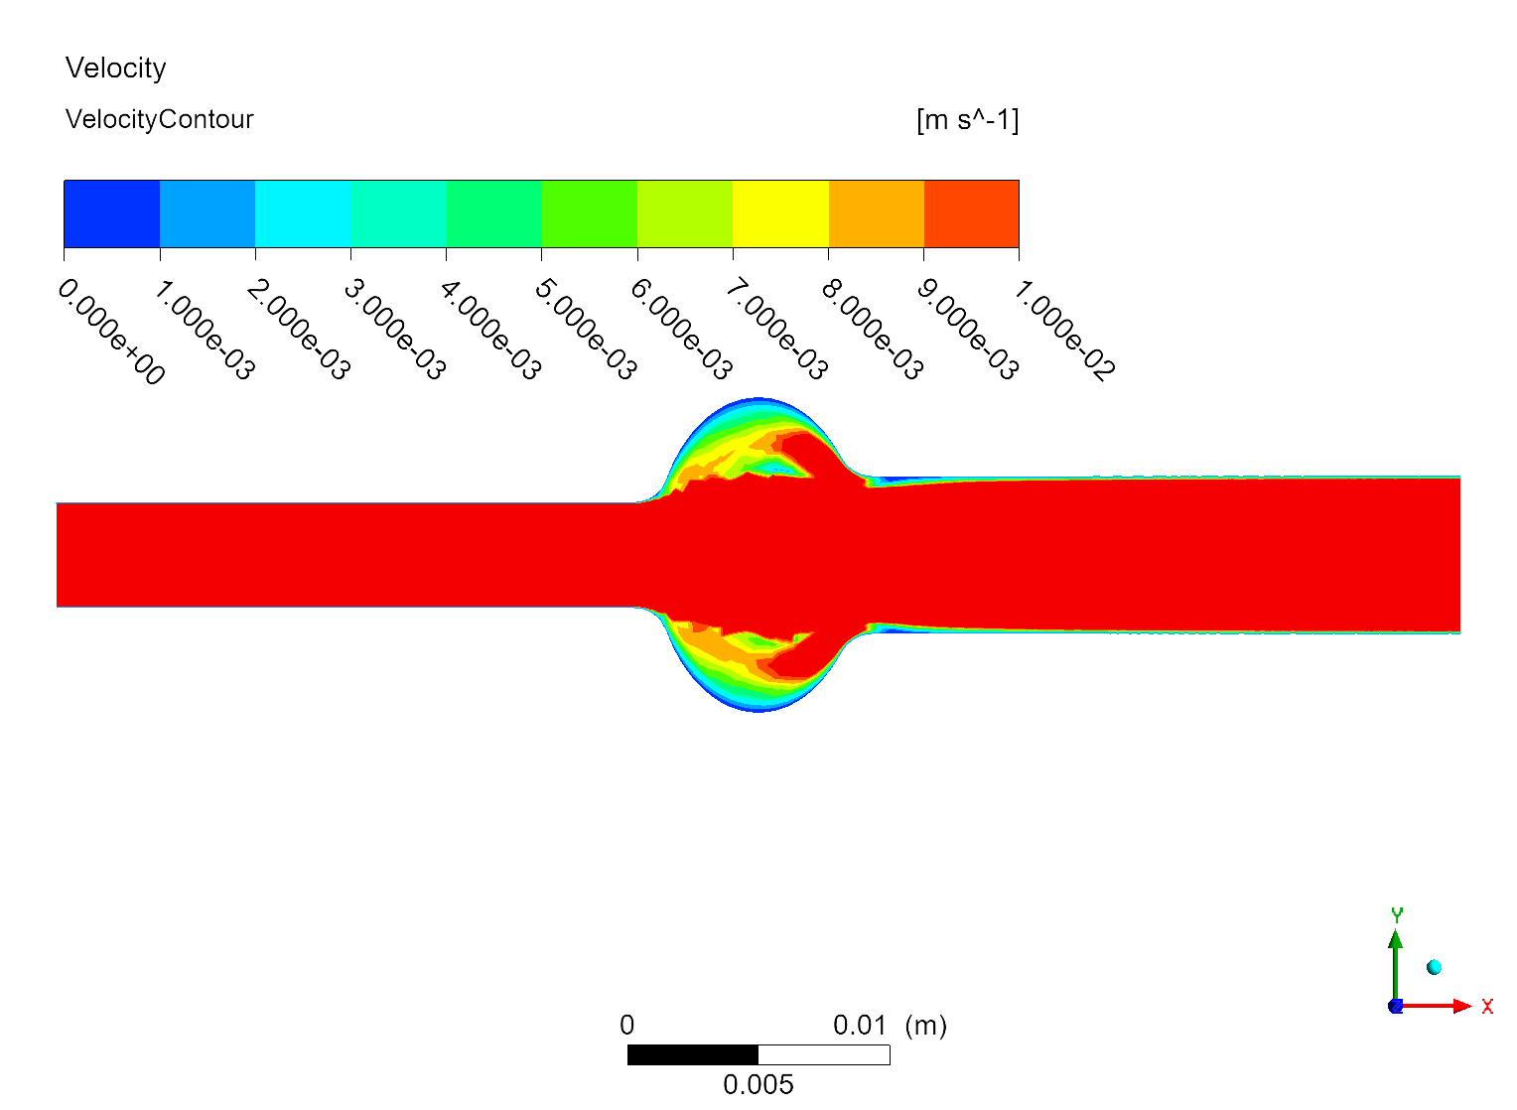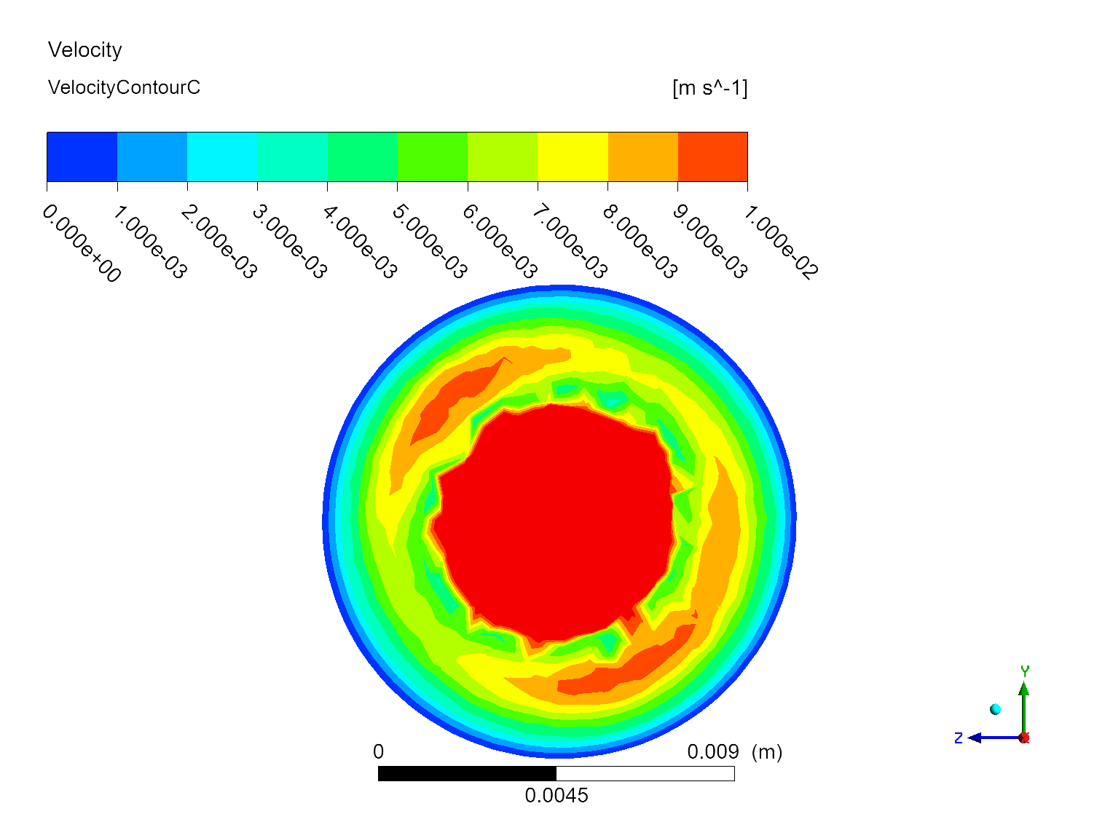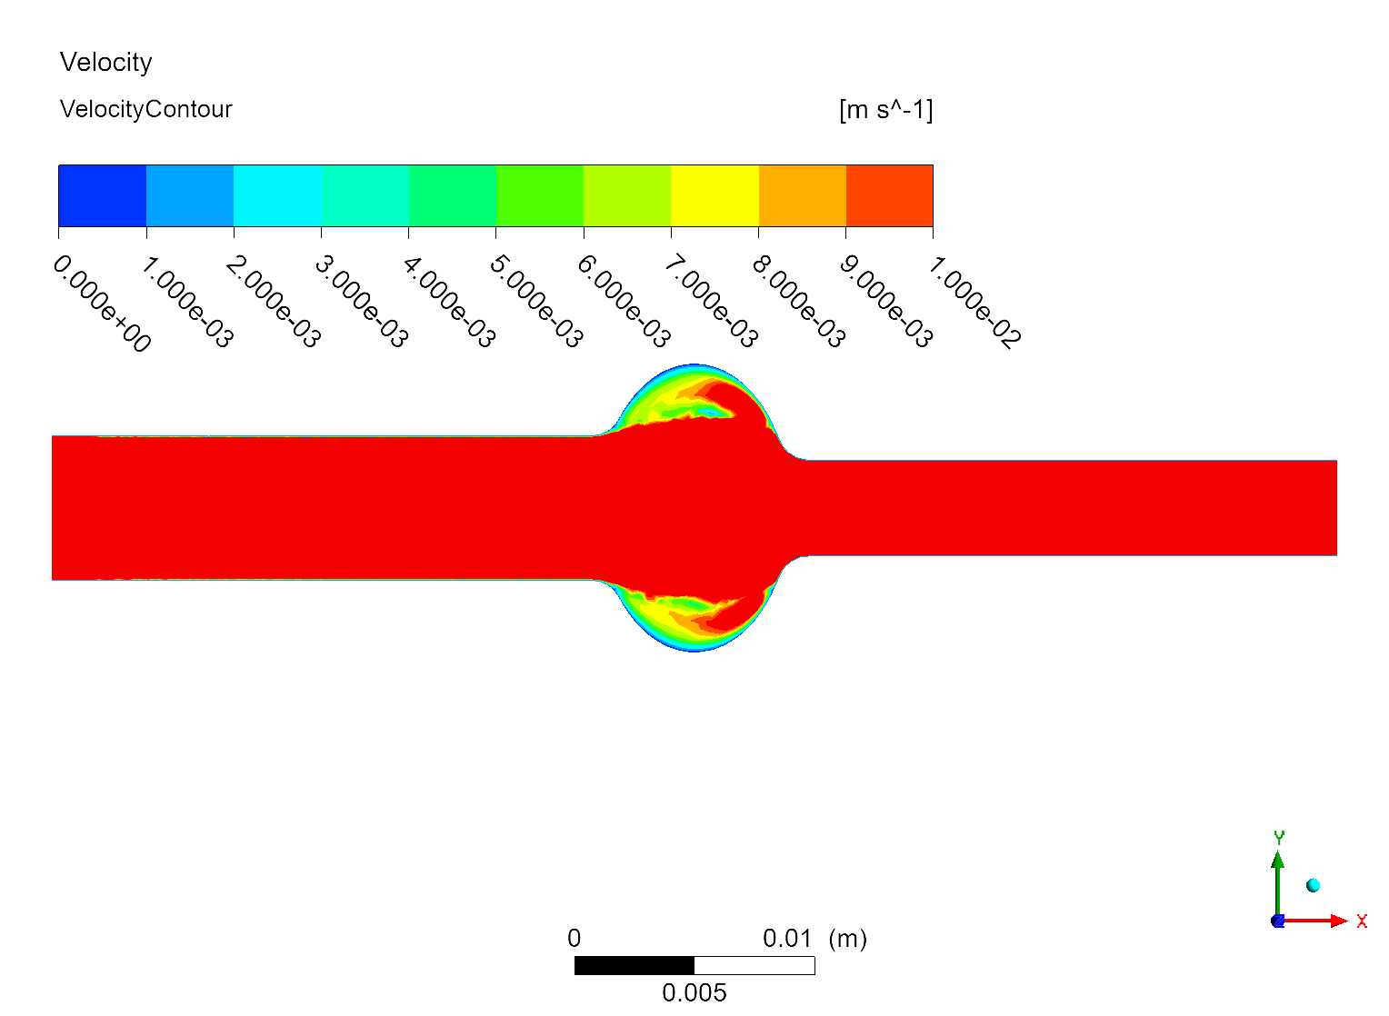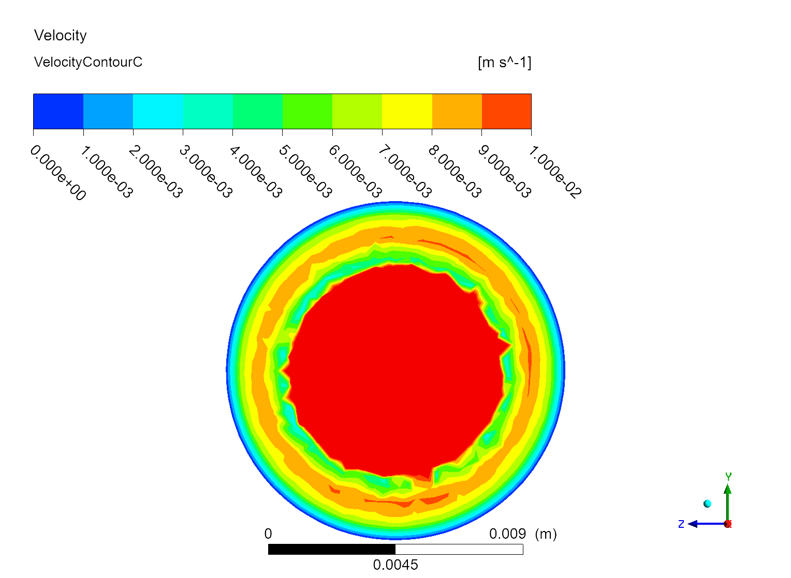

*Figure 5: Blood velocity profile at t=2.4s (only velocity values less than the stagnation limit of 0.01 m/s are shown). The side view (on the left) and the view of the cross section of the anastomosis on the largest diameter (on the right). On the top there are the velocity results for Case I, on the middle there are the velocity results for Case II and on the bottom there are the velocity results for Case III.*

*Results regarding blood velocity*

In the three simulated cases there were areas in the peak of the heartbeat velocity where the blood velocity is lower than 0.01 m/s (see Figure 5). Note that the largest area of stagnant flow according to literature is found in Case II. Then Case I follows and finally Case III is the case with the smallest stagnant conditions according to literature.

* + 1. Limitations of this study

This study can be seen as a simplistic approach to try to understand and provide solutions for the hepatic artery thrombosis phenomenon in liver transplant recipients. There are several limitations in the present study. The first limitation includes the simplified geometry, which in this case it can provide results in the anastomosis area but can only account for the complex geometry of vessel-anastomosis-vessel structure in an approximate sense (e.g., via the hydraulic diameter analogue), the second limitation is the number of the pulses in each simulation. A more important limitation is the number of cases simulated in total which were only three. Finally, a major limitation is that there were no experimental data for comparison with the simulation results.

* + 1. Future Steps

The current study was a feasibility study to see whether the geometric characteristics of an anastomosis (i.e., diameter and length of the anastomosis and diameter of the vessels) could be associated with thrombosis and plaque formation in the case of hepatic artery. To advance the quality of the study and see the characteristics that can potentially be used to explain and eventually prevent hepatic artery thrombosis, there are necessary steps to be made in the current model. First of all, the geometry of the anastomosis has to be made more realistic. One way to do that is the use of a computational tomography scan to take the realistic geometry of the anastomosis after a transplant from a real liver graft recipient. The second step would be to simulate more pulses in the total simulation run. This can provide more stable conditions for the flow velocities. Currently, 3 pulses have been utilized and we aim for at least 5 to 10 pulses. Moreover, the pulses had a steady pace of 75 beats per min. It is better also to include cases with brachycardia (<60 bpm), tachycardia (>100 bpm) and also cases where the heartbeat pace changes from a low bpm value to a high bpm value and vice versa. This can provide conditions that may drastically change wall shear and blood velocity in such values to be problematic for a patient. In addition, more geometries with different ratio of Danast/Dvessel to get a map of the phenomenon and try to achieve clinical-related conclusions. These can provide the initial step to proceed with the most realistic or patient-obtained geometries and reduce the area of different ratio of Danast/Dvessel to be examined. It is also desirable to include more realistic conditions in terms of flow and the interaction between the fluid and the structure. For this reason, a fluid structure interaction model should be implemented. Additionally, a more realistic flow pattern and blood velocity profile should be utilized. This could be taken from flow velocity measurements during surgery after the transplantation. In the present study three cases of geometric and flow conditions have been compared to each other and have been put in descending order for thrombosis risk. This idea is good but there should be found a better and more efficient way to measure the risk of thrombosis with an absolute value or with a final probability and finally calculate the risk of thrombosis. There is potential to include a simple thrombosis model to the CFD simulations (Yazdani et al., 2017) or to utilize CFD results in a separate thrombosis model.

* 1. Conclusions

The hepatic artery patch is applied in the anastomosis of the hepatic artery to minimize complications such as hepatic artery thrombosis during liver transplantation. CFD simulations have been used to determine the wall shear and blood velocity in three different geometries of anastomosis (i.e., Case I-III). Literature findings insist to associate thrombosis and plaque formation with: i) Wall shear stress; ii) Blood velocity. These efforts include blood velocity and wall shear cut-offs (some of them are empirical). The stagnant conditions are decreasing following this order: Case II > Case I > Case III. In all Cases (i.e., I, II, III) there are areas on the wall of the anastomoses where wall shear stress is ≤1 Pa during the whole simulation (3 pulses). In all Cases (i.e., I, II, III) there are areas on the wall before and after anastomosis with a wall shear ≥7 Pa at the point of peak blood flow velocity. In Case III there is an area after the anastomosis where there is wall shear stress ≥7 Pa during the whole simulation. Our study may be beneficial to hepatic artery stenosis, but more realistic conditions are necessary to be used. The current results are one of the first studies to study this effect and could be the basis of more studies to come not only by providing guidelines for more precise simulations but also by identifying the worse cases that are likely of high risk for arterial thrombosis.

Nomenclature

ρb – density of blood, kg/m3

n – power index, -

μ0 – zero shear viscosity, kg/m-s

RI – resistive index, -

λ – time constant, s

μ –viscosity, kg/m-s

μ∞ – infinite shear viscosity, kg/m-s

γ – shear rate, s-1

References

Bilir, A., Fazliogullari, Z., Koplay, M., Dogan, N.U. and Karabulut, A.K., 2021. Diameter Measurements and Variations of the Hepatic Arterial System in Multidetector Computed Tomography Images. International Journal of Morphology, 39(3)

Cheng, C., Tempel, D., Van Haperen, R., Van Der Baan, A., Grosveld, F., Daemen, M.J., Krams, R. and De Crom, R., 2006. Atherosclerotic lesion size and vulnerability are determined by patterns of fluid shear stress. Circulation, 113(23), pp.2744-2753

Cizman, Z. and Saad, W., 2023. Transplant Hepatic Artery Complications. Techniques in Vascular and Interventional Radiology, 26(4), p.100923.

Cohn, S., Stein, J., Koffron, A. and Raofi, V., 2012. Vascular and biliary anastomoses in deceased donor orthotopic liver transplantation. LIVER TRANSPLANTATION–TECHNICAL ISSUES AND COMPLICATIONS, p.97. http://dx.doi.org/10.5772/33305

Iranpour, P., Lall, C., Houshyar, R., Helmy, M., Yang, A., Choi, J.I., Ward, G. and Goodwin, S.C., 2016. Altered Doppler flow patterns in cirrhosis patients: an overview. Ultrasonography, 35(1), p.3.

Karageorgos, F.F., Karakasi, K.E., Vasileiadou, S., Kofinas, A., Antoniadis, N., Katsanos, G. and Tsoulfas, G., 2024. The Evolving Role of Transplant Oncology. In: Interdisciplinary Cancer Research. Springer, Cham. https://doi.org/10.1007/16833\_2024\_261

Katyal, S., Oliver III, J.H., Buck, D.G. and Federle, M.P., 2000. Detection of vascular complications after liver transplantation: early experience in multislice CT angiography with volume rendering. American Journal of Roentgenology, 175(6), pp.1735-1739

Kiparissides, C., Alexopoulos, A.H., Karageorgos, P., Vasileiadou, A. and Bourganis, V., 2018. A Process System Approach to Nose-to-Brain Delivery of Biopharmaceutics. In Computer Aided Chemical Engineering (Vol. 43, pp. 1661-1666). Elsevier. https://doi.org/10.1016/B978-0-444-64235-6.50289-8

Makowka, L., Stieber, A.C., Sher, L., Kahn, D., Mieles, L., Bowman, J., Marsh, J.W. and Starzl, T.E., 1988. Surgical technique of orthotopic liver transplantation. Gastroenterology Clinics of North America, 17(1), pp.33-51

Malek, A.M., Alper, S.L. and Izumo, S., 1999. Hemodynamic shear stress and its role in atherosclerosis. Jama, 282(21), pp.2035-2042

Papadimitriou, D., Alexopoulos, A.H., Gerasimidis, T. and Kiparissides, C., 2011. Computational investigation of vascular surgical interventions on popliteal artery aneurysms. In Computer Aided Chemical Engineering (Vol. 29, pp. 1515-1519). Elsevier. https://doi.org/10.1016/B978-0-444-54298-4.50082-9

Pareja, E., Cortes, M., Navarro, R., Sanjuan, F., López, R. and Mir, J., 2010, October. Vascular complications after orthotopic liver transplantation: hepatic artery thrombosis. In Transplantation Proceedings (Vol. 42, No. 8, pp. 2970-2972). Elsevier. https://doi.org/10.1016/j.transproceed.2010.07.063

Raman, R.K., Dewang, Y. and Raghuwanshi, J., 2018. A review on applications of computational fluid dynamics. International Journal of LNCT, 2(6), pp.137-143

Reorowicz, P., Tyfa, Z., Obidowski, D., Wiśniewski, K., Stefańczyk, L., Jóźwik, K. and Levy, M.L., 2022. Blood flow through the fusiform aneurysm treated with the Flow Diverter stent–Numerical investigations. biocybernetics and biomedical engineering, 42(1), pp.375-390. https://doi.org/10.1016/j.bbe.2022.02.008

Saldarriaga, B., Larrotta, O. and Ballesteros, L., 2023. Morphological characteristics of the left gastric, common hepatic and splenic arteries. A descriptive study in human cadaveric specimens. Revista do Colégio Brasileiro de Cirurgiões, 50, p.e20233403

Shukla, A., Vadeyar, H., Rela, M. and Shah, S., 2013. Liver transplantation: east versus west. Journal of clinical and experimental hepatology, 3(3), pp.243-253

Singh, B.G., Bhatt, C.R., Patel, S.V. and Mehta, C.D., 2014. Morphometric study of coeliac trunk specific reference to hepatic artery pattern in the west-indian population. Indian Journal of Surgery, 76, pp.359-362

Terrault, N.A., Francoz, C., Berenguer, M., Charlton, M. and Heimbach, J., 2023. Liver transplantation 2023: status report, current and future challenges. Clinical Gastroenterology and Hepatology, 21(8), pp.2150-2166.

Todo, S., Makowka, L., Tzakis, A.G., Marsh Jr, J.W., Karrer, F.M., Armany, M., Miller, C., Tallent, M.B., Esquivel, C.O., Gordon, R.D. and Iwatsuki, S., 1987, February. Hepatic artery in liver transplantation. In Transplantation proceedings (Vol. 19, No. 1 Pt 3, p. 2406). NIH Public Access

Yazdani, A., Li, H., Humphrey, J.D. and Karniadakis, G.E., 2017. A general shear-dependent model for thrombus formation. PLoS computational biology, 13(1), p.e1005291.

Zarrinpar, A., Busuttil, R. Liver transplantation: past, present and future. Nat Rev Gastroenterol Hepatol 10, 434–440 (2013).

Zhong, J., Smith, C., Walker, P., Sheridan, M., Guthrie, A. and Albazaz, R., 2020. Imaging post liver transplantation part I: vascular complications. Clinical radiology, 75(11), pp.845-853

Zouggari, L., Bou-said, B., Massi, F., Culla, A. and Millon, A., 2018. The role of biomechanics in the assessment of carotid atherosclerosis severity: a numerical approach. World Journal of Vascular Surgery, 1(1)