|  |  |
| --- | --- |
| cetlogo***CHEMICAL ENGINEERINGTRANSACTIONS***  ***VOL.xxx,2025*** | A publication of  aidiclogo_grande |
| The Italian Association  of Chemical Engineering  Online at www.cetjournal.it |
| Guest Editors:Fabrizio Bezzo, Flavio Manenti,Gabriele Pannocchia, Almerinda di Benedetto  Copyright © 2025, AIDIC ServiziS.r.l. **ISBN**979-12-81206-17-5;**ISSN** 2283-9216 | |

CO2 Methanation: Thermodynamic Simulations for Enhanced Methane Production and Hydrogen Source Evaluation

Bruna Gava Floriam\*, Letícia M. S. Barros, Aulus R. R. Bineli, Rubens Maciel Filho

VALPET, School of Chemical Engineering, Universidade Estadual de Campinas. R. Josiah Willard Gibbs, s/n, Cidade Universitária, Campinas, SP, Zip code 13417-780, Brazil

brunna.gfl@gmail.com, b219361@dac.unicamp.br

Carbon dioxide (CO2) methanation has emerged as a powerful tool, allowing CO2-rich gas utilization to generate value-added products, such as methane (CH4), which can be used as a fuel and chemicals. This process helps to recycle gases that would otherwise be released into the atmosphere, contributing to climate change mitigation. However, a key challenge is ensuring that methanation is thermodynamically favorable and operates under optimal conditions. In this sense, the present study employs thermodynamic simulations to identify the best operating parameters, such as temperature, pressure, and feed composition. The findings indicate that the ideal temperature for methanation is around 573 K, which significantly improves CH4 yield and CO2 conversion efficiency. The optimal feed composition has a molar ratio of CO2 to hydrogen of 1:4, which meets the reaction's stoichiometric requirements. A comparison of hydrogen sources reveals that while ethanol steam reforming is energetically feasible, water electrolysis offers higher CO2 conversion, though at a greater energy cost.

* 1. Introduction

Carbon dioxide (CO2) is a significant contributor to global warming, making its reduction a priority in environmental research. To address this issue, various policies and technologies have been developed to capture and repurpose CO2, which helps limit its release into the atmosphere. Reducing CO2 levels is essential for controlling temperature rise and supports the goals of the Paris Agreement (UNFCCC, 2015). Furthermore, CO2 can be utilized as a resource to produce fuels, chemicals, and materials, thereby promoting a circular economy and decreasing reliance on fossil fuels (Jiang et al., 2010). Concurrently, CO2 consumption fosters technological innovation, stimulating the advancement of clean technologies and efficient processes, such as carbon capture and utilization (CCU) (IEA, 2023), bearing in mind that high conversion, leading to lower production costs is a desired target. For instance, CO2 can be utilized to generate synthetic fuels in combination with green hydrogen (H2), enhancing global energy security by broadening energy sources and decreasing dependence on fossil fuels. A particularly promising approach is methanation, where CO2 reacts with H2 to produce methane (CH4) through catalytic processes such as the Sabatier reaction (Eq. 1) (Kakoee and Gharehghani, 2020):

|  |  |  |
| --- | --- | --- |
| $$C{O_{2}}_{(g)}+4 {H_{2}}_{(g)}⇋C{H_{4}}_{(g)}+2 H_{2}O_{(g)}$$ | $$ΔH_{298K}^{0}= -165.1$$ | (1) |

Methane has a high energy density of 891.6 kJ/mol (Waldheim and Nilsson, 2001), allowing it to be effectively stored, utilized for power generation, or incorporated into natural gas systems. Methanation has garnered attention, particularly during energy crises, for its potential to decrease CO2 emissions, support the circular economy, and provide a sustainable energy source when combined with renewable hydrogen.

However, producing H2 sustainably and economically remains a challenge. Currently, around 95% of global hydrogen is derived from fossil fuels (IEA, 2023), undermining sustainability goals and potentially increasing CO2 emissions. Green hydrogen, produced through water electrolysis powered by renewable energy, is a cleaner alternative, but its high cost limits the large-scale economic feasibility of methanation (IEA, 2023).

A thermodynamic study of operating conditions is crucial in optimizing the methanation process. By identifying the optimal parameters for maximizing CO2 conversion and selectivity to methane, it is possible to ascertain the most favorable reaction paths and, consequently, the most desirable by-products. Moreover, the thermodynamic study facilitates comprehension of the influence of operating conditions on the overall energy efficiency. The source of hydrogen is of great consequence in the methanation process, as it directly impacts the process's sustainability and economic viability. Green hydrogen represents the cleanest option; however, it remains expensive and requires a high availability of renewable energy (Zhu et al., 2024). Other methods of obtaining sustainable H2, such as from a fuel with a negative carbon footprint, *e.g.* bioethanol, could be a promising avenue to explore, particularly in the medium term whereas technologies for electrolysis remain commercially unfeasible (Bineli, 2013). Another possible way to obtain renewable hydrogen is through sugarcane bagasse syngasification which is cheaper than water electrolysis by almost 8 times, considering the price of such feedstock in Brazil, but this is not going to be considered in this work.

It is important to evaluate routes that require less energy to produce methane. Reducing energy demand increases the overall efficiency of the process, lowering operating costs and indirect emissions associated with energy production. In addition, energy-efficient routes facilitate integration with renewable energy sources, where available energy can be intermittent and limited, making the process more viable and competitive on a large scale. The objective of this work is to evaluate the operating conditions for methane production using thermodynamic simulations, searching for operating ranges with the highest methane yield and CO2 conversion. It also evaluates the energy efficiency of two methanation routes by varying the hydrogen source, either by ethanol steam reforming (ESR) or alkaline electrolysis of water.

* 1. Methodology

This investigation was carried out using the Aspen Plus® V10 software to determine the operating conditions of the methanation reaction and subsequently analyze the energy efficiency of the methanation process using two hydrogen sources: ethanol steam reforming and alkaline water electrolysis, as shown respectively in Figures 1a and 1b. For this, thermodynamic analyses were conducted considering the ideal temperature and pressure conditions for the CO2methanation, followed by an assessment of the energy performance of each route. In the first process, H2 was produced by ESR and employed in the methanation of CO2; in the second process, H2 was generated by alkaline electrolysis of water, followed by CO2 methanation. The aim was to provide an account of both systems for a comparative analysis of their energy efficiencies.

* + 1. Thermodynamic Assessment

The evaluation of the methanation reaction in a reactor was conducted through the implementation of a *RGibbs* reactor model, which calculates the chemical equilibrium by minimizing the Gibbs energy. Soave–Redlich–Kwong (SRK) thermodynamic model was used to provide satisfactory predictions at high temperature and pressure (Kakoee and Gharehghani, 2020).

* + 1. Sensitivity Analysis

Sensitivity analyses of the methanation reaction in Aspen Plus were performed for a temperature range of 300 to 850 K, with 50 K increments; pressures from 0.1 to 5 bar; and H2/CO2ratio from 2 to 8. The variables were adjusted to assess their impact on CO2 conversion and CH4 yield, calculated respectively by Eq(2) and Eq(3).

|  |  |
| --- | --- |
|  | (2) |
|  | (3) |

* + 1. CO2 Methanation process with ESR as a hydrogen source

The proposed process integrates ethanol steam reforming as a source of hydrogen and the subsequent methanation reaction to produce methane (see Figure 1a). First, ethanol and steam are mixed and heated to promote steam reforming in the ESR reactor, where ethanol is converted to a gas mixture rich in H2, CO, and CO2. The gas stream is cooled to 473.15 K and sent to the membrane module where H2 is partially purified and separated for process optimization. A portion of the non-permeated gas is recirculated and remixed to adjust the H2/CO2 ratio before being sent to the methanation reactor (METR). This reactor is operated at high temperature (573 K) and moderate pressure (5 bar), based on thermodynamic evaluation. The resulting gas is cooled to 298.15 K, which favors the condensation of water that is separated in the final unit, resulting in a methane-rich stream. The SRK model is used throughout the process to accurately describe the behavior of the gases and ensure thermodynamic equilibrium in the reforming, separation, and methanation stages.

* + 1. CO2 Methanation process with water electrolysis as a hydrogen source

In the methanation process with hydrogen production by alkaline water electrolysis (see Figure 1b), the ELECNRTL thermodynamic model was used to describe the electrolytic system, followed by the methanation reaction with CO2 in a reactor operated with the SRK model. In electrolysis, water is decomposed into hydrogen and oxygen with a workload calculated to produce the H2 flow to achieve the previously studied H2/CO2ratio at 80°C, considering a cell potential of 1.8 V (Sánchez et al., 2020). The hydrogen produced is mixed with CO2, heated, and fed to the methanation reactor where CH4 is exothermically synthesized, with subsequent cooling, separation, and gas recycling steps to optimize the process.

* + 1. Energy Analysis

An overall energy analysis was performed, considering the energy requirements of each operation. The energy requirements in each production, compression, delivery, and distribution unit were compared for both processes, as well as the feed and product flows at each stage.

*Figure 1: Methanation process flowchart using (a) ethanol steam reform as a hydrogen source; (b) alkaline water electrolysis as a hydrogen source*

* 1. Results and discussion

Thermodynamic analyses of CO₂ methanation are illustrated in Figure 2. These graphs demonstrate significant relationships between temperature, pressure, and the H2/CO2 molar ratio, and their influence on the CH4 yields and the conversion of CO2. As observed in Figures 2a and 2b, the methane yield is affected by temperature and pressure. As anticipated for the exothermic reaction in Eq(1), the yield of CH4 decreases as temperature increases, particularly at lower pressures, as the equilibrium shifts towards the reactants. Conversely, elevated pressures enhance the yield of CH4, as postulated by Le Chatelier's principle, due to the diminution in the total number of gaseous molecules in the equilibrium (Buelens et al., 2016). Figure 2b illustrates that the H₂/CO₂ ratio is likewise of considerable importance, with the maximum yield attained at a ratio approaching 4, which represents the stoichiometric optimum for the methanation reaction.

With respect to CO2 conversion, Figures 2c and 2d exhibit comparable behavior. The conversion of CO2 decreases with increasing temperature and lower pressures, which reflects the exothermic nature of the reaction and the adverse thermodynamic impact under conditions of high thermal energy. Figure 2d illustrates that the H2/CO2 ratio has a direct and pronounced impact on CO2 conversion, with ratios approaching the values approaching the stoichiometric ideal being most favorable for attaining maximum conversion. A decrease in this ratio may result in a reduction in process efficiency, with the potential for parallel or incomplete reactions to occur.

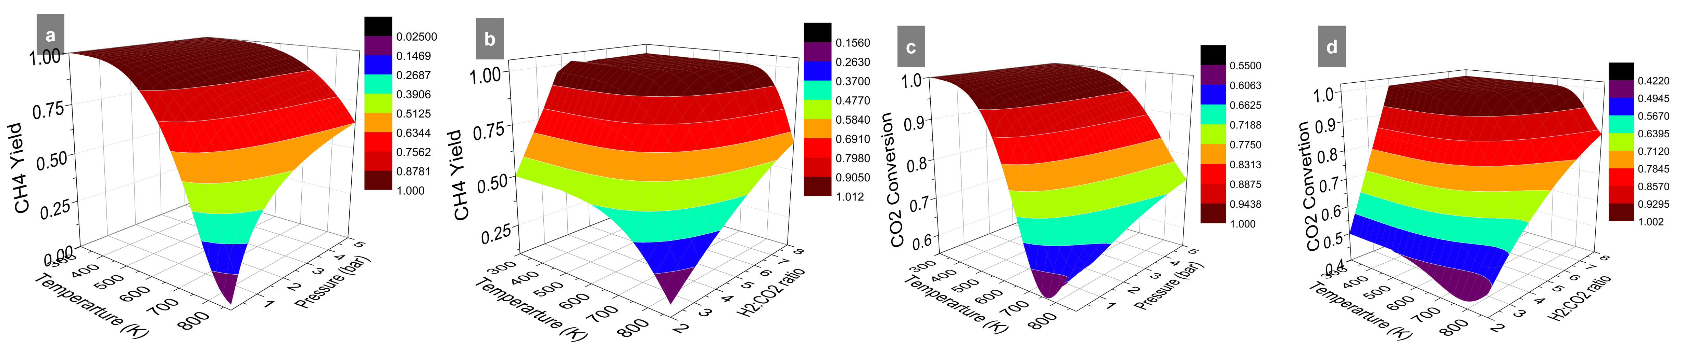

*Figure 2: Effect of varying (a) temperature and pressure on CH4 yield; (b) temperature and H2/CO2 ratio on CH4 yield; (c) temperature and pressure on CO2 conversion; (d) temperature and H2/CO2 ratio on CO2 conversion.*

As shown in Figures 3a and 3c, the increase in pressure significantly affects yield at lower temperatures (<600 K). Under these conditions, both CH4 yield and CO2 conversion achieve maximum values, reaching 100% at a pressure of 5 bar. This evidences that elevated pressures facilitate the methanation reaction since a reduction in the number of gaseous molecules in the equilibrium state is conducive to the process. Figures 3b and 3d depict the impact of the H2/CO2 ratio on the CH4 yield and CO2 conversion, respectively. A stoichiometric ratio of 4 is the most efficient, while lower values result in lower yields due to the limited availability of reactants. Conversely, ratios exceeding 4 maintain a high yield, although this may not be economically feasible. Notably, a decline in the yield occurs at elevated temperatures (>600 K) due to the appearance of parallel reactions, such as the methane reforming that occurs in the opposite direction to the methanation reaction.

*Figure 3: Influence of pressure and H2/CO2 molar ratio on CH4 yield and CO2 conversion as a function of temperature (a) Yield of CH4 at different pressures; (b) CH₄ yield at different H2/CO2 ratios; (c) CO2 conversion at different pressures; (d) CO2 conversion as a function of temperature at different pressures.*

Analysis of the composition of the reactor outlet stream, Figure 4a, confirms that the H2/CO2 ratio, pressure, and temperature play a crucial role in optimizing the CO2 methanation reaction. Increasing the H2/CO2 ratio favors the formation of CH4 and H2O while reducing the residual CO2. A stoichiometric ratio of 4:1 is sufficient to maximize conversion, with no significant additional gains for higher ratios, and the undesired products CO and C are disadvantaged. In addition, high pressures, Figure 4b, increase the selectivity for CH4, minimizing the presence of residual CO2 and promoting the formation of H2O according to the Le Chatelier principle, while the formation of CO remains negligible in all the pressure conditions analyzed.

The effect of temperature, as depicted in Figure 4c, confirms that moderate conditions within the range of 500–600 Kare ideal for maximizing CH4 production and minimizing CO2 at the outlet. At higher temperatures (>600 K), CO2 conversion and CH4 formation decrease due to the unfavorable thermodynamics of the reaction, so the formation of CO as a by-product is favored. Thus, the combination of an H2/CO2 ratio close to 4, high pressures (≥4 bar), and moderate temperatures ensures high CO2 conversion and high selectivity for CH4, and these conditions are recommended for the efficient operation of the methanation process. In this sense, for a high methane yield and 100% CO2 conversion, the reactor has to operate under a temperature range between 500 and 600 K, high pressures (>5bar),and a stoichiometric H2/CO2 feed ratio.

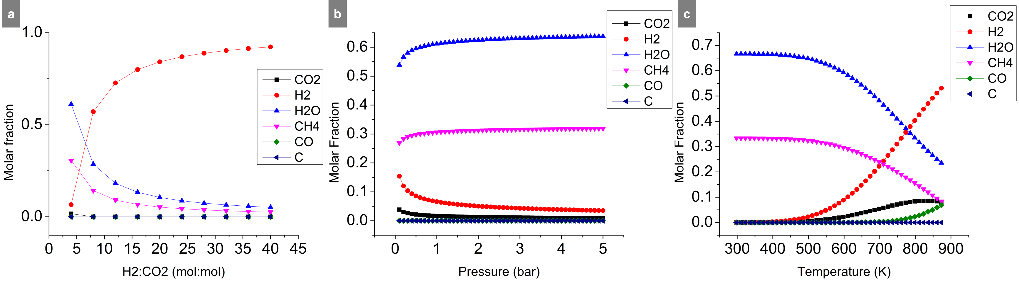

*Figure 4: Molar fraction of the methanation products varying (a) H2/CO2 ratio; (b) pressure; (c) temperature.*

Figure 5 shows the mass balances of the methanation process using different hydrogen sources. In the ESR process, Figure 5a, methane productivity is directly related to the efficiency of the reforming step and the energy balance of the system. For every mole of CH4 produced, 7 moles of ethanol are required in the feed, with a 97.4% yield of CH4. A major advantage of this approach is that ethanol can be effectively obtained from renewable sources, such as bioethanol produced from sugarcane(Bineli, 2013; Grandis et al., 2024).Although there is the formation of by-products such as CO2, impacting directly in its capture and usage, it is worthwhile mentioning that CO2from ethanol is biogenic. One alternative would be to directly couple the ESR process to the methanation system, improving the methane production in a single step. On the other hand, methanation with hydrogen from water electrolysis, Figure 5b, is more direct and involves the production of H₂ and O2 from electrolysis using electricity. This process has a simplified mass balance because water and electricity are the unique inputs. The methane yield in this case is 96.8%, being slightly lower than the ESR process, with the advantage of producing fewer products and capturing more CO2. Besides, it can also be integrated with clean energy sources to produce green hydrogen.

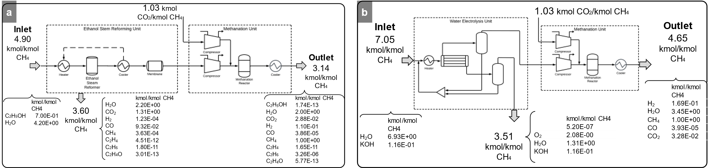

*Figure 5: Mass balance of methanation process using (a) ESR as a hydrogen source; (b) Alkaline water electrolysis as a hydrogen source.*

Analysis of the energy balance of methanation processes with different hydrogen sources, Figure 6, reveals significant differences in their energy requirements and efficiencies. In the ESR process, Figure 6a depicts that the cooling system and the reactor consume a significant energy amount, representing 55% and 28% of the total demand of 3.86x102 kW/kmol CH4, respectively. Much of the energy demand is associated with the heating required for ethanol reforming and maintaining the thermal conditions of the process. The contribution of the cooling system reflects the need to control the temperature in endothermic reactions, which increases energy costs. Nevertheless, the process has the advantage of using ethanol, a renewable raw material, especially in regions with abundance of this resource, such as Brazil, which can balance energy demand with economic viability (Grandis et al., 2024). The methanation process with hydrogen produced by electrolysis has a higher energy demand, as shown in Figure 6b. Electrolysis consumes most of the total energy, representing 88% of the total demand of 1.04x103 kW/kmol CH4. The main advantage of this method is the production of green hydrogen, which does not emit CO2 and contributes to the decarbonization of the methanation process. Electrolysis has a high energy demand and its integration with renewable energy makes it essential for the sustainability of the process and the energy matrix must be considered.

*Figure 6: Energy requirement per category of the methanation process using (a) ESR as a hydrogen source; (b) Alkaline water electrolysis as a hydrogen source.*

* 1. Conclusions

The thermodynamic analysis of CO2 methanation emphasizes the significant impact of temperature, pressure, and the H2/CO2 molar ratio on both CH4 yield and CO2 conversion. The findings indicate that optimal conditions for maximizing methane production and achieving complete CO2 conversion while maintaining process selectivity, include moderate temperatures (500–600 K), high pressures (over5 bar), and a stoichiometric H2/CO2 ratio of 4. Additionally, an analysis of different hydrogen sources reveals the advantages and disadvantages of ESR compared to alkaline water electrolysis. While the ESR process relies on renewable ethanol, it has high energy requirements for heating and cooling. However, it offers a high yield of CH4 and benefits from bioethanol as a sustainable feedstock. Conversely, the electrolysis-based process results in lower by-product formation and improved sustainability when paired with renewable energy sources, even though it demands significantly higher energy for H2 production. For scalable methanation, strategies should be adopted, such as coupling ESR with the methanation system or utilizing green hydrogen generated from renewable-powered electrolysis.

Acknowledgments

The authors gratefully acknowledge the support from FAPESP (the Sao Paulo Research Foundation, Project Number 2022/10644-1 and 2015/20630-4, Grant Numbers 2021/08940-9, 2023/14455-1 and 2023/08594-9).

References

Bineli A., 2013, Design, Manufacture and Testing of a Catalytic Microreactor for Hydrogen Production from Ethanol Steam Reforming, PhD Thesis, Faculdade de Engenharia Química da Universidade Estadual de Campinas, Campinas, SP, Brazil.

Buelens L.C., Galvita V.V., Poelman H., Detavernier C., Marin G.B., 2016, Super-dry reforming of methane intensifies CO2 utilization via Le Chateliers principle, Science, 354, 6311, 449–452.

Grandis A., Fortirer S., Pagliuso D., Buckeridge M.S., 2024, Scientific Research on Bioethanol in Brazil: History and Prospects for Sustainable Biofuel, Sustainability, 16, 10, 167–4167.

IEA, 2023, Global Hydrogen Review 2023, International Energy Agency <https://www.iea.org/reports/global-hydrogen-review-2023> accessed 15.12.2024.

Jiang Z., Xiao T., Kuznetsov V.L., Edwards P.P., 2010, Turning carbon dioxide into fuel. Philosophical Transactions of the Royal Society A: Mathematical, Physical and Engineering Sciences, 368, 1923, 3343–3364.

Kakoee A., Gharehghani A., 2020, Carbon oxides methanation in equilibrium; a thermodynamic approach, International Journal of Hydrogen Energy, 45, 55, 29993–30008.

Sánchez M., Amores E., Abad D., Rodríguez L., Clemente-Jul C., 2020, Aspen Plus model of an alkaline electrolysis system for hydrogen production, International Journal of Hydrogen Energy, 45, 7, 3916–3929.

UNFCCC, 2015, Paris Agreement, United Nations Framework Convention on Climate Change <https://unfccc.int/sites/default/files/english\_paris\_agreement.pdf> accessed 15.12.2024.

Waldheim L., Nilsson T., 2001, Heating Value of Gases from Biomass Gasification, TPS Termiska Processer AB, Nyköping, Sweden.

Zhu P., Mae M., Matsuhashi R., 2024, Techno-Economic Analysis of Grid-Connected Hydrogen Production via Water Electrolysis, Energies, 17, 7, 1653.