|  |  |
| --- | --- |
| cetlogo ***CHEMICAL ENGINEERING TRANSACTIONS***  ***VOL. xxx, 2025*** | A publication of  aidiclogo_grande |
| The Italian Association  of Chemical Engineering  Online at www.cetjournal.it |
| Guest Editors: Fabrizio Bezzo, Flavio Manenti, Gabriele Pannocchia, Almerinda di Benedetto  Copyright © 2025, AIDIC Servizi S.r.l. **ISBN** 979-12-81206-17-5; **ISSN** 2283-9216 | |

Basalt Dissolution Reaction of The Paraná-Etendeka Volcanic Province and Its Potential to Sequester Carbon Dioxide

Klebson C. Silvaa\*, Leonardo F. Curyb, Luiz F. L. Luz Júniora

aFederal University of Paraná, Department of Chemical Engineering, Curitiba, PR, Brazil

bFederal University of Paraná, iLAMIR Institute, 81531-980, Curitiba, PR, Brazil

klebsonsilva@ufpr.br

Volcanic rocks have demonstrated high efficiency in reacting with carbonated fluids and mineralizing CO2, as shown in experimental studies and pilot projects. The Paraná-Etendeka Magmatic Province represents a promising site for carbon storage due to its extensive deposits of volcanic rocks and abundant water resources. However, the limited number of studies means little is known about how the basalts from this province react. This study aims to evaluate the behavior of a basalt sample collected from the African side of the Paraná-Etendeka Province when exposed to a solution of deionized water and carbon dioxide. Reactions were carried out in a pressurized vessel at 100 bar and 50 °C, over periods ranging from 1 hour to 15 days. The findings showed that after one hour of reaction, the Ca2+ concentration increased to 15.75 mg/L and Mg2+ concentration to 3.08 mg/L. The pH rose from 4.80 to 5.71 at the end of the first hour. Results indicate that reactions occur rapidly, with calcium and magnesium ion concentrations, as well as pH levels, increasing over time, peaking after 7 days, and then slightly decreasing suggesting the possible onset of secondary mineral precipitation. The predominant release of Ca2+ suggests that Plagioclase is the primary mineral dissolved under the experimental conditions, followed by pyroxenes and olivines. These findings improve our understanding of rock-fluid interactions and provide valuable insights for future CCS projects involving the Paraná-Etendeka volcanic rocks, contributing to global CO2 emission reduction efforts.

* 1. Introduction

The climate impacts caused by carbon dioxide emissions and the projected increase in these emissions in the coming years (IPCC, 2019) have spurred the development of various innovative solutions. Among the most promising alternatives for reducing CO2 emissions is Carbon Capture and Storage (CCS). This technique provides a viable pathway for meeting the objectives of the 2015 Paris Agreement, which aims to limit greenhouse gas emissions among participating countries.

Numerous research efforts focus extensively on improving techniques for the geological storage of CO2, particularly in sedimentary formations. However, studies have also demonstrated that volcanic rocks, especially basalts, are highly effective for greenhouse gas storage, as evidenced by laboratory experiments and pilot projects such as Iceland´s CarbFix. These investigations have demonstrated that up to 95% of the CO2 can mineralize within two years (Matter et al., 2016).

Several volcanic provinces worldwide are excellent candidates for Carbon Capture and Storage, including the Paraná-Etendeka Magmatic Province, one of the largest volcanic provinces on the planet. This province spans central South America— encompassing Brazil, Paraguay, Uruguay, and Argentina—and extends into southeastern Africa, particularly in regions of Namibia and Angola (Rossetti et al., 2019). Due to its extensive volcanic rocks and abundant nearby water resources, the Paraná-Etendeka Province is considered a strong candidate for carbon storage (McGrail et al., 2003).

Similar lava sequences to those found in this province have also been identified as potential targets for Carbon Storage and are considered exploration targets within hydrocarbon basins associated with the Brazilian pre-salt, such as the Cabiúnas volcanic sequences (Campos Basin) and Camburiú volcanic sequences (Santos Basin), which are stratigraphically correlated with the Paraná-Etendeka Magmatic Province lavas (Stica et al., 2014). Consequently, studies on the rocks of the Parana-Etendeka Province can serve as valuable analogs for the volcanic rocks found in the Brazilian pre-salt.

However, there is a lack of research on the application of these rocks and associated fluids for CCS, leading to an incomplete understanding of how basalts interact with carbonated fluids. Existing studies rarely simulate reactive processes under reservoir conditions, particularly with CO2 in its supercritical state.

This work aims to evaluate the behavior of a basalt sample collected from an outcrop on the African side of the Paraná-Etendeka Magmatic Province in reactions with carbonated fluids under shallow reservoir conditions. The study focuses on the interactions between basalt and carbonated water to provide insights into the dissolution phenomena and their implications for carbon capture and storage.

* 1. Materials and methods

2.1. Geological context

The sample used in this study was provided by iLamir (Mineral and Rock Analysis Laboratory – Federal University of Paraná, Brazil). It was collected from an outcrop in the Bero volcanic complex, located in Namibe Basin, southwestern Angola (Figure 1). The sample under analysis is a basalt rock characterized by a crystalline matrix and is designated as NB-29 in the field documentation.

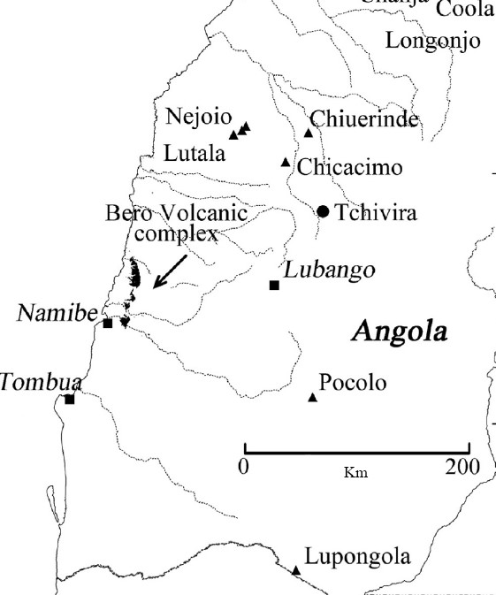

Figure 1: Location of the Bero volcanic complex in Eastern Africa. Source: Marsh and Swart (2018)

The Namibe Basin is situated at the southernmost end of the salt basins along Angola´s Atlantic margin. It serves as Africa's counterpart to the hydrocarbon-rich Santos Basin in Brazil. Onshore outcrops are found in a coastal strip approximately 20 km wide and 150 km long. Due to sharp drainage and an arid climate, both pre-salt and post-salt geological formations are exposed.

The oldest deposits associated with rift activity include basalts, rhyolites, and aeolian-alluvial clastics, which are exposed in a series of inclined fault blocks. Above the volcanic flows, carbonate outcrops such as travertine are observed, along with associated lacustrine sediments. These rocks display complex secondary diagenesis, including processes like dolomitization, silicification, and hydrothermal alteration.

The non-marine carbonates formed during the post-salt period are linked to a later phase of igneous activity, featuring exposures of both subaerial and submarine volcanic flows (Sharp et al., 2012).

The Bero volcanic complex is a geological formation spanning approximately 7 km in width and over 65 km in length along the eastern edge of the Namibe Basin in Angola. This complex is associated with the opening of the Atlantic Ocean. The volcanic sequences in this area are approximately 150 to 170 m thick, although marine transgressions have eroded their upper portions. Additionally, the sequence is influenced by small-scale faults, primarily aligned parallel to the coast (Marsh and Swart, 2018).

2.2. Experimental apparatus

The tests were carried out in a pressure vessel initially connected to a carbonated water injection system. This system comprises a CO2 tank, a solubilization column, a thermostatic bath, and an HPLC pump. The reaction setup also has three needle valves, a pressure gauge, and a thermal bath where the reactor is placed (Figure 2).

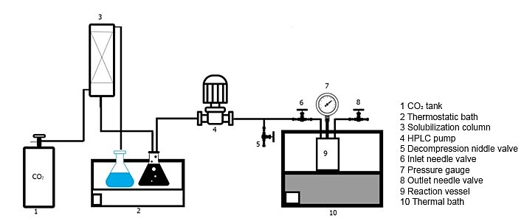

Figure 2: Reaction system

Initially, the reaction vessel is filled with 10 grams of ground sample and then sealed. To remove the oxygen from the vessel, gaseous CO2 is passed through the inlet and outlet valves.

The reactive fluid is prepared by dissolving gaseous carbon dioxide (99% purity) in deionized water at a temperature of 20 ºC, using a column operating at atmospheric pressure. This temperature was chosen arbitrarily to standardize the tests, ensuring that the same amount of CO2 is solubilized and injected into the system, even on different days when ambient temperatures may vary.

Once the desired temperature is reached, it is maintained using a thermostatic bath that regulates the fluid´s heating and cooling. Solubilization begins after achieving the target temperature and is conducted in a column filled with Raschig rings. Detailed specifications of the column and the solubilization procedure are described n Silva (2021).

After preparing the carbonated solution, the reactor is filled with the fluid using an HPLC pump. Initially, the decompression needle valve is closed while the reactor inlet and outlet valves are open. The carbonated fluid is pumped into the reactor until it is filled, at which point the outlet valve is closed. Pumping continues, pressurizing the system until it reaches 20 bars with the fluid at 20 ºC. Once this pressure is achieved, the reactor inlet valve is also closed.

The reaction vessel is then disconnected from the rest of the system and taken to a thermal bath set at 50 ºC (± 0.1 ºC). As the system reaches thermal equilibrium, the pressure is increased until it reaches 100 bar, as indicated on the pressure gauge.

Basalt formations can reach thicknesses of up to 5 km, resulting in a wide range of temperatures and pressures. A temperature of 50 °C was chosen to simulate the carbon storage process at shallow depths (Schaef et al., 2011). The supercritical point of carbon dioxide occurs at 31.2 °C and 74 bar. Therefore, when the final temperature and pressure of the system are reached, the carbon dioxide is in a supercritical state.

The tests were carried out varying the time: 1 h, 12 h, 24 h, 7 days and 15 days.

At the end of the reaction time, the thermal bath is turned off, and the temperature is gradually reduced until it reaches 20 °C again.

The supersaturation of carbonates remains relatively constant with pressure at low temperatures. Therefore, in this study, depressurization does not significantly affect the precipitation of carbonates, allowing the cations in solution to remain stable during the fluid collection period (Dyer and Graham, 2002).

Once the temperature is stabilized, the valves are opened to depressurize the vessel, and the fluid is collected for analysis. The wet rock sample is then recovered, dried in an oven at 60 °C for 12 hours, and subsequently sent for analysis.

Analyses are conducted on the reactive fluid both before and after the reaction. A benchtop pH meter is used for pH analysis. Inductively Coupled Plasma Atomic Emission Spectroscopy (ICP-OES) is utilized to observe variations in the concentration of Ca+, Mg2+, Fe2+,and Al+. The concentration of these ions is directly related to the dissolution or precipitation of minerals during the tests.

For the analysis, 50 mL fluid samples are collected both before and after the reaction. These samples are acidified with 5% nitric acid (by sample volume) and stored at an average temperature of 5 °C. According to Wang et al. (2013), nitric acid prevents mineral precipitation in liquid samples. The analyses are conducted using the equipment Varian Agilent 720-ES.

Additionally, X-ray fluorescence was done before experiments to characterize the sample chemically. X-ray diffraction (XRD) analyses are performed on the rock sample before and after the tests to monitor any changes in the mineralogical composition that might result from mineral precipitation.

* 1. Results and discussion

X-ray fluorescence analysis (Figure 3) indicates that the NB-29 sample contains 50.03% SiO2., thus categorizing it as a mafic volcanic rock. According to the classification system of the International Union of Geological Sciences (IUGS), which considers alkali (Na+K) and silica (SiO2) content, the NB-29 sample is indeed classified as basalt. This composition is particularly favorable for carbon mineralization processes, as the sample also contains significant quantities of calcium, magnesium, and iron. These metals can be mobilized into the liquid phase, allowing for potential interactions with carbonate ions (CO3)²⁻, leading to the precipitation of new carbonate minerals such as calcite (CaCO3), siderite (FeCO3), or magnesite (MgCO3).

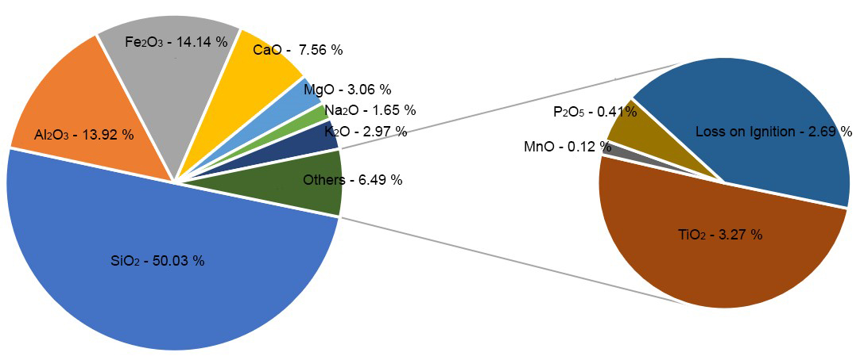

Figure 3 – Results of X-ray fluorescence analysis

The XRD results indicated that the primary minerals present were andesine and albite, both belonging to the plagioclase group, as well as augite, a type of pyroxene, and sanidine, which is categorized under alkali feldspar. These minerals contain calcium and magnesium, which are essential elements for the formation of carbonate minerals. XRD analyses conducted after the tests did not reveal any significant changes in the mineralogical composition of the sample caused by precipitation of secondary minerals.

Additionally, analyses were performed on the reactive fluid. Deionized water analyzed prior to the tests did not show significant amounts of aluminium (Al+), calcium (Ca2+), magnesium (Mg2+), or iron (Fe2+).

After CO2 was solubilized in the liquid phase, the measured pH was found to be 4.84. This value falls within the acidic range, which helps to dissolve minerals from the rock samples, thereby releasing ions into the fluid. According to Clark et al. (2019), the pH should be below 6 at the moment of injection into reservoirs to enhance mineral dissolution. Results regarding ion concentrations and pH after the tests are presented in Table 1.

Table 1 - Results of ion concentration analyses by ICP-OES and pH of liquid samples after tests

|  |  |  |  |  |  |
| --- | --- | --- | --- | --- | --- |
| Test duration | Al+ | Ca2+ (mg/L) (±0.05) | Fe2+ (mg/L)  (±0.05) | Mg2+ (mg/L)  (±0.05) | pH (±0.1) |
| 1 h | - | 15.75 | 0.74 | 3.08 | 5.71 |
| 12 h | - | 29.80 | 0.63 | 4.68 | 5.81 |
| 24 h | - | 12.15 | 1.65 | 2.60 | 5.92 |
| 7 d | - | 130.00 | 0.51 | 21.85 | 6.09 |
| 15 d | - | 119.00 | 3.76 | 17.90 | 6.13 |

After the reactions, there was a significant increase in calcium concentration even after only one hour, with this tendency persisting in all subsequent tests and reaching its highest value after 7 days. A similar trend was observed for magnesium ion concentration, which also rose significantly after the first hour and reached its peak at 21.85 mg/L after 1 week. In contrast, the increase in iron concentration was smaller, rising to 0.74 mg/L after the first hour and reaching a maximum of 3.76 mg/L after 15 days of reaction. The slight reduction in calcium and magnesium ion concentrations after the first week may indicate the onset of mineral precipitation from the leached cations. Variations in temperature or pressure during the experiment may lead to mineral precipitation, which can sequester cations released into the fluid by rock dissolution. Consequently, this decreases the concentration of a given ion species in the ICP-OES analysis. This may be what occurred after 24 hours; however, further precipitation analysis studies are required.

Gudbrandsson et al. (2011) studied the dissolution rates of the primary minerals found in mafic volcanic rocks: plagioclase, pyroxene, and olivine. Calcium is mainly present in plagioclase, while magnesium and iron are found in pyroxenes and olivines. The authors note that under very acidic conditions, crystalline basalts preferentially release magnesium; however, as the pH increases and approaches the alkaline range, this pattern changes, leading to higher dissolution rates of plagioclase resulting in a higher concentration of calcium for the analyzed fluids.

The results of this study align with the findings of the aforementioned authors. Under the acidic conditions of the tests, basalt preferentially released calcium, primarily sourced from plagioclase. The presence of magnesium and iron ions indicates the dissolution of other minerals such as pyroxenes and olivines but to a lesser extent. Alkaline feldspars also react with the carbonated fluid, releasing aluminum. Despite the significant amounts of alkali feldspars in the samples, no aluminum above the detection limit of the equipment was identified. This may suggest that plagioclase dissolves more rapidly than K-feldspars or that the dissolution of K-feldspars was negligible throughout the reactions.

The initial pH also tends to increase rapidly going from 4.84 to 5.71 after one hour.

Gudbrandsson et al. (2011) note that plagioclase dissolution tends to slow down as the pH approaches neutrality. This observation may explain the initial rapid increase in pH followed by a slowdown over time. In more acidic environments, reactions usually occur through the process of dissolution.

The ideal pH range for the precipitation of carbonate minerals is between 5.2 and 6.5 (Snæbjörnsdóttir et al., 2018). Throughout all tests, the pH remained within this range, surpassing the lower limit after one hour and staying below the upper limit even after 15 days of testing. This indicates that the tests provided optimal pH conditions for mineral precipitation and consequently CO2 mineralization.

* 1. Conclusion

The volcanic rock sample collected from the Bero Basin serves as analogs for the basalts found in Paraná-Etendeka Magmatic Province and the volcanic rocks found in the Brazilian pre-salt. The basalt used in these investigations displayed exceptional reactivity, which highlights its considerable potential for carbon storage and the mineralization of CO2.

XRD and X-ray fluorescence analyses revealed that the basalt sample from this magmatic province has chemical and mineralogical compositions ideal for reactions with carbonated fluid, indicating the presence of minerals containing calcium, magnesium, and iron. The experiments showed a significant increase in pH levels during reactions, going from 4.84 to 5.71 after 1 hour of reaction and a peak in Ca2+ concentration (130 mg/L) after 7 days which means rapid dissolution of minerals, mainly plagioclase, and favorable pH conditions for the precipitation of carbonate minerals, effectively trapping carbon and reducing atmospheric CO2 concentrations.

Overall, this basalt sample suggests that rocks from Parana-Etendeka Magmatic Province could serve as a valuable resource in efforts to mitigate climate change in countries located in the southern area of the Atlantic Ocean.

Acknowledgments

This research was partially conducted in association with the completed R&D project registered as ANP No. 20257-2, “Diagenesis in the carbonate sequences of the Pre-Salt and its impact on the exploration and production of hydrocarbon reservoirs” (UFPR/Shell Brasil/ANP), sponsored by Shell Brasil Petróleo Ltda. Additionally, the authors express their gratitude to CAPES – DS for funding this work, as well as to the iLamir Institute and the CFDeq, LES, and Lacaut laboratories for providing materials, space, equipment, and support for the experimental analyses.

References

Clark, D. E.; Galeczka, I. M.; Dideriksen, K.; Voigt, M. J.; Wolff-Boenisch, D.; Gislason, S. R., 2019, Experimental observations of CO₂-water-basaltic glass interaction in a large column reactor experiment at 50 °C. International Journal of Greenhouse Gas Control, V. 89, p. 9-19. https://doi.org/10.1016/j.ijggc.2019.07.007

Dyer, S.; Graham, G., 2002, The effect of temperature and pressure on oilfield scale formation. Journal of Petroleum Science and Engineering, V. 35, N. 1, p. 95-107. https://doi.org/10.1016/S0920-4105(02)00217-6

Gudbrandsson, S.; Wolff-Boenisch, D.; Gislason, S. R.; Oelkers, E. H., 2011, An experimental study of crystalline basalt dissolution from 2 ≤ pH ≤ 11 and temperatures from 5 to 75 ºC. Geochimica et Cosmochimica Acta, V. 75, p. 5496-5509. https://doi.org/10.1016/j.gca.2011.06.035

IPCC., 2019, Refinement to the 2006 IPCC Guidelines for national greenhouse gas inventories, chapter 3.

Marsh, J. S.; Swart, R., 2018, The Bero Volcanic Complex: Extension of the Paraná-Etendeka Igneous Province into SW Angola. Journal of Volcanology and Geothermal Research, V. 355, p. 21-31. https://doi.org/10.1016/j.jvolgeores.2016.10.011

Matter, J.M., Stute, M., Snæbjornsdottir, S.O., Oelkers, E.H., Gislason, S.R., Aradottir, E. S., Sigfusson, B., Gunnarsson, I., Sigurdardottir, H., Gunnlaugsson, E., 2016, Rapid carbon mineralization for permanent disposal of anthropogenic carbon dioxide emissions. Science v. 352 n. 6291, p. 1312–1314. https://www.science.org/doi/10.1126/science.aad8132

McGrail, B.P., Ho, A.M., Reidel, S.P., Schaef, H.T., 2003, Use and Features of Basalt Formations for Geologic Sequestration. Greenhouse Gas Control Technologies-6th International Conference. Elsevier, pp. 1637–1640. https://doi.org/10.1016/B978-008044276-1/50264-6

Rossetti, L.; Healy, D.; Hole, M. J.; Millett, J. M.; Lima, E. F.; Jerram, D. A.; Rossetti, M. M., 2019, Evaluating petrophysical properties of volcano-sedimentary sequences: A case study in the Paraná-Etendeka Large Igneous Province. Marine and Petroleum Geology, V. 102, p. 638-656. https://doi.org/10.1016/j.marpetgeo.2019.01.028

Schaef, H. T.; Mcgrail, B. P.; Owen, A. T., 2011, Basalt reactivity variability with reservoir depth in supercritical CO₂ and aqueous phases. Energy Procedia, V. 4, p. 4977-4984. https://doi.org/10.1016/j.egypro.2011.02.468

Sharp, I.; Verwer, K.; Ferreira, C. H.; Snidero, M.; Machado, V.; Holtar, E.; Swart, R.; Marsh, J.; Gindre-Chanu, L.; Puigdefabregas, C.; Fejerskov, M., 2012, Pre and post-salt non-marine carbonates of the Namibe Basin, Angola. AAPG Annual Convention and Exhibition. American Association of Petroleum Geologists.

Snæbjörnsdóttir, S. Ó.; Gislason, S. R.; Galeczka, I. M.; Oelkers, E. H., 2018, Reaction path modelling of in-situ mineralisation of CO₂ at the CarbFix site at Hellisheidi, SW-Iceland. Geochimica et Cosmochimica Acta, V. 220, p. 348-366. https://doi.org/10.1016/j.gca.2017.09.053

Silva, K. C., 2021, Study of reactive flow in carbonate rocks: Study of the effect of pressure and fluid salinity. Master's dissertation, Federal University of Paraná (in Portuguese).

Stica, J.M., Zalán, P.V., Ferrari, A.L., 2014, The evolution of rifting on the volcanic margin of the Pelotas Basin and the contextualization of the Paraná–Etendeka LIP in the separation of Gondwana in the South Atlantic. Mar. Petrol. Geol. V. 50, p. 1–21. https://doi.org/10.1016/j.marpetgeo.2013.10.015

Wang, X.; Alvarado V.; Swoboda-Colberg, N.; Kaszuba, J.P., 2013, Reactivity of dolomite in water-saturated supercritical carbon dioxide: Significance for carbon capture and storage and for enhanced oil and gas recovery. Energy Conversion and Management v.65 p.564–573. https://doi.org/10.1016/j.enconman.2012.07.024