|  |  |
| --- | --- |
| cetlogo ***CHEMICAL ENGINEERING TRANSACTIONS***  ***VOL. xxx, 2025*** | A publication of  aidiclogo_grande |
| The Italian Association  of Chemical Engineering  Online at www.cetjournal.it |
| Guest Editors: Fabrizio Bezzo, Flavio Manenti, Gabriele Pannocchia, Almerinda di Benedetto  Copyright © 2025, AIDIC Servizi S.r.l. **ISBN** 979-12-81206-17-5; **ISSN** 2283-9216 | |

Exergy and exergetic resilience of energy-integrated large-scale suspension PVC polymerization.

Antonio Mendivil-Arrietaa, Juan Manuel Diaz Pereza, Ángel Darío Gonzaléz-Delgadoa,\*

aNanomaterials andComputer Aided Process Engineering Research Group (NIPAC), Chemical Engineering Department

Faculty of Engineering, University of Cartagena, Av. del Consulado Calle 30 No. 48-152, Cartagena, Colombia.

\*[agonzalezd1@unicartagena.edu.co](mailto:agonzalezd1@unicartagena.edu.co)

Polyvinyl chloride (PVC) has become one of the most common plastics. However, its production method (suspension) presents significant challenges in terms of sustainability, such as the intensive use of energy resources and high volumes of water. In this work, the exergetic resilience analysis of the energetically integrated suspension PVC production process was carried out, where it is proposed to carry out a sensitivity analysis valuing the exergetic residues of the process in question, however, said residues were obtained through a study previous case of the same energetically integrated case using the exergetic analysis methodology, where the use of energy in quantity and quality of the process was understood, along with the efficiency of each of the stages. To carry out the resilience analysis, 4 scenarios were proposed where global efficiencies were compared, of which, in case 4 there was an increase in efficiency of up to 89% and a reduction in the irreversibilities of the process of up to 67%. However, if we want to obtain a significant increase of up to 98% in terms of overall efficiency, the monomer recovery (VCM) stage must be quickly improved.

**Keywords:** PVC, sustainability, exergy, efficiency, analysis, irreversibilities, VCM.

* 1. Introduction

The growing global demand for polymeric materials has driven the need to optimize the industrial processes associated with their production (Uribe and Diaz, 2021). In this context, polyvinyl chloride (PVC) stands out as one of the most versatile and widely used polymers, due to its applicability in sectors such as construction (Marson et al., 2021b), automotive and manufacturing (Abraham, 2020). However, PVC production is an energy and resource-intensive process, which generates a critical need to implement strategies that promote its sustainability from aspects such as the circular economy (Navarro, R. 2015). Exergy analysis is presented as a powerful tool to address this problem, by allowing a detailed evaluation of the thermodynamic performance of industrial systems (González-Delgado et al., 2022). This approach considers exergy as the maximum theoretical capacity to perform useful work by bringing a system from its initial state to a state of equilibrium with the environment through reversible processes (Terzi, R. 2018). In this way, exergy analysis not only identifies the sources of irreversibility in the process, but also quantifies energy inefficiencies, offering a clear diagnosis to implement improvements in the design and operation. In an energy-integrated PVC production plant, exergy analysis becomes an essential tool to maximize the use of internal energy flows, minimize losses associated with irreversibilities and promote optimal interaction between the different process units (Ostadi et al., 2019). This work aims to carry out a detailed exergy assessment of an energy-integrated PVC production plant. Through this assessment, we seek to identify the main points of exergy destruction, calculate the overall exergy efficiency of the system and propose improvement alternatives based on the principles of energy sustainability. The results obtained will serve as a basis to guide the design and operation of chemical plants towards greater economic competitiveness and lower environmental impact.

* 1. Methodology
     1. Process description

An energy-integrated, industrial-scale PVC slurry production process is described in Figure 1. The process starts with the introduction of VCM (vinyl chloride monomer) into a polymerization reactor, mixed with water, a stabilizer (polyvinyl alcohol) and a polymer initiator (peroxide). Polymerization occurs at 70 °C and 10 kgf/cm², resulting in an exothermic reaction with a conversion rate of 85%. The resulting mixture contains the polymer, unreacted VCM, water, initiator and stabilizer. Unreacted VCM is removed in a gasification step by reducing the pressure to 1.8 kgf/cm², separating 95% of the monomer, and the remaining 5% is removed in a stripping column using high-pressure steam at 225 °C.



Figure 1: Energy-integrated suspension PVC production process diagram.

The monomer-rich stream is processed in a recovery system that uses compressors, heat exchangers and vacuum pumps to cool and condense the VCM for recirculation. The bottoms stream from the stripper column, primarily water (70%), is fed to a heat exchanger to recover excess heat, which is used in a later stage of the process as part of energy integration (Indicated in red are the hot currents and in blue are the cold currents in Figure 1). It is conveyed to a centrifuge rotating at 1,800 rpm, removing 75% of the water. The wet slurry is dried with hot air at 250°C, reducing the moisture content and heating the polymer to 70°C. The resulting gas-polymer mixture passes through a cyclone, separating the dry polymer with 0.01% moisture, ready for packaging.

* + 1. Exergy analysis

Exergy analysis is based on the application of the first and second laws of thermodynamics to identify and quantify inefficiencies in a system, determining both their origin and location. This analysis requires mass and energy balances, which are essential to establish the exergy balance and evaluate the system's performance. The exergy balance considers the exergy flows entering the system and those leaving it, which are generally classified into useful flows and residual flows. Through this analysis, the magnitude of the exergy destroyed in each component of the process is calculated. Under steady-state conditions, the exergy destroyed is related to the net exergies associated with the transfer of mass, work and heat by means of equation 1. The exergy associated with work is represented in equation 2 and W refers to the work of the system. The exergy associated with a mass flow can be determined using equation (3), omitting magnetic, nuclear, electrical and surface tension effects (Peralta-Ruiz et al., 2018). Furthermore, the contributions of kinetic and potential energies are usually neglected due to their minimal influence on the total exergy value. Equation 4 allows us to calculate the standard chemical exergy, although this is already tabulated in many cases (Herrera et al., 2022). The chemical and physical exergy of a mixture can be defined respectively by means of Equations (5) and (6), respectively.

Table 1: Equations used in exergy analysis

|  |  |  |
| --- | --- | --- |
| Name | Equation | Number |
| Exergy destroyed | $${Ex}_{destroyed} = {Ex}_{Mass }+ {Ex}_{heat} + {Ex}_{work}$$ | 1 |
| Exergy by work | $${Ex}_{Work}=W$$ | 2 |
| Exergy by mass | $${Ex}_{mass} = {Ex}_{physical }+ {Ex}_{chemical} + {Ex}_{potential}+{Ex}_{kinetic }$$ | 3 |
| Chemical Exergy | $${Ex}_{chemical}=∆G_{f}^{◦}+\sum_{j}{v_{j}{Ex}_{chemicalj}^{◦}}$$ | 4 |
| Chemical exergy of the  flows | $${Ex}_{chemical, mix}=\sum_{i}{y_{i}{Ex}_{chemicali}^{◦}}+RT_{0}\sum_{i}{y_{i}*ln⁡(y_{i})}$$ | 5 |
| Physical exergy of the  flows | $${Ex}_{physical, mix}=C_{p}\left[{(T+T}_{0}\right)+T_{0}ln\frac{T}{T_{0}}]-v_{m}*(P-P_{0})$$ | 6 |
| Exergy total inputs | $${Ex}_{total, in}=\sum{{Ex}_{mass,in}}+\sum{{Ex}_{utilities}}$$ | 7 |
| Exergy output | $${Ex}_{mass, out}=\sum{{Ex}_{products}}+\sum{{Ex}_{waste}}$$ | 8 |
| Unavoidable exergy losses | $${Ex}_{unavoidable}={Ex}_{mass, in}-\sum{{Ex}_{mass, out}}$$ | 9 |
| Exergy efficiency | $$η_{exergy}=1-(\frac{{Ex}_{destroyed}}{{Ex}_{total, in}})$$ | 10 |

Equation (7) calculates the total input exergy, as the sum of the exergy of mass flows and energy utilities. Equation (8) defines the output exergy, as the sum of the exergy in useful products and waste. Equation (9) describes the unavoidable losses, as the difference between mass input and output. Finally, equation (10) defines the exergy efficiency as a function of the destroyed and total exergy (K. Moreno-Sader et al., 2019). Finally, the process was divided into four stages: polymerization, drying, recovery and purification.

* 1. Results and discussion
     1. Results of exergetic analysis for energy-integrated PVC production.

Figure 2 shows the performance or efficiency for each stage of the energy-integrated suspension PVC production process, in addition to the contributions generated by exergy parameters, such as the exergies of the waste at the process outlet, the exergy losses at each stage, total irreversibilities and the percentage of exergy destroyed per stage. Thus, it is analyzed for the polymerization, purification, recovery and drying stages, which presented efficiencies of 96%, 76%, 80% and 94% respectively. Thus, it is concluded that the purification stage is the least efficient, due to exergy losses of 322,732 MJ/h, a value up to six times higher than any of the other stages for this indicator. PVC purification consists of a flasher and a boiler. The latter generates the greatest exergy losses, caused by inefficient heat transfer (typical of this equipment) and irreversibilities associated with the exothermic combustion reactions that take place inside the boiler, in addition to the expansion of combustion gases. In an investigation carried out by Mehrpooya et al. (2018), they mention that the equipment with the greatest exergy losses within the biomass gasification process were the gasifier and the boiler, due to the execution of exothermic chemical reactions and the release of combustion gases, which thermodynamically causes irreversibilities since the supply of an external action is required to return to the original state. In said investigation, it was concluded that passing the combustion gases through pipes and preheating some other substance that is required in the process, would increase the efficiency of the process. On the other hand, the drying stage is the one that shows the highest amount of exergy content in the residual streams leaving the stage with 18334.41 MJ/h, which reflects a decrease of approximately 60% with respect to the base case without energy integration (46688 MJ/h). An overall exergy efficiency of 87% indicates that the process exergies are being managed well, since in comparison with the efficiencies of other processes such as the one recorded by Hamedi et al. (2022) where an olefins plant had an efficiency of 79.94% and for a cement production industry investigated by Madlool et al. (2012), ranges between 18 and 49% were presented. There is a possibility of improving the process through exergy resilience, in which the exergies of the waste are valued at the exit as if they were usable products. This can be done due to the high content of exergies (physical and chemical) found at the exit of the waste, giving a total value of 21352.93 MJ/h for the entire process in general, showing potential for the reuse of waste.

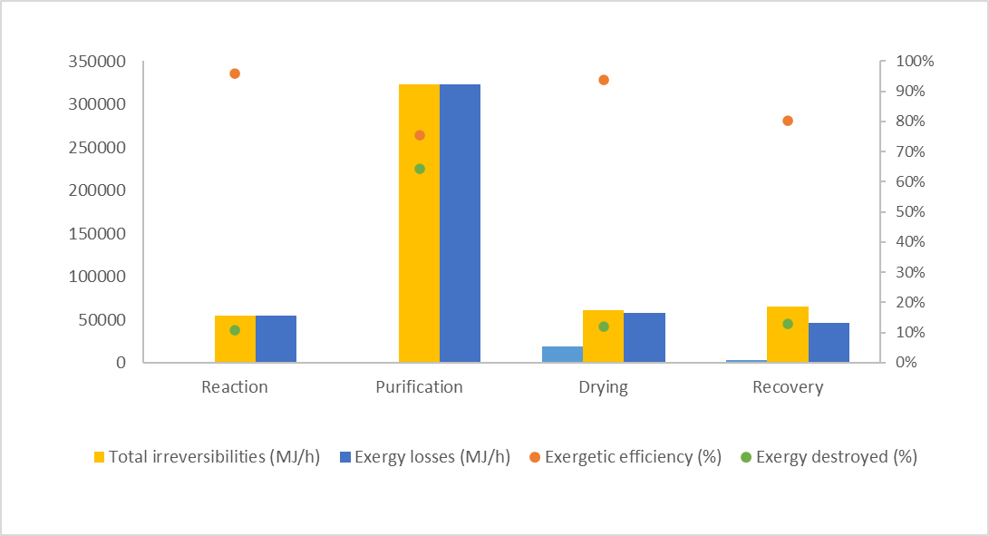

Figure 2. Exergy analysis for each stage of the energy-integrated PVC suspension process

Figure 3 shows the overall efficiency of the energy-integrated suspension PVC production process, where its value is 87%, which shows the correct control of the energy of the polyvinyl chloride production plant, which translates into the correct use of the high exergies that enter the process (physical, chemical, work and heat input).

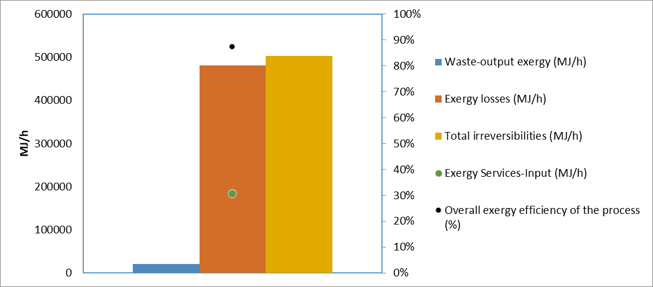

Figure 3. Global exergy analysis of the energy-integrated PVC suspension process

Likewise, this figure shows other global exergy parameters of the process, such as the exergy of waste at the exit, exergy losses, irreversibilities and the exergy contributed by industrial services (exergy input by work and heat), of which there are values ​​of 21352.93 MJ/h, 481558.1 MJ/h, 502911.1 MJ/h and 184581.6 MJ/h, respectively. Since an exergy value is present for the output streams of the PVC process, a resilience analysis is recommended again, where these streams are valued, which have the potential to improve the overall efficiency of the process and thus have better energy control.

* + 1. Exergetic resilience of the energy-integrated PVC suspension process.

Figure 4 shows the exergy resilience of the energetically integrated PVC production plant, which shows a significant improvement in exergy performance by implementing waste stream utilization strategies in cases 2, 3, and 4. This stream reuse arises from the need to make the most of both the energy contents and the product traces that are wasted in the process. Examples of this are streams 14 and 28, which are cooling water and waste stream with product traces, respectively. In Case 2, by considering wastewater streams as streams of interest, a reduction in total irreversibilities to 499,893 MJ/h and a slight improvement in overall exergy efficiency, reaching 87.39%, was achieved. In Case 3, by utilizing the process outlet streams (water R and 18), total irreversibilities further decreased to 484,577 MJ/h, increasing the exergy efficiency to 87.78%. Finally, in Case 4, by integrating all stages as usable streams, the waste outlet exergy was completely eliminated, reducing total irreversibilities to the minimum possible 481,558 MJ/h and achieving the highest overall exergy efficiency of 87.86%. This sensitivity analysis shows that the progressive utilization of waste, from wastewater to the integration of all process streams, contributes significantly to improving the sustainability and energy efficiency of the system, with Case 4 being the most optimal scenario for the process. Therefore, the implementation of other process engineering methodologies such as mass integration could be a viable source for increasing thermodynamic efficiency.

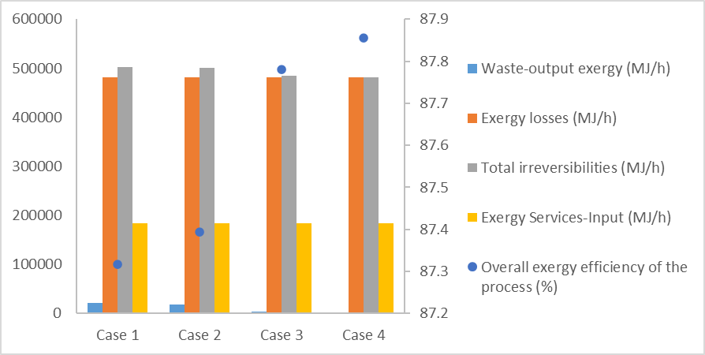

Figure 4. Exergetic resilience for 4 possible cases of the energy-integrated PVC process

* 1. Conclusions

For the present work, thermodynamic concepts were used through the use of the exergy analysis methodology applied to the Energy-integrated industrial PVC production process by suspension, which presented an overall efficiency of 87% demonstrating that a large part of the exergy that enters the process in the form of physical and chemical exergy is used, presenting irreversibilities of approximately 502911.1 MJ / h being these the main losses of the process, in addition to this the process was valued stage by stage to find which of them had the highest exergy losses, thus naming the drying stage as the stage that had the highest exergy waste with a value of 18334.41 MJ / h, in addition to this the purification stage was the one that presented the lowest efficiency of 76%, due to inevitable losses related to the exergies of residual currents. In order to try to improve the overall efficiency of the process, a sensitivity or exergy resilience analysis was carried out, in which there were 4 possible cases for the same PVC production process, where output waste streams were valued, as if they were usable or recyclable products in the process, in such a way that case 4 presented the best overall efficiency with 88%, that is, increasing by 1% with respect to the base case, in the same way for the recovery stage it went from 80% to 81% with respect to the efficiency per process stage. It is recommended to carry out a much more detailed analysis in terms of process equipment, taking into account almost all the process stages and focusing on which equipment requires an improvement or update.

Acknowledgements

The authors would like to thank the University of Cartagena for funding this work via research projects "Optimization of the PVC production process on an industrial scale combining sustainability analysis and computer-assisted mass integration of processes" and "Optimization of the PVC production process on an industrial scale combining sustainability analysis and computer-assisted energy integration of processes". Approved by resolution 01385 with commitment act No. 106 of 2021 and Resolution 01845 with commitment act No. 049 of 2024

References

Abraham, B. Z. J. (2020). Identification and analysis of quality control for the main defects that occur during the extrusion process of PVC-U pipes at the company Piping and Geosystems of Peru, part of the Orbia Group.[hdl.handle.net/20.500.12773/12052](http://hdl.handle.net/20.500.12773/12052).

Alejandra, U. A. M., & Sebastián, D. C. (2021, 24 may). Positioning of decorative PVC panels in the American market.[repository.uniminuto.edu/handle/10656/15655](https://repository.uniminuto.edu/handle/10656/15655) (in spanish)

González-Delgado, Á. D., Moreno-Sader, K. A., & Martínez-Consuegra, J. D. (2022). Sustainable shrimp biorefining: developments from computer-aided process engineering.[doi.org/10.26620/uniminuto/978-958-763-558-4](https://doi.org/10.26620/uniminuto/978-958-763-558-4).

Hamedi, M., Omidkhah, M., Sadrameli, S. M., & Khoshgoftar Manesh, M. H. (2022). Exergetic, exergoeconomic, and exergoenvironmental analyses of an existing industrial olefin plant. *Sustainable Energy Technologies and Assessments*, *52*, 102175. doi.org/10.1016/j.seta.2022.102175

Herrera, T., Parejo, V., & González-Delgado, Á. (2022). Quality of Energy Conservation in an Avocado Oil Extraction Process Via Exergy Analysis. Chemical Engineering Transactions, 91, 241-246.

Madlool, N. A., Saidur, R., Rahim, N. A., Islam, M. R., & Hossian, M. S. (2012). An exergy analysis for cement industries: An overview. *Renewable and Sustainable Energy Reviews*, *16*(1), 921–932. doi.org/10.1016/j.rser.2011.09.013

Marson, A., Manzardo, A., Piron, M., Fedele, A., & Scipioni, A. (2021b). Life Cycle Assessment of Pvc-a Polymer Alloy Pipes for the Impacts Reduction in the Construction Sector. Chemical Engineering Transactions, 86, 721-726. [doi.org/10.3303/cet2186121](https://doi.org/10.3303/cet2186121).

Mehrpooya, M., Khalili, M., & Sharifzadeh, M. M. M. (2018). Model development and energy and exergy analysis of the biomass gasification process (Based on the various biomass sources). Renewable and Sustainable Energy Reviews, 91, 869–887. [doi.org/10.1016/j.rser.2018.04.076](https://doi.org/10.1016/j.rser.2018.04.076)

Moreno-Sader, K., Meramo-Hurtado, S., & González-Delgado, A. (2019). Computer-aided environmental and exergy analysis as decision-making tools for selecting bio-oil feedstocks. Renewable And Sustainable Energy Reviews, 112, 42-57. [doi.org/10.1016/j.rser.2019.05.044](https://doi.org/10.1016/j.rser.2019.05.044).

Navarro, R. (2015). VinylPlus– A step closer to PVC sustainability. Journal of Modern Plastics: Polymer Science and Technology,109(697), 6-10. (in Spanish)

Ostadi, M., Austbø, B., & Hillestad, M. (2019). Exergy Analysis of a Process Converting Power and Biomass to a Liquid Fuel. [hdl.handle.net/11250/2639370](http://hdl.handle.net/11250/2639370).

Peralta-Ruiz, Y., Obregon, L. G., & Gonzalez-Delgado, A. D. (2018). Design of biodiesel and bioethanol production process from microalgae biomass using exergy analysis methodology. Chemical Engineering Transactions, 70, 1045-1050. [doi.org/10.3303/cet1870175](https://doi.org/10.3303/cet1870175).

Terzi, R. (2018). Application of exergy analysis to energy systems. Application of exergy, 109.