|  |  |
| --- | --- |
| cetlogo ***CHEMICAL ENGINEERING TRANSACTIONS***  ***VOL. , 2024*** | A publication of  aidiclogo_grande |
| The Italian Association  of Chemical Engineering  Online at www.cetjournal.it |
| Guest Editors: Leonardo Tognotti, Rubens Maciel Filho, Viatcheslav Kafarov  Copyright © 2024, AIDIC Servizi S.r.l. **ISBN** 979-12-81206-09-0; **ISSN** 2283-9216 | |

Life cycle assessment of a novel process for the production of Synthetic Natural Gas from empty fruit bunches

Otto A. Ortiza, Karina A. Ojedab,\*, Luis A. Riosa

aGrupo Procesos Quimicos Industriales (PQI), Department of Engineering, University of Antioquia, Medellín, Colombia

bProcess Design and Biomass Utilization Research Group (IDAB). Chemical Engineering Program, Cartagena, Colombia

kojedad@unicartagena.edu.co

The production of Synthetic Natural Gas (SNG) from residual biomass is an alternative to replace or reduce the consumption of fossil-origin natural gas. In this work, using life cycle assessment (LCA) methodology, the environmental viability of a novel synthetic natural gas production process from empty fruit bunches was evaluated. The LCA is based on the standards of the International Organization for Standardization ISO 14040 and ISO 14044 and systematically covers goal and system definition, life cycle inventory, life cycle impact assessment, and interpretation. A gate-to-gate approach was used, which includes: drying of the empty fruit bunches (EFB), gasification, cleaning of the produced gas, and production of SNG by methanation. The functional unit for impact assessment was 1 kg/h of SNG produced. The LCA shows that the production of SNG has representative impacts in several categories, such as carcinogenic human toxicity, freshwater ecotoxicity, marine ecotoxicity, terrestrial ecotoxicity, freshwater eutrophication and water consumption. The two sub-processes that generate the most environmental impacts are those associated with the production of EFB and peridotite (a novel bed material), but when analyzing the environmental load associated with these materials, it should be taken into account that they are currently considered waste, and even in the case of peridotite, it is even used as filler for tertiary roads.

* 1. Introduction

Climate change and the inevitable depletion of fossil fuels have prompted the search for renewable energy sources to help achieve a global energy transition. Therefore, sustainable and renewable alternatives to fossil fuels are needed. In particular, biomass, which is considered a carbon-neutral resource (Pour, 2019), can be converted not only into heat and electricity but also into valuable products such as biohydrocarbons, renewable hydrogen, bioalcohols, aviation biofuel, SNG (biomethane), and biofuels (Seo et al., 2022). SNG is the term used by many authors to define gas produced from biomass because it shares similar chemical and physical properties with fossil natural gas but is artificially generated from renewable sources, such as biomass, instead of being extracted from underground natural gas reservoirs (Cormos et al., 2024; Jaffar et al., 2020; Jalili et al., 2024; Katla-Milewska et al., 2024; Sun et al., 2024). One of the biomasses potentially used as raw material for fuel production is empty fruit bunch (EFB) waste from the palm oil industry due to its abundance, inexpensive, safe for food security, and favorable physicochemical characteristics (Chang, 2014; Sunarno et al., 2020). Biomass transformation processes must be evaluated to determine their environmental impacts. Life cycle assessment (LCA) is an internationally recognized methodology for quantifying the environmental impacts of a product or process throughout its life cycle (ICONTEC, 2007b, 2007a). This approach identifies the stages and subprocesses with the highest environmental burden and guides the design of improvement strategies. This work performed a life cycle assessment of the production of SNG from the EFB. Previous LCA studies have suggested improvements in similar processes that use EFB as a raw material to generate products such as ethylene (Akmalina & Pawitra, 2020) and xylitol (Hafyan et al., 2019).

The aim of this study was to quantify and evaluate the environmental impacts of a new process for the production of SNG from EFB using the LCA method. The assessment considers only the gate-to-gate scope. The EFB conversion process was simulated using Aspen Plus software, whereas the LCA was calculated using SimaPro.The evaluated process used a rock as an alternative catalyst, called peridotite, which is waste material from mining activities such as copper extraction in Colombia. To assess the environmental impacts, this study used the ReCiPe method, which is a tool in LCA that allows the life cycle inventories to be converted into significant environmental impacts. This method integrates impact categories at the midpoint (such as terrestrial acidification, eutrophication and ozone formation) and endpoint (affecting human health, ecosystem quality and resource availability) levels (Huijbregts et al., 2017). The LCA method was used to identify the subprocesses that contribute most to the environmental impact and, therefore, those that should be intervened to improve environmental performance.

* 1. Process design description

The process conditions were based on (Ortiz et al., 2024) (Using peridotite as a catalyst replacing olivine in the gasification stage), and the simulation was conducted using Aspen plus (V12.1). The overall process of SNG production can be divided into four main stages: drying of EFB, gasification, cleaning of the produced gas, and production of SNG by methanation. First, biomass is introduced into the drying stage to reduce moisture using hot air. The dried biomass is fed into a dual-type gasifier to generate a raw gas called syngas (H2, CO, CO2, CH4, H2O, and in smaller quantities, tars, sulfur compounds such as H2S and COS, and particulate matter). The unconverted char is transported along with the bed material (peridotite) to the combustor, where it is burned together with other waste streams from the process to heat the peridotite, which returns to the gasifier and provides the heat for the endothermic gasification reactions. Fresh peridotite is continuously fed to the combustor to maintain its catalytic activity and replenish the material leaving the system along with ash and flue gas. Syngas is fed to a scrubber that uses rapeseed methyl ester (RME) as a scrubbing liquid, which removes 99.9% of the heavy tars and polycyclic aromatic hydrocarbons. After scrubbing, the unwanted components present in the gas are predominantly light cyclic hydrocarbons, such as benzene, toluene, and xylene (referred to as BTX), a small fraction of naphthalene, and traces of heavier tar components. These compounds were removed in a series of three fixed beds containing activated carbon. The product gas leaving the activated carbon beds is compressed in a centrifugal compressor and sent to a reactor where the alkenes are converted to alkanes. Next, the COS component is catalytically converted to H2S in the COS hydrolysis unit, and the resulting stream is cooled to enter a scrubber employing MDEA as a scrubbing solvent, where 99.0 % of the H2S present is removed. The gas enters a scrubber using MEA as the scrubbing solvent to remove 95 % of the CO2. Finally, the syngas enters the methanation stage, which comprises three adiabatic fixed-bed reactors. At the end of the methanation stage, CH4-rich synthetic natural gas (SNG) is obtained.

* 1. Life cycle assessment (LCA)

The methodology for the LCA of the SNG production process was based on the International Organization for Standardization standards ISO 14040 and ISO 14044. The LCA is divided into four phases: goal and scope definition, Life Cycle Inventory (LCI), Life Cycle Impact Assessment (LCIA), and interpretation of results. SimaPro 9.4.0.2 software was used to construct the inventory and perform impact assessment.

* + 1. Goal and Scope

This study aimed to quantify the environmental impact of the production of SNG from EFB. A "gate-to-gate" approach was employed to evaluate the drying, gasification, cleaning, and methanation stages. The functional unit selected was 1 kg of SNG. Figure 1 shows the system boundaries of this study.

* + 1. Life Cycle Inventory (LCI)

The Life Cycle Inventory includes the quantities of input and output materials of the overall SNG production process, energy consumption, and emissions released into the environment. The data is calculated based on the mass and energy balance provided by the Aspen Plus Simulation. The LCI is associated with the previously defined functional unit, shown in Table 1.

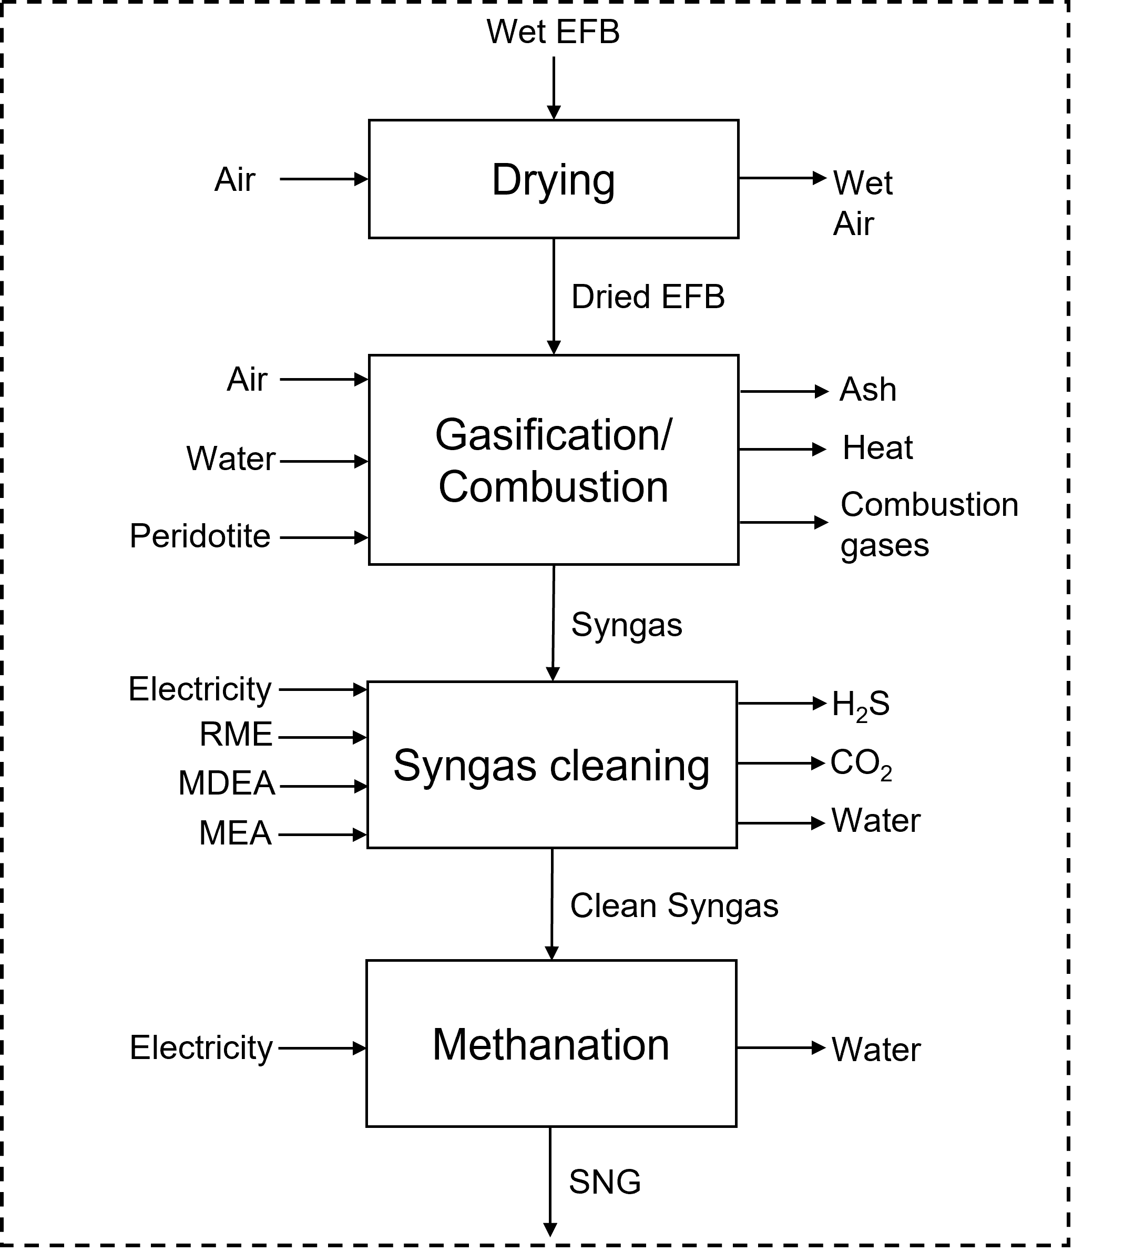

Figure 1: Limits of the SNG production system.

Table 1: LCI of 1 kg SNG production.

|  |  |  |  |  |
| --- | --- | --- | --- | --- |
| **Stage** | **Inputs** | | **Outputs** | |
| DRYING | Wet EFB [kg/h] | 5.82 | Air [kg] | 15.27 |
| Air [kg] | 15.27 | Water [kg] | 1.48 |
|  |  | Residual heat (air) [MJ] | 4.77 |
|  |  | Dry EFB [kg] | 4.34 |
| GASIFICATION | Dry EFB [kg] | 4.34 | Ash [kg] | 0.17 |
| Steam [kg] | 2.17 | Syngas [kg] | 6.11 |
| Peridotite [kg] | 52.36 | Residual heat (Ash) [MJ] | 0.02 |
| Air [kg] | 8.24 | Residual heat (Combustion gas) [MJ] | 1.35 |
|  |  | N2 [kg] | 6.32 |
|  |  | O2 [kg] | 0.56 |
|  |  | CO2 [kg] | 1.61 |
|  |  | H2O [kg] | 0.23 |
| GAS CLEANING | Syngas [kg] | 6.11 | H2S [kg] | <0.01 |  |
| Electricity [kWh] | 1.41 | CO2 [kg] | 2.71 |  |
| RME [kg] | 0.13 | Water [kg] | 2.32 |  |
| MDEA [kg] | 5.34 | Clean syngas [kg] | 1.73 |  |
| MEA [kg] | 7.12 |  |  |
| METHANATION | Clean syngas [kg] | 1.73 | Water [kg] | 0.01 |
| Electricity [kWh] | 0.02 | **SNG [kg]** | **1.00** |
|  |  |  |  |  |

3.3 Life Cycle Impact Assessment (LCIA)

​​The life cycle impact assessment was performed using the ReCiPe method in SimaPro. It should be noted that several inputs and outputs of the different stages of the process were selected from the SimaPro database and therefore had environmental loads associated with the production process. Figure 1 shows the environmental impacts generated in the production of the main products of each stage (dry EFB for the drying stage, Syngas for the gasification stage, clean Syngas from the gas cleaning stage and Synthetic Natural Gas from the methanation stage). The impacted categories, in decreasing order of impact magnitude, are: human carcinogenic toxicity, freshwater ecotoxicity, marine ecotoxicity, terrestrial ecotoxicity, freshwater eutrophication, water consumption, fossil resource scarcity, global warming, ozone formation (terrestrial ecosystems), ozone formation (human), fine particulate matter formation, land use, ionizing radiation, and human noncarcinogenic toxicity. Taking into account that the main product of a stage is an input for the next stage and that the consecutive order of the stages is drying, gasification, syngas cleaning, and methanation, it is clear that, from the second stage onwards, the environmental impacts of the previous stages accumulate. Therefore, the stages that generate representative environmental impacts are drying, gasification, and gas cleaning, whereas methanation does not generate representative impacts.

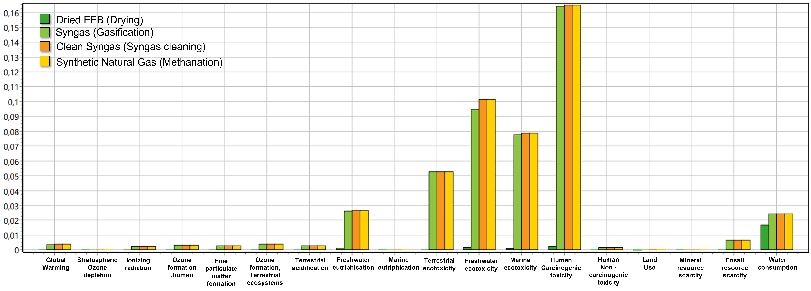

Figure 1: Environmental impacts (normalized) generated in the production of the main products of each stage of the process

Using the SimaPro database, it is possible to identify which sub-processes are generating representative environmental impacts. For this identification, each stage of the process was evaluated, and Figures 2-5 show the results obtained for drying, gasification, syngas cleaning, and methanation.

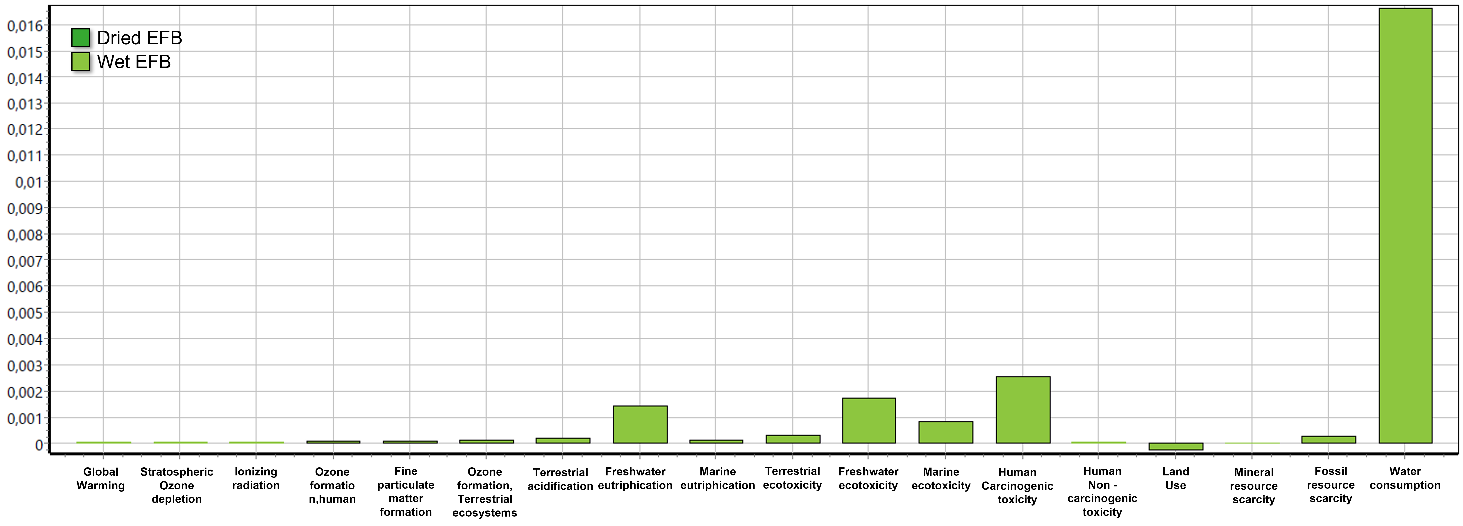

Figure 2: Environmental impacts (normalized) generated in the wet EFB drying stage.

Figure 2 shows that the environmental impacts of the drying stage are mainly associated with the environmental load related to the production of wet EFB, with water consumption being the category with the greatest impact.

Figure 3 clearly shows that the gasification stage affects the following categories in decreasing order: human carcinogenic toxicity, freshwater ecotoxicity, marine ecotoxicity, terrestrial ecotoxicity, freshwater eutrophication, water consumption, mineral resource scarcity, ozone formation (terrestrial ecosystems), global warming, ozone formation (human), terrestrial acidification, ionizing radiation, fine particulate matter formation, and human noncarcinogenic toxicity. The above categories are affected by the environmental loads associated with the production of peridotite (catalyst used), the drying stage, and the production of syngas.

Figure 4 shows that when analyzing the syngas cleanup stage, all categories in which an impact is generated are mainly affected by the environmental load associated with syngas.

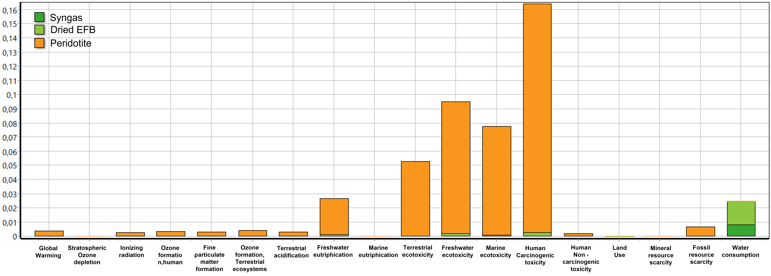

Figure 3: Environmental impacts (normalized) generated in the gasification stage of the dried EFB.

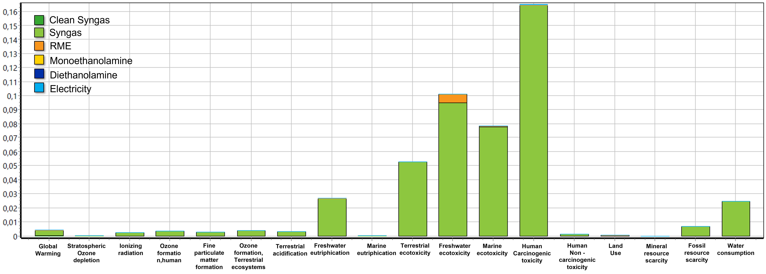

Figure 4: Environmental impacts (normalized) generated in the syngas cleaning stage.

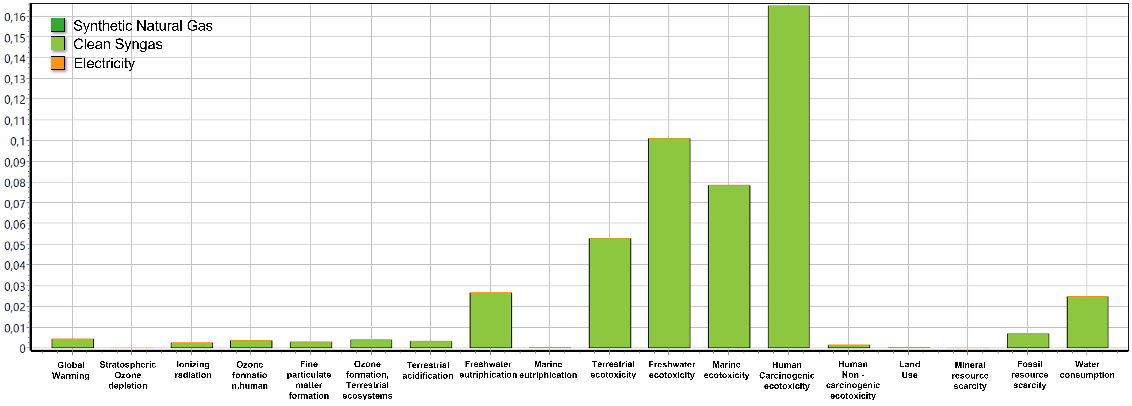

Figure 5: Environmental impacts (normalized) generated in the methanation stage.

Finally, Figure 5 shows that the impacts generated in the methanation stage are associated with the previous stages. Methanation did not have a significant impact on the overall syngas production process from EFB, which was also observed in Figure 1.

3.4 Interpretation of results

Each stage of SNG production has impacts that can be interpreted as follows: 1) Drying of EFB: The drying stage significantly affects water consumption and human toxicity due to the processes associated with the production of wet EFB. The water consumption of palm oil extraction was particularly high due to crop irrigation and water usage. To mitigate these impacts, the implementation of water reuse and regeneration technologies is suggested. Additionally, steel production for equipment significantly contributes to human carcinogenic toxicity due to industrial waste generated during manufacturing; 2) Gasification: The impacts at this stage were attributed to the use of peridotite as a catalyst and water consumption in syngas production. Peridotite, a byproduct of ferronickel production, is not the primary product of this industrial process, offering a key environmental advantage: its use as a gasification catalyst significantly reduces the need for new mineral resource extraction. Although ferronickel extraction generates environmental impacts, repurposing peridotite as a byproduct minimizes waste generation and its disposal in landfills. Furthermore, steam used as a gasifying agent presents an opportunity to integrate recycling strategies and optimize residual heat to reduce thermal losses and additional water consumption; 3) Gas Cleaning: Solvents used, such as rapeseed methyl ester (RME), and cleaning agents like monoethanolamine (MEA) and methyldiethanolamine (MDEA), significantly contribute to the ecotoxicity and water consumption categories. Optimizing solvent formulations and developing alternatives with lower ecological impacts are viable strategies to improve the sustainability of this stage; 4) Methanation: This stage had a minimal impact because of its efficiency and low additional resource consumption.

* 1. Conclusions

LCA revealed that the drying, gasification, and cleaning stages were most responsible for the environmental impact of SNG production from EFB. The main contributing factors are water consumption, peridotite production, and solvent use. Energy integration proved effective in reducing external energy requirements. A significant advantage of using peridotite is that it is a byproduct of ferronickel extraction, which is currently considered a waste with no defined use in many industrial applications. Leveraging this material not only reduces the need for extracting new mineral resources, but also mitigates the environmental issues associated with their final disposal. Moreover, using peridotite as a catalyst exemplifies practical circular economy principles, where industrial waste is transformed into valuable inputs for other production processes, improving the overall sustainability of the system. This study highlights the importance of optimizing each stage of the SNG production process from a life cycle perspective. It is recommended to improve water recycling by evaluating its purity for reuse and to adopt more sustainable construction materials that consider environmentally friendly practices in their production. Additionally, integrating more efficient recycling strategies for process streams could significantly reduce generated waste, strengthening the environmental feasibility of this technology.

References

Akmalina, R., & Pawitra, M. G. (2020). Life cycle assessment of ethylene production from empty fruit bunch. *Asia-Pacific Journal of Chemical Engineering*, 1–9. https://doi.org/10.1002/apj.2436

Chang, S. H. (2014). An overview of empty fruit bunch from oil palm as feedstock for bio-oil production. *Biomass and Bioenergy*, *62*, 174–181. https://doi.org/10.1016/j.biombioe.2014.01.002

Cormos, C. C., Dragan, M., Petrescu, L., Cormos, A. M., Dragan, S., Bathori, A. M., & Galusnyak, S. C. (2024). Synthetic natural gas (SNG) production by biomass gasification with CO2 capture: Techno-economic and life cycle analysis (LCA). *Energy*, *312*(December 2023), 133507. https://doi.org/10.1016/j.energy.2024.133507

Hafyan, R., Bhullar, L., Putra, Z., Bilad, M., Wirzal, M., & Nordin, N. (2019). Sustainability assessment of xylitol production from empty fruit bunch. In *MATEC Web of Conferences* (Vol. 268, p. 06018). https://doi.org/10.1051/matecconf/201926806018

Huijbregts, M. A. J., Steinmann, Z. J. N., Elshout, P. M. F., Stam, G., Verones, F., Vieira, M., Zijp, M., Hollander, A., & van Zelm, R. (2017). ReCiPe2016: a harmonised life cycle impact assessment method at midpoint and endpoint level. *International Journal of Life Cycle Assessment*, *22*(2), 138–147. https://doi.org/10.1007/s11367-016-1246-y

ICONTEC. (2007a). NORMA TECNICA COLOMBIA NTC-ISO14040. Gestión ambiental. Análisis de ciclo de vida. Principios y marco de refencia. *Icontec*, *2*, 1–24.

ICONTEC. (2007b). NORMA TECNICA COLOMBIA NTC-ISO14040. Gestión ambiental. Análisis de ciclo de vida. Requisitos y directrices. requisitos del ciclo de vida. *Icontec*, *2*(571), 1–24. http://files.control-ambiental5.webnode.com.co/200000127-a0991a28c5/NTC-ISO14040-2007 Analisis\_CicloVida.pdf

Jaffar, M. M., Nahil, M. A., & Williams, P. T. (2020). Synthetic natural gas production from the three stage (i) pyrolysis (ii) catalytic steam reforming (iii) catalytic hydrogenation of waste biomass. *Fuel Processing Technology*, *208*(June). https://doi.org/10.1016/j.fuproc.2020.106515

Jalili, M., Beyrami, J., Ziyaei, M., Chitsaz, A., & Rosen, M. A. (2024). Innovative synthetic natural gas production from biomass and renewable hydrogen: Evaluation and optimization with sustainability perspective. *Process Safety and Environmental Protection*, *182*(May 2023), 139–153. https://doi.org/10.1016/j.psep.2023.11.074

Katla-Milewska, D., Nazir, S. M., & Skorek-Osikowska, A. (2024). Synthetic natural gas (SNG) production with higher carbon recovery from biomass: Techno-economic assessment. *Energy Conversion and Management*, *300*(November 2023), 117895. https://doi.org/10.1016/j.enconman.2023.117895

Ortiz, O. A., Ojeda, K. A., & Rios, L. A. (2024). Case Study: Simulation of Synthetic Natural Gas Production Plant from Empty Fruit Bunches. *Chemical Engineering Transactions*, *109*, 637–642. https://doi.org/10.3303/CET24109107

Pour, N. (2019). Status of bioenergy with carbon capture and storage-potential and challenges. *Bioenergy with Carbon Capture and Storage: Using Natural Resources for Sustainable Development*, 85–107. https://doi.org/10.1016/B978-0-12-816229-3.00005-3

Seo, M. W., Lee, S. H., Nam, H., Lee, D., Tokmurzin, D., Wang, S., & Park, Y.-K. (2022). Recent advances of thermochemical conversion processes for biorefinery. *Bioresource Technology*, *343*, 126109. https://doi.org///doi.org/10.1016/j.biortech.2021.126109

Sun, Z., Chen, X., Kuo, P. C., Ding, L., & Aziz, M. (2024). Co-feeding biomass and municipal solid waste for enhanced hydrogen and synthetic natural gas yields employing chemical looping process. *Chemical Engineering Journal*, *493*(May), 152487. https://doi.org/10.1016/j.cej.2024.152487

Sunarno, Saputra, E., Fermi, M. I., & Utama, P. S. (2020). Non-catalytic co-pyrolysis of empty fruit bunch of palm and solid tire waste into upgrade bio-oil. *International Journal of Renewable Energy Research*, *10*(2), 687–692. https://doi.org/10.20508/ijrer.v10i2.10690.g7940