|  |  |
| --- | --- |
| cetlogo ***CHEMICAL ENGINEERING TRANSACTIONS***  VOL. xxx, 2025 | A publication of  aidiclogo_grande |
| The Italian Association  of Chemical Engineering  Online at www.cetjournal.it |
| Guest Editors: Fabrizio Bezzo, Flavio Manenti, Gabriele Pannocchia, Almerinda di Benedetto  Copyright © 2025, AIDIC Servizi S.r.l. **ISBN** 979-12-81206-17-5; **ISSN** 2283-9216 | |

## Interfacial Solar Steam Generator Based on Reduced Graphene Oxide/Polyurethane Monolith for Efficient Seawater Desalination

Bontle A. Manotoa,\*, Fisseha A Bezzaa, , Sherperd M. Tichapondwaa , Evans MN Chirwaa

aWater Utilization and Environmental Engineering Division, Department of Chemical Engineering, University of Pretoria, Pretoria 0002, South Africa

[bontlemanoto@gmail.com](mailto:bontlemanoto@gmail.com)

Seawater desalination using renewable energy sources is a promising solution to combat global water scarcity. In this study, the development and performance of an interfacial solar steam generator (ISSG) based on a reduced graphene oxide/polyurethane (rGO/PU) monolith is reported. Graphene is a hexagonal lattice 2D structure of sp2 hybridized carbon atom. It has excellent properties such as high thermal conductivity and high specific surface area making it a suitable candidate for thermal desalination. Pristine graphite was oxidised following Tour`s method. The rGO/PU monolith was fabricated through a hydrothermal self-assembly process and characterized using Raman spectroscopy, SEM, XRD, FTIR, and BET. Under 1 sun illumination, the ISSG achieved an evaporation rate of 1.34 kg·m⁻²·h⁻¹ and a photothermal conversion efficiency of 93%. This porous device effectively addressed the issue of energy localization, heat management, anti-scaling, and salt rejection. Our results demonstrate that the rGO/PU-based ISSG is a promising solution for efficient seawater desalination, and upscaling is recommended for practical applications.

* 1. Introduction

Water scarcity is a significant challenge worldwide, affecting over billions of people, agricultural and industrial sectors (Population media centre, 2022). This is exacerbated by population growth, pollution, and climate change. Traditional desalination methods, such as reverse osmosis, thermal distillation, and electrodialysis, often require significant energy inputs, advanced infrastructure, and high operational costs. Furthermore, these methods consume more electricity, posing additional challenges for water treatment (Gupta et al., 2015). Interfacial Solar Steam Generation (ISSG) has emerged as an innovative solution, leveraging photothermal materials to convert solar energy into steam for desalination. ISSG works by absorbing light from the sun, converting it to heat energy which is used to produce steam which is collected as fresh water (Worku et al., 2023).

Among various solar absorber materials, carbon-based absorbers such as reduced graphene oxide (rGO) have gained attention for their superior photothermal properties (Jian et al., 2021). These carbons based have low emissivity, light absorption over broad spectrum, good surface tunability, excellent photothermal conversion efficiency (Liu et al., 2023).

Graphene is a hexagonal lattice 2D structure of sp2 hybridized carbon atom. It is a near-infra red (NIR) absorber and has excellent properties such as high thermal conductivity and high specific surface area making it a suitable candidate for thermal desalination (Yusaf et al., 2022). Hydrothermal reduction can be employed to convert graphene 2D to 3D structure by using water as reducing agent to eliminate oxygen containing functional groups on graphene oxide plane (Garcia-Bordejé et al., 2021). The partial reduction of oxygen-containing functional groups in rGO improves results highlight the synergistic benefits of combining rGO's photothermal properties with a 3D porous

substrate, positioning the rGO/PU device as a promising candidate for sustainable and efficient water desalination technologies (Diez et al., 2013).

This study focuses on rGO/PU, a composite ISSG device that integrates rGO with a polyurethane sponge, offering lightweight thermal insulation, flexibility, and efficient water transport pathways to the water-air interface where evaporation occurs. This combination creates an efficient ISSG device capable of addressing the challenges associated with seawater desalination (Jian et al., 2021). Graphene-based ISSG material can be enhanced for photothermal improvement with materials such as metallic nanostructures, semiconductors, other carbon-based nanomaterials, organic polymers, MXenes (Zhou et al., 2020). For example, Huo et al. (2019) doped graphene material with nitrogen to enhance porosity. The plasmonic silver nanoparticles were used for the improvement of ISSG (Karimi‑Nazarabad et al., 2024).

Guo et al. (2020) highlighted the advantages of using reduced graphene oxide (rGO) in interfacial solar steam generation (ISSG) without additional enhancers. These include its high photothermal efficiency, effective water transport facilitated by its mesoporous structure, and its scalability and stability under solar irradiation. rGO also maintains an optimal balance of hydrophilic and hydrophobic properties, enabling efficient water interaction and evaporation. Furthermore, its demonstrated competitive evaporation rates (e.g., 1.34 kg·m⁻²·h⁻¹) and photothermal efficiencies rival those of more complex materials, making it a practical, cost-effective, and scalable option for ISSG without the need for further modifications.

* 1. Material and Methods
     1. Material

Chemical vapor deposition (CVD) synthesised Multiwalled carbon nanotubes were purchased from Sabinano (Randburg, Johannesburg). Other chemicals involved were purchased from sigma-Aldrich (Switzerland and Germany). It is worth noting the harshness of the materials used; therefore, proper health and safety precautions were carefully observed.

* + 1. Synthesis of GO

In this study, **graphene oxide (GO)** was synthesized from **graphite powder** using an improved version of the **Hummers' method** (Habte and Ayele., 2019). This process effectively restored the sp² carbon network, enhancing rGO’s photothermal and hydrophilic properties.

* + 1. Fabrication of 3D ISSG

The fabrication of reduced graphene oxide (rGO) monoliths was achieved through a one-pot hydrothermal reduction method, building on the approach described by Gao *et al*. (2020). A homogenous graphene oxide suspension was allowed for reaction process to occur using auto-clave reactor, at 180°C for 16 hours. The resulting product was retrieved and washed with a 10% ethanol solution to remove residual impurities. The self-assembled 3D framework was pre-frozen at −62°C for 24 hours and subsequently freeze-dried at −50°C and 0.001 kPa for 72 hours. The resultant reduced graphene oxide (rGO) monolith was placed on a polyurethane (PU) sponge, which acted as a thermal insulator, without any chemical interaction or mechanical bonding between the layers. This bilayer monolith was designated as rGO/PU.

* + 1. Experimental setup

The rGO/PU interfacial solar steam generator device with effective absorption area of 9.65 x10-3 m2, was placed in a beaker containing 250ml of artificial seawater with 3.5% salinity to simulate typical seawater conditions. The beaker was covered with a glassware inclined at an angle about 20o to prevent steam escape and facilitate water collection. The ISSG was tested using solar simulator under one-sun illumination (1 kW/m²). Specifically, the evaporation rate and photothermal conversion efficiency were calculated based on measured parameters.

* 1. Results and discussions
     1. X-ray diffraction (XRD)

The XRD analysis of graphite revealed a sharp peak at 30.70° (2θ), corresponding to the (002) crystal plane, confirming its high crystallinity. Additional peaks at 52.09° (004) and 63.96° (110) indicated the presence of other crystalline planes (Kim et al., 2021). Upon oxygen functionalization to form graphene oxide (GO), a new peak at 11.9° (001) was observed, reflecting increased interlayer spacing due to functional groups, along with a smaller peak at 49.49° (100), suggesting turbo-static disorder from incomplete oxidation (Afzal, 2024). Reduction of GO to reduced graphene oxide (rGO) caused broadening of the (002) peak, indicating decreased crystallinity and partial restoration of the sp² carbon structure with residual defects (Liu et al., 2021).

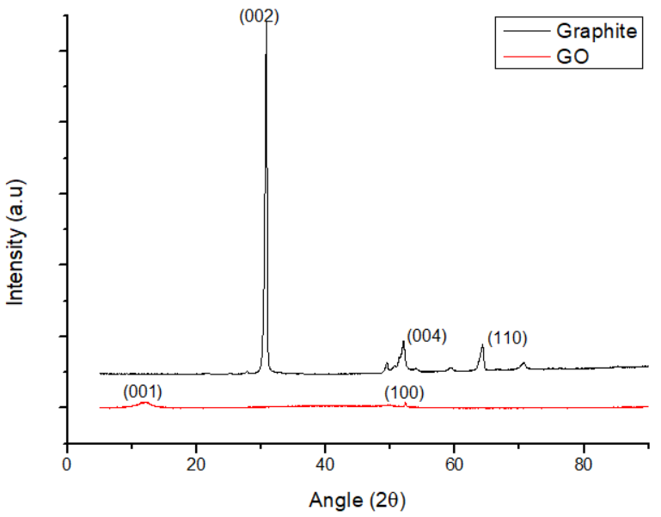

Figure 1: XRD peaks showing miller indices.

* + 1. Fourier Transform Infrared Spectroscopy (FTIR)

Fourier Transform Infrared Spectroscopy (FTIR) was used to characterize surface functional groups and chemical modifications in the synthesized materials. The FTIR spectrum of graphene oxide (GO), synthesized via the improved Hummers' method, showed a broad -OH stretching vibration at 3216 cm⁻¹, indicating hydroxyl groups, along with C=O stretching vibrations at 1718 cm⁻¹ and 2333 cm⁻¹, confirming the hydrophilic nature and edge defects of GO. Peaks at 1542 cm⁻¹ (C=C), 1429 cm⁻¹ (C-O-H), 1204 cm⁻¹ (C-O-C), 1015 cm⁻¹ (C-O), and 2104 cm⁻¹ (C≡C) reflected the coexistence of oxidized and unoxidized regions (Johra et al., 2014; Hassanzadeh-Tabrizi, 2023; Kim et al., 2021; Liu et al., 2022).

Reduction of GO to reduced graphene oxide (rGO) diminished oxygen-containing groups, evidenced by a weakened -OH stretching vibration and a reduced C=O peak. The dominant C=C vibration at 1614 cm⁻¹ indicated the restoration of the sp² carbon lattice, while the reduced hydrophilic peak at 3431 cm⁻¹ suggested increased hydrophobicity (Habte et al., 2019; Singh et al., 2022).

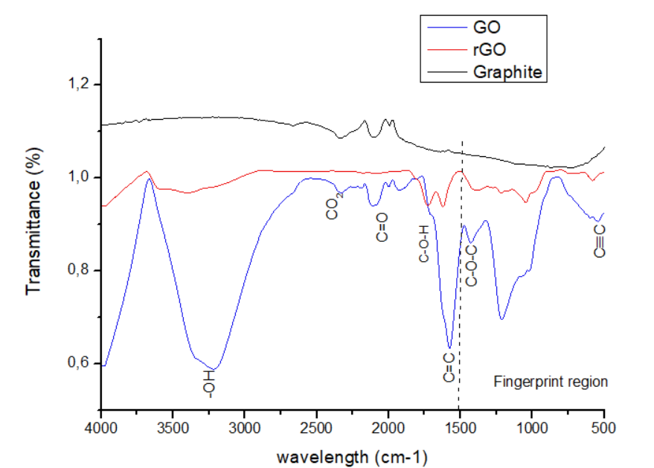

Figure 2: FTIR showing graphene oxide in relation to reduced graphene oxide

* + 1. Scanning Electron Microscope (SEM)

Scanning Electron Microscope (SEM) images of synthetic graphite revealed ordered crystalline structures, confirming sp² hybridization and high graphitization of the material. The observed crystallinity supports its synthetic nature and structural integrity (Yang et al., 2020). In Fig. 2(b) Exfoliation of graphite via ultrasonication and oxidation was evident in the SEM images of GO, showing a multi-layered structure consistent with FTIR results. Wrinkled morphologies, indicative of defects or structural distortions associated with oxygen-containing functional groups on basal planes and edges, were observed (Liu et al., 2020). SEM images of rGO captured on Fig. 2(c) showed smoother surfaces with reduced oxygen-containing functional groups compared to GO, aligning with FTIR and XRD results (Lui et al., 2021). Enhanced crystal ordering within rGO sheets, improving thermal conductivity, corroborates previous findings (Kim et al., 2018; Xu et al., 2010).

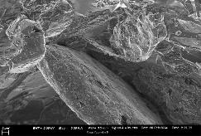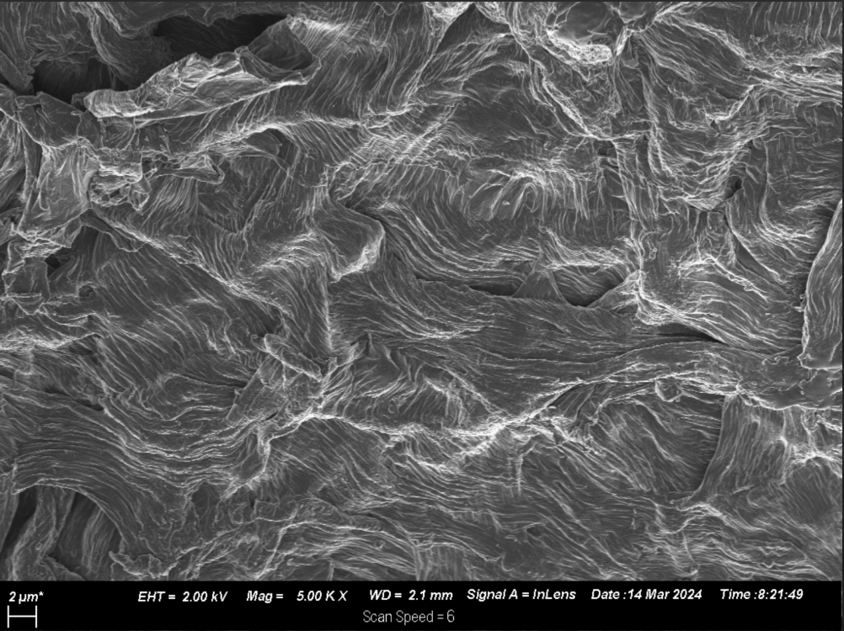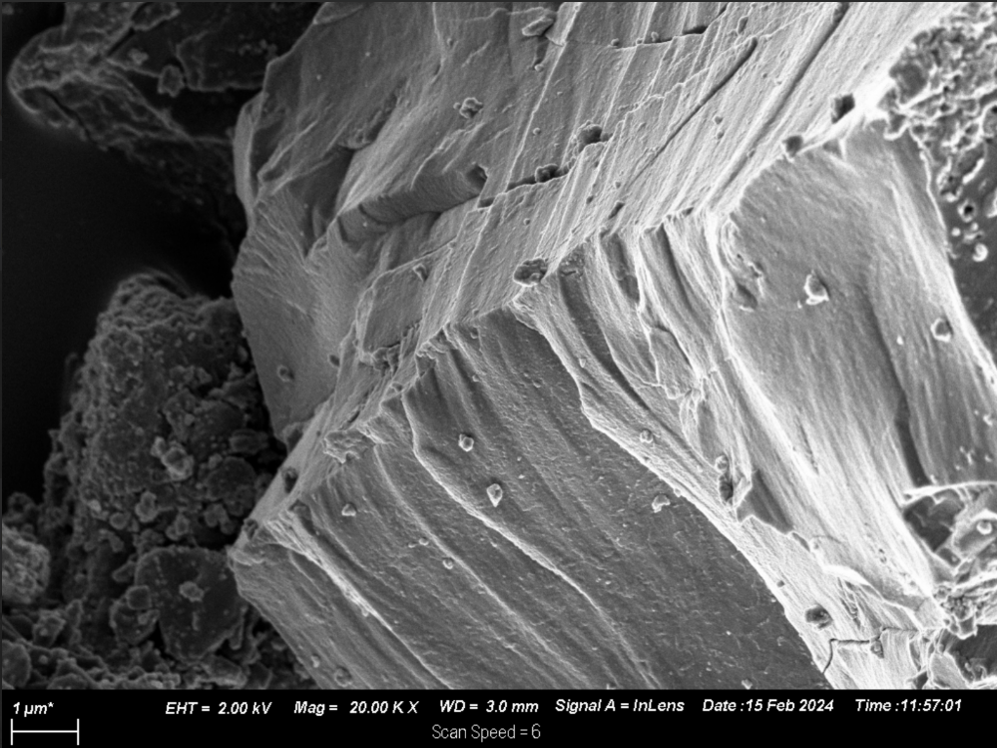

**(a)**

**(b)**

**(c)**

Figure 3: SEM images captured at magnification of 2µm, Graphite (a), Graphene oxide (b), reduced graphene oxide (c).

* + 1. Ultraviolet-visible spectroscopy (UV-Vis)

The Ultraviolet-visible spectroscopy analysis (200–700 nm) revealed distinct absorbance characteristics for graphene oxide (GO) and reduced graphene oxide (rGO). GO exhibited a primary absorption peak at 229 nm, corresponding to the π → π\* transition of aromatic C-C bonds, and a secondary shoulder peak at 304 nm, attributed to the n → π\* transition of C=O bonds (Hu et al., 2017). In contrast, rGO displayed a redshifted absorption maximum at 259 nm, indicating the partial reduction of oxygen-containing functional groups. These findings highlight the structural and electronic changes induced during the reduction process.

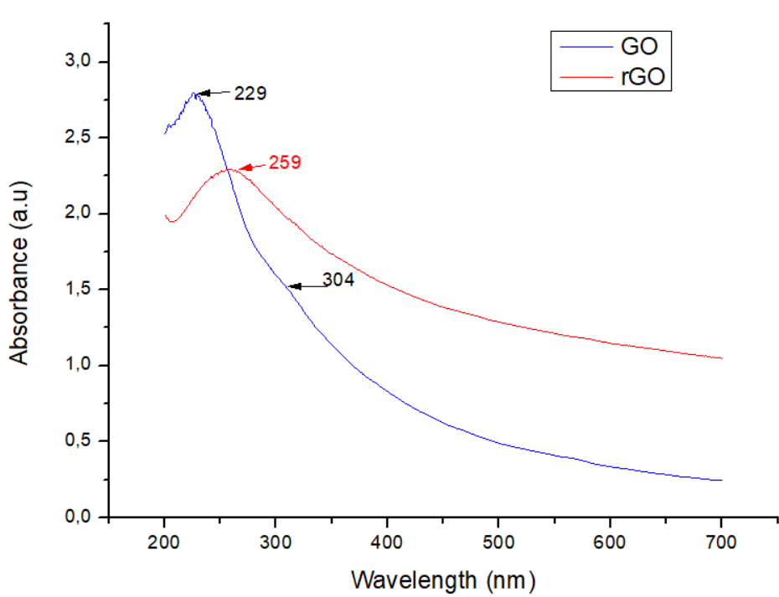

Figure 4: Ultraviolet-visible spectroscopy absorbance spectrum.

* + 1. Brunauer-Emmett-Teller (BET) analysis

The Brunauer-Emmett-Teller (BET) analysis of the rGO/PU device revealed structural properties that confirm its suitability for photothermal and evaporation applications. The isotherms, classified as Type IV(a), indicated the mesoporous nature of the rGO structure, with a predominant pore size around 38 nm. The "knee" at low relative pressure highlights efficient monolayer adsorption, while the observed hysteresis loop suggests wedge-shaped pores formed by rGO sheets. Despite its lower specific surface area compared to highly modified composites, rGO in the PU matrix retains sufficient porosity (26.07 m²/g) and a pore volume of 0.04596 cm³/g, providing efficient water transport pathways and enhancing thermal localization. These properties contribute to the device's high evaporation rate and photothermal efficiency, underscoring the structural benefits of incorporating rGO into a porous polyurethane scaffold.

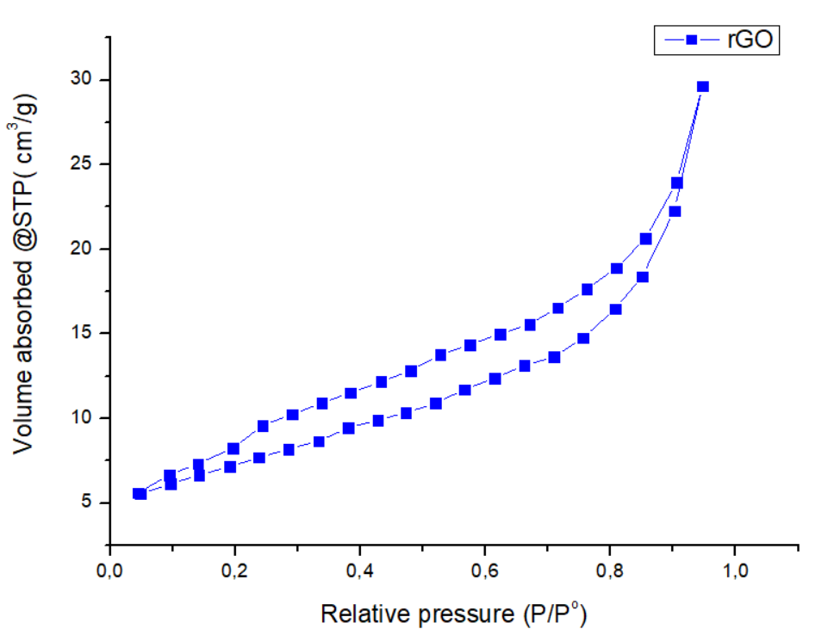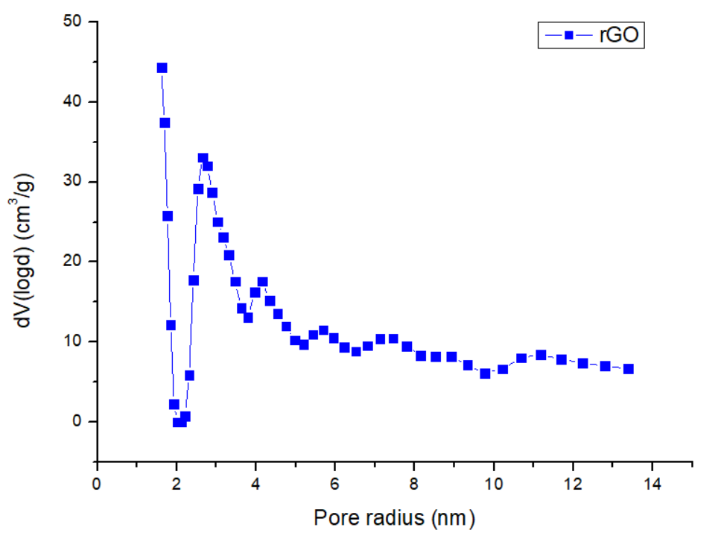

(a)

(b)

Figure 5: UV-Vis N2 adsorption–desorption isotherm (a) and pore size distribution (b) for rGO absorber

* + 1. Photothermal conversion efficiency and evaporation rate

The photothermal conversion efficiency and evaporation rate are critical parameters for evaluating the performance of interfacial solar steam generation (ISSG) devices. Fig 6(a) shows water production during the solar adsorption testing. In this study, the rGO absorber reached the surface temperature of 41.7oC (with starting T of 21.8oC) in 4hour testing period as illustrated by IR images on Fig.6(b). The Fabricated ISSG demonstrated an evaporation rate, $v$ of 1.34 kg·m⁻²·h⁻¹ when tested with artificial seawater (3.5 wt.% salts using solar similar under 1 sun illumination). This performance is attributed to the inherent properties of reduced graphene oxide (rGO) and the advantages of fabricating three-dimensional (3D) ISSG structures. The PU substrate significantly reduced heat loss to the bulk water, with a measured thermal conductivity of 0.023 W/m·K. PU as thermal management tool is observed in Fig. 6(c), where bulk water temperature reached only 23oC (from 21.8oC) after 4h testing cycle. This thermal insulation ensured efficient heat localization at the air-water interface, critical for high photothermal efficiency (Shi et al., 2018). Fig.5 (d) shows the fabricated rGO solar absorber. PU also provided a 3D water transport which is highly effective (Zhou et al., 2024).

The photothermal conversion efficiency, $η$ and evaporation rate, $v$ were calculated using $v=\frac{∆m}{S*t}$, and $η=\frac{υ (l_{v}+Q)}{p_{i}}$ where $∆m$ is the water volume accumulated, *S* is the effective absorption area, *t* is the cycle time, $l_{v}$ latent heat of vaporization, $Q$ is the specific heat capacity of water and $p_{i}$ is the incidence solar light intensity, as explained by Wei et al. (2022). The photothermal efficiency was reported to reach 93% without introducing any enhancers into the system. The fabrication of 3D ISSG structures not only enhances efficiency but also offers scalability, mechanical flexibility, and potential cost advantages (Xiao et al., 2023).

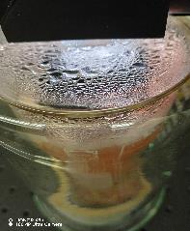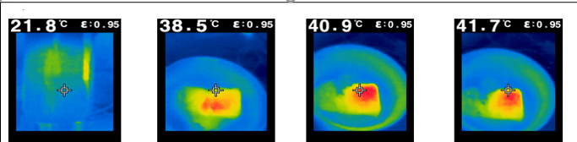

(a)

(b)

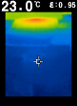

(c)

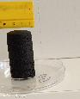

(d)

Figure 6: ISSG performance, showing on (a) testing of the absorber, (b) IR camera aerial view images of rGO/PU, (c) IR camera lateral view images of rGO/PU in bulk water, showing PU as thermal management tool during testing, (d) fabricated rGO absorber.

* 1. Conclusions

The reduced graphene oxide/polyurethane (rGO/PU) monolith demonstrates significant potential as an interfacial solar steam generator (ISSG) for seawater desalination. The device achieved an evaporation rate of 1.34 kg·m⁻²·h⁻¹ under one-sun illumination and a photothermal conversion efficiency of 93%, highlighting the excellent light absorption and thermal conductivity of rGO combined with the lightweight, porous structure of polyurethane. The integration of rGO into the PU matrix enabled efficient heat localization, minimized thermal losses to bulk water, and facilitated capillary-driven water transport to the evaporation interface.

The mesoporous architecture of rGO/PU, confirmed by BET analysis, and its scalable, flexible design make it a promising candidate for addressing global water scarcity through sustainable desalination technologies. Future work should focus on optimizing material properties and scaling up production for practical applications in diverse water treatment scenarios.

References

Diez, N., Śliwak, A., Gryglewicz, S., Grzyb, B., Gryglewicz, G. 2015. Enhanced reduction of graphene oxide by high-pressure hydrothermal treatment. **RSC Adv ,5**, 81831-81837.

Fathy, M., Gomaa, A., Taher, F. A., El-Fass, M. M., Kashyout, A. E. B. 2016. Optimizing the preparation parameters of GO and rGO for large-scale production. J Mater Sci, 51, 5664–5675.

Garcia-Bordejé, E., Benito, A. M., Maser, W. K. 2021. Graphene aerogels via hydrothermal gelation of graphene oxide colloids: Fine-tuning of its porous and chemical properties and catalytic applications. *Advances in Colloid and Interface Science*, 292, 102420.

Guo, X., Gao, H., Wang, S., Yin, L., Dai, Y. 2020. Scalable, flexible and reusable graphene oxide-functionalized electrospun nanofibrous membrane for solar photothermal desalination. Desalination, 488, 114535.

Gupta, A., Sakthivel, T., Seal, S. 2015. Recent development in 2D materials beyond graphene. Progress in Materials Science 73, 44–126.

Habte, A. T., Ayele, D. W. 2019. Synthesis and Characterization of Reduced Graphene Oxide (rGO) Started from Graphene Oxide (GO) Using the Tour Method with Different Parameters. *Advances in Materials Science and Engineering*,1- 9.

Hu, X., Zhu, J. 2020. Tailoring Aerogels and Related 3D Macroporous Monoliths for Interfacial Solar Vapor Generation. *Adv. Funct. Mater*, 30, 1907234*.*

Huang, Q., Liang, X., Yan, C., Liu, Y. 2021. Review of interface solar-driven steam generation systems: High-efficiency strategies, applications and challenges. [*Applied Energy*](https://www.sciencedirect.com/journal/applied-energy), 283, 116361.

Huo, B., Jiang, D., Cao, X., Liang, H., Liu, Z., Li, C., Liu, J. 2019. N-doped graphene /carbon hybrid aerogels for efficient solar steam Generation. Carbon, 142, 13, 19.

Jian, H., Wang, Y., Li, W., Ma, Y., [Wang](https://www.sciencedirect.com/author/56943053300/wei-wang), W., [Yu](https://www.sciencedirect.com/author/55700453800/dan-yu), D. 2021. Reduced graphene oxide aerogel with the dual-cross-linked framework for efficient solar steam evaporation. *Colloids and Surfaces A: Physicochemical and Engineering Aspects.* 629, 127440.

[Liu](https://pubmed.ncbi.nlm.nih.gov/?term=Liu%20C%5BAuthor%5D), C., [Yin](https://pubmed.ncbi.nlm.nih.gov/?term=Yin%20Z%5BAuthor%5D), Z., [Hou](https://pubmed.ncbi.nlm.nih.gov/?term=Hou%20Y%5BAuthor%5D), Y., [Yin](https://pubmed.ncbi.nlm.nih.gov/?term=Yin%20C%5BAuthor%5D), C., [Yin](https://pubmed.ncbi.nlm.nih.gov/?term=Yin%20Z%5BAuthor%5D), Z. 2023. Overview of Solar Steam Devices from Materials and Structures. *Polymers*, 15, 2742.

Manawi, Y. M., Ihsanullah, Samara, A., Al-Ansari, T., Atieh, M. A. 2018. A Review of Carbon Nanomaterials’ Synthesis via the Chemical Vapor Deposition (CVD) Method. Materials, 11, 5, 822.

Min, X., Zhu, B., Li, B., Li, J., Zhu, J. 2021. Interfacial Solar Vapor Generation: Materials and Structural Design. *Acc. Mater*. Res, 2, 198−209.

Miśkowiec, P. 2020. Name game: the naming history of the chemical elements—part 1—from antiquity till the end of 18th century. Foundations of Chemistry, 25, 29–51.

Karimi‑Nazarabad, M., Goharshadi, E. K., Sadeghi, F., Ebrahimi, A. 2024. Highly efficient and sustainable wood‑based plasmonic photo absorber for interfacial solar steam generation of seawater. Wood Science and Technology, 58, 213–231.

Population media centre. 2022. “How is population growth responsible for the growing problem of water scarcity”,<<https://www.populationmedia.org/the-latest/population-growth-and-water-scarcity>>[2022, October 13].

Sharma, B., Rabinal, M. K. 2017. Plasmon based metal-graphene nanocomposites for effective solar vaporization. *Journal of Alloys and Compounds.* 690, 57- 62.

Shi, Y., Li, R., Jin, Y., Zhuo, S., Shi, L., Chang, J., Hong, S., Ng, K. C., Wang, P. 2018. A 3D Photothermal Structure toward Improved Energy Efficiency in Solar Steam Generation. *Joule* 2, 1171–1186.

Singh, R., Ullah, S., Rao, N., Singh, M., Patra, I., Darko, D. A., Issac, P. J., Esmaeilzadeh-Salestani, K., Kanaoujiya, R., Vijayan, V. 2022, Synthesis of Three-Dimensional Reduced-Graphene Oxide from Graphene Oxide. *Journal of Nanomaterials*, 1-18.

Thoai, D. N., Hoai-Ta, Q. T., Truong, T. T., Van-Nam. H., Van-Vo, G. 2021. Review on the recent development and applications of three dimensional (3D) photothermal materials for solar evaporators. *Journal of Cleaner Production*, 293,126122.

Wei, Z., Arshad, N., Hui, C., Irshad, M. S., Mushtaq, N., Hussain, S., Shah, M., Naqvi, S. Z. H., Rizwan, M., Shahzad, N., Li, H., Lu, Y., Wang, X. 2022. Interfacial Photothermal Heat Accumulation for Simultaneous Salt Rejection and Freshwater Generation; an Efficient Solar Energy Harvester. Nanomaterials, 12, 18, 3206.

Worku, A. K., Ayele, D. W. 2023. Recent advances of graphene-based materials for emerging technologies. *Results in Chemistry*, 5, 100971.

Wu, L., Dong, Z., Cai, Z., Ganapathy, T., Fang, N. X., Li, C., Yu, C., Zhang, Y., Song, Y. 2020. Highly efficient three-dimensional solar evaporator for high salinity desalination by localized crystallization. *Nature Communications*, 11, 521.

Xiao, W., Li, B., Yan, J., Wang, L., Huang, X., Gao, J. 2023. Three dimensional graphene composites: preparation, morphology and their multi-functional applications. *Composites Part A,* 165, 107335.

Xu, C., Haibo Li, H. 2022. Engineering of porous graphene oxide membranes for solar steam generation with improved efficiency. Environ. Sci.: Water Res. Technol, 8, 249.

Yusaf, T., Mahamude, A. S. F., Farhana, K., Harun, W. S. W., Kadirgama, K., Ramasamy, D., Kamarulzaman, M. K., Subramonian, S., Hall, S., Dhahad, H. A. 2020. A Comprehensive Review on Graphene Nanoparticles: Preparation, Properties, and Applications. Sustainability, 14, 19, 12336.

Zhou, P., Fan, W., Sun, Y., Zhao, Y., Sun, F., Xu, J. 2024. Highly efficient hydrothermal management, shape-controlled 3D conical aerogels for solar high-salinity seawater desalination and water purification. Chemical Engineering Journal, 498, 155529.