|  |  |
| --- | --- |
| cetlogo ***CHEMICAL ENGINEERING TRANSACTIONS***  ***VOL. xxx, 2025*** | A publication of  aidiclogo_grande |
| The Italian Association  of Chemical Engineering  Online at www.cetjournal.it |
| Guest Editors: Fabrizio Bezzo, Flavio Manenti, Gabriele Pannocchia, Almerinda di Benedetto  Copyright © 2025, AIDIC Servizi S.r.l. **ISBN** 979-12-81206-17-5; **ISSN** 2283-9216 | |

Graphene oxide modified bimetallic Al/Fe (hydro)oxides doped activated carbon composite for efficient adsorption of hexavalent chromium from aqueous solution

Tsheamo W. Mogalea,\*, Fisseha A Bezzaa, Shepherd Tichapondwaa,Evans MN Chirwaa

a Water Utilization and Environmental Engineering Division, Department of Chemical Engineering, University of Pretoria, Pretoria 0002, South Africa

\*u15212191@tuks.co.za

The uncontrolled release of Cr(VI) poses significant risks to ecosystems, with studies showing that its concentrations in surface and groundwater frequently exceed safe limits for freshwater, wastewater, and soil. Cr(VI) is particularly hazardous due to its high solubility and mobility in water, as well as its ability to cause harm to humans and aquatic organisms even at trace levels. In this study, Al₂O₃@Fe₂O₃ nanoparticles doped activated carbon was synthesized via a co-precipitation method, using equimolar amounts of iron (Fe) and aluminium (Al) salts in the presence of finely ground wheat straw at a bimetal-to-straw mass ratio of 10:1. After co-precipitation, the mixture was dried and chemically activated with potassium hydroxide (KOH) at 500°C, which facilitated the formation of a porous carbon structure. Subsequently, the Al₂O₃@Fe₂O₃ doped activated carbon was grafted with an equal mass of graphene oxide (GO), freeze-dried, and used for adsorbing Cr(VI) from water. The adsorption performance of the material was assessed at various initial concentrations of the adsorbate, different adsorbent dosages, and pH levels. The adsorbent achieved up to 99.9% removal of Cr(VI) from a 100 mg/L Cr(VI) contaminated solution. It exhibited a broad pH range adsorption potential, effectively functioning across a pH range of 4 to 7, with the highest adsorption occurring at lower pH levels. The grafting of GO significantly improved the adsorbent’s capacity, enabling complete elimination of residual Cr(VI). The isotherm adsorptive study obeyed to the Langmuir isotherm, with a maximum adsorptive capability ( $q_{max})$ of 95.17 mg/g and a 99.24% fit to the model. An extremely porous structure was displayed using scanning electron microscopy (SEM) with uniformly dispersed Al₂O₃@Fe₂O₃ nanoparticles on the porous graphene oxide/carbon matrix. The Fourier Transform Infrared Spectroscopy (FTIR) study displayed high surface area of the adsorbent with rich oxygen containing functional groups.

* 1. Introduction

Heavy metal contamination has become a pressing challenge for humanity due to advancements in industrial and agricultural activities, increased anthropogenic activities, and natural processes. Since the planet’s formation, heavy metals have naturally been present in the crust of the Earth. However, the amount of metallic materials in both terrestrial and aquatic habitats has significantly increased because of a sharp rise in the use of heavy metallics (Gautam et al., 2016). Even in trace amounts, common heavy metallics such as cadmium (Cd), lead (Pb), mercury (Hg), chromium (Cr), nickel (Ni) and arsenic (As) are extremely poisonous. These metallics have the potential to cause major health issues in humans and other organisms, such as carcinogenicity and toxicity affecting various organs, including the liver, kidney, brain, heart and skin toxicity. Additionally, they can cause reproductive issues and developmental abnormalities (Mitra et al., 2022). Trivalent-Cr(III) and Hexavalent-Cr(VI) are the two stable oxidation states of chromium, which is one of the most dangerous heavy metal. There are two types of Cr found in aquatic media: Cr(VI) and Cr(III). In reducing conditions, Cr(III) is dominant, but in oxidizing situations, Cr(VI) is dominant. The relative distribution of Cr(VI) predominant species (Cr2O72−, CrO42−, H2CrO4, and HCrO4−) in water depends on the pH of the solution and redox potential (Rahman and Singh, 2019). Cr(VI) is a strong oxidizing agent, mobile, and highly diffusive, enabling it to easily pass through membrane barriers. It is highly toxic and carcinogenic, leading to severe health issues such as liver failure, pulmonary congestion, vomiting, and acute diarrhoea. In contrast, Cr(III) is insoluble in water, less mobile, less toxic, and can be easily removed from solutions as it precipitates as Cr(OH)₃ (Hossini et al., 2022). According to the International Agency for Research on Cancer (IARC), hexavalent chromium is a group 1 carcinogen (Hossini et al., 2022). Actually, chromium-VI is over 100 times more hazardous than chromium-III in aquatic systems (Jang et al., 2020).

Chromium finds extensive application across various industries, with over 90% of the 18,000–30,000 × 10³ tons produced annually being utilized by metallurgical industries for manufacturing chrome alloys and chromium metal. Additionally, chromium is employed in processes like tanning of leather, corrosion inhibition, dyeing of textiles, and preservation of wood (Mitra et al, 2022). Several techniques of chromium remediation like adsorption, ion-exchanging, electrochemical separation, chemical precipitation, membrane technology, coagulation, flocculation, and biological process have been employed (Qasem et al., 2021; Rajoria et al., 2022; Deepa et al., 2025). However, majority of the approaches involve high remediation costs, are less efficient, require significant chemical use resulting in secondary contamination (Deepa et al., 2025). Among all the remediation techniques, adsorption stands out as the best method because of its affordability, ease of use, environmental sustainability, and simplicity of design (Jang et al., 2020).

A wide range of adsorbents were investigated to remove Cr(VI), which includes activated carbon, metal-doped activated carbons, zeolites, layered double hydroxides, and graphene oxide-based materials (Jang et al., 2020). Graphite-derived graphene oxide is gaining significant attention for its high adsorption potential for heavy metals. This is primarily because of the rich functional groups containing oxygen such as carboxylic acids, hydroxy, carbonyl, and epoxy species. These functional groups enhance the surface reactivity and present a lot of active sites to bind heavy metallic ions, making graphene oxide a highly efficient adsorbent (Chen et al., 2014; Ruhaimi et al., 2022). Despite that, because of its great dispersion in water, it is difficult to recover from water after adsorption (Pakade et al., 2019). Graphene oxide-based metallic oxide adsorbents demonstrate great capability in adsorbing Cr(VI) due to their oxygen-rich functional groups and easily modifiable structures, enabling selective adsorption and removal of various heavy metals. The fabrication of bimetallic oxide nanoadsorbents through the combination of two distinct metallic oxides introduces novel properties and synergetic effects missing in their monometallic forms (Scaria et al., 2020). These synergetic interactions at the nanoscale result in unique electronic, catalytic, and surface properties, making them greatly efficient for diverse utilization, particularly for treating wastewater (Hamza et al., 2024). The development of bimetallic nanocomposites on activated carbon with a high surface area avoids agglomeration of the nanometallic composites and provides two key benefits: increased surface area and additional active sites, which together enhance chromate adsorption performance. Further graphene oxide functionalization of the bimetallic-doped activated carbon enhances adsorption ability of the material because of the synergistic interaction between the activated carbon anchored bimetallic nanocomposites, and graphene oxide. In this study, graphene oxide-functionalized Al/Fe bimetallic oxide-doped activated carbon was successfully synthesized to effectively remove chromate from water.

* 1. Methods

**2.1 Graphene oxide functionalized activated carbon supported Al2O3/Fe₂O₃ bimetallic nanocomposite (GO/ Al2O3/Fe₂O₃ @AC) synthesis**

Graphene oxide was produced from graphite using Tour’s method, as detailed by Mogale et al. (2024). The Al2O3/Fe₂O₃ bimetallic nanocomposite, anchored onto activated carbon, was synthesized through co-precipitation of metallic salts, utilizing activated carbon prepared as described in the previous study (Mogale et al., 2024). This co-precipitation process was carried out in the presence of pre-synthesized activated carbon, maintaining a 1:10 ratio of activated carbon to metallic salts. Equimolar amounts of ferrous sulfate and aluminium salt were used. The functionalization of the activated carbon-anchored Al2O3/Fe₂O₃ bimetallic nanocomposite (GO/Al2O3/Fe₂O₃@AC) with graphene oxide was achieved by mixing equal weights of freeze-dried graphene oxide with Fe/Al bimetallic oxide-doped activated carbon (Al2O3/Fe₂O₃@AC). Subsequently, the nanocomposites were used for adsorption experiments after being characterized.

**2.2 Characterization of GO/Al2O3/Fe₂O₃@AC nanocomposites**

The as-synthesised graphene oxide functionalized activated carbon anchored Al2O3/Fe₂O₃ bimetallic nanocomposite (GO/Al2O3/Fe₂O₃@AC) was examined using a scanning electron microscope that uses field emission (FESEM, Zeiss 540 X-beam) for determining the morphology and size distribution of the components. The functional groups contained in the adsorbent were identified using Fourier Transform Infrared Spectroscopy (FTIR).

**2.3 Batch adsorption experiments**

Using 250 ml flasks containing 100 mL of a 100 mg/L Cr(VI) solution at different adsorbent doses (1.0 – 4.0 g/L) and an initial solution pH of 5, a series of batch adsorption studies were conducted. For 24 hours at 27°C, the flasks were shaken at 150 rpm using a rotary shaker. The samples were then collected and centrifuged for five minutes at 10,000 rpm. Using sodium 1,5-diphenylcarbazide at a wavelength of 540 nm, the residual Cr(VI) concentration in the supernatant was measured spectrophotometrically (Rani et al., 2017). Using 0.1 M HCl and 1 M NaOH solutions, the pH of the solution was varied from 3 to 11 in order to investigate the impact of pH on the elimination of Cr(VI) at an initial concentration of 100 mg/L. By adjusting the initial Cr(VI) concentration from 20 to 200 mg/L at 3.0 g/L, pH 5, and an adsorption duration of 1400 minutes long enough to establish equilibrium, the adsorption isotherm of Cr(VI) adsorption was investigated. Equilibrium adsorptive capacities (qₑ) and removal efficiencies can be calculated using the following equations:

|  |  |
| --- | --- |
| $Chromium \left(VI\right) removal \left(\%\right)=\frac{C_{o}-C_{t}}{C_{o}}×100$ | (1) |
| $q_{e}=\left(\frac{C_{0}-C_{e}}{m}\right).V$ | (2) |

Where: $q_{e}$ = equilibrium adsorptive capacities (mg/g), $C_{0}$ = Initial concentration of Cr(VI) in solution (mg/L); $C_{e}$ = Equilibrium concentration of Cr(VI) in solution (mg/L); $V=$ Volume of the solution (mL); $m=$ Mass of the adsorbent (g) $C_{t}$*=* Concentration at time t.

**2.4 Adsorption isotherm study**

The Langmuir and Freundlich models were fitted to the isotherm data to investigate the interaction between the adsorbent and the adsorbate and ascertain the adsorbent's performance (Gorzin et al., 2018).

|  |  |
| --- | --- |
| $q_{e} = \frac{q_{max}{.K}_{L}{.C}_{e}}{1 +K_{L}{.C}_{e}}$ | (3) |
| $q_{e}=K_{f}{.C}_{e}^{\frac{1}{n}}$ | (4) |

Where *Ce* is the Cr(VI) concentration after adsorption (mg/L), *qmax* and *qe* are the maximum and equilibrium adsorptive capabilities (mg/g) respectively. The Langmuir constants, *KL,* and Freundlich constants, *n* and *Kf*.

* 1. **Results and discussion**
     1. Characterizations

**Scanning Electron Microscope (SEM)**

The scanning electron microscope (SEM) analysis has been conducted to study the morphology and distribution pattern of the bimetallic components in the activated carbon and graphene oxide matrix, as displayed in Figure 1a. It can be observed that the adsorbent has a highly porous morphology due to the synergistic effects of activated carbon and graphene oxide, which impart porosity to the nanocomposite. The bimetallic nanocomposite is also uniformly dispersed on the graphene oxide and activated carbon matrices. The porous morphology demonstrates the potential of the adsorbent to efficiently adsorb and anchoring of Cr (VI) metallic anions.

**Fourier transform infrared (FTIR)**

Besides the greatly porous morphology and great surface area, the binding capacity is significantly influenced by the existence of functional groups containing oxygen in the graphene oxide, as well as the additional functionalities imparted by the activated carbon and bimetallic oxide composite. As clearly observed in Figure 1b, the GO/Al₂O₃/Fe₂O₃@AC nanocomposites exhibit carboxylic acid, hydroxyl, and epoxy functional groups in the nanopores, which are derived from the graphene oxide. The Al₂O₃/Fe₂O₃@AC shows the functional groups of the activated carbon as well as the bimetallic composites (Liu et al., 2012) providing the GO/Al₂O₃/Fe₂O₃@AC nanocomposites with additional functional groups that enhance the synergistic adsorption performance.

*Figure 1: Morphological analysis (a) and Fourier transform infrared (FTIR) analysis of the GO/Al₂O₃/Fe₂O₃@AC nanocomposite (b).*

**3.2 Adsorption studies**

The chromate adsorption efficiency of the adsorbent was evaluated under varying pH conditions and adsorbent dosages. Both parameters; adsorbent dosage and solution pH are important in determining adsorption potential. The solution pH notably impacts the charge on the adsorbent surface, which in turn significantly influences its adsorption capability. A sufficient adsorbent dosage ensures the availability of adequate adsorption sites for chromate anions.

**Effects of pH solution**

The impact of pH solution has been examined at different pH values using an adsorbent dose of 3 g/L, as seen in Figure 2a. The pH range of 3 to 6 was where maximum adsorption took place. At higher pH levels, adsorption performance declined significantly, with a marked decrease beyond pH 7. Since Cr(VI) exist in water as oxyanions (HCrO4−, Cr2O72− and CrO42−), this reduction was ascribed to the hydroxide ions' negative surface charge on the adsorbent, which resulted in electrostatic repulsion between the chromate anions and the hydroxide ions (Pakade et al., 2019).

**Effects of adsorbent dose**

The adsorption study was conducted using adsorbent dosages ranging from 1.0 g/L to 4.0 g/L. As the adsorbent dosage rose from 1.0 g/L to 3.0 g/L, as seen in Figure 2b, adsorption performance dramatically improved. However, no noticeable improvement was seen over 3 g/L. This plateau effect is attributed to over-saturation and overlapping of adsorption sites, which limit further adsorption. The remarkable adsorption observed is ascribed to the synergetic effect of the rich functional groups imparted by graphene oxide (GO) as well as the active sites and functionalities provided by the bimetallic oxides and the activated carbon. Recent studies have shown that functionalised and modified adsorbents outperform their native counterparts (Cai et al., 2019). The interactivity amongst the functional groups on the activated carbon, bimetallic oxides, and rich functional groups imparted by GO enhance the removal methods direct or indirect. These processes consist of physical adsorption, ion exchanging, precipitation, surface complexation and electrostatic contact (Yang et al., 2019).

**3.3 Adsorption isotherm studies**

Adsorptive isotherms are important for designing and optimizing adsorbents because they offer important insights into the adsorption process. Furthermore, adsorption isotherm models offer useful details regarding the maximum adsorption capacity and adsorption mechanisms, both of which are critical for evaluating the effectiveness of adsorbents (Wang and Guo, 2020). To fit equilibrium adsorptive data, evaluate the mechanisms involved in the adsorptive process, and determine the relation between the adsorbate on the surface of the adsorbent and its concentration in the surrounding environment, Langmuir (3), Freundlich (4), and adsorption isotherm models were employed in this investigation.

In contrast to the Freundlich model (R2 = 0.98), the Langmuir model (R2 = 0.991) for Cr(VI) adsorption was best matched by the isotherm data, as shown in Figure 2c. This suggests that monolayer adsorption was the mode of adsorption for Cr(VI). A maximum adsorptive capability (qmax) of 95.17 mg/g was shown using the Langmuir adsorption isotherm model fit.

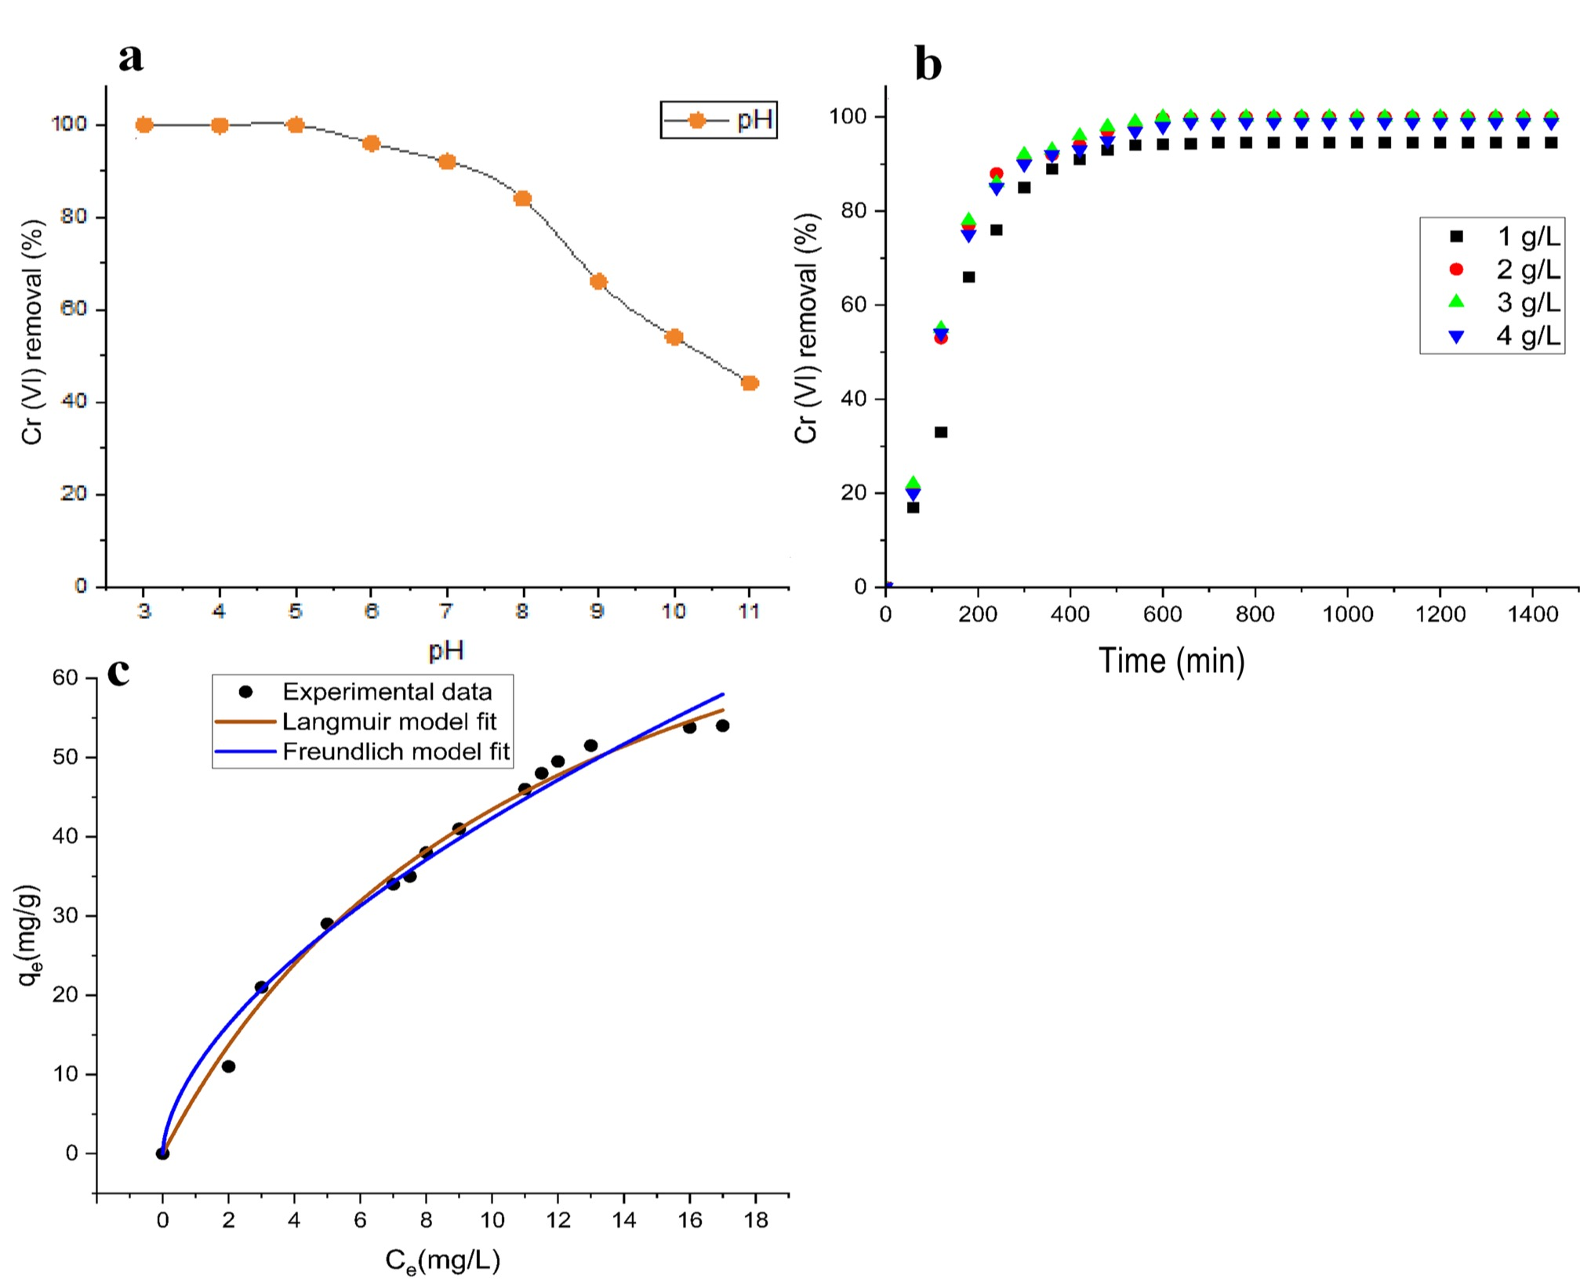

Figure 2: Adsorption performance of GO/Al₂O₃/Fe₂O₃@AC nanocomposites at various pH levels (a), different adsorbent dosages (b), and adsorptive isotherms model fits to the experiment data (c).

* 1. Conclusions

The current study demonstrated the efficient chromium adsorption potential of the GO/Al₂O₃/Fe₂O₃@AC nanocomposite. The adsorbent showed remarkable adsorption over a wide pH range and achieved almost complete adsorption of Chromium (VI) at dosages of 3 g/L, with a maximum adsorptive potential of 95.17 mg/g as derived from the Langmuir isotherm model study. A little decrease in adsorption was observed when the adsorbent dose rose to 4 g/L. The efficient and superb adsorptive potential of the composite is ascribed to the rich functional groups predominantly imparted by the graphene oxide, as well as the additional functionalities provided by the bimetallic nanocomposite and the activated carbon. These components synergistically displayed a remarkable adsorption potential. Overall, the adsorbent shows promising potential for scaling up and wide real-world application potential.

Acknowledgments

The authors thank the South African National Research Foundation (NRF), Water Research Commission (WRC), and Environmental Resource Management (ERM) for their assistance.

**References**

Ali E.M., El-Shehawy A.S., 2023, Metallic nanoparticles and bioremediation for wastewater treatment, Advanced Application of Nanotechnology to Industrial Wastewater, 215–239.

Al-Othman Z.A., Ali R., Naushad M., 2012, Hexavalent chromium removal from aqueous medium by activated carbon prepared from peanut shell: adsorption kinetics, equilibrium and thermodynamic studies, Chemical Engineering Journal, 184, 238 – 247.

Cai W., Wei J., Li Z., Liu Y., Zhou J., Han B., 2019, Preparation of amino-functionalized magnetic biochar with excellent adsorption performance for Cr (VI) by a mild one-step hydrothermal method from peanut hull, Colloids and Surfaces A: Physicochemical and Engineering Aspects, 563, 102-111.

Chen J.H., Xing H.T., Guo H.X., Weng W., Hu S.R., Li S.X., Huang Y.H., Sun X., Su Z.B., 2014, Investigation on the adsorption properties of Cr (VI) ions on a novel graphene oxide (GO) based composite adsorbent, Journal of Materials Chemistry A, 2(31), 12561-12570.

Deepa A., Mastan A., Buddolla V., Kumar Y.A., Lakshmi B.A., Kim Y.J., 2025, Bioremediation approaches for chromium detoxification and transformation: Advanced strategies and future Perspectives, International Biodeterioration & Biodegradation, 196, 105951.

Gautam P.K., Gautam R.K., Banerjee S., Chattopadhyaya M.C., Pandey J.D., 2016, Heavy metals in the environment: fate, transport, toxicity and remediation technologies, Nova Sci Publishers, 60, 101-130.

Gorzin F., Bahri Rasht Abadi M.M., 2018, Adsorption of Cr (VI) from aqueous solution by adsorbent prepared from paper mill sludge: Kinetics and thermodynamics studies, Adsorption Science & Technology, 36(1-2), 149-169.

Hamza A., Ho K.C., Chan M.K., 2024, Recent development of substrates for immobilization of bimetallic nanoparticles for wastewater treatment: a review, Environmental Science and Pollution Research, 1-30.

Hossini H., Shafie B., Niri A.D., Nazari M., Esfahlan A.J., Ahmadpour M., Nazmara Z., Ahmadimanesh M., Makhdoumi P., Mirzaei N., Hoseinzadeh E., 2022, A comprehensive review on human health effects of chromium: Insights on induced toxicity, Environmental Science and Pollution Research, 29(47), 70686-70705.

Jang E.H., Pack S.P., Kim I., Chung S., 2020, A systematic study of hexavalent chromium adsorption and removal from aqueous environments using chemically functionalized amorphous and mesoporous silica nanoparticles, Scientific reports, 10(1), 5558.

Liu C., Shih K., Gao Y., Li F., Wei L., 2012, Dechlorinating transformation of propachlor through nucleophilic substitution by dithionite on the surface of alumina, Journal of soils and sediments, 12, 724-733.

Marcano D.C., Kosynkin D.V., Berlin J.M., Sinitskii A., Sun Z., Slesarev A., Alemany L.B., Lu W., Tour J.M., 2010, Improved synthesis of graphene oxide, ACS nano, 4(8), 4806-4814.

Mitra S., Chakraborty A.J., Tareq A.M., Emran T.B., Nainu F., Khusro A., Idris A.M., Khandaker M.U., Osman H., Alhumaydhi F.A., Simal-Gandara J., 2022, Impact of heavy metals on the environment and human health: Novel therapeutic insights to counter the toxicity, Journal of King Saud University-Science, 34(3), 101865.

Mogale T.W., Bezza F.A., Chirwa E.M., 2024, Graphene Oxide Grafted MgO Doped Activated Carbon for Efficient Remediation of Hexavalent Chromium [Cr (VI)] Contaminated Water, Chemical Engineering Transactions, 111, 613-618.

Pakade V.E., Tavengwa N.T., Madikizela L.M., 2019, Recent advances in hexavalent chromium removal from aqueous solutions by adsorptive methods, RSC advances, 9(45), 26142-26164.

Qasem N.A., Mohammed R.H., Lawal D.U., 2021, Removal of heavy metal ions from wastewater: A comprehensive and critical review, Npj Clean Water, 4(1), 1-15.

Rahman Z., Singh V.P., 2019, The relative impact of toxic heavy metals (THMs)(arsenic (As), cadmium (Cd), chromium (Cr)(VI), mercury (Hg), and lead (Pb)) on the total environment: an overview, Environmental monitoring and assessment, 191, 1-21.

Rajoria S., Vashishtha M., Sangal V.K., 2022, Treatment of electroplating industry wastewater: a review on the various techniques, Environmental Science and Pollution Research, 29(48), 72196-72246.

Ruhaimi A.H., Hitam C.N.C., Aziz M.A.A., Hamid N.H.A., Setiabudi H.D., Teh L.P., 2022, The role of surface and structural functionalisation on graphene adsorbent nanomaterial for CO2 adsorption application: Recent progress and future prospects, Renewable and Sustainable Energy Reviews, 167, 112840.

Scaria J., Nidheesh P.V., Kumar M.S., 2020, Synthesis and applications of various bimetallic nanomaterials in water and wastewater treatment, Journal of Environmental Management, 259, 110011.

Wang J., Guo X., 2020, Adsorption isotherm models: Classification, physical meaning, application and solving method, Chemosphere, 258, 127279.

Yang, X., Wan Y., Zheng Y., He F., Yu Z., Huang J., Wang H., Ok Y.S., Jiang Y., Gao B., 2019, Surface functional groups of carbon-based adsorbents and their roles in the removal of heavy metals from aqueous solutions: a critical review, Chemical Engineering Journal, 366, 608-621.