 CHEMICAL ENGINEERING TRANSACTIONS  VOL. xxx, 2025 | A publication of  
The Italian Association
of Chemical Engineering
Online at www.cetjournal.it

Guest Editors: Fabrizio Bezzo, Flavio Manenti, Gabriele Pannocchia, Almerinda di Benedetto
Copyright © 2025, AIDIC Servizi S.r.l.
ISBN 979-12-81206-17-5; ISSN 2283-9216

Benchmarking and Trends around In-Situ and Ex-Situ Sensors in Bioreactors
David A. Pineda-Rincon^{a,b}, David Camilo Corrales^{a,b}, Fayza Daboussiª, Julien Cescutª, Luc Fillaudeau^{b}, César A. Aceves-Lara^{b}*
ª INRAE, UMS (1337) TWB, 135 Avenue de Rangueil, 31077 Toulouse, France
^{b} TBI, Université de Toulouse, CNRS UMR5504, INRAE UMR792, INSA, Toulouse, France
* Corresponding author: aceves@insa-toulouse.fr

This work presents a benchmark of bioreactor instrumentation and describe its relationship to critical biotic variables, exploring technologies of sensors, control loops, and the integration of 4.0 technologies, such as artificial intelligence (AI) and Internet of Things (IoT). A review of literature through scientific database was conducted with accurate methodology. Out of 28,200 papers retrieved in the bibliographic search, the most relevant ones were extracted and classified, arriving at a working database of 89 articles from which 130 instruments were analysed and referenced. This benchmark highlighted significant advancements in Bioindustry 4.0, particularly trends surrounding in-situ and ex-situ sensors. Six major trends were identified, including the adoption of Process Analytical Technology (PAT) nomenclature, the growing use of optical and integrative instruments for real-time data, the vital role of soft sensors that estimate unmeasured variables, and the integration of AI into bioprocess monitoring and control. While these developments indicate a shift toward a more automated and adaptable biotechnology landscape, challenges such as data processing and scaling of sensor technologies remain. In summary, this research provides a comprehensive perspective on the evolution of instrumentation into bioprocess and highlights the importance of emerging technologies in the move towards a faster, easier, more sustainable, integrated, smarter and more efficient bioindustry.
  - Introduction
Since the beginning of the 21st century, the biotechnology market and bioprocessing have been growing quickly (Martin et al. 2021). The development of breakthrough technologies like CRISPR-CAS9 genome editing has revolutionized microbiology field. Introducing mutations or inserting genes to rewire the metabolism of microorganisms has become increasingly easy and efficient. However, these bio-machines require optimal physico-chemical conditions such as oxygen, substrate, mixing, temperature, pH… This is why bioprocesses are being tilted towards a technological evolution that allows not only to ensure the quality and quantity of a product, but also that allows a fast way towards the screening of strains to optimize all the process. Therefore, the process instrumentation must be adapted to meet the characteristics expected by the industry. This was reflected in the PAT initiative (U.S. Food and Drug Administration 2004). The purpose of this new technology is "to be a system for designing, analysing, and controlling manufacturing through timely measurements (i.e., during processing) of critical quality and performance attributes of raw and in-process materials and processes, with the goal of ensuring final product quality" (U.S. Food and Drug Administration 2004). In other words, the aim is to have an instrumentation able to describe the real-time variables in a bioprocess in order to have timely and rigorous control. The PAT initiative seeks to ensure the quality of biomanufacturing processes by design (QbD) (Gerzon et al. 2022), keeping them standardized from their conception to their implementation and control, thanks to a deep technical knowledge of the system's specifications. The post-pandemic effect also highlighted the importance of implementing PAT technologies, "the consequences of the pandemic helped biopharmaceutical industries to understand the necessity of innovation in process understanding and control, and its importance to competitively create and understand new biological products and scale-up for quick development and validation of both upstream (USP) and downstream (DSP) processes to develop biological products in response to medical need" (Gerzon et al. 2022). Nevertheless, it is important to mention that several questions arise from this accelerated evolution. In particular, how and in what way this emerging technology is being related to bioprocessing and its dynamics. This document will present a referential of the state of the art of bioreactors instrumentation.
  - Methodology
In this study, we have adopted different steps of a systematic mapping based on the methodology proposed by Petersen et al. (2015). The aim of a systematic mapping is to provide an overview of a research area by building a classification scheme and structuring evidences on a research field. In our case, the initial stage of the process entails the identification of two principal categories of defining keywords (KWs) and queries. The keywords were established prior to conducting an analysis of the literature. The initial keyword set, comprising "Instrumentation", "Sensor", "Actuator" and "Control," ensures that only research scientific papers corresponding to control loop components, such as sensors, actuators, or controllers, are retrieved. The subsequent keyword set, consisting of "Bioprocess," "Bioreactor," "Biotechnology," and "PAT," focus the scope to instrumentation relevant to the biotechnology or pharmaceutical industries. Once the two sets had been defined, the initial general search profile was established. This profile is broad in scope and aims to capture as much information as possible about instrumentation in bioprocesses. However, to provide more detailed insights based on specific variables, additional refined query profiles were created. The inclusion of specific keyword sets was determined after the first research iteration to facilitate a deeper investigation (Table 1). Three scientific databases were chosen for this research to analyse publications from 1950 to 2024:
- Web of Science ® (WoS) Core collection - editor Clarivate Analytics): https://www.webofscience.com
-Science Direct ® (SD) - editor Elsevier: https://www.sciencedirect.com
-Pascal (Pa) - editor: EBScoHost: https://www.ebsco.com
To follow closely the new trends, priority was given to scientific reviews and articles published since 2020. A classification was defined for each instrument found in the database. The classification was divided into two parts, the first part concerns a separation of the instrument according to the variable to be measured and the second part is the classification according to the specific technological criteria.
The following nomenclature was defined for the classification by variable:
- Nature: Determines if the measurement is related to cells (Biotic nature), chemical species (Physicochemical nature), physical properties (Physical nature) or bioprocess validation.
- Phase: Determines in which phase the measurement is carried out; measurements can be made in the liquid phase as well as in the gas phase.
- Variable: It is the factor or quantity that changes during the process and is going to be measured by the instrumentation. It could be the biomass, pH, Substrate concentration, etc.
- Specification: Detailed information on the chemical species or characteristic to be measured. For example, the specification of the substrate concentration could be O2, CO2, sugars, etc.
- Principle: Phenomenon considered to measure the change of the variable. For example, an optic, capacitance or voltametric phenomenon.
- Type: It is the name of the instrument used. For example: Mass analytical balance, Paramagnetic probe, Glass bulb electrode, etc.
For the technological criteria classification the following nomenclature was used:
- Instrument type: classify the instrument into sensor, experiment, controller or actuator.
- Result: describe whether the result is immediate (on-time) or delayed (off-time).
- Readiness: describes if the instrument is already in use at laboratory, pilot or industrial scale.
- Use: Describe whether the instrument is standard, alternative or under development (advanced).
- Ad/Dis: Describe precisely the limitations, advantages and disadvantages of each instrument.
A term called “measure” was added to describe whether the instrument was In-line, On-line, At-line or Off-line. This classification is based on the Process Analytical Technology (PAT) initiative and is related to the position of the instrument in relation to the bioprocess (Minnich et. al 2016). In-line instrument means an in-situ analyzer that is inside the process stream; On-line means an analyzer that is connected to a bypass in the process stream; At-line means an analyzer that needs an automatic or manual sampling action but is close to the process and can generate data with short time delays and Off-line means an instrument that is disconnected from the process that needs sampling and that its processing time could be much longer than the process time.
  - Results & discussion.
After the database creation, a quantitative (all working database) and qualitative (recent papers and review) benchmarking approach was applied to compare and to discriminate sensors, methods and technical innovation. The database with the most information concerning the proposed research topic is WoS, followed by SD and finally Pa with limited information.
    - Quantitative analysis and controlled vocabulary
Once the initial database search was completed three general profiles were created with the key words proposed in the methodology. P1 was the general profile that focused on the instruments themselves, P2 focused on our field of bioindustries, a profile P3=P1+P2 which covered the instruments that can be found in bioindustries and finally the combination with some other specific words were made (Table 1). The year 1950 was specified in the search motor so that no publication of the study would be left out. The discrepancy could be explained by the fact that the subject of bio industries and especially of instrumentation 4.0 came a long time after. The information found includes a large number of scientific articles, thesis, dissertations and conferences that help to consolidate the referential. Two filters were applied to select fewer articles without hiding any information of interest for the research. The first filter was the selection of “Review” articles on each variable and the second filter was the selection of recent articles (2020-2024), in order to observe the most recently developed or investigated techniques. Once these filters had been applied, a database of approximately 89 articles was stored in Zotero. The year 1950 was specified in the search motor so that no publication of the study would be left out. However, results related to the subject of bio-industries and especially instrumentation begin to emerge from 1990 onwards.
Table 1. Number of articles per search profiles (P1, P2), refining keywords (E1, E2, E3, and E4) and database (WoS, SD, Pa) over 1990-2024 (Field : TOPIC).
Profile | Key Words (KWs) | WoS | SD | Pa
P1 | Instrumentation OR Sensor OR Actuator OR Control | 9534311 | 1000000+ | 36016
P2 | Bioprocess OR Bioreactor OR Biotechnology OR PAT | 143514 | 64646 | 1670
(P1+P2) | Profile 1 AND Profile 2 | 27629 | 12409 | 380
(P1+P2) +E1 | Profile 1 AND Profile 2 AND (Optic OR Optode OR spectroscopy) | 1737 | 405 | 76
(P1+P2) +E2 | Profile 1 AND Profile 2 AND Biosensor | 629 | 296 | 15
(P1+P2) +E3 | Profile 1 AND Profile 2 AND (Soft-sensor OR Estimators) | 358 | 99 | 22
(P1+P2) +E4 | Profile 1 AND Profile 2 AND (Artificial Intelligence OR Artificial Neural Networks) | 321 | 77 | 50
    - Trend towards the development and use of optical instrumentation
The research has shown that the use of optical sensors has also been increasing as a topic of scientific publications. As shown in Figure 1, the number of publications per year increased from 2004 until 2021 with a slightly decreased in the last 4 years. This increase is explained by the large number of variables that can be analyzed with this type of instrument and the great acceptance by the industry. A detailed investigation was carried out in a database with the search profile (P1+P2) and 1 set of specific KW (E1). Several variables have been influenced by this trend and have evolved rapidly. For example, in the case of pH, it was found technologies that have been predominant over time, such as glass blub electrodes or specialized Ion-Selective Field Effect Transistors (ISFET) sensors. However, since the introduction of the PAT initiative, measurements are required to be much more accurate and faster without compromising the safety of the process. To meet these requirements, the use of optical sensors such as Optical Chemosensor System (Optodes) or disposable pH patch sensors has been increasing in the industry. In this case, the use of such sensors provides pH measurements that are fast, sensitive, accurate and do not compromise the safety of the culture as they can be performed non-invasively. Other variables such as pO₂ and pCO₂ have also turned to be measured by optical means, especially fiber optic instrumentation such as Optodes. Biomass instrumentation has also evolved towards the implementation of optical sensors. Optical methods such as spectroscopy, fluorometry, and optical density are used for the measurement of biomass concentration in bioreactors. For this technology the use of correlations in relation to the cell dry weight are mandatory since, contrary to biochemical species which are measured at pH or pO₂ variables, microorganisms change their elemental composition between strains. This is why, together with a good optical measurement, there is a classical gravimetric reference to correlate the data to a concentration. Another interesting example is cell morpho granulometry. Recent studies have described how this variable is directly related to the productivity of the bioprocess. There are some examples of competitors to classical microscopy: the use of flow cytometry, the microtomography for the identification of fungi pellets and the Focus Beam Reflectance Measurement (FBRM), which has become more accepted in industrial processes. All of the above demonstrates then a great acceptance and adaptation of optical instrumentation in bioprocesses, with which data can be obtained quickly, but with restrictions for its use and processing.
    - The implementation of Biosensors in bioindustries
In general terms, a biosensor is a device “that use specific biochemical reactions mediated by isolated enzymes, immunosystems, tissues, organelles or whole cells to detect chemical compounds, usually by electrical, thermal or optical signals” (Nagel et al. 1992). In this work all biosensors that have been studied in integration with bioprocesses were considered (Figure 2). Although there has been a slow growth in the total number of publications per year, the number has always been increasing. In fact, biosensors are classified according to the active agent they use for quantification. In this case they can be enzymatic, genetically encoded, microbial, based on transcription factors, and sterilization bio-indicators. One example of this kind of biosensors was proposed by Kinet et al. (2024). A genetically encoded biosensor that transcribed and translated into a fluorescent protein such as GFP shown that cellular stress was due to a lack of ammonium in the medium.
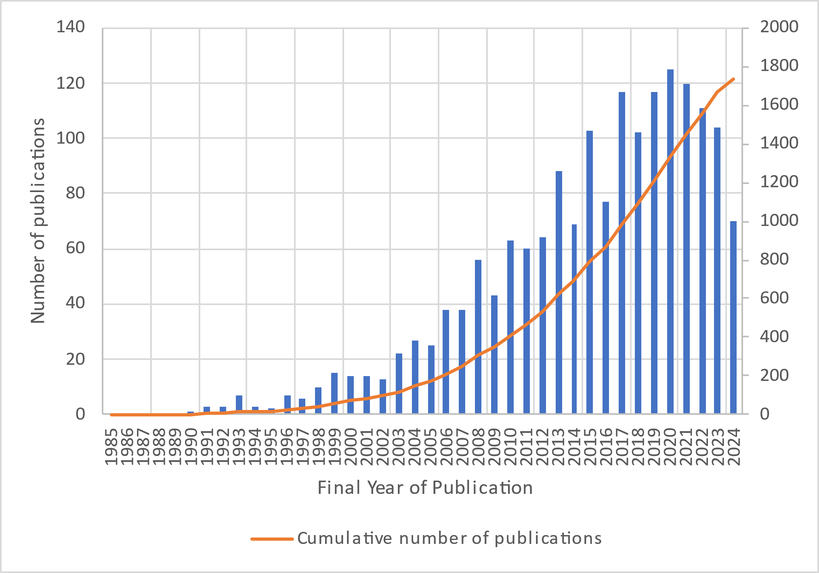 | 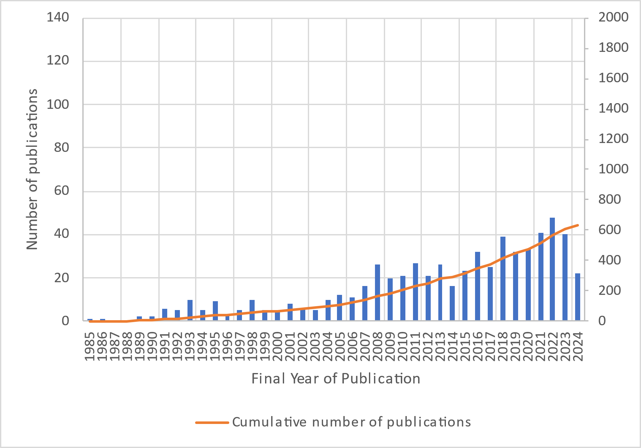
Figure 1. Number of publications per year related to “Optic OR Optode OR spectroscopy instrumentation” (cross with P1 and P2) in bioprocesses (Source: WoS, Period: 1990-2024) | Figure 2. Number of publications per year related to “Biosensor instrumentation in bioprocesses” (Source: WoS, Period: 1985-2024)

Figures 1 and 2 show similar trends in terms of growth in the number of publications on optical sensors and biosensors in bioprocesses. However, while optical sensors (Figure 1) experienced accelerated growth until 2021, followed by a slight decline over the past four years, biosensors (Figure 2) have shown a more stable and sustained increase. This suggests that optical sensors may have reached a stage of maturity in the industry, whereas biosensors are still expanding.
    - Trend towards the miniaturization of the sensing element and the creation of integrative sensors.
The pO₂ is another great example of a phenomenon that has been carried out in parallel to the development of optical sensor: the miniaturization of the sensitive element. Generally, in bioprocesses, dissolved oxygen is an important variable to ensure a productive process. If there is a significant lack of oxygen, the productivity and maintenance of the micro-organisms can be shifted to other processes. To measure this type of variable, Clark-type sensors are normally used, which relate an amperometry measurement to the concentration of oxygen in the medium. However, the adoption of optical methods has led to the use of sensors with elements that are chemically sensitive to oxygen. Chelation and oxidation reactions are normally used on the sensitive elements, giving a color change and thus producing an optical signal that is related to the oxygen concentration. These sensitive elements, being chemical in origin, are easily miniaturized. A property that has been used to not only make instrumentation less invasive, but also to make single-use instrumentation. This type of instrumentation carries the sensitive element inside as a patch-type configuration and the measuring element is outside the bioreactor, usually being instrumentation with optical principles. This type of configuration has also been applied for the measurement of CO₂ dissolved in the medium. For this variable, the classical technology was the Severinghaus type electrodes, which are electrodes that take advantage of the high solubility and reactivity of carbon dioxide in the liquid phase. These electrodes selectively pass the carbon dioxide through a polytetrafluoroethylene (PTFE) membrane. The analyte enters an aqueous medium where a pH meter measures the change in acidity in this medium and correlates it directly with the concentration of the analyte in the culture medium. These electrodes contain part of the basic principle of miniaturization of the sensitive elements, adding a selective layer that only allows the diffusion of the chemical species of interest. With this technology, various types of optodes and patches have been developed for cell cultures that are particularly interested in the measurement of carbon dioxide or other organic species dissolved in aqueous media. The consequence of this miniaturization phenomenon is the new trend of manufacturing integrative sensors. These sensors capable of measuring more than 3 variables on-time and in-line are especially accepted to not only detect variables such as temperature, pH or pO₂, but also relate them to a spatial variable in the bioreactor. This generates data on mixing capacity and homogeneity in the culture medium and could be send information wirelessly using IoT systems.
    - The implementation of soft-sensors in bioindustries
A Soft-Sensor are process analytical devices that grant access to important non-measured process variables by mathematical processing of readily available process data (Sagmeister et al. 2013). This type of instrumentation can be classified as Model-drive, Data-Driven or hybrid model sensors. Since the creation of the PAT initiative, Soft-Sensors have been increasingly studied by academia, with a peak of publications between 2020 and 2021 (Figure 3). An example of Soft-Sensors is the use of bio-calorimeter to estimate the amount of biomass in the bioreactor. This Soft-Sensor use the temperature, the power and flow rates and correlate them by means of heat balance models to determine the biomass produced by the process (Sivaprakasam et al. 2018).
    - Artificial Intelligence in bioprocess instrumentation
The latest trend in bioprocesses is the inclusion of artificial intelligence (AI). This trend has touched the agents of the control loops, turning sensors and actuators into intelligent instrumentation. Figure 4 shows two phases in this process, the first one comprising the advance of artificial neural networks and machine learning in bioprocessing (1993-2009), and the second one that joins these two strategies with the new trends towards Deep Learning and problem solving in data management (2009-2023).

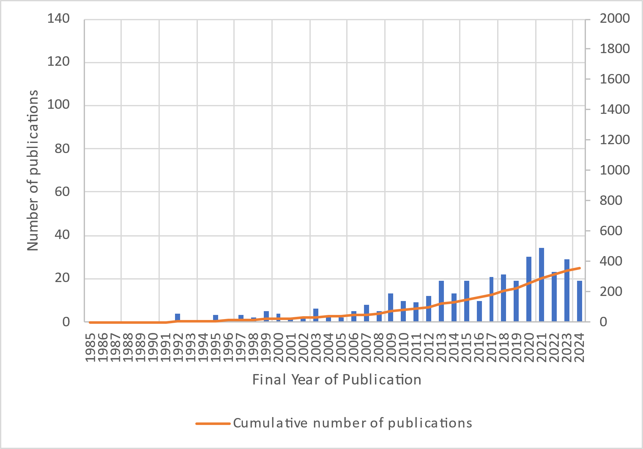 | 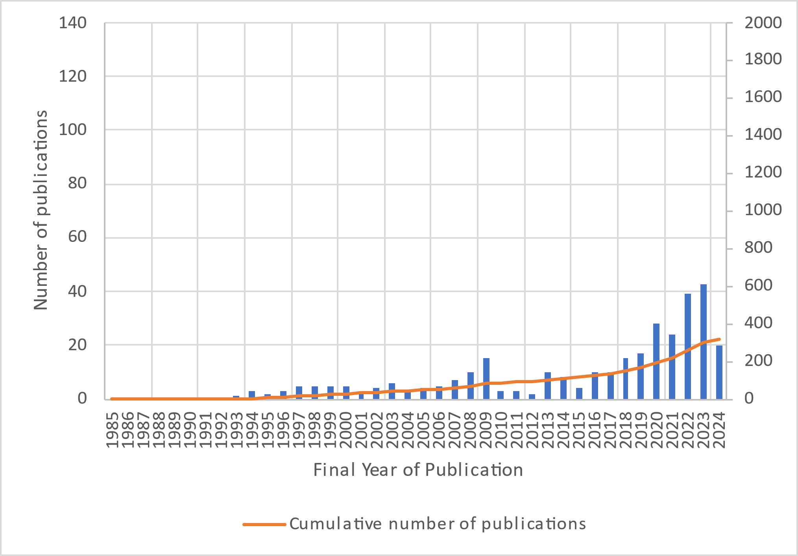
Figure 3. Publications related to Soft-sensor OR Estimators (cross with P1 and P2) in bioprocesses (Database: WoS, Period: 1990-2024) | Figure 4. Publications related to Artificial Intelligence OR Artificial Neural Networks in bioprocesses instrumentation (Database: WoS, Period: 1990-2023)

The implementation of artificial intelligence in bioprocess instrumentation has revolutionized monitoring and control capabilities, enabling unprecedented optimization. A key example is the use of artificial neural networks to perform simulations of directed evolution or combinatorial problem solving, at the genetic level, to choose the best strain for a process. In addition, AI-based control strategies have been applied to improve complex culture systems such as the cultivation of consortia of microorganisms (co-cultures). The use of AI in these types of systems helps to maintain stable critical parameters, such as the population levels, and can even take on the role of a proportional-integral controller to keep the culture stable. These advances demonstrate that AI not only complements traditional instrumentation but also introduces new levels of adaptability and precision in biomanufacturing, accelerating the transition to more intelligent and autonomous bioprocesses.
The classical research method, by means of database consultation, identified 6 main trends in the instrumentation of a bioprocess (Figure 5): adoption of the PAT nomenclature, development and use of optical instrumentation, miniaturization of the sensing element and the creation of integrative sensors, implementation of biosensors, implementation of soft sensors and AI in bioprocess instrumentation.
  - Conclusion
This article, focused on the comparative analysis and trends of in-situ and ex-situ sensors in bioreactors, underlines the evolution and sophistication of instrumentation in Bioindustry 4.0. Throughout the benchmark It was shown how the evolution of instrumentation in bioprocesses has shifted from relying exclusively on physical sensors to integrating advanced computational models and artificial intelligence techniques, marking a clear transition toward intelligent automation in the bioindustry techniques.
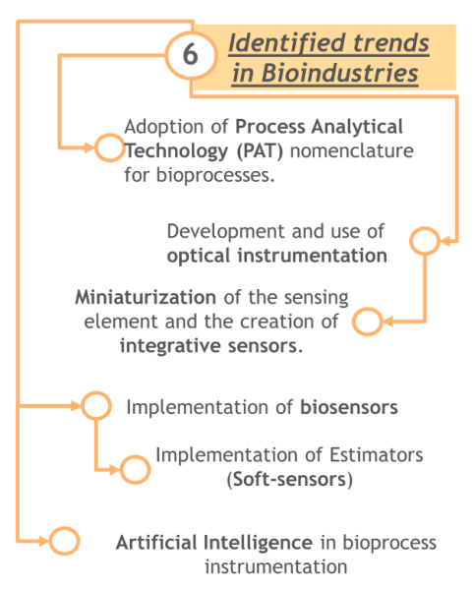
Figure 5. Major trends of the benchmark analysis

This integration not only optimizes process performance, but also opens new possibilities for innovation in sustainable biomanufacturing. Going through the strong adoption of optical and integrative instrumentation to make processes with reliable and on-line information, as well as the crucial role of soft-sensors to estimate variables not directly measured in real time. These developments highlight the transition to more automated and adaptive control in bioindustry (e.g. Digital Twins), setting the framework for future innovations in biotech production where AI methods are enriched with expert knowledge.
  - Acknowledgments
This work was funded (or co-funded) by the European Union under the Horizon Europe project Bioindustry 4.0, grant n.101094287.
Appendix
The following link contains 30,000 papers found in the bibliographic search and the Zotero database mentioned in section 3 https://doi.org/10.57745/PLNRMN.
  - References
Austerjost, J., Söldner, R., Edlund, C., Trygg, J., Pollard, D., and Sjögren, R., 2021, A Machine Vision Approach for Bioreactor Foam Sensing, SLAS Technol., 26 (4), 408–414, doi: 10.1177/24726303211008861.
Beutel, S., Henkel, S., 2011, In situ sensor techniques in modern bioprocess monitoring. Appl Microbiol Biotechnol 91, 1493–1505. https://doi.org/10.1007/s00253-011-3470-5
Gerzon, G., Sheng, Y., and Kirkitadze M., 2022, Process Analytical Technologies – Advances in bioprocess integration and future perspectives, J. Pharm. Biomed. Anal., 207, 114379, doi: 10.1016/j.jpba.2021.114379.
Kinet R, Richelle A, Colle M, Demaegd D, von Stosch M, Sanders M, Sehrt H, Delvigne F, Goffin P., 2024, Giving the cells what they need when they need it: Biosensor-based feeding control. Biotechnol Bioeng. 121(4),1271-1283, doi: 10.1002/bit.28657.
Martin, D. K., Vicente, O., Beccari, T., Kellermayer, M., Koller, M., Lal, R. and Dundar, M., 2021, A brief overview of global biotechnology. Biotechnology & Biotechnological Equipment, 35(1), S5–S14. https://doi.org/10.1080/13102818.2021.1878933
Minnich, C., Hardy, S. and Krämer, S., 2016, Stopping the Babylonian Confusion: An Updated Nomenclature for Process Analyzers in PAT Applications, Chem. Ing. Tech., 88 (6), 694–697, doi: 10.1002/cite.201500188.
Nagel, B., Dellweg, H. and Gierasch, L. M., 1992, Glossary for chemists of terms used in biotechnology (IUPAC Recommendations 1992), Pure and Applied Chemistry, 64 (1), 143-168.
O’Mara, P., Farrell, A., Bones, J. and Twomey, K., 2018, Staying alive! Sensors used for monitoring cell health in bioreactors, Talanta, 176 (130–139), doi: 10.1016/j.talanta.2017.07.088.
K. Petersen, S. Vakkalanka, and L. Kuzniarz, 2015, Guidelines for conducting systematic mapping studies in software engi- neering: an update, Information and Software Technology, vol. 64, pp. 1–18.
Sagmeister, P, Wechselberger, P, Jazini, M., Meitz, A., Langemann T. and Herwig C, 2013, Soft sensor assisted dynamic bioprocess control: Efficient tools for bioprocess development, Chem.Eng.Sci., 96, 190–198.
Sivaprakasam, S., Schuler, M. M., Hama, A., Hughes, K.-M., and Marison, I. W., 2011, Biocalorimetry as a process analytical technology process analyser; robust in-line monitoring and control of aerobic fed-batch cultures of crabtree-negative yeast cells,” J. Therm. Anal. Calorim., 104 (1), 75–85
U.S. Department of Health Food and Drug Administration and Human Services, 2004, Guidance for Industry PAT A Framework for Innovative Pharmaceutical Development, Manufacturing and Quality Assurance. https://www.fda.gov/regulatory-information/search-fda-guidance-documents/pat-framework-innovative-pharmaceutical-development-manufacturing-and-quality-assurance

