|  |  |
| --- | --- |
| cetlogo ***CHEMICAL ENGINEERING TRANSACTIONS***  ***VOL. xxx, 2025*** | A publication of  aidiclogo_grande |
| The Italian Association  of Chemical Engineering  Online at www.cetjournal.it |
| Guest Editors: Fabrizio Bezzo, Flavio Manenti, Gabriele Pannocchia, Almerinda di Benedetto  Copyright © 2025, AIDIC Servizi S.r.l. **ISBN** 979-12-81206-17-5; **ISSN** 2283-9216 | |

Ultrasonic-assisted Extraction of Dietary Fiber from Defective Lemon Basil (*Ocimum basilicum* var. *citriodorum*) Seed

Kamonthip Nilmata, Sajee Noitanga, Wirasinee Supanga, Winatta Sakdasrib, Natthaporn Chotigavinb, Somkiat Ngamprasertsithc, Ruengwit Sawangkeawa,\*

aCenter of Excellence in Bioconversion and Bioseparation for Platform Chemical Production, Institute of Biotechnology and Genetic Engineering, Chulalongkorn University, Bangkok, Thailand

bSchool of Food Industry, King Mongkut’s Institute of Technology Ladkrabang, Bangkok, Thailand.

cDepartment of Chemical Technology, Faculty of Science, Chulalongkorn University

Rueangwit.s@chula.ac.th

Lemon basil (*Ocimum basilicum* var. *citriodorum*) is an herbaceous plant cultivated for seed consumption only in Sukhothai Province, Thailand. Unlike cultivating for fresh leave consumption, the production of lemon basil seed requires maturity and reproduction phases, the same as rice and wheat. After harvesting, the farmer separates unmatured red basil seeds (RBS) because of their diverse color. The RBS contains valuable compounds, such as dietary fiber, that could be extracted by an ultrasonic-assisted extraction (UAE). This work aims to extract DF with the highest brightness using L\*a\*b\* color in liquid form as an indicator. The optimal condition was identified by the crossing point between the brightness (L\*) and extraction yield. The proximate nutrient analysis showed that RBS has a higher fiber content than high-quality basil seed (HBS). For water swelling ability, HBS performed 4-fold higher than RBS. The complete extraction of dietary fiber was observed at 10 min for UAE at 200 W, a water-to-seed ratio of 30:1, and 100% amplitude, and it was preferably conducted at room temperature (30±2°C) without an external cooling system. The correlation between UAE extraction time and temperature at constant total power and amplitude was also explored. When the extraction temperature exceeded 80°C, the extracted mucilage was rotten within 24 h, even if stored at 4°C. Moreover, the extracted RBS contained Omega-3 oil that a screw-press machine or supercritical CO2 could extract in further study.

* 1. Introduction

Lemon basil (*Ocimum basilicum* var. *citriodorum*), locally named “Maenglak,” is an exotic basil variety uniquely cultivated in the Sukhothai Province, Thailand, for producing seeds to consume as a healthy dessert. Because Sukhothai Province has a delayed rainy season, lemon basil seeds completely dry before harvest. The water-soaked seed is combined with fruit juice, milk, or soy milk. It is also used as an ice cream dressing or mixed with jelly. It significantly improves the human excretory system because basil mucilage has high dietary fiber (Calderon Bravo et al., 2021). Previously, lemon basil seeds were extracted by supercritical CO2 to produce the defatted fiber with a 3-fold swelling index higher than that of raw lemon basil seeds (Sakdasri et al., 2019). Commercial water-soluble dietary fiber, made from beans, barley, nuts, lentils, and psyllium, is gelatinized after stirring in water for 30 min.

In contrast, the defatted fiber from basil seeds could preserve its fluidity for over 12 h. Although the techno-economic analysis showed that the production plant operated with 50-L and 100-L extractors is profitable, the grayish color of defatted fiber affects the appearance of food products. Hence, defatted fiber is limited to darkened foods and beverages such as chocolate and black sesame drinks.

The main dietary fiber constituents are insoluble dietary fiber (IDF) and soluble dietary fiber (SDF). IDF consists of hemicellulose, cellulose, lignin, and resistant starch. On the other hand, SDF could be gum, beta-glucan, pectin, arabinoxylan, oligosaccharides, inulin, and mucilage (Ciudad-Mulero et al., 2019). IDF is beneficial for partial colonic fermentation, while SDF is a prebiotic. The primary sources of gums are plant exudates, e.g., guar gum and gum Arabic. Thus, gum compositions depend on its sources; for example, the main polysaccharides in guar gum and gum Arabic are galactomannan and arabinogalactan, respectively. Mucilage is polysaccharides constituted by large molecules of sugars and uronic acids linked by glycosidic bonds. Dietary fiber extraction from basil seeds was reported in the total extraction yield of gum (Guan et al., 2024), mucilage (Hasan et al., 2023), or gel (Zhang et al., 2024). Due to the unclear definition between gum and mucilage and the properties of the products obtained from aqueous extraction, hereafter, the extracts are named dietary fiber (DF) in this work. Methods for DF aqueous extraction from basil seeds are summarized in Table 1.

Table 1: Extraction method, media, and extraction yield of basil seeds

|  |  |  |  |  |  |
| --- | --- | --- | --- | --- | --- |
| Variety,  Country source | Extraction method and condition | Main component | %Yield | Molecular weight | Reference |
| Ocimum basilicum L., Iran | SSE, 1:65 (S/W), 68°C, 20 min, pH 7 | Glucomannan and Uronic acid | 10.16±0.54 | 2320 kDa | (Naji-Tabasi et al., 2016) |
| Ocimum basilicum L., India | SSE, 1:67 (S/W), 56.7°C, 1.6 h | N/R | 20.49 | N/R | (Nazir et al., 2017) |
| *Ocimum* × *africanum* L., Thailand | UAE, 1:30 (S/W), 120 mL, 70% A, 20 kHz, 30 kJ, 7 min | Arabinogalactan and Uronic acid | 5.22±0.15 | ∼480 kDa. | (Methacanon et al., 2023) |
| Ocimum basilicum L., Pakistan | MSE, 1:30 (S.W), 56°C, 6 h, pH 7 | N/R | 9.94 | N/R | (Hasan et al., 2023) |
| Ocimum basilicum L., China | MSE, 1:60 (S/W), 50°C, 30 min, pH 8 | Glucose, Uronic acid, Galactose, Mannose | 11.26–11.37 | N/R | (Guan et al., 2024) |
| Ocimum basilicum L., India | MSE, 1:70 (S/W), 57°C, 1.31 h | N/R | 26.30 | N/R | (Neeharika & Vijayalaxmi, 2023) |
| Ocimum basilicum L., India | UAE, 1:100 (S/W), 40 kHz, 70°C, 15 min, pH 4 | D-galacturonic acid | 6.95 | N/R | (Bhadange & Saharan, 2023) |

UAE is Ultrasonic-assisted extraction, SSE is sieve scraping extraction, MSE is mechanical extraction with stirring, A is amplitude, S/W is seed-to-water ratio (w/v), N/R is not reported,

According to Table 1, basil seeds (*Ocimum basilicum* L.) served as a widely recognized substrate for the extraction of DF through sieve scraping (SSE) and mechanical extraction (MSE) methods. Lemon basil seeds (*Ocimum* × *africanum* L.) were reported as a substrate for UAE (Methacanon et al., 2023). All extraction methods require substrates to be soaked in water at specific temperatures, durations, and pH levels before extraction. The water-soaked seeds were manually pressed through a fine screen or sieve using the SSE method. A kitchen blender, a juicer, a mechanical stirrer, and a magnetic bar were employed in MSE. The purification methods used for the extracted DF included filtration, centrifugation, and ethanolic precipitation. For drying methods, a hot-air oven, a freeze drier, a vacuum oven, and a spray drier were reported. The additional information on basil seed extraction, purification, and drying was reviewed elsewhere (Guan et al., 2023).

The UAE of lemon basil seeds (*Ocimum × africanum* L.) produced a lower molecular weight, approximately 480 kDa, in comparison to the SSE of basil seeds (*Ocimum basilicum* L.), which exhibited a molecular weight of 2320 kDa. Although the primary components of DF extracted from lemon basil seeds, Arabinogalactan, differ from those found in basil seeds, Glucomannan, both types of DF contain uronic acid. This indicates a shared characteristic of mucilage in both extracts.

The DF appeared white, especially far from the seedcoat, when the water-soaked lemon basil seeds were observed under a microscope (See Figure 3). Complete extraction of DF may incorporate the dull color of the seed coat into the extracted DF. This work aims to extract DF with the highest brightness by varying extraction time at constant S/W, ultrasonic amplitude, and frequency. The extracted DF was measured L\*a\*b\* color in liquid form and extraction yield on a wet basis. Furthermore, the extraction temperature was examined as a function of extraction time to create the correlation. Chemical purification, such as ethanolic precipitation, and mechanical separation, such as centrifugation, were avoided to minimize chemical usage and investment costs. The extracted DF was dried in a hot-air oven at 60°C for 24 h before the measure of extraction yield, based on a dried basis.

* 1. Materials and Methods
     1. Feedstock and Chemicals

Royal Thai Seeds Company Limited, Thailand, donated unmatured red basil seeds (RBS) and high-quality basil seeds (HBS). The average seed diameter was 0.5–1.0 mm in width and 1.0–1.5 mm in length. The bulk density of RBS and HBS, estimated by the gravimetric method, was 0.633–0.647 g/ml and 0.716–0.725, respectively.

* + 1. Water Swelling Ability

The seed samples, weighing 1.00–3.00 g, were separately added into three 50 mL graduate cylinders, and the 50 mL DI water was gently poured into the cylinder. The seeds were allowed to naturally without shaking or stirring. During the experiments, RBS was separated into upper and lower layers because unmatured seeds have a density lower than water. The swelling volume of RBS is the summation of upper and lower volumes. The swelling volumes were recorded from time to time. The experiments were performed in triplicates.

* + 1. Ultrasonic-Assisted Extraction (UAE) Procedure

UAE employed a digital sonicator (Hielscher, Model UP400St) attached with a 14-mm sonotrode (S24d14D). The sonicator was connected to a computer, and temperatures were automatically recorded on an integrated SD card. The 13.0 g of RBS seeds and 400 mL of DI water were placed into a 500-mL stainless steel container and soaked for 60 min. For HBS, the sample weight was 8.0 g and soaked for 30 min. Sample weights were calculated from the water swelling ability of seed samples (See Section 3.2). The temperature-time curves were constructed in triplicates with the DI water blank test. The extraction yields were calculated, and the microscopic images (Nikon, YS2-H with iPhone 13 Pro MAX) were taken at designated sampling intervals. The correlations between temperature and extraction time were estimated by the least-square method.

* + 1. Feedstock and Extracts Characterization

RBS and HBS samples were grided by a kitchen grinder (Panasonic, MX-AC400, Thailand) before the proximate nutrient analysis (Nilmat et al., 2024). The extraction yield was estimated by gravimetric method. The L\*a\*b\* values of dried DF were determined by using a color Reader (CR-10, Minolta Co., Japan). The optimal conditions were established by maximizing the dried DF's extraction yield and whiteness.

* + 1. Statistical Analysis

Total variations were estimated by one-way analysis of variance (ANOVA). Duncan’s multiple range test (DMRT) was used for determining significance (p ≤ 0.05) by SPSS program version 22.

* 1. Results and Discussion
     1. Proximate Nutrient Analysis

Table 1 displays the results of proximate nutrient analysis of RBS and HBS.

Table 1: Proximate nutrient analysis of unmatured red basil seeds (RBS) and high-quality basil seeds (HBS)

|  |  |  |  |  |  |  |
| --- | --- | --- | --- | --- | --- | --- |
| Source | Moisture (%wt) | Lipid  (%wt) | Protein  (%wt) | Carbohydrate (%wt) | Crude fiber (%wt) | Ash  (%wt) |
| RBS | 7.07 ± 0.69 a | 13.18 ± 0.24 b | 17.63 ± 0.02 c | 29.29 ± 0.23 d | 27.23 ± 0.15 f | 5.59 ± 0.05 h |
| HBS | 7.05 ± 0.02 a | 19.99 ± 0.21 c | 17.29 ± 0.91 c | 23.23 ± 0.32 e | 24.35 ± 0.09 g | 5.48 ± 0.07 h |

Mean values with different superscript letters in each column are significantly different (*p* < 0.05)

The RBS has a lower lipid content than HBS. However, RBS has higher crude fiber than HBS, which is suitable for DF extraction. The difference in lipid and crude fiber contents is probably because of the maturity level (Zamani Ghaleshahi et al., 2020).

* + 1. Water Swelling Ability of Red Basil Seeds (RBS) and High-Quality Basil Seeds (HBS)

Figure 1 depicts the swelling volume as a function of soaking time for RBS and HBS at various S/W ratios. It also includes photographs of experiments at 90 and 10 min for RBS and HBS, respectively.

|  |  |
| --- | --- |
| (a) | A group of test tubes with black liquid  Description automatically generated  3 g/50 mL  2 g/50 mL  1 g/50 mL  (b) |
| Several test tubes with a mixture of black and grey  Description automatically generated with medium confidence  1 g/50 mL  2 g/50 mL  3 g/50 mL  (c) |

Figure 1: (a) Water swelling volume as a function of soaking time and photographs of experiments conducted on (b) unmatured red lemon basil seeds at 90 min and (c) high-quality lemon basil seeds at 5 min

In Figure 1 (a), the swelling rate of RBS is dramatically lower than that of HBS. In other words, RBS fully swelled in 50 mL of DI water over 60 min, while HBS took only 5 min. Figures 2 (b) and (c) showed that the minimum S/W of RBS and HBS were 3 g RSB/50 mL DI water (1:16) and 2 g HBS/50 mL DI water (1:25), respectively.

* + 1. Effects of Extraction Time on Extraction Yield and Temperature of UAE

Figure 2 shows temperature as a function of the extraction time of UAE at the powers of 100 and 200 W.

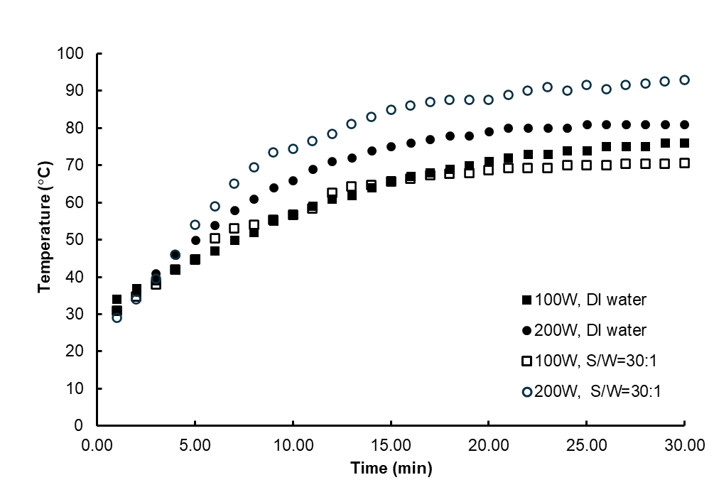

Figure 2: Temperature-time diagram for DI water (blank) and unmatured red lemon basil seeds

According to Figure 2, UAE at a power of 100 W, the temperature trends observed in both DI water and the RBS-DI water mixture were consistent. On the other hand, the temperature of the RBS-DI water mixture was higher than that of DI water because the high DF extraction rate occurs at high ultrasonic power. The extracted SDF could influence the thermal conductivity of the mixture. Equation 1 illustrates the correlation between UAE extraction time (t) and temperature (T), with coefficients (A, B, and C) listed in Table 2.

|  |  |
| --- | --- |
| T = At2 + Bt + C | (1) |

Table 2: Coefficients of the quadratic models, pivotal in predicting temperature at different extraction times

|  |  |  |  |  |  |
| --- | --- | --- | --- | --- | --- |
| Power (W) | Sample | A | B | C | R2 |
| 100 | DI water | -0.055 | 3.124 | 30.764 | 0.999 |
| 100 | S/W = 30:1 | -0.073 | 3.480 | 29.489 | 0.987 |
| 200 | DI water | -0.094 | 4.426 | 29.672 | 0.999 |
| 200 | S/W = 30:1 | -0.119 | 5.595 | 27.402 | 0.986 |

According to Figure 2, the slopes of UAE at the total power of 200 W increased more sharply than that at the total power of 100 W. At an ultrasonic power of 100 W, adding RBS to DI water slightly changed the curvature of the temperature-time relationship, as noticed by the coefficient values in Table 2. In contrast, the dramatic upward curvature of the temperature-time relationship was observed when adding RBS to DI water at an ultrasonic power of 200 W. The hypothesis that the extracted DF can enhance the thermal conductivity of extracting fluid may be accurate.

* + 1. Microscopic Images and CIE L\*a\*b\* Color Scale Values

Figure 3 reveals the microscopic images (4x) of HBS and RBS during UAE at an ultrasonic power of 200 W and aptitude 100%. HBS demonstrates a consistent level of DF, as shown in Figure 3(a), in contrast to RBS, which is depicted in Figure 3(b). The appearances of Figures (f)–(h) are similar, indicating that DF was completely extracted after 10 min. Table 3 shows the L\*a\*b color values of extracts at various extraction times.

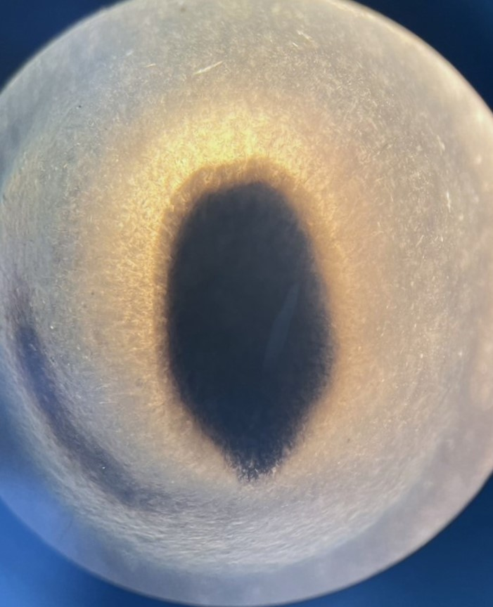

(d)

(c)

(e)

(a)

(b)

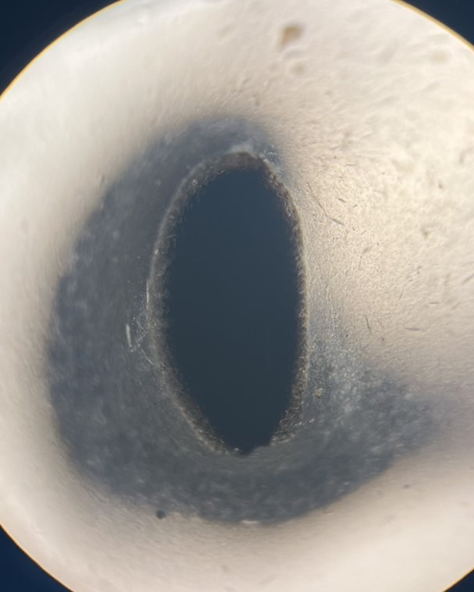

(h)

(g)

(f)

Figure 3: Microscopic images of (a) high-quality lemon basil seed and unmatured red lemon basil seed conducted on (b) 0 min, (c) 5 min, (d) 10 min, (e) 15 min, (f) 20 min, (g) 25 min, and (h) 30 min extraction time

Table 3: Color L\*a\*b value and extraction yield of DF extracted from UAE at 200 W and 100% Amplitude

|  |  |  |  |  |  |
| --- | --- | --- | --- | --- | --- |
| Source | L\* | a\* | b\* | Yield  (%wt, wet basis) a | Yield  (%wt, dried basis) b |
| RBS at 5 min | 67.9 ± 0.8 | -11.7 ± 0.2 | 17.2 ± 0.4 | 37.96 ± 0.12 | 4.90 ± 0.04 |
| RBS at 10 min | 62.1 ± 0.8 | -11.6 ± 0.1 | 15.8 ± 0.7 | 55.85 ± 0.13 | 10.97 ± 0.07 |
| RBS at 15 min | 51.6 ± 0.4 | -9.9 ± 0.1 | 21.0 ± 0.2 | 63.66 ± 0.15 | 21.19 ± 0.45 |
| RBS at 20 min | 52.5 ± 1.1 | -10.1 ± 0.2 | 22.2 ± 0.2 | 57.56 ± 0.18 | 22.44 ± 0.46 |
| RBS at 25 min | 54.8 ± 0.7 | -10.4 ± 0.4 | 22.5 ± 0.1 | 55.12 ± 0.15 | 12.21 ± 0.45 |
| RBS at 30 min | 49.2 ± 0.6 | -9.2 ± 0.2 | 23.6 ± 0.3 | 44.72 ± 0.45 | 11.52 ± 0.15 |

a Yield (wet basis) calculated by 100 × the weight of liquid DF divided by the weight of seed and water (413 g).

b Yield (dried basis) calculated by 100 × the weight of dried DF divided by the weight of dried seed (13 g).

As expected, the DF obtained after 5 minutes has the lowest lightness index (L\*). The extracted DF's L\* decreases as the extraction time increases. The values of the red-green component (a\*) showed negligible changes, while the blue-yellow component (b\*) slightly increased. In other words, the DF obtained with a longer extraction time appeared darker and more yellow than that obtained with a shorter extraction time. The maximum extraction yields, based on the wet and dried basis, were observed at 15–20 min extraction time where the optimal conditions were located.

* 1. Conclusions

The proximate nutrient analysis showed that RBS has lower lipid content and higher fiber content than HBS. Despite HBS having an extremely high swelling rate, it is not a promising feedstock for DF extraction due to its higher cost (€6.0) than RBS (€0.5). However, DF extracted from HBS could be sold as a premium product, and an economic feasibility study could identify the minimum selling price. Because L\* linearly escalated with increasing extraction time, the optimal condition was located by a turning point of extraction yield at 15–20 min of extraction time. Since both DF samples extracted from RBS and HBS had a distinct lemongrass scent, the chemical composition of volatile oil will be investigated in further study.

Nomenclature

CIE – the International Commission on Illumination

HBS – High-quality basil seed

IDF – Water-insoluble dietary fiber

MSE – Mechanical extraction with stirring

RBS – Unmatured red basil seeds

SDF – Water-soluble dietary fiber

SSE – Sieve scraping extraction

S/W – seed-to-water ratio (w/v)

UAE – Ultrasonic-assisted Extraction

Acknowledgments

The authors thank Royal Thai Seeds, Company Limited for providing the Thai lemon basil seed samples and Panusorn Hunsub, Faculty of Food Technology, Rangsit University, for providing a color Reader.

References

Bhadange, Y.A., Saharan, V.K., 2023. Optimization and Kinetic Studies of D-Galacturonic Acid Extraction from Basil Seed Using Different Extraction Techniques. Sustainable Chemistry and Pharmacy, 33.

Calderon Bravo, H., Vera Cespedes, N., Zura-Bravo, L., Munoz, L.A., 2021. Basil Seeds as a Novel Food, Source of Nutrients and Functional Ingredients with Beneficial Properties: A Review. Foods, 10, 1467.

Ciudad-Mulero, M., Fernández-Ruiz, V., Matallana-González, M.C., Morales, P. 2019. Dietary Fiber Sources and Human Benefits: The Case Study of Cereal and Pseudocereals. in: *Advances in Food and Nutrition Research*, Vol. 90, pp. 83-134.

Guan, L., Ma, Y., Yu, F., Jiang, X., Jiang, P., Zhang, Y., Yuan, C., Huang, M., Chen, Z., Liu, L., 2023. The Recent Progress in the Research of Extraction and Functional Applications of Basil Seed Gum. Heliyon, 9, e19302.

Guan, L., Zhang, Y., Yu, F., Yuan, C., Song, H., Wang, K., Jiang, X., Liu, L., 2024. Extraction of Basil Seed Gum: Optimization and Functional Properties. Journal of Applied Research on Medicinal and Aromatic Plants, 42, 100570.

Hasan, S., Hasan, M.A., Hassan, M.U., Amin, M., Noreen, S., Anwar, A., Abbas, N.S., 2023. Statistical and Neural Intelligence Modeling for Basil Seed Mucilage Extraction Optimization: Implications for Sustainable and Cost-Effective Industrial Plant Products. Industrial Crops and Products, 204, 117258.

Methacanon, P., Kongjaroen, A., Gamonpilas, C., 2023. Structural and Shear and Extensional Rheological Properties of Hairy Basil Seed Mucilage for Potential Application as Oropharyngeal Dysphagia Diets. Food Hydrocolloids, 143, 108903.

Naji-Tabasi, S., Razavi, S.M.A., Mohebbi, M., Malaekeh-Nikouei, B., 2016. New Studies on Basil (*Ocimum bacilicum* L.) Seed Gum: Part I – Fractionation, Physicochemical and Surface Activity Characterization. Food Hydrocolloids, 52, 350-358.

Nazir, S., Wani, I.A., Masoodi, F.A., 2017. Extraction Optimization of Mucilage from Basil (*Ocimum basilicum* L.) Seeds using Response Surface Methodology. Journal of Advanced Research, 8, 235-244.

Neeharika, B., Vijayalaxmi, K.G., 2023. Optimisation of Clove Basil and Sweet Basil Seeds Mucilages Extraction for Utilisation as Functional Ingredients. Journal of Scientific & Industrial Research, 82, 989-999.

Nilmat, K., Ngamprasertsith, S., Sakdasri, W., Karnchanatat, A., Sawangkeaw, R., 2024. Sequential Process to Valorisation of Rambutan Seed Waste by Supercritical CO2-Ethanol and Subcritical Water Extractions. Chemical Engineering Transactions, 109, 313-318.

Sakdasri, W., Ngamprasertsith, S., Sooksai, S., Noitang, S., Sukaead, W., Sawangkeaw, R., 2019. Defatted Fiber Produced from Lemon Basil (*Ocimum citriodorum* Vis.) Seed with Supercritical CO2: Economic Analysis. Industrial Crops and Products, 135, 188-195.

Zamani Ghaleshahi, A., Ezzatpanah, H., Rajabzadeh, G., Ghavami, M., 2020. Comparison and Analysis of Characteristics of Flax, Perilla, and Basil Seed oils Cultivated in Iran. Journal of Food Science and Technology, 57, 1258-1268.

Zhang, J., Peng, X., Xing, K., Liu, S., Shi, C., Liu, X., 2024. Research Progress on Functional Properties of Basil Seed Gel and its Application in Food. Food and Fermentation Industries, 50, 341-349.