 CHEMICAL ENGINEERING TRANSACTIONS  VOL. xxx, 2025 | A publication of  
The Italian Association
of Chemical Engineering
Online at www.cetjournal.it

Guest Editors: Fabrizio Bezzo, Flavio Manenti, Gabriele Pannocchia, Almerinda di Benedetto
Copyright © 2025, AIDIC Servizi S.r.l.
ISBN 979-12-81206-17-5; ISSN 2283-9216
Multi-analyte electrochemical sensor platform for simultaneous measurement of inflammatory airway disease biomarkers
Nadia Moukriª, Federico Massaroª, Bernardo Patellaª, Giuseppe Aielloª, Chiara Cipollina^{b}, Elisabetta Pace^{c}, Rosalinda Inguantaª
ªUniversità degli Studi di Palermo, Viale delle scienze 6, 90128, Palermo, Italy
^{b}Fondazione Ri.MED, Via Ugo La Malfa 153, 90146, Palermo, Italy
^{c}Istituto di Farmacologia Traslazionale (IFT), Via Ugo La Malfa 153, 90146, Palermo, Italy
nadia.moukri@unipa.it

Asthma and Chronic Obstructive Pulmonary Disease are two widespread chronic inflammatory lung diseases. Asthma impacts approximately 300 million people worldwide, while COPD is the fourth leading cause of death globally. Monitoring these diseases progression through biomarker measurements could be crucial to improve disease management and create personalized treatments. Furthermore, detecting multiple biomarkers quickly and directly in situ can significantly improve the knowledge of airway diseases using cell culture models that replicate airway tissues. For this aim, in this work a novel multianalyte sensor platform was fabricated using laser scribing, for highly sensitive detection of H₂O₂, and pH levels chosen as biomarkers due to their significant role in lung damage during inflammation. Electrochemical methods offer the opportunity to perform rapid, simple, and accurate analysis. The sensor design consists of two working electrodes and integrated counter and Ag/AgCl reference electrodes. The electrode for H₂O₂ detection was modified with reduced graphene oxide and gold nanoparticles, while the pH electrode was modified with the conductive polymer Polyaniline. The sensors detected accurately and sensitively all two analytes demonstrating excellent performance in phosphate buffer. Linear scan voltammetry was utilized for the detection of H₂O₂, and potentiometry was used for pH level measuring. This approach demonstrated the sensors efficacy in analysing multiple analytes simultaneously.
  - Introduction
Inflammatory airway diseases, like other inflammatory conditions, have no definitive cure. Management involves monitoring symptoms and adjusting treatment to maintain the patient’s quality of life and, when possible, prevent hospitalizations. Asthma and COPD (Chronic Obstructive Pulmonary Disease) are two major chronic inflammatory lung diseases. Asthma impacts approximately 300 million people worldwide (Rabe et al. 2023), while COPD is a leading cause of chronic morbidity and it is the fourth leading cause of death globally (Albano et al. 2022). The ability to recognize and measure biomarkers closely associated with disease progression, and to monitor their changes before symptoms appear, would enable better management and more targeted, personalized treatments for patients. Additionally, biomarkers measurement could be highly beneficial for monitoring in vitro cell culture models that mimic the airway mucosa. This approach could improve the accuracy and efficiency of studying airway-related diseases. Detecting biomarkers related to oxidative stress, such as H₂O₂, is crucial for monitoring the progression of airway diseases. Airway oxidative stress arises from an imbalance between the production of reactive oxygen species (ROS) and the efficiency of anti-oxidant systems. Increased oxidative stress amplifies airway inflammation and can reduce the efficacy of treatments (Aghasafari et al. 2019). Among ROS, H₂O₂ plays a significant role, as it is generated during inflammatory responses. Emelyanov et al. (2001) have measured H₂O₂ in exhaled breath condensate (EBC), founding that, in patients with asthma, the mean H₂O₂ concentration was significantly elevated compared to values in normal subjects.
However, the evaluation of a single biomarker may not provide a comprehensive understanding of the inflammatory processes.
Another significant biomarker is pH; endogenous airway acidification, assessed through EBC pH, has been documented in patients with stable COPD (Papaioannou et al. 2011).
Thus, measuring these biomarkers in situ, without the need for time-consuming laboratory procedures, would be ideal for both patient monitoring and cell culture applications in research.
In this context, electrochemical sensors can provide a rapid and effective means of detecting these biomarkers. Electrochemical sensors, especially those enhanced with carbon-based (Power et al. 2018) and metallic nanomaterials (Patella et al. 2024), provide high sensitivity and selectivity, making them ideal for real-time, on-site monitoring. This approach enables the detection of airways inflammation biomarkers, thus improving the management of respiratory diseases and enabling personalized treatment strategies.
For this purpose, in this work a novel multianalyte sensor platform, fabricated using laser scribing on ITOPET (Indium tin oxide coated PET), for the detection of H₂O₂, and pH levels was developed. Each electrode was selectively modified through electrodeposition. The electrode for H₂O₂ detection was enhanced with rGO (reduced graphene oxide) and AuNPs (gold nanoparticles) electrodeposition, while the pH electrode was modified with the conductive polymer PANI (Polyaniline). The sensors demonstrated excellent performance in PBS (phosphate buffer solution), accurately and sensitively detecting all analytes. Linear scan voltammetry (LSV) was utilized for the detection of H₂O₂ and potentiometry was used for pH level measuring. This approach demonstrated the device efficacy in analysing multiple analytes simultaneously.
  - Experimental

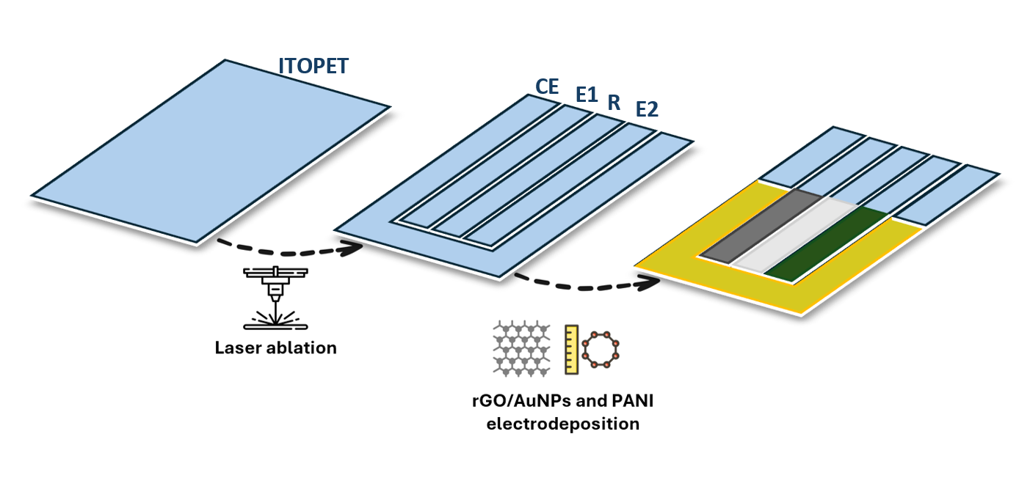
Figure 1 Multianalyte sensor fabrication scheme from ITOPET sheet.
The ITOPET sheets were used as a substrate for the fabrication of the multi-analyte device. On this sheet, two working electrodes (E1, E2), a reference electrode (R), and a counter electrode (CE) were fabricated as summarized in the Figure 1 scheme.
The design of the four electrodes was obtained onto the ITOPET substrate using laser ablation. Particularly, the laser locally removes the ITO layer making possible to obtain different patterns, such as in Figure 1. This goal was obtained with a laser cutter apparatus equipped with a CO₂ laser. A power setting of 3.5% (of the machine nominal 50 W) and a scanning speed of 50 mm/s were employed to ensure the complete removal of the ITO layer. Those parameters were optimized in order to obtain a perfect electrical isolation of the electrodes.
The area designated for the reference electrode (R) was coated with a silver/silver chloride (Ag/AgCl) paste. The counter electrode (CE) area was sputtered with a thin layer of gold. The electrical contacts were made using conductive copper tape. The two working electrodes were electrodeposited with rGO/AuNPs for E1 and rGO/AuNPs/PANI for E2.
    - rGO/AuNPs deposition
The rGO/AuNPs co-deposition was carried out using an acetate buffer solution (ABS, pH 5) containing 0.5 mg/mL of graphene oxide and 0.5 mM of chloroauric acid. The sensor was fixed to a glass slide and placed inside a cell fabricated via 3D printing, where 10 mL of the previously described solution was used.
The electrodeposition was carried out by applying a constant potential of -0.8 V for 200 s. The contact for the working electrode (ITOPET) was ensured by applying copper tape, while a platinum mesh was used as the counter electrode, and a saturated calomel electrode (SCE) served as the reference electrode. This process resulted in a deposited layer of 0.72 cm² (1.8 x 0.4 cm).
    - PANI deposition
For the electrodeposition of PANI, an electrolytic solution of 0.1 M aniline in 1 M sulfuric acid was used. The electrodeposition was performed using a potentiostatic technique at +2 V for 90 s. The same three-electrode system was used. The contact with the working electrode (ITOPET) was ensured by applying copper tape, a platinum mesh was used as counter electrode, and a SCE electrode served as the reference electrode.
    - Electrochemical measurement
All sensing electrochemical measurement were performed inside a 3D-printed cell capable of holding a solution volume of 4 mL. When the sensor was placed inside the cell, an electrode area of approximately 0.52 cm² (1.3 x 0.4 cm) was exposed. The internal ITOPET electrode coated with Ag/AgCl was used as the reference electrode, while the gold-sputtered electrode was used as the counter electrode.
LSW for H₂O₂ calibration was performed over a potential range from 0.2 V to -1.2 V with a scan rate of 25 mV/s. For calibration, solutions of 0.088 M and 0.0088 M H₂O₂ in PBS (pH = 7.4) were used. The cell was filled with 4 mL of PBS, concentration was progressively increased in the concentration range of 25–6000 μM.
All electrochemical measurements were performed using a PAR potentiostat/galvanostat (PARSTAT, model 2273).
  - Results and discussion

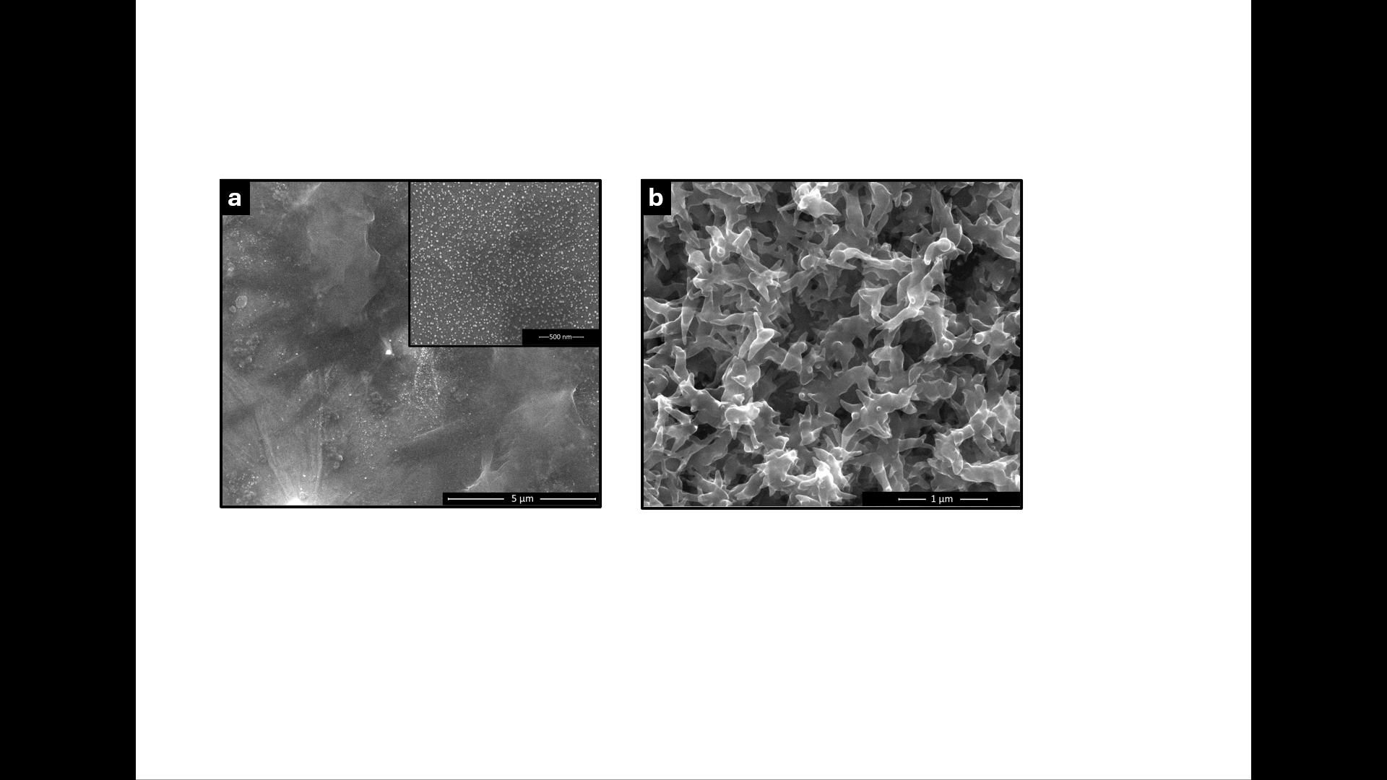
Figure 2 a) rGO/AuNPS based electrode SEM image, in the inset a higher magnification image; b) SEM image of PANI layer after deposition on rGO/AuNPs electrode.
The multi-analyte device for the simultaneous detection H₂O₂ and pH measurement was fabricated on a commercially available conductive substrate: ITOPET sheets. The detection of multiple analytes was made possible by the fabrication of different working electrodes, on the same device. Additionally, the integration of a reference electrode and a counter electrode within the device enhances its usability, making it suitable for on-site applications. The device does not require complex equipment, making it both portable and user-friendly. This was made possible by the development of a process capable of designing electrodes directly on an ITOPET sheet. A CO₂ laser was used to ablate the surface ITO layer, thus creating four electrodes (E1, E2, R, CE) that were completely isolated from each other. The power and speed parameters used for ablation were effective in creating well-defined electrodes while preserving the mechanical integrity of the PET substrate and avoiding damage to the ITO layer. This preservation was crucial for subsequent electrodeposition steps.
The electrodeposition process, optimized in an earlier study, enabled the co-electrodeposition of rGO and AuNPs. This was achieved through a 200-second potentiostatic deposition, resulting in the formation of the typical sheet-like structure of rGO on the electrode surface as shown in Figure 2-a SEM image. Within this structure, AuNPs with an average size of approximately 33 nm were successfully embedded (Patella et al. 2022), as highlighted in the inset of Figure 2-a.
The catalytic action of rGO and AuNPs enabled the E1 electrode to detect H₂O₂. The E2 electrode, selected for pH measurement, was modified with another active material. PANI was deposited following an optimized process described by Mazzara et al. (2021), using an acidic solution containing aniline. By applying an anodic potential of +2 V, the electro-polymerization of PANI was achieved.
    - H₂O₂ detection
The rGO/AuNPs electrode was employed for the detection of H₂O.
H₂O₂ detection relies on its reduction to H₂O. Its detection was performed using LSV in the potential range from 0.2 V to -1.2 V. Figure 3-a shows the voltammograms obtained at various concentrations of H₂O₂.
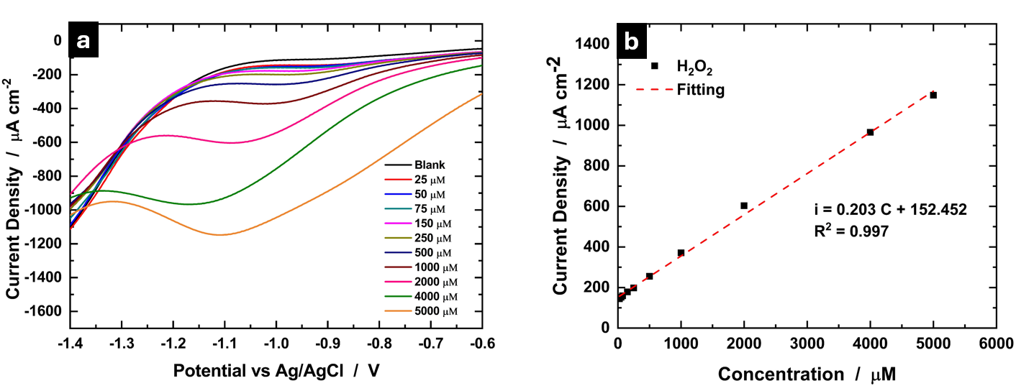
Figure 3 a) LSV voltammograms at increasing H₂O₂ concentrations in PBS; b) Sensor H₂O₂ calibration line and respective line equation.
A linear relationship was observed between the reduction peak current and the H₂O₂ concentration, as demonstrated by the calibration curve in Figure 3-b. In the linear range from 25 to 5000 µM, a sensitivity of 0.203 µA cm⁻² µM⁻¹ was measured.
The sensor performance underscored the effectiveness of the co-deposited materials, rGO and AuNPs, as active components for H₂O₂. These materials enabled high sensitivity using a simple electrodeposition process that required only a few seconds.
Comparable performance has been reported in the literature for single-analyte detection. For instance, Jiang et al. (2021) developed a sensor for H₂O₂ using rGO as support for CuCo₂O₄ nanocomposites, and achieving 0.3 µA cm⁻² µM⁻¹ sensitivity. Maji et al. (2014), on the other hand, utilized AuNPs immobilized in mesoporous silica, obtaining a sensitivity of 0.0392 μA cm^{–2} µM⁻¹, demonstrating the potential of these materials for effective H₂O₂ detection.
Currently, the same rGO/AuNPs electrode is being investigated for the detection of uric acid (UA). Preliminary results are promising, as they indicate the possibility of simultaneous detection on the same electrode E1 without interference between the two analytes. Therefore, further studies will focus on assessing the sensor capability for H₂O₂ and UA simultaneous detection. This will include evaluations in cell culture media and subsequent testing in real cell supernatant samples. Additionally, its performance in biological fluids, such as EBC, will be explored to extend its potential applications.
    - pH measurement
The E2 electrode is covered with PANI that is the active sensing material to detect pH changes in the solution.
The pH of the solution was assessed by correlating it with open circuit potential (OCP) measurements over a 250-second period. The measured OCP values were related to the pH of the solution according to Nernst’s equation:
$E = E_{0}-\frac{RT}{nF }pH$ Eq (1)
where E₀ is the standard redox potential, R is the universal gas constant, T is the temperature, n is the number of electrons involved in the electrochemical reaction, F is the Faraday constant.
OCP was measured by immersing the device in different buffer solutions, varying the pH from 7 to 4. The graph in Figure 4 shows the OCP trend at different pH values, displaying the last 100 seconds of each separate measurement. The dashed line represents the calibration curve obtained by plotting OCP against pH. The reason for these OCP changes behaviour can be attributed to PANI multiple oxidation states, which are influenced by both pH and potential (De Albuquerque et al. 2004). The PANI pH sensitivity is linked to its reversible transformation to emeraldine salt or emeraldine base during acid–base reactions. In acidic solutions, PANI is doped with H⁺ ions, forming the electrically conductive emeraldine salt state. This doping increases the surface charge, leading to an increased potential (Zhu et al. 2024). For this reason, PANI has been used in various studies for pH measurement using different transduction methods, such as optical or electrochemical techniques (as discussed in a review by Korostynska,2007).
Figure 4 OCP measurements conducted in buffer solutions (pH 7, 6, 5, and 4). The dashed line represents the calibration curve obtained, illustrating the relationship between OCP and pH.
  - Conclusion
In this work, a novel multianalyte sensor platform for highly sensitive detection of H₂O₂, and pH levels was developed. This device design consisted of two working electrode and integrated counter and reference electrode. This design was achieved through laser scribing on a commercial ITOPET sheet. The laser beam was used to remove the conductive surface layer of ITOPET, allowing the desired configuration to be drawn. Each electrode was selectively modified through electrodeposition. The electrode for H₂O₂ detection was enhanced with rGO and AuNPs, while the pH electrode was modified also with PANI. The rGO/AuNPs electrode was used for the sensitive detection of H₂O₂ in PBS. H₂O₂ exhibited high sensitivity of 0.203 µA cm⁻² µM⁻¹ in a wide linear range from 25 to 5000 µM. The rGO/AuNPs/PANI electrode was used to measure the pH of various buffer solution, demonstrating its sensitivity through evident changes in OCP with varying pH levels.
Therefore, a simple method was developed for the fabrication of a substrate suitable for multianalyte platform construction. Preliminary studies show the ability of the device in buffer solutions to detect uric acid and hydrogen peroxide in the same electrode. Future studies will focus on evaluating device performance in complex fluids, such as cell culture media, before progressing to the analysis of real samples derived from cell cultures and body fluids closely associated with the respiratory system.

Acknowledgments
This work was partially financed by the project PRIN 2022 PNRR, P2022CHAHX, “Development and validation of an innovative multianalyte sensor for the simultaneous evaluation of biomarkers of oxidative stress and inflammation in advanced experimental models of chronic airways diseases”.

Reference
Aghasafari P, George U, Pidaparti R (2019) A review of inflammatory mechanism in airway diseases. Inflamm. Res. 68(1):59–74.
Albano GD, Gagliardo RP, Montalbano AM, Profita M (2022) Overview of the Mechanisms of Oxidative Stress: Impact in Inflammation of the Airway Diseases. Antioxidants 11(11):2237.
De Albuquerque JE, Mattoso LHC, Faria RM, Masters JG, MacDiarmid AG (2004) Study of the interconversion of polyaniline oxidation states by optical absorption spectroscopy. Synthetic Metals 146(1):1–10.
Emelyanov A, Fedoseev G, Abulimity A, Rudinski K, Fedoulov A, Karabanov A, Barnes PJ (2001) Elevated Concentrations of Exhaled Hydrogen Peroxide in Asthmatic Patients. Chest 120(4):1136–1139.
Jiang L, Zhao Y, Zhao P, Zhou S, Ji Z, Huo D, Zhong D, Hou C (2021) Electrochemical sensor based on reduced graphene oxide supported dumbbell-shaped CuCo2O4 for real-time monitoring of H2O2 released from cells. Microchemical Journal 160:105521.
Korostynska O (2007) Review on State-of-the-art in Polymer Based pH Sensors.
Maji SK, Sreejith S, Mandal AK, Ma X, Zhao Y (2014) Immobilizing Gold Nanoparticles in Mesoporous Silica Covered Reduced Graphene Oxide: A Hybrid Material for Cancer Cell Detection through Hydrogen Peroxide Sensing. ACS Appl. Mater. Interfaces 6(16):13648–13656.
Mazzara F, Patella B, D’Agostino C, Bruno MG, Carbone S, Lopresti F, Aiello G, et al. (2021) PANI-Based Wearable Electrochemical Sensor for pH Sweat Monitoring. Chemosensors 9(7):169.
Papaioannou AI, Loukides S, Minas M, Kontogianni K, Bakakos P, Gourgoulianis KI, Alchanatis M, Papiris S, Kostikas K (2011) Exhaled breath condensate pH as a biomarker of COPD severity in ex-smokers. Respir Res 12(1):67.
Patella B, Di Vincenzo S, Moukri N, Bonafede F, Ferraro M, Lazzara V, Giuffrè MR, et al. (2024) Gold nanowires-based sensor for quantification of H2O2 released by human airway epithelial cells. Talanta 272:125772.
Patella B, Vincenzo SD, Zanca C, Bollaci L, Ferraro M, Giuffrè MR, Cipollina C, et al. (2022) Electrochemical Quantification of H2O2 Released by Airway Cells Growing in Different Culture Media. Micromachines 13(10):1762.
Power AC, Gorey B, Chandra S, Chapman J (2018) Carbon nanomaterials and their application to electrochemical sensors: a review. Nanotechnology Reviews 7(1):19–41.
Rabe AP, Loke WJ, Gurjar K, Brackley A, Lucero-Prisno Iii DE (2023) Global Burden of Asthma, and Its Impact on Specific Subgroups: Nasal Polyps, Allergic Rhinitis, Severe Asthma, Eosinophilic Asthma. JAA Volume 16:1097–1113.
Zhu X, Sun H, Yu B, Xu L, Xiao H, Fu Z, Gao T, Yang X (2024) A flexible pH sensor based on polyaniline@oily polyurethane/polypropylene spunbonded nonwoven fabric. RSC Adv. 14(8):5627–5637.

