|  |  |
| --- | --- |
| cetlogo ***CHEMICAL ENGINEERING TRANSACTIONS***  ***VOL. xxx, 2025*** | A publication of  aidiclogo_grande |
| The Italian Association  of Chemical Engineering  Online at www.cetjournal.it |
| Guest Editors: Fabrizio Bezzo, Flavio Manenti, Gabriele Pannocchia, Almerinda di Benedetto  Copyright © 2025, AIDIC Servizi S.r.l. **ISBN** 979-12-81206-17-5; **ISSN** 2283-9216 | |

Comparative Life Cycle Assessment of Pyrolysis vs. Incineration for Treating Sludge and Nanofiltration Concentrate from Landfill Leachate Treatment Plant Effluent Contaminated with PFAS

Elisa Blumenthala\*, Ali Hydara, Massimiliano Sgroia, Alessandro Frugisb, Maria Grazia Ascic, Giancarlo Cecchinib,c, Anna Laura Eusebia, Francesco Fatonea

aDepartment of Science and Engineering of Materials, Environment and Urban Planning-SIMAU, Marche Polytechnic University (UNIVPM), Via Brecce Bianche, 12, 60131 Ancona, Italy

bAcea Infrastructure, gruppo Acea S.p.A., Via Vitorchiano, 165, 00189 Roma, Italy

cSIMAM S.p.A., gruppo Acea S.p.A., Via Giovanni Cimabue, 11/2, 60019 Senigallia, Italy

[e.blumenthal@pm.univpm.it](mailto:e.blumenthal@pm.univpm.it)

Per- and polyfluoroalkyl substances (PFAS) are persistent environmental contaminants commonly found in landfill leachates and wastewater treatment plant (WWTP) effluents, posing significant risks to environmental and human health. This study evaluates the environmental impacts of two treatment methods - incineration and pyrolysis - for managing PFAS-rich waste, specifically the sludge generated in a Landfill Leachate Treatment Plant (LLTP) and the concentrate produced by a Nanofiltration (NF) system treating the effluent from the same plant. A Life Cycle Assessment (LCA) was performed to compare the environmental impacts of these methods in terms of Global Warming Potential (GWP), Marine Eutrophication (MEP) and Terrestrial Ecotoxicity (TETP). Pyrolysis treatment results in 26 % lower GWP impacts (70.8 kg CO2-eq per 1000 kg of input), 85 % lower MEP impacts (0.0065 kg N-eq per 1000 kg of input), and 91 % lower TETP impacts (216 kg 1,4-DBC-eq per 1000 kg of input) compared to incineration (96.2 kg CO2-eq, 0.0437 kg N-eq, and 2330 kg 1,4-DBC-eq per 1000 kg of input, respectively).The study highlights pyrolysis as a more eco-friendly and energy-efficient option for managing PFAS-rich waste, outperforming incineration in the considered environmental categories.

* 1. Introduction

Per- and poly-fluoroalkyl substances (PFAS) are a family of compounds widely used in many commercial and industrial application. Consumer goods like carpets, fabrics, clothing, packaging, food wrappers, and even cleaning and personal care products that are stain- and water-resistant contain PFAS (Hamid et al., 2018; Prevedouros et al., 2006). Both short- and long-chain PFAS are characterized as persistent, mobile, and potentially toxic substances. In landfills, PFAS sources such as fluorotelomer-based coatings on carpet, clothing and food packaging are biologically transformed into stable and more mobile PFAS (Hamid et al., 2020). Globally, landfills are considered one of the primary sources of PFAS contamination in the environment, where these substances can leach into groundwater and potentially be released into the air (Wei et al., 2019). Wei et al. (2019) carried out a review on the presence of PFAS in several landfills worldwide, and they reported that, in Europe, PFAS concentrations in landfill leachates generally range from 0.005 to 18 μg/L. Additionally, Masoner et al. (2020) highlighted that disposal of treated leachate into wastewater treatment plants (WWTPs) can contribute substantially to the increase of PFAS concentrations in the wastewater influents. Research by Helmer et al. (2022) indicated that leachate from young landfills tends to have a higher presence of short-chain PFAS than older landfills, due to industrial bans on long-chain PFAS in the recent years. Short-chain PFAS have higher solubility and lower sorptivity than long-chain PFAS.

It is common practice for landfill leachates, after partial treatment, to be discharged into municipal WWTPs. However, conventional WWTPs have demonstrated to be ineffective at removing PFAS and the presence of precursors in the influent may lead to an increase of PFAS concentrations in the effluent after biological transformation (Lenka et al., 2021). Consequently, PFAS from landfill leachate may be released to the aquatic environment via WWTP effluents but can also be adsorbed into municipal sewage sludge limiting its agronomic reutilization (Fredriksson et al., 2022). Given the persistence and potential toxicity of PFAS, advanced treatment processes are required for their effective removal and management.

This study considers a pilot plant designed to remove PFAS from the effluent of a Landfill Leachate Treatment Plant (LLTP) in Italy, prior to its discharge into a WWTP. The pilot system consists of a Nanofiltration (NF) to selectively remove and concentrate PFAS from the effluent stream.

The concentrate from NF requires subsequent treatment for PFAS destruction or disposal in compliance with national regulations. In this study, the concentrate generated was subjected to evaporation. The resulting salts require further treatment or safe disposal due to their high concentration of PFAS, heavy metals, and other pollutants.

This study presents a Life Cycle Assessment (LCA) aimed at evaluating the environmental impacts associated with two alternative methods – incineration and pyrolysis – for treating and disposing of salts derived from NF concentrate evaporation, as well as the sludge generated in the LLTP, resulting in a salt proportion of 30 % of the total dry sludge weight.

* 1. Material and methods

LCA is an evaluation technique used for analysing the energy and the material flow throughout the life cycle of a product or a process. It examines the whole life cycle of the system or product under study, considering a wide range of environmental impacts and providing a quantitative assessment (Hauschild et al., 2018). The study was conducted in four phases: goal and scope definition, inventory analysis, impact assessment, and interpretation. This approach follows the framework and principles universally valid to plan and conduct an LCA, as established by ISO 14044 (ISO, 2006).

* + 1. Goal and scope definition

During the first phase, the objective of the analysis, the system boundaries, and the functional unit (FU) are established. Defining system boundaries is crucial, as it sets the limits for determining which inputs and outputs are relevant to the system. The scope of this study was to compare the pyrolysis and the incineration as two alternative methods to treat and dispose the LLTP sludge and the salts derived from the evaporation of the concentrate from the NF system.

The pyrolysis scenario includes: i) drying of the sludge from a solid content of 25 % to 70 %, along with the thermal energy consumed during the process; ii) pyrolysis of the sludge and the salt, and the energy consumed to initiate the system; iii) production of syngas, including the emissions associated to its combustion and the excess thermal energy produced; iv) production of bio-oil, the emissions linked to its combustion and the thermal energy produced; v) production of the biochar and its disposal to the hazardous landfill due to the high concentrations of heavy metals.

The incineration scenario includes: i) transportation of the salt and the sludge to the incineration facility (with the sludge entering at a water content of 75 %, according to (Jungbluth et al., 2007); ii) energy consumption and production during the incineration of the sludge and the salt; iii) emissions generated from the incineration process and disposal of the ash to an hazardous landfill due to its high concentrations of heavy metals.

The FU chosen for the study is 1 ton of the waste treated, which consists of a mixture of dewatered sludge and salt with a salt proportion of 30 % of the total dry sludge weight.

The boundaries of the two scenarios are illustrated in Figure 1.

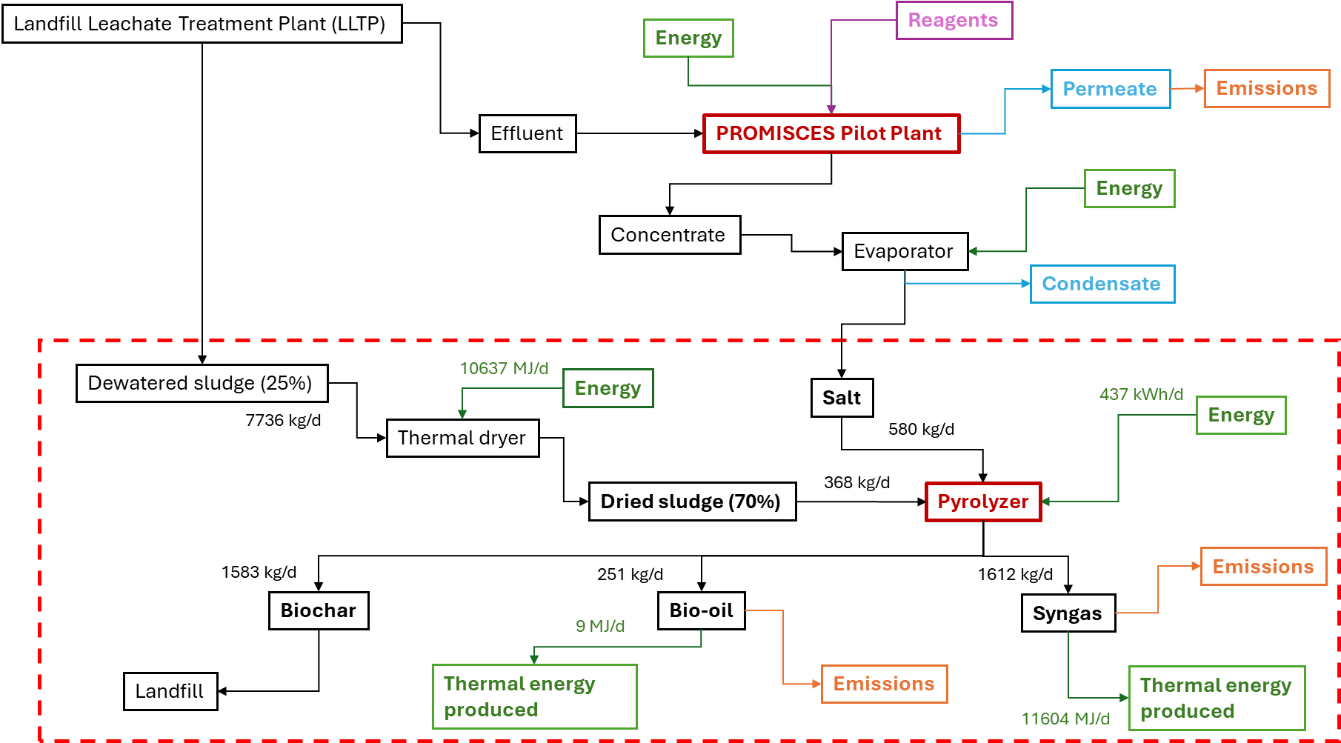

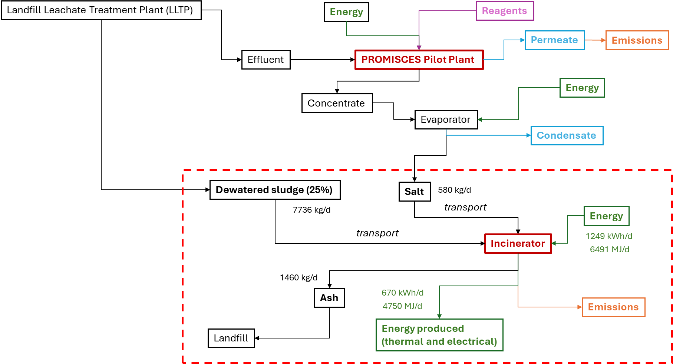

*Figure 1: Boundaries of the pyrolysis (on the top) and the incineration (on the bottom) scenarios*

In this study, the analysis considered the environmental impact directly related to the treatment system (foreground system), as well as the background impact from the supplementary supply chains delivering energy, chemicals, or auxiliaries (background system) using the Ecoinvent database and physical allocation. This database is published and maintained by the Ecoinvent Centre in Switzerland, and it is the most renowned database for Life Cycle Inventory (LCI) datasets. Specifically, the version 3.10 was applied.

The LCA software adopted was Umberto LCA+ v11. This software uses graphic modelling of the product life cycle and allows analysing, assessing, and visualising the environmental impacts in different categories. The Impact Assessment Method used was ReCiPe 2016 with the Hierarchist (H) variant.

* + 1. Life Cycle Inventory

The LCI involves compiling a flow tree that accounts for all relevant processes involved in producing, transporting, using, and disposing of the selected product or process. This phase is critical as it gathers all input and output data for the system under analysis. The life cycle of a system or a product is intrinsically linked to substance emissions and resource extractions, quantified during this phase. For this study, data were collected from both laboratory tests and literature. Both pyrolysis and incineration were considered as full-scale systems.

In the pyrolysis scenario, data on biochar, bio-oil, and syngas production were derived from tests conducted in a pyrolysis reactor treating the same proportion of salt and sludge considered in this study. For the energy consumption and production of the pyrolyzer, the Pyreg PX 500 was used as a reference (“Home - PYREG GmbH,” 2024). The calorific value of the bio-oil was based on the study by Huang et al. (2022). Emissions to air and water resulting from the combustion of syngas and bio-oil were calculated following Steele et al. (2012).

In the incineration scenario, data on energy consumption and production were taken from Jungbluth et al. (2007), while emissions to air and water were calculated based on the study by Alyaseri et al. (2017). The ash production was estimated based on the inorganic matter content of the input.

The amount of salt was calculated starting from the Total Dissolved Solids (TDS) of the concentrate. The quantity of LLTP sludge included in the study was adjusted to achieve a salt concentration equal to the 30 % of the mass of the total dry sludge.

* 1. Results and discussion
     1. Life Cycle Impact Assessment

The Life Cycle Impact Assessment (LCIA) translates the emissions and resource extractions into environmental impact scores, supporting the interpretation of LCA results. This is achieved using characterization factors, that indicate the environmental impact per unit of stressor. There are two mainstream ways of deriving characterization factors: at midpoint or endpoint (Huijbregts et al., 2017). Midpoint characterization models the impact at an intermediary point along the environmental mechanism (Hauschild et al., 2018; JRC, 2010). This study considered the following midpoint categories: Climate Change (GWP), Marine Eutrophication (MEP) and Terrestrial Ecotoxicity (TETP).

* + 1. Interpretation of the results

The final phase of the LCA is the interpretation, which summarizes the results and provides a comprehensive and critical analysis of the relevant data.

The results of the LCA are listed in the Table 1.

*Table 1: Impacts associated with the Climate Change, Marine Eutrophication and Terrestrial Ecotoxicity categories for each process in the analysed scenarios*

|  |  |  |  |  |  |  |
| --- | --- | --- | --- | --- | --- | --- |
|  | **GWP (kg CO2-eq/FU)** | | **MEP (kg N-eq/FU)** | | **TETP (kg 1,4-DBC-eq/FU)** | |
| **Process** | **INCINERATION** | **PYROLYSIS** | **INCINERATION** | **PYROLYSIS** | **INCINERATION** | **PYROLYSIS** |
| Electric energy pyrolysis | - | 2.02E+01 | - | 3.57E-04 | - | 1,03E+02 |
| Emissions to air from bio-oil combustion | - | 2.15E-04 | - | - | - | - |
| Emissions to air from incineration | 6.78E-01 | - | - | - | 1.48E+03 | - |
| Emissions to water from incineration | - | - | 3.72E-02 | - | 2.78E-17 | - |
| Landfill for hazardous wastes | 4.83E+01 | 5.23E+01 | 5.73E-03 | 6.21E-03 | 1.16E+02 | 1.26E+02 |
| Thermal energy bio-oil (pyrolysis) | - | -1.61E-02 | - | -4.25E-07 | - | -1.18E-01 |
| Transport to incinerator | 1.75E+01 | - | 2.38E-04 | - | 5.76E+02 | - |
| Excess thermal energy pyrolysis | - | -2.04E+01 | - | -5.39E-04 | - | -1.49E+02 |
| Net electric energy incineration | 2.67E+01 | - | 4.73E-04 | - | 1.37E+02 | - |
| Net thermal energy incineration | 3.05E+00 | - | 8.08E-05 | - | 2.24E+01 | - |
| Thermal energy dryers | - | 1.87E+01 | - | 4.94E-04 | - | 1.37E+02 |
| **Total** | **9.62E+01** | **7.08E+01** | **4.37E-02** | **6.52E-03** | **2.33E+03** | **2.16E+02** |

In terms of GWP, the total impact generated by the pyrolysis treatment of salts and sludge results in 70.8 kg CO2-eq per 1000 kg of input, whereas incineration leads to 96.2 kg CO2-eq per 1000 kg of input. Thus, the pyrolysis scenario reduces the impacts associated with the treatment and disposal of salts and sludge by 26 % compared to incineration. This reduction is primarily due to the excess thermal energy produced during pyrolysis (“Home - PYREG GmbH,” 2024), whereas in the incineration scenario, the energy produced does not exceed the energy consumed by the system (Jungbluth et al., 2007). The higher environmental impact associated with landfill disposal in the pyrolysis scenario is attributed to the larger mass of biochar compared to ash, as laboratory tests indicate that residual organic matter remains in the biochar following the pyrolysis process.

Regarding the MEP, the total impact from pyrolysis treatment results in 0.0065 kg N-eq per 1000 kg of input, whereas incineration leads to 0.0437 kg N-eq per 1000 kg of input. Therefore, the impacts of the treatment and disposal of salts and sludge are 85 % lower in the pyrolysis scenario compared to the incineration scenario. This difference is mainly due to the impacts in water bodies from incineration (Jungbluth et al., 2007).

Focusing on the TETP, the total impact of the pyrolysis scenario is 216 kg 1,4-DBC-eq per 1000 kg of input, whereas incineration leads to 2330 kg 1,4-DBC-eq per 1000 kg of input. This means that the impacts of the pyrolysis scenario in this category are 91 % lower than the ones of the incineration scenario. The main causes are the emissions to air from the incineration process and the impacts of the transport of the sludge and the salts to the incineration plant.

The impacts contribution of the different processes involved and the comparison between the incineration and pyrolysis scenarios are illustrated in the Figure 2.

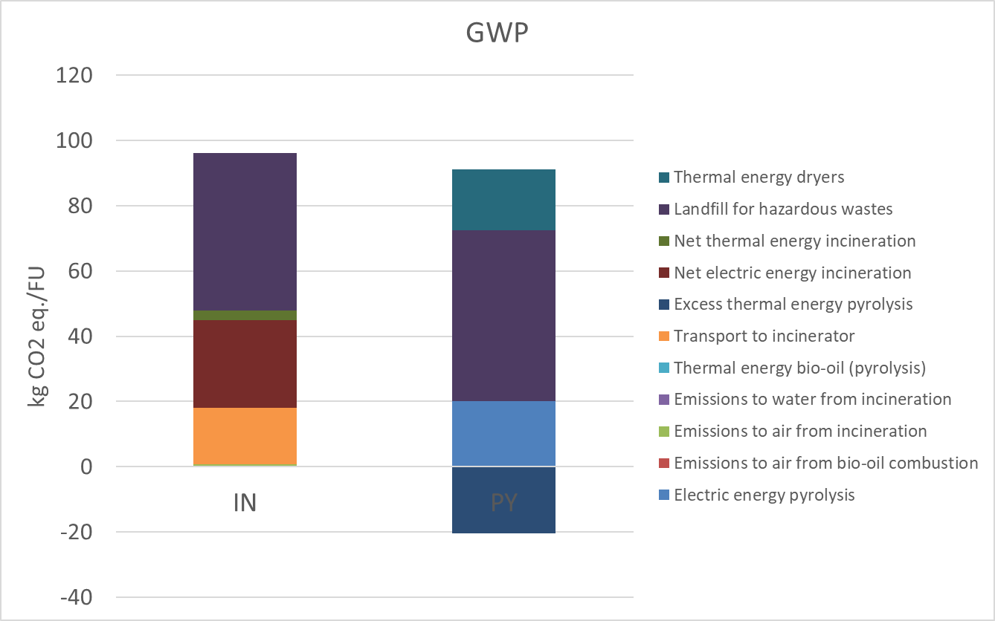 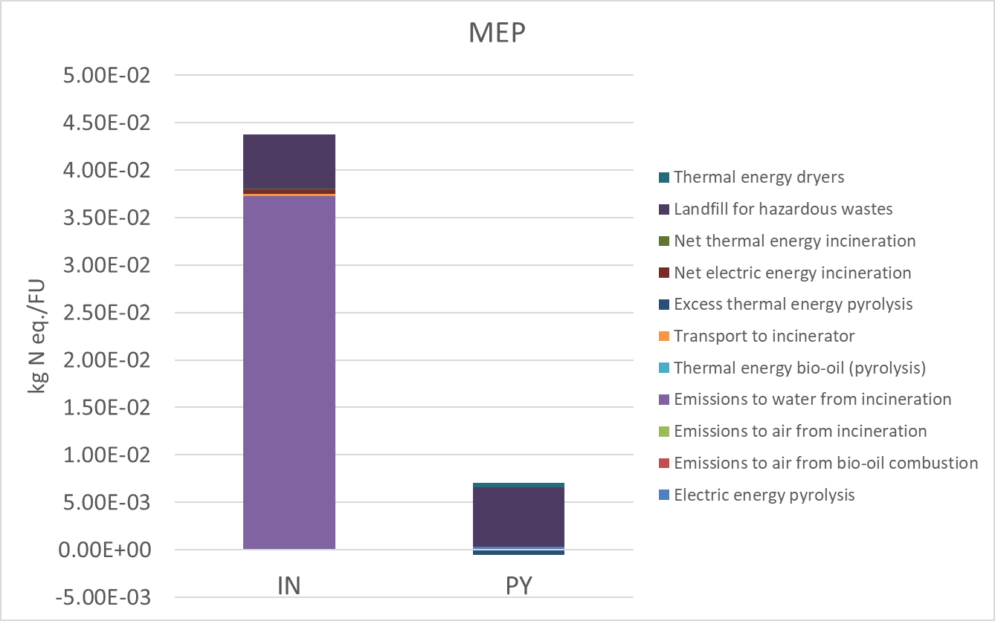

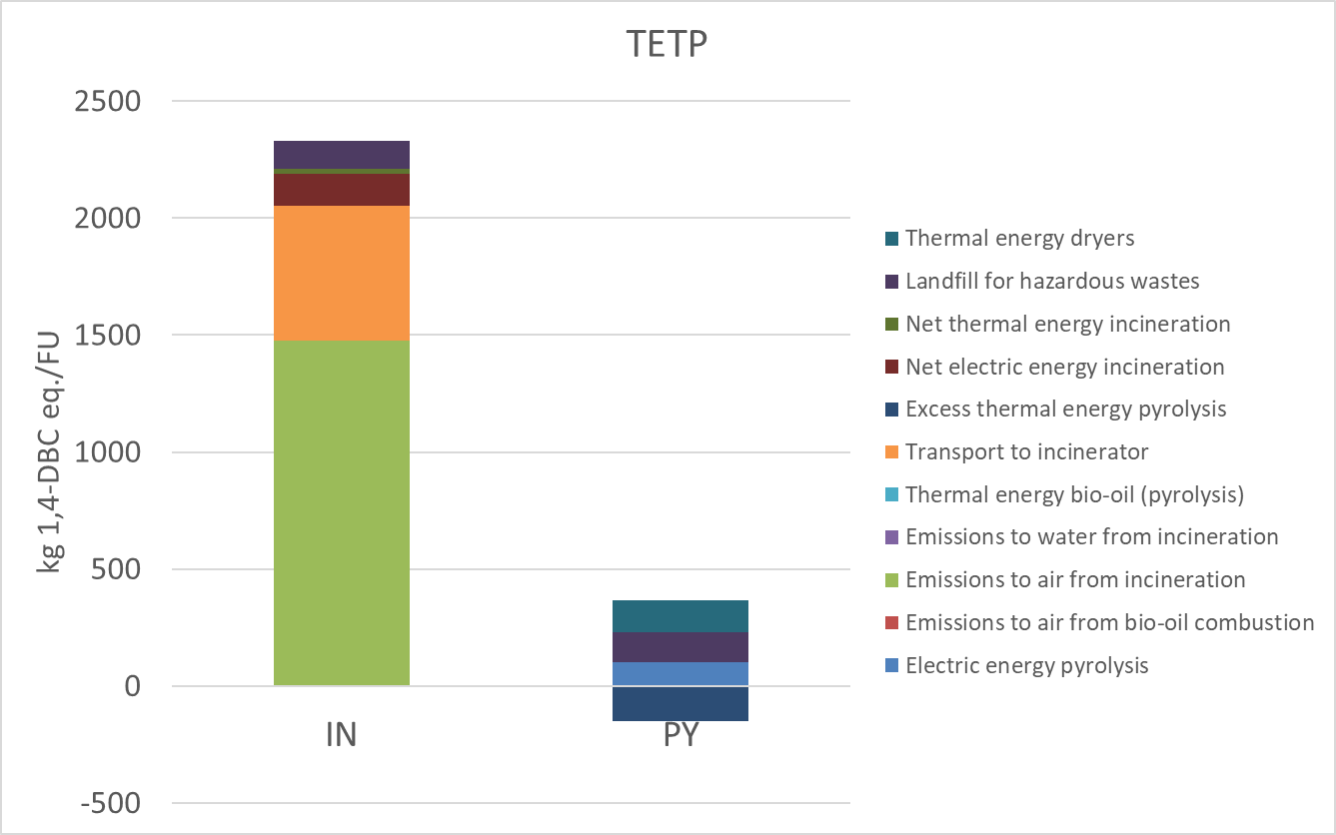

*Figure 2: Comparison between the impacts associated with the GWP, MEP and TETP for the pyrolysis and the incineration scenarios and contribution of the different processes involved*

* 1. Conclusion

This study evaluated the environmental impacts of incineration and pyrolysis for treating the concentrate from a Nanofiltration (NF) system processing effluent from a Landfill Leachate Treatment Plant (LLTP), as well as sludge generated from both the LLTP and a Wastewater Treatment Plant (WWTP). The Life Cycle Assessment (LCA) revealed clear differences between the two methods in terms of Global Warming Potential (GWP), Marine Eutrophication (MEP) and Terrestrial Ecotoxicity (TETP).

In terms of GWP, the pyrolysis treatment results in 70.8 kg CO2-eq per 1000 kg of input, compared to 96.2 kg CO2-eq per 1000 kg of input from incineration. This corresponds to a 26 % reduction in emissions for the pyrolysis scenario. The lower emissions from pyrolysis are primarily due to the excess thermal energy generated during the process, which contrasts with the incineration scenario, where the energy produced does not surpass the energy consumed by the system (“Home - PYREG GmbH,” 2024; Jungbluth et al., 2007).

In terms of the MEP, pyrolysis achieves a remarkable 85 % reduction in impact, emitting just 0.0065 kg N-eq per 1000 kg of input, compared to 0.0437 kg N-eq per 1000 kg of input for incineration. The higher impact in MEP for incineration is mainly attributed to the impacts on water bodies (Jungbluth et al., 2007).

When examining TETP, pyrolysis leads to 216 kg 1,4-DBC-eq per 1000 kg of input, which is 91% lower than the 2330 kg 1,4-DBC-eq per 1000 kg of input from incineration. The primary contributors to this large reduction are the emissions released during incineration and the transportation of salts and sludge to the incineration facility.

Overall, the LCA indicates that pyrolysis is an eco-friendly and energy-efficient option for managing the treatment and disposal of PFAS-rich waste from the LLTP and WWTP, performing better than incineration in all the analyzed environmental categories.

Acknowledgement

The authors acknowledge the European Union’s Horizon 2020 research and innovation programme for its support to fund the “PROMISCES” project under grant agreement 101036449.

References

Alyaseri, I., Zhou, J., 2017. Towards better environmental performance of wastewater sludge treatment using endpoint approach in LCA methodology. Heliyon 3. https://doi.org/10.1016/j.heliyon.2017.e00268

Fredriksson, F., Eriksson, U., Kärrman, A., Yeung, L.W.Y., 2022. Per- and polyfluoroalkyl substances (PFAS) in sludge from wastewater treatment plants in Sweden — First findings of novel fluorinated copolymers in Europe including temporal analysis. Science of The Total Environment 846, 157406. https://doi.org/10.1016/J.SCITOTENV.2022.157406

Hamid, H., Li, L.Y., Grace, J.R., 2020. Aerobic biotransformation of fluorotelomer compounds in landfill leachate-sediment. Science of The Total Environment 713, 136547. https://doi.org/10.1016/J.SCITOTENV.2020.136547

Hamid, H., Li, L.Y., Grace, J.R., 2018. Review of the fate and transformation of per- and polyfluoroalkyl substances (PFASs) in landfills. Environmental Pollution 235, 74–84. https://doi.org/10.1016/J.ENVPOL.2017.12.030

Hauschild, M.Z., Rosenbaum, R.K., Olsen, S.I., 2018. Life Cycle Assessment. https://doi.org/10.1007/978-3-319-56475-3

Helmer, R.W., Reeves, D.M., Cassidy, D.P., 2022. Per- and Polyfluorinated Alkyl Substances (PFAS) cycling within Michigan: Contaminated sites, landfills and wastewater treatment plants. Water Res 210. https://doi.org/10.1016/j.watres.2021.117983

Home - PYREG GmbH [WWW Document], 2024. URL https://pyreg.com/ (accessed 11.15.24).

Huang, C., Mohamed, B.A., Li, L.Y., 2022. Comparative life-cycle assessment of pyrolysis processes for producing bio-oil, biochar, and activated carbon from sewage sludge. Resour Conserv Recycl 181. https://doi.org/10.1016/j.resconrec.2022.106273

Huijbregts, M.A.J., Steinmann, Z.J.N., Elshout, P.M.F., Stam, G., Verones, F., Vieira, M., Zijp, M., Hollander, A., van Zelm, R., 2017. ReCiPe2016: a harmonised life cycle impact assessment method at midpoint and endpoint level. International Journal of Life Cycle Assessment 22, 138–147. https://doi.org/10.1007/s11367-016-1246-y

ISO, 2006. ISO 14044 Environmental management - Life cycle assessment - Requirements and guidelines.

JRC, 2010. International Reference Life Cycle Data System (ILCD) Handbook: Framework and Requirements for Life Cycle Impact Assessment Models and Indicators 103. https://doi.org/10.2788/38719

Jungbluth, N., Dinkel, F., 2007. Life Cycle Inventories of Bioenergy. ecoinvent report No. 17.

Lenka, S.P., Kah, M., Padhye, L.P., 2021. A review of the occurrence, transformation, and removal of poly- and perfluoroalkyl substances (PFAS) in wastewater treatment plants. Water Res 199, 117187. https://doi.org/10.1016/J.WATRES.2021.117187

Masoner, J.R., Kolpin, D.W., Cozzarelli, I.M., Smalling, K.L., Bolyard, S.C., Field, J.A., Furlong, E.T., Gray, J.L., Lozinski, D., Reinhart, D., Rodowa, A., Bradley, P.M., 2020. Landfill leachate contributes per-/poly-fluoroalkyl substances (PFAS) and pharmaceuticals to municipal wastewater. Environ Sci (Camb) 6, 1300–1311. https://doi.org/10.1039/d0ew00045k

Prevedouros, K., Cousins, I.T., Buck, R.C., Korzeniowski, S.H., 2006. Sources, fate and transport of perfluorocarboxylates. Environ Sci Technol 40, 32–44. https://doi.org/10.1021/ES0512475/SUPPL\_FILE/ES0512475.PDF

Steele, P., Puettmann Venkata, M.E., Penmetsa, K., Cooper, J.E., 2012. Life-Cycle Assessment of Pyrolysis Bio-Oil Production\*.

Wei, Z., Xu, T., Zhao, D., 2019. Treatment of per- And polyfluoroalkyl substances in landfill leachate: Status, chemistry and prospects. Environ Sci (Camb). https://doi.org/10.1039/c9ew00645a