|  |  |
| --- | --- |
| cetlogo ***CHEMICAL ENGINEERING TRANSACTIONS***  ***VOL. xxx, 2025*** | A publication of  aidiclogo_grande |
| The Italian Association  of Chemical Engineering  Online at www.cetjournal.it |
| Guest Editors: Fabrizio Bezzo, Flavio Manenti, Gabriele Pannocchia, Almerinda di Benedetto  Copyright © 2025, AIDIC Servizi S.r.l. **ISBN** 979-12-81206-17-5; **ISSN** 2283-9216 | |

Innovative sodium cleaning process using saline solutions

Leïla Gicquela,\*, Sébastien Lefèvrea, Laure Moinota, Benjamin Tardivela

aCEA, DES, IRESNE, DTN, Cadarache, F-13108, Saint-Paul-lez-Durance, France

leila.gicquel@cea.fr

During the development of NOAH process at CEA in the 1980s (Rodriguez, 2021), the addition of sodium hydroxide to water was identified as an interesting way to moderate the kinetics of the sodium-water reaction. Based on these observations, studies were launched at CEA in 2007 with the aim of developing an innovative process for treating remaining sodium in the components of a sodium fast reactor (SFR). This process would have the following advantages: control of the sodium-water reaction and limitation of its effects by adding an appropriate salt; flexibility and increase in treatment rates by rapid immersion of the components. In order to overcome the corrosive nature of sodium hydroxide, new salts were studied. Several salts appeared promising in that, for some of them, the reaction no longer generates a shock wave despite an excess of water, the kinetics are slowed down and the release of energy occurs gradually in the reaction medium. Following these results, new experimental campaigns were launched and enabled to identify the influential parameters and to quantify the effects of two salts on the moderation of the sodium-water reaction: tetrasodium EDTA and sodium acetate.

* 1. Introduction

As part of the development of the IVth Generation of nuclear reactors, studies were launched at CEA in 2007 with the aim of developing an innovative process for treating sodium in the components of a sodium fast reactor (SFR). A fuel assembly has a limited lifetime and when the fuel loses reactivity, the assemblies are removed from the reactor core and transported to deactivation pools after treating the residual sodium on their surface. To do this, the method used consists of reacting sodium and water in cleaning pits or cells. Since the sodium-water reaction (SWR) can be violent and generate an explosion phenomenon, the cleaning times for the assemblies are quite long. New processes would make it possible to control the SWR and limit its effects by adding an appropriate salt, with significant benefits such as flexibility and increased processing rates thanks to the rapid immersion of components. In order to overcome the corrosive nature of sodium hydroxide, several salts were studied at CEA (Lacroix, 2014), some of which appeared promising such as lithium acetate, tetrasodium EDTA or even iron(III) chloride. The reaction no longer generated a shock wave despite an excess of water, the kinetics were slowed down and the release of energy occurred gradually in the reaction medium. These results led to the publication of a patent (Lacroix et al., 2015). Other test campaigns were carried out from 2019, including small-scale tests to quantify the impact of salt concentration on the effects of SWR and pilot-scale tests which seemed to indicate that there was no scale effect. A new experimental campaign was launched at the end of 2023 to identify influential parameters and quantify the effects of salts on SWR moderation (Gicquel et al., 2024). Following these experiments, improvements were made to the device, and a new experimental campaign was launched, with the aim of providing information on the chemical kinetics.

* 1. Methodology
     1. Sodium-water reaction

The sodium-water reaction (SWR) is an exothermic reaction with a reaction enthalpy of -184 kJ/molNa, taking into account the dissolution of sodium hydroxide in water. The reaction equation is the following:

*Na (s) + H2O (l) → NaOH (l) +1/2 H2 (g)* (1)

In addition to the exothermic nature of the reaction, SWR is almost instantaneous, produces sodium hydroxide, which can lead to corrosion problems and hydrogen, which is a flammable and explosive compound depending on its concentration (between 4 and 75 % in volume in air) and the presence of oxygen in the environment. SWR is explosive, leading to overpressure due to the pressure wave released (Figure 1).

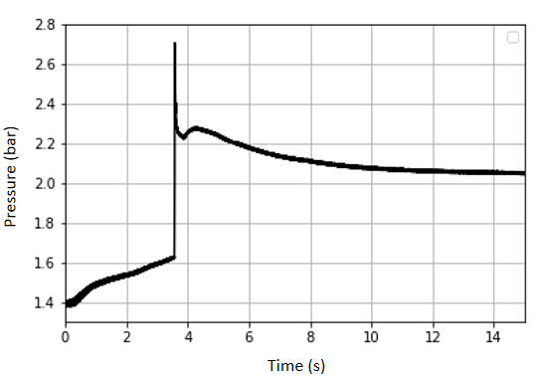

Figure 1: Sodium-water reaction with a 4-gram pellet of sodium

* + 1. Experimental device

The experiments have been carried out in LAVINO device (Innovative Cleaning), presented in the Figure 2. This device comprises several parts including:

* A 3.5 L reactor. For each experiment, 700 mL of solution were introduced into the reactor, leaving a total of 2.8 L of gaseous phase volume;
* A sodium pellet introduction device. This device allows the pellet to be transported from the glove box where it has been manufactured to the reactor, while avoiding contact between the sodium and the surrounding air. Once placed on top of the reactor, it is connected to a pneumatic cylinder that allows the basket containing the sodium pellet to be immersed into the solution;
* Three thermocouples (in the solution, in the gas and on the reactor wall), a dynamic pressure sensor, and a gas analysis board (O2 and H2). These acquisition tools enable data collection on each experiment;
* A high-speed Phantom camera (1,000 – 28,000 fps with a resolution of 1,024 x 768) as well as a GoPro camera, allowing the reaction to be filmed with varying degrees of precision through the reactor's portholes.

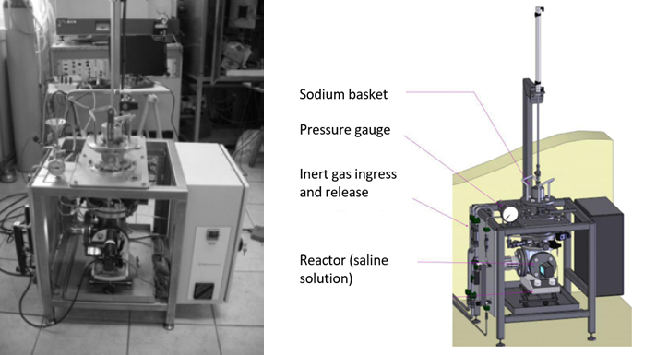

Figure 2: Picture and sketch of LAVINO facility

The demineralized water used for all tests has a resistivity of 18 MΩ.cm-1 which corresponds to an electrical conductivity of 5.55·10-5 mS/cm and a neutral pH of 7.

* + 1. Theoretical calculations

The experimental data is used primarily for energy balance between, before and after the reaction. The LAVINO reactor is an irreversible closed adiabatic system whose gas phase is assimilated to a mixture of perfect gases. Thus, the Antoine’s law is used to calculate the saturated vapour pressure of water:

$\ln\left(P_{sat}\right)=A-\frac{B}{C+T}$ (2)

And the mole numbers of each constituent are calculated from the equation: $P_{i}=\frac{n_{i}}{n_{tot}}P$ (3)

The enthalpy of such a mixture depends only on the temperature according to the first law of Joule for monoatomic or diatomic gas: $∆H=\frac{5}{2}nR∆T$, $∆H=\frac{7}{2}nR∆T$ (4)

Finally, the molar latent heat of vaporization of water will be added to complete the calculation of the variation of enthalpy in the gas phase. For the solution, the variation of enthalpy shall be calculated as: $∆H=mC_{p}∆T$  
 (5)

The thermal capacity used will be approximated by that of water, for which no data have been found for high concentration solutions. The mass is calculated using the density of the solution while considering that 700 mL of sodium acetate solution was introduced. For EDTA, due to lack of data, water density will be used. Theoretically, it is expected that: $Q_{theo}=∆H_{sol}+∆H_{gaz}$ (6)

assuming that the change in enthalpy of the gas phase is negligible compared to that of the solution, the theoretical temperature difference of the solution should be such that: (7)

* + 1. Control tests with water

Control tests (CT) were conducted with 2-gram balls and 4-gram balls. SWR trials “explode” almost systematically according to the literature. However, of the five tests with 2-gram balls, only one was observed to explode. The peak pressure phenomenon associated with the explosion occurred for both 4-gram tests.

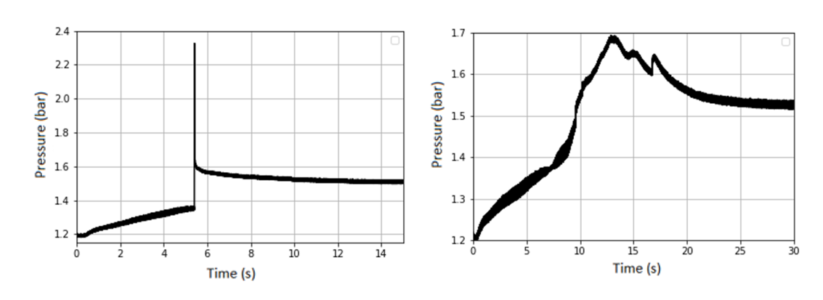

Figure 3: Comparison of two conventional SWR; left: control test 2; right: control test 3

These graphs (Figure 3) show the difference in reaction behaviour. The reaction starts with a fairly similar behaviour with a fairly regular pressure rise and then a slight stabilisation (the reaction slows down), the difference being mainly on the absence of the explosion phenomenon compared to the control test 2 whose reaction ends at that moment. For the other tests, a more marked reaction is observed and the ball is completely consumed. Table 1 compares the difference in gas phase pressure between the initial and final states of the hydrogen production, as well as the difference in maximum pressure reached. The theoretical value is never reached because of several factors, but the experimental values still show the production of dihydrogen. The differences are mainly due to the reactor pressure drop of about 30 mbar per minute, but also to unexpected sodium combustion phenomena which will be discussed in section 3.

*Table 1: Energy balances of several control tests*

|  |  |  |  |  |  |  |  |
| --- | --- | --- | --- | --- | --- | --- | --- |
| Test | mNa/S (g/cm2) | QTheo (kJ) | QExp (kJ) | Rel. Dev.\* | ΔPTheo (bar) | ΔPExp (bar)\*\* | Rel. Dev. |
| CT 1 | 0.26 | 15.93 | 12.74 | 20.0% | 0.382 | 0.303 / 0.465 | 2.6% |
| CT 2 | 0.26 | 15.85 | 17.55 | 10.7% | 0.375 | 0.294 / 1.13 | 2.7% |
| CT 3 | 0.26 | 16.01 | 11.95 | 25.3% | 0.378 | 0.287 / 0.494 | 3.2% |
| CT 4 | 0.26 | 16.25 | 10.61 | 34.7% | 0.387 | 0.328 / 0.627 | 1.8% |

*\*relative deviation, \*\*first value is ending pressure, second value is maximum pressure during the test*

The maximum pressure (ΔPExp max) indicates whether the reaction is explosive (CT 2) or not (CT 1, 3 and 4). In the case of control tests 1, 3 and 4, the pressure variation exceeds the expected one, despite reactor pressure drop, due to small explosion of a piece of sodium on the surface as well as an increase in the gas-phase temperature from the combustion of the sodium.

* 1. Experimental results with saline solutions

This new experimental campaign focused on the study of sodium acetate and tetrasodium EDTA. These salts were chosen based on their performances in moderation as well as their costs or environmental issues. Each experiment was conducted twice, in order to determine the repeatability between two experiments under the same operating conditions.

* + 1. Results with sodium acetate (NaOAc)

Of the 20 tests carried out, the explosion phenomenon with pressure peak only occurred for two tests (8.1 and 8.2). At a concentration of 1 mol/L, the explosion phenomenon disappears when a 2-gram pellet reacts, but this phenomenon is still present during the same reaction with a pellet twice as heavy and therefore thicker. In terms of concentration, it is clear that a 3 mol/L solution is more effective than a 1 mol/L solution. The comparison is based first on the pressure rise, which appears smoother and more regular at higher concentrations, and also in terms of reaction time, which is much longer when using a 3 mol/L sodium acetate solution. With a 4-gram pellet and 1 mol/L solution, the pressure peak appears after 6 seconds, whereas it appears after 4 seconds for SWR. This delay can be attributed to the difference of oxide’s layers or due to an ionic layer in solution. These hypotheses will be studied during a PhD to come in the laboratory.

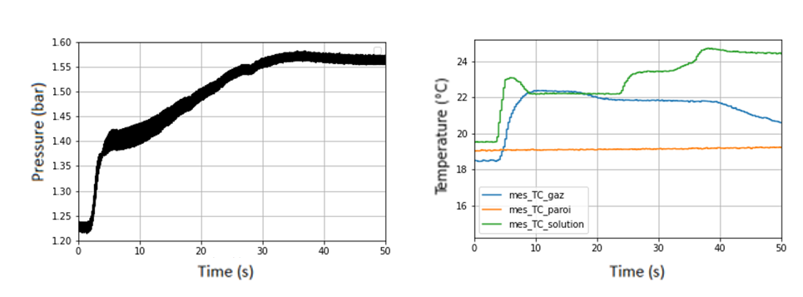

Figure 4: Pressure and temperature curves for test 2.1; mNa = 2 g; C°NaOAc = 2.5 mol/L

The graphs presented on Figure 4 and Figure 5, representing pressure and temperatures as a function of time, demonstrate whether the reaction is well moderated or not. At a concentration of 1 mol/L, the explosion phenomenon disappears when a 2-gram pellet reacts, but this phenomenon is still present during the same reaction with a pellet twice as heavy (and therefore thicker). On Figure 5 the pressure peak is correlated to the increase of temperature in liquid and gas phases, linked to the exothermicity of reaction released in the reaction medium.

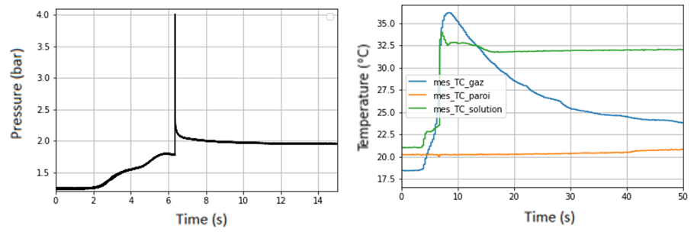

Figure 5: Pressure and temperature curves for test 8.1; mNa = 4 g; C°NaOAc = 1 mol/L

The Table 2 compares the pressure difference in the gas phase between the initial state and the final state reflecting the production of dihydrogen, as well as the maximum pressure difference reached. The theoretical value is never reached due to several factors, but the experimental values ​​still demonstrate the production of dihydrogen. The deviations are mainly due to the reactor pressure loss, of the order of 30 mbar per minute, but also to a sodium combustion phenomenon, which is unexpected and will be discussed in section 3. For energy balance, supposing that the enthalpy variation in the gas phase is negligible compared to that of the liquid phase, we supposed that all the sodium is consumed and the enthalpy of reaction fully transferred to the liquid phase.

*Table 2: Energy and pressure balances for several tests with sodium acetate*

|  |  |  |  |  |  |  |  |  |
| --- | --- | --- | --- | --- | --- | --- | --- | --- |
| Test | mNa/S (g/cm2) | [Salt] (mol/L) | QTheo (kJ) | QExp (kJ) | Rel. Dev. | ΔPTheo (bar) | ΔPExp (bar) | Rel. Dev. |
| 1.1 | 0.26 | 1.0 | 16.25 | 11.84 | 27.1% | 0.391 | 0.350 | 10.4% |
| 4.1 | 0.26 | 1.5 | 16.17 | 15.45 | 4.5% | 0.381 | 0.352 | 7.6% |
| 6.1 | 0.20 | 1.0 | 8.01 | 3.46 | 56.8% | 0.190 | 0.160 | 15.7% |
| 8.1 | 0.32 | 1.0 | 31.78 | 31.81 | 0.1% | 0.748 | 0.701 | 6.2% |

The higher the temperature in the gas phase, the less the temperature variation corresponds to that expected, with the exception of the tests with 1-gram balls, found here. It should also be noted that the salt concentration influences this temperature because the reaction is less violent at high concentration. The relative difference is the lowest for the only test where the pressure wave phenomenon occurred and test 6.1 with a   
1-gram ball has a significant difference compared to the other tests. For the sodium acetate solutions, at the same concentration, the results are showing a greater reaction rate when the sodium mass increases. This can be supported by the fact that at 2 mol/L, 4 grams of sodium burn at a rate of 0.24 g/s while 2 grams burn at a rate of about 0.09 g/s.

* + 1. Results with tetrasodium EDTA

All these trends can also be observed in tests with tetrasodium EDTA solutions (Figure 6 and Figure 7). Indeed, for a concentration of 0.1 mol/L, the reaction is moderated whether it is for a pellet of 1, 2, or 4 grams; however, it is not for a concentration of 0.075 mol/L with a 2-gram pellet or a concentration of 0.05 mol/L with a 4-gram pellet.

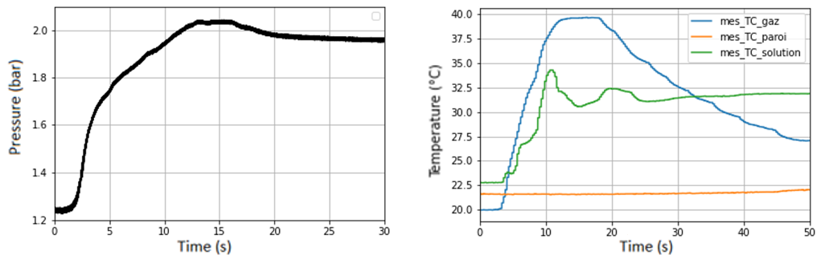

*Figure 6: Pressure and temperature curves for test 11.1; mNa = 4 g; C°EDTA = 0.1 mol/L*

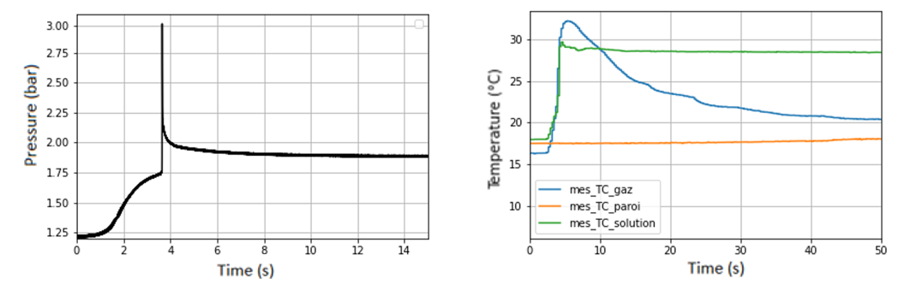

*Figure 7: Pressure and temperature curves for test 12.2; mNa = 4 g; C°EDTA = 0.05 mol/L*

On the temperature graph of Figure 6 (right side), it can be seen that the temperature measured in the gas phase is increasing significantly during the test until almost 40°C. The higher the gas phase temperature, the less the temperature variation corresponds to that expected, with the exception of the experiments with 1-gram pellets, for which the temperature variations are lower than expected. In addition, it seems that when the explosion phenomenon occurs, the temperature variation is closer to the theory. However, the temperature in the gas phase does not seem to depend on the mass of sodium involved, nor on the salt concentration. This means that the high temperature rise in the gas phase is not only related to the quantity of dihydrogen produced and to sodium combustion. When the reaction is moderated, the pressure rise only slightly exceeds the expected final variation, showing a successful moderation of the reaction. The differences between theoretical and experimental overpressures are rather satisfactory. It is also possible to say that the explosion phenomenon does not affect the production of dihydrogen. It was shown in a previous campaign that the uncertainty of the pressure sensor can be taken equal to 10% of the measurement made for low pressure measurements (< 2 bar).

*Table 3: Energy and pressure balances for tests with tetrasodium EDTA*

|  |  |  |  |  |  |  |  |  |
| --- | --- | --- | --- | --- | --- | --- | --- | --- |
| Test | mNa/S (g/cm2) | [Salt] (mol/L) | QTheo (kJ) | QExp (kJ) | Rel. Dev. | ΔPTheo (bar) | ΔPExp (bar) | Rel. Dev. |
| 9.2 | 0.20 | 0.10 | 8.164 | 5.116 | 37.3% | 0.195 | 0.167 | 14.3% |
| 10.2 | 0.26 | 0.10 | 16.008 | 12.356 | 22.8% | 0.380 | 0.318 | 16.3% |
| 11.2 | 0.32 | 0.10 | 32.015 | 28.191 | 11.9% | 0.760 | 0.717 | 5.6% |
| 12.2 | 0.03 | 0.05 | 31.775 | 30.647 | 3.5% | 0.742 | 0.675 | 9.0% |

As with the sodium acetate tests, it is possible to determine experimental consumption rates. Having conducted fewer tests with this salt due to the narrower concentration range, the conclusion is that a 2-gram pellet and a 4-gram pellet are consumed at the same rate at a concentration of 0.1 mol/L. Indeed, these two experiments led to a consumption rate of around 0.27 g/s. Conversely, a 1-gram pellet has a slower consumption rate, around 0.06 g/s.

* + 1. Discussion

The reaction of sodium with salt solutions can be described according to the following 3 steps (Figure 8): (1) dissolution of soda/oxide layer: start of reaction, first hydrogen bubbles appear; (2) runaway of the reaction: formation of an unstable gas film with large bubbles that coalesce and move to the surface; (3) slowdown of the reaction: the gas film around the bubbles is stabilizing, few bubbles are released until the end of the reaction.

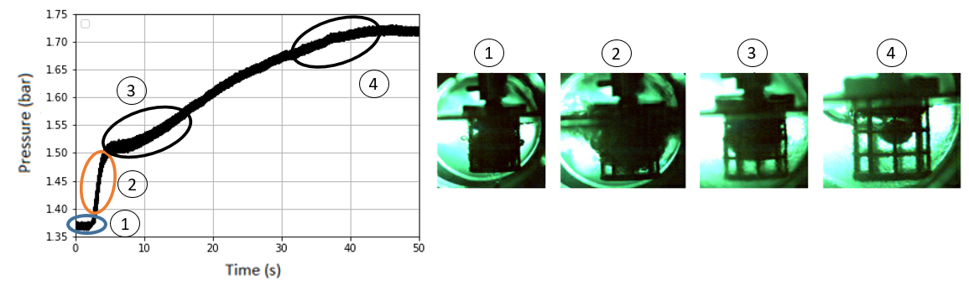

*Figure 8: Classic pathway of a mitigate reaction*

The characteristic white smoke of sodium oxide production and the red/orange colour of the particle show that a combustion phenomenon is almost systematic during each test, with abnormal variations of the gas phase temperature. This implies that all sodium does not react with water, according to the SWR reaction balance equation. Considering the difference between theoretical (QTheo) and experimental (QExp) energy released, it is possible to estimate the mass of sodium burned. As explained above, sodium samples are prepared in an argon-inert glove box and stored in jars. Unfortunately, the glove box used still contains enough traces of oxygen and water (< 200 ppm) causing oxidation of the sodium ball on its surface (Figure 9), but it is impossible to estimate the oxidation layer and therefore the mass of pure sodium lost. SWR being a surface reaction, it cannot take place as long as there is an oxide layer around the ball. The enthalpy of this reaction is about -330 kJ/mol (with dissolution of soda) and does not produce dihydrogen. This could therefore be a cause of deviations in the expected overpressure and the energy balance, with an enthalpy of reaction almost twice as high as a SWR.

*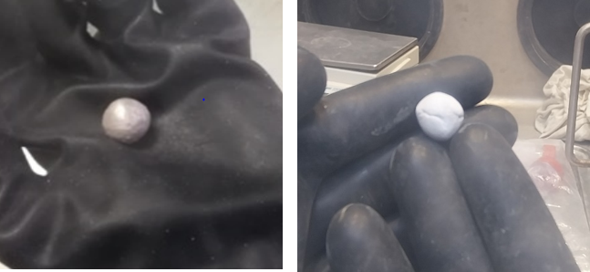*

*Figure 9: Comparison of a pure sodium ball (on left) with an oxidised ball*

* 1. Conclusion

These experimental results provide first trends in the moderation of the sodium-water reaction. In order to improve the results, in the aim of establishing the reaction kinetics, future experiments will be performed with some modifications. Specific weight moulds will be used to manufacture the sodium pellets in a pure argon environment. This modification will allow to confirm the concentration thresholds (perfectly spherical pellets, no oxide crust on the surface). In addition, some evolutions of LAVINO device will be carried out in order to be able to collect samples of the liquid solution and the gas during the reaction. These modifications will allow to determine the reaction kinetics in a near future for an industrial scale-up. This new process with saline solutions, seems to be a good alternative to traditional water cleaning for big sodium fast reactors components and fuel assemblies treatment in order to optimise handling and dismantling operations.

Acknowledgments

The authors acknowledge former internship Sacha Bruno, the former research team who worked on this subject in CEA Cadarache and the project managers and team managers for their financial and material support.

References

Gicquel L., Lefèvre S., Bruno S., Moinot L., Tardivel B., 2024, GLOBAL2024, Tokyo, Japan.

Gicquel L., Lefèvre S., Bruno S., Moinot L., Tardivel B., 2024, 19ème Congrès de la SFGP, Deauville, France.

Lacroix M., 2014, Étude de l’effet modérateur de sels sur la réaction sodium-eau pour le lavage d’assemblages de combustible irradiés issus de réacteurs à caloporteur sodium, PhD, Pierre and Marie Curie University.

Lacroix M., Lorcet H., Perrais C., 2015, Procédé de traitement du sodium par une solution de sel aqueux et procédé de lavage d’assemblages combustibles de réacteur nucléaire utilisant ledit procédé de traitement, WO2015/110480.

Rodriguez G., 2021, Le caloporteur sodium, Tech Ingénieur, BN 3680v2.