|  |  |
| --- | --- |
| cetlogo ***CHEMICAL ENGINEERING TRANSACTIONS***  ***VOL. xxx, 2025*** | A publication of  aidiclogo_grande |
| The Italian Association  of Chemical Engineering  Online at www.cetjournal.it |
| Guest Editors: Fabrizio Bezzo, Flavio Manenti, Gabriele Pannocchia, Almerinda di Benedetto  Copyright © 2025, AIDIC Servizi S.r.l. **ISBN** 979-12-81206-17-5; **ISSN** 2283-9216 | |

Extraction of Rare Earth Elements (REE) from End-of-Life NiMH Battery Electrode Powders Using Deep Eutectic Solvent (DES)

Francesca Pagnanelli\*, Pier Giorgio Schiavi, Marco Colasanti, Pietro Altimari

Department of Chemistry, La Sapienza University. P.le Aldo Moro 5, 00185 Rome (IT)

\*francesca.pagnanelli@uniroma1.it

Rare Earth Elements (REEs) are critical raw materials essential for energy and digital transitions. In this study, original data are presented on the extraction of REEs from electrode powders of NiMH batteries pre-treated through physical methods in a cryo-mechanical pilot plant. The electrode powder was characterized for its chemical composition and subsequently subjected to extraction using a DES based on choline chloride and lactic acid (with a molar ratio of 1:2). The performance of DES extraction was compared with leaching using sulfuric acid under varying temperatures. Empirical modeling of extraction with sulfuric acid revealed a significant negative effect of increasing temperature on the extraction of both Lanthanum and Cerium, which consequently reduced REE selectivity. Kinetic tests using DES showed a positive effect of time on REE extraction, while other metals (such as Nickel and Manganese) exhibited a non-monotonic effect of time, ultimately enhancing REE selectivity at longer durations.

* 1. Introduction

Rare Earth Elements (REEs) are considered Critical Raw Materials in the EU due to their importance in emerging technologies supporting the green transition and their associated supply risk. According to the Critical Raw Materials Act, EU member states must implement actions to ensure minimum benchmarks for the extraction (10%), processing (40%), and recycling (15%) of these materials. Currently, REEs are primarily used in catalysts, glass, and ceramics industries in the US and EU. However, on a global scale—dominated by China's leadership in the REE sector—the primary application is in magnet production (Salehi et al., 2023).

REEs naturally occur in various minerals, including silicates, carbonates, and phosphates, and exhibit interchangeable properties due to their similar ionic radii. These characteristics complicate their separation during mineral processing (Ganguli et al., 2018). Their limited availability is primarily due to low concentrations in most deposits, making economic exploitation feasible only in specific cases (Van Gosen et al., 2017). Recovery of REEs involves physical, pyrometallurgical, and hydrometallurgical processes (McNulty et al., 2022).

Major secondary resources of REEs include permanent magnets, batteries, fluorescent lamps, catalysts, phosphogypsum, bauxite residue (red mud), mine tailings, metallurgical slags, and fly ash (Dushyantha et al., 2024). Among these, NiMH batteries (used in first-generation electric vehicles) are an interesting secondary source, containing approximately 8–10% REE content (Dushyantha et al., 2024).

NiMH batteries employ NiOOH as the positive electrode, a metal hydride as the negative electrode, and an alkaline electrolyte (KOH). During discharge, hydrogen storage alloys (e.g., LaNi5) at the anode release hydrogen, which is oxidized (from 0 to +1), while nickel in NiOOH at the cathode reduces to Ni(OH)2, transitioning from a +3 valence state to +2 (Sarmah et al., 2023). The initial composition of end-of-life electrode materials (black mass) includes Ni in reduced and oxidized forms (0, +1, and +2) and REEs in their reduced state (0). However, due to decomposition phenomena during operation (Walther et al., 2023) and air oxidation during mechanical pretreatment, the final speciation of metals includes oxidized forms of REEs (+3).

REE recovery from NiMH black mass can be achieved via pyrometallurgical or hydrometallurgical processes. Pyrometallurgical methods exploit the high affinity of REEs for oxygen. During smelting of NiMH black mass with fluxing agents (e.g., SiO2-CaO or CaO-CaF2 mixtures to reduce viscosity), REEs oxidize and concentrate in the slag, while Ni, Co, Si, and Ca are reduced into a metal phase (Müller and Friedrich, 2006).

Hydrometallurgical approaches include complete leaching, separation by solvent extraction (Larsson et al., 2012; Ahn et al., 2020; Jha et al., 2022; Zhang et al., 2024), and precipitation. Innovative separation techniques have also been proposed, including the use of ionic liquids (Vander Hoogerstraete and Binnemans, 2014), biphasic aqueous systems (Vargas et al., 2021), and deep eutectic solvents (DES) (Cruz et al., 2024). To avoid separation in leach liquor, selective precipitation from leach liquors can be employed (Bertuol et al., 2009; Tanji et al., 2024) or selective leaching methods can be applied (Meshram et al., 2017; Porvali et al., 2018; Lie et al., 2021). Furthermore, innovative chemicals such as organic acids (Gismonti et al., 2021; Constantine et al., 2022; Rasoulnia et al., 2023) and supercritical fluids (Yao et al., 2018) have been proposed for selective extraction of REEs from NiMH black mass.

Among innovative leaching extractants, DESs have been investigated for REE recovery from various matrices such as magnets (Riano et al., 2017; Liu et al., 2020; Yu et al., 2024), mine tailings (Drogobuzhskaya et al., 2024), coal fly ash (Karan et al., 2022), and fluorescent lamps (Pateli et al., 2020). A DES based on choline chloride (ChCl) and lactic acid or para-toluenesulfonic acid achieved a REE extraction efficiency of 85–95% when used with coal fly ash (Karan et al., 2022); similarly, a ChCl:lactic acid DES demonstrated high leaching efficiencies with selectivity for REEs over base metals when applied to NdFeB magnets (Riano et al., 2017), while a ChCl:levulinic acid DES system dissolved 100% of phosphorus-containing REEs in fluorescent powders, facilitated by high temperatures and water content (Pateli et al., 2020). Nevertheless, the literature lacks studies directly utilizing DESs for REE recovery from NiMH black mass. DESs hold potential to enhance the selectivity of REE extraction from NiMH black mass, while reducing operational costs associated with solvent extraction using flammable organic solvents (Alguacil and Robla, 2023).

Specifically, choline chloride-lactic acid DES can selectively dissolve REE oxides in metallic matrices through a multi-step mechanism. Initially, the acidic nature of lactic acid protonates the REE oxides and forms complexes with REEs (Riano et al., 2017). Chloride ions from choline chloride further enhance solubilization by coordinating with rare-earth ions, effectively drawing them into the solution. In contrast, metals such as nickel and manganese resist dissolution due to their lower susceptibility to the acidic and coordinating properties of the DES. This selectivity is advantageous for recovering REEs while leaving base metals intact.

This study reports, for the first time, original results on metal extraction from NiMH black mass using choline chloride-lactic acid DES, compared to conventional acid leaching.

* 1. Materials and methods
     1. Black mass and metal extraction tests

The NiMH black mass was provided by S.E.Val. End-of-life NiMH batteries were cryo-crushed, and the black mass was recovered by sieving, collecting particles smaller than 1 mm as undersieve (Pagnanelli et al., 2023).

The metal content of the NiMH black mass was determined by mineralizing the solids in an acid solution, followed by analysis of the resulting solutions using an Inductively Coupled Plasma–Optical Emission Spectrophotometer (ICP-OES, Avio 220 Max, Perkin Elmer) (Pagnanelli et al., 2024). Acid leaching tests were conducted in thermostated jacketed vessels under magnetic stirring using a sulfuric acid solution (VWR Chemicals, 95% w/w) at a solid-to-liquid ratio of 1:10 (g/mL) for 3 hours. After leaching, residual solids were separated by centrifugation, and the resulting liquid phase was diluted and analyzed by atomic absorption spectrophotometer (AAS - ContraAA 300 - Analytik Jena AG).

DES extraction tests were performed using a DES based on choline chloride (98%, Alfa Aesar) and lactic acid (85-90%, Alfa Aesar) in a molar ratio of 1:2. The experiments employed a solid-to-liquid ratio of 1:10 (g/mL) without stirring at a fixed temperature of 80°C. Samples were taken periodically, centrifuged, diluted, and analyzed by ICP-OES to determine metal concentrations.

2.2 Regression analysis

Empirical models were developed to identify the significant effects of the investigated factors (acid concentration, temperature, and time) on the output variables (metal extraction and selectivity) using JMP software. For acid leaching, the initial full model included quadratic and linear terms for acid concentration, a linear term for temperature, and one interaction term. For DES extraction, only the dependence on time was assessed using a univariate linear model. All variables (investigated factors) were coded within the range of -1 to +1 to allow for direct comparison of the magnitudes of the effects based on regression coefficients. Significant regression coefficients were identified through statistical tests, with the alternative hypothesis evaluating their difference from zero. Coefficients with the highest p-values were progressively removed using stepwise regression. The reduced models retained only the parameters that were significantly different from zero, with p-values lower than 0.05, while adhering to the hierarchical principle.

* 1. Results and discussion
     1. Black mass chemical composition

The preliminary characterization of the metal content in NiMH black mass samples is presented in Table 1, with results reported as mean values and standard deviations in mg/g. Experimental analysis revealed that nickel (Ni) is the primary component of the black mass, accompanied by smaller amounts of cobalt (Co). Lanthanum (La) and Cerium (Ce) were also found at relevant concentrations accounting for more than 10% in weight.

Table 1: Mean content (mg/g) of La, Ce, Ni and Co in black mass of NiMH batteries

|  |  |  |
| --- | --- | --- |
| %w/w | Mean | Standard Deviation |
| La | 8.2 | 0.4 |
| Ce | 3.8 | 0.2 |
| Ni | 40.3 | 1.9 |
| Co | 5.0 | 0.4 |

A comprehensive characterization of the black mass revealed the presence of other REEs, such as neodymium and praseodymium, as well as other metals like manganese and zinc. However, this preliminary study focuses on the extraction yield and selectivity of different procedures, considering only La, Ce, Ni, and Co. These four elements were chosen as they are the most abundant metals, accounting for 83% of the total metal content in the black mass. In subsequent analyses, La and Ce were selected as representatives of the rare earth elements in the black mass, while Ni and Co were used as representatives of bulk metallic materials. The selectivity of the extraction procedures for REEs was evaluated as the percentage of the total extracted metals (La, Ce, Ni, and Co) attributable to La and Ce.

* + 1. Extraction using acid leaching

Table 2 presents the experimental results for metal extraction and selectivity. A qualitative analysis of the data shows that the extraction of REEs decreases as temperature increases. In contrast, the extraction yields of nickel and cobalt appear unaffected by the investigated factors, consistently exhibiting higher extraction yields than REEs. Consequently, selectivity for REEs is greatest at the lowest temperature (28.9%).

Table 2: Extraction yield of metals (%) and selectivity (%) performing acid leaching in different operating conditions.

|  |  |  |  |  |  |  |
| --- | --- | --- | --- | --- | --- | --- |
| H2SO4 (M) | T (°C) | La Extraction  (%) | Ce Extraction  (%) | Ni Extraction  (%) | Co Extraction  (%) | REE Selectivity (%) |
| 0.7 | 25 | 60.5 | 50.5 | 45.5 | 70.2 | 28.9 |
| 1 | 25 | 60.5 | 63.8 | 90.2 | 64.6 | 17.6 |
| 2 | 25 | 77.1 | 78.8 | 100 | 100 | 19.3 |
| 1 | 80 | 33.8 | 31.6 | 83.7 | 89.3 | 10.1 |
| 2 | 80 | 9.8 | 5.8 | 98.1 | 91.2 | 2.3 |
| 3 | 80 | 24.9 | 20.8 | 89.1 | 81.6 | 6.9 |

Regression analysis evidenced that La extraction experienced both temperature and acid effects (eq. 1), while Ce was only negatively affected by temperature (eq. 2) as REE selectivity (eq. 3). As for Ni and Co extraction, all tested conditions are equivalents and observed differences are due only due to random errors.

$La Extraction \left(\%\right)=42+12∙x_{1}-31∙x_{2}+25∙x_{1}∙x_{2}$ (1)

$Ce Extraction \left(\%\right)=42-22∙x_{2}$ (2)

$REE Selectivity \left(\%\right)=15-8∙x_{2}$ (3)

where x1 is the coded variable for acid concentration and x2 for temperature.

The observed negative effect of temperature can be related to the decrease of REE solubility in sulfuric acid media [Nguyen et al., 2023], leading to a reduction of REE concentration in solution and then a decrease of REE extraction.

Model predictions are reported in Figures 1. According to these results, in order to increase selectivity towards REE temperature should be kept at the lowest investigated value, but using sulphur acid even at the lowest concentration determined a high extraction of Ni and Co leading to low selectivity towards REE.

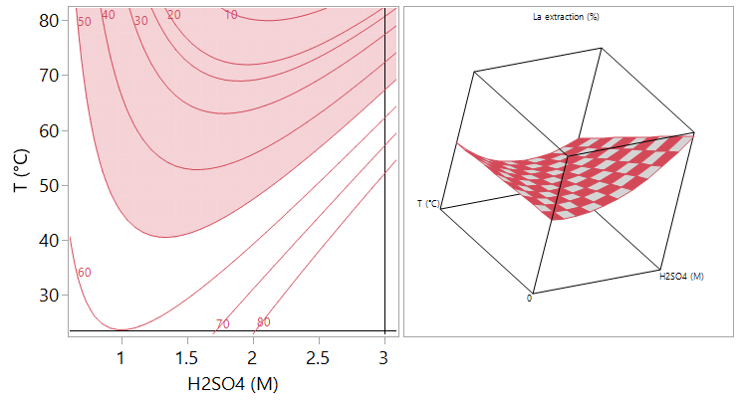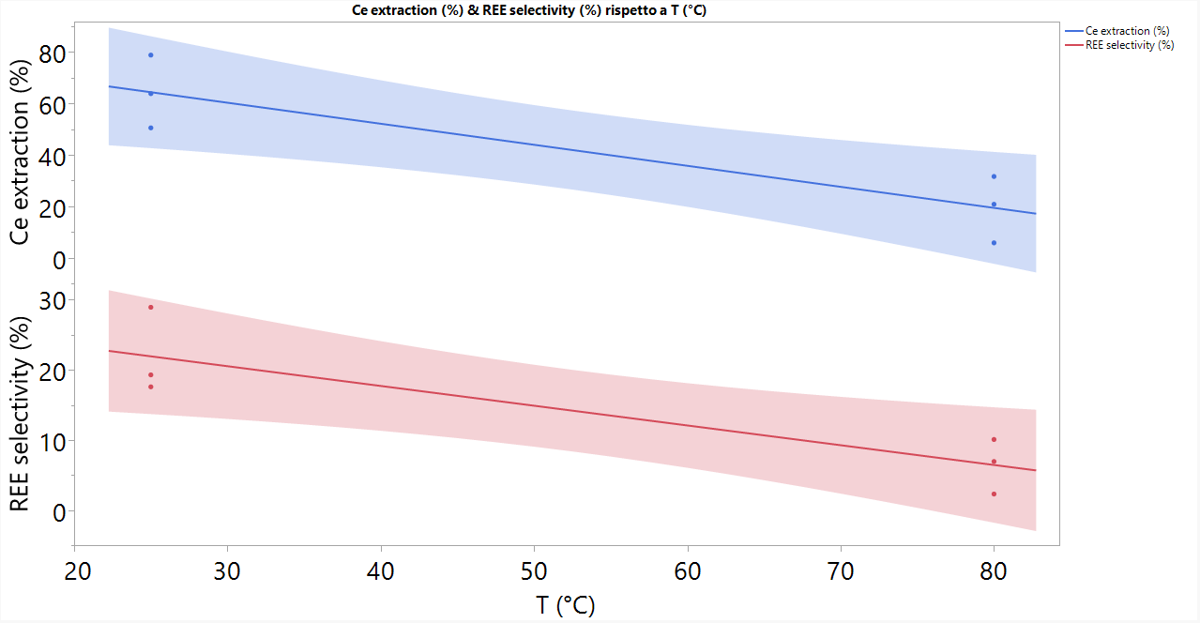

Figure 1: Acid leaching: isometric profiles for the effect of temperature and acid concentration on La extraction yield (%) (left); effect of temperature on Ce extraction yield (%) and REE selectivity (right).

* + 1. Extraction using DES

Metal extraction using DES was preliminarily assessed under fixed conditions of solid-to-liquid ratio, agitation, and temperature, focusing solely on the effects of time (Table 3). Under these preliminary conditions, metal extractions are lower compared to acid leaching. However, higher values of REE selectivity, reaching up to 35%, were achieved. This outcome is primarily attributed to the distinct effect of time on metal extraction, as evidenced by the regression analysis results shown in Figure 2. Specifically, for La and Ce, a significant positive effect of time on extraction was observed within the investigated range (Figure 2, left). In contrast, Ni and Co displayed a non-monotonic extraction trend over time (Figure 2, right). This behavior resulted in a notable increase in REE selectivity as time progressed (Figure 2, right).

Table 3: Extraction yield of metals (%) and selectivity (%) performing extraction with DES at different times.

|  |  |  |  |  |  |
| --- | --- | --- | --- | --- | --- |
| Time (h) | La Extraction (%) | Ce Extraction (%) | Ni Extraction (%) | Co Extraction (%) | REE Selectivity (%) |
| 0.5 | 7.1 | 4.9 | 12.8 | 14.6 | 11.5 |
| 0.5 | 7.5 | 4.8 | 11.4 | 11.8 | 13.4 |
| 1 | 7.6 | 5.7 | 14.2 | 16.1 | 11.4 |
| 1 | 8.6 | 7.3 | 14.8 | 16.1 | 12.6 |
| 2 | 9.2 | 6.8 | 19.6 | 20.9 | 10.2 |
| 2 | 10.7 | 8.3 | 15.8 | 13.8 | 14.4 |
| 6 | 20.9 | 13.7 | 19.6 | 25.8 | 19.6 |
| 6 | 24.9 | 17.3 | 22.0 | 30.6 | 20.6 |
| 24 | 38.5 | 32.0 | 18.2 | 25.3 | 33.7 |
| 24 | 39.6 | 31.2 | 17.2 | 25.6 | 35.1 |

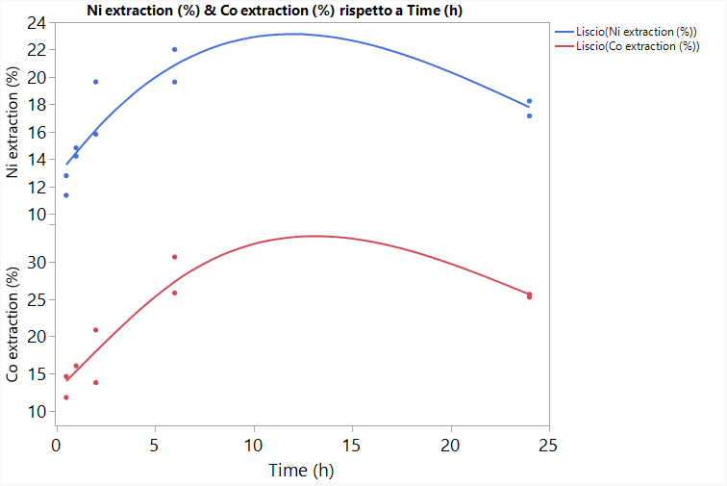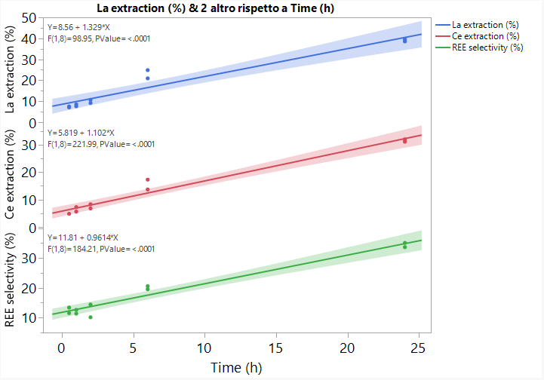

Figure 2: Metal extraction (%) and REE selectivity during time for DES extraction: La, Ce extractions and REE selectivity (left); Ni and Co extractions (right).

The non monotonic effect of time on Ni and Co extraction is not commonly observed in the literature. At this stage of knowledge, one possible explanation for the extraction decrease during time could be the precipitation of metals due to local pH increase and/or reoxidation.

* 1. Conclusions

The paper presents, for the first time in the literature, the extraction kinetics of metals from the black mass of NiMH batteries using a DES based on lactic acid and choline chloride. The results show that the system can more selectively extract rare earth elements compared to the base metals (Ni and Mn), though with lower extraction efficiencies that require further optimization of operational conditions. Specifically, this preliminary test was conducted on black mass without agitation and at a relatively low temperature. Both factors, considering the viscosity of the DES, may negatively affect metal extraction and should be further investigated.

Acknowledgments

The research was funded by the European Union - NextGenerationEU under the National Recovery and Resilience Plan (NRRP), Mission 4 Component 2 Investment 1.3 - Call for tender No. 1561 of 11.10.2022 of Ministero dell’Università e della Ricerca (MUR), Project code PE0000021, CUP B53C22004070006, Project title “Network 4 Energy Sustainable Transition – NEST”

References

Ahn N.K., Shim H.W., Kim D.W., Swain B., 2020, Valorization of waste NiMH battery through recovery of critical rare earth metal: A simple recycling process for the circular economy, Waste Management, 104, 254-261. https://doi.org/10.1016/j.wasman.2020.01.014

Alguacil F.J., Robla J.I., 2023, Recent Work on the Recovery of Rare Earths Using Ionic Liquids and Deep Eutectic Solvents, Minerals, 13(10), 1288. https://doi.org/10.3390/min13101288

Bertuol D.A., Bernardes A.M., Tenório J.A.S., 2009, Spent NiMH batteries—The role of selective precipitation in the recovery of valuable metals, Journal of Power Sources, 193(2), 914-923. https://doi.org/10.1016/j.jpowsour.2009.05.014

Constantine J., Lie J., Liu J.C., 2022, Recovery of rare earth elements from spent NiMH batteries using subcritical water extraction with citric acid, Journal of Environmental Chemical Engineering, 10(3), 108000. https://doi.org/10.1016/j.jece.2022.108000

Cruz K.A.M.L., Rocha F.R.P., Hespanhol M.C., 2024, Greener Route for Recovery of High-Purity Lanthanides from the Waste of Nickel Metal Hydride Battery Using a Hydrophobic Deep Eutectic Solvent, ACS Sustainable Chemistry & Engineering, 12(16), 6169-6181. https://doi.org/10.1021/acssuschemeng.3c07784

Drogobuzhskaya S., Frolova M., Shishov A., Tsvetov N., 2024, Comparison of extraction abilities of deep eutectic solvents and aqueous acid solutions for extraction of rare earths and transition metals, Journal of Rare Earths, 42(6), 1157-1164. https://doi.org/10.1016/j.jre.2023.06.014

Dushyantha N., Kuruppu G.N., Nanayakkara C.J. et al., 2024, The Role of Permanent Magnets, Lighting Phosphors, and Nickel-Metal Hydride (NiMH) Batteries as a Future Source of Rare Earth Elements (REEs): Urban Mining Through Circular Economy, Mining, Metallurgy & Exploration, 41, 321–334. https://doi.org/10.1007/s42461-023-00904-0

Ganguli R., Cook D.R., 2018, Rare earths: A review of the landscape, MRS Energy & Sustainability, 5, E9. https://doi.org/10.1557/mre.2018.7

Gismonti P.R., Paulino J.F., Afonso J., 2021, Recovery of metals from electroactive components of spent Ni-MH batteries after leaching with formic acid, Detritus, 14, 68–77. https://doi.org/10.31025/2611-4135/2021.14063

Jha M.K., Choubey P.K., Dinkar O.S., Panda R., Jyothi R.K., Yoo K., Park I., 2022, Recovery of Rare Earth Metals (REMs) from Nickel Metal Hydride Batteries of Electric Vehicles, Minerals, 12(1), 34. https://doi.org/10.3390/min12010034

Karan R., Sreenivas T., Kumar M.A., Singh D.K., 2022, Recovery of rare earth elements from coal fly ash using deep eutectic solvents as leachants and precipitating as oxalate or fluoride, Hydrometallurgy, 214, 105952. https://doi.org/10.1016/j.hydromet.2022.105952

Larsson K., Ekberg C., Ødegaard-Jensen A., 2012, Using Cyanex 923 for selective extraction in a high concentration chloride medium on nickel metal hydride battery waste, Hydrometallurgy, 129–130, 35-42. https://doi.org/10.1016/j.hydromet.2012.08.011

Lie J., Liu J.C., 2021, Selective recovery of rare earth elements (REEs) from spent NiMH batteries by two-stage acid leaching, Journal of Environmental Chemical Engineering, 9(5), 106084. https://doi.org/10.1016/j.jece.2021.106084

Liu C., Yan Q., Zhang X., Lei L., Xiao C., 2020, Efficient Recovery of End-of-Life NdFeB Permanent Magnets by Selective Leaching with Deep Eutectic Solvents, Environmental Science & Technology, 54(16), 10370–10379. https://doi.org/10.1021/acs.est.0c03278

McNulty T., Hazen N., Park S., 2022, Processing the ores of rare-earth elements, MRS Bulletin, 47, 258–266. https://doi.org/10.1557/s43577-022-00288-4

Meshram P., Somani H., Pandey B.D., Mankhand T.R., Deveci H., Abhilash, 2017, Two stage leaching process for selective metal extraction from spent nickel metal hydride batteries, Journal of Cleaner Production, 157, 322-332. https://doi.org/10.1016/j.jclepro.2017.04.144

Müller T., Friedrich B., 2006, Development of a recycling process for nickel-metal hydride batteries, Journal of Power Sources, 158(2), 1498-1509. https://doi.org/10.1016/j.jpowsour.2005.10.046

Nguyen, T. T. H., & Lee, M. S. (2023). A Simple Process for the Recovery of Rare Earth Elements and Iron from Sulfuric Acid Leaching Solution of NdFeB Magnets by Double Salt Precipitation. Mineral Processing and Extractive Metallurgy Review, 45(6), 654–668. https://doi.org/10.1080/08827508.2023.2232932

Pagnanelli, F., Schiavi, P.G., Altimari, P., Beolchini, F., Amato, A., Coletta, J., Forte, F., Moscardini, E., Toro, L., 2023 Economic and Environmental Sustainability of an Innovative Cryo-Mechano-Hydrometallurgical Process Validated at Pilot Scale for the Recycling of Li Batteries, Metals (Basel) 13. <https://doi.org/10.3390/met13030497>.

Pagnanelli, F., Altimari, P., Colasanti, M., Coletta, J., D’Annibale, L., Mancini, A., Russina, O., & Schiavi, P. G. (2024). Recycling Li-Ion Batteries via the Re-Synthesis Route: Improving the Process Sustainability by Using Lithium Iron Phosphate (LFP) Scraps as Reducing Agents in the Leaching Operation. Metals, 14(11), 1275. <https://doi.org/10.3390/met14111275>

Pateli I.M., Abbott A.P., Binnemans K., Rodriguez Rodriguez N., 2020, Recovery of yttrium and europium from spent fluorescent lamps using pure levulinic acid and the deep eutectic solvent levulinic acid–choline chloride, RSC Advances, 10(48), 28879–28890. https://doi.org/10.1039/D0RA05508E

Porvali A., Wilson B.P., Lundström M., 2018, Lanthanide-alkali double sulfate precipitation from strong sulfuric acid NiMH battery waste leachate, Waste Management, 71, 381-389. https://doi.org/10.1016/j.wasman.2017.10.031

Rasoulnia P., Hajdu-Rahkama R., Puhakka J.A., 2023, High-rate and -yield continuous fluidized-bed bioconversion of glucose-to-gluconic acid for enhanced metal leaching, Chemical Engineering Journal, 462, 142088. https://doi.org/10.1016/j.cej.2023.142088

Riano S., Petranikova M., Onghena B., Vander Hoogerstraete T., Banerjee D. et al., 2017, Separation of rare earths and other valuable metals from deep-eutectic solvents: a new alternative for the recycling of used NdFeB magnets, RSC Advances, 7(51), 32100-32113. https://doi.org/10.1039/c7ra06540j

Salehi H., Maroufi S., Mofarah S.S., Nekouei R.K., Sahajwalla V., 2023, Recovery of rare earth metals from Ni-MH batteries: A comprehensive review, Renewable and Sustainable Energy Reviews, 178, 113248. https://doi.org/10.1016/j.rser.2023.113248

Sarmah S., Lakhanlal, Kakati B.K., Deka D., 2023, Recent advancement in rechargeable battery technologies, WIREs Energy and Environment, 12, e461. https://doi.org/10.1002/wene.461

Tanji K., Ouzaouit K., Belghiti M., Lamsayety I., Faqir H., Benzakour I., 2024, Hydrometallurgy two-stage process for preparation of (Nd, La, Ce)2O3 from end-of-life NiMH batteries, Journal of Rare Earths, 42(2), 415–423. https://doi.org/10.1016/j.jre.2023.02.020

Van Gosen B.S., Verplanck P.L., Seal II R.R., Long K.R., Gambogi J., 2017, Rare-earth elements, US Geological Survey, No. 1802-O. https://pubs.usgs.gov/pp/1802/o/pp1802o.pdf

Vander Hoogerstraete T., Binnemans K., 2014, Highly efficient separation of rare earths from nickel and cobalt by solvent extraction with the ionic liquid trihexyl(tetradecyl)phosphonium nitrate: a process relevant to the recycling of rare earths from permanent magnets and nickel metal hydride batteries, Green Chemistry, 16(3), 1594-1606. https://doi.org/10.1039/C3GC41577E

Walther T., 2023, Chemical structure comparison via scanning electron microscopy of spent commercial nickel–metal hydride batteries, Materials, 16(17), 5761. https://doi.org/10.3390/ma16175761

Vargas S.J.R., Schaeffer N., Souza J.C., da Silva L.H.M., Hespanhol M.C., 2021, Green separation of lanthanum, cerium and nickel from waste nickel metal hydride battery, Waste Management, 125, 154–162. https://doi.org/10.1016/j.wasman.2021.02.038

Yao Y., Farac N.F., Azimi G., 2018, Supercritical fluid extraction of rare earth elements from nickel metal hydride battery, ACS Sustainable Chemistry & Engineering, 6(1), 1417–1426. https://doi.org/10.1021/acssuschemeng.7b03803

Yu G., Ni S., Gao Y., Mo D., Zeng Z., Sun X., 2024, Recovery of rare earth metal oxides from NdFeB magnet leachate by hydrophobic deep eutectic solvent extraction, oxalate stripping and calcination, Hydrometallurgy, 223, 106209. https://doi.org/10.1016/j.hydromet.2023.106209

Zhang S., Ni S., Zeng Z., Yu G., Huang B., Sun X., 2024, A clean process for the recovery of rare earth and transition metals from NiMH battery based on primary amine and lauric acid, Journal of Environmental Management, 351, 119788. https://doi.org/10.1016/j.jenvman.2023.119788