|  |  |
| --- | --- |
| cetlogo ***CHEMICAL ENGINEERING TRANSACTIONS***  ***VOL. xxx, 2025*** | A publication of  aidiclogo_grande |
| The Italian Association  of Chemical Engineering  Online at www.cetjournal.it |
| Guest Editors: Fabrizio Bezzo, Flavio Manenti, Gabriele Pannocchia, Almerinda di Benedetto  Copyright © 2025, AIDIC Servizi S.r.l. **ISBN** 979-12-81206-17-5; **ISSN** 2283-9216 | |

Copper nanoparticles in liquid by a non-capacitive wire explosion technique

Andrea P. Reverberia,\*, Virginia Bazzurrob, Anna Maria Cardinalea, Marco Vocciantea, Omar Sodac, Bruno Fabianod

a DCCI – Department of Chemistry and Industrial Chemistry, University of Genova, via Dodecaneso 31, 16146 Genova, Italy

b DIFI – Department of Physics, University of Genova, via Dodecaneso 33, 16146 Genova, Italy

c DCCI – Department of Chemistry and Industrial Chemistry and Laboratory of Advanced Electron Microscopy, University of Genova, via Dodecaneso 31, 16146 Genova, Italy

dDICCA – Department of Civil, Chemical and Environmental Engineering, Polytechnic School, University of Genova, via Opera Pia 15, 16145 Genova, Italy

andrea.reverberi@unige.it

An experimental study for copper nanoparticles (NPs) synthesis in aqueous phase, relying upon a physical top-down technique, is proposed. It differs from the well-known wire-explosion protocol, in that two wire-shaped conductors, made of metal precursors of different sections, undergo a short circuit at low voltage where a high current density leads to an instantaneous disaggregation of preferentially one of the two electrodes immersed in a liquid phase, without establishing a stable arc-discharge regime. The as-obtained NPs have been characterized in size by dynamic light scattering (DLS) and in morphology by transmission electron microscopy (TEM). Two non-ionic polymeric capping agents having the same monomeric structure, but differing from one another in molecular weight, have been dissolved in the liquid holdup and the average diameter of the as-obtained Cu NPs is 63 and 72 nm. The present work, thanks to a relatively easy experimental setup and to the mitigation of risk conditions usually related to the use of high voltages, may represent a promising technique in alternative to other physical top-down methods for a sustainable and cost-effective metal NPs synthesis.

* 1. Introduction

Nanotechnology has today assumed a key role in the production of highly engineered materials on a small and medium scale, with attractive applications in many different sectors (Korkmaz and Gupta, 2024). For example, micro and nanopatterning of surfaces proved to be a useful technique in increasing biocompatibility of metals used in dental implants (Shayganpour et al., 2015). Likewise, laser-induced surface activation with formation of micro- and nanostructures by local etching, led to an increase of polymer-surface adhesion strength (Omiya et al., 2022). In the field of pollution control and environmental remediation (Vocciante et al., 2017), the use of green nanostructured chemisorbents of natural origin represents a green and sustainable technology for wastewater treatment (Fathi et al., 2024).

In the specific context of NPs synthesis, the most widely adopted protocols rely upon chemical methods, generally comprising bottom-up and top-down techniques. The former, based on a process of nucleation and particle growth from atomic/molecular dimension up to a nanosized diameter, may be carried out in various experimental conditions both in solid and in liquid embedding medium. For example, NPs made of oxides of non-noble elements may be synthesized at the dry state by pyrolysis of a precursor undergoing a spontaneous thermal decomposition (Chiarioni et al., 2006). More routinely, NPs of many different compositions can be produced in a liquid phase using reactants having an active function during the process of nanosynthesis. This is the case of reductants required when metal NPs are the target of the process, based on redox reactions where the electron donors are, in many cases, much more toxic and environmentally noxious than the precursors itself (Lu et al., 2017). For this reason, the recent trends in NPs synthesis in liquid phase refer to the use of green reactants in processes carried out at milder operating conditions, in order to fulfill a multitasking objective of environmental protection and energy saving (Melo et al., 2023). This protocol proved to be efficient not only as far as metal NPs are concerned, but also in the production of metal oxide NPs. In this context, many reagents of vegetal origin have been successfully utilized, as proposed by Avila-Concepctión et al. (2024), who used an aqueous extract of Annona muricata leaves for the production of ZnO NPs. Analogously, other researchers synthesized ZnO nanostructures using a different vegetal extract and tested the as-produced solid phase (Aliannezhadi et al., 2024). The substitution strategy not only pertains to the selection of reactants, but it may also concern the choice of capping agents, namely the chemicals damping NPs aggregation (Skiba and Vorobyova, 2023). That is why thiols, aliphatic amines and artificially made ionic surfactants are going to be progressively replaced by saponins, aminoacids (Ghiyasiyan‑Arani et al., 2018), polysaccharides like starch (Tiwari et al., 2024) and gums (Rahdar et al., 2020), and other compounds of natural origin inhibiting or at least attenuating particle aggregation.

As an alternative to all aforementioned chemical methods, physical methods have been proposed in NPs synthesis (Reverberi et al., 2022), and they differ from one another in the complexity and cost of the experimental setup. El-Khawaga et al. (2023) authored an interesting review on this topic and we refer the reader to the references quoted therein. Namely, while NPs synthesis carried out by laser ablation and sputtering usually require expensive apparatuses and an accurate control setup, mechanosynthesis methods represent a class of economically viable processes to produce NPs even at a medium and large scale. As a first rough classification, these methods can be divided in wet and liquid-assisted mechanosynthesis processes, according to whether a solvent is present during the comminution process (Reverberi et al., 2020). The latter can be carried out in autogenous or non-autogenous mode, depending on the presence of a milling medium, generally represented by hard metallic or ceramic spheres.

Wire explosion methods occupy a sort of niche position in the context of physical nanosynthesis, but they have already been tested in the preparation of zerovalent metal dispersions in organic and aqueous solvent (Bac et al., 2010), or in a gas (Wada et al., 2013). The standard technique is based on an instantaneous discharge of an electric capacitor, whose current is passed through a wire of a relatively thin metal conductor immersed in a fluid and short-circuited between the poles of the aforementioned charged capacitor. The wire, undergoing thermal disaggregation by Joule effect, is the metal precursor of the corresponding nanoparticles released into an embedding fluid.

The method proposed here may be considered as a variant of the standard wire explosion technique, as it relies upon a pulsed contact disaggregation not requiring a capacitive discharge at high voltage (Jankauskas et al., 2011), usually adopted in most experimental techniques based on wire disaggregation by Joule effect (Nguyen et al., 2018). The method has been tested in an aqueous liquid phase containing two different capping agent formulations to prevent NPs aggregation and oxidation.

The paper is divided as follows. In Section 2, the materials used and the relevant experimental setup have been described. In Section 3, the as-synthesized NPs have been characterized in morphology and composition according to the different experimental conditions here adopted. In Section 4, the conclusions are drawn and an outlook on future development of this research is suggested.

* 1. Experimental setup
     1. Materials and methods

Two copper wires of 0.4 and 2 mm diameter (Cu, 99.999%, Sigma-Aldrich, Milano, Italy), two polyvinyl pyrrolydone oligomers having different molecular weight of 40 kDa and 10 kDa (PVP40 and PVP10, (C6H9NO)x, 99%, La Farmochimica, Genova, Italy), n-hexane ( C6H14, >99%, Carlo Erba, Milano, Italy) and deionized water have been employed. The wires were previously degreased with hexane in order to avoid any possible contamination with unwanted organic material. Before each experimental test, water has been bubbled by an argon stream to strip all residual oxygen present in it, in order to damp NPs oxidation. All experiments were carried out at room temperature.

The NPs diameter was investigated by dynamic light scattering (Zetasizer Nano, Malvern Instruments, Malvern, UK). A polystyrene cuvette was filled with 1.3 mL of solution, carrying the suspended solid phase. The refractive index of Cu and the liquid holdup viscosity at room temperature were taken from literature data.

The particle shape has been investigated by transmission electron microscopy (TEM, JEOL 2100 Plus, Akishima, Japan), using a copper lacey grid on which an aliquot of the liquid dispersion was collected and further vacuum dried. After graphitization, the relevant residue was finally scanned by a 200 kV electron beam.

* + 1. The wire explosion setup

In Figure 1, a simplified scheme of the experimental setup is reported. A cylindrical glass vessel, containing an aqueous liquid holdup and a teflon (PTFE) stirring bar, is located on a magnetic stirrer ensuring a good agitation of the liquid holdup, where a fixed amount of capping agent has been dissolved. A L-shaped copper electrode is kept stick to the inner side surface of the vessel so that its horizontal side draws into the liquid parallel to the bottom of the vessel, as described in Figure 1. This electrode is connected with a pole of a low-voltage alternate current generator. The other electrode, made of a thinner Cu wire and representing the sacrificial electrode, is inserted into the solution and, as soon as it comes into contact with the L-shaped electrode, a short-circuit is established whose current causes part of the copper electrode to shatter instantaneously, while macroscopic chunks of it remain at the bottom of the vessel. The as-produced Cu particles are released in the surrounding liquid, the colour of which darkens progressively as the number of contacts and relative short circuits increase.

Suitable fittings around the vessel had to be mounted, in order to damp mechanical vibrations as a consequence of shock wave propagation deriving from bubble formation and implosion in the zone of wire contact. The data pertaining to the operating conditions and to the geometric characteristics of the experimental setup are reported in Table 1.

An attempt was made to install a device for automatic wire feed, but some technical difficulties were encountered due to contact disconnection events outside the solution. For this reason, a manual feed of the wire subject to disconnection was chosen. For each sample prepared, 100 short-circuit events were implemented.

The method described here is a pulsed wire deconstruction technique, differing both from submerged arc and standard wire explosion techniques for two different reasons:

* Standard wire explosion techniques generally rely upon a capacitive current discharge through a metal wire, while here a wire deconstruction is carried out only by simple low-voltage short-circuiting.
* Submerged arc techniques are based on a steady current arc, needing high current intensity and producing a considerable heating of the liquid holdup. Here, instead, the current is too low to ensure a self-sustained arc discharge, but there is only a current pulse disconnecting the conductor and causing an instantaneous unbundling of a part of it. As a consequence, the temperature rise in the liquid holdup at the end of each cycle comprising 100 short-circuits never exceeded 5 °C during each experimental run.

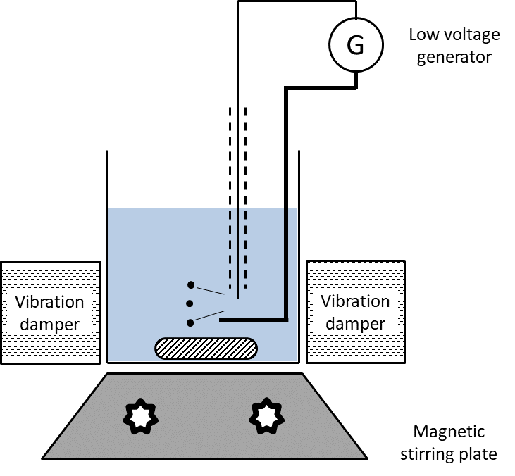

*Figure 1: Simplified scheme of the experimental setup where wire explosion experiments beneath a liquid are carried out.*

Table 1: Data concerning experimental conditions and configuration of the experimental setup.

|  |  |  |  |  |  |
| --- | --- | --- | --- | --- | --- |
| Holdup volume | Vessel  diameter | Fixed electrode  diameter | Moving electrode  diameter | Voltage | Surfactant  concentration |
| 30 [cm3] | 42 [mm] | 2 [mm] | 0.4 [mm] | 14 [V] | 10 [g/L] |

* 1. Results and discussion

In the present paper, Cu has been chosen as a base metal in NPs for different reasons. Like many other transition elements, Cu may enter the composition of intermetallics with singular physical properties (Freccero et al., 2017) and its compounds have been extensively used in semiconductor technology (Freccero et al., 2023). Despite the noxious role of Cu cation in wastewaters (Beolchini et al., 2003), Cu NPs proved to be an efficient source of Cu ions having a basic role in phytopharmacy, owing to selective activity of Cu against pathogens like fungi and nematodes (Tryfon et al., 2022). Likewise, the choice of PVP as capping agent in the present experiments can be motivated by the satisfactory results obtained in many different situations of Cu NPs synthesis, both in bottom-up and in top-down processes. In the latter, often based on collision or surface friction schemes, capping agents may have a basic role in determining short-term and long-term physico-chemical characteristics of the dispersion (Reverberi et al., 2020). Additionally, PVP is recognized as a non-toxic, biodegradable and biocompatible material, with extended uses in medicine and also in products of everyday’s life (Mangang et al., 2023).

During each aforementioned cycle of 100 short-circuiting events, the solution progressively darkens and, at the end of each cycle, the solution becomes so dark that the light emitted in the area of contact between the two wires is mainly absorbed by the surrounding liquid. In Figure 2, two photographs of the liquid suspension after 25 and 100 short-circuiting events have been reported to qualitatively account for this phenomenon. After each cycle, the solution is allowed to stand for 12 h in order to promote the sedimentation of the agglomerated particles. Furthermore, an aliquot of the supernatant liquid is collected for DLS analysis, whose results are reported in Figure 3. From each curve, the calculated average particle diameter in case of PVP10 is 63±10 nm, while the corresponding value in case of PVP40 is 72±12 nm. These results are consistent with TEM images reported in Figure 4, proving that the surfactant efficiency tend to increase for lower values of surfactant’s molecular weight. A possible explanation could be found by taking into account the different mechanism of NPs formation by a chemical reduction technique, implying nucleation from atomic species, and the present technique, where NPs might be present from the very first moments following the short-circuit. Admittedly, in this case, the capture kinetics is favoured by a lower mass polymer. Another interesting aspect arises by simple visual comparison of the two panels in Figure 4. In fact, Cu NPS obtained with PVP40 show the presence of polygon-shaped NPs, while they are scanty when PVP10 is used. Therefore, one may conclude that capping agents of the same chemical composition but different molecular weight, may have a role in NPs shaping.

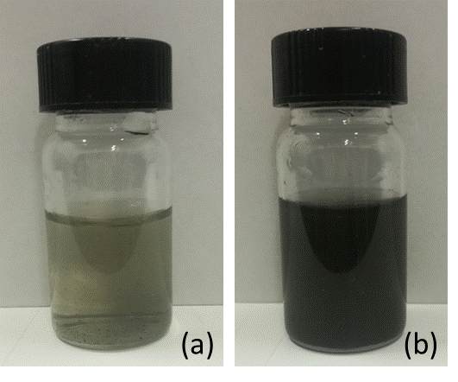

Figure 2: Photographs of a liquid holdup containing PVP10 during wire explosion experiments. (a): after 25 short-circuits; (b): after 100 short-circuits.

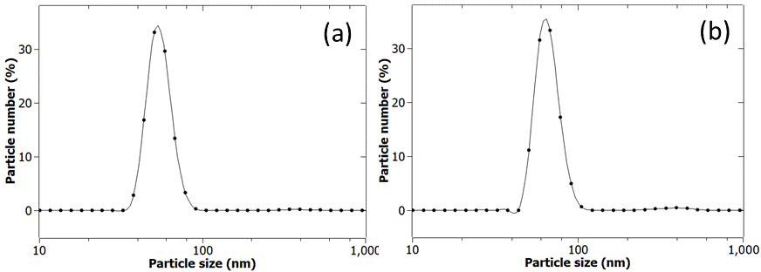

Figure 3: Particle size distributions for Cu NPs in water containing capping agents of two different molecular weights. (a): PVP10; (b): PVP40. Each plot reports the average value of three different runs.

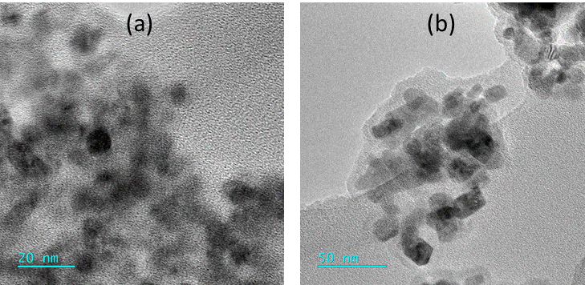

Figure 4: TEM images of Cu NPs obtained using capping agents of two different molecular weight. (a): PVP10; (b): PVP40.

* 1. Conclusions

In the present experimental study, a variant of the wire explosion method has been proposed. The main results can be summarized in the following points:

* The experimental setup, based on a submerged short-circuiting between wires of the metal precursor beneath a water solution where suitable capping agents have been dissolved, does not require the use of high voltage, generally adopted in standard wire explosion techniques. For this reason, this experimental route can contribute to the improvement of safety conditions in a nanosynthesis process, irrespective of the precursor composition.
* With respect to other top-down processes based on autogenous or non-autogenous solid disaggregation, the present technique has a greater hourly productivity. This aspect may have important repercussions in a future scale-up of this technique.

A further development of this process will be based on an improvement in the wire feed technique, possibly making it semi-automatic.

Acknowledgments

The authors are grateful for the TEM characterizations to the Laboratory of Advanced Electron Microscopy - ELEMENTAL (https://elemental.unige.it/en) , co-funded by Regione Liguria within the POR FESR 2014-2020 - Axis 1 - Research and Innovation.

References

Aliannezhadi M., Mirsanaee S.Z., Jamali M., Shariatmadar Tehrani F., 2024, The physical properties and photocatalytic activities of green synthesized ZnO nanostructures using different ginger extract concentrations, Scientific Reports, 14, 2035.

Avila-Concepción S.P.R., Samanamud-Moreno F., Chinchay-Espino H., Zavaleta-Espejo G., Valle-Rivera E., Carranza-Segura E., Jáuregui-Rosas S., 2024, Green Synthesis and characterization of ZnO nanoparticles using Annona Muricata leaves, Chemical Engineering Transactions, 113, 637-642.

Bac L.H., Kim J. S., Kim J. C., 2010, Synthesis of Fe–Ni invar alloy nanopowder by the electrical explosion of wire in the liquid, Research on Chemical Intermediates, 36, 795–800.

Beolchini F., Pagnanelli F., Reverberi A.P., Vegliò F., 2003, Copper biosorption onto Rhizopus oligosporus: pH-edge tests and related kinetic and equilibrium modeling, Industrial and Engineering Chemistry Research, 42, 4881 – 4887.

Chiarioni A., Reverberi A.P., Fabiano B., Dovì V.G., 2006, An improved model of an ASR pyrolysis reactor for energy recovery, Energy, 31, 2460 – 2468.

El-Khawaga A.M., Zidan A., Abd El-Mageed A.I.A., 2023, Preparation methods of different nanomaterials for various potential applications: A review, Journal of Molecular Structure, 1281, 135148.

Fathi A., Asgari E., Danafar H., Salehabadi H., Fazli M.M., 2024, A comprehensive study on methylene blue removal via polymer and protein nanoparticle adsorbents, Scientific Reports, 14, 29434.

Freccero R., Solokha P., Proserpio D.M., Saccone A., De Negri S., 2017, A new glance on R2MGe6 (R = rare earth metal, M = another metal) compounds. An experimental and theoretical study of R2PdGe6 germanides, Dalton Transactions, 46, 14021.

Freccero R., Grin Y., Wagner F.R., 2023, Polarity-extended 8 − Neff rule for semiconducting main-group compounds with the TiNiSi-type of crystal structure, Dalton Transactions, 52, 8222.

Ghiyasiyan‑Arani M., Salavati‑Niasari M., Masjedi‑Arani M., Mazloom F., 2018, An easy sonochemical route for synthesis, characterization and photocatalytic performance of nanosized FeVO4 in the presence of aminoacids as green capping agents, Journal of Materials Science: Materials in Electronics, 29, 474–485.

Jankauskas V., Padgurskas J., Žunda A., Prosyčevas I., 2011, Research into nanoparticles obtained by electric explosion of conductive materials, Surface Engineering and Applied Electrochemistry, 47, 170–175.

Korkmaz M.E., Gupta M.K., 2024, Nano lubricants in machining and tribology applications: A state of the art review on challenges and future trend, Journal of Molecular Liquids, 407,125261.

Lu H., Tian B., Wang J., Hao, H., 2017, Montmorillonite-supported Fe/Ni bimetallic nanoparticles for removal of Cr(VI) from wastewater, Chemical Engineering Transactions, 60,169-174.

Mangang K.N., Thakran P., Halder J., Yadav K.S., Ghosh G., Pradhan D., Rath G., Rai V.K., 2023, PVP-microneedle array for drug delivery: mechanical insight, biodegradation, and recent advances, Journal of Biomaterials Science, Polymer Edition, 34, 986-1017.

Melo A.A., Rodrigues E.P., Vasconcelos J.S., Medeiros E.S., Oliveira L.C., Lima A.M.N., 2023, Dielectric function of gold nanoparticles synthesized using Camellia sinensis extract, Plasmonics, 18, 529–540.

Nguyen, M.T., Kim, J.H., Kim, J.C., 2018, Formation of different Cu nanopowders and stability of Cu fluids produced by electrical explosion of wire in liquid, Archives of Metallurgy and Materials, 63, 1453-1457.

Omiya M., Nakajima A., Yan J., 2022, Design and fabrication of micro and nano surface structures for enhancing metal–polymer adhesion using femtosecond laser treatment, Materials & Design, 224, 111349.

Rahdar A., Beyzaei H., Askari F., Kyzas G.Z., 2020, Gum‑based cerium oxide nanoparticles for antimicrobial assay, Applied Physics A, 126, 324.

Reverberi A.P., Vocciante M., Salerno M., Ferretti M., Fabiano B., 2020, Green synthesis of silver nanoparticles by low-energy wet bead milling of metal spheres, Materials, 13, 63.

Reverberi A.P., Vocciante M., Salerno M., Soda O., Fabiano B., 2022, A sustainable, top-down mechanosynthesis of carbohydrate-functionalized silver nanoparticles, Reaction Chemistry and Engineering, 7, 888-897.

Shayganpour A., Rebaudi A., Cortella P., Diaspro A., Salerno M., 2015, Electrochemical coating of dental implants with anodic porous titania for enhanced osteointegration, Beilstein Journal of Nanotechnology, 6, 2183.

Skiba M., Vorobyova V., 2023, Evaluation of antibacterial, antioxidant, photocatalytic activities of silver‑decorated TiO2 comparison green and classic capping agent, Applied Nanoscience, 13, 5185–5198.

Tiwari A., Singh S., Srivastava P., 2024, Exploring the potential of potato starch-capped TiO2 nanoparticles for DSSC photoanodes, Results in Optics, 15, 100630.

Tryfon P., Kamou N.N., Ntalli N., Mourdikoudis S., Karamanoli K., Karfaridis D., Menkissoglu-Spiroudi U., Dendrinou-Samara C., 2022, Coated Cu-doped ZnO and Cu nanoparticles as control agents against plant pathogenic fungi and nematodes, NanoImpact, 28, 100430.

Vocciante M., Reverberi A.P., Pietrelli L., Dovì V.G., 2017, Improved remediation processes through cost-effective estimation of soil properties from surface measurements, Journal of Cleaner Production,167, 680- 686.

Wada N., Akiyoshi K., Morita K., Hokamoto K., 2013, Reaction synthesis of several titanium oxides through electrical wire explosion in air and in water, Ceramics International, 39, 7927–7933.