|  |  |
| --- | --- |
| cetlogo ***CHEMICAL ENGINEERING TRANSACTIONS***  ***VOL. xxx, 2025*** | A publication of  aidiclogo_grande |
| The Italian Association  of Chemical Engineering  Online at www.cetjournal.it |
| Guest Editors: Fabrizio Bezzo, Flavio Manenti, Gabriele Pannocchia, Almerinda di Benedetto  Copyright © 2025, AIDIC Servizi S.r.l. **ISBN** 979-12-81206-17-5; **ISSN** 2283-9216 | |

Simulation and Analysis of a Novel Isopropanol and Acetone Production via Propylene

Marco Vaccari\*, Federico Baglioni, Leonardo Zandó, Leonardo Tognotti

University of Pisa, Department of Civil and Industrial Engineering, Largo Lucio Lazzarino 2, 56126 Pisa (Italy)

marco.vaccari@unipi.it

Isopropanol (IPA) is an essential industrial solvent with growing demand, necessitating sustainable and cost-effective production methods. This study evaluates a novel integrated process for producing IPA and acetone via propylene hydration. Using UniSim Design©, advanced process simulation and heat integration techniques optimize energy efficiency and internal heat recovery, aligning with sustainability and regulatory goals. Sensitivity analysis reveals the economic feasibility is sensitive to fluctuations in feedstock and product prices, utility costs, and inflation rates, potentially impacting different performance indicators. The process also demonstrates flexibility in modulating IPA and acetone production to adapt to market changes. These findings provide insights into sustainable chemical production while addressing economic and regulatory challenges.

* 1. Introduction

Isopropyl Alcohol (IPA) was the first petrochemical product commercialized globally, and its versatility across various industries make its market continuously growing (Straits Research, 2024b). IPA is primarily used as an intermediate in producing acetone and other chemicals for cosmetics and pesticides. Its solvent properties make it valuable in chemical, pharmaceutical, paint, ink, and semiconductor applications, while its antiseptic qualities support its use in medical and food processing environments. Additionally, IPA has emerged also a promising hydrogen donor in the jet fuel production from waste oil (Asiedu et al., 2021). Similarly, acetone is a highly versatile compound, widely utilized in cosmetics, pharmaceuticals, synthetic fibers, and paints due to its solvating properties and reactivity. Its potential as a green fuel has also been explored in recent studies (Li et al., 2019). The global demand for IPA and acetone is rising, driven by robust growth, particularly in the Asia-Pacific (APAC) region. IPA, valued at USD 3.2 billion in 2022, is expected to reach USD 5.3 billion by 2031 (Composed Annual Growing Rate - CAGR 7.5%), guided by the electronics, pharmaceutical, and personal care sectors (Straits Research, 2024b). The acetone market, valued at USD 6.5 billion in 2024, is projected to grow to USD 13 billion by 2033 (CAGR 7.9%), fueled by the plastics, methyl methacrylate, and construction industries (Straits Research, 2024a). The production of IPA and acetone relies on distinct yet interrelated chemical processes. IPA is commercially synthesized via three primary routes: indirect hydration of refinery-grade propylene, direct hydration of chemical-grade propylene, and hydrogenation of acetone. Indirect hydration, prevalent in the U.S., involves esterification and hydrolysis using sulfuric acid and accommodates low-purity feedstocks (40–60% propylene). However, it incurs high operational costs due to acid reconcentration and environmental concerns from acidic effluents, and the main by-product is di-isopropyl ether (DIPE) (Logsdon & Loke, 2000). Direct hydration, more common in Europe and Japan, is a single-step acid-catalyzed process requiring high-purity propylene (≥ 90%) and offers advantages such as reduced corrosion and environmental impacts by using water as a solvent (Xu et al., 2002). Among emerging approaches, propane dehydrogenation followed by the direct hydration of propylene, offers the best compromise among technical, economic, and environmental benefits (Panjapakkul & El-Halwagi, 2018). Acetone production is mainly associated with the cumene process, a key route for phenol synthesis. This process entails benzene alkylation with propylene to form cumene, air oxidation to cumene hydroperoxide, and its decomposition to phenol and acetone in equimolar amounts (Luyben, 2010). The cumene process is economically viable only where both phenol and acetone demand align. Alternatively, IPA dehydrogenation converts IPA into acetone and hydrogen using a platinum catalyst (Luyben, 2011). In this context, the present study focuses on evaluating a novel integrated process for the production of IPA and acetone from propylene. Rigorous process simulation is nowadays adopted in different field of the process industry to evaluate plant criticalities (Vaccari et al., 2023a), or to optimize energy use and evaluate greenhouse gas emissions (Vaccari et al., 2023b). UniSim Design© software is here used to evaluate plant material and energy flows focusing on maximizing internal heat recovery. A sensitivity analysis is also conducted to assess the impact of price fluctuations in feedstocks (propylene) and products (IPA and acetone) on the economic feasibility of the process. Finally, the plant’s flexibility to modulate IPA and acetone production is evaluated to ensure adaptability to changing market conditions.

* 1. Plant Design
     1. Plant Description and modelling

This section outlines the conceptual plant and describes all the processes simulated using UniSim Design© R491 software, including the direct hydration of propylene for IPA production, the extractive distillation of the azeotropic IPA-water mixture, and the dehydrogenation of IPA for acetone production. A block diagram of the plant is shown in Figure 1. Simulations provided detailed material and energy balances, as well as essential data on process streams needed for the further equipment sizing. The plant is designed for an annual production of 71.5 kton of IPA and 104.4 kton of acetone, using *Chemical Grade* propylene (purity 93–96 wt%) and water as feedstocks. The plant is strategically situated near the Paradip refinery (India), which lists propylene among its key products. The production is planned for an operational time of 335 days per year, working 24 hours per day and the plant is designed with a 10-year lifespan.

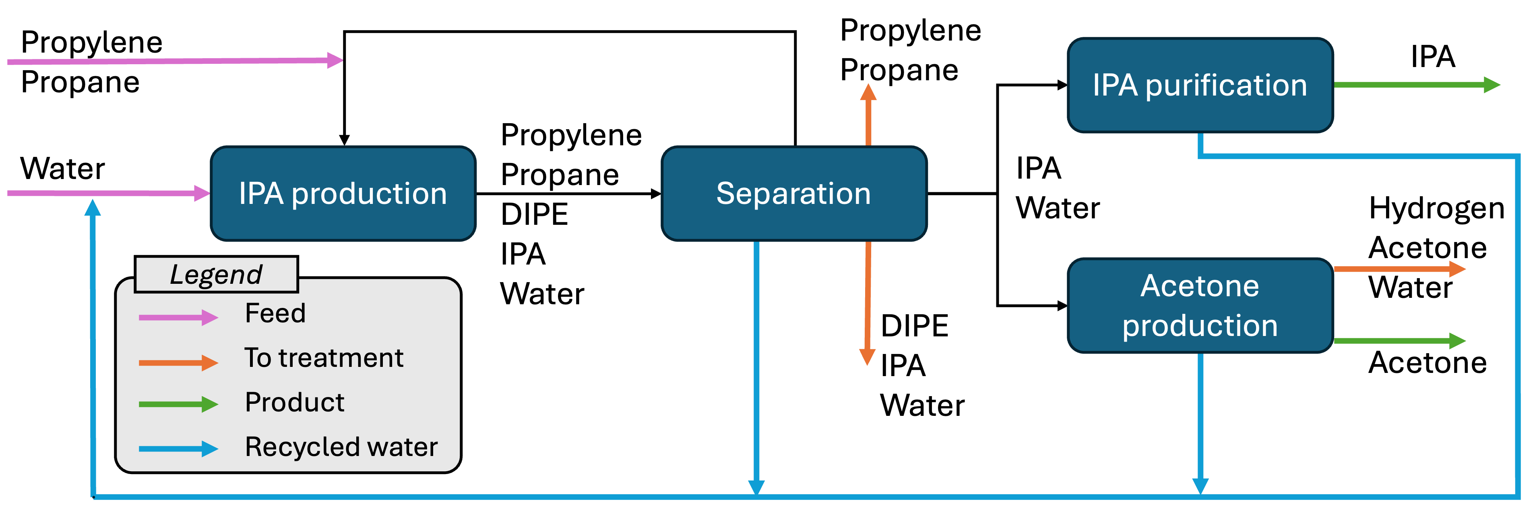

Figure 1 Plant block diagram

Figure 2 shows the Process Flow Diagram of the entire plant simulated. In section 100, IPA is produced by reacting propylene with water over an acidic ion-exchange resin catalyst. The feed streams of propylene and water are pressurized to 120 bar, mixed with recycled streams, and heated to 140°C before entering a series of reactors. The water-to-propylene molar ratio is maintained at 3:1, as recommended ratios between 2:1 and 7:1 minimize oligomer formation (Mahajani et al., 2002). Under reaction conditions, propylene exists in a supercritical phase (critical pressure $P_{c}=49$ bar, critical temperature $T_{c}=91.85$ °C), while water is liquid. This propylene state enhances reaction efficiency through improved solvation properties, which remove the product from the aqueous phase and catalyst interface (Mahajani et al., 2002). Indeed, the IPA produced distributes between the supercritical and liquid phases in a 3:2 volumetric ratio. At 140°C and 120 bar, the reaction achieves a 65% conversion with a 99% selectivity, with DIPE as the main by-product (Xu et al., 2002). To this aim, the chosen reactor is a Trickle Bed Reactor operating in cocurrent gas-liquid flow. The propylene is modeled as a heavy gas with the UNIQUAC fluid package under supercritical conditions, and the reaction is assumed to occur on a fixed bed of heterogeneous catalyst with first-order kinetics (Xu et al., 2002). The necessary catalyst volume ($V_{cat}$) calculated is 120 m³ (Xu et al., 2002), and the reactor's diameter and length ($L$) are determined iteratively, ensuring fluid dynamic constraints and conversion targets were met (65% under chosen conditions). After setting a trial column diameter and calculating the cross-sectional area ($A$), the reactor length is determined as $L=V_{cat}/(1 -ϵ)A$ where $ϵ$ is the void fraction (0.3). To ensure proper reactor operation, the flow regime is verified to remain within the trickle flow range by comparing the inlet and outlet mass velocities to established limits: a liquid mass velocity lower than 5 kg/m2s and a gas mass velocity lower than 1 kg/m2s. The pressure drops across the reactor is calculated with the Ergun equation, accounting for redistributor and catalytic bed losses. This iterative approach yielded a diameter of 2.7 m and $L=30$ m. To optimize performance, the final design split the catalyst into five reactors, each with two beds separated by liquid redistributors. A detailed analysis, here omitted for the sake of brevity, confirmed negligible mass transfer resistance (Damköhler number   
  
Figure 2 Process Flow Diagram (PFD) simulated via UniSim Design®

$Da≪1$). Conversion for each reactor was calculated by imposing equal catalyst quantities, with intermediate streams resolved through simulation. The reactor train is simulated as two conversion reactors, one for each reaction (the main and the one producing DIPE). Since both reactions are exothermic with a temperature rise of 44.7°C, adiabatic reactors were selected. Finally, the reactor effluent is brought to 18 bar and sent to Section 200 for separation.

Section 200 consists of four distillation columns for reagent recovery and product purification. The first column removes light volatiles (e.g., propane and unreacted propylene) from the mixture, the second one separates propane/propylene. The recycled stream matches the feed composition (95 mol% propylene), while the propane-rich stream is purged and sent to the furnace. Follows the recovery of unreacted water, which is recycled back to the reactor, and finally DIPE is separated as by-product, which forms a ternary azeotrope with IPA and water exiting as the overhead product. The ternary system water-DIPE-IPA is complex, presenting one ternary and three binary azeotropes. Although solutions for recovering all components are available (Lin et al., 2020), this study treats the stream conservatively as waste, and its disposal considered as cost.

The water-IPA mixture entering Section 300 exhibits a minimum boiling azeotrope (boiling point: 80.1°C, molar composition: 68.7% IPA at atmospheric pressure), making the production of highly pure IPA challenging. Among different options available in the literature, this study adopts extractive distillation using a high-boiling entrainer, dimethyl sulfoxide (DMSO), which increases the relative volatility between water and IPA without inducing liquid-liquid separation (Arifin & Chien, 2008). Literature identifies DMSO as the most effective entrainer for separating water-IPA mixtures, offering the highest separation factor at infinite dilution (2) and avoiding the formation of new azeotropes. The setup includes two distillation columns: an extractive column, which produces high-purity IPA as the overhead product, and an entrainer regeneration column. The water-DMSO mixture collected at the bottom of the extractive column is then sent to the entrainer regeneration column, where DMSO is recovered and recycled back to the first column, minimizing the need for fresh DMSO replenishment. Subcooling the DMSO stream to 75°C reduces the number of theoretical stages required in the IPA recovery column (Arifin & Chien, 2008). The DMSO flow rate was determined through process optimization, setting the azeotropic IPA/water feed-to-entrainer molar ratio at 1 (Arifin & Chien, 2008). The design and performance of the extractive distillation section are rigorously evaluated, with detailed considerations for distillation columns, condensers, and reboilers. The columns are designed by analyzing the head (rectifying section) and bottom (stripping section) trays. Tray spacing is determined with the liquid and vapor flow rates using the FLV parameter, while the column diameter is obtained by applying a 75% flooding margin to the vapor velocity limit. Once geometrical features are defined, pressure drops are verified to meet acceptable ranges. Performance checks ensured no issues with weeping, flooding, or liquid-vapor disengagement, and the turn-down ratio is assessed to guarantee operational flexibility. The effective number of trays is then calculated using O’Connell’s efficiency model, considering liquid viscosity and relative volatility. For column *C-301*, the high tray count (95) necessitated its division into two sections with distributor trays for optimal operation. The total vapor condensers *E-301* and *E-303* are designed for nearly pure streams of IPA and water. These horizontal condensers utilize film condensation on external tube surfaces, with the heat transfer coefficient calculated via Nusselt’s theory for laminar film flow. The vapor-side load was determined iteratively, and shell-side pressure drops were estimated to be half those of a full vapor flow scenario. The bottom reboilers *E-302* and *E-304*, designed as vertical thermosiphons, employ natural circulation with vaporization within the tubes. A critical heat flux of 38 kW/m² is imposed to prevent blanketing phenomena. The overall heat transfer coefficient is calculated as the sum of convective and nucleate boiling contributions, adjusted for two-phase flow using Chen’s method (Towler & Sinnot, 2021), in which the vapor quality, liquid, and vapor properties are used, and the nucleate boiling component is derived from Mostinski’s correlation. Natural circulation is verified by ensuring the total $ΔP$ do not exceed the gravitational driving force, calculated using the average density of the two-phase mixture.

To guarantee production flexibility, Section 400 is focused on producing acetone. Its feed is the azeotropic IPA-water mixture, which undergoes complete vaporization in a flash evaporator with recycle (*E-400* in Figure 2). The vapor is then fed to the reactor at 2.5 bar and its saturation temperature (105.2°C). The reaction is highly endothermic, with heat supplied by hot flue gases from a furnace (thermal duty: 6 MW). The reactor design is a shell-and-tube configuration, with the catalyst housed in the tubes. The reactor effluent at 350°C is cooled and partially condensed (temperature controlled by cooling tower water). To maximize acetone recovery, the vapor is compressed in *K-450* to 8 bar (Luyben, 2011) and sent to a physical absorption column where hydrogen by-product is separated using water as the absorbent. The liquid streams from the condenser and the absorption column bottom are processed in a separation train comprising two distillation columns: the first one separates high-purity acetone (99.9%) from the unconverted IPA-water mixture, while the second one remove water (recycled to Section 100) from the azeotropic mixture (recycled within the acetone production process).

* + 1. Thermal Integration

Thermal integration for the IPA-water azeotropic mixture production and acetone production sections is addressed independently to maintain operational flexibility, enabling adjustments in IPA and acetone output based on market demand. Pinch Analysis is used within each section to identify potential stream integrations with a 20°C minimum temperature difference imposed. In Sections 100 and 200, key streams identified from the PFD include preheating for water (*111*) and propylene (*102*) entering the reactor, condensing vapor (*207*) and heating liquid (*206*) for column *C-203*, and condensing vapor from column *C-204*. For Section 400 the streams analyzed comprise the evaporator recycle stream (*402*), the reactor effluent requiring cooling and partial condensation (*406*), the compressed gas effluent requiring cooling (*410*), vapor effluent from column *C-401* requiring condensation (*422*), and the liquid effluent from column *C-401* requiring vaporization (*424*). The analysis showed limited potential in Sections 100 and 200, with only 1.3 MW of the required 36.7 MW being recoverable, causing not implementation to avoid design complexity. However, in Section 400, 6 MW of the 26 MW required are recovered with by integrating the *R-400* reactor effluent stream with the evaporator recycle stream. Lastly,in Section 300, Pinch Analysis was omitted in favor of targeted integration based on stream requirements. Stream *300*, containing the azeotropic mixture at 25°C, was preheated to saturation before feeding column *C-301* exploiting stream *304*, the saturated bottom product from column *C-302*, needing subcooling before recycling.

* 1. Techno-Economic Analysis
     1. Total Capital Investment and Total Production Cost

This section estimates the capital (CapEx) and operational expenditures (OpEx) for plant construction and operation, evaluating its economic feasibility. The cash flow model assumes a 3-year construction period starting in 2024, a 6-month start-up phase, with all calculations in USD. Equipment costs are estimated based on type, size parameters (e.g., area, flow), or, for pressure vessels, geometrical features and operating pressure (Towler & Sinnot, 2021). All Costs are updated to 2024 values using the Chemical Engineering Plant Cost Index and adjusted for location in India with a multiplicative factor of 1.02. Material and utility costs, and product values are detailed in Table 1. On-site water production costs include reagent consumption for resin regeneration and groundwater extraction. Labor costs assume three 8-hour shifts with minimum wage rates in India ($2/h).

Table 1 Raw Material Costs, Product Value, and Utilities costs

|  |  |  |  |  |  |  |  |  |  |  |  |
| --- | --- | --- | --- | --- | --- | --- | --- | --- | --- | --- | --- |
|  |  | Flow (kT/y) | Price ($/kg) | Value (M$/y) | |  | |  | Unit Cost | Annual Demand | Cost  (M$/y) |
| Raw materials | Propylene | 148.4 | 0.80 | 118.7 | Utilities | | Electricity | | 0.077 $/kWh | 68105 kWh/y | 0.52 |
| Water | 75 | 0.001 | 0.01 | Natural Gas | | 14.9 $/GJ | 244000 GJ/y | 3.64 |
| DMSO | 0.063 | 2.66 | 0.17 | Instrument Air | | 0.9 $/100 m³ | 105 m³/y | 0.001 |
| Products | IPA | 71.5 | 1.25 | 89.4 | Hazardous Waste | | 145 $/103kg | 7134 $⋅$ 10³ kg/y | 1.03 |
| Acetone | 104.4 | 1.38 | 144.1 | Total | |  |  | 5.2 |

With 11 operators per shift the total labor cost is estimated at 0.193 M$/year. Table 2 summarizes Total Capital Investment (TCI), comprising Fixed Capital Investment (FCI) for construction and setup, and Working Capital (WC) for commissioning and initial operations, along with the Annual Total Product Cost (TPC) including Manufacturing Costs (variable costs, fixed charges, overhead) and General Expenses (administration, R&D).

Table 2: Estimation Factors for Calculating TCI and main results

|  |  |  |  |  |  |  |  |
| --- | --- | --- | --- | --- | --- | --- | --- |
| Estimation Factors | | | | Results | | | |
| FCI - Direct Costs | | FCI - Indirect Costs | | Total costs (M$) | | TPC (M$) | |
| Equipment installation | 0.47 | Engineering/supervision | 0.33 | Equipment | 20.3 | Manufacturing Costs | 144.8 |
| Instrumentation and control | 0.36 | Construction expenses | 0.41 |
| Piping | 0.36 | Legal fees | 0.04 | FCI | 112.7 | General Expenses | 15.6 |
| Electrical system | 0.11 | Contractor fees | 0.22 |
| Ancillary construction | 0.18 | Contingencies | 0.44 | WC | 19.9 | * TPC (excluding depreciation) | 157.35 |
| Infrastructure improvement | 0.1 |  | |
| Service structures | 0.7 | WC - Working Capital | 0.89 | TCI | 133.6 |

* + 1. Profitability Analysis

Profitability is assessed based on return on investment (ROI), payback period (PBP) and net present value (NPV). ROI assesses investment efficiency as the ratio between annual net profit and TCI. Since net profit may vary over time, an average ROI is typically computed and the corporate tax rate in India is considered (25%). Conversely, PBP measures the time required to recover the fixed capital, while NPV is the present value of future cash flows discounted at a given rate of return from a reference point (e.g. plant startup). If NPV > 0, the investment is considered profitable. The annual discount rate used in this analysis is 15%. The analysis applies the Declining Balance Method of depreciation, using a 40% rate over five years and established literature correlations (Towler and Sinnott, 2022).

* + 1. Results

Figure 3 provides an overview of the annual net profit, illustrating the economic performance considering a 3-year construction period followed by 10 years of operation. During the first operational year, the plant operates at 50% capacity, leading to an initial negative net profit. The results of the economic analysis, summarized in Figure 3a, demonstrate that the project surpasses reference benchmarks, with an ROI of 18.4% (benchmark: 15%) and a PBP of 3.3 years (benchmark: 3.7 years). Further, Figure 3b explores the sensitivity of NPV to changes in product and raw material prices, revealing that a 6% reduction in product prices or an 8% increase in propylene prices results in a negative NPV. Similarly, sensitivity to utility costs in Figure 3d indicates that a 2-fold increase in energy prices reduces the NPV to $19 M, while a 4-fold increase yields a negative NPV of -$18.3 M. Inflation scenarios, presented in Figure 3c, highlight that moderate inflation (e.g., 2–3%) has varying impacts on economic indicators depending on construction, TPC, and product price growth rates. Lastly, Figure 3e also captures the flexibility of production modulation, allowing redistribution of the azeotropic mixture between IPA (99.8%) and acetone (99.9%) production. Sensitivity analysis for three production splits shows that increasing acetone production to 65% improves NPV to $42.17 M and reduces PBP to 3.2 years, while a higher IPA share (45%) results in lower profitability with an NPV of $34.19 M and a PBP of 3.7 years.

* 1. Conclusions

This study provides a comprehensive evaluation of an integrated process for producing isopropanol (IPA) and acetone, using advanced modelling and simulation tools. The use of UniSim Design© was essential for performing mass and energy balances and enabling effective thermal integration, reducing energy consumption and operational costs. The model also facilitated the identification of critical areas requiring detailed equipment sizing and optimization. This detailed equipment sizing was not only crucial for ensuring technical feasibility and economic efficiency but also formed the basis for the techno-economic analysis (TEA), providing accurate cost estimations and deeper insights into the process's financial viability. The economic analysis yielded promising results, with an ROI of 18.4%, a PBP of 3.3 years, and an NPV of $37.66 million, while sensitivity analyses highlighted the impact of market and cost variables on profitability. The plant’s flexibility in adjusting IPA and acetone production enhances its ability to adapt to market changes. However, while the process appears to be techno-economically viable, a complete environmental impact assessment, including a Life Cycle Assessment (LCA), has not yet been performed and should be considered in future work, as modern chemical processes must address environmental sustainability.

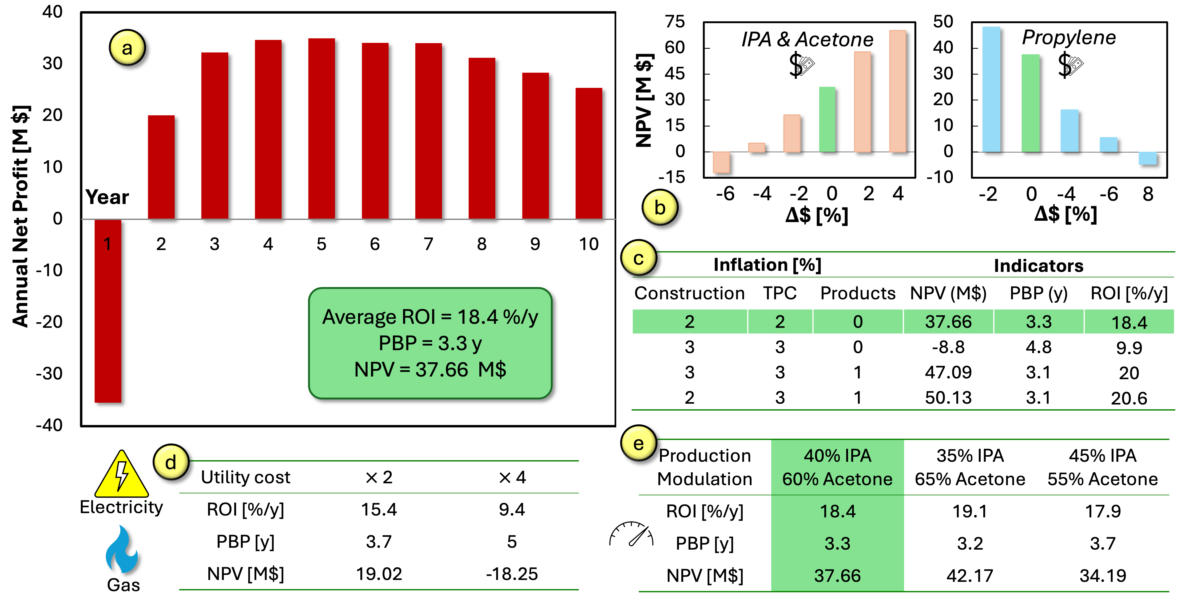Figure 3 Economic performances and sensitivity analysis. Annual net profit and indicators (a) are reported with variation of material prices (b), inflation changes (c), utility costs (d), and production modulation (e). Green-coloured bars/cells indicate the base case reported in (a).

References

Arifin, S., & Chien, I.-L. (2008). Design and Control of an Isopropyl Alcohol Dehydration Process via Extractive Distillation Using Dimethyl Sulfoxide as an Entrainer. Industrial & Engineering Chemistry Research, 47(3), 790–803.

Asiedu, A., Barbera, E., Naurzaliyev, R., Bertucco, A., & Kumar, S. (2021). Waste cooking oil to jet-diesel fuel range using 2-propanol via catalytic transfer hydrogenation reactions. Biofuels, 12(6), 723–736.

Li, Y., Tang, W., Chen, Y., Liu, J., & Lee, C. F. (2019). Potential of acetone-butanol-ethanol (ABE) as a biofuel. Fuel, 242, 673–686.

Lin, K.-Y., Tsai, M.-L., & Chien, I.-L. (2020). Energy-efficient separation design of diisopropylether/isopropanol/water system having three distillation regions and liquid-liquid envelope. Separation and Purification Technology, 251, 117292.

Logsdon, J. E., & Loke, R. A. (2000). Isopropyl Alcohol. In Kirk-Othmer Encyclopedia of Chemical Technology. Wiley.

Luyben, W. L. (2010). Design and Control of the Cumene Process. Industrial & Engineering Chemistry Research, 49(2), 719–734.

Luyben, W. L. (2011). Design and Control of the Acetone Process via Dehydrogenation of 2-Propanol. Industrial & Engineering Chemistry Research, 50(3), 1206–1218.

Mahajani, S. M., Sharma, M. M., & Sridhar, T. (2002). Direct hydration of propylene in liquid phase and under supercritical conditions in the presence of solid acid catalysts. Chemical Engineering Science, 57(22–23), 4877–4882.

Panjapakkul, W., & El-Halwagi, M. M. (2018). Technoeconomic Analysis of Alternative Pathways of Isopropanol Production. ACS Sustainable Chemistry & Engineering, 6(8), 10260–10272.

Straits Research. (2024a, October 8). Acetone Market. https://straitsresearch.com/report/acetone-market

Straits Research. (2024b, December 4). Isopropyl alcohol market. https://straitsresearch.com/report/isopropyl-alcohol-market

Towler, G., & Sinnot, R. (2021). Chemical Engineering Design. Elsevier.

Vaccari, M., Pannocchia, G., Tognotti, L., & Paci, M. (2023). Rigorous simulation of geothermal power plants to evaluate environmental performance of alternative configurations. Renewable Energy, 207, 471–483.

Vaccari, M., Papa, G., & Brunazzi, E. (2023). Rigorous Simulation Model of a KCl Food Production Plant to Address Impurity Precipitation. Chemical Engineering Transactions, 99, 565–570.

Xu, Y., Chuang, K. T., & Sanger, A. R. (2002). Design of a Process for Production of Isopropyl Alcohol by Hydration of Propylene in a Catalytic Distillation Column. Chemical Engineering Research and Design, 80(6), 686–694.