|  |  |
| --- | --- |
| cetlogo ***CHEMICAL ENGINEERING TRANSACTIONS***  ***VOL. xxx, 2025*** | A publication of  aidiclogo_grande |
| The Italian Association  of Chemical Engineering  Online at www.cetjournal.it |
| Guest Editors: Fabrizio Bezzo, Flavio Manenti, Gabriele Pannocchia, Almerinda di Benedetto  Copyright © 2025, AIDIC Servizi S.r.l. **ISBN** 979-12-81206-17-5; **ISSN** 2283-9216 | |

Computational analysis of the effect of inhibitor proteins p21/p27 on cell cycle under microgravity conditions.

Gabriele Traversari\*,1, Antonio Mario Locci1,2, Alessandro Concas1,2, Nicola Lai1,2, Alberto Cincotti1,2, Giacomo Cao1,2

1 Dipartimento di Ingegneria Meccanica, Chimica e dei Materiali, Università degli Studi di Cagliari,

Via Marengo 2, Cagliari, 09123, Italy

2 Centro Interdipartimentale di Ingegneria e Scienze Ambientali (CINSA), Università degli Studi di Cagliari,

Via San Giorgio 12, 09124 Cagliari, Italy

[gabriele.traversari@unica.it](mailto:gabriele.traversari@unica.it)

The cell cycle progression is fundamental for the life of all living organisms and its alteration from physiological conditions may interfere with its primary function, thus driving potentially harmful consequences. More specifically, during space missions, astronauts are continuously exposed to non-physiological conditions due to microgravity and suffer from a series of health issues once come back to earth; exposure to real or simulated microgravity conditions can disrupt normal cell cycle regulation. For this reason, the possibility to predict any change in cell division time could represent a valuable tool for understanding the pathologies and health issues experienced by astronauts during their time in orbit.

In this study, we employed a previously developed mathematical model to simulate the impact of the inhibitor proteins p21 and p27 on cell cycle progression. These proteins are known to be overexpressed under microgravity conditions, potentially leading to altered or even arrested cell division, depending on the extent of the overexpression. In particular, the aim of this work is the analysis of p21/p27 over expression induced by microgravity, with particular attention to its effect on cell duplication time and quality. Indeed, depending on the extent of such an over expression, not only duplication time varies but also cellular abnormalities such as biperiodic duplication, endoreplication or tetraploidy, as well as cessation of cell replication may take place.

* 1. Introduction

From a chemical engineering point of view, cell cycle consists of a cascade of complex enzymatic reactions aiming to the synthesis of biological molecules required for cell duplication. It is typically divided in different phases as shown in Figure 1.

Figure 1: scheme of a standard cell cycle. G1 (gap 1, cell growth after mitosis); S (synthesis, DNA duplication); G2 (gap 2, cell growth in preparation for mitosis), M (mitosis, cell division); and G0 (gap 0, resting phase, cell leaves the cycle and duplication stops).

After cell division, the newborn cells begin their cycle from the G1 phase, where they undergo growth through biosynthetic activities and the replication of cytoplasmic organelles. Once G1 is complete, cells enter the S phase, devoted to DNA duplication, before transiting into the G2 phase, where proteins and other cellular components necessary for mitotic division are synthesized. Eventually the cells enter the M phase (mitosis), where they divide into two newborn, daughter cells. When any variation from the physiological-homeostatic state takes place, cells may exit the cell cycle to enter a quiescent or senescent state, known as the resting phase G0. The cell cycle with its intricate biochemical pathways was extensively studied in medical science to provide a deep understanding of its core mechanisms. However, the regulatory mechanisms of the cell cycle are less clear in presence of cancer, aging processes as well as under microgravity conditions.

Previous computational works (Pisu et al. 2015, 2022) combined a population balance approach with a cell cycle phases model (Gérard and Golbeter, 2009, 2012, 2014) to simulate the culture growth quantifying cell volume and age distributions. Specifically, the cyclin/Cyclin dependent kinase (cyclin/Cdk) network model (Gérard and Golbeter, 2009, 2012, 2014) was used under physiological conditions, inhibiting effects of cytostatic drugs or the promoting effects of growth factors to quantify the elapsed time of each cell cycle required to estimate the kinetic rate constants in the population balance model (Pisu et al. 2015, 2022). In this context, it is important to relate the inhibitory or promoting effects of biochemical agents and stimuli to the duplication time. Thus, it has been identified an important parameter ($v_{s1p27}$) mimicking proteins p21/p27 basal production (Gérard and Golbeter, 2012) responsible for an inhibitory effect of the cell cycle. High value of this parameter representing high p21/p27 protein content allow to simulate the condition leading to the cell cycle inhibition or even arrest. This semi quantitative analysis on the effects of p21/p27 basal production appears to be a promising approach to assess the p21/p27 protein roles on the cell cycle under external stimuli such as microgravity conditions. Using a random positioning machine (RPM), human cells, initially synchronized in the G1 phase, overexpressed p21 inhibitor protein genes after exposure to simulated microgravity, and even fail to duplicate within the typical 24-hour temporal interval (Coinu et al. 2006). Even though the biological mechanism for such an over expression is not clear, this finding suggests that cells require more time to duplicate when larger p21 inhibitor proteins levels are reached under microgravity conditions.

Thus, in this work, a mathematical model previously developed (Gérard and Golbeter, 2009, 2012, 2014) was used to quantify the effect of the proteins p21/p27 basal production rate on the cell cycle dynamics, i.e. mirroring microgravity conditions. The duplication time is determined from the dynamics of cyclin/Cdk complex formation reflecting the temporal progression of the cell cycle phases. In presence of a p21 overexpression, duplication time is lengthened and abnormalities such as biperiodic duplication, endoreplication or tetraploidy, as well as cessation of cell replication may occur.

* 1. Mathematical model

The kinetic model used for the description of the complex network of biochemical reactions that governs the cell cycle phases were developed and proposed by Gérard and Goldbeter (2014). A schematic of the complex model including a series of biological reactions is shown in Figure 2. This model describes the activation dynamics of specific cyclin/Cdk complex Md, Me, Ma and Mb (cyclin D/Ckd4-6, cyclin E/Cdk2, cyclin A/Cdk2 and cyclin B/Cdk1, respectively), whose temporal maxima and minima mark the progression of the different phases in the cell cycle. Also, the model describes the regulatory effect of Cdh1, Cdc20, Wee1, Skp2 and cdc25 phosphatase proteins and complex inhibitors (p21/p27), the synthesis and degradation of cyclins, their binding with complexes, and the opposed effect of the tumour suppressor pRB and the transcription factor E2F. It also incorporates the positive influence of external growth factors GF, signalling from the extracellular matrix ECM and accounts for the reduction in proliferation rate related to contact inhibition. The mathematical model includes a system of 42 ordinary differential equations (ODEs) with the following form:

$\frac{dC}{dt}=v_{b}+\sum{r_{pro}}-\sum{r_{inhi}}-k_{d}C$ (1)

Here, the generic specie C is formed by an interplay among a basal production rate ($v_{b}$), reaction rates related to stimulatory ($r_{pro}$) and ($r_{inhi}$) inhibitory effects, and degradation ($k_{d}C$). The chemical kinetics are defined using power-law or Michaelis-Menten relationships depending on the type of interaction.

The model equations and parameters are taken from the original work by Gérard and Goldbeter (2014) and are not reported in this work for the sake of brevity. In this work, the model was used to analyse the effect of inhibitor proteins p21 and p27 on the active Md, Me, Ma, Mb complexes and assess the impact on the cell cycle phases.

To simulate the effects of p21 gene overexpression observed under microgravity conditions (Coinu et al. 2006), model simulations were performed for different $v_{s1p27}$ parameter values representing the basal production rate of inhibitor proteins p21 and p27.

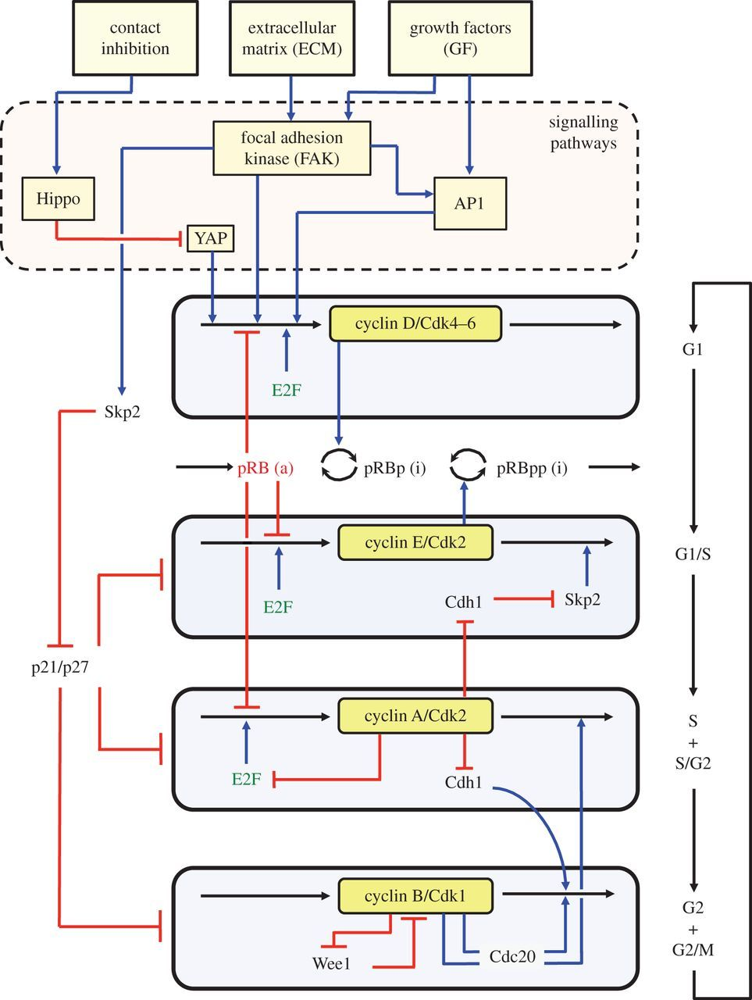

Figure 2. Cyclin/Cdk network kinetic model driving the mammalian cell cycle (Gerard and Goldbeter, 2014).

More specifically, it was assumed that adjustment of the cell culture to microgravity condition occurs during a time frame of 24 h. Thus, the $v_{s1p27}$ parameter was simulated as increasing linearly in time during the first 24 h up to a maximum value and then kept fixed for later times, according to the following relationship:

$v_{s1p27}\left[\frac{µM}{h}\right]=0.8+\frac{\left(v_{s1p27}^{max}-0.8\right)}{24 h}t t<24h$ (2)

$v_{s1p27}\left[\frac{µM}{h}\right]=v_{s1p27}^{max} t≥24h$ (3)

where $v_{s1p27}^{max}$ parameter indicates the maximal value of $v_{s1p27}$ corresponding to the p21 overexpression.

* 1. Results and discussions

Model simulations are performed by integrating a system of 42 ODEs as an initial value problem using FORTRAN standard numerical libraries based on Gear method (IMSL). The effect of $v_{s1p27}$ parameter on the cell cycle progression was investigated for different scenarios as reported in Table 1. The $v_{s1p27}^{max}$ value used for the base case corresponds to the homeostatic conditions under normal gravity on earth.

Table 1: The duplication time ($t_{D}$) obtained for different $v_{s1p27}$ value to simulate normo- and micro-gravity.

|  |  |  |  |  |
| --- | --- | --- | --- | --- |
| Gravity | Earth | Microgravity | | |
|  | Base Case | Case 1 | Case 2 | Case3 |
| $$v_{s1p27}^{max}\left[\frac{µM}{h}\right]$$ | 0.8 | 2.4 | 3.6 | 4.8 |
| $$t_{D} [h]$$ | 24 | 32 and 52 | 97 | cell cycle arrest |

* + 1. Base Case

The cell duplication occurs regularly every 24 h under the simulated earth gravity conditions (Figure 3a). The time profiles of the Md+Mdp27, Me, Ma, and Mb complexes present a periodic pattern marking the transition between the cell cycle phases (Figure 3b). The minimum concentration value of Md+Mdp27 complexes marks the beginning of the cell cycle (G1), whereas the maximum peak corresponds to the begging of S phase. The G2 phase starts with the peak of Ma complex concentration which must be preceded by the peak of Me complex concentration. Then, M phase start with the peak of Mb complex concentration and ends with the beginning of a new cell cycle.



(b)

(a)

Figure 3: Base Case: a) $v_{s1p27}$ temporal profile (solid line) and simulated duplication time $t_{D}$ (square symbol); b) on the left scale simulated temporal profiles of Me, Ma and Mb active complexes and on the right scale simulated sum of Md active and Mdp27 inhibited by p21/p27 complexes.

* + 1. Case 1

The cell duplication increases progressively during the first 4 days to reach a bi-periodic regime (Figure 4a) characterized by two alternated duplication times (32 and 53 h) both larger than the one observed under physiological condition (24 h). The duplication time increase observed in our simulation is consistent with the experimental findings reported by Coinu et al., (2006). In particular, in that study the overexpression of the p21 gene caused a cell cycle characterized by a cell duplication time greater than 24 h. For a cell duplication time of 32 h the DNA replication is still normal as the one observed for 24 h. In contrast, for a cell duplication time of 53 h the DNA is quadrupled before cell division (i.e. tetraploidy). This phenomenon is highlighted by the repetition of G1 phase after G1/S phase (Figure 4b). Additionally, the microgravity condition appears to short the duration of phase S (Figure 4b) characterized by higher peak of the active Me and Ma complexes than those observed for earth gravity (Figure 3b).



(b)

(a)

Figure 4: Case 1: a) $v_{s1p27}$ temporal profile (solid line) and simulated duplication time $t_{D}$ (square symbol); b) on the left scale simulated temporal profiles of Me, Ma and Mb active complexes and on the right scale simulated sum of Md active and Mdp27 inhibited by p21/p27 complexes.

* + 1. Case 2

Similarly to the case 1, the cell duplication increases progressively during the first 8 days to reach a periodic regime (Figure 5a) with a duplication time of 97 h. Overall, in comparison to case 1, the increase of the $v_{s1p27}$ parameter value observed is amplified for both duplication time (Figure 5a) and peak of Md+Mdp27, Me, and Ma complexes (Figure 5b). Thus, under these conditions, all cell duplications occur with tetraploidy. Opposed to the Me and Ma temporal profile observed for case 1 (Figure 4b), in case 2 the peak of Me is higher than that of Ma (Figure 5b).



(b)

(a)

Figure 5: Case 2: a) $v_{s1p27}$ temporal profile (solid line) and simulated duplication time $t_{D}$ (square symbol); b) on the left scale simulated temporal profiles of Me, Ma and Mb active complexes and on the right scale simulated sum of Md active and Mdp27 inhibited by p21/p27 complexes.

* + 1. Case 3

In this scenario the microgravity conditions simulated are extreme and represent a p21/p27 overexpression capable to arrest the cell cycle (Figure 6a) without the periodic oscillations (Figure 6b). Under such extreme conditions, model simulations show that, after a single “normal” cell duplication taking place in 1.5 days, cell cycle is eventually arrested. The concentration of the active Me, Ma and Mb complexes do not show a peak because of the P21 inhibitory effect (Figure 6b).



(b)

(a)

Figure 6: Case 3: a) $v_{s1p27}$ temporal profile (solid line) and simulated duplication time $t_{D}$ (square symbol); b) on the left scale simulated temporal profiles of Me, Ma and Mb active complexes and on the right scale simulated sum of Md active and Mdp27 inhibited by p21/p27 complexes.

* 1. Conclusions

The alterations induced in the cell cycle under microgravity conditions were simulated by increasing the basal production rate of inhibitor proteins p21 and p27. This analysis was performed to assess the effect of an overexpression of p21 observed in cell cultures exposed to microgravity condition by random positioning machine (RPM). A previously developed kinetic model was employed to estimate cell duplication time under both earth and micro- gravity conditions. This model enabled a detailed investigation of how microgravity impacts cell cycle dynamics. A series of simulations were conducted by incrementally varying the basal production rate of p21/p27 mirroring microgravity conditions. The results align well with experimental observations reported by Coinu and colleagues, demonstrating that duplication time increases progressively to ultimately arrest at higher levels of inhibitor protein expression (to the best of authors’ knowledge no other data are available in the literature to further validate the proposed model). These findings highlight the significant impact of microgravity on cellular replication processes. Although the results are promising, the parameters used in the model were derived from literature and have not yet been rigorously validated with specific experimental data. With the model parameters fine-tuned for particular cell lines, numerical simulations could provide valuable insights into the quality of cells post-duplication under both terrestrial gravity and microgravity. Such simulations could help identify whether cell division occurs “normally” or if cells exhibit anomalies such as endoreplication, tetraploidy, or other replication-related abnormalities. This approach has the potential to enhance our understanding of cellular responses to microgravity, paving the way for applications in space biology, regenerative medicine, and cancer research. By refining the model and incorporating experimental validation, these simulations may also serve as predictive tools for assessing cellular health and function in altered gravitational environments.

Nomenclature

C – generical species, µM

G0 – gap 0, resting phase, -

G1 – gap 1, initial cell growth phase, -

G2 – gap 2, second cell growth phase, -

$k_{d}$– degradation kinetic rate constant, h-1

M – mitosis, cell division, -

Ma – activate cyclin/Cdk complex A/Cdk2, µM

Mb – activate cyclin/Cdk complex B/Cdk1, µM

Md – activate cyclin/Cdk complex D/Ckd4-6, µM

Mdp27 – Md inhibited by p21/p27, µM

Me – activate cyclin/Cdk complex E/Cdk2, µM

p21/p27 – inhibitor proteins, µM

RPM – random positioning machine, -

$r_{pro}$– generical promoting effect rate, μM h-1

– generical inhibition effect rate, μM h-1

S – synthesis, DNA duplication phase, -

$t_{D}$– duplication time, h

$v_{b}$– generical basal production, μM h-1

– basal p21/p27 production, μM h-1

– max value of , μM h-1

Acknowledgments

This work has been developed within the framework of the project e. INS-Ecosystem of Innovation for Next Generation Sardinia (cod. ECS 00000038) funded by the Italian Ministry for Research and Education (MUR) under the National Recovery and Resilience Plan (NRRP)—MISSION 4 COMPONENT 2, “From research to business” INVESTMENT 1.5, “Creation and strengthening of Ecosystems of innovation” and construction of “Territorial R&D Leaders”.

References

Coinu R., Chiaviello A., Galleri G., Franconi F., Crescenzi E., Palumbo G., 2006, Exposure to modeled microgravity induces metabolic idleness in malignant human MCF-7 and normal murine VSMC cells, FEBS Letters 580, 2465–2470.

Gérard C., Goldbeter A., 2009, Temporal self-organization of the cyclin/Cdk network driving the mammalian cell cycle. Proc. Natl. Acad. Sci. U.S.A. 106, 21643–21648.

Gérard C., Goldbeter A., 2012, From quiescence to proliferation: Cdk oscillations drive the mammalian cell cycle, Frontiers in Physiology, Sec. Systems Biology Archive, Volume 3

Gérard C., Goldebeter A., 2014, The Balance between cell cycle arrest and cell proliferation: control by the extracellular matrix and by contact inhibition. Interface Focus 4: 20130075.

Pisu M., Concas A., Cao G., 2015, A novel quantitative model of cell cycle progression based on cyclin-dependent kinases activity and population balances, Computational Biology and Chemistry 55, 1–13

Pisu M., Concas A., Cao G., Pantaleo A., 2022, Mathematical Modelling and Computational Simulation of Mammalian Cell Cycle Progression in Batch Systems. European Journal of Biology and Biotechnology, 3(1), 1–10.