|  |  |
| --- | --- |
| cetlogo ***CHEMICAL ENGINEERING TRANSACTIONS***  ***VOL. xxx, 2025*** | A publication of  aidiclogo_grande |
| The Italian Association  of Chemical Engineering  Online at www.cetjournal.it |
| Guest Editors: Fabrizio Bezzo, Flavio Manenti, Gabriele Pannocchia, Almerinda di Benedetto  Copyright © 2025, AIDIC Servizi S.r.l. **ISBN** 979-12-81206-17-5; **ISSN** 2283-9216 | |

Innovative 3D Printing Processes for the Production of High-Efficiency Drug Release Tablets with Different Drug Loadings

Giovanni Casconea,b\*, Carmine Laudatoa, Pierluigi Lambiasea, Daniele Sofiaa,c

aADIVO SRL, Via Croce Malloni 93, Nocera Superiore (SA), 84015, Italy

bENEA, National Agency for New Technologies, Energy and Sustainable Economic Development, P.le Enrico Fermi 1, Portici (NA), 80055, Italy

cDepartment of Computer Engineering, Modeling, Electronics and Systems, University of Calabria, Via P. Bucci cubo 44/a Rende (CS), 87036, ITALY

giovanni.cascone@enea.it

The advent of 3D printing technology has revolutionized the pharmaceutical industry, particularly in the development of personalized medicines. This study explores the fabrication of drug-loaded tablets using the fused deposition modeling (FDM) method, employing polyvinyl alcohol (PVA) as the main polymer matrix and fluorescein as the model drug. The aim of this work is to compare the release profiles of fluorescein in a tablet that is first printed and then impregnated with the tracer, versus a tablet printed using a filament pre-impregnated with the tracer. The PVA filament and tablets were impregnated with a 2% w/v ethanolic solution of fluorescein, followed by a drying process until a constant weight was achieved. Subsequently, the filament underwent the printing process.

The printing parameters were established based on literature to ensure good physical-mechanical properties and an optimal drug release profile. Specifically, the parameters considered included printing speed, infill percentage, and layer thickness. Drug release profiles were monitored through dissolution studies under physiological conditions. Fluorescein release was determined using fluorescence spectrophotometry.

The results highlighted a significant correlation between the impregnation technique and the release curves, emphasizing how the transport phenomena involved in drug loading affect the release itself; in particular, the impregnation of a tablet showed a penetration of the drug especially in the most external areas of it, determining the release of 65% of the drug after two hours, while the tablet printed with a loaded filament showed a more gradual release of the drug during the dissolution test.

This approach demonstrates the potential of 3D printing in the design of efficient and patient-specific drug delivery systems. The study underscores the importance of combining shape studies and printing conditions as formulation strategies in the development of 3D-printed pharmaceutical products, promoting new opportunities for advanced and personalized therapeutic applications.

**Keywords:** 3D printing, tablets, dissolution, polyvinyl alcohol, fluorescein, fused deposition modeling.

* 1. Introduction

Three-dimensional printing (3DP) has emerged as a groundbreaking additive manufacturing technology that fabricates objects layer by layer, offering unprecedented precision and versatility (Ferraresi et al., 2021). While initially employed in industries like engineering, aerospace, and design, 3DP has recently gained traction in the pharmaceutical sector, where it promises to transform traditional manufacturing processes. Its capacity to produce highly complex geometries, tailor material properties, and deliver on-demand production aligns with the growing emphasis on personalized medicine (Yu et al., 2008)​.

Traditional pharmaceutical production methods are inherently designed for mass manufacturing (Shastry, 2006). Processes such as tablet compression and coating are optimized for large-scale production to meet the needs of extensive patient populations. However, these methods are often ill-suited for addressing the individualized requirements of modern healthcare, where patients increasingly demand tailored therapeutic regimens. Variability in patient responses to medications, often driven by genetic, metabolic, and physiological differences, has necessitated a shift toward more adaptable production methods​.

Personalized medicine aims to customize drug formulations to optimize therapeutic efficacy while minimizing adverse effects. This paradigm requires a production platform capable of creating small-batch or even single-dose formulations with high precision and minimal waste. Three-dimensional printing offers a promising solution by enabling precise control over drug composition, dosage, and release profiles​ (Scoutaris et al., 2011).

Among the different 3DP methods, fused deposition modeling (FDM) has gained prominence in pharmaceutical applications due to its simplicity, cost-effectiveness, and adaptability. FDM uses thermoplastic filaments, which are heated and extruded through a nozzle to create structures layer by layer. This process allows for intricate control over the geometry, density, and internal structure of printed objects, providing unique opportunities to design pharmaceutical dosage forms with tailored properties. Furthermore, FDM systems are relatively inexpensive, making them accessible for research and clinical use (Zhao, 2017)​.

FDM 3DP has been successfully employed to fabricate tablets with various drug release profiles, from immediate-release to sustained-release systems. Key parameters such as infill percentage, surface area-to-volume ratio, and layer thickness can be adjusted to influence drug dissolution kinetics (Patti et al., 2023). For instance, modifying the geometry of tablets or embedding internal channels can accelerate or slow down drug release, offering versatility in dosage form design​. Additionally, the integration of multiple Active Pharmaceutical Ingredients (APIs) into a single tablet allows for the development of combination therapies, which can enhance patient compliance and simplify complex treatment regimens​.

One of the most notable advancements in 3DP for pharmaceuticals is the approval of Spritam®, the first FDA-approved 3D-printed drug. Spritam® demonstrated the feasibility of using 3DP for producing high-precision, rapidly disintegrating tablets (Samiei, 2020). This milestone has catalyzed interest in expanding the use of 3DP in drug manufacturing, particularly for applications requiring controlled-release systems, complex formulations, or on-demand production (​Zhang et al., 2020).

Despite its potential, several challenges remain in optimizing 3DP for pharmaceutical use. The mechanical properties of printed tablets, dissolution behavior, and drug stability can be significantly influenced by printing parameters such as nozzle temperature, layer thickness, and printing speed (Ngo et al., 2018). Additionally, drug loading techniques play a critical role in determining the uniformity and release kinetics of APIs from the polymer matrix. Research is needed to better understand how these variables interact to achieve consistent and reproducible drug release profiles​.

This study addresses these challenges by investigating the fabrication of drug-loaded tablets using FDM 3DP technology (Liparoti et al, 2021) and polyvinyl alcohol (PVA) as the primary polymer matrix; in particular the differences in drug release between a tablet printed with a fluorescein-loaded PVA filament and a tablet printed from pure PVA and loaded with fluorescein by immersion in ethanolic solution are compared. PVA is a hydrophilic, biocompatible polymer widely used in pharmaceutical formulations for its excellent mechanical strength and suitability for controlled drug release (Pietrzak et al., 2015).

The research focuses on comparing two distinct drug-loading methods: (1) tablets printed with PVA filaments preloaded with fluorescein, a model drug, and (2) tablets printed first and subsequently loaded with fluorescein via immersion in an ethanolic solution. By examining the differences in drug release profiles between these approaches, the study aims to elucidate the impact of fabrication techniques on dissolution kinetics and therapeutic efficacy​.

Beyond its immediate objectives, this work highlights the broader implications of 3DP in pharmaceutical science. By enabling the customization of dosage forms, 3DP can address critical unmet needs in drug delivery, including the development of age-specific formulations for pediatric and geriatric populations, combination therapies for chronic conditions, and localized delivery systems for targeted treatments. Furthermore, the ability to produce complex dosage forms with minimal waste aligns with the principles of sustainable manufacturing, a growing priority in the pharmaceutical industry.

Future directions for research include the systematic exploration of 3DP parameters such as layer thickness, printing speed, and infill density to fine-tune drug release profiles. Additionally, the potential of novel tablet geometries, such as multi-layered or porous designs, should be investigated to further enhance dissolution control. Incorporating advanced polymers and functional excipients into 3DP formulations could expand the range of achievable release mechanisms, from pulsatile to delayed-release systems. Ultimately, the integration of 3DP with emerging technologies such as artificial intelligence and machine learning could pave the way for fully automated, adaptive manufacturing platforms capable of delivering truly personalized medicine on demand.

Through continuous innovation and interdisciplinary collaboration, 3DP has the potential to revolutionize pharmaceutical manufacturing, bridging the gap between traditional mass production and the personalized healthcare of the future.

* 1. Materials and method

Polyvinyl alcohol (PVA) extruded filament with a diameter of 1.75 mm and a printing temperature of 200°C obtained from eSUN (China). Analytical-grade ethanol solution and was utilized for the impregnation of Fluorescein sodium salt, which was obtained from Sigma-Aldrich (Darmstadt, Germany). Hydrochloric acid, water and sodium bicarbonate sourced from Sigma-Aldrich. The dimensions of tablets, including diameter and thickness, were measured using a digital callipers (measurement range: 0–150 mm).

* + 1. Drug loading of tablet and filament

Polyvinyl alcohol (PVA) is a thermoplastic synthetic polymer characterized by high water solubility, low solubility in ethanol, and insolubility in many organic solvents. It is odorless, tasteless, and possesses excellent mechanical properties. PVA is synthesized through the partial or complete hydrolysis of polyvinyl acetate, involving the removal of acetate groups (Cerda et al., 2020).

For drug loading, PVA filament was immersed in an ethanolic solution of fluorescein (2% w/v) and subjected to magnetic stirring for 24 hours. The drug-loaded filament and was subsequently removed, dried in an oven at 60°C until a constant weight was achieved (2 hours), and stored in a vacuum desiccator to preserve their properties until further use (Tagami et al., 2019) (Figure 1C).

To load the PVA (drug unloaded) tablet the same procedure described above was followed (Figure 1D).

* + 1. Print of drug loaded tablet and drug unloaded tablet

A Creality (Shenzhen, China) CR-10S printer (Figure 1B) with nozzle diameter: 0.4 mm was utilized to fabricate drug-loaded tablets. The tablet design was prepared using Freecad v1.0 (Figure 1A) an open-source computer-aided design (CAD) software, and the model was saved in the .stl file format. The .stl files were processed using slicing algorithms to generate G-codes, which were subsequently uploaded to the printer to produce tablets with the desired dimensions (Figure 1D, E). The tablets were designed with a diameter of 10 mm and a height of 4 mm.

Layer thickness, infill percentage, and print speed (Table 1) were selected to ensure both mechanical robustness of the tablet and an appropriate filling to allow the drug loading by immersion (Kumar et al., 2017) and fixed to appropriately compare the release profile of fluorescein from the tablet printed with a drug-unloaded filament and then drug-loaded, versus the tablet printed using the drug-loaded filament.

**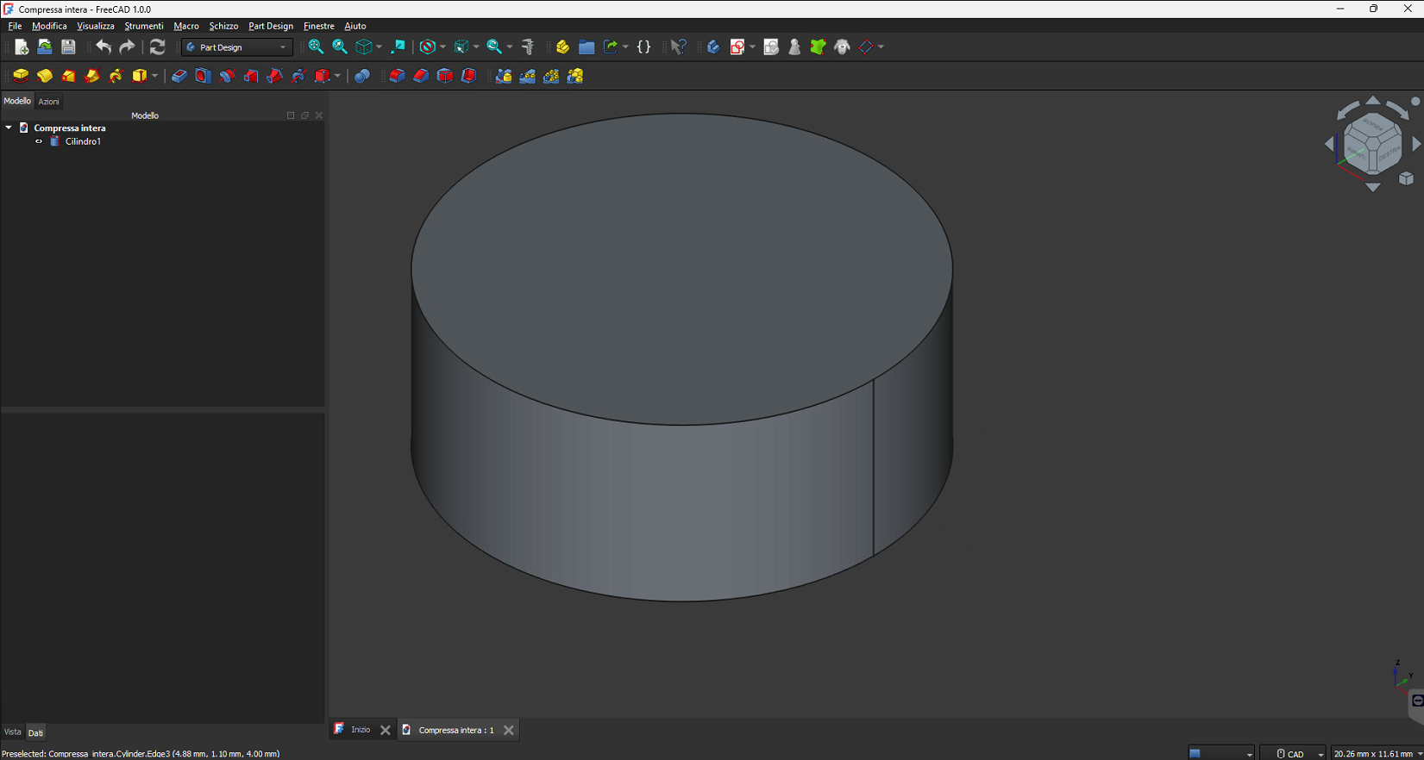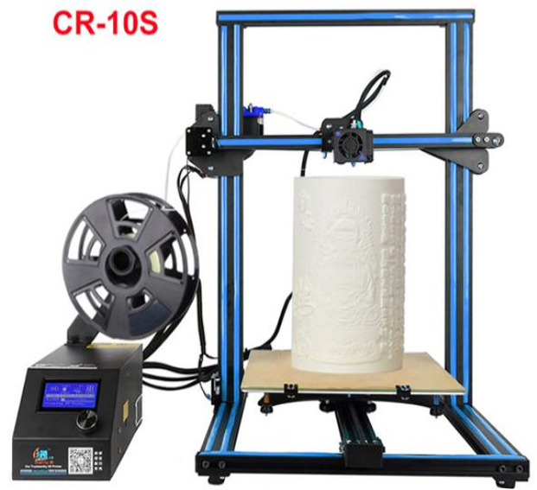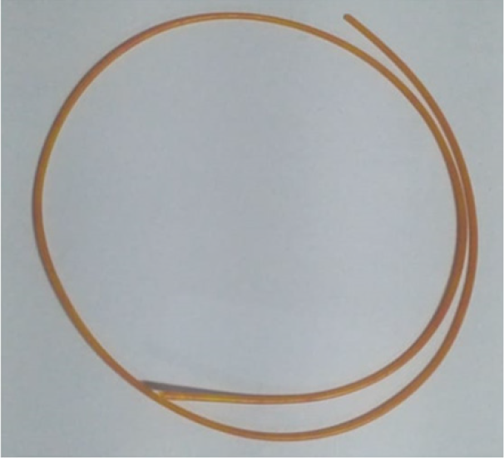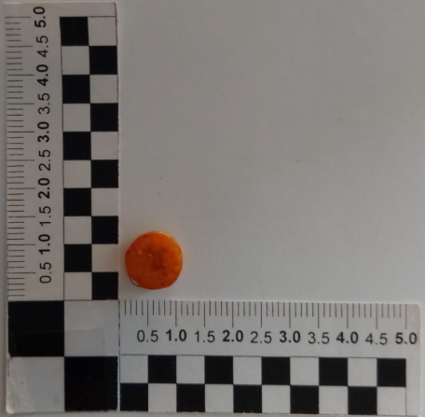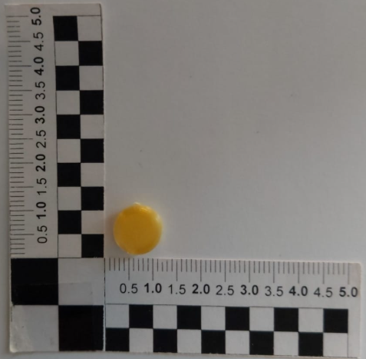**

E

D

C

B

A

*Figure 1: A) Freecad software, B)* *Creality CR-10S printer, C) Drug loaded filament, D) Drug loaded tablet, E) Tablet* printed with loaded filament.

Table 1: Parameters set on the 3D printer to get the tablet.

|  |  |  |
| --- | --- | --- |
| Layer thickness | Infill % | Print speed |
| 0.1 | 20 | 60 |

* + 1. Dissolution testing

The drug release profiles from the printed tablets were evaluated using a flask-based method. Each tablet was placed at the bottom of a flask and stirred at 50 rpm in 900 mL of dissolution medium maintained at 37°C (Goyanes et al., 2015). The experiments were performed in triplicate under sink conditions.

During the dissolution process, samples were manually withdrawn and filtered through 0.1 µm filters. Fluorescein concentration was measured using a spectrophotometer (Synergy HT BioTek) with excitation at 485 nm and emission at 530 nm (Shaik et al., 2020). Results were expressed as a percentage of fluorescence relative to the total amount of fluorescein detected after complete tablet dissolution (approximately 24 hours) (Cascone et al., 2023).

The dissolution tests were conducted in a modified bicarbonate buffer (pH 6.8) (Merchant et al., 2012). At each sampling point, the pH was adjusted using HCl, and the 10 mL aliquot removed was replaced with fresh buffer. The bicarbonate buffer was chosen for its superior physiological resemblance to gastrointestinal fluid compared to traditional phosphate buffers (Fadda et al., 2005) (Liu et al., 2011).

For the determination of fluorescein concentration in the buffer, a calibration curve was generated using known concentrations of fluorescein (Figure 2), achieving an R² value greater than 0.99.

*Figure 2: Calibration curve for measuring fluorescein concentration during release.*

* 1. Results and discussion

The objective of this study was to compare the release profiles of fluorescein loaded into polyvinyl alcohol (PVA) under two different approaches: (1) tablets that were first printed and subsequently loaded with fluorescein through immersion in an ethanolic solution, and (2) tablets printed using a filament preloaded with fluorescein via immersion in an ethanolic solution.

Sampling was performed at time intervals of 2, 4, 6, and 8 hours, as well as upon complete dissolution of the tablets, which occurred approximately 24 hours after immersion in the dissolution buffer.

The release profiles were expressed as percentages of the fluorescein loaded into each tablet, calculated relative to the total amount of fluorescein detected in the buffer at the point of complete tablet dissolution.

The tablet that was first printed and subsequently loaded with fluorescein exhibited a release (Figure 3) of approximately 65% of the loaded drug within the first 2 hours. This rapid release is likely due to the combined effect of two phenomena:

Surface Deposition of the Drug: A thin layer of fluorescein deposited on the tablet's surface is immediately transferred to the dissolution buffer upon immersion.

Drug Transport within the Tablet: The larger dimensions of the tablet, compared to the filament used for printing, limit its swelling capacity and reduce fluorescein uptake, especially in the innermost regions where transport resistance is higher.

As a result, subsequent sampling shows only a modest increase in the percentage of drug release during tablet erosion. Specifically, the release reaches approximately 71%, 78%, and 85% after 4, 6, and 8 hours, respectively.

This observation highlights that the loading technique is particularly inadequate for designing a customized tablet aimed at achieving controlled drug release over time during dissolution in the intestinal environment. Such a tablet should ideally ensure sustained drug delivery to maximize bioavailability while avoiding peak concentrations that could be ineffective or, worse, harmful to the patient's health.

The tablet printed using a fluorescein-loaded filament exhibited a drug release (Figure 4) of approximately 10% of the total fluorescein within the first 2 hours. This delayed release can be attributed to the presence of fluorescein in the deeper layers of the polymer matrix, requiring an initial swelling period before the drug begins to diffuse out.

At 4, 6, and 8 hours, the release profile follows a parabolic trend, reaching approximately 24%, 63%, and 85%, respectively. This behavior is explained by the absence of surface deposition of fluorescein and the drug's encapsulation within the inner layers of the tablet.

This tablet design enables a more controlled drug release in the intestinal environment, avoiding sharp concentration peaks and enhancing the bioavailability of the active ingredient. Moreover, this approach allows for the customization of tablets to meet the specific needs of individual patients, ensuring tailored therapeutic outcomes.

*Figure 3: Fluorescein release over time from tablets printed with an unloaded filament and loaded subsequently.*

*Figure 4: Fluorescein release over time from tablets printed with a fluorescein pre-loaded filament.*

* 1. Conclusions

This study highlights the critical impact of drug loading techniques on the release profile of active compounds from 3D-printed tablets. Tablets printed first and subsequently loaded with fluorescein showed a rapid initial release due to surface deposition, but were less effective in achieving controlled, sustained release. Conversely, tablets printed using fluorescein-loaded filaments demonstrated a delayed and more gradual release profile, attributed to the encapsulation of the drug within the polymer matrix.

The findings emphasize the importance of selecting appropriate drug loading methods for the development of personalized drug delivery systems. In particular, the use of preloaded filaments offers significant advantages in controlling drug release, enhancing bioavailability, and avoiding undesirable peak concentrations that may harm the patient.

To further refine drug release profiles, future studies should investigate:

-3D Printing Parameters: Examining how variations in layer thickness, infill percentage, and printing speed influence drug transport within the polymer matrix and the resulting release dynamics.

-Tablet Geometry: Exploring how the shape and surface-to-volume ratio of tablets affect dissolution kinetics.

-Material Modifications: Incorporating different polymer blends or functional additives to enhance matrix swelling and drug transport properties.

-Release Kinetics: Employing mathematical modeling to predict and optimize drug release behaviour under various physiological conditions.

Such investigations will allow a precise and effective control of drug release over time in the patient's body, supporting the development of highly customizable and efficient drug delivery systems according to individual clinical needs, advancing the potential of 3D printing technologies in personalized medicine.

References

Cascone G., Crescente G., Petruzziello A., Bouymajane A., Volpe M.G., Russo G.L., Moccia S., 2023, A comparative study between MHG and UAE: chemical and biological characterization of polyphenol-enriched extracts from aglianico grape pomace, Foods, 12, 2678, DOI: 10.3390/foods12142678.

Cerda J.R., Arifi T., Ayyoubi S., et al., 2020, Personalised 3D printed medicines: optimising material properties for successful passive diffusion loading of filaments for fused deposition modelling of solid dosage forms, Pharmaceutics, 12(4), 345.

Fadda H.M., Basit A.W., 2005, Dissolution of pH-responsive formulations in media resembling intestinal fluids: bicarbonate versus phosphate buffers, J. Drug Del. Sci. Tech., 15, 273–279.

Ferraresi C., de Benedictis C., Bono L., et al., 2021, A methodology for the customization of hinged ankle-foot orthoses based on in vivo helical axis calculation with 3D printed rigid shells, Proc. IMechE, Part H: J. Engineering in Medicine, 235(4), 367–377.

Goyanes A., Buanz A.B.M., Hatton G.B., et al., 2015, 3D printing of modified-release aminosalicylate (4-ASA and 5-ASA) tablets, Eur. J. Pharm. Biopharm., 89, 157–162.

Kumar P., Sharma G., Kumar R., et al., 2017, Enhanced brain delivery of dimethyl fumarate employing tocopherol-acetate-based nanolipidic carriers: evidence from pharmacokinetic, biodistribution, and cellular uptake studies, ACS Chem. Neurosci., 8, 860–865.

Liu F., Merchant H.A., Kulkarni R.P., Alkademi M., Basit A.W., 2011, Evolution of a physiological pH 6.8 bicarbonate buffer system: application to the dissolution testing of enteric coated products, Eur. J. Pharm. Biopharm., 78, 151–157.

Liparoti S. et al, 2021. Fused filament deposition of pla: The role of interlayer adhesion in the mechanical performances DOI: 10.3390/polym13030399.

Merchant H.A., Frost J., Basit A.W., 2012, Apparatus and method for testing medicaments, PCT/GB2013/051145.

Ngo T.D., Kashani A., Imbalzano G., et al., 2018, Additive manufacturing (3D printing): a review of materials, methods, applications and challenges, Compos. B: Eng., 143, 172–196.

Patti A., Acierno S., Cicala G., Acierno D., 2023, Controlling process variables in 3D printing to limit the energy consumption, Chemical Engineering Transactions, 105, 373–378, DOI: 10.3303/CET23105063.

Pietrzak K., Isreb A., Alhnan M.A., 2015, A flexible-dose dispenser for immediate and extended-release 3D printed tablets, Eur. J. Pharm. Biopharm., 96, 380–387.

Samiei N., 2020, Recent trends on applications of 3D printing technology on the design and manufacture of pharmaceutical oral formulation: a mini review, Beni-Suef Univ. J. Basic Appl. Sci., 9, 12.

Scoutaris N., Alexander M.R., Gellert P.R., Roberts C.J., 2011, Inkjet printing as a novel medicine formulation technique, J. Control. Release, 156, 179–185.

Shaik K.M., Sarmah B., Wadekar G.S., et al., 2020, Regulatory updates and analytical methodologies for nitrosamine impurities detection in sartans, ranitidine, nizatidine, and metformin along with sample preparation techniques, Crit. Rev. Anal. Chem., DOI: 10.1080/10408347.2020.1788375.

Shastry B.S., 2006, Pharmacogenetics and the concept of individualized medicine, Pharmacogenomics J., 6, 16–21.

Tagami T., Kuwata E., Sakai N., et al., 2019, Drug incorporation into polymer filament using simple soaking method for tablet preparation using fused deposition modeling, Biol. Pharm. Bull., 42, 1753–1760.

Yu D.-G., Zhu L.-M., Branford-White C.J., Yang X.-L., 2008, Three-dimensional printing in pharmaceutics: promises and problems, J. Pharm. Sci., 97, 3666–3690.

Zhang X., Zhou J., Xu Y., 2020, Experimental study on preparation of coaxial drug-loaded tissue-engineered bone scaffold by 3D printing technology, Proc. IMechE, Part H: J. Engineering in Medicine, 234, 309–322.

Zhao J., 2017, Design of 3D metal FDM printing nozzle based on melt forming, Chemical Engineering Transactions, 59, 73–78, DOI: 10.3303/CET1759013.