 CHEMICAL ENGINEERING TRANSACTIONS  VOL. xxx, 2025 | A publication of  
The Italian Association
of Chemical Engineering
Online at www.cetjournal.it

Guest Editors: Fabrizio Bezzo, Flavio Manenti, Gabriele Pannocchia, Almerinda di Benedetto
Copyright © 2025, AIDIC Servizi S.r.l.
ISBN 979-12-81206-17-5; ISSN 2283-9216

Volatile fatty acid recovery from simulated digestate by stripping
Simeone Chianese^{a,}*, Angelo Fentiª, Giovanni Falco^{b}, Valentina Innocenzi^{c}, Marina Prisciandaro^{c}, Pasquale Iovino^{b}, Dino Musmarraª
ªDepartment of Engineering, University of Campania Luigi Vanvitelli, Via Roma 29, 81031 Aversa, Italy
^{b}Department of Environmental, Biological and Pharmaceutical Science and Technologies, University of Campania Luigi Vanvitelli, Via Vivaldi 43, 81100 Caserta, Italy
^{c}Department of Industrial and Information Engineering and of Economics, University of L’Aquila, Monteluco Di Roio, 67040 L’Aquila, Italy
simeone.chianese@unicampania.it]
Volatile Fatty Acids (VFAs) are essential building block chemicals with a significantly increasing market demand. However, their production is traditionally based on non-renewable petrochemical sources, causing severe adverse health and environmental effects. The recovery of VFAs from organic substrates matches the need to approach a circular economy, which includes resource recovery, reuse and recycling. This work aimed to recover VFAs from simulated digestate by using an innovative and sustainable approach consisting of gas stripping followed by absorption. Gas stripping is based on separating volatile compounds from fermented broth or process streams through its interaction with the water-saturated gas phase. The proposed approach aims to be a breakthrough technology focused on the clean production of raw materials.
Experimental investigations were performed on a lab scale to recover VFAs from a water solution by considering a single acid and a mix of acids. Moreover, the process simulation was carried out to validate the stripping step and the thermodynamic model to scale up the technology.
  - Introduction
The expanding global population, coupled with rapid industrialization, has intensified the demand for vital resources such as food, energy, and raw materials, leading to considerable depletion of these essential assets. Achieving environmental sustainability in the 21st century requires a shift toward a circular economy that prioritizes resource recovery, reuse, and recycling. These practices help conserve raw materials and reduce waste generation (Atasoy et al., 2018). Supporting this transition, the European Commission’s 2014 and 2015 circular economy guidelines focused on reducing waste and maintaining resources to promote long-term sustainability (Viancelli et al., 2023). A sustainable solution to these environmental challenges involves converting the large amount of biodegradable organic waste produced daily, including municipal and industrial by-products such as food waste, agricultural residues, sewage sludge, microalgae, and other organic-rich waste streams, into valuable resources (Wainaina et al., 2019; Lamolinara et al., 2018).
Anaerobic digestion (AD) is a well-established and efficient method for nutrient recovery and waste remediation, traditionally used for biogas and fertilizer production through microbial conversion of organic residues. AD can efficiently convert organic waste into renewable energy and digestate—a residue often used as a soil amendment—while reducing greenhouse gas emissions (GHG), water pollution, and landfill waste and contributing to the circular economy (Pervez et al., 2022). Beyond biogas production, advancements in the AD process enable the generation of value-added streams rich in volatile fatty acids (VFAs) (Valentino et al., 2021). VFAs play a pivotal role as foundational chemicals or precursors for reduced chemicals and derivatives, including esters, ketones, aldehydes, alcohols, and alkanes, in conventional organic chemistry with a rapidly growing demand in the global market. Despite their importance, the conventional production of VFAs heavily depends on non-renewable petrochemical sources that contribute to significant environmental and health challenges. Petrochemical processes currently account for approximately 90% of the global VFA supply. Notably, the production of acetic acid through these methods generates considerable GHG emissions, estimated at 3.3 tCO₂eq. per ton over its life cycle (including incineration without energy recovery) (Wang et al., 2022). For this reason, developing alternative methods for VFA production is increasingly desirable.
Although AD process (acidogenesis and acetogenesis) waste effluent is a viable platform for producing VFAs, it is essential to note that this stream is an unrefined and complex mixture containing VFAs, microorganisms, salts, proteins, lipids, solids, and more. These components limit the use of the solution as a purified VFA source. Additionally, the high-water content, in most cases, leads to a diluted VFA solution (Battista et al., 2020; Da Ros et al., 2020). VFAs are obtained as mixed products, which necessitates the separation of individual VFAs for specific applications, such as producing biopolymers (Amabile et al., 2023a; Amabile et al., 2023b; Amabile et al., 2023c). Separating VFAs from the bulk fermentation media is challenging due to their low concentration (below 5%) (Coma et al., 2017). Concentrating the VFA stream for further value addition requires significant energy, and extracting VFAs at high rates and yields from this complex effluent is difficult. These challenges can be overcome by enhancing productivity, optimizing upstream fermentation, or utilizing effective separation and concentration techniques (Masse et al., 2008). Recently, there has been increased focus on improving downstream VFA recovery, as the design of a suitable separation and recovery process is key to the economic viability of the process. Since VFAs are low-volume fermentation products, obtaining high purity in their separation demands careful process design to reduce energy consumption and costs. Due to the energy-intensive nature of these processes, scaling them up may not always be feasible. An efficient separation process can lead to better VFA utilization and commercialization (Arias et al., 2020; Moncada et al., 2015).
Various techniques have been developed for VFA recovery, with membrane-based processes such as microfiltration, ultrafiltration, nanofiltration, forward osmosis, and electrodialysis commonly used to recover, purify, and concentrate VFAs from mixed solutions (Pervez et al. 2022). However, one of the main challenges with membrane processes is membrane fouling and pore-wetting, where ions and impurities remain inside the pores, reducing the effectiveness of rejection rates over time (Wang et al., 2018). These issues require further investigation and validation to improve VFA separation and recovery. The present study aims to validate an innovative and sustainable approach for recovering VFAs from liquid digestate, which consists of gas stripping with absorption. Experimental investigations were performed on a lab scale to recover VFAs from a water solution by considering a single acid and a mix of acids. Moreover, the process simulation was carried out to validate the stripping schematization and the thermodynamic model to scale up the technology.
  - Materials and methods
    - Experimental set-up and process simulation
A laboratory bench-scale extraction apparatus schematized in Figure 1 was utilized for the VFA recovery experiments. The pH was adjusted to 1.7 with concentrated H₂SO₄ before transferring 1 L of a 10.0 g L⁻¹ acid solution into the first 3-port round bottom flask. This flask was connected to a pump, an air flowmeter to provide a constant flow to the system, and a heater to control temperature. Downstream, the second flask contained an alkaline solution (Na₂CO₃, 0.05 M) with a pH of about 11 to trap the volatilized acids operated as adsorption liquid. The flask was immersed in a water bath to cool the solution and stabilize the temperature. An additional flask downstream (Na₂CO₃, 0.05 M) collected any potential volatilized acids. All connections and flask stoppers were sealed with high-temperature-resistant tape to prevent gas dispersion. Experiments were carried out keeping the temperature (95°C) and the airflow rate (2 L min⁻¹) constant. The samples from the alkaline solution were sampled at certain times (0-240 min). Acetic Acid (AA) and Valeric Acid (VA) recovery from single acid solutions and a mix of acid solutions was investigated. Volatile free acid mix containing 10 mM in deionized water (Sigma Aldrich, St. Louis, MO, USA) was used as an analytical standard. Furthermore, solutions of acetic acid (glacial, ACS reagent, ≥ 99.7%), valeric acid (ACS reagent, ≥ 99 %), and phosphoric acid (ACS reagent, ≥ 85 wt. %) were purchased from the same supplier. Sulfuric acid (ACS reagent 95.0-97.0 %) and sodium carbonate (ACS reagent, anhydrous, ≥99.8%) were obtained by Honeywell (Seelze, Germany). A solution of sodium hydroxide (J.T. Baker) was used to adjust the solution pH if necessary. All solutions were prepared with Milli-Q water (18.2 MΩ cm⁻¹ resistivity, 25 °C) from an Elix ® Essential 10 UV water purification system (Merck, Darmstadt, Germany).
At regular time intervals, samples were withdrawn from the alkaline solution in the 3-port round bottom flask and subjected to analysis using high-performance liquid chromatography (HPLC) equipped with a UV diode array detector (DAD) (Shimadzu, model CBM-20A). The data was processed on the Shimadzu LabSolutions software (version 5.86). A Supelcogel H column (packing type: sulfonated polystyrene/divinylbenzene, 250 mm × 4.6 mm, 5 μm) served as the stationary phase. The mobile phase consisted of 0.1% H₃PO₄ (v/v), with a flow rate of 0.3 mL min⁻¹ (Han et al., 2019). Analyses were conducted isocratically at room temperature, with an injection volume of 20 μL and a total run time of 22.5 min. Quantitative analysis of acids was performed using an absorbance–concentration calibration curve at 206 nm, which exhibited linearity within the range of 0.02–10.0 g L⁻¹. A certified standard solution of 10 mg L⁻¹ caffeine (Shimadzu Corporation, Japan) was employed to confirm the instrument's absorbance linearity. The limit of detection (LOD) and limit of quantification (LOQ) of the method were determined based on a signal-to-noise ratio of 3:1 and 10:1, respectively. Specifically, the LOD and LOQ were 0.0197 and 0.0650 g L⁻¹ for acetic acid and 0.0227 and 0.0749 g L⁻¹ for valeric acid.
ASPEN Plus (V15) was used for the process simulation. The validation of the stripping schematization and the thermodynamic model was carried out using the experimental results and the test conditions from acetic acid stripping.
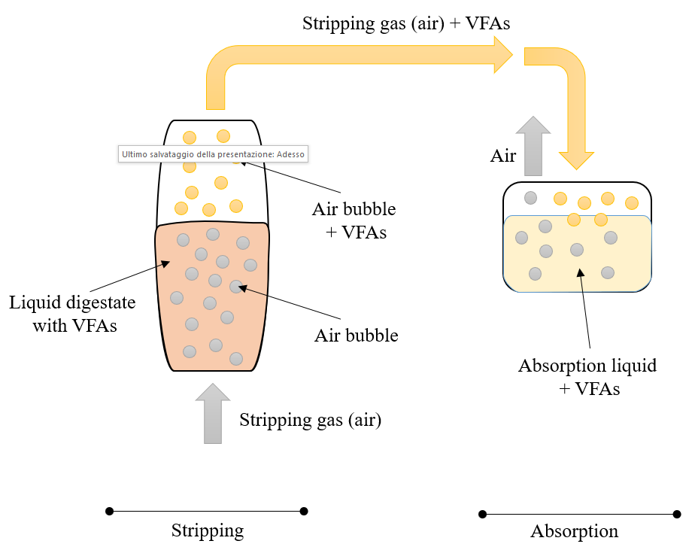
Figure 1: schematization of the VFA recovery experimental set-up.
  - Results and discussion
    - Experimental results
The acid and water mass balances, including the average temperature of the acid solution (T_{a}) and the stripping efficiency, calculated according to Eq(1), are reported in Tables 1 and 2, respectively.
$$Stripping efficiency=\frac{M_{S}}{M_{0}}x100$$ | (1)
Table 1: Acid mass balance
Acid | Initial mass in the acid solution (M₀)  [g] | Mass stripped  (Ms)  [g] | Stripping efficiency  [%] | Mass  recovered  [g] | Mass balance [%]
AA  (T_{a} = 93.8°C) | 10.18 | 1.65 | 16.17 | 1.65 | 100
VA  (T_{a} = 92.9°C) | 9.62 | 6.12 | 63.61 | 6.12 | 100
AA/VA  (T_{a} = 92.5°C) | AA = 10.38  VA = 10.51 | AA = 1.77  VA = 6.67 | AA = 17.11  VA = 63.45 | AA = 1.49  VA = 5.91 | AA = 84  VA = 88
Table 2: Water mass balance
Acid | Initial mass of the acid solution  [g] | Final mass of  the acid solution  [g] | Initial mass of  the alkaline solution  [g] | Final mass of  the alkaline solution  [g] | Water balance [%]
AA | 1000 | 740 | 1000 | 1259 | 99.6
VA | 1000 | 755 | 1000 | 1229 | 93.5
AA/VA | 1000 | 760 | 1000 | 1215 | 89.6

The results highlight that the maximum stripping performance was achieved with a water solution made with single compounds; however, a relevant stripping efficiency was also determined with the mixing of acids. The highest stripping efficiency was achieved for the Valeric Acid in both single-compound and two mixed-compound. This result can be justified considering the higher hydrophobicity of the acids with the higher molecular weight (Ravishankar et al., 2021).
    - Stripping schematization and thermodynamic model validation
The process scheme implemented in the Aspen environment is reported in Figure 2. The details of the stripping step, consisting of a batch stripper (blue box), a heat exchange (green box) and a flash (red box), are schematized in Figure 3. The stripping step is included in a hierarchy-block to separate the stripping and the absorption in two consecutive simulation phases.
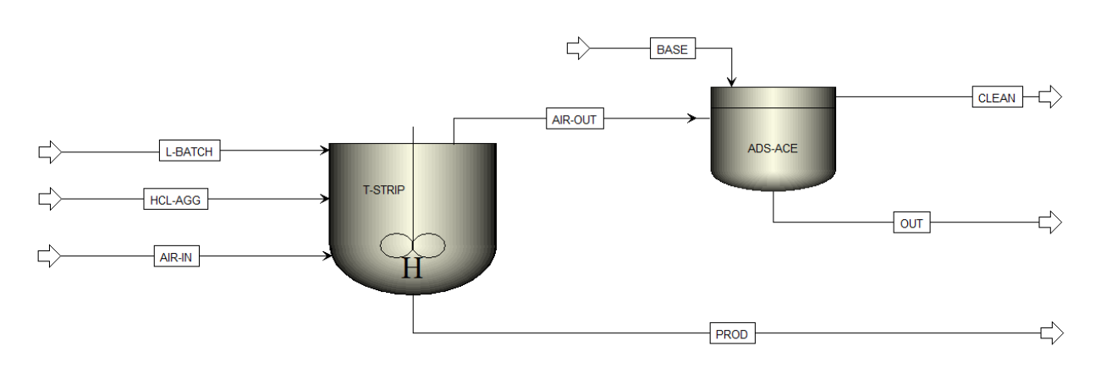
Figure 2: stripping and absorption step schematization

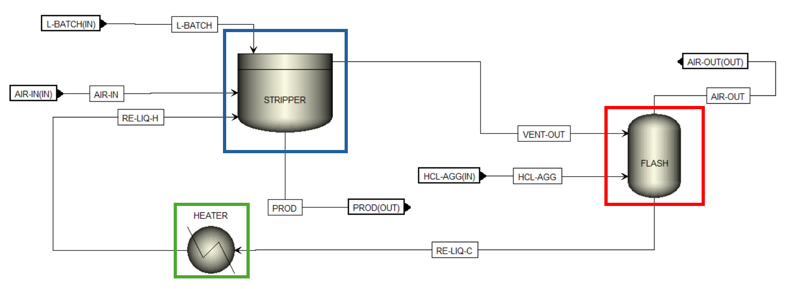
Figure 3: stripping step schematization detail
The flash allows the definition of the non-equilibrium between the gas phase and the liquid phase. The gaseous stream from the stripping step (VENT-OUT) is in equilibrium with the liquid phase (Temperature = 93.8°C). The VENT-OUT stream is sent to the flash, where a lower temperature is set than the stripper temperature; in this way, a non-equilibrium condition is implemented. The HCL-AGG stream serves to acidify the liquid fraction in the FLASH to prevent the dissociation of carboxylic acids. The function of the heater is to take back the temperature of the liquid stream from the flash at the temperature of the stripper.
The thermodynamic UNIFAC-HOC model was used for all the blocks except for the absorption for which the ELECNRTL model was adopted.
The test with the acetic acid was used to validate the process scheme and thermodynamic model. The comparison between the experimental results and the simulation results, in terms of the final mass of acetic acid and the final volume of the acid solution, is reported in Table 3.
The simulations were carried out considering an atmospheric pressure (1.01325) for the three steps reported in Figure 3 with the following temperature: stripping = 93.8°C; flash = 81°C; heater = 93.8°C.
Table 3: stripping step and thermodynamic model validation
Parameter | Experimental results | Simulation results | Δ[%]
Final mass of acetic acid [g] | 8.53 | 8.59 | +0.7%
Final volume of acid solution [ml] | 740 | 715 | -3.4%
Mass stripped of acetic acid [g] | 1.65 | 1.61 | -2.4%

Figure 4: model validation: dots = experimental; continuous = model – acetic acid stripping test.
The comparison highlights an excellent agreement between the experimental and the simulation results, validating the stripping step and the thermodynamic model proposed.
  - Conclusions
The present study aimed to validate and test an innovative and sustainable approach for recovering VFAs from liquid digestate, consisting of gas stripping followed by absorption.
Experimental investigations were performed on a lab scale to recover VFAs from a water solution by considering single acids and a mix of acids. Moreover, the process simulation was carried out to validate the stripping schematization and the thermodynamic model, which are essential for the scale-up of the technology.
Experimental findings highlighted that the stripping of acids as a single solution and a mixture was carried out, validating the approach proposed.
The process scheme was implemented, and the stripping step and the thermodynamic model were successfully validated.
Further investigations are required to optimize the process in terms of variation of the operative conditions and scale-up of the technology.
Acknowledgments
Authors would like to thank the Italian Fund PRIN: PROGETTI DI RICERCA DI RILEVANTE INTERESSE NAZIONALE – Bando 2022 PNRR – MISSION 4 EDUCATION RESEARCH – Funded by the European Union NextGenerationEU - Project: Recovery of bio-based volatile fatty acids from digestates (RECREATE) – ID project: P2022ZTAKR - Finanziato dall’Unione europea- Next Generation EU, Missione 4 Componente 1 CUP B53D23027420001.
References
Amabile C., Abate T., Chianese S., Musmarra D., Muñoz R., 2023a, Assessing the performance of synthetic co-cultures during the conversion of methane into Poly(3-hydroxybutyrate), Chemical Engineering Journal, 476, 146646.
Amabile C., Abate T., De Crescenzo C., Migliaccio A., Capece G., Ciampa R., Muñoz R., Chianese S., Musmarra D., 2023b, A Simulation Approach for Investigating the Effect of Valeric Acid Concentration on Poly(3-hydroxybutyrate-co-3-hydroxyvalerate) Generation in Presence of Methane, Chemical Engineering Transactions, 98, 177–182.
Amabile C., Abate T., De Crescenzo C., Muñoz R., Chianese S., Musmarra D., 2023c, An innovative and sustainable process for producing poly(3-hydroxybutyrate-co-3-hydroxyvalerate): simulating volatile fatty acid role and biodegradability, Chemical Engineering Journal, 473, 145193.
Arias A., González-García S., González-Rodríguez S., Feijoo G., Moreira M.T., 2020, Cradle-to-gate Life Cycle Assessment of bio-adhesives for the wood panel industry. A comparison with petrochemical alternatives, Science of the Total Environment, 738, 140357.
Atasoy M., Owusu-Agyeman I., Plaza E., Cetecioglu Z., 2013, Bio-based volatile fatty acid production and recovery from waste streams: Current status and future challenges, Bioresource Technology, 268, 773–786.
Battista F., Remelli G., Zanzoni S., Bolzonella D., 2020, Valorization of Residual Orange Peels: Limonene Recovery, Volatile Fatty Acids, and Biogas Production, ACS Sustainable Chemistry and Engineering, 8, 6834–6843.
Coma M., Martinez-Hernandez E., Abeln F., Raikova S., Donnelly J., Arnot T.C., Allen M.J., Hong D.D., Chuck C.J., 2017, Organic waste as a sustainable feedstock for platform chemicals, Faraday Discussions, 202, 175–195.
Da Ros C., Conca V., Eusebi A.L., Frison N., Fatone F., 2020, Sieving of municipal wastewater and recovery of bio-based volatile fatty acids at pilot scale, Water Research, 174, 115633.
Han Y., Du J., Li J., Li M., 2019, Quantification of the organic acids in hawthorn wine: A comparison of two HPLC methods, Molecules, 24, 2150.
Lamolinara B., Pérez-Martínez A., Guardado-Yordi E., Guillén Fiallos C., Diéguez-Santana K., Ruiz-Mercado G.J., 2022, Anaerobic digestate management, environmental impacts, and techno-economic challenges, Waste Management, 140, 14 – 30.
Masse L., Massé D.I., Pellerin Y., 2008, The effect of pH on the separation of manure nutrients with reverse osmosis membranes, Journal of Membrane Science, 325, 914–919.
Moncada J., Posada J.A., Ramírez A., 2015, Early sustainability assessment for potential configurations of integrated biorefineries. Screening of bio-based derivatives from platform chemicals, Biofuels, Bioproducts and Biorefining, 9, 722–748.
Pervez M.N., Mahboubi A., Uwineza C., Zarra T., Belgiorno V., Naddeo V., Taherzadeh M.J., 2022, Factors influencing pressure-driven membrane-assisted volatile fatty acids recovery and purification-A review, Science of the Total Environment, 817, 152993.
Ravishankar H., Dessì P., Trudu S., Asunis F., Lens P.N.L., 2021, Silicone membrane contactor for selective volatile fatty acid and alcohol separation, Process Safety and Environmental Protection, 148, 125–136.
Valentino F., Munarin G., Biasiolo M., Cavinato C., Bolzonella D., Pavan P., 2021, Enhancing volatile fatty acids (VFA) production from food waste in a two-phases pilot-scale anaerobic digestion process, Journal of Environmental Chemical Engineering, 9 (5), 106062.
Viancelli A., Schneider T.M., Demczuk T., Delmoral A.P.G., Petry B., Collato M.M., Michelon W., 2023, Unlocking the value of biomass: Exploring microbial strategies for biogas and volatile fatty acids generation, Bioresource Technology Reports, 23, 101552.
Wainaina S., Parchami M., Mahboubi A., Horváth I.S., Taherzadeh M.J., 2019, Food waste-derived volatile fatty acids platform using an immersed membrane bioreactor, Bioresource Technology, 274, 329–334.
Wang Z., He P., Zhang H., Zhang N., Lü F., 2022, Desalination, nutrients recovery, or products extraction: Is electrodialysis an effective way to achieve high-value utilization of liquid digestate?, Chemical Engineering Journal, 446, 136996.
Wang Z., Chen Y., Sun X., Duddu R., Lin S., 2018, Mechanism of pore wetting in membrane distillation with alcohol vs. surfactant, Journal of Membrane Science, 559, 183–195.

