|  |  |
| --- | --- |
| cetlogo ***CHEMICAL ENGINEERING TRANSACTIONS***  ***VOL. xxx, 2025*** | A publication of  aidiclogo_grande |
| The Italian Association  of Chemical Engineering  Online at www.cetjournal.it |
| Guest Editors: Fabrizio Bezzo, Flavio Manenti, Gabriele Pannocchia, Almerinda di Benedetto  Copyright © 2025, AIDIC Servizi S.r.l. **ISBN** 979-12-81206-17-5; **ISSN** 2283-9216 | |

A Preliminary Investigation on the Role of Hemicellulose in Hydrothermal Carbonization with Recycled Process Water

Antonio Piconea, Chiara Corradob, Antonio Messineoa, Maurizio Volpea\*

aDipartimento di Ingegneria e Architettura, Università di Enna Kore, Cittadella Universitaria, 94100, Enna, Italia

bDipartimento di Biomedicina, Neuroscienze e Diagnostica Avanzata, Università di Palermo, Via Divisi 83, 90133, Palermo, Italia

\* corresponding author: [maurizio.volpe@unikore.it](mailto:maurizio.volpe@unikore.it)

Hydrothermal carbonization (HTC) is a promising thermochemical technology to upgrade biomass waste into valuable solid bio-fuels and functionalized carbon materials for various applications. In order to better govern the process, the complex reaction pathways involved in the hydrochar formation need to be more deeply investigated and understood. In this work, the influence of hemicellulose on HTC with recycled process water was studied and preliminary results were reported. Commercially available microcrystalline xylose and cellulose were separately treated at different reaction severity conditions and the effect of process water (PW) recycling on HTC of cellulose was assessed in terms of mass yield computation, secondary char (SC) extraction and hydrochars properties. For all HTC conditions tested, hydrochar and gas mass yields increased with PW recirculation. SC formation was remarkably enhanced with the increase of conversion severity, when PW from xylose was used as a solvent; correspondingly, a slight increase in the hydrochars’ energy content was also found.

* 1. Introduction

Lignocellulosic biomass is a promising candidate to replace fossil fuels in providing energy carriers and platform chemicals due to its wide range of sources, large availability and fast renewal rates (Volpe, R., et al., 2016). Hemicellulose, cellulose and lignin are the main macro-components of lignocellulosic biomass such as agro-industrial, forestry and agricultural wastes. When subjected to hydrothermal treatments at temperatures below 250 °C, the lignin fraction is likely to remain relatively stable while hemicellulose and cellulose undergo significant decomposition, due to their lower thermal stability (Volpe M., et al., 2020).

Recently, hydrothermal carbonization (HTC) has emerged as an effective technology, broadly suitable for high-moisture feedstock, in which biomass is converted into a carbonaceous solid product, called hydrochar, with high bio-fuel potential. HTC takes place in batch reactors in the presence of subcritical water at temperature typically ranging between 180 and 250 °C and corresponding autogenous pressures between 10 and 40 bars, respectively. Therefore, together with the main solid product, and a small gaseous fraction, the process yields a large volume of wastewater by-products having a complex composition and high hydrothermal reactivity (Wang et al., 2020). Recirculation of the exhausted HTC process water (PW) represents a practical and economic strategy to valorize the residual solvent and increase the HTC environmental and economic sustainability (Picone et al., 2024). It was recently reported that the reuse of PW could considerably improve the process sustainability, in terms of hydrochar production and carbonization degree, due to the catalytic activity promoted by the highly reactive compounds accumulated in it (Poerschmann et al., 2017a). At mild HTC reaction temperatures (180-230 °C), the interactions between hemicellulose, cellulose and the intermediates dissolved in the PW are the major reactions involved in HTC with recycled solvent, as they severely affect the substrate hydrolysis and, accordingly, the hydrochar formation pathways (Wang et al., 2020).

During HTC, the unhydrolyzed feedstock undergoes pyrolysis-like reactions of various nature, including intramolecular condensation, dehydration, and decarboxylation (Wang et al., 2022). The resulting hydrochar fraction, produced via solid-to-solid mechanism, is commonly referred as primary char; simultaneously, secondary carbonaceous structures (secondary char, SC), are formed via condensation and polymerization of dissolved compounds in the PW. Mass yield and properties of SC were found to be strictly related to the substrate type subjected to HTC and thus to the nature of conversion intermediates concentrated in the PW. In particular, when PW is rich in hemicellulose by-products, synergistic or antagonistic interactions between the dissolved compounds and the solid feedstock could occur, having a significant impact on HTC pathways (Lu et al., 2018).

In this study, a preliminary investigation on the role of hemicellulose in HTC with PW recirculation was conducted in order to shed light on the complex interaction mechanism between the biomass polymers macro-components and the compounds dissolved in the PW. To reach the goal, commercially available microcrystalline xylose and cellulose were used as substrates for HTC experiments carried out under different reaction severity conditions. PW produced via HTC of xylose and cellulose at different temperatures and residence times were used as recycled solvent in the subsequent HTC tests. The collected data, obtained through mass yield computation and hydrochars analytical characterization, could provide new insights to elucidate the mechanism of primary and secondary hydrochar formation, which is still far from being comprehensively understood.

* 1. Materials and methods
     1. Experimental procedure

Microcrystalline D-Xylose (Chem-Lab, 99% purity) and pure microcrystalline cellulose (sigmacell, cellulose type 50, Sigma-Aldrich) were used as feedstock for HTC experiments carried out in a stainless steel batch reactor with an internal volume of 50 mL. The reactor was loaded with 3.0±0.01 g of dry solid feedstock and deionized water or residual PW in order to reach a biomass to solvent (B/W) mass ratio of 0.15. Xylose was hydrothermally carbonized at temperatures ranging from 180 to 230 °C and reaction times of 20 and 60 min. Cellulose was treated at a temperature of 230 °C and residence times of 20 and 60 min in the reactor, since it was proved that cellulose starts to be decomposed at a HTC temperature higher than 220 °C (Volpe, M. et al., 2020). The reaction conditions of HTC tests are summarized in Table 1.

HTC residues recovery procedures were carried out as already recently reported (Picone et al., 2024). The collected hydrochar was dried in a ventilated oven at 55 °C until constant weight before mass yield determination while the residual PW was used as recycled solvent in the subsequent HTCs. Spent PWs from the conversion of xylose and cellulose were separately recirculated for HTC of cellulose at 230 °C and 60 min in order to study the effect of the two substrates on the hydrochar formation and recovery. All HTC runs were repeated at least two times to ensure reproducibility and the results were considered valid if relative standard deviation (RSD) < 2.5.

Table 1: Hydrothermal carbonization experiments (SF=severity factor, logR0).

|  |  |  |  |  |  |
| --- | --- | --- | --- | --- | --- |
| HTC test | Feedstock | Reaction conditions | | | |
| Temperature | Time | SF | Solvent |
| (1) | xylose | 180 | 20 | 3.66 | DW |
| (2) | xylose | 180 | 60 | 4.13 | DW |
| (3) | xylose | 205 | 20 | 4.39 | DW |
| (4) | xylose | 205 | 60 | 4.87 | DW |
| (5) | xylose | 230 | 20 | 5.13 | DW |
| (6) | xylose | 230 | 60 | 5.61 | DW |
| (7) | cellulose | 230 | 20 | 5.13 | DW |
| (8) | cellulose | 230 | 60 | 5.61 | DW |
| (9) | cellulose | 230 | 60 | 5.61 | PW (7) |
| (10) | cellulose | 230 | 60 | 5.61 | PW (8) |
| (11) | cellulose | 230 | 60 | 5.61 | PW (1) |
| (12) | cellulose | 230 | 60 | 5.61 | PW (2) |
| (13) | cellulose | 230 | 60 | 5.61 | PW (3) |
| (14) | cellulose | 230 | 60 | 5.61 | PW (4) |
| (15) | cellulose | 230 | 60 | 5.61 | PW (5) |
| (16) | cellulose | 230 | 60 | 5.61 | PW (6) |

* + 1. Mass yield determination and analytical methods

The solid mass yield was computed as the percentage ratio between the mass of the recovered hydrochar and that of the starting feedstock:

|  |  |
| --- | --- |
| $$Solid yield=m_{HC}/m_{raw}$$ | (1) |

Similarly, the gas yield was obtained as:

|  |  |
| --- | --- |
| $$Gas yield=m_{gas}/m_{raw}$$ | (2) |

Liquid yield was determined by difference, subtracting solid and gas yields from 100%.

SCs were extracted from hydrochars using 30 mL acetone for 0.5 g of solid sample. The acetone-hydrochar mixture was shaken for 3 h at 200 rpm in a 100 mL beaker. Thereafter, the extracted SC and the residual solid residue, named primary char (PC), fractions were recovered via vacuum filtration using ashless cellulose filter paper. SC mass yield was determined through Eq (3):

|  |  |
| --- | --- |
| $$SC mass yield=100-PC mass yield$$ | (3) |

where PC mass yield was obtained as the mass of non-extractable hydrochar per unit mass of solid sample.

Proximate analysis and higher heating value (HHV) measurement were carried out for raw samples and hydrochars characterization. Proximate analysis was performed by a LECO Thermogravimetric Analyzer TGA 701 (ASTM D standard) to quantify volatile matter (VM), ashes (ASH) and fixed carbon (FC), through the following thermal program: 5 °C/min ramp to 105 °C in air, held until constant weight (<±0.05 %) to remove moisture; 16 °C/min ramp from 105 to 900 °C, hold time 7 min, in nitrogen to determine VM as the mass lost; natural cooling down to 500 °C in nitrogen; 30 °C/min ramp in air to 800 °C and isothermal until constant weight to evaluate ASH as the remaining mass. FC was evaluated by difference. HHVs were calculated according to the CEN/TS 14,918 standard by means of a LECO AC500 calorimeter.

The reaction severity (severity factor, SF) was quantified as the combined effect of temperature (°C) and time (min):

|  |  |
| --- | --- |
|  | (4) |

* 1. Results and discussion
     1. HTC products mass distribution

Both solid and gas mass yields obtained by HTC of sole xylose were found to be increasing linear functions of the reaction severity (Figure 1a). As predictable, the increase of HTC severity led to an enhanced formation of solid products due to the endothermic nature of re-polymerization reactions. Indeed, the hydrochar from HTC of xylose consists of only secondary char, since xylose is a hemicellulose hydrolysis product, completely dissolved in water before HTC starting (Lu et al., 2018). The hydrochar yield was close to zero after tests conducted at 180 °C (1.9 wt% d.b. at 20 min and 3.3 wt% d.b. at 60 min) and moderately increased after the hydrothermal treatment carried out at 205 °C and 20 min (8.8 wt% d.b.). After HTC at 205 °C and 60 min, the recovered hydrochar mass doubled compared to that one obtained at the same temperature but 20 min of residence time, and reached the maximum yield of 20.1 wt% d.b. at the highest conversion severity (230 °C, 60 min). These outcomes are in good agreement with the works done by Jia et al. (Jia et al., 2022) and Poerschmann and co-workers (Poerschmann et al., 2017a). The most abundant xylose-derived intermediate, in the HTC aqueous phase at low severities, is furfural, which has a considerable low reactivity with respect to poly-condensation reactions and thus a low tendency to produce solid hydrochar, as seen in this study and in previous works (Kim et al., 2016; Poerschmann et al., 2017b; Sheng et al., 2019). Similarly, gas production increased with the HTC severity, ranging from 0.9 to 4.2 wt% d.b.

Regarding HTC of cellulose, it is noteworthy that after tests carried out at 20 and 60 min (230 °C), very similar hydrochar yields were found: 40.9 and 41.2 wt% d.b., respectively. The reason of this finding is likely related to the cellulose hydrothermal reactivity. In fact, it is was proved that cellulose starts to be appreciably decomposed at HTC temperatures higher than 220 °C (Volpe, M. et al., 2020), thus a conversion time of 20 min could be insufficient to enable the development of condensation and re-polymerization reactions, after the hydrolysis stage. Conversely, when the HTC time was set at 60 min, the rate of hydrochar yielding reactions at the liquid-solid interface was probably improved, forming secondary char phases and thus counterbalancing the solid mass loss due to the more severe conditions.

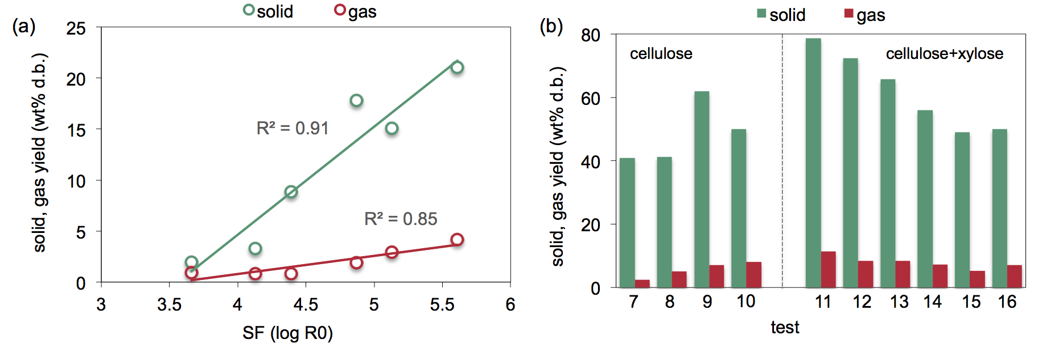

Figure 1: (a) Solid and gas yields versus severity factor for xylose-based samples; (b) solid and gas yields after HTC of cellulose and solvent recirculation tests (RSD≤1.1 for solid and 1.8 for gas) .

Recirculation phases with PW from cellulose reflected the probably different reaction pathways occurred during HTC performed at 20 and 60 min, and thus the different nature of dissolved organics in the spent solvents. When PW from HTC at 20 min was recycled, compared to hydrochar obtained with deionized water, an increased solid yield of 61.9 wt% d.b. (+20.7%) was found versus the 50.0 wt% d.b. (+8.8%) with PW from HTC at 60 min. After HTCs with PW from xylose, a clear decreasing trend for the hydrochar yield increment can be observed (Figure 1b). Also in this case, it appears that PWs from HTC performed at low conversion severity had a greater positive influence on the final hydrochar recovery. Further research and in-depth analyses of PWs composition and properties are definitely needed to investigate this phenomenon and accurately distill its causes. Gas yield slightly increased after all PW recirculation tests, probably due to the high concentration of organic acids in the aqueous solvent e their decarboxylation (Volpe, M., et al., 2020).

* + 1. Hydrochars characterization

Recirculation of PWs obtained after HTC of xylose and cellulose evidently boosted the formation of SC phases with the increase of reaction severity, and led to a specular decreasing trend of PC fraction, accordingly (Figure 2). After recirculation phases with PW from xylose, the SC yield increased by almost 12 wt% d.b., in absolute terms, from 24.1 wt% d.b., with PW by HTC at 180 °C and 20 min, to 35.9 wt% d.b., with PW from conversion at 230 °C and 60 min. The increase in SC formation was even more evident after recirculation with PW from cellulose: 23.2 and 40.8 wt% d.b. with PWs from HTC at 20 and 60 min, respectively.

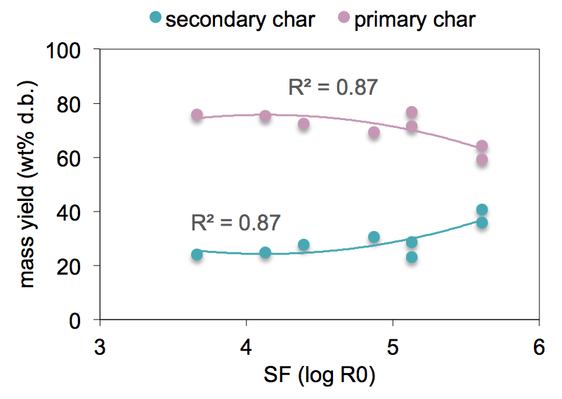

Figure 2: Primary and secondary char mass yields versus severity factor for cellulose-derived hydrochars (dots represent the experimental data while solid line is a second-degree polynomial fitting curve). In the plot, SF indicates the reaction severity with which PW was obtained in the prior HCT of xylose or cellulose.

Literature indicates that alongside furfurals, low molecular mass organic acids, such as lactic, formic, glycolic and acetic, are the most abundant liquid by-products from HTC of xylose, and the total acids concentration typically increases with HTC severity due the more intense dehydration reactions (Liu et al., 2022). These organic acids are known to have a notable impact on HTC as they strongly enhance the solid substrate hydrolysis and catalyze the repolymerization of both furfural from xylose and 5-HMF from cellulose. More specifically, when PW is recirculated, the conversion intermediates (furans, aldehydes, ketones and others) progressively accumulate in the liquid phase as a direct outcome of the promoted HTC; subsequently, they are involved into re-solidification reactions, forming new carbonaceous micronuclei, suspended in the PW; when their concentration reaches a critical value, the re-polymerized carbon particles aggregate into clusters and eventually precipitate on the hydrochar surface (Arauzo et al., 2020).

On the basis of this reaction mechanism, the increasing SC mass yield trend found could be related to a possible higher concentration of organic acids in PWs from HTC under more severe conditions. Compared to recirculation tests with PW from xylose, the greater increase of SC yield observed when PW from cellulose was reused, could be ascribed to the more rapid formation of solid char particles from 5-HMF, the main glucose dehydration product (Jia et al., 2022). From Table 2, it can be seen that the SC formation was accompanied by an increase of HHVs. The slight hydrochars’ energy densification can be explained by the fact that SC phases tend to increase the carbon content in the final HTC solid product. Moreover, the organic acids’ catalytic activity could be responsible of a higher carbonization degree by promoting the starting feedstock deoxygenation (Wang et al., 2022).

At low HTC temperatures, SC formation was considerably lower compared to the more severe conditions, leading to larger liquid yields and thus more concentrated PWs after conversion with deionized water. Recirculation of PWs with a high starting concentration of organic compounds may have accelerated the aqueous phase saturation during the process and thus slowing down the feedstock hydrolysis favoring solid-solid conversions, with a dominant hydrochar PC fraction, as the main result (Arauzo et al., 2020).

For all hydrochars, proximate analysis results reveal a remarkable reduction in VM content and a correspondent increase of FC, as an obvious consequence of the feedstock carbonization. VM, FC and HHV values of samples (7) and (8) corroborate former hypothesis, according to which cellulose treated for 20 and 60 min underwent significantly different reactions in terms of nature and intensity. Indeed, compared to sample (7), the higher carbonization degree suggested by the proximate composition and HHV value of sample (8) is symptomatic of a more intense conversion, which led to a greater SC formation (10.0 wt% d.b. for sample 7 and 28.9 wt% d.b. for sample 8) and an almost unchanged solid mass yield. No recognizable trends in proximate composition were observed after HTC with PW recirculation.

Table 2: Proximate analysis results and HHV of raw xylose (raw\_x), raw cellulose (raw\_c) and hydrochars derived from cellulose (VM and FC measured in wt% d.b.; HHV measured in MJ/kg). RSD≤1.7 for VM and FC; RSD≤2.1 for HHV. All samples were free of ASH content.

|  |  |  |  |  |  |  |
| --- | --- | --- | --- | --- | --- | --- |
|  | Sample | | | | | |
|  | raw\_x | raw\_c | (7) | (8) | (9) | (10) |
| VM | 98 | 86.0 | 76.5 | 52.3 | 53.9 | 51.4 |
| FC | 1.2 | 14.0 | 23.5 | 47.7 | 46.1 | 48.6 |
| HHV | 15.1 | 16.9 | 21.5 | 27.8 | 27.9 | 28.7 |
|  | (11) | (12) | (13) | (14) | (15) | (16) |
| VM | 52.6 | 50.3 | 53.3 | 51.0 | 52.9 | 52.0 |
| FC | 47.4 | 49.7 | 46.7 | 49.0 | 47.1 | 48.0 |
| HHV | 25.3 | 25.9 | 26.1 | 26.8 | 26.4 | 27.3 |

* 1. Conclusions

This study focused on the role of hemicellulose in hydrothermal carbonization (HTC) with recycled process water (PW). Results highlighted that formation of secondary chars (SC) and gaseous products from xylose was enhanced with the increase of reaction severity due to the highly endothermic nature of re-polymerization and decarboxylation reactions. Recirculation of the exhausted PW had a significant impact on HTC, leading to an increased hydrochar yield at all operating conditions. A SC mass yield increasing trend was found after recirculation of PWs obtained from xylose, with the increase of conversion severity. In comparison, recirculation of PW from cellulose led to an even greater increase of SC formation, probably due to the higher tendency of cellulose soluble by-products to condense and re-polymerize. The effect of hemicellulose-derived PW on HTC with solvent recirculation deserves further investigation in order to elucidate the interactive polymerization pathways of dissolved organics and their impact on hydrochar formation and properties. A thorough understanding of the hydrochar forming mechanism could allow to better govern HTC with a considerable, positive influence on the process economic and environmental footprints, given the optimized hydrochar production and the exhausted solvent recycling.

Acknowledgments

Authors gratefully acknowledge support of the "SiciliAn MicronanOTecH Research And Innovation Center - SAMOTHRACE" project (MUR, PNRR-M4C2, ECS\_00000022).

References

Arauzo P.J., Olszewski M.P., Wang X., Pfersich J., Sebastian V., Manyà J., Hedin N., Kruse A., 2020, Assessment of the effects of process water recirculation on the surface chemistry and morphology of hydrochar, Renew. Energy 155, 1173–1180.

Jia J., Wang R., Chen H., Xue Q., Yin Q., Zhao Z., 2022, Interaction mechanism between cellulose and hemicellulose during the hydrothermal carbonization of lignocellulosic biomass, Energy. Sci. Eng., 1–12.

Kim D., Lee K., Park K.Y., 2016, Upgrading the characteristics of biochar from cellulose, lignin, and xylan for solid biofuel production from biomass by hydrothermal carbonization, J. Ind. Eng. Chem. 42, 95–100.

Liu T., Jiao H.T., Yang Longsheng, Zhang W., Hu Y., Guo Y., Yang Lihong, Leng S., Chen, Jiefeng, Chen, Jie, Peng H., Leng L., Zhou W., 2022, Co-hydrothermal carbonization of cellulose, hemicellulose, and protein with aqueous phase recirculation: Insight into the reaction mechanisms on hydrochar formation, Energy 251.

Lu J., Liu Z., Zhang Y., Savage P.E., 2018, Synergistic and Antagonistic Interactions during Hydrothermal Liquefaction of Soybean Oil, Soy Protein, Cellulose, Xylose, and Lignin, ACS Sustain. Chem. Eng. 6, 14501–14509.

Picone A., Volpe M., Messineo A., 2024, Synergistic Effects towards Hydrochar Recovery during Hydrothermal Carbonization of Ferula Communis with Process Water Recirculation, Chem. Eng. Trans. 109, 121–126.

Poerschmann J., Weiner B., Koehler R., Kopinke F.D., 2017, Hydrothermal Carbonization of Glucose, Fructose, and Xylose - Identification of Organic Products with Medium Molecular Masses, ACS Sustain. Chem. Eng. 5, 6420–6428.

Sheng K., Zhang S., Liu J., E S., Jin C., Xu Z., Zhang X., 2019, Hydrothermal carbonization of cellulose and xylan into hydrochars and application on glucose isomerization, J. Clean. Prod. 237, 117831.

Volpe M., Messineo A., Mäkelä M., Barr M.R., Volpe R., Corrado C., Fiori L., 2020, Reactivity of cellulose during hydrothermal carbonization of lignocellulosic biomass, Fuel Process. Technol. 206. https://doi.org/10.1016/j.fuproc.2020.106456

Volpe R., Messineo S., Volpe M., Messineo A., 2016, Catalytic effect of char for tar cracking in pyrolysis of citrus wastes, design of a novel experimental set up and first results, Chem. Eng. Trans. 50, 181–186.

Wang R., Jia J., Jin Q., Chen H., 2022, Forming mechanism of coke microparticles from polymerization of aqueous organics during hydrothermal carbonization process of biomass, Carbon N. Y. 192, 50–60.

Wang R., Jin Q., Ye X., Lei H., Jia J., Zhao Z., 2020, Effect of process wastewater recycling on the chemical evolution and formation mechanism of hydrochar from herbaceous biomass during hydrothermal carbonization, J. Clean. Prod. 277.