|  |  |
| --- | --- |
| cetlogo ***CHEMICAL ENGINEERING TRANSACTIONS***  ***VOL. xxx, 2025*** | A publication of  aidiclogo_grande |
| The Italian Association  of Chemical Engineering  Online at www.cetjournal.it |
| Guest Editors: Fabrizio Bezzo, Flavio Manenti, Gabriele Pannocchia, Almerinda di Benedetto  Copyright © 2025, AIDIC Servizi S.r.l. **ISBN** 979-12-81206-17-5; **ISSN** 2283-9216 | |

Renewable methanol production from polyolefin waste via pyrolysis: process simulation and GHG emissions evaluation

Mariangela Guastaferro\*, Federico Baglioni, Letizia Marchetti, Leonardo Tognotti, Cristiano Nicolella

University of Pisa, Department of Civil and Industrial Engineering, Largo Lucio Lazzarino 2, 56126 Pisa (Italy)

mariangela.guastaferro@unipi.it

This study presents an integrated process for the valorization of plastic solid waste using a thermal pyrolysis stage followed by a steam reforming system, focusing on energy recovery and methanol production. The first pyrolysis reactor operated at 500°C, while the second reactor temperature was set at 800°C, achieving a gas yield of 98%. The gas composition profile exhibited a favorable (H₂ - CO)/(CO + CO₂) ratio of 2.06 for plastic waste, further enhancing methanol production. The data from these experimental campaigns was used to model the reaction section using Unisim Design® software. A comprehensive process scheme was developed, incorporating compressors to achieve 70 bar and 220°C, the required conditions to optimize methanol synthesis in a plug flow reactor with an integrated purification unit. This setup was simulated to ensure optimal thermal integration for efficient methanol production from syngas. The environmental impact of the process was assessed by evaluating plant emissions across a short supply chain, following the criteria set out in Annex I of the Renewable Energy Directive (RED III). The assessment focused on determining whether the methanol obtained from recycled carbon could be classified as renewable, based on achieving emission savings of more than 70% compared to conventional fossil fuel production and usage. The results underscore the feasibility of producing renewable fuels (i.e. methanol) from plastic waste, highlighting the vital role of closed-loop recycling in reducing carbon emissions and improving the sustainability of polyolefin production.

* 1. Introduction

Plastic waste management has assumed a crucial role in advancing circular economy initiatives and supporting the energy transition (Nayanathara Thathsarani Pilapitiya and Ratnayake, 2024). Even though polymers are key materials in several industrial sectors, they represent the largest consumers of energy and feedstock derived from oil and gas (Tumu et al., 2023). Upon global plastic production increase, reaching 368 million tons in 2024 and expected to increase in the next years, effective management of plastic waste is critical to addressing both pollution and resource sustainability challenges. Indeed, the chemical industry is identified as the largest industrial consumer of fossil fuels derived compounds and energy, consequently, it faces a dual challenge: reducing carbon emissions while transforming waste streams into valuable materials. Among the various strategies for valorizing waste, chemical recycling is a promising candidate to transform low-quality plastic waste with high levels of impurities into high value-added compounds (Marchetti et al., 2024). Methanol represents a versatile compound central to both the chemical and energy sectors. It acts as a key intermediate for the production of formaldehyde, acetic acid, light olefins, and dimethyl ether. Additionally, its role in CO₂ hydrogenation positions it as a promising candidate for carbon utilization technologies. Conventionally, methanol is produced from syngas, that is a mixture of CO, H₂, and CO₂, typically derived from fossil-based resources like natural gas or coal. The stoichiometric properties of syngas, especially the H₂/CO ratio and the stoichiometric number (SN), which is defined as (H₂ - CO)/(CO + CO₂), play a critical role in determining methanol yield (Prifti et al., 2023). Recent studies have demonstrated that syngas derived from plastic waste can meet the required synthesis conditions effectively. Methanol synthesis itself is a catalytic process that involves the hydrogenation of CO and CO₂, along with the water-gas shift reaction. The design of the reactor is a pivotal factor in optimizing process efficiency (Grabow and Mavrikakis, 2011). Moreover, assessing the existing legislative framework is a key step in advancing the production of renewable methanol from recycled carbon. To assess whether methanol produced from recycled carbon-based feedstocks (RCFs) can be qualified as a renewable energy source, it is necessary to evaluate its greenhouse gas (GHG) emissions along its production and use phases in comparison to those of traditional fossil-based methanol. This analysis is crucial for assessing the environmental benefits of RCF-derived methanol and its potential to lower pollution levels. To this aim, on February 10, 2023, updates were introduced in the Renewable Energy Directive (RED II) under Directive (EU) 2018/2001 (RED II), establishing criteria for minimum GHG emission savings and providing an assessment methodology for RCFs, detailed in Annex I of the delegated act. According to these guidelines, methanol can be deemed renewable if its global GHG emissions are reduced by at least 70% compared to fossil-derived methanol, using a baseline of 94 gCO₂eq/MJfuel as specified in paragraph 19, Annex V, Part C, of Directive 2018/2001. Therefore, the goals of this study are twice: i) to convert plastic waste into methanol via pyrolysis, integrating thermodynamic viability of producing methanol from the pyrolysis of plastic solid waste while analyzing plant configurations and reactor performance under varying conditions, such as temperature, pressure, and purge ratio, and ii) to develop and apply an innovative approach to assess the sustainability of the methanol production process.

* 1. Plant Design
     1. Thermodynamic background

The stoichiometric reactions involved in methanol synthesis using syngas as feedstock are:

1. CO2 hydrogenation: $CO_{2}+3H_{2 }⮂CH_{3}OH+H_{2}O ΔH_{R}^{0}\left(298K\right)=-90.7 kJ/mol$
2. CO hydrogenation: $CO+H_{2}⮂ CH_{3}OH+H_{2}O ΔH_{R}^{0}\left(298K\right)=-41.51 kJ/mol$

From (1) and (2), carbon monoxide (CO) and carbon dioxide (CO₂) react, respectively, with hydrogen (H₂) to produce methanol with water generated as a byproduct. In addition to these two methanol synthesis reactions, the reverse water-gas shift (rWGS) reaction may occur, further influencing the reaction dynamics (Leonzio et al., 2019):

1. rWGS: $CO_{2}+H_{2}⮂ CO+H_{2}O ΔH_{R}^{0}\left(298K\right)=+41.19 kJ/mol$

The reactions involved in methanol synthesis are reversible and governed by thermodynamic equilibrium principles. The hydrogenation of both CO and CO₂ are exothermic processes that result in a decrease in the total number of moles. Consequently, higher pressures and lower temperatures promote the forward direction of methanol synthesis, in alignment with Le Chatelier's principle. Conversely, the reverse water-gas shift (rWGS) reaction is endothermic and does not involve a change in the total number of moles. Industrial production typically employs a Cu/ZnO/Al₂O₃ catalyst due to its compatibility with operational conditions. The rWGS reaction interlinks other reactions in the system, which means only two of the three key reactions are independent and must be analyzed in stoichiometric models. Reaction kinetics are commonly described using the Vanden Bussche and Froment model, which is based on the mechanism of Langmuir Hinshelwood HougenWatson. This approach identifies carbon dioxide as the main reactant in methanol synthesis and provides rate equations suitable for computational modelling:

$$r_{CO2→MeOH}=\frac{k_{1}p_{CO_{2}}p_{H_{2}}-k_{2}p_{H_{2}O}p_{MeOH}p_{H_{2}}^{-2}}{{\left(1+K_{1}p_{H_{2}O}p_{H_{2}}^{-1}+K_{2}p_{H_{2}}^{0.5}+K_{3}p_{H_{2}O}\right)}^{3}} \left[\frac{mol}{kg_{cat}s}\right]$$

$$r_{rWGS}=\frac{k_{3}p_{CO_{2}}-k_{4}p_{CO}p_{H_{2}O}p_{H_{2}}^{-1}}{\left(1+K_{1}p_{H_{2}O}p_{H_{2}}^{-1}+K_{2}p_{H_{2}}^{0.5}+K_{3}p_{H_{2}O}\right)} \left[\frac{mol}{kg_{cat}s}\right]$$

The partial pressures of the compounds are expressed in bar. The constants used in this study are presented in Table 1, with activation energies expressed in J/mol.

Table 1. Kinetic parameters of kinetic constants and adsorption constants.

|  |  |  |  |  |  |
| --- | --- | --- | --- | --- | --- |
|  | Kinetic constants | |  | Adsorption constants | |
|  | Ai | Ei [J/mol] |  | Ai | Ei [J/mol] |
| k1 [bar-2] | 1.07 | -40000 | K1 [-] | 3453 | - |
| k2 [-] | 4.2\*10^10 | 18695 | K2 [bar-0.5] | 0.49 | -17197 |
| k3 [bar-1] | 1.22\*10^10 | 98084 | K3 [bar-1] | 6.62\*10^-11 | -124119 |
| k4 [bar-1] | 1.14\*10^8 | 58365 |  |  |  |

In this study, methanol synthesis is conducted within a tubular fixed-bed reactor using syngas as the feedstock. Given the negligible concentration gradients between the gas and solid phases along the reactor axis, the pseudo-homogeneous reactor model is deemed appropriate for simulating the methanol synthesis process. The primary assumptions of the pseudo-homogeneous model include: (1) steady-state flow conditions prevail throughout the reactor; (2) catalyst effectiveness remains constant, with axial mass diffusion and heat conduction considered insignificant; (3) the cooling jacket operates efficiently without coolant accumulation, ensuring effective heat removal under isothermal conditions; and (4) side reactions are assumed to be negligible.

* + 1. Modeling of methanol plants

Figure 1 presents the flowsheet of a methanol production plant utilizing pyrolytic syngas, simulated using UniSim Design® software. This simulation is used to analyze operating conditions and calculate material and energy balances, as well as utility requirements. The Peng–Robinson thermodynamic property fluid package is employed to ensure precise modeling of hydrocarbons and light gas components, which are common in refinery processes.

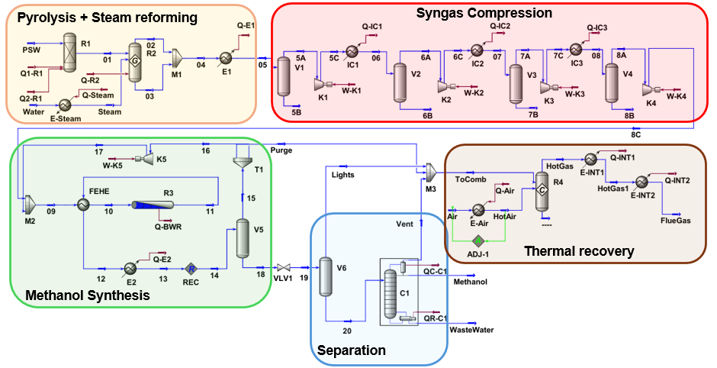

Figure 1. Process Flow Diagram of methanol produced from syngas derived from PSW pyrolysis + steam reforming and simulated in UniSim Design®.

Differential scanning calorimetry analysis identified polyolefins (polyethylene and polypropylene) as the primary hydrocarbon in PSW and modelled using UNIFAC group contribution methods. The plant size selected for this study is designed to process 1000 kg/h of dry plastic waste (*PSW*). The two reactive stages were simulated using Yield Shift reactors (R-Yield, *R1*) and Gibbs reactor (R-Gibbs, *R2*). *R1* represents the pyrolysis stage at 500°C, whereas *R2* represents the steam reforming at 900°C. The heat of reaction for *R1* (834 kJ/kg, *Q1-R1*) was evaluated by summing the contributions of the pyrolysis enthalpy of plastics (541 kJ/kg, Jin et al. 2018) and their latent heats of fusion (293 kJ/kg). To maintain a constant temperature profile of 500°C within the reactor, this temperature was set at the reactor outlet (*01*), and the total thermal energy required (*Q2-R1*) was calculated accordingly. A significant assumption was introduced by using a Gibbs reactor (*R2*) to simulate a reformer operating under thermodynamic equilibrium. This type of reactor determines the outlet composition by satisfying chemical and phase equilibrium conditions while adhering to atomic balance constraints. The reactor operates at 800°C with an excess of steam (*Steam*) to convert heavy hydrocarbons and olefins into methane and syngas. It is also assumed that coke gasification occurs within the reactor. The resulting syngas (*04*) was characterized by the *SN* value and the literature suggests an optimal range of 2.05/2.1 for syngas entering the methanol synthesis reactor (Riaz et al., 2013); consequently, in this study, the *SN* has been set at 2.06. The fresh syngas is mixed with the recycled gas, compressed using four compressors with a compression ratio of 2.88, pressurized, and then fed to the reactor. The methanol reactor is a multi-tubular reactor having the following characteristics: 6 m of length, 1700 tubes of 0.04 meters of diameter containing Cu/ZnO/Al2O3 catalyst. The void fraction and the amount of catalyst used are equal to 0.285 and 2000 kg/m3, respectively. The reactor's outlet stream is cooled through two heat exchangers before being flashed to separate gases (CO, CO2 and H2) from methanol-water mixture. After undergoing a variable purge, ranging from 2.5% to 10%, the gas stream is compressed and mixed with fresh reactants before being recirculated back to the reactor. Methanol-water is sent to a high-pressure flash separator (*V5*) operating at the same reactor pressure, and a low-pressure flash separator (*V6*) operating at 1.4 bar is employed for further removing of non-condensable gases. Direct feeding of the stream to the distillation column would lead to the accumulation of non-condensable gases in the condenser, necessitating either the use of a colder utility or operation at higher pressures. The liquid stream obtained (2*0*) is sent to a tray distillation column (*C1*) for further separation. The *C1* column produces *Wastewater* with minimal methanol content (<0.01 mol%) as bottom product and *Methanol* with a molar purity of 99.8% as distillate. The column is equipped with a partial condenser to remove residual non-condensable gases through the *Vent* (i.e., 0.99 kmol/h). Summarizing, 1000 kg/h of *PSW* and 1500 kg/h of *Steam* flow rate at various operative conditions (i.e., temperature, pressure and purge) have been processed to figure out the best operative conditions allowing to maximize methanol yield. Thermal integrations were also performed. *Steam* for the reforming reactions was generated by cooling the syngas produced in *R2*, that was thermally integrated by burning the purge streams from methanol production with a 12% excess of air. Additionally, the saturated steam at 216 °C obtained from the methanol synthesis reactor was employed to thermally integrate the distillation column reboiler.

* + 1. Emissions evaluation

The equations used to estimate greenhouse gas (GHG) emissions associated with the production and utilization of recycled carbon fuels, as well as to calculate GHG emission savings, are provided in Annex I, sections 1(A) and 2(A), of the Delegated Act dated May 20, 2022.

|  |  |
| --- | --- |
| $$E=e_{i}+e_{p}+e_{td}+e_{u}-e_{ccs}$$ | (1) |
| $$Savings=(E_{f}-E)/E$$ | (2) |

The term $E_{f}$, representing emissions from fossil fuels, is defined as 94 gCO2eq/(MJ of fuel), as specified in paragraph 19 of Annex V, part C of Directive (EU) 2018/2001. A fuel is classified as renewable if its emission savings exceed 70%. The parameter $e_{i}$ accounts for emissions from input supplies, including power used for compressor operation, methane combustion to generate thermal energy for the endothermic reactions in R1 and R2, and steam production for reforming reactions in R2. Processing emissions ($e_{p}$) originate from the combustion of purged gases, while emissions from methanol's final use ($e_{u}$) are assessed based on its direct application as a fuel, which enables thermal energy recovery. Transport and distribution ($e_{td}$) emissions are calculated considering the requirement of 1450 trucks to transport methanol annually over an average distance of 100 km. Since the process does not include a carbon capture plant, carbon capture and storage ($e_{ccs}$) savings are set to zero. The contributions of $e_{i}$ and $e_{p}$ are subject to an emission allocation criterion, which, as per Annex I, involves multiplying these terms by the allocation factor (f*A*). In this study, f*A* is taken as one, given that methanol is the sole product of the process.

* 1. Results

Figure 2a shows the effect of inlet temperature and pressure on global methanol yield and Figure 2b shows the effect of purge percentage and pressure on global methanol yield.

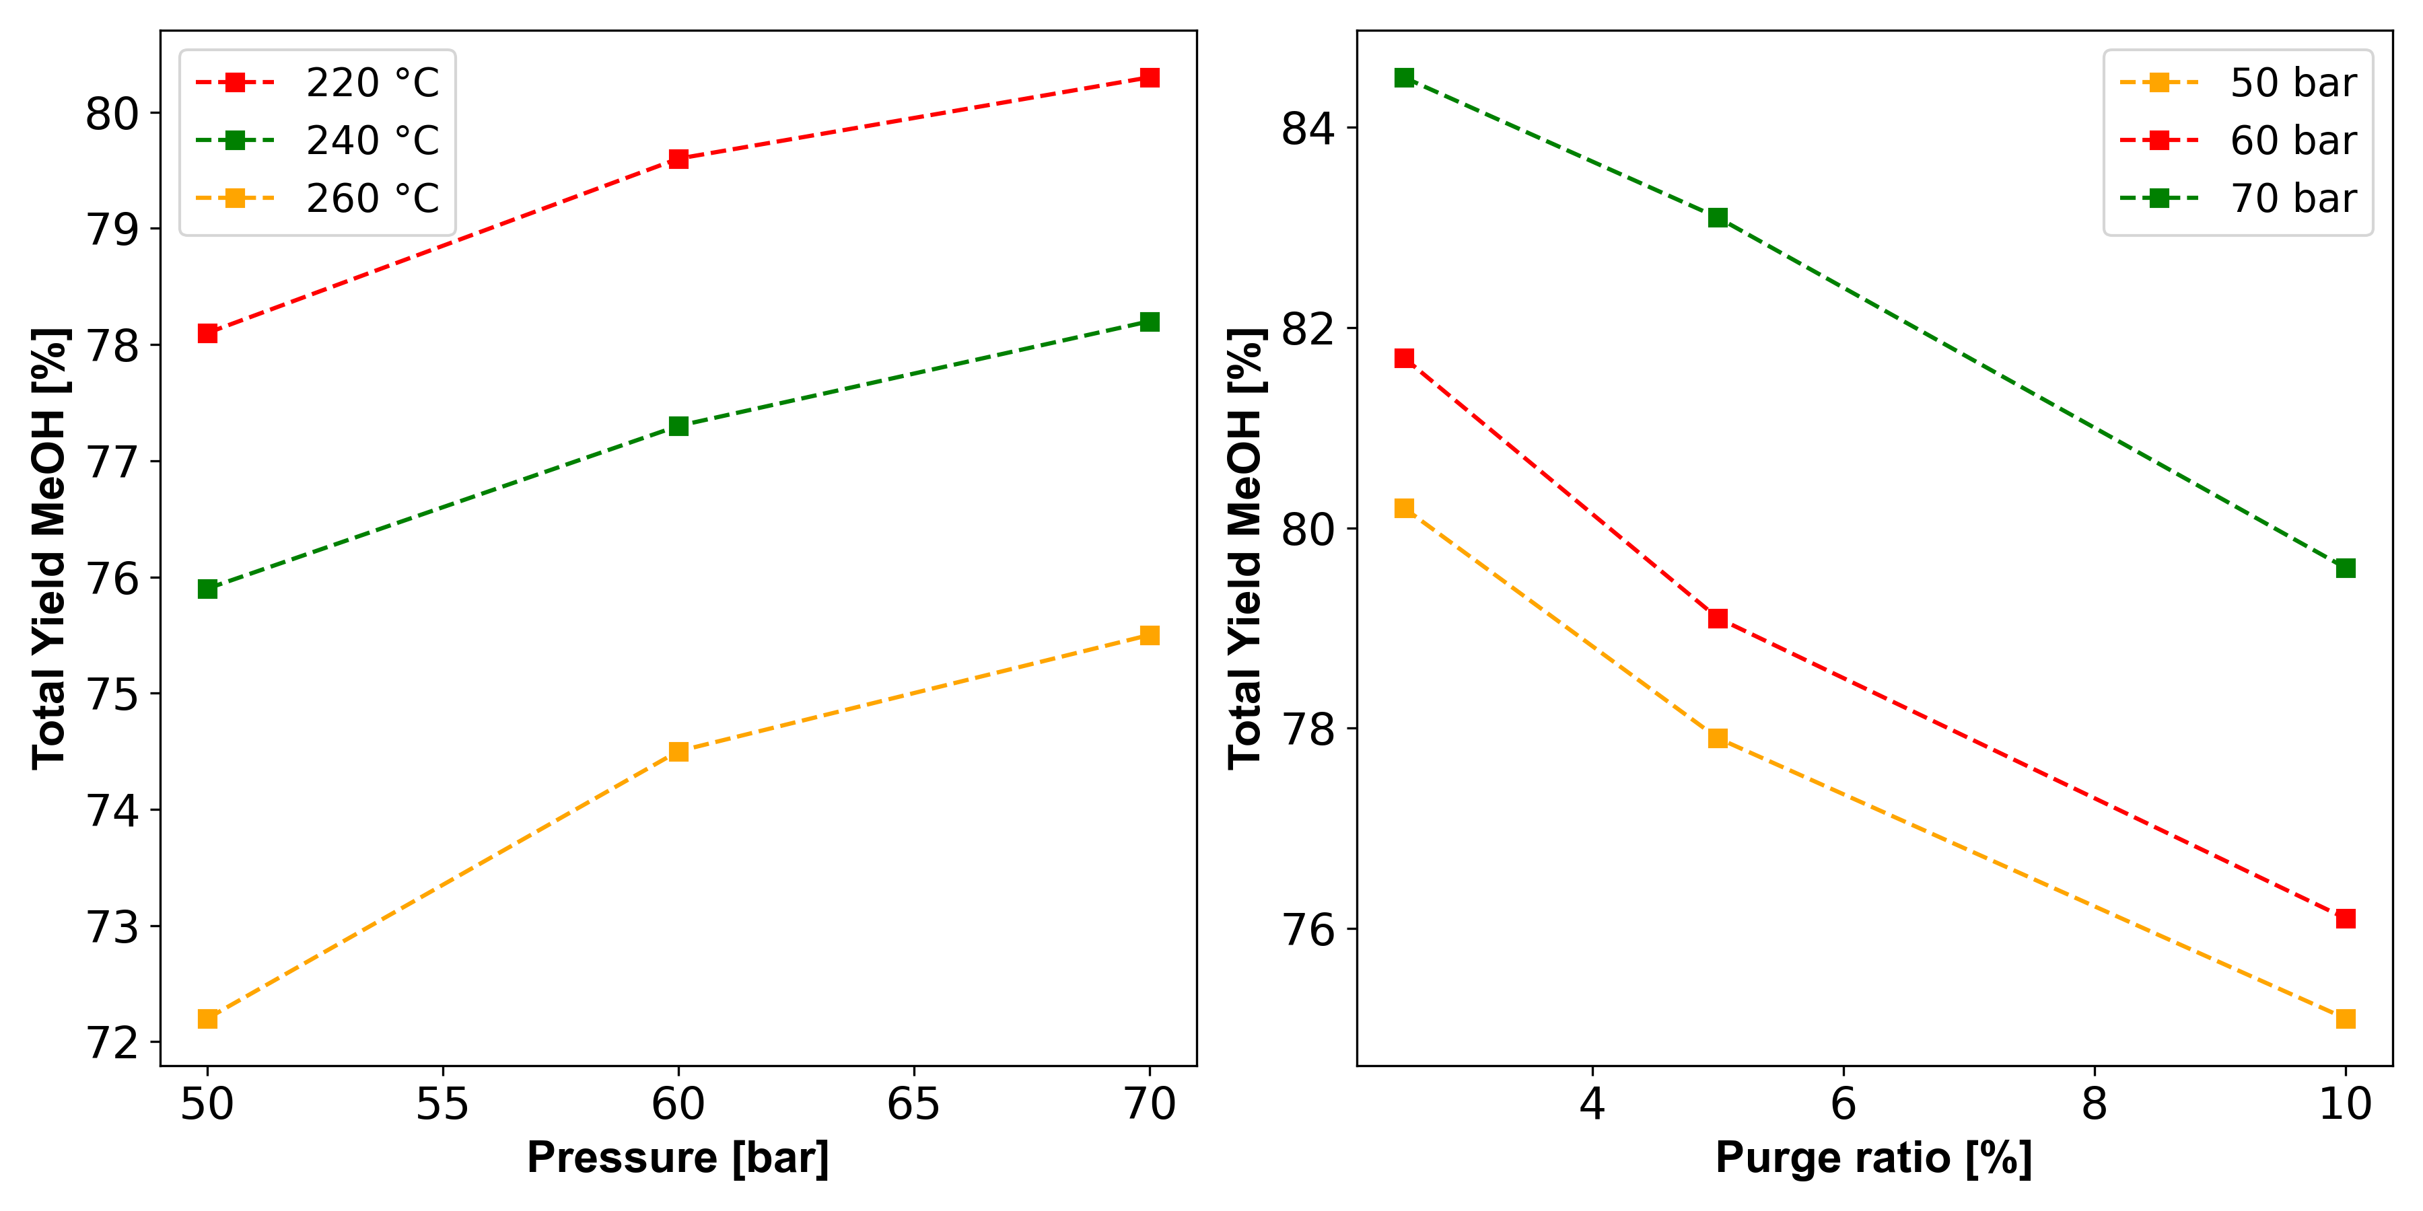

1. **(b)**

Figure 2. a) Effect of P and T on Total MeOH yield, b) Effect of purge ration and P on Total MeOH yield.

Figure 2a illustrates that temperature negatively impacts CO₂ conversion to methanol, while pressure has a positive effect, consistent with Le Chatelier’s principle. This reaction is exothermic and involves a reduction in the number of moles. As a result, the highest methanol production was achieved at the lowest temperature tested (220°C) and the highest pressure tested (70 bar). Figure 2b shows that incorporating a recycling system in the reactor, which recirculates gases after methanol and water are separated, enables the process to overcome equilibrium limitations on product yield while maintaining constant operational pressure. Additionally, increasing the recycled stream of unconverted gases (CO-CO₂-H₂) improves methanol production. The presence of CO in the feed syngas at concentrations higher than equilibrium levels enhances the water-gas shift reaction, thereby increasing the availability of CO₂ and boosting methanol yield (Leonzio et al., 2019).

Furthermore, mass and energy balance calculations performed using simulation software (refer to Section 2.2) provide inventory data to estimate greenhouse gas (GHG) emissions. These estimates were prepared following the guidelines outlined in Annex I of the Delegated Act 20/05/22, with the resulting values presented in Figure 3.

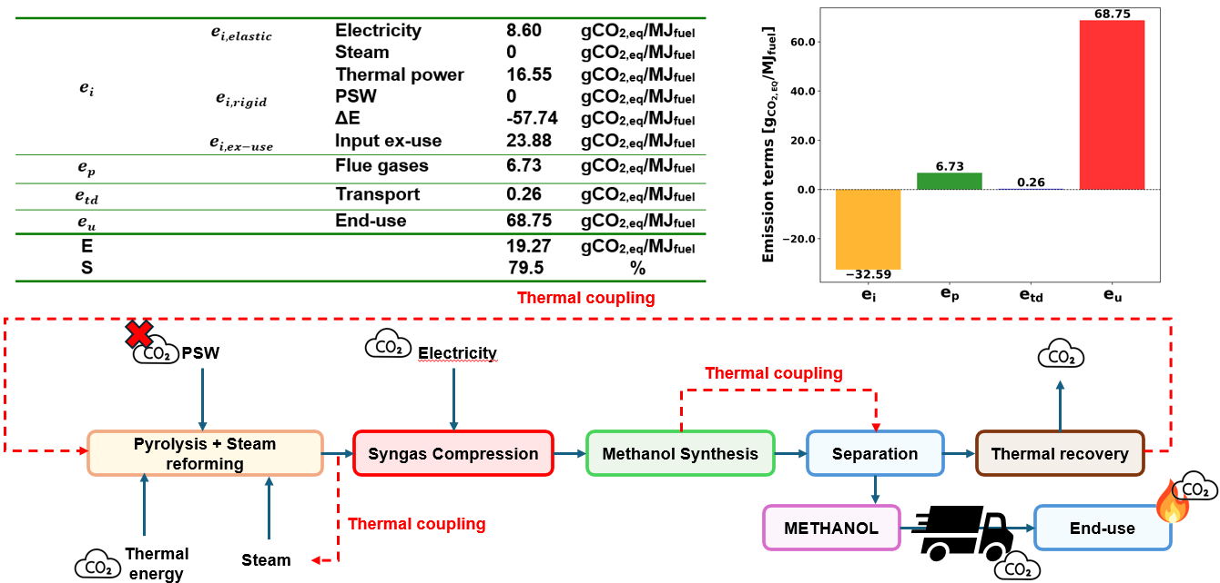

Figure 3. GHG emissions evaluation of simulated plant for methanol production according to the Annex I of the Delegated Act 20/05/22.

To calculate the $e_{p}$ term as described in Eq. (1), the mass flows of CO2 equivalent emissions from burning purged gases in *R4* was determined to be $M_{CO2,FlueGas}=$ 273.66 kg/h. For emissions related to methanol transportation to the usage site, it is assumed that 150 5-LH per year are required to transport 15 tons of methanol over 150 km, with an emission factor of 56.60 gCO2eq/t·km as per International Council of Clean Transportation (ICCT). In contrast, the $e_{i, elastic}$ term was evaluated using Italy’s grid emission intensity, set at 94 gCO2eq/MJfuel (Annex I), multiplied by the electrical energy requirement for the compression section (i.e., 1053 kWe). Similarly, emissions from methane combustion in Italy, with an intensity of 66 gCO2eq/MJfuel (Annex I) were multiplied by the thermal energy required to sustain the endothermic reactions in *R2* (i.e., 1852 kW). Emissions from *Steam* production at 100 °C are set equal to 0 since it is generated by cooling the syngas. The $e_{i,rigid}$ manufacturing term is also considered zero since the processed material is classified as waste (Annex I). This term also considers the difference in thermal energy produced by waste-to-energy treatment versus the simulated pyrolysis plant. Waste-to-energy recovery is estimated at 3.88\*107 MJ/y, based on the assumption that only 66% of the waste undergoes such treatment with a thermal efficiency of 0.20; whereas the pyrolysis plant in this study produces 3.37·108 MJ/y. The $e_{i,ex-use}$ value was calculated as 23.88 gCO2eq/MJfuel by assessing the GHG emissions avoided when replacing conventional treatments with pyrolysis. Conventional methods, such as waste-to-energy, disposal, and incineration processes produce emissions of 898, 60, and 2894 gCO2eq/tfuel, respectively. These values were multiplied by the corresponding plastic weight percentages processed by conventional treatment methods (i.e., 66.5%, 20.9%, and 12.6%, respectively). The $e_{u,end-use}$ value was determined by considering the stoichiometric combustion of methanol resulting in 68.75 gCO2eq/MJfuel. Contributions to the final $E$ value in Eq. (1) were evaluated by multiplying the emissions over a full-time operational period of 345 days per year and dividing by the gaseous fuel’s low heating value (i.e., 3.37·108 MJ/y). The resulting S*avings* calculated using Eq. (2) were approximately 80%, exceeding the Renewable Energy Directive (REDII) threshold of 70%. This indicates that methanol produced by the proposed simulated plant can be classified as renewable.

* 1. Conclusions

The study presented in this paper demonstrates the feasibility of producing renewable methanol from plastic solid waste through a novel integrated process combining thermal pyrolysis and steam reforming, focusing on energy recovery and methanol synthesis. By operating a two-stage pyrolysis system at temperatures of 500°C and 800°C, the process achieved a high gas yield of 98%, with a favorable syngas composition characterized by an H₂-to-CO ratio conducive to efficient methanol production. The thermodynamic and kinetic modeling of the process, conducted using UniSim Design® software, provided insights into the optimal conditions for reactor operation and syngas treatment, while incorporating a detailed process design that included syngas compression and thermal integration strategies. Methanol synthesis was carried out in a plug flow reactor at 70 bar and 200°C, producing high-purity methanol with a molar purity of 99.8%. This process was further optimized through the recycling of unconverted syngas and the implementation of heat recovery systems to improve overall efficiency. The environmental impact assessment, adhering to the Renewable Energy Directive (RED III), confirmed that the proposed plant configuration can achieve greenhouse gas emission savings of 80% compared to conventional fossil fuel-based methanol production. These results validate the classification of the produced methanol as renewable under the directive, underscoring the environmental benefits of repurposing plastic waste into valuable chemical feedstocks. This work not only highlights the technical and environmental advantages of closed-loop recycling of plastic waste but also emphasizes the potential of such integrated processes to contribute to carbon reduction targets and promote sustainability within the chemical industry. Through rigorous modeling, experimental validation, and adherence to legislative standards, the study showcases an innovative approach to addressing the challenges related to plastic waste management and to renewable fuel production.

Acknowledgments

Project funded under the National Recovery and Resilience Plan (NRRP), Mission 4 Component 2 Investment 1.3 - Call for tender No. 1561 of 11.10.2022 of Ministero dell’Università e della Ricerca (MUR); funded by the European Union – NextGenerationEU: Award Number: Project code PE0000021, Concession Decree No. 1561 of 11.10.2022 adopted by Ministero dell’Università e della Ricerca (MUR), CUP - I53C22001450006, Project title “Network 4 Energy Sustainable Transition – NEST”.

References

Grabow, L.C., Mavrikakis, M., 2011. Mechanism of methanol synthesis on cu through CO2 and CO hydrogenation. ACS Catal 1, 365–384. https://doi.org/10.1021/cs200055d

Leonzio, G., Zondervan, E., Foscolo, P.U., 2019. Methanol production by CO2 hydrogenation: Analysis and simulation of reactor performance. Int J Hydrogen Energy 44, 7915–7933. https://doi.org/10.1016/j.ijhydene.2019.02.056

Marchetti, L., Guastaferro, M., Annunzi, F., Tognotti, L., Nicolella, C., Vaccari, M., 2024. Two-stage thermal pyrolysis of plastic solid waste: Set-up and operative conditions investigation for gaseous fuel production. Waste Management 179, 77–86. https://doi.org/10.1016/j.wasman.2024.03.011

Nayanathara Thathsarani Pilapitiya, P.G.C., Ratnayake, A.S., 2024. The world of plastic waste: A review. Cleaner Materials. https://doi.org/10.1016/j.clema.2024.100220

Prifti, K., Galeazzi, A., Manenti, F., 2023. Design and Simulation of a Plastic Waste to Methanol Process: Yields and Economics. Ind Eng Chem Res 62, 5083–5096. https://doi.org/10.1021/acs.iecr.2c03929

Tumu, K., Vorst, K., Curtzwiler, G., 2023. Global plastic waste recycling and extended producer responsibility laws. J Environ Manage. https://doi.org/10.1016/j.jenvman.2023.119242