|  |  |
| --- | --- |
| cetlogo ***CHEMICAL ENGINEERING TRANSACTIONS***  ***VOL. xxx, 2025*** | A publication of  aidiclogo_grande |
| The Italian Association  of Chemical Engineering  Online at www.cetjournal.it |
| Guest Editors: Fabrizio Bezzo, Flavio Manenti, Gabriele Pannocchia, Almerinda di Benedetto  Copyright © 2025, AIDIC Servizi S.r.l. **ISBN** 979-12-81206-17-5; **ISSN** 2283-9216 | |

Utilization of potato wastewater for *Chlorella vulgaris* cultivation on Mars

Agnieszka Sidorowicza,†, Eliška Robenhauptováa,†, Giacomo Faisa,b, Mattia Casulaa, Bartolomeo Cosenzac, Giovanni Antonio Lutzud, Giacomo Caoa,b,, Alessandro Concas a,b,\*

a Interdepartmental Centre of Environmental Science and Engineering (CINSA), University of Cagliari, Via San Giorgio 12, 09124 Cagliari, Italy

b Department of Mechanical, Chemical and Materials Engineering, University of Cagliari, Via Marengo 2, 09123 Cagliari, Italy

c Department of Civil and Industrial Engineering, University di Pisa, Largo Lucio Lazzarino, 56122 Pisa (PI).

dTeregroup Srl, via David Livingstone 37, 41123 Modena, MO, Italy; luca.usai@teregrpoup.net (L.U.), gian-ni.lutzu@teregroup.net (G.A.L.)

† These authors contributed equally to this work. Correspondence to: [alessandro.concas@unica.it](mailto:alessandro.concas@unica.it)

Potatoes have been demonstrated to be a crop potentially cultivable on Mars to sustain long term manned missions in the next future. Moreover, it has been recently demonstrated that starch from potatoes could be used on Mars to obtain a building material from locally available resources. However, both cooking and extracting starch from potatoes can generate large volumes of wastewater that, beyond posing a pollution burden can determine a loss of organic resources on Mars. Indeed, on the red planet, each organic stream represents a precious resource to produce useful materials to aid the sustainment of an eventual Martian colony. The current study aims to contribute to understanding the feasibility of growing *Chlorella vulgaris* in potato starch wastewater. This can lead to the remediation of the wastewater, the production of photosynthetic oxygen and the contextual generation of valuable microalgal biomass that can also represent a source of food for astronauts. Additional investigations were carried out to evaluate the nutritional quality of the obtained *C. vulgaris* biomass.

* 1. Introduction

The race to colonize Mars is intensifying, driven not only by the pursuit of technological leadership and geopolitical influence on Earth but also by the future of humanity itself. As a result, increasing investments are being directed toward technologies that support long-term human missions to Mars (Fais et al., 2022). In this context, developing efficient systems for producing oxygen and food using locally available resources and astronaut-generated waste is critical. Terrestrial crops like potatoes (Caporale et al., 2024) and aquatic plants such as edible microalgae (Casula et al., 2024) have demonstrated significant potential in this regard. Studies have shown that both plants can thrive on simulated Martian regolith and atmospheric CO₂, utilizing astronauts’ metabolic waste while simultaneously generating food and oxygen to sustain crew members. Recent research has also explored the feasibility of fabricating construction materials on Mars using in-situ resources. Roberts and Scrutton (2023) demonstrated that a starch-based binder, extracted from Martian-grown potatoes, could be used to produce a durable building material when combined with Martian regolith simulant. The starch extraction process mirrors that performed on Earth, producing a byproduct known as potato starch wastewater. This wastewater is characterized by high chemical oxygen demand (COD) and biological oxygen demand (BOD) (Kot et al., 2017), presenting an environmental challenge. However, it is also exceptionally rich in carbohydrates, nitrogen, phosphorus, and trace minerals—ideal conditions for microalgae growth. Given microalgae’s well-documented ability to thrive in simulated Martian environments (Fais et al., 2024) and their capacity to utilize various wastewater sources (Lutzu et al., 2020; Concas et al., 2021a), we propose for the first time a circular process that integrates food, oxygen, starch, and building material production on Mars (Fig. 1). Beyond its effectiveness in wastewater remediation, microalgae cultivation on Mars presents additional benefits.

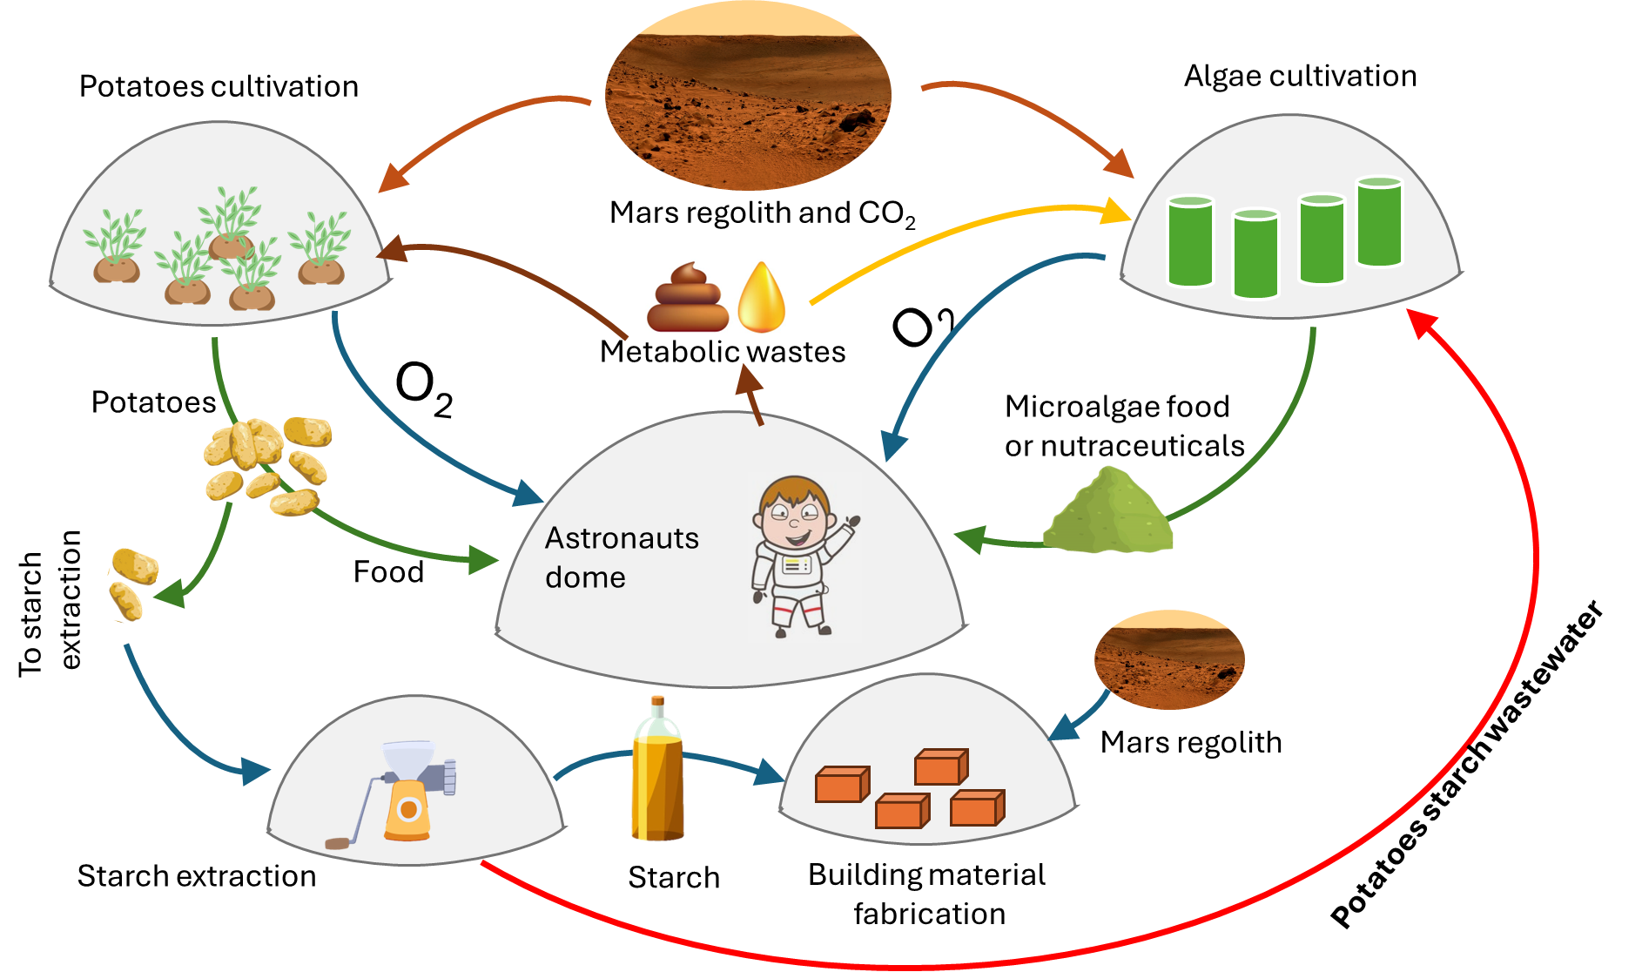

*Figure 1. Scheme of the envisioned process to exploit Martian resources to produce food, oxygen and building materials involving the recycling of potatoes wastewater using microalgae.*

By leveraging in-situ resources, microalgae biomass can be sustainably produced and used for multiple applications, including food and biofertilizers (Concas et al., 2021b). While many microalgae species can remove pollutants from wastewater, only few strains are suitable for food or fertilizer production. Among these, *Chlorella vulgaris* has demonstrated remarkable efficiency in wastewater treatment, reducing total nitrogen by 89% and total phosphorus by 85% (Wang et al., 2015). Additionally, certain *Chlorella* strains have shown high efficacy in removing metal ions. Other widely used genera for similar applications include *Scenedesmus* and *Desmodesmus*. In this study, we investigated the potential of using potato starch wastewater (as illustrated in Fig. 1) as a growth medium for *Chlorella vulgaris*, comparing its performance to the commonly used Bold Basal Medium supplemented with carbonates (BBM+C). The resulting biomass was analysed for its protein, carbohydrate, and lipid content, with additional assessments of its fatty acid composition and antioxidant activity to evaluate its potential as an astronaut food source. Furthermore, we analysed the medium before and after cultivation to assess *C. vulgaris* effectiveness in wastewater remediation. Overall, our findings highlight the potential of *C. vulgaris* cultivated in potato wastewater as a versatile resource for sustaining a future Mars colony, offering a sustainable solution for food production, oxygen generation, and environmental management in extraterrestrial habitats. The produced starch can then be used to fabricate in-situ building material.

* 1. Materials and methods
     1. Medium preparation

Potato starch wastewater medium (PM) was prepared in the laboratory using a method mimicking the standard process of industrial potato starch production with standard pretreatment steps for the utilization by microorganisms, as previously described (Kot et al., 2017). Potatoes were peeled and crushed with a blender (Imetec Dolcevita Bl3, 600 W) with a small amount of distilled water (50 mL of distilled water per 0.5 kg of peeled potatoes). The produced slurry was then filtered with gauze. The collected filtrate was centrifugated at 4000 rpm and 5 °C for 10 minutes. The supernatant was separated from the solids and acidified with diluted sulphuric acid to pH 5. After acidification, the wastewater was sterilized in an autoclave at 121°C and 1 bar pressure for 20 minutes. As a result of the exposure to high temperature, the proteins in the wastewater precipitated, which were separated by means of another centrifugation with the same conditions as in the previous step. After another autoclave cycle, the obtained stock solution of potato wastewater was stored in the refrigerator at 4 °C.

* + 1. Evaluation of optimal dilution ratio

In the first step, *C. vulgaris* grown in BBM+C medium was collected into 3 falcons, each of 50 ml volume. The content was centrifugated at 4000 rpm, 5 °C for 5 minutes to divide the biomass and the medium. The obtained biomass was resuspended in distilled water and centrifugated again to clean the biomass of the remaining medium. The supernatant was removed, and the biomass was again resuspended in distilled water. The optimal dilution of PM was tested in two microtiter plates, each plate with 9 wells. In total, 6 concentrations of potato wastewater medium were tested in triplicates - 50%, 25%, 12.5%, 6.25%, 3.125%, and 1.5625%. The microtiter plates were placed in an incubator to grow under 23 °C, 150 µmol/m2∙s light intensity, and 12/12 h photoperiod.

The growth of the microalgae was monitored every workday with a spectrophotometric plate reader (BioTek® Instruments, Inc. Highland Park, P.O. Box 998. Winooski, Vermont 05404-0998 USA.). To subtract the absorbance of the medium itself, two microtiter plates with medium concentrations identical to the testing plates were prepared. The absorbance was measured at the wavelength 630 nm. The experiment was terminated after 4 days of cultivation since the growth reached the stationary phase. For the wells with the three highest concentrations of medium, the experiment was terminated after 2 days of growth. Due to visible contamination, these concentrations were excluded as too high in nutrients, enabling a more rapid growth of bacteria and fungi, rather than algae. Based on this experiment, the concentration with the highest growth rate and no visible contamination was selected as the optimal dilution of the medium. The stock solution was then diluted accordingly, and the pH was altered with sodium hydroxide solution to the value of 6.8, which corresponds to the pH value of BBM+C medium, ordinarily used for the growth of *C. vulgaris*. The medium was then autoclaved.

To evaluate the growth in the newly developed medium, the growth curve of *C. vulgaris* in PM was measured, as well as the time development of pH during cultivation. The results were subsequently compared to the growth of *C. vulgaris* in BBM+C medium under the same growth conditions – three flasks of 150ml of *C. vulgaris* in medium, 22°C, light intensity 100 µmol/m2∙s and 12/12 h photoperiod. 1 ml of sample was taken out of each flask and centrifugated under 4000 rom, 20°C for 2 minutes. Then, 1 ml of BBM was added to biomass and mixed. The optical density was measured with the spectrophotometer using distilled water as a blank sample.

* + 1. Analyses of dry biomass

The determination of total protein content was conducted with a colorimetric reaction according to the following protocol. The 2 mg of dry biomass samples were extracted with 1 mL of distilled water and sonicated for 30 minutes in an ultrasonic bath. 500 µL of the extract or standard (albumin) were added to 500 µL of sodium hydroxide solution (40 g/L) for 5 minutes at 100 °C. Afterward, 2.5 mL of sodium carbonate (5 g/mL), copper sulfate (0.005 g/mL), and sodium potassium tartrate (0.01 g/mL) were added to the samples. After 10 minutes, 500 µl of Folin-Ciocalteau reagent (1 g/L) was added. The samples were incubated for 30 minutes at room temperature. Then, the OD was measured at 750 nm using a 1 cm wide cuvette. Quantitative analysis was carried out using an external standard calibration method with albumin as a reference. All analyses were conducted in triplicates and results were expressed as weight fractions of dry biomass.

The total content of carbohydrates was determined using a colorimetric analysis based on the following protocol. Samples of 2.5 mg were extracted with 1 mL of distilled water. The created suspension was subjected to a treatment in an ultrasonic bath for 30 minutes. Subsequently, 200 µL of the extract or a standard solution (glucose) were combined with 200 µL of 5% phenol and 1 mL of concentrated sulfuric acid. After 30 minutes of incubation at room temperature, the OD was measured at 490 nm. Quantitative analysis was performed using an external standard calibration method with glucose as standard. The analysis was performed in triplicates and the results were expressed as weight fractions of dry biomass.

Lipids were extracted from the dry biomass (1.5 mg) following a modified protocol based on Chen et al. (2009). 100 µL of PBS and 1.5 mL of sodium hydroxide (1 g/L) containing 25% methanol were added to the samples. The mixture was shaken using a vertical mixer and heated to 100 °C. After centrifugation at 4000 rpm for 15 minutes, 1 mL of the supernatant was collected and combined with a 1:2 methanol/chloroform solution and 0.5 mL of 0.88% potassium chloride solution. The mixture was shaken for 10 minutes and centrifuged again at 4000 rpm for 10 minutes. The detection of lipids was performed using a colorimetric assay. The chloroform phase (1 mL) was dried and then treated with 100 µL of concentrated sulfuric acid at 90 °C for 10 minutes. 2.4 mL of 68% phospho-vanillin reagent were added to the sample. After a 10-minute incubation at room temperature, the OD was measured at 530 nm. Quantitative analysis was conducted using an external standard calibration method with oil containing 100% fat as the reference.

Fatty acids methyl esters were obtained by performing a transesterification with sodium methoxide solution in the lipidic extract. FAME extracts were injected into gas chromatography system equipped with a flame ionization detector (FID) and a fused capillary column. Peak identification was done by comparing peak retention time with Supelco 37 component FAME Mix (Sigma Aldrich).

To analyse the antioxidant activity 2 mg of dry biomass samples were extracted with 1 mL of methanol and sonicated for 30 minutes in an ultrasonic bath. After centrifugation at 4000 rpm for 10 minutes, the supernatant was used for the DPPH assay. The DPPH (1,1-diphenyl-2-picryl-hydrazyl). 20 µL of the extract or a standard solution (Trolox, 6-hydroxy-2,5,7,8-tetramethylchroman-2-carboxylic acid) were added to 2 mL of methanolic solution containing DPPH at a concentration of 40 µM. After a 90-minute incubation period at room temperature, the OD was measured at 517 nm. Quantitative analysis was performed using an external standard calibration method, and the results were expressed in mM/g of TEAC (Trolox equivalent antioxidant capacity).

2.4 Evaluation of wastewater remediation

Samples of potato medium before and after cultivation were analysed for the content of sulphates, nitrates, phosphates, and COD (chemical oxygen demand). The analyses were performed with analytic kits by GM Solution (Sardinia, Italy). All analyses were colorimetric, based on color-shifting reactions and further spectrophotometric readings. The analyses were performed in triplicates and evaluated quantitively using the external standard calibration method and the results were expressed in terms of concentration in mg/L.

* 1. Results and discussion

Figure 2 shows the growth of *C. vulgaris* in BBM+C and PM medium in terms of dry weight of biomass and pH. The specific growth rate in the exponential phase of growth was calculated for each of the respective curves. For 5 days, a very steep increase in biomass weight is evident in PM compared to BMM+C. In BBM+C, *Chlorella* grew with *µ* = 0.358 day-1, however in PM the specific growth rate reached a value of *µ* = 0.763 day-1, more than double the standard laboratory medium. In eight days of growth, Δ*m* = 246 mg of dry biomass was produced, which represents a 3.6-fold greater increase than that for *Chlorella* in BBM+C over the same time. The pH curve shows a drop between days 2 and 5, most probably as a response of the change from photoautotrophic to mixotrophic nutrition strategy. The pH value then continues rising on the last day of cultivation, recording pH 10, which is a standard value for the growth of *C. vulgaris*.

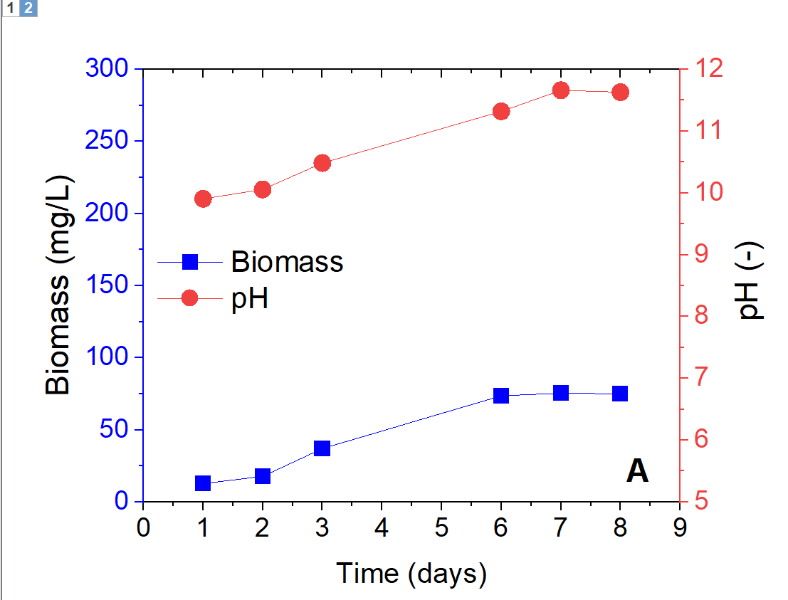 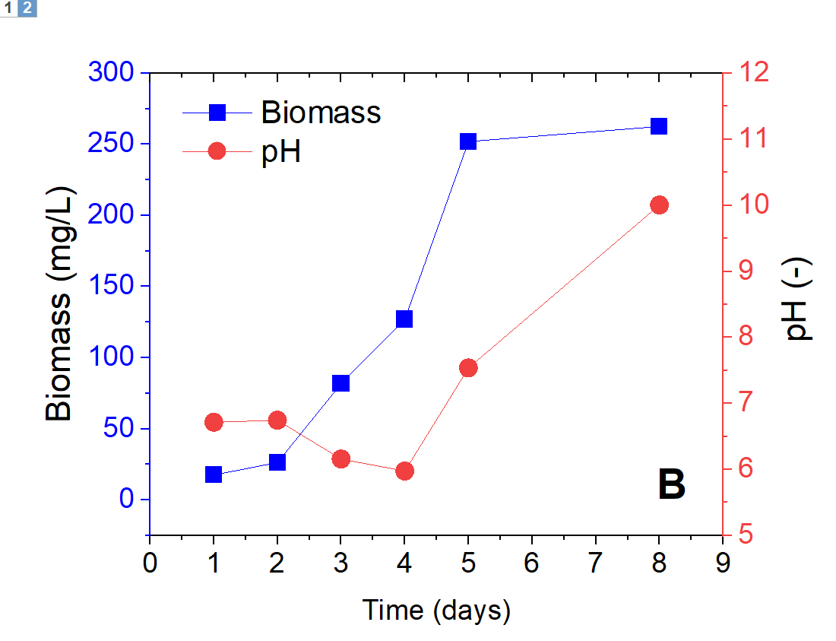

*Figure 2. C. vulgaris growth and pH evolution, (A) in BBM+C, (B) in PM.*

The obtained biomass was further analysed for its composition in comparison with commercially available C. vulgaris powder, as shown in Figure 3.

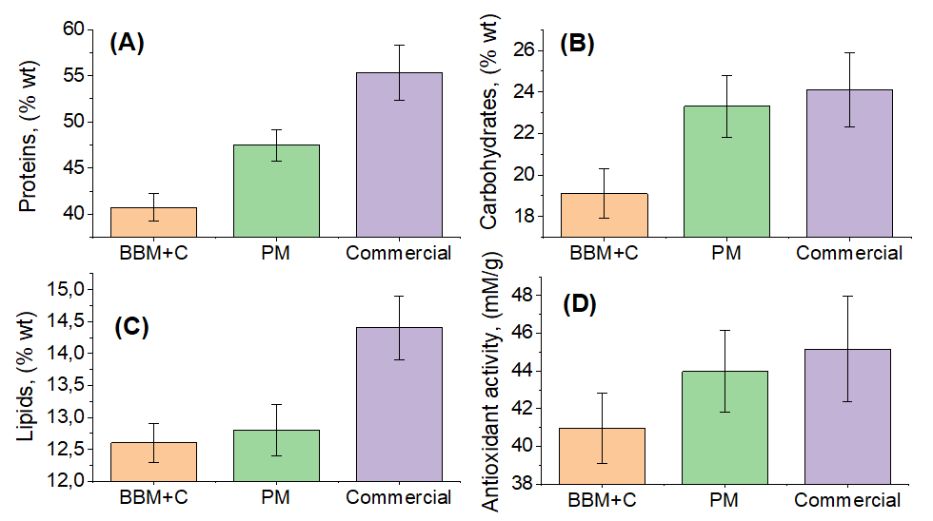

*Figure 3. Nutrient composition of C. vulgaris cultivated in BBM+C and PM in comparison with commercially available C vulgaris, (A) protein content, (B) carbohydrate content, (C) lipid content, (D) antioxidant activity.*

The dry biomass of *Chlorella vulgaris* grown in PM was also characterized in terms of main nutrients and antioxidant activity in comparison with BBM+C and commercially available *Chlorella.* According to the analysis, PM *Chlorella* contains 47.5% protein, i.e. more than BBM+C, however, it does not reach the quality of commercial *Chlorella* (55%). The dependence on the protein content and cultivation conditions was studied before. The literature reports increased protein production from microalgae with increased photoperiod and higher irradiance of the culture (Chia et al., 2019). In addition, *Chlorella* cultured in PM showed a higher amount of carbohydrates in dry biomass compared to cultivation in BBM+C, up to 23.3%, comparable to the carbohydrate content of commercial *Chlorella* which can be used for nutrition purposes. This increase can be justified by the presumed higher amount of organic carbon compounds in the PM medium, which are more available to produce carbohydrates. As for the amount of lipids, *Chlorella* PM is comparable to *Chlorella* BBM+C (12.8% and 12.6%), while the content was the highest in commercial *Chlorella* (14.4%). The analysis of fatty acid methyl esters (FAME) (Table 1) showed the proportion of unsaturated fatty acids in *Chlorella* BBM+C to be 71.9%, whereas *Chlorella* in PM exhibited a proportion of only 31.7%.

Table 1: Results of fatty acids content in two types of microalgal biomass.

|  |  |  |  |
| --- | --- | --- | --- |
| Fatty acid | Lipid number | Mass fraction (%) | |
|  |  | Chlorella BBM+C | Chlorella PM |
| Capric acid | C10:0 | 0.70 ± 0.08 | 7.02 ± 0.43 |
| Lauric acid | C12:0 | 0.17 ± 0.03 | 5.58 ± 0.58 |
| Palmitic acid | C16:0 | 18.10 ± 0.43 | 30.86 ± 3.12 |
| Palmitoleic acid | C16:1 | 0.54 ± 0.07 | 1.70 ± 0.10 |
| Stearic acid | C18:0 | 9.20 ± 0.87 | 28.40 ± 2.94 |
| Oleic acid | C18:1 | 16.00 ± 0.80 | 6.13 ± 0.56 |
| Linoleic acid | C18:2 | 2.41 ± 0.06 | 0.83 ± 0.14 |
| γ-Linolenic acid | C18:3 | 14.97 ± 0.89 | 19.61 ± 2.07 |
| α-Linolenic acid | C18:3 | 38.06 ± 1.06 | 4.06 ± 0.49 |

This lipid composition is suitable for astronauts’ nutrition; however, future research can further improve the lipid composition. In terms of antioxidant activity, *Chlorella* PM exhibits values between that of *Chlorella* BBM+C and commercial *Chlorella*. This fact points to the possible use of this cultivation to produce food, supplements or fertilizers on Mars.

Another tested application involved the remediation capacity of *C. vulgaris* as shown in Table 2. The anion and COD analysis showed effective remediation of wastewater using the microalgae. The pollution characterized by the COD parameter was eliminated by 90% in 30 days of growth to a value of 194 mg/L. This value is below the limit set by Government Regulation No. 401/2015 Coll, which specifies a COD limit of 200 mg/L for starch industry waste. It should be noted that these results were reached after the pretreatment of the medium with a 1:15 dilution. The analyses also showed an effective removal of sulphates at 88% and phosphates at 96%. The concentration of nitrate in the medium after cultivation was below the quantification limit of the analytical method, which is equal to 1 mg/mL. Therefore, a minimum of 93% removal of these ions is assumed.

Table 2: Results of the remediation of potato wastewater medium by C. vulgaris.

|  |  |  |  |
| --- | --- | --- | --- |
| Analysis | Concentration before remediation  (mg/L) | Concentration after remediation  (mg/L) | Removal efficiency  (%) |
| SO42- | 183.60 ± 0.35 | 21.92 ± 0.27 | 88 |
| PO43- | 689 ± 38 | 27.15 ± 0.02 | 96 |
| NO3- | 14.30 ± 0.10 | <LOQ (1 mg/L) | >93 |
| COD | 1962 ± 10 | 194 ± 1 | 90 |

The research conducted by Yuan et al., 2021 investigated the remediation of potato wastewater performed in the same way as in the experiment, with 1:5 dilution and 7 days of growth of microalgae of the genus *Scenedesmus* sp. at 25 °C, photon flux 60 µmol/m2∙s, 12/12 photoperiod, and mild aeration. During this time, COD was reduced by 88-93% depending on the strains selected. Other pollution indicators, total nitrogen (TN) and total phosphorus (TP) were reduced from 59% and 63%, respectively. However, a study by You et al., 2021 examined the remediation using *C. vulgaris* of a mixture of regulating pond wastewater and anaerobic starch wastewater (exact source of starch unspecified) in a volumetric ratio of 1:2*.* Under conditions of 25 ± 1°C, photon flux of 120 µmol/m2∙s, and photoperiod 12/12, determined COD removal of only 50.9% after 3 days of growth.

The removal of TN and TP reached 77% and 62.9%, respectively. In terms of effective COD removal, the current study outperformed the research devoted to the cultivation of *C. vulgaris* and matched the research conducted on *Scenedesmus* sp. The proficient ability of microalgae to remediate main ions has been demonstrated. Therefore, *C. vulgaris* shows great potential as an effective and economical strategy for recycling potatoes starch wastewater on Mars while producing edible biomass for astronauts.

* 1. Conclusions

A novel process to preduce, food, oxygen and building materials is envisioned in this work. The growth of *C. vulgaris* microalgae was significantly improved in PM obtainable on Mars in comparison with BBM+C commonly used in the laboratory. The obtained biomass showed higher protein, carbohydrate, and lipid content, however, it was lower than the commercially available *C. vulgaris*. The lipid composition, along with high antioxidant level, displayed the potential of *the C. vulgaris* biomass from PM to be used for astronauts’ nutrition. In addition, *C. vulgaris* exhibited high remediation capacity.

Acknowledgements

This work has been developed within the framework of the project eINS- Ecosystem of Innovation for Next Generation Sardinia (cod. ECS 00000038) funded by the Italian Ministry for Research and Education (MUR) under the National Recovery and Resilience Plan (PNRR) - MISSION 4 COMPONENT 2, “From research to business” INVESTMENT 1.5, “Creation and strengthening of Ecosystems of innovation” and construction of “Territorial R&D Leaders”. F.A. also acknowledge the PhD programme in Innovation Science and Technologies available at the University of Cagliari- The project MABIZO funded by Sardegna Ricerche and Regione Autonoma della Sardegna is also gratefully acknowledged.

References

Chen, W., Zhang, C., Song, L., Sommerfeld, M. & Hu, Q. 2009. A high throughput Nile red method for quantitative measurement of neutral lipids in microalgae. Journal of microbiological methods, 77, 41-47.

Chia, S. R., Chew, K. W., Zaid, H. F. M., Chu, D.-T., Tao, Y. & Show, P. L. 2019. Microalgal protein extraction from Chlorella vulgaris FSP-E using triphasic partitioning technique with sonication. Frontiers in bioengineering and biotechnology, 7, 396.

Caporale, A. G., Paradiso, R., Palladino, M., Arouna, N., Izzo, L., Ritieni, A., ... & Adamo, P. (2024). Assessment of fertility dynamics and nutritional quality of potato tubers in a compost-amended Mars regolith simulant. Plants, 13(5), 747.

Concas, A., Lutzu, G. A., & Dunford, N. T. 2021a. Experiments and modeling of *Komvophoron sp*. Growth in hydraulic fracturing wastewater. Chemical Engineering Journal, 426, 131299.

Concas A., Steriti A., Pisu M., Cao G., 2021b, Experimental and theoretical investigation of the effects of iron on growth and lipid synthesis of microalgae in view of their use to produce biofuels, Journal of Environmental Chemical Engineering, 9(4), 105349.

Fais G., Manca A., Concas A., Pantaleo A., Cao G., 2022, A novel process to grow edible microalgae on Mars by exploiting in situ-available resources: Experimental investigation, Acta Astronautica, 201, 454-463.

Kot A. M., Błażejak S., Kurcz, A., Bryś J., Gientka I., Bzducha-Wróbel A., Maliszewska M. & Reczek L. 2017. Effect of initial pH of medium with potato wastewater and glycerol on protein, lipid and carotenoid biosynthesis by Rhodotorula glutinis. Electronic Journal of Biotechnology, 27, 25-31.

Lutzu G. A., Marin M. A., Concas A., Dunford N. T., 2020, Growing *Picochlorum oklahomensis* in hydraulic fracturing wastewater supplemented with animal wastewater, Water, Air, & Soil Pollution, 231, 1-16.

Roberts, Aled D. and Scrutton, Nigel S., 2023, StarCrete: A starch-based biocomposite for off-world construction, Open Engineering, 13 (1), 20220390. <https://doi.org/10.1515/eng-2022-0390>

Wang, B., Liang, W., Guo, Z. & Liu, W. 2015. Biomimetic super-lyophobic and super-lyophilic materials applied for oil/water separation: a new strategy beyond nature. Chemical Society Reviews, 44, 336-361.

You K., Ge F., Wu X., Song K., Yang Z., Zhang Q., Liu Y., Ruan R. & Zheng H. 2021. Nutrients recovery from piggery wastewater and starch wastewater via microalgae-bacteria consortia. Algal Research, 60, 102551.

Yuan S., Ye S., Yang S. & Luo G. 2021. Purification of potato wastewater and production of byproducts using microalgae Scenedesmus and Desmodesmus. Journal of Water Process Engineering, 43, 102237.