|  |  |
| --- | --- |
| cetlogo ***CHEMICAL ENGINEERING TRANSACTIONS***  ***VOL. xxx, 2025*** | A publication of  aidiclogo_grande |
| The Italian Association  of Chemical Engineering  Online at www.cetjournal.it |
| Guest Editors: Fabrizio Bezzo, Flavio Manenti, Gabriele Pannocchia, Almerinda di Benedetto  Copyright © 2025, AIDIC Servizi S.r.l. **ISBN** 979-12-81206-17-5; **ISSN** 2283-9216 | |

TRAM-R2: A Quantitative Model for Railway Tunnel Risk Analysis

Marco Derudia,\*, Fabio Borghettib, Alessio Frassoldatia

a Politecnico di Milano, Dip. di Chimica, Materiali e Ingegneria Chimica “G. Natta”, P.zza L. Da Vinci 32, 20133, Milano, Italy

b Politecnico di Milano, Dip. di Design, Laboratorio Mobilità e Trasporti, Via Durando 10, 20158, Milano, Italy

\*marco.derudi@polimi.it

The paper introduces TRAM-R2 (Tunnel Risk Analysis Model – Road&Railway), a novel quantitative risk analysis model for rail and road tunnels, compliant with European and Italian safety regulations. TRAM-R2 generates F-N curves, relating the frequency of accidental scenarios to potential fatalities, aligning with safety directives. It considers four initial events: collision, derailment, fire, and dangerous goods release, resulting in 30 scenarios analyzed using Event Tree Analysis (ETA). The model estimates fatalities considering train and tunnel characteristics and assesses user evacuation feasibility via egress modeling. It employs results of 1D, zone, and 3D computational fluid dynamics (CFD) simulations to evaluate scenario dynamics and consequences. TRAM-R2 allows simulating scenarios for different tunnels, considering layout, infrastructure, equipment, and management impacts on egress and scenario propagation. It accounts for interdependent measures and their reliability during emergencies. The paper demonstrates TRAM-R2's application through case studies, highlighting its potential for quantitative risk assessment in railway tunnels, facilitating comparison with regulatory criteria. Overall, TRAM-R2 provides a comprehensive tool for assessing and mitigating risks in rail tunnel operations, aiding compliance with safety standards and regulations.

1. Introduction

Italy plays a pivotal role in the management of road and rail tunnels safety due to the unique characteristics of its terrain, often necessitating the construction of lengthy tunnels to cross regions with mountains. With approximately 16,000 kilometers of railways and around 2,000 tunnels, Italy boasts one of Europe's most extensive tunnel networks (Martinelli et al., 2008).

Railway tunnels can present significant risks, posing threats to both passengers and infrastructure integrity. Among the different risks, derailment and collision within tunnels are particularly hazardous, closely followed by possible fires (Diamantidis et al., 2000). The confined environment of tunnels exacerbates fire consequences, increasing also the likelihood of passenger entrapment due to rapid spreading of smoke, toxic gases, and lack of visibility (Vanorio and Mera, 2012) emphasizing the challenges of evacuation in emergency situations (Fridolf et al., 2013; Bosco et al., 2018). Stakeholders have intensified safety scrutiny, leading to the formulation of new standards and recommendations (2008/163/EC, in Italy D.M. 2005/10/28 on Safety in railway tunnels).

This paper fills a void by introducing a new Quantitative Risk Analysis (QRA) methodology designed specifically for assessing risks within railway tunnels; it integrates a previous model developed for the risk analysis of road tunnels (Derudi et al., 2018; Borghetti et al., 2019). Through the development of this QRA framework, the aim is to provide a tool for assessing and mitigating risks in railway tunnels, aiming to enhance safety protocols and decision-making processes.

* 1. Model description

The original model TRAM was a comprehensive quantitative risk analysis model developed for road tunnels considering equipment, infrastructure and management measures prescribed by EU Directive 2004/54/EC on minimum safety requirements for tunnels in the Trans-European Road Network. The risk evaluation was done through the estimation of F-N curves (cumulative Frequencies vs Number of fatalities of identified accidental scenarios) and the comparison with the ALARP (*As Low As Reasonably Practicable*) acceptance criterion. This model has been updated including the analysis of fire accidents within railway tunnels, as well as a sub-model to assess fatalities resulting from collisions and derailments; in TRAM-R2 a dedicated approach to evaluate the egress of train passengers, with the possibility to consider underground train stations and emergency exits, has been developed. Technical measures and operating procedures for risk mitigation that are specific for railway tunnels have been also added to the model.

The TRAM-R2 model refers to Event Trees to estimate the frequencies of occurrence of the different accidental scenarios identified for the considered tunnel. The consequences of fires, expressed in terms of fatalities, are derived by simulating passengers’ egress from the tunnel, comparing evacuation times (RSET) with the maximum allowable residence time (ASET). Calculation of fatalities for collisions and derailments follows a dedicated methodology. The overall logical structure of the TRAM-R2 model is depicted in Figure 1.

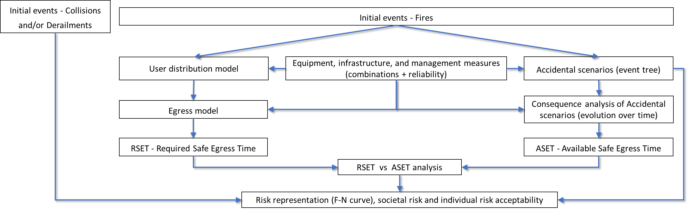

*Figure 1: Logical outline of the implemented risk analysis model for railway tunnels (TRAM-R2).*

2.1 Event tree analysis and frequencies of possible accidental scenarios

The model typically considers three main initial events (collision, derailment, and rolling stock fire); an additional one, the release of Dangerous Goods (DG) can be also considered if freight trains with hazardous materials (TDG) can use the railway tunnel. As an example, Figure 2 illustrates an event tree for the collision events.



Figure 2: Example of an Event Tree (upper part) related to the collision event (frequency in events/year).

Through the Event Tree Analysis, the model can evaluate up to 24 accidental scenarios, with 9 attributed to collisions and derailments (Table 1), which include also possible fires as domino effects. Additionally, alternative fire scenarios featuring reduced Heat Release Rates (HRRs) are contemplated, particularly in tunnels equipped with mitigation measures like automatic fire extinguishing or suppression systems. The model assumes that the presence of such mitigation systems can notably diminish the HRR, especially in scenarios involving smaller fires; the values provided for HRR indicate the maximum fire intensity (fully developed fire) achievable for each fire scenario.

As it is not possible to determine where the accidents could occur along the tunnel, it is hypothesized that the source of the initial event can be located in a generic position expressed as a percentage of the total length of the railway tunnel. A minimum of 6 positions is considered by the TRAM-R2, as reported in Figure 3.

Table 1: Accidental scenarios available in the TRAM-R2 model: Derailment, Collision, fire and DG release (TPAX: passengers train; FT: Freight train; TDG: Train with Dangerous Goods).

|  |  |  |  |  |
| --- | --- | --- | --- | --- |
| ***Initial event*** | ***N. accidental scenario*** | | ***Accidental scenario SCs*** | |
| Derailment | | 1 | D1 | Derailment and resulting fire |
| 2 | D2 | Derailment and resulting collision with TPAX |
| 3 | D3 | Derailment and resulting collision with FT / TDG |
| 4 | D4 | Derailment with rollover or collision with obstacle |
| Collision | | 5 | C1 | Collision and resulting fire |
| 6 | C2 | Collision with obstacle |
| 7 | C3 | Collision with other TPAX |
| 8 | C4 | Collision with FT / TDG |
| 9 | C5 | Collision and resulting derailment |
| Rolling stock Fire | | 10 | F1 | Fire Q= 4 MW |
| 11 | F2 | Fire Q= 10 MW |
| 12 | F3 | Fire Q= 30 MW |
| 13 | F4 | Fire Q= 50 MW |
| 14 | F5 | Fire Q= 100 MW |
| 15 | F6 | Fire Q= 150 MW |
|  | | 16 | R1 | Pool-fire (major spillage) |
|  | | 17 | R2 | Pool-fire (minor spillage) |
|  | | 18 | R3 | Jet-fire/BLEVE (liquid+vapor) |
| Dangerous Good (DG) | | 19 | R4 | Toxic dispersion (gas, relevant) |
| release | | 20 | R5 | Toxic dispersion (vapor, relevant) |
|  | | 21 | R6 | Jet-fire (gas) |
|  | | 22 | R7 | Jet-fire (gas/vapors) |
|  | | 23 | R8 | VCE/Flash-fire (gas) |
|  | | 24 | R9 | VCE/Pool-/Flash-fire (liquid+vapor) |
| Fire scenarios in presence of a fixed fire-fighting system | | | | |
| Fire | | 25 | F7 | Fire Q= 2 MW |
| 26 | F8 | Fire Q= 5 MW |
| 27 | F9 | Fire Q= 20 MW |
| 28 | F10 | Fire Q= 35 MW |
| 29 | F11 | Fire Q= 80 MW |
| 30 | F12 | Fire Q= 120 MW |

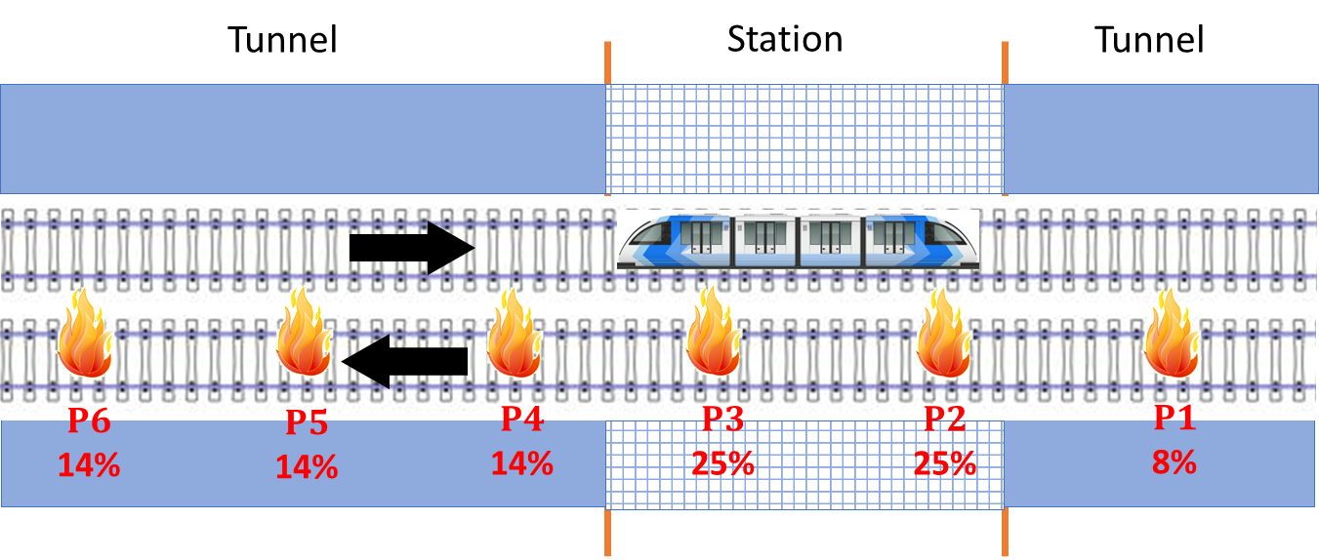

Figure 3: Examples of locations where the accidental scenario may occur within the railway tunnel or station and their probabilities of occurrence. Positions P2 and P3 are located in the station and therefore a higher probability (25%) with respect to other positions in the tunnel can be assumed for fire events.

2.2 Analysis of the frequency of occurrence

The process of Risk Analysis initiates by identifying potential events that could occur within a railway tunnel, followed by statistical analysis to determine the frequency of these events. This analysis allows for the estimation of expected fatalities resulting from such events. Table 2 contains the reference values for the frequency of occurrence for main initial events (derailments, collisions, and fires) of railway tunnels adopted in this work.

Table 2: Accident rates estimated from data of the Italian statistical database ISTAT [years 2005÷2019].

|  |  |
| --- | --- |
| **Initial event** | **Events/Gtrains·km** |
| Collisions | 15.51 |
| Derailments | 18.75 |
| Rolling stock fires | 8.34 |

2.3 Development of accidental scenarios, passengers’ egress and calculation of the F-N curve

Upon estimating the number of occupants within the tunnel, derived from the total count of passengers aboard the trains and the length of the involved trains, the egress process is assessed for each possible train position along the tunnel. Any evacuation pathway requires the passengers to reach a designated safe zone (shelter), the tunnel entrance/exit, or available emergency exits. However, the egress of the users is affected by the evolution of the accidental scenario. Notably, a pre-movement time is considered for each passenger, accounting for actions such as leaving the train, which is influenced by safety measures of the tunnel such as the presence of loudspeakers. For instance, Figure 4 illustrates the evolution of a fire scenario within the tunnel using CFAST (Peacock et al., 2017), a two-zone fire model able to predict dispersion of smoke, toxic gases, and the distribution of the temperature inside the tunnel during a fire (Tavelli et al., 2014). Each accidental scenario impacts the evacuation process, as reduced visibility due to smoke further diminishes egress speed, potentially resulting in fatalities from heat and toxic effects. This dynamic evaluation occurs for each passenger throughout his egress trajectory. Reference values for pre-movement time and egress speed of the users adopted in this work are reported in Table 3. Pre-movement time and the time needed for complete evacuation from the train vary depending on whether the train is halted at the platform or positioned within the tunnel.

Table 3: Egress speed distribution [DoT, 2015].

|  |  |  |
| --- | --- | --- |
| **Passenger type** | **Distribution [%]** | **Egress speed [m/s]** |
| Type 1 | 5 | 0.25 |
| Type 2 | 10 | 0.45 |
| Type 3 | 85 | 0.6 |
| **Time** | **Platform** | **Tunnel** |
| Pre-movement time [min] | 2 | 10 |
| Train total egress time [min] | 1.5 | 3 |

|  |  |
| --- | --- |
|  |  |

Figure 4: Example of fire consequence dynamics inside a poorly ventilated railway tunnel obtained with CFAST.

In general, the procedure for the evaluation of users’ tenability considers two steps:

• Verification of tenability of the users during pre-movement time;

• Verification during the egress process to the closest emergency exit (or safe place).

Tenability limits to passengers who may be potentially exposed to the effects of one or more accidents can be derived from the literature (ISO 13571, 2012; Ingason et al., 2015). According to the considered accidental scenarios, a set of acceptance criteria for tenability limits are considered by the model; in particular, tenability thresholds have been defined for thermal radiation, smoke temperature, toxicity of gas and/or vapors, overpressure, and visibility (Borghetti et al., 2019). Therefore, the tunnel is discretized into cells, thus creating a two-dimensional grid, within which it is possible to associate a number of passengers depending on the type of train and the composition of rail cars considered. Tram-R2 includes and combines calculation sub-models that dynamically describe the stopping of the train in a certain position of the tunnel, the evolution of the accidental scenario, as previously mentioned, taking also into account the effectiveness of safety equipment, management measures and/or emergency procedures that can affect the dynamics of user egress from the tunnel (as reported also by Di Graziano et al., 2021).

Utilizing the TRAM-R2 methodology enables the estimation of total fatalities (N) within the tunnel for each accidental scenario (s) and accident position (p). Then, combining this information with the frequency of occurrence of the event (F) identified for each scenario, it is possible to determine the risk curve specific to the tunnel being analyzed (F-N curve, which reports the cumulative frequency, normalized per km of tunnel, as a function of the number of potential fatalities expected). To illustrate this process, a case study is utilized.

* 1. Case Study

In this study, a single representative tunnel is chosen for comparison, with its key characteristics outlined in Table 4. The comparison is facilitated through an F-N curve, demonstrating the relationship between frequencies and consequences, particularly using the TRAM-R2 model. To evaluate the risk associated with the tunnel, the ALARP criterion is employed, as specified in the Italian D.M. 2005/10/28 on Safety in railway tunnels.

Table 4: Main characteristics of the investigated Railway Tunnel (with train stop platform).

|  |  |
| --- | --- |
| ***Parameter*** | ***Value*** |
| Total tunnel length including platform [m] | 1730 |
| Section [m2] | 60 |
| Tunnel length before the platform [m] | 632 |
| Platform length [m] | 510 |
| Tunnel length after the platform [m] | 588 |
| Number of tracks | 2 |
| Distance of the emergency exits in the tunnel before the platform [m] | 300 |
| Distance of the emergency exits in the tunnel after the platform [m] | 300 |
| Maximum number of passengers per train | 1500 |
| Average occupation rate of trains [%] | 80 |
| Number of trains/day | 250 |

The analysis of the tunnel's F-N curve, shown in Figure 5, indicates its positioning within the lower bounds of the ALARP zone, implying a risk level deemed acceptable but open to further reduction when reasonably feasible. Furthermore, Figure 5 illustrates the distribution of fatalities across fire events, derailments, and collisions. While fires account for a substantial number of fatalities, collisions and derailments emerge as more frequent contributors to fatalities, particularly in instances with fewer fatalities overall. In particular, results concerning fires are consistent with those obtained by Park&Shim (2017) for a railway tunnel with similar accidental rates and reference scenarios.

In summary, the study assesses the risk profile of the tunnel, emphasizing various event types and their impact on fatalities, while also applying the ALARP criterion to determine the risk acceptance.

* 1. Conclusions

This paper briefly illustrates and describes the structure of a new quantitative risk analysis model for railway tunnels, named TRAM-R2. The model, in accordance with the legislation requirements, calculates the F-N curves of societal risk, by evaluating the frequency of occurrence of different accidental scenarios (F) and their expected consequences in terms of potential victims (N: number of fatalities). Different initial events are considered, collision, derailment, fire and a DG release, and up to 24 accidental scenarios can be evaluated. The frequencies of occurrence of each scenario analysed is obtained using the Event Tree Analysis (ETA) technique. Then, a consequence analysis has to be performed for the reference accidental scenarios and the results are implemented in a sub-model for egress that evaluate users’ tenability during egress, which takes into account at least 6 possible positions of the accident along the tunnel. The model includes and combines calculation sub-models that dynamically describe the stopping of the train in a certain position of the tunnel, the evolution of the accidental scenario considering also the effectiveness of safety equipment, management measures and/or emergency procedures suggested and/or prescribed by national and international standards and regulations on safety for railway tunnels. The proposed model provides a tool for assessing and mitigating risks in railway tunnels, aiming to enhance safety protocols and decision-making processes.

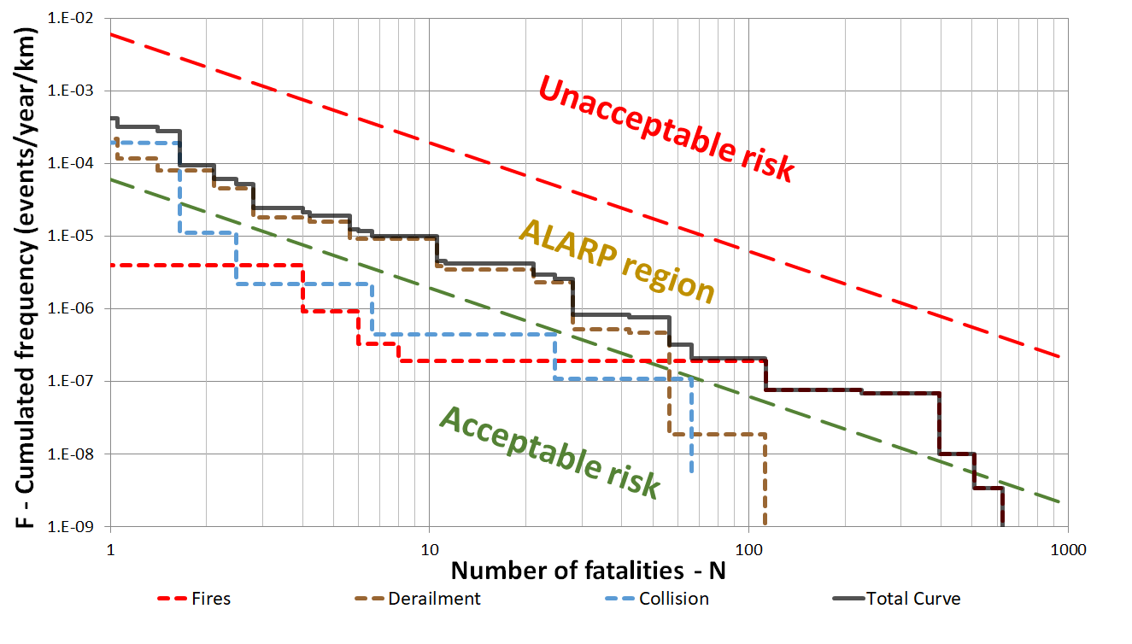

Figure 5: F-N curves from present model, TRAM-R2.

References

Bosco D., Lovreglio R., Frassoldati A., Derudi M., Borghetti F., 2018, Queue formation and evacuation modelling in road tunnels during fires, Chemical Engineering Transactions, 67, 805-810.

Borghetti F., Cerean P., Derudi M., Frassoldati A., 2019, Consequence Analysis of the Accidental Scenarios, In Road Tunnels: An Analytical Model for Risk Analysis, Springer International Publishing, 55-68, DOI: 10.1007/978-3-030-00569-6\_1.

Derudi M., Borghetti F., Favrin S., Frassoldati A., 2018, TRAM: a new quantitative methodology for tunnel risk analysis, Chemical Engineering Transactions, 67, 811-816, DOI: 10.3303/CET1867136.

Diamantidis D., Zuccarelli F., Westhäuser A., 2000, Safety of long railway tunnels, Reliability Engineering and System Safety, 67, 135–145.

Di Graziano A., Marchetta V., Grande J., Fiore S., 2021, Application of a decision support tool for the risk management of a metro system, International Journal of Rail Transportation, DOI: 10.1080/23248378.2021.1906341.

DoT, 2015, U.S. Department of Transportation, Federal Railroad Administration, Office of Research and Development. Passenger Train Emergency Systems: Single-Level Commuter Rail Car Egress Experiments.

Fridolf K., Ronchi E., Nilsson D., Frantzich H., 2013, Movement speed and exit choice in smoke-filled rail tunnels, Fire Safety Journal, 59, 8-21.

Ingason H., Li Y.Z., Lönnermark A., 2015, Tunnel Fire Dynamics, Springer, DOI: 10.1007/978-1-4939-2199-7.

ISO 13571, 2012, Life-threatening components of fire—guidelines for the estimation of time to compromised tenability in fires. International Standardization Organization, Switzerland.

ISTAT, 2022, The Italian National Institute of Statistics data warehouse, https://esploradati.istat.it/databrowser/#/en, accessed 22.07.2022.

Martinelli F., Cara S., Domenichini L., 2008, Rail tunnel risk analysis: a tool to improve rail tunnel design, Transportation Research Record, 2043, 41–48.

Park J.H., Shim, C.S., 2017, Quantitative Risk Analysis for Railway Tunnels, Journal of the Korean Society for Railway, 20, 400-412.

Peacock R.D, McGrattan K.B., Forney G.P., Reneke P.A., 2017, CFAST – Consolidated Fire and Smoke Transport (Version 7), NIST Technical Note 1889v1.

Tavelli S., Rota R., Derudi M., 2014, A critical comparison between CFD and zone models for the consequence analysis of fires in congested environments, Chemical Engineering Transactions, 36, 247-252.

Vanorio G., Mera J.M., 2012, Methodology for risk analysis in railway tunnels using Monte Carlo simulation, Proceedings of 3IWRDD-FORUM, 127, 673-683.