|  |  |
| --- | --- |
| cetlogo ***CHEMICAL ENGINEERING TRANSACTIONS***  ***VOL. xxx, 2025*** | A publication of  aidiclogo_grande |
| The Italian Association  of Chemical Engineering  Online at www.cetjournal.it |
| Guest Editors: Fabrizio Bezzo, Flavio Manenti, Gabriele Pannocchia, Almerinda di Benedetto  Copyright © 2025, AIDIC Servizi S.r.l. **ISBN** 979-12-81206-17-5; **ISSN** 2283-9216 | |

Ethanol Conversion into Acetone Over Binary Cerium–Zinc Oxide Catalysts

Tahmina Taghi\*, Vaghif Baghiyev

Azerbaijan State Oil and Industry University, Azadliq Av. 34, AZ1010

[tahmina.taghi@gmail.com](mailto:tahmina.taghi@gmail.com)

This paper is devoted to the study of ethanol conversion to acetone in the presence of water vapor using binary cerium-zinc oxide (Ce-Zn-O) catalysts. Catalysts containing ZnO have high selectivity in the reaction of ethanol conversion to acetone, while CeO₂ has a high activity in ethanol conversion process. The catalytic activity of these samples was studied over a temperature range of 250–700 °C. Chromatographic analysis was used to determine the products of the process and their yields. It was found that the atomic ratio of Ce to Zn significantly influences acetone yield and ethanol conversion. The highest yield of acetone made up 63.7 % and was observed on the sample with atomic ratio Ce:Zn = 2:8. Ethanol conversion on this sample achieved 87.7 %. X-ray diffraction analysis confirmed that all samples contained only the phases of the initial oxides: CeO₂ and ZnO. Moreover, the degree of crystallinity of the prepared samples was studied. It was found that with increase in crystallinity the yield of the target product acetone and the overall ethanol conversion reduced. The obtained results prove the relationship between the structure and activity of Ce-Zn-O catalysts and offer both theoretical and practical importance of optimizing the process of obtaining of acetone from bioethanol.

* 1. **Introduction**

Acetone is one of the most important compounds widely used in the chemical industry. It is used as a solvent, a monomer for organic synthesis and a raw material for a number of valuable chemicals. One of the possible methods for producing acetone is the vapor-phase conversion reaction of ethanol [10]. The reaction of steam conversion of ethanol to acetone proceeds according to the following reaction:

2C2H5OH + H2O → CH3COCH3 + CO2 + 4H2

This method of producing acetone is of interest to researchers all over the world, since this method is promising from both an economic and an environmental point of view. Bioethanol is a renewable raw material and is produced in large quantities from biomass [9]. In connection with the above, the search for and development of catalysts that would be active and selective for use in this process in the chemical industry is very relevant. It is known from periodical literature that zinc oxide-based catalysts exhibit high activity in the reaction of converting ethanol to acetone [7]. Mixed oxide catalysts containing cerium exhibit high activity in the reaction of ethanol conversion into valuable chemical products in the presence of water vapor [6,11]. In this regard, we previously studied the effect of cerium oxide on the activity of zinc oxide in the reaction of converting ethanol to acetone [12,13]. It is known that the activity of catalysts depends on both its surface [3,15,16] and structural properties [1,4,5].

In this regard, this article is devoted to the study of the effect of the specific surface area and the degree of crystallinity on the activity of cerium-zinc oxide catalysts in the reaction of steam conversion of ethanol into acetone.

* 1. **Experimental technique**

Binary cerium-zinc oxide catalysts of various compositions were prepared by coprecipitation method. Aqueous solutions of suspensions of cerium and zinc nitrates were used. The resulting mixture was evaporated at 95–100 °C, dried at 100 – 120 °C, and calcined at 250 – 350 °C until nitrogen oxides were completely released. The resulting solid mass was calcined at 700 oC for 10 hours. The prepared samples were tableted and then granulated. Thus, nine samples of binary cerium-zinc oxide catalysts of various composition were synthesized. The atomic ratio Ce : Zn varied from 1 : 9 to 9 : 1.

**2.1. Determination of the activity of the synthesized catalyst in the reaction of ethanol vapor-phase conversion to acetone**

The activity of the synthesized catalysts in the reaction of ethanol conversion to acetone in the presence of water vapor was studied on a flow-through setup with a quartz reactor at atmospheric pressure in the temperature range of 250 – 700 °C every 50 °C. 5 ml of catalyst with a grain size of 1.0-2.0 mm were loaded into the reactor and the reaction of ethanol conversion to acetone in the presence of water vapor was studied. The ethanol : water vapor : nitrogen ratio was 1 : 1 : 8. Under these conditions, the contact time was 2 seconds. Changing the grain size in the range from 0.5 to 5 mm, as well as the linear feed rate of the raw material at a constant contact time did not affect the reaction rate of steam conversion of ethanol to hydrogen. This indicates the absence of internal and external diffusion complications. The catalyst activity at each temperature was measured for 40-50 minutes. The achievement of the steady state of the catalyst at a given temperature was indicated by the constancy of the chromatographic analyses. During this period, the composition of the feedstock and reaction products was analysed 3-4 times by the chromatographic method, after which they moved on to the next temperature. In general, studying the activity of one sample took from 8 to 10 hours. Considering that during the experiments the catalysts did not lose their activity in the ethanol conversion reaction, it can be said that no changes in the catalytic properties occurred. To determine the yields of the obtained products and the amount of unreacted ethanol, a chromatograph with a flame ionization detector and a 2 m column filled with specially treated Polysorb-1 sorbent was used. The amount of carbon dioxide formed was determined on a chromatograph with a 6 m column filled with Celite sorbent coated with Vaseline oil.

**2.2. X-Ray analysis**

X-ray diffraction studies of the phase composition of the synthesized Ce-Zn-O catalysts were carried out on an automatic powder diffractometer “D2 Phaser” from Bruker (Germany) (CuKα radiation, Ni filter). Figure 1 shows the diffraction patterns of all nine mMg:nZn ratios collected together. At the beginning and end of these diffraction patterns, CeO2 and ZnO oxides are also presented.

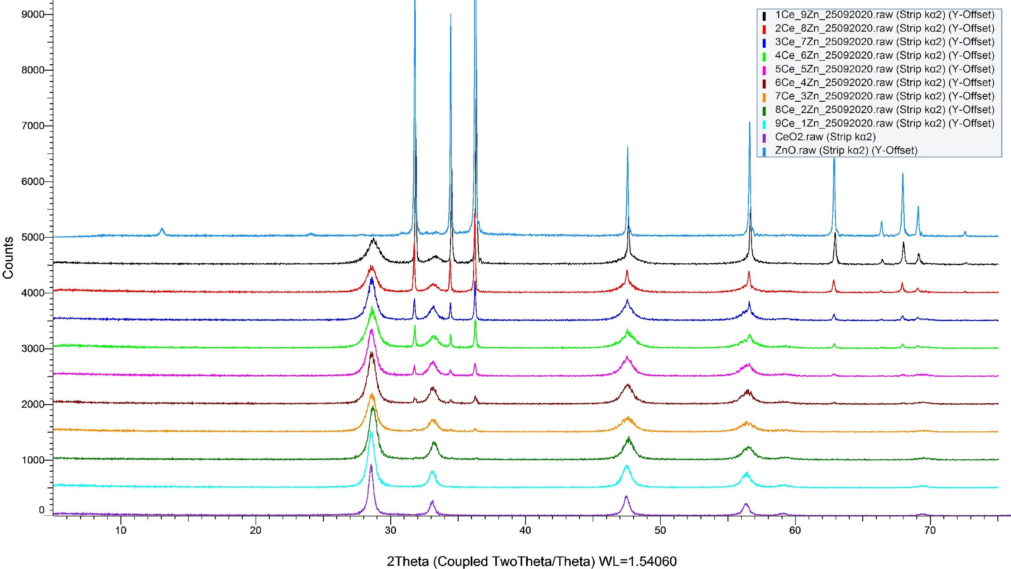

*Figure 1: Diffractograms of Ce-Zn-O catalysts with different Ce:Zn ratios*

Degree of crystallinity of the studied samples was determined using the program DIFFRAC.EVA. As is evident from Table 1 that the degree of crystallinity of binary cerium-zinc oxide samples is practically independent of the zinc content in the composition of the samples and varies within the range from 75.4 % in the Ce-Zn=4-6 sample to 79.5 % in the Ce-Zn=9-1 sample.

**2.3. Determination of specific surface area by thermal desorption of nitrogen**

To determine the specific surface area of the studied catalysts, the method of thermal desorption of nitrogen in a helium flow was used. The studied sample was first placed in a flow of a nitrogen-helium mixture and then cooled to the temperature of liquid nitrogen. During cooling, a monomolecular coating formed on the surface. Therefore, the partial pressure of nitrogen in the mixture was selected in an amount sufficient to form this coating. After cooling, the sample was heated again to room temperature. When heated, nitrogen desorbs from the surface of the sample. This desorption can be observed on the recorder tape as a desorption peak. The amount of desorbed nitrogen is directly dependent on the sample under study. Depending on this amount, the peak area (Sdes) can be different.

**2.4. Infrared spectroscopy analysis**

In order to obtain information on the intermediate compounds and complexes present on the catalyst surface, we used IR spectroscopy in our research to study the binary oxide systems Mg-Zn-O, Ce-Zn-O and Zr-Zn-O tested in the reaction of steam reforming of ethanol into acetone. IR spectroscopic studies of the spent catalysts were carried out on a Nikolet-iS10 IR Fourier spectrophotometer in the range of 400-4000 cm-1. To obtain good spectra, samples of the primary catalyst were ground in an agate mortar until a fine powder was obtained, then placed in a special cuvette and the IR spectra were recorded in the diffuse reflection mode. IR spectra of all the spent samples of the Ce-Zn-O catalysts are shown in Figure 2.

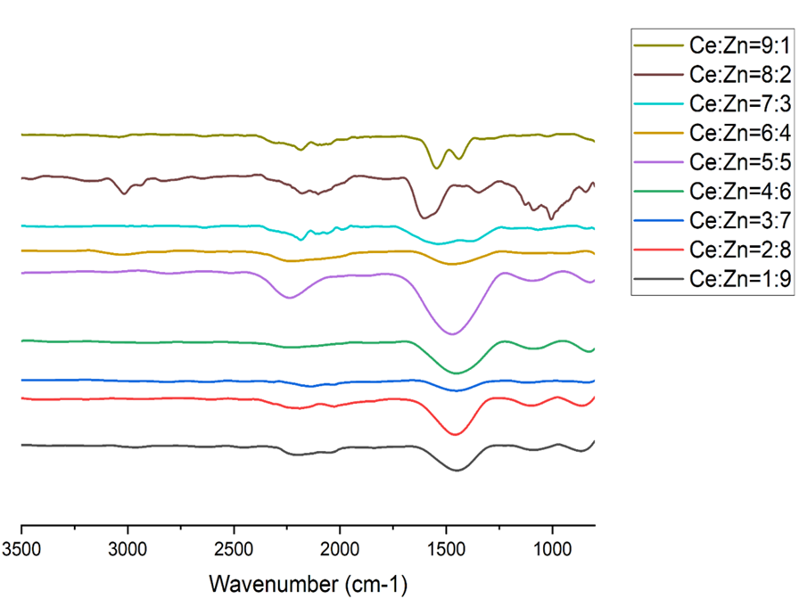

*Figure 2: IR spectra of the spent samples of the Ce-Zn-O catalytic system of different compositions*

* 1. **Results and discussions**

It was found that the products of the reaction ethanol conversion on binary Ce-Zn-O catalysts are ethylene, acetaldehyde, acetone, carbon dioxide. The effect of temperature on the yields of reaction products was studied. Dependence of the products yields on the reaction temperature over the sample Ce:Zn=2:8 is given in Figure 3.

*Figure 3: Effect of temperature on the yields of ethanol conversion reaction products over catalyst Ce-Zn=2-8*

As can be seen, the conversion of ethanol on this catalyst begins at a temperature of 300 °C. At this temperature, 0.8 % acetaldehyde is formed. The formation of ethylene and acetone begins at 350 °C, their yields at this temperature are 1.2 % and 3.1 %, respectively.

With an increase in the reaction temperature, the yield of acetone passes through a maximum and reaches 63.7 % at 500 °C. The yield of carbon dioxide increases throughout the studied temperature range and at 550 °C is 9.9 %. The ethanol conversion on this sample reaches 89.8 % at 550 °C.

Table 1 shows the degrees of crystallinity of the Ce-Zn-O catalytic system samples and the phases present in these samples*.* As can be seen from the table the prepared catalytic systems consist of only the phases of initial oxides. No intermediate chemical compounds are formed.

*Table 1: Degrees of crystallinity of the Ce-Zn-O catalytic system samples and the phases present in these samples*

|  |  |  |
| --- | --- | --- |
| Atomic ratio Ce:Zn | Present phases | Degree of crystallinity |
| 1:9 | CeO+ZnO | 76.3 |
| 2:8 | CeO+ZnO | 75.5 |
| 3:7 | CeO+ZnO | 78.7 |
| 4:6 | CeO+ZnO | 75.4 |
| 5:5 | CeO+ZnO | 77.5 |
| 6:4 | CeO+ZnO | 78.4 |
| 7:3 | CeO+ZnO | 75.5 |
| 8:2 | CeO+ZnO | 79 |
| 9:1 | CeO+ZnO | 79.5 |

Table 2 shows the bands observed on Ce-Zn-O catalysts of different compositions. On the series of cerium-zinc oxide catalysts, the bands at 852-863, 940-980, 1065-1084, and 1421-1444 cm-1 are observed at all Ce to Zn ratios. Starting with the Ce-Zn=3-7 sample, a band at 1500-1544 cm-1 is observed in the IR spectra. In the Ce-Zn-O catalytic system, in addition to the Ce-Zn=3-7, Ce-Zn=4-6, and Ce-Zn=5-5 samples, the presence of a band at 2620-2655 cm-1 in the spectra is observed. On samples with a low zinc content, namely Ce-Zn=1-9 and Ce-Zn=2-8, there is a band in the region of 2977-2987 cm-1.

The first group of absorption bands appears in the spectra in the region of 800 – 870 cm-1. According to the literature, these bands can be attributed to deformation vibrations of C-H bonds in alkenes or alcohols [8].

The second group of absorption bands appears in the spectra in the region of 1050 – 1140 cm-1. Based on the literature [2], they can be attributed to intermediate complexes of the alcoholate type R-CH2-O-.

The third group of absorption bands appears in the spectra in the region of 1400 – 1530 cm-1 and refers to the surface group, which most likely represents carbonate-carboxylate structures [14].

*Table 2: IR spectra of spent samples of the Ce-Zn-O catalytic system of different compositions*

|  |  |  |
| --- | --- | --- |
| Number | Sample | Bandwidths, cm-1 |
| 1 | Ce-Zn=1-9 | 855, 1080, 1425, 2164, 2641, 2890, 2977 |
| 2 | Ce-Zn=2-8 | 859, 1083, 1433, 2168, 2650, 2987 |
| 3 | Ce-Zn=3-7 | 859, 1100, 1435, 2156 |
| 4 | Ce-Zn=4-6 | 859, 1090, 1433, 1505 |
| 5 | Ce-Zn=5-5 | 850, 1100, 1437, 1516 |
| 6 | Ce-Zn=6-4 | 857, 1128, 1435, 1496, 2162, 2655 |
| 7 | Ce-Zn=7-3 | 858, 1098, 1414, 1500, 2645 |
| 8 | Ce-Zn=8-2 | 857, 1072, 1415, 1538, 2620 |
| 9 | Ce-Zn=9-1 | 858, 1016, 1450, 1544, 2662 |

The obtained results of IR spectroscopic studies show that on the surface of binary zinc-containing catalysts there are mainly alcoholate and carbonate-carboxylate structures, which, apparently, are intermediate stages in the reaction of converting ethanol into acetone in the presence of water vapor.

To determine the specific surface of the studied samples of the catalysts the method of thermal desorption of nitrogen was used. It was found that the specific surface of cerium oxide 6.2 m2/g. As can be seen from Table 3 the specific surface area of the CeO2-ZnO catalytic systems with an increase in the cerium content in the catalyst composition changes insignificantly in systems with a ratio from Ce-Zn=1-9 to Ce-Zn=7-3, varying within 1.1 m2/g (on the Ce-Zn=1-9 catalyst) and 2.6 m2/g (on the Ce-Zn=5-5 catalyst), and then sharply increases, amounting to 24 m2/g on the Ce-Zn=9-1 catalyst.

*Table 3: Specific surfaces of Ce-Zn-O catalysts*

|  |  |  |  |  |  |  |  |  |  |  |  |
| --- | --- | --- | --- | --- | --- | --- | --- | --- | --- | --- | --- |
| Atomic ratio Ce:Zn | CeO2 | 1:9 | 2:8 | 3:7 | 4:6 | 5:5 | 6:4 | 7:3 | 8:2 | 9:1 | ZnO |
| S, m2/g | 6.2 | 1.1 | 2.1 | 2.2 | 2.1 | 2.6 | 1.7 | 1.9 | 8.7 | 24.0 | 4.5 |

Correlations between the yields of the reaction products and their specific surfaces at 500 oC are shown in Figure 4. As can be observed from the picture, with increase in specific surface of the catalysts the yield of the target product acetone decreases, and the yield of ethylene increases. The overall conversion of ethanol and selectivity also decrease with increase in specific surface. The yield of carbon dioxide stays stable and does not change with change of specific surface.

*Figure 4: Dependence of the activity of Ce-Zn-O catalysts on their specific surface at the temperature 500 °C*

The activity of a catalyst, as is known, can in some way depend on the structural properties of the catalyst [13]. One of the properties of a catalyst, which is determined by the structural properties of a solid, is crystallinity, which in turn depends on both the preparation conditions and the initial compounds taken to prepare the catalyst. In this regard, the dependence of the activity of binary zinc oxide catalysts in the reaction of steam reforming of ethanol on the degree of crystallinity of the synthesized catalysts was studied. Figure 5 shows the dependences of the yields of acetone, ethylene and carbon dioxide and the conversion of ethanol on the degree of crystallinity of binary cerium-zinc oxide catalysts.

*Figure 5: Dependence of the activity of Ce-Zn-O on their degree of crystallinity at the temperature 500 °C*

It is evident from Figure 5 that with an increase in the crystallinity of cerium-zinc oxide catalysts, the yield of acetone decreases, and the yield of ethylene decreases, while the yield of carbon dioxide practically does not change with a change in the degree of crystallinity of the catalyst.

It should also be noted that an increase in the degree of crystallinity also leads to a decrease in the total conversion of ethanol. This allows us to say that an increase in the crystallinity of cerium-zinc oxide catalysts leads to an increase in the rate of ethanol dehydration reaction and a decrease in the rate of steam conversion of ethanol to acetone. This allows us to say that increasing the crystallinity of cerium-zinc oxide catalysts leads to an increase in the rate of ethanol dehydration reaction and a decrease in the rate of steam conversion of ethanol to acetone.

* 1. **Conclusions**
* The most active catalyst among all the studied samples for the reaction of ethanol conversion to acetone was the one with the atomic ration Ce:Zn=2:8. This catalyst is promising for further promotion and study of the kinetics of the reaction of conversion of ethanol to acetone.
* Increasing the crystallinity of binary cerium-zinc oxide catalysts leads to an increase in the yield of ethylene and a decrease in the yield of acetone. Ethanol conversion also decreases with increase in degree of crystallinity.
* Increasing the specific surface area of binary cerium-zinc oxide catalysts leads to an increase in the yield of ethylene and a decrease in the yield of acetone.

**References**

1. Baranova E.A., Padilla M.A., Halevi B., Amir T., Artyushkova K., Atanassov P., 2012, Electrooxidation of ethanol on PtSn nanoparticles in alkaline solution: Correlation between structure and catalytic properties, Electrochimica Acta, 80, 377-382
2. Davydov A.A., Shchekochikhin V.M., 1971, Study of surface compounds in the reaction of ethanol conversion on aluminum-zinc catalysts by IR spectroscopy and thermal desorption methods, Kinetics and Catalysis, 12(2), 383-389
3. Jung J.W., Lee Y.J., Um S.H., Yoo P.J., Lee D.H., Jun K.W., Bae J.W., 2012, Effect of copper surface area and acidic sites to intrinsic catalytic activity for dimethyl ether synthesis from biomass-derived syngas, Applied Catalysis B: Environmental, 126, 1-8
4. Knyazeva E.I., Pylinina A.I., Mikhalenko I.I., 2019, Relationship between the crystal structure, conductive and catalytic properties of perovskites Bi4Fe2xV2−2xO11−δ, Mendeleev Communications, 29(5), 541-543
5. Kushal S., Kundan K., Saurabh S., Anirban C., 2017, Effect of rare-earth doping in CeO2 matrix: Correlations with structure, catalytic and visible light photocatalytic properties, Ceramics International, 43(18), 17041-17047
6. Lima A.F.F., Moreira C.R., Alves O.C., Avillez R.R., Zotin F.M.Z., Appel L.G., 2021, Acetone synthesis from ethanol and the Mars and Van Krevelen mechanism using CeO2 and AgCeO2 nanostructured catalysts, Applied Catalysis A: General, 611, 117949
7. Mateos-Pedrero C., Silva H., Tanaka D.A., Liguori S., Lulianelli A., Basile A., Mendes A., 2015, CuO/ZnO catalysts for methanol steam reforming: The role of the support polarity ratio and surface area, Applied Catalysis B: Environmental, 174–175, 67–76
8. Nakanishi K., Solomon P.H., Infrared Absorption Spectroscopy, second edition, Holden-Day, Incorporated, San Francisco, 1977, 287
9. Patel A., Shah A.R., 2021, Integrated lignocellulosic biorefinery: Gateway for production of second-generation ethanol and value-added products, Journal of Bioresources and Bioproducts, 6, 2, 108-128. 8
10. Rodrigues C.P., Zonetti P.C., Silva C.G., Gaspar A.B., Appel L.G., 2013, Chemicals from ethanol—The acetone one-pot synthesis, Applied Catalysis A:General, 458, 111-118
11. Sartoretti E., Novara C., Chiodoni A., Giorgis F., Piumetti M., Bensaid S., Russo N., Fino D. Nanostructured ceria-based catalysts doped with La and Nd: How acid-base sites and redox properties determine the oxidation mechanisms. Catalysis Today, 2022, Volumes 390–391, Pages 117-134
12. Taghi T.Ch., Baghiyev V.L. 2022, Conversion of ethanol to acetone on cerium-zinc oxide catalysts, VII International Conference for Young Scientists Catalysis: From Science to Industry, Tomsk, Russia, 11-15
13. Taghi T.Ch., Baghiyev V.L., 2022, Ethanol conversion to acetone on binary Ce-Zn-O catalysts, The Austrian Journal of Technical and Natural Sciences, 5-6, 62-65
14. Yakerson V.I., Lafer L.I., Rubinshtein A.M., 1975, IR spectroscopy of the adsorbed state and the role of surface states in catalysis, Problems of kinetics and catalysis, M., Science, 46-49
15. Yu Q., Zhuang R., Gao W., Yi H., Xie X., Zhang Y., Tang X., 2022, Mesoporous Co3O4 with large specific surface area derived from MCM-48 for catalytic oxidation of toluene, Journal of Solid State Chemistry, 307, 122802
16. Zhang L., Li L., Zhang Y., Zhao Y., Li J., 2014, Nickel catalysts supported on MgO with different specific surface area for carbon dioxide reforming of methane, Journal of Energy Chemistry, 23, 1, 66–72