|  |  |
| --- | --- |
| cetlogo ***CHEMICAL ENGINEERING TRANSACTIONS***  ***VOL. xxx, 2025*** | A publication of  aidiclogo_grande |
| The Italian Association  of Chemical Engineering  Online at www.cetjournal.it |
| Guest Editors: Fabrizio Bezzo, Flavio Manenti, Gabriele Pannocchia, Almerinda di Benedetto  Copyright © 2025, AIDIC Servizi S.r.l. **ISBN** 979-12-81206-17-5; **ISSN** 2283-9216 | |

Effect of Thermo-catalytic Process on the Viscosity, Composition of a Colombian Heavy Crude Oil and the Corrosion on API N-80 Steel

Julián Sanabriaa\*, Darío Peñaa, Daniel Molinab, Michell Jiméneza, Manuel Cabarcasd, Adan Leóna,c

aUniversidad Industrial Santander, Escuela de Ingeniería Metalúrgica y Ciencia de los Materiales, Grupo de Investigaciones en Corrosión – GIC, cra 27 calle 9, Bucaramanga –Santander, Colombia.

b Universidad Industrial Santander, Escuela de Química, Laboratorio de Espectroscopia Atómica Molecular - LEAM, cra 27 calle 9, Bucaramanga –Santander, Colombia.

c Universidad Industrial Santander, Escuela de Ingeniería de Petróleos, Grupo de Investigación Recobro Mejorado – GRM, cra 27 calle 9, Bucaramanga –Santander, Colombia.

d Universidad Industrial Santander, Escuela de Ingeniería de Petróleos, Grupo de Investigación Modelamiento de Procesos de Hidrocarburos GMPH, cra 27 calle 9, Bucaramanga –Santander, Colombia.

\*Email: [julian2248101@correo.uis.edu.co](mailto:julian2248101@correo.uis.edu.co)

Global oil reserves indicate that a high percentage corresponds to heavy and extra-heavy crude oils. Numerous techniques exist to upgraded the properties of petroleum, among which catalytic aquathermolysis as a recovery method plays a key role. In this research, the effect of three oil-soluble catalysts, NFe, NNi, and NMo, at a concentration of 100 ppm relative to the metal was evaluated on a Colombian heavy crude with an °API of 11.6 and viscosity of 22000 cP (@ 30 °C). The tests were carried out in a batch reactor at 3103 KPa (@ 25 °C) and two temperatures of 220 and 270 °C over a 66 h reaction period. The upgraded crudes were characterized through viscosity testing and maltenes/asphaltenes content analysis. Tests at 270 °C showed an upgrading in crude oil properties, with catalyst performance following the order iron naphthenate (NFe) > nickel naphthenate (NNi) > molybdenum naphthenate (NMo). Iron naphthenate (NFe) reduced the crude oil viscosity by approximately 56%. On the other hand, tests conducted at 220 °C showed a deterioration in the crude oil properties, significantly increasing both the viscosity and asphaltene content.

Finally, the optimal temperature and catalyst conditions were selected, and the corrosive effect on API N-80 steel and the microstructural changes in the material were analyzed using SEM-EDS. The results conclude that using the catalyst during the aquathermolysis process promotes the upgrading of heavy crude oil properties while reducing the corrosive effect generated on API N-80 steel.

* 1. Introduction

With the continuous decrease of reserves in conventional reservoirs, it has become necessary to investigate and increase the efficiency of the different recovery methods that allow the exploitation of heavy and extra heavy (unconventional) crude oil reservoirs; however, due to the high viscosity and complexity of their physicochemical properties, their exploitation is difficult and expensive (Chao et al., 2012, Vo et al., 2021). Among the various EOR techniques that exist and are currently used, one of the most effective and efficient with this kind of hydrocarbon is the steam injection, a technique which reduces viscosity, increases pressure in the reservoir, and improves crude mobility, thus favoring the separation of heavy components into lighter compounds (Maity et al., 2010; Karimov & Toktarbay, 2024). Steam injection was first investigated by Hyne and collaborators in 1986. The analysis of Canadian and Venezuelan heavy crude oils found that a series of chemical reactions occur when steam comes into contact with heavy hydrocarbons at high temperatures (200–320 °C, the aquathermolysis window). These reactions involve subprocesses such as hydrolysis, pyrolysis, water-gas shift reaction, and hydrodesulfurization, which together constitute what is known as aquathermolysis; it is a process where the chemical bonds of organic compounds are broken and form lighter compounds. The study of catalytic aquathermolysis as a method of enhanced recovery has become an area of high interest to the hydrocarbon industry. The use of catalysts in steam injection enhances aquathermolysis reactions, significantly improving the efficiency in transforming the physicochemical properties of hydrocarbons from heavy to light components, where the catalyst facilitates the breaking of heteroatoms with C-S or C-O bonds, a key factor in avoiding polymerization and formation of larger molecules (Wang et al., 2010; Muraza & Galadima, 2015). Several operational constraints must be considered in the selection process of tubing materials for steam injection operations, as an inadequate design or improper selection of the tubing string may compromise the mechanical integrity of the well, leading to increased operational costs. In the oil and gas industry, it is common to employ carbon steel and low-alloy steel pipes in production and injection systems, with grades such as API K-55, J-55, L80, P-110, and N-80. Among these, N-80 is one of the most widely used due to its superior strength and ductility compared to other grades. In this study, N-80 steel was selected in consideration of the harsh conditions typical of steam injection processes, where high temperatures and pressures, in conjunction with water vapor, significantly enhance the corrosive effects on the tubing material (Chelgham et al., 2021; Yang et al., 2018). The present study intends to analyze catalytic aquathermolysis as a recovery method for improving the physicochemical properties of a Colombian heavy crude oil and the corrosive effect and/or structural changes that this technology generates on the integrity of an API N80 steel, evaluating the fluid-fluid interaction of three liposoluble catalysts of metallic nature with the heavy crude oil, under controlled temperature and pressure conditions at laboratory scale in a batch reactor. Characterization of the crude oil was carried out by analytical tests, such as viscosity measurement and analysis of maltenes and asphaltenes content; on the other hand, the steel coupons were analyzed using scanning electron microscopy/energy dispersive X-ray spectroscopy (SEM).

* 1. Material and Methods
     1. Methodology

The reactivity tests were carried out in two stages. In the first stage, fluid-fluid interactions were conducted to identify the temperature and catalyst that produced the greatest enhancement in the physicochemical properties of the heavy crude oil, which was characterized through analytical techniques such as viscosity measurement and asphaltene content analysis. Once these parameters were established, the second stage focused on evaluating the effect of these catalytic aquathermolysis conditions on the corrosion behavior of API N80 steel at elevated temperatures by analyzing the metal–fluid interaction under controlled reactor conditions and assessing the morphological and compositional modifications induced in the material’s structure. A Colombian heavy crude oil from the Middle Magdalena Valley basin with an API gravity of 11.6 and initial viscosity of 22000 cP (@30 °C) was analyzed to establish the best conditions to generate a reduction in its viscosity and heavy components content by subjecting it to catalytic aquathermolysis conditions at two different temperatures 220 and 270 °C, initial pressure of 3103 KPa at room temperature, applying three liposoluble catalysts: iron naphthenate (NFe), nickel naphthenate (NNi) and molybdenum naphthenate (NMo) at a concentration of 100 ppm concerning the metal. These reactivity analyses were evaluated in a batch reactor for 66 hours at a laboratory scale, using deionized water with a mass ratio of 2:1 with the crude and high-quality grade 5.0 nitrogen to establish the initial pressure required to reach saturation pressure at the analysis temperature.

The batch reactor is constructed of AISI 316 stainless steel and is equipped with Swagelok stainless steel fittings. It has an internal diameter of 3.8 cm and a maximum volume of 168 cm3. A graphite sealing element was used between the lid and the base of the reactor to ensure proper sealing and tightness at the high temperatures and pressures handled. The assembly scheme is shown in Figure 1, where the autoclave was placed in a thermal bath consisting of a magnetic stirring motor, heating sleeve, thermocouple, and manometer to control the pressure.

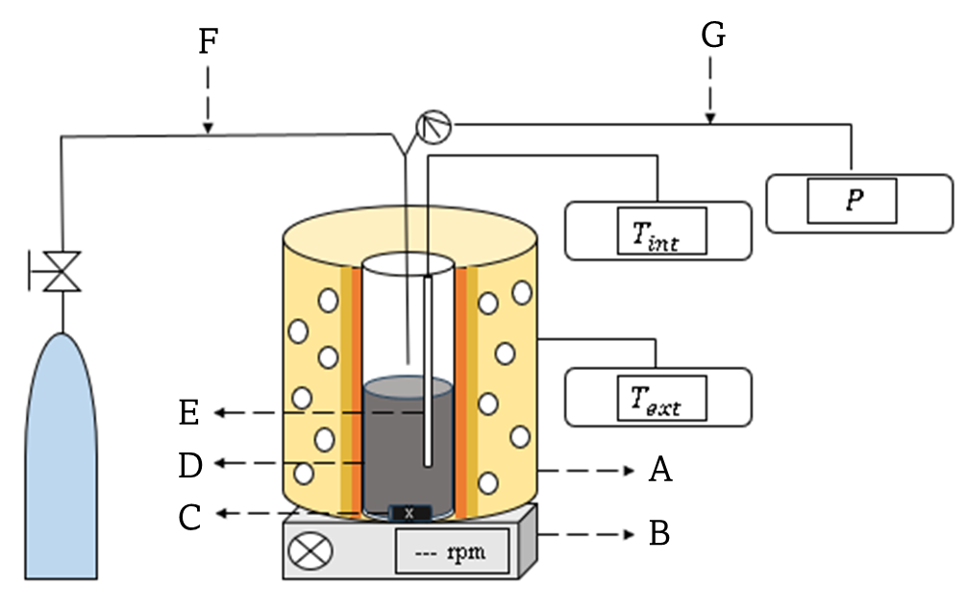

Figure 1: Schematic representation of the experimental setup, (A) Heating equipment; (B) Magnetic stirring motor; (C) Stirrer; (D) Batch reactor; (E) Thermocouple; (F) Gas inlet; (G) Pressure gauge.

To analyze the corrosive effect, API N80 steel coupons with approximate dimensions of 2 cm long, 1.5 cm wide, and 0.3 cm thick were used; each coupon has a perforation of approximately 0.3 cm in diameter to be assembled in the reactor's coupon holder. The optimal catalyst and temperature for improving the properties of the crude oil were selected from stage I, and corrosion was analyzed under this scenario. Two coupons are placed in each test, one positioned in the vapor phase and the other submerged in the liquid phase, in order to analyze the differences between these two corrosive environments in each experiment. The coupons were prepared under the ASTM G1-03 standard to guarantee an adequate surface and to analyze the corrosion generated.

* + 1. Characterization

To determine the viscosity of the crude oils subjected to aquathermolysis, a Lamy B-One plus rotational viscometer was used, which complies with ASTM D789, D2196, and ISO 1652 standards. A VWR refrigerated circulation bath was used in conjunction with the viscometer, which allows calculating the viscosity at different temperatures from the environment.

In order to determine the asphaltene and maltene content in both the base and upgraded crude, a 40:1 (%p/v) mixture of crude and n-heptane was established. The sample was subjected to reflux for one hour to facilitate the separation and suspension of asphaltenes; then, the sample was left to stand for 24 hours. Subsequently, using Whatman No. 42 filter paper, the asphaltenes were separated by filtration, and the remaining filtration fluid was placed at roto evaporation to separate the solvent from the mixture and leave only the maltenes in the container. Finally, by preparing the steel coupons under ASTM G1-03, they were characterized in a TESCAN MIRA 3 LMU scanning electron microscope (SEM) and a Bruker 129 eV energy dispersive X-ray detector (EDS).

* 1. Results and Discussion

**3.1 Asphaltene & Maltene**

Figure 2 shows the percentage reduction in asphaltene content under different reactivity scenarios using NFe, NNi, and NMo as catalysts, in comparison with a blank test, which corresponds to the steam injection process without catalyst, all relative to the initial asphaltene content in the crude oil. In the tests conducted at 220 °C, an increase in asphaltene content was observed regardless of the catalyst used, with the highest increase of up to 21 % by weight using NMo as the catalyst. On the other hand, in the 270 °C tests, a reduction in the content of heavy fractions was obtained (except for the non-catalyst test, Blank test), reaching a maximum reduction of 16 % by weight with NNi and 12 % by weight with NFe.

Figure 2: Asphaltene content determined in tests conducted at 220 and 270°C.

**3.2 Viscosity**

Figure 3 compares the viscosity reduction percentages of the tests carried out at 220 and 270 °C, where the fundamental role of temperature on this parameter is evidenced. At temperatures close to the onset of the aquathermolysis window, such as 220 °C, a significant increase in the viscosity of the crude oil is generated, indicating that this temperature does not allow a permanent rupture of the heavy components. Instead, after thermal cracking, a polycondensation of the chemical structures is produced, forming much more complex and heavier alkyl chains than those initially present. Although the results do not favor the upgrading of the crude oil at this temperature, using the NFe catalyst mitigates this negative effect by preventing the polymerization of more molecules, as observed with NMo or NNi.

However, at 270 °C, reducing the viscosity of the crude oils with all the catalysts was possible, showing the positive effect that the catalytic aquathermolysis reactions are generated in an environment of high temperatures. In this environment, the hydrogenation process is much more efficient, which helps the free radicals to be inhibited, and thus, the polycondensation of these structures is not generated.

In summary, it is possible to establish that the viscosity variable can be applied as a comparison or control variable when we want to analyze the effects produced by the thermal process of steam injection with catalysts, since any compositional variation in the crude oil presents greater sensitivity in the variation of this property.

Figure 3: Viscosity reduction observed in experiments conducted at 220 and 270 °C.

**3.3 SEM – EDS**

In the tests conducted, significant differences were observed in the morphology of the coupons depending on both the phase of exposure to the corrosive medium and the presence or absence of a catalyst. The SEM micrographs obtained at various magnifications are presented in the following images. Elemental composition measurements (EDS) were performed at a magnification of 50 µm, as shown in Figures 4 and 5. In these figures, the green circle highlights the area analyzed for composition.

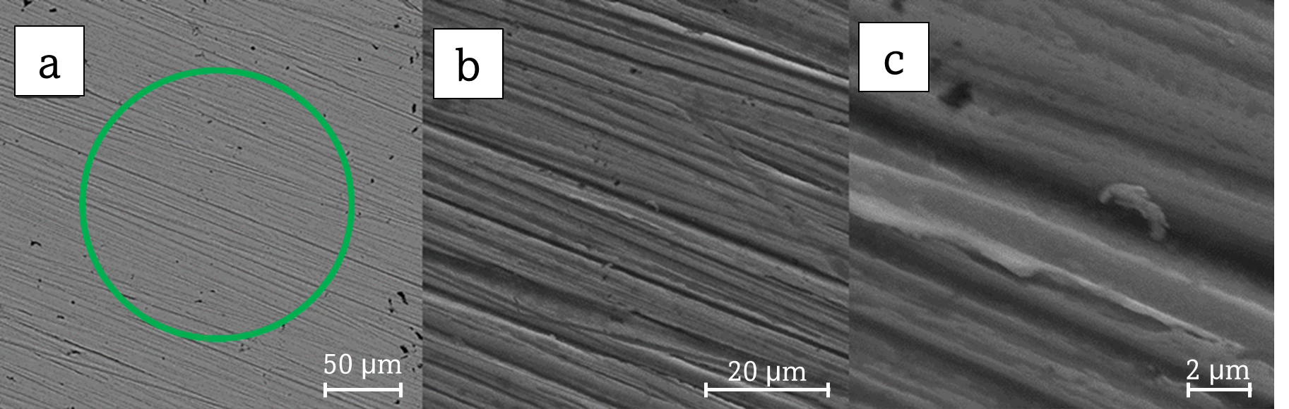

Figure 4: SEM images of N80 Control Steel Coupon at different magnifications.

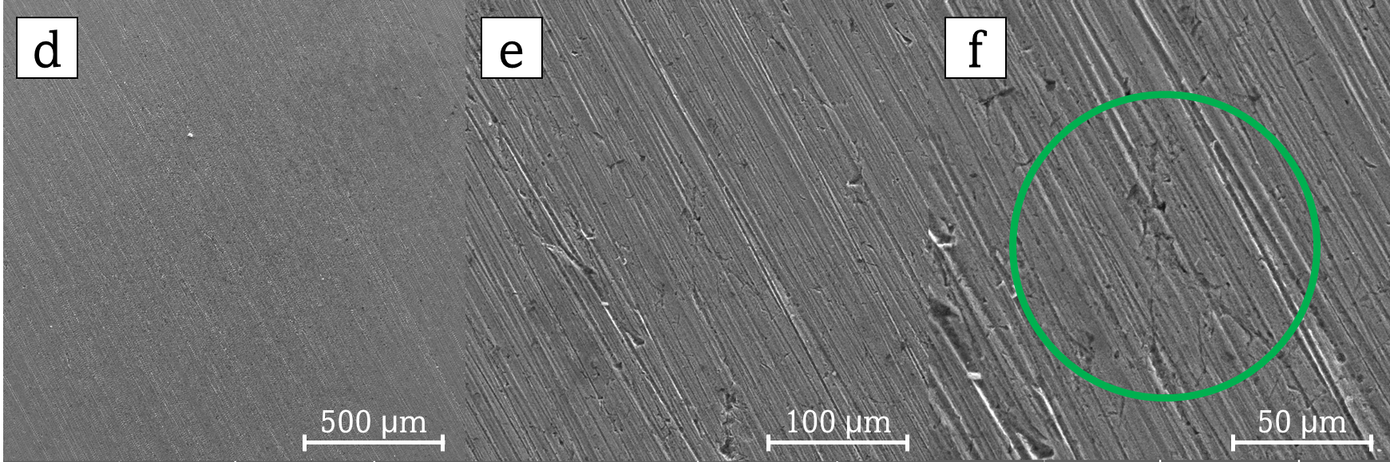

Figure 5: SEM images of N80 Steel subjected to the liquid phase in aquathermolysis environment (Blank test) at 270°C.

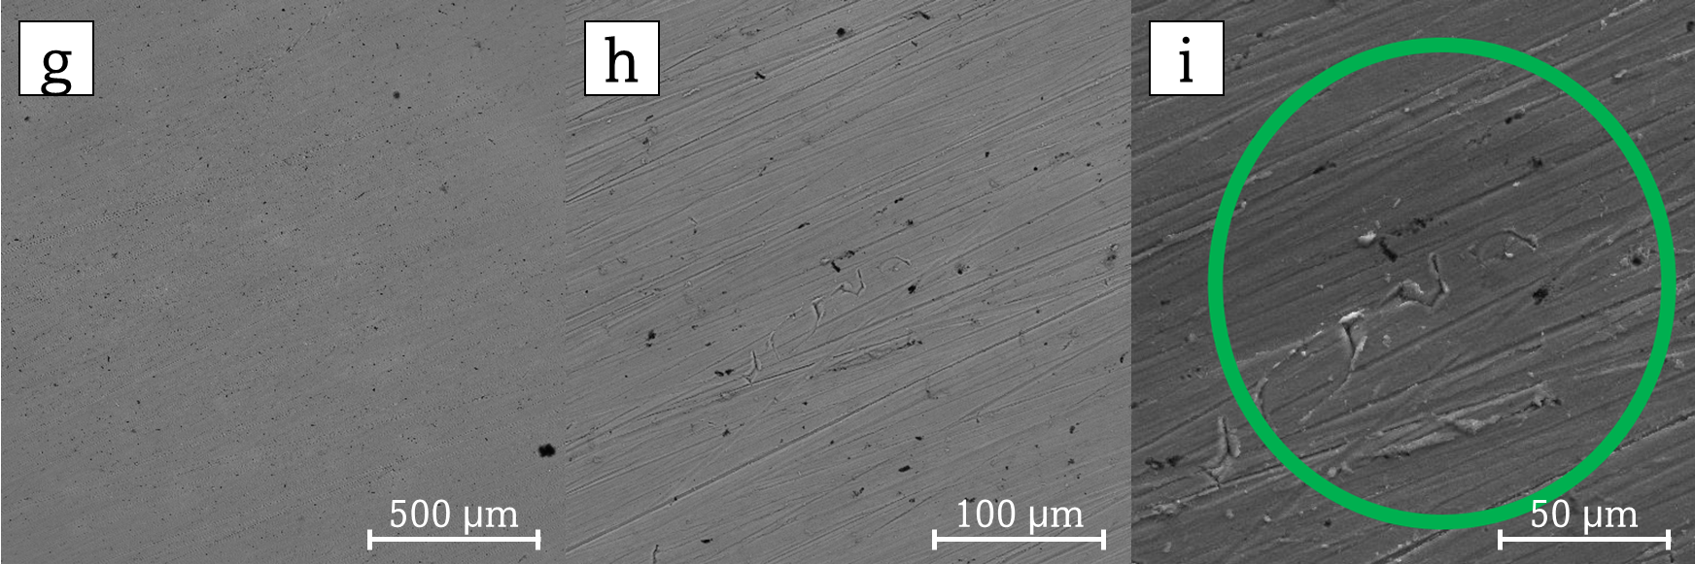

Figure 6: SEM images of N80 Steel subjected to CAQ (Catalytic aquathermolysis) in liquid phase environment using NFe as a catalyst at 270°C.

With Figures 5 and 6, a comparison is made between the effects of the presence or absence of NFe in the steam injection process. From this analysis, it can be concluded that, in the non-catalytic environment (blank test), the SEM micrographs of the N80 steel coupons showed a heterogeneous surface, characteristic of a severe and unmitigated corrosion process under high-temperature steam conditions. The formation of iron oxides, such as magnetite (Fe3O4) and hematite (Fe2O3), was likely favored in this environment, contributing to surface roughness and localized attack. Although pitting and cavity formation was also observed in the catalytic aquathermolysis tests, these features were less pronounced and more localized, suggesting a partial mitigation of the corrosive effects when the catalyst (NFe) was present. All of this is supported and corroborated by the results obtained from the EDS analysis presented in Figure 7, where the variation in the elemental composition of the N80 steel coupons under the previously established reactivity conditions can be analyzed.

Figure 7: EDS-based comparison of elemental composition in coupons exposed to NFe-catalyzed and non-catalyzed steam injection.

Focusing on the elemental composition of each coupon shown in Figure 7, in the control coupon, iron (Fe) is the predominant element, while other elements such as carbon (C), oxygen (O), chromium (Cr), and manganese (Mn) are present in lower concentrations. In the blank test, an increase in oxygen, nickel, chromium, and manganese concentrations is observed, resulting from the corrosive process generated under these conditions. Additionally, compounds such as sulfur, molybdenum, and calcium appear due to the coupons being immersed in an environment with hydrocarbons, a component that releases these compounds when subjected to high temperatures during the aquathermolysis reactions. On the other hand, in the coupons exposed to catalytic aquathermolysis tests, the presence of NFe significantly contributes to mitigating the notable increase in oxygen content observed in the tests without a catalyst. In the absence of the catalyst, there was a 7 % by weight increase in oxygen content, compared to only a 2 % by weight increase in the presence of the catalyst. Similarly, the catalyst helps mitigate the reduction in iron content compared to the blank test. In the latter, the steel, which initially contains 74 % by weight iron, experiences a decrease to 47 % by weight, while in the test with NFe, the iron content is reduced only to 52%. This behavior suggests that NFe helps reduce the impact of the steam injection process on the oxidation and corrosion of steel, promoting the preservation of its structural integrity and limiting degradation caused by these phenomena.

Figures 8 and 9 present the SEM micrographs of the N80 steel coupons submerged in the vapor phase. These images show the formation of crystals across the entire surface of the material, which were not present on the coupons submerged in the liquid phase. This difference suggests that exposure to the vapor phase promotes the formation of these crystalline structures on the steel surface, potentially linked to the specific corrosion and oxidation processes occurring in this environment with hydrocarbon.

Figure 8: SEM images of N80 steel coupon exposed to the vapor phase during the blank aquathermolysis test (without catalyst)

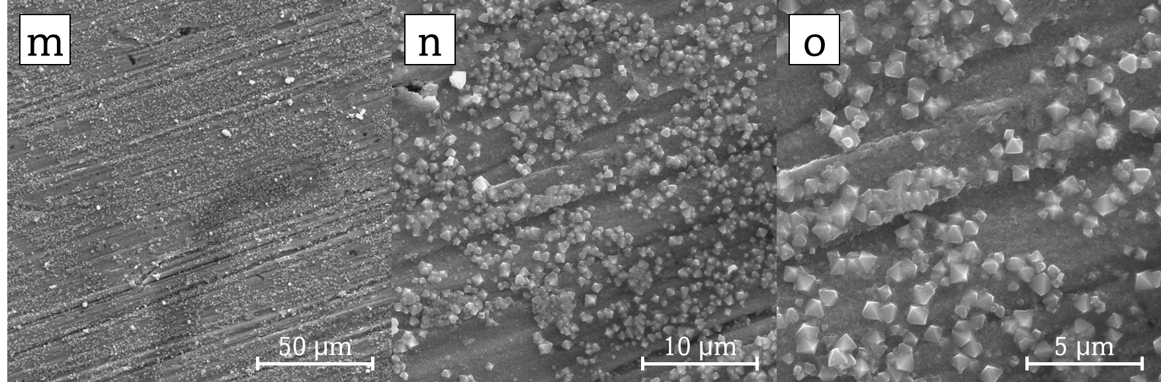

Figure 9: SEM images of N80 steel coupon exposed to the vapor phase during the catalytic aquathermolysis test (NFe catalyst).

The analysis of the morphological changes observed in the coupons presented in Figures 5-6 and 8-9 demonstrates that the corrosion mechanisms vary significantly between the two phases studied. In the liquid environment, corrosion is more aggressive due to the greater accessibility of the corrosive medium in contact with the hydrocarbons, leading to more pronounced corrosive effects such as pitting and cavitation. In contrast, in the vapor phase, the formation of crystals was observed, which, according to the results obtained through energy dispersive X-ray spectroscopy (EDS), are associated with calcium oxides such as calcium carbonate (CaCO3), calcium oxalate (CaC2O4), and calcium hydroxide (Ca(OH)2), among others. These compounds are generated from the gases released during the interaction of hydrocarbons with water vapor at high temperatures. Additionally, the coupons exposed to the liquid phase showed significantly higher oxygen concentrations than those exposed to the vapor phase. This supports the hypothesis that the liquid medium, with its higher concentration of dissolved oxygen, accelerates electrochemical corrosion processes. Regarding the comparison between Figure 6(l) and figure 9(o) it is observed that in the first, the geometric structure of the crystals is heterogeneous, while in Figure 9(o) (CAQ environment), the crystals exhibit a more homogeneous structure, spatially distributed in a more orderly manner and with a clearer definition of their structure.

* 1. Conclusions

The results of viscosity reduction and asphaltene content in the upgraded crudes show that the catalysts present different selectivity in the occurrence of catalytic aquathermolysis reactions. Furthermore, temperature plays a fundamental role in the changes generated in the hydrocarbon; in the tests at 220 °C, regardless of the catalyst used, there is a negative effect on the viscosity parameter and the asphaltene content of the crude oils as a consequence of the low temperature at testing, where insufficient hydrogen production leads to the re-polymerization of chemical structures, thereby causing an increase in the viscosity of the oil and the content of the heavy fractions. On the contrary, at 270 °C, an upgrading of the crude oil is generated, reaching a maximum viscosity reduction of 56 % using NFe as a catalyst. Finally, concluding in an order of catalyst performance follows NFe > NNi > NMo.

The presence of the NFe catalyst in the vapor phase resulted in more homogeneous surfaces. In contrast, the absence of the catalyst in the liquid phase led to more severe corrosion, such as pitting and cavitation. EDS analysis confirmed higher oxygen concentrations and iron reduction in the liquid phase, indicating a more aggressive corrosive environment. These results demonstrate that iron naphthenate (NFe) effectively mitigates corrosion by reducing oxygen content and stabilizing the corrosion products, thereby protecting material integrity.

Acknowledgments

The authors would like to thank the Industrial University of Santander (UIS, Colombia) for its support through Project 2423. We also thank the Ministry of Science and Technology (MINCIENCIAS) through Project 941-2023 “Convocatoria Fortalecimiento del Sector Hidrocarburos en Colombia Mecanismo 1 – 107578.” Additionally, we express our gratitude to the Nanoscience and Nanotechnology Laboratory of the Pontifical Bolivarian University in Bucaramanga for its support.

References

Chao, K., Chen, Y., Liu, H., Zhang, X., & Li, J. (2012). Laboratory experiments and field test of a difunctional catalyst for catalytic aquathermolysis of heavy oil. *Energy and Fuels*, *26*(2), 1152–1159.

Chelgham, F., Bouzid, N., Saidi, M., Ouakkaf, A., Taabouche, A., Boudjema, S., Largot, H., Mamanou, A., & Meddoura, N. (2021). Effects of Temperature on Microstructure and Corrosion behavior of API N80 Carbon Steel. Asian Journal Of Research in Chemistry, 14(1), 1–6.

Hyne J.B., 1986, Aquathermolysis: a synopsis of work on the chemical reaction between water (steam) and heavy oil sands during simulated steam stimulation, AOSTRA Publication Series 55.

Karimov, D., & Toktarbay, Z. (2024). Enhanced Oil Recovery: Techniques, Strategies, and Advances. In *ES Materials and Manufacturing* (Vol. 23). Engineered Science Publisher.

Maity, S. K., Ancheyta, J., & Marroquín, G. (2010). Catalytic aquathermolysis used for viscosity reduction of heavy crude oils: A review. Energy and Fuels, 24(5), 2809–2816.

Muraza, O., & Galadima, A. (2015). Aquathermolysis of heavy oil: A review and perspective on catalyst development.

Vo A.C., Le T.S., Maneeintr K., 2021, Simulation Study of Sodium 4-Vinylbenzene Sulfonate as a Surfactant for Enhanced Oil Recovery in the North of Thailand, Chemical Engineering Transactions, 89, 559-564.

Wang, Y., Chen, Y., He, J., Li, P., & Yang, C. (2010). Mechanism of catalytic aquathermolysis: Influences on heavy oil by two types of efficient catalytic ions: Fe3+ and Mo6+. *Energy and Fuels*, *24*(3), 1502–1510.

Yang, S., Han, L., Feng, C., Wang, H., Feng, Y., & Wu, X. (2018). Mechanical performance of casing in in-situ combustion thermal recovery. *Journal of Petroleum Science and Engineering*, *168*, 32–38.