|  |  |
| --- | --- |
| cetlogo ***CHEMICAL ENGINEERING TRANSACTIONS***  ***VOL. xxx, 2025*** | A publication of  aidiclogo_grande |
| The Italian Association  of Chemical Engineering  Online at www.cetjournal.it |
| Guest Editors: Fabrizio Bezzo, Flavio Manenti, Gabriele Pannocchia, Almerinda di Benedetto  Copyright © 2025, AIDIC Servizi S.r.l. **ISBN** 979-12-81206-17-5; **ISSN** 2283-9216 | |

Analysis of Catalytic Aquathermolysis on the Physicochemical Properties of Colombian Heavy Crude Oils Using MALDI TOF Mass Spectrometry

Adan León\*,a,b, Darío Peñaa, Emiliano Arizac, Nicolas Santosd, Daniel Molinac

aUniversidad Industrial Santander, Escuela de Ingeniería Metalúrgica y Ciencia de los Materiales, Grupo de Investigaciones en Corrosión – GIC, cra 27 calle 9, Bucaramanga –Santander, Colombia.

bUniversidad Industrial Santander, Escuela de Ingeniería de Petróleos, Grupo de Investigación Recobro Mejorado – GRM, cra 27 calle 9, Bucaramanga –Santander, Colombia.

cUniversidad Industrial Santander, Escuela de Química, Laboratorio de Espectroscopia Atómica Molecular - LEAM, cra 27 calle 9, Bucaramanga –Santander, Colombia.

dUniversidad Industrial Santander, Escuela de Ingeniería de Petróleos, Grupo de Investigación en Tomografía Computarizada para Caracterización de Yacimientos GIT, cra 27 calle 9, Bucaramanga –Santander, Colombia.

[adanleon@uis.edu.co](mailto:adanleon@uis.edu.co)

Enhanced recovery methods play an important role in extracting crude oil from reservoirs using different processes. The catalytic aquathermolysis process is a promising technique due to the interaction of the catalyst, heavy oil fractions, and hydrogen (Water-Gas-Shift, WGS reactions). Fluid-fluid thermochemical interaction tests were performed in a batch reactor on three Colombian heavy crude oils (C1, C2, and C3) with iron naphthenate (100 ppm or mg/L, metal ion. Conditions at 270 °C and 800 psi during 66 h of reaction were set. To analyze the upgraded crude oils, physicochemical properties such as viscosity, density, and fraction distribution by simulated distillation (ASTM/D-7169) and SARA compositional analysis (saturated, aromatic, resins, asphaltenes) were evaluated.

The results showed that heavy crude oils subjected to steam injection conditions presented an increase in viscosity and density compared to the original crude oils. Meanwhile, the viscosity and density reductions of the crude oils upgraded under catalytic aquathermolysis conditions ranged from 33.3 to 46.4 % and 0.22 to 1.71 %, respectively. With the information from the distillation curves, an increase between 3.5 and 7.8 % by weight in the content of light fractions (IBP - 370 °C) was evident. The increase in light fractions is mainly due to the conversion of vacuum residues (540°C+). On the other hand, the compositional analysis shows that the resin and asphaltenes fractions are reduced between 9.1 to 18.9 % by weight and between 14.8 to 25.9 % by weight. Saturates showed an increase in the range of 9.9 to 13.6 % by weight. Additionally, the results of MALDI-TOF mass spectrometry confirmed that the heavy fractions and asphaltenes tend to form species with lower molecular weight. Finally, the variation in the physicochemical properties of heavy crude oils shows that the thermochemical method is a valuable and complementary tool in thermal recovery.

* 1. Introduction

Oil extraction processes are primarily classified as non-thermal and thermal. Non-thermal processes include gas and chemical injection (polymers, surfactants, and alkaline agents). Thermal processes use heat transfer technologies to reduce the viscosity of heavy crude oils (Vo et al., 2021). During steam injection, the appropriate pressure and temperature conditions are generated for the steam to react with some hydrocarbons and minerals in the reservoir. Some authors, such as Hyne (1986), Urazov et al., (2022), and Huang et al., (2019), have managed to establish that reactions are generated between the fractions of heavy crude oil with water at high temperatures regardless of its phase. This process is known as aquathermolysis. Aquathermolysis is related to the steam injection process. Furthermore, the conditions of this thermal recovery technology produce in situ conversion of high-sulfur fractions in heavy oil crude. In the aquathermolysis process, gaseous compounds such as H₂, CH₂, CO₂, H₂S, and high molecular weight gas are produced. Furthermore, hydrogen participates in hydrodesulfurization reactions. Hydrogen participates in hydrodesulfurization reactions. Although this process can be considered a complex mechanism, some authors represent the transformation of the heavy fractions of crude oil in a finite number of first-order parallel reactions (Huang et al., 2019).

Under conventional process conditions, the conversion of the liquid phase of crude oil is low unless the reactions are catalyzed by transition metals, M+ (catalytic aquathermolysis). Therefore, in situ catalyst generation favors the cleavage of C-S bonds, given their lower activation energies during the chemical reactions. The reaction occurs because S has greater electronegativity than C. Therefore, the H+ of the system reacts with the S present in heavy crude oil, while the OH– reacts with the C (Zhao et al., 2014). Generally, several studies have established that Group VIII transition metals contribute to the enhancement of heavy crude oil desulfurization. Furthermore, this process involves Water Gas Shift and hydrotreatment reactions, which are carried out by the reactions of pyrolysis, hydrolysis, hydrodesulfurization (HDS), hydrodenitrogenation (HDN), and hydrodeoxygenation (HDO). It has been established that the operating temperature window where the aquathermolysis reactions occur is 200 to 300 °C. In this temperature range, solids (coke) and gas production are insignificant (Hyne,1986; Fajun et al., 2014; Muraza et al., 2015). Figure 1 schematizes the general reaction of aquathermolysis with and without catalysts, highlighting the production of carbon dioxide, hydrogen sulfide, carbon monoxide, and hydrocarbons with different molecular weights (Zhao et al., 2014).

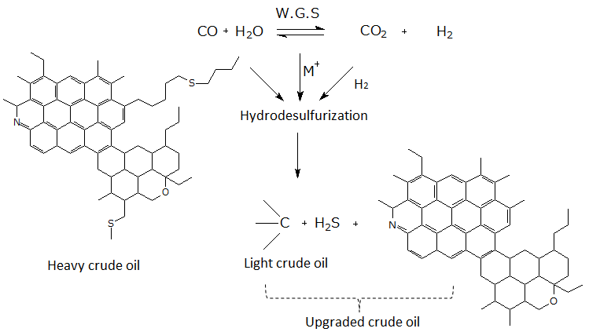

Figure 1: *General scheme of the catalytic aquathermolysis reaction in heavy crude oils*.

In different research works, Kapadia et al. (2015), Abdelsalam et al. (2023), and Salas et al. (2023) have evaluated aquathermolysis in heavy crude oils with values ​​lower than 12.5 °API using crude oil-soluble catalysts (e.g., iron naphthenate, nickel naphthenate, among others). The results showed that heavy crude oils exhibit different reactivity, even when the same catalyst is applied under the same temperature and pressure conditions. Meanwhile, the reduction of some properties, such as density and viscosity in the upgraded crude oils, is due to the increase in the fraction of saturates and aromatics and the decrease in resins and asphaltenes. In general, catalytic aquathermolysis can be considered as an additional recovery mechanism during the enhanced recovery process. This process favors the permanent viscosity reduction of the crude oil and facilitates its movement in the porous medium.

Additionally, this process allows for an increase in production, which in turn produces fluids with greater commercial value. Furthermore, the improved crude oil changes facilitate the treatments implemented in refineries and transportation. Considering the above, this work aims to evaluate the effect of the aquathermolysis process with iron naphthenate on the physicochemical properties of three Colombian heavy crude oils. The study maintains constant conditions such as catalyst concentration, temperature, pressure, and reaction time.

* 1. Results and Discussion
     1. Materials.

Three Colombian heavy crude oils with values ​​ranging from 7.8 to 12.4 °API were selected. The thermocatalytic tests used iron naphthenate (6 % by iron weight, Strem Chemicals) as a catalyst. In addition, n-heptane, methanol, dichloromethane, and toluene solvents from the commercial company Sigma - Aldrich were used for the SARA analysis.

* + 1. Catalytic aquathermolysis tests

Reactivity tests were performed in a 170 cm3 batch reactor. The cylinder and its accessories are made of 316 stainless steel. In the tests, heavy crude oil and water were added in a mass ratio of 2:1. The reactions were carried out under temperature and pressure conditions at 270 °C and 800 psi for 66 h (aquathermolysis). In the process, iron naphthenate was used as a precursor at a concentration of 100 concerning the iron metal ion (catalytic aquathermolysis). After the reaction time, the reactor was removed from the system and allowed to cool to room temperature using an ice water bath. The upgraded crude oil and water are separated using a Hettich Universal 320 R centrifuge at 6000 rpm for 20 minutes. During the aquathermolysis and catalytic aquathermolysis tests, the temperature, pressure, and reaction conditions were constant.

* + 1. Characterization

**2.3.1 SARA composicional analysis**

Asphaltenes were separated according to ASTM D6560. Saturated, aromatic and, resin fractions were separated according to ASTM D2007. Asphaltenes were separated by adding n-heptane in a volume ratio 40:1 to the crude oil, refluxing for 1 h. Then, asphaltenes were obtained by filtration, and n-heptane was recovered. Saturated, aromatic, and resin fractions were separated by elution with n-heptane, dichloromethane, and a dichloromethane/methanol solution, using two columns containing silica gel, alumina, and Florisil (León et al., 2024).

**2.3.2 Viscosity analysis**

The First Pro Plus® rotational viscometer, Lamy Rheology Instruments©, was used to measure viscosity. The viscosity curve was measured at 35, 45, and 60 °C for the original crudes and their upgraded crudes.

.

**2.3.3 MALDI – TOF Mass Spectrometry**

The crude oil samples were dissolved in toluene at a concentration of 2000 ppm. Then, a 1 μl aliquot of the solution was added to the target spot. A mixture of peptides was used as a calibration agent for spectra acquisition. Mass spectra were acquired with Flexcontrol software on the Bruker Daltonics ultraflextreme instrument. The instrument contains an ion source and a TOF analyzer with a Neodymium-doped Yttrium Aluminum Garnet (Nd:YAG, 355nm) smartbeam II laser. Finally, the average molecular weight can be defined as the molecular weight distribution of the set of ions, m/z (Lozano et al., 2016). The molecular weight was calculated with Equation 1.

$MW=\frac{\sum{I_{i}{MW}_{i}}}{\sum{I_{i}}}$ (1)

Where: MW is the average molecular weight, Ii and MWi are the intensity and molecular weight for each m/z species.

* 1. Results and discussion

The physicochemical properties of the three heavy crude oils are shown in Table 1. The results show that the selected crude oils correspond to heavy crude oils (10 to 22.3 °API) and extra-heavy crude oils (less than 10 °API). On the other hand, the values ​​of the SARA compositional analysis and the viscosities indicate that the crude oils present a significant variation in their components. Likewise, the high distillation temperatures T50 (50 % by weight of distilled sample) indicate that the crude oils are suitable for evaluating the effect of catalytic aquathermolysis (Li et al., 2018).

Table 1. Physicochemical properties of Colombian crude oils.

|  |  |  |  |
| --- | --- | --- | --- |
| Property | Crude A | Crude B | Crude C |
| API Gravity | 7.8 | 12.3 | 12.4 |
| Saturates % by weight | 47.2 | 42.9 | 30.4 |
| Aromatics % by weight | 16.8 | 22.8 | 20.9 |
| Resins % by weight | 20.2 | 30.6 | 29.3 |
| Asphaltenes % by weight | 15.8 | 3.7 | 19.5 |
| viscosity cP, (@ 45 °C) | 372529 | 8317 | 42658 |
| Simulated distillation (ASTMD7169) | | | |
| T5, °C | 264.6 | 278.7 | 213.5 |
| T10, °C | 318.3 | 319.5 | 272.5 |
| T30, °C | 466.1 | 430.3 | 423.4 |
| T50, °C | 627 | 535.5 | 591.2 |
| T60, °C | 686.7 | 599.3 | 677.9 |

Figure 2 shows the distribution of the SARA composition (saturates, aromatics, resins, and asphaltenes) of the original crude oils (C (x)), the crude oils obtained under steam injection conditions (C (x) AQ), and the crude oils improved with catalytic aquathermolysis (C (x) AQ-NFe) where x represents the selected crude A, B or C.



**a b**

*Figure 2: Distribution of physicochemical properties: a- SARA compositional analysis, and b- Viscosity variation (@ 35 °C).*

The results show an increase in the content of saturates and aromatics in all the upgraded crudes. The tests without catalyst (AQ) show an increase in saturate and aromatic content of around 1.7 to 4.1 % by weight and between 5.7 and 11.3 % by weight. Meanwhile, the crude oils obtained during catalytic aquathermolysis (AQ-NFe) presented a higher content of saturates and aromatics, and their values ​​were in the range of 2.8 to 13.9 % by weight and 7.3 and 11.4 % by weight, respectively. On the other hand, the conversion of asphaltenes and resins was higher for the tests with catalyst, where percentage reductions were obtained in the range of 6.2 to 25.8 % by weight and between 7.8 to 20.6 % by weight. In the tests without catalyst, the percentage reduction of asphaltenes and resins was lower, and their values ​​were in the range of 3.8 to 19.6 % and between 1.9 to 10.8 %. The decrease in the content of resins and asphaltenes is due to their conversion into new species of saturates and aromatics (Vakhin et al., 2018, Li et al., 2023).

Figure 2b shows the viscosity reduction of the upgraded crudes. The viscosity reduction (Δμ) was determined using equation 2.

$∆μ \left(\%\right)=\frac{{100.(μ}_{o}-μ)}{μ_{o}}$ (2)

Where ∆μ (%) is the percentage of viscosity reduction, μo and μ are the viscosities of the original crude oil and the upgraded crude oil.

The viscosity for both crudes is expressed in centipoise (cP). The results show that the catalyst significantly reduces viscosity in ascending order for crude A, C and B, which presented values ​​of 10.3, 33.8, and 44.4 %, respectively. While crudes A, C, and B, in the absence of the catalyst, showed increases in viscosity around 4.1 (-4.1), 15.2 (-15.2), and 32.9 % (-32.9). Negative values ​​indicate that the viscosity of the upgraded crude oil is higher compared to the viscosity of the original crude oil. The above is due to the ability of hydrogen and the catalyst in the mixture to regulate the polycondensation reactions of hydrocarbons. In addition, the reduction in viscosity is due to the formation of light species from the saturated and aromatic fractions (Chen et al., 2010). Figures 3a to 3c show the molecular weight distribution (m/z) results by MALDI TOF spectrometry for crude oil B and its upgraded crudes.

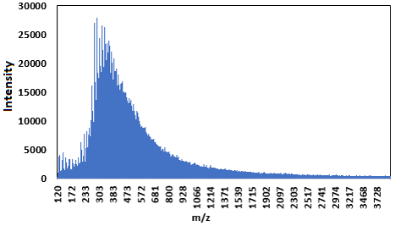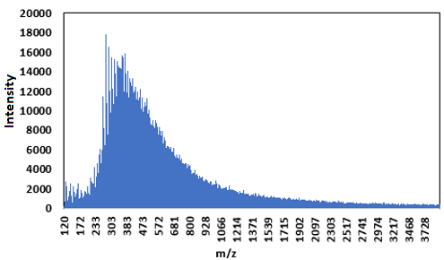

a b

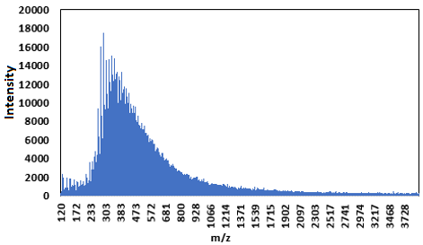

c d

*Figure 3: MALDI TOF-TOF mass spectra for crude oils: a- crude (B), b- crude (B) AQ, c- crude (B) AQ-NFe, and d- Summary of average molecular weights of base oil crudes and upgraded crude oils.*

The crude oils obtained from crude oil B present a higher abundance of species in the range of 120 to 1500 m/z, being higher in the presence of a catalyst. Figure 3d shows the average molecular weight distribution for the original and the upgraded crude oils. As expected, all the upgraded crude oils in the presence of iron naphthenate present a lower average molecular weight than those obtained without a catalyst. It is important to consider that the MALDI TOF-TOF mass spectrometry technique allows the ionization of polar fractions such as asphaltenes, resins, and aromatics. In the case of non-polar compounds such as saturates, it is impossible to identify the ionized sample accurately.

The information from the distillation curves obtained with the ASTM D7169 standard shows that the presence of the catalyst increases the content of light fractions (IBP - 370 °C), with values ​​in the range of 3.5 to 7.8 % by weight. Meanwhile, the increase in light fractions is mainly due to the vacuum residue conversion (540 °C+). Furthermore, this can be attributed to the transformation of resins and asphaltenes into saturates and aromatics.

In general, the trends in the results of the physicochemical properties of the upgraded crude oils show different behaviors. This behavior can be attributed to the effect of the in-situ catalysts and the presence of hydrogen formed from water and gas shift reactions. Finally, it can be noted that the three heavy crudes show different reactivity under the same operating conditions. Therefore, the effect of catalytic aquathermolysis depends on the chemical nature of the species present in the heavy crude oils.

* 1. Conclusions

The temperature condition at 270 °C and the concentration of iron naphthenate at 100 ppm with respect to the metal ion generates a favorable effect on the physicochemical properties of heavy crude oils. The above is possibly due to the synergy generated by adding iron naphthenate and the presence of steam on the chemical reactions in hydrocarbons. However, it is necessary to consider factors such as the nature of the original crude oils, which are a determining parameter when subject to the same thermocatalytic conditions.

Iron naphthenate exhibits a favorable catalytic reaction on SARA compositional variation and viscosity reduction of heavy crude oils. The three selected crudes presented viscosity increases when subjected to steam injection conditions without iron naphthenate. However, crudes A, B, and C during catalytic aquathermolysis showed viscosity reductions of 10.3, 44.4 and 33.8%, respectively.

**Acknowledgments**

The authors express their gratitude to the “Ministerio de Ciencia y Tecnología (MINCIENCIAS)”, “Agencia Nacional de Hidrocarburos (ANH)”, Energy Frontera and Universidad Industrial de Santander for the financial support. This work was financially supported by Project 1102-1035-92931 contract 036 2023. Also, the authors are grateful the “Ministry of Science and Technology (MINCIENCIAS)” through Project 107578- 941-2023 Convocatoria Fortalecimiento del Sector Hidrocarburos en Colombia.

**References**

Chen Y., He J., Wang Y., Li, P., 2010, GC-MS used in study on the mechanism of the viscosity reduction of heavy oil through aquathermolysis catalyzed by aromatic sulfonic H3PMo12O40, Energy, 35(8), 3454-3460.

Chew K.H., Klemeš J.J., Wan Alwi S.R., Abdul Manan Z., 2013, Industrial implementation issues of Total Site Heat Integration, Applied Thermal Engineering, 61, 17–25.

Huang S., Cao M., Huang Q., Liu B., Jiang J., 2019, Study on reaction equations of heavy oil aquathermolysis with superheated steam, International journal of environmental science and technology, 16, 5023-5032.

Hyne J.B., 1986, Aquathermolysis: a synopsis of work on the chemical reaction between water (steam) and heavy oil sands during simulated steam stimulation, AOSTRA Publication Series 55.

Kapadia P.R., Kallos M.S., Gates, I.D., 2015, A review of pyrolysis, aquathermolysis, and oxidation of Athabasca bitumen, Fuel Processing Technology, 131, 270-289.

León A.Y., Núñez-Méndez K.S., Salas-Chia L.M., Orozco-Agamez J.C., Peña-Ballesteros D.Y., Martínez-Vertel, J.J., Molina-Velasco D.R., 2024, Prediction of some physicochemical properties in Colombian crude oils upgraded by catalytic aquathermolysis using UV–VIS spectroscopy associated with chemometric methods, Spectrochimica Acta Part A: Molecular and Biomolecular Spectroscopy, 310, 123965.

Li Y., Zhang S., Wang Y., Qi G., Yu T., Xin X., Chen G., 2023, Oil-Soluble Exogenous Catalysts and Reservoir Minerals Synergistically Catalyze the Aquathermolysis of Heavy Oil, Molecules, 28(19), 6766.

Li Y.R., Li Q.Y., Wang X.D., Yu L.G.,Yang J.J., 2018, Aquathermolysis of heavy crude oil with ferric oleate catalyst, Petroleum Science, 15, 613-624.

Lozano D.C.P., Orrego-Ruiz J.A., Barrow M.P., Hernandez R.C., Mejía-Ospino E., 2016, Analysis of the molecular weight distribution of vacuum residues and their molecular distillation fractions by laser desorption ionization mass spectrometry, Fuel, 171, 247-252.

Muraza O., Galadima A., 2015, Aquathermolysis of heavy oil: A review and perspective on catalyst development, Fuel, 157, 219-231.

Salas-Chia L.M., Naranjo P.A.L., Bermúdez A.Y.L., 2023, Effect of Rock on Aquathermolysis Reactions at Laboratory Scale (A Review), Petroleum Chemistry, 63(3), 241-256.

Urazov K.K., Sviridenko N.N., Iovik Y.A., Kolobova E.N., Grabchenko M.V., Kurzina, I.A., Mukhamatdinov, I.I., 2022, Effect of hydrogen-donor of heavy crude oil catalytic aquathermolysis in the presence of a nickel-based catalyst, Catalysts, 12(10), 1154.

Vakhin V., Aliev F.A., Kudryashov S.I., Afanasiev I.S., Petrashov O.V., Sitnov S.A., Nurgaliev D.K., 2018, Aquathermolysis of heavy oil in reservoir conditions with the use of oil-soluble catalysts: Part I-changes in composition of saturated hydrocarbons, Petroleum Science and Technology, 36(21), 1829-1836.

Vo A.C., Le T.S., Maneeintr K., 2021, Simulation Study of Sodium 4-Vinylbenzene Sulfonate as a Surfactant for Enhanced Oil Recovery in the North of Thailand, Chemical Engineering Transactions, 89, 559-564.

Zhao F., Liu Y., Fu Z., Zhao X., 2014, Using hydrogen donor with oil-soluble catalysts for upgrading heavy oil, Russian Journal of Applied Chemistry, 87, 1498-1506.