|  |  |
| --- | --- |
| cetlogo ***CHEMICAL ENGINEERING TRANSACTIONS***  ***VOL. xxx, 2025*** | A publication of  aidiclogo_grande |
| The Italian Association  of Chemical Engineering  Online at www.cetjournal.it |
| Guest Editors: Fabrizio Bezzo, Flavio Manenti, Gabriele Pannocchia, Almerinda di Benedetto  Copyright © 2025, AIDIC Servizi S.r.l. **ISBN** 979-12-81206-17-5; **ISSN** 2283-9216 | |

Water Leaching of Wood Barks for Biocarbon Production

Zsuzsanna Czégénya,\*, István S. Cziroka,b, Gergő Szabóa,b, Zoltán Sebestyéna, Bence Babinszkia, Emma Jakaba, Liang Wangc, Øyvind Skreibergc

aHUN-REN Research Centre for Natural Sciences, Institute of Materials and Environmental Chemistry, Budapest, Hungary

bELTE Eötvös Loránd University, Hevesy György PhD School of Chemistry

cSINTEF Energy Research, Trondheim, Norway

czegeny.zsuzsanna@ttk.hu

Water leaching of birch bark, pine bark and spruce bark performed at 25 and 60 °C with and without stirring was tested as a pretreatment method to reduce the inorganic content of the feedstock. The yields of the solid demineralized bark and the dry material content of the leachate were determined. The effect of water leaching on the properties of bark materials was assessed by inductively coupled plasma optical spectroscopy (ICP-OES), element composition analysis and thermogravimetry (TGA).

The solid yield of water-leached bark samples was around 90 % for all three types of barks. The water leaching process removed significant amounts of organic material together with the inorganics. The C content of the water-leached samples decreased by 2-5 %, while the O content increased by 2-5 % comparing to the raw bark materials. Among the inorganic components, the concentrations of alkali ions (K, Na) decreased the most for all three types of bark. The leaching efficiency for Ca, K and Na was higher for birch bark comparing to pine bark and spruce bark. The effect of alkali ion removal and partial removal of the extractives is reflected on the thermal behaviour of the water-leached bark samples.

* 1. Introduction

Modern bioenergy applications ensure the use of renewable energy sources, especially of biomass, which offers a solution for reducing the global net greenhouse gas emissions by partially substituting fossil fuels. Biocarbon, the solid product of biomass pyrolysis, has various applications. However, these technologies require biocarbon with different physical and chemical properties. The amount and composition of volatile matter of the biocarbon are important properties for utilization, while high biocarbon yields with high fixed carbon content are always desirable. Ash content and inorganic composition of the biocarbon are also critical factors in several applications, such as in certain metallurgical processes. Metallurgical applications require large amounts of biocarbon to replace partially or fully fossil carbon with a renewable alternative. Stem wood has low ash content and produces high quality biocarbon, but it is the most valuable part of harvested wood with limited availability. Therefore, a less utilized and cheaper feedstock is needed for the biocarbon production. Bark is available in large quantities and at lower prices as a by-product of the wood processing industry. Birch, pine and spruce are common tree species in the Northern Hemisphere, and their bark is an abundant and a relatively cheap biomass. However, the bark has a higher inorganic content compared to the stem wood (Werkelin et al., 2005; Saarela et al., 2005), which needs to be reduced to make bark a suitable biocarbon feedstock for certain industrial processes. Water leaching is an efficient method to reduce the amount of several inorganic elements in woody biomass (Singhal et al., 2023; Wang and Skreiberg, 2023). The water-soluble fraction of biomass materials vary in a large range (Vassilev and Vassileva, 2019), as the leaching of inorganic and organic contents is affected by different factors (e.g., plant species, composition of extractive contents, leaching conditions).

In this study, the effect and efficiency of water leaching on both the organic and inorganic composition as well as on the thermal behaviour of birch bark, pine bark and spruce bark were investigated and compared.

* 1. Materials and methods
     1. Raw materials and leaching procedure

Bark samples of birch (*Betula pubescens*), spruce (*Picea abies*), and pine (*Pinus sylvestris*) were obtained from southern Norway (Hobøl, 59°35′35″N 10°56′45″E). The bark was chipped to 3–5 cm pieces and dried at room temperature to approximately 15 % moisture content. The bark chips were further dried in an oven at 105 °C for 16 h. The dried chips were ground to a particle size of < 1 mm by a cutting mill equipped with a sieve.

An amount of 6 g raw ground bark sample was leached by 60 mL deionized water in each isothermal leaching experiment. The temperature of the water was set to 25 or 60 °C before it was poured on the ground bark sample, and the temperature was maintained by a water bath for 60 min. Relatively low solvent: biomass ratio and moderate temperature were chosen to keep costs low considering an industrial application. In the cases of leaching pretreatments performed at 60 °C, the effect of leaching was further increased by stirring the mixture continuously with a magnetic stirrer (Heidolph MR Hei-standard, 400 rpm). The experiments performed at 25 °C were static and not stirred. Three parallel leaching experiments were performed under each condition.

After 60 min leaching the sample was filtered in a glass Büchner funnel (G3). The leached bark samples were dried in an oven at 105 °C for 16 h prior to weight measurement for yield calculation. The leachate was poured into a crystallizing dish and dried at 50 °C until the water content evaporated completely (48 h). The weight of the dried leachate was measured for extract yield calculation.

Table 1: Sample designations and conditions of leaching experiments.

|  |  |  |  |
| --- | --- | --- | --- |
| Sample name | Raw material | Leaching temperature | Stirring |
| BB(raw) | Birch bark | – | – |
| BB25N | Birch bark | 25 °C | No |
| BB60S | Birch bark | 60 °C | Yes |
| PB(raw) | Pine bark | – | – |
| PB25N | Pine bark | 25 °C | No |
| PB60S | Pine bark | 60 °C | Yes |
| SB(raw) | Spruce bark | – | – |
| SB25N | Spruce bark | 25 °C | No |
| SB60S | Spruce bark | 60 °C | Yes |

* + 1. Characterization methods

The ultimate analysis of the dried bark chips was conducted by using an elemental analyser (Eurovector EA 3000 CHNS-O Elemental Analyser). Oxygen content of the samples was calculated by difference. For each sample, triplicate measurements were conducted and the mean values are presented.

For determination of ash content, approximately 0.5 g of each sample was ashed in a furnace using a two-step heating program up to 550 °C final temperature (holding time 120 min). The ashes were cooled down in a desiccator to room temperature prior to weight measurement of the residues. Triplicates were carried out for each sample.

Inductively coupled plasma–optical emission spectrometry (ICP-OES, Thermo Scientific iCAP 6300 Duo

View ICP Emission Spectrometer) measurements were performed to determine the inorganic contents of the raw and water-leached bark samples. Each sample was digested with mixture of HNO3 (65%), HF (40%), H3BO3 (4%), according to CEN/TS 15290. The content of inorganic elements in the resulting solution was determined by the ICP-OES.

Thermogravimetry (TGA) measurements were performed using a TGS-2 thermobalance with a modified furnace (Perkin Elmer). Approximately 3 mg samples were loaded in a platinum sample pan and were continuously purged by argon at a flow rate of 140 ml/min before (for 40 min) and during the TGA analysis. The samples were heated at a rate of 20 °C/min from 25 to 900 °C.

* 1. Results and discussions
     1. Yields and characterization of the composition of the raw and leached bark samples

The obtained solid bark yield and the dried extract yield data are presented in Figure 1. The yield of the water-leached dry bark samples was around 90 %, as an effect of leaching temperature and stirring, the results changed within the SD of the procedure (Figure 1a). The weight loss due to water leaching originates from the extraction of water-soluble inorganic and organic matter and from some loss during sample handling (e.g., material stuck on glass filter). After filtration, the leachate was dried at 50 °C until the complete evaporation of the water. The yield of this fraction, which contains the extracted water-soluble inorganic and organic matter is shown in Figure 1b (extract yield). The extract yield of birch bark was the highest (ca. 8 %), and that of spruce bark was the lowest (ca. 6 %) among the three studied barks. These values are somewhat higher than the average water-soluble content of woody biomass (5.8 %); however, significantly lower than that of herbaceous and agricultural biomass materials (14.3 %) (Vassilev and Vassileva, 2019). The extract yield was higher for the samples leached at 60 °C temperature with stirring, comparing to the 25 °C experiments indicating that leaching of these components were more effective at higher temperature with continuous stirring. This effect was observed for all three types of bark samples. Considering the relatively small decrease in the ash content (0.1–0.2 %, see Table 2) of the leached samples in all three types of barks, it can be concluded that the majority of the dried bark extract, which represents 6–8 % of the raw material, is organic matter.

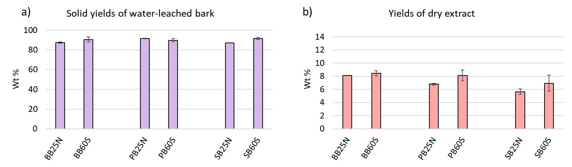

*Figure 1: (a) Solid yields of water leaching experiments, and (b) yields of the dry extracts.*

Differences in the ash content of the raw and leached bark samples, shown in Table 2, provides information about the overall efficiency of inorganic content removal by water leaching, and about the accessibility and solubility of the inorganic content of birch, pine and spruce bark. Among the studied raw materials, birch bark has the lowest ash content (1.22 %), pine bark contains somewhat more (1.69 %) and spruce bark has the highest ash content (4.14 %), which is in agreement with literature data (Saarela et al., 2005) for samples from environmentally clean areas. As a result of water leaching, the ash content decreased moderately, indicating limited accessibility and solubility of the inorganic content of the bark ground to 1 mm. The ash content values decreased by about 0.1–0.2 % regardless of the raw material, which means higher efficiency (10–12 %) for birch bark and pine bark due to their lower ash content, while the ash content of spruce decreased only by 2–5 %. The effect of leaching time and leaching temperature was not significant in the cases of the studied bark samples, the measured values of the leached samples changed within the uncertainty of the gravimetric data of leaching experiments and ash content analysis.

Table 2: Ash, volatile matter (VM) and fixed carbon (FC) content (% on dry basis), and concentration (mg/kg) of the major inorganic elements measured by ICP-OES in the raw and leached bark samples.

|  |  |  |  |  |  |  |  |  |  |  |  |
| --- | --- | --- | --- | --- | --- | --- | --- | --- | --- | --- | --- |
|  | BB(raw) | BB25N | BB60S |  | PB(raw) | PB25N | PB60S |  | SB(raw) | SB25N | SB60S |
| Ash | 1.22 | 1.09 | 1.08 |  | 1.69 | 1.47 | 1.49 |  | 4.14 | 3.93 | 4.06 |
| VM | 81.55 | 81.11 | 80.65 |  | 73.62 | 73.36 | 74.00 |  | 72.39 | 72.90 | 73.35 |
| FC | 17.23 | 17.8 | 18.27 |  | 24.69 | 25.16 | 24.51 |  | 23.47 | 23.17 | 22.59 |
| Ca | 3990 | 3433 | 3049 |  | 5530 | 5280 | 5137 |  | 17397 | 16137 | 15748 |
| K | 887 | 420 | 334 |  | 1692 | 1051 | 884 |  | 1178 | 935 | 725 |
| Na | 248 | 83 | 42 |  | 66 | 57 | 22 |  | 73 | 62 | 53 |
| P | 231 | 182 | 149 |  | 374 | 296 | 261 |  | 210 | 183 | 148 |
| S | 285 | 256 | 210 |  | 450 | 330 | 315 |  | 266 | 252 | 258 |
| Zn | 203 | 185 | 163 |  | 88 | 63 | 59 |  | 186 | 171 | 167 |

The effects of leaching on the removal of specific inorganic elements was studied by ICP-OES measurements. Table 2 summarizes the concentration of the major inorganic elements in the raw and leached bark samples. Among inorganics, Ca was measured in the highest concentration, and K was the second most abundant element in all raw and leached samples. As an effect of water leaching, the K and Na content of bark samples decreased to a greater extent, especially from birch bark. Ca is mainly present in organically associated, ion-exchangeable form in the biomass (Werkelin et al., 2010). 15–24 % of it was removed by the cold and hot water leaching from birch bark, and less than 10 % of the Ca content was removed from the coniferous barks regardless of the leaching temperature. In general, the removal of the given elements was more effective from birch bark comparing to pine bark and spruce bark and was somewhat more effective using 60 °C water leaching with stirring comparing to 25 °C without stirring experiment.

The results of the elemental analysis of raw and leached bark samples are presented in Figure 2. The measured values clearly show that the C and H content of the bark samples slightly decreased as an effect of water leaching, while the O content of the leached samples increased. This effect of leaching was the most significant in the case of the birch bark, while the changes were very slight for the two coniferous bark samples. The C content of the birch bark samples leached at 60 °C with continuous stirring was slightly less comparing to the birch bark samples leached at 25 °C without stirring, indicating the enhanced solubility at higher temperature and by mechanical stirring. The decreased C and H contents of the leached samples clearly indicate that considerable amounts of organic material were dissolved besides the inorganics. The main water-extractable organic compounds of the wood barks are phenolic compounds like tannins, lignans and flavanols (Kilpelainen et al., 2023; Liimatainen et al., 2012). The leaching of some of these compounds can be related to the decreased C and increased O content of the leached bark samples.

The nitrogen content of the bark samples was measured to be 0.3–0.4 %. Among the selected bark samples, spruce bark has the lowest N content (0.3 %); the obtained result is in agreement with literature data (Singhal et al., 2023). The N content of the studied bark samples did not change significantly or slightly increased as an effect of water leaching.

As a result of water leaching, the same tendencies (decreased C and H content) were reported on spruce bark by Singhal et al. (2023), while increased C and decreased O content was measured on water-leached pongamia pods (Fu et al., 2021). These observations highlight that the composition of the different types of biomass affect the composition and amount of leachable organic compounds and hence the elemental composition of the leached biomass.

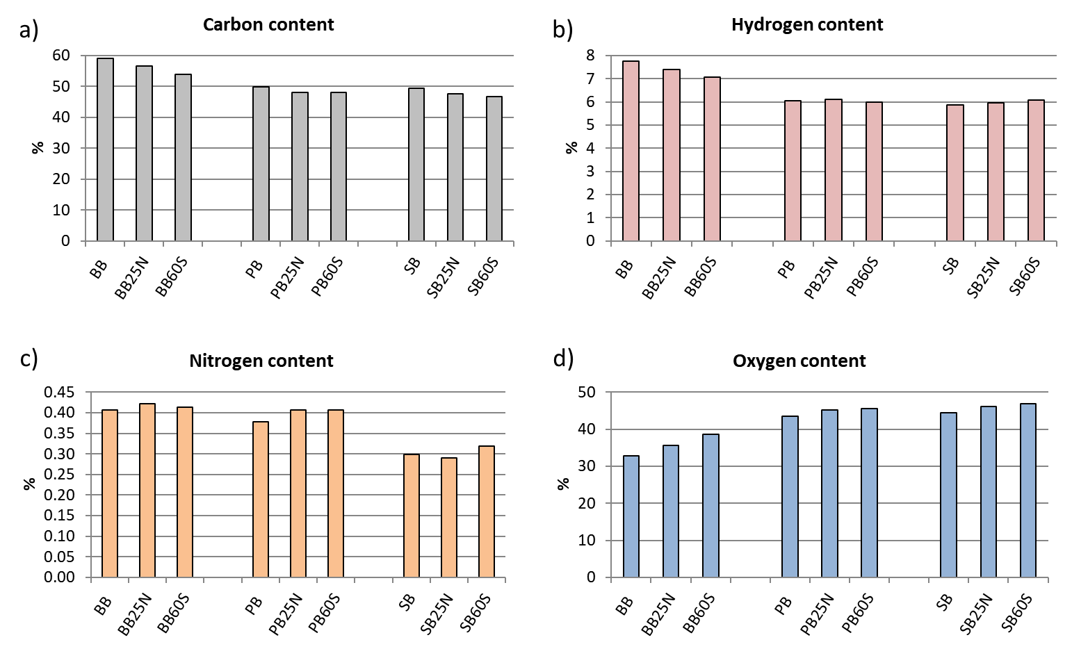

*Figure 2: Results of the elemental analysis of the raw and leached bark samples*. (a) Carbon content, (b) hydrogen content, (c) nitrogen content, (d) oxygen content (calculated by difference). Values calculated on dry ash free basis.

* + 1. Effect of leaching on the thermogravimetric properties of bark samples

The TG and DTG curves of the raw bark samples are compared in Figure 3a. The small weight loss below 150 °C indicates the evaporation of the moisture content of the samples. The evaporation of extractives started at around 180 °C from all three types of barks resulting in a small shoulder on the DTG curves. In the next step, the thermal decomposition of hemicellulose began, along with further evaporation and decomposition of extractives. Birch bark had markedly higher weight loss rate compared to spruce bark and pine bark (Figure 3a) in this temperature range (250–330 °C), which can be explained by the high suberin content of birch bark (Sjöström, 1993; Miranda et al., 2013). Suberins are complex polyesters, which probably decompose in this temperature range. Cellulose decomposes in a narrow temperature range and the DTG peak at the maximal rate of thermal decomposition of bark samples (at around 380 °C) can be attributed mainly to the decomposition of cellulose. The catalytic effect of alkali ions, especially potassium ion on the thermal decomposition of cellulose is known from the literature (DeGroot and Shafizadeh, 1984; Barta-Rajnai, 2018). The results of the ICP measurements in Table 2 show that pine bark had the highest K content, while birch bark had the lowest one among the studied bark samples. The different K content is reflected in the temperatures belonging to the DTGmax values of the raw barks, which increased with the decreasing K concentration in the order of PB<SB<BB. Lignin decomposed in a wide temperature range. The shoulder on the DTG curves of pine bark and spruce bark, and the small peak on the DTG curve of birch bark above 400 °C can be ascribed to the decomposition of lignin. Table 2 shows the volatile matter (VM) and fixed carbon (FC) data calculated from the results of TGA measurements and ash content data. Comparing the three studied bark feedstocks, pine bark and spruce bark had similar FC content (25–23 %), while that of the birch bark was significantly less (17 %), which can be related to the different lignin contents.

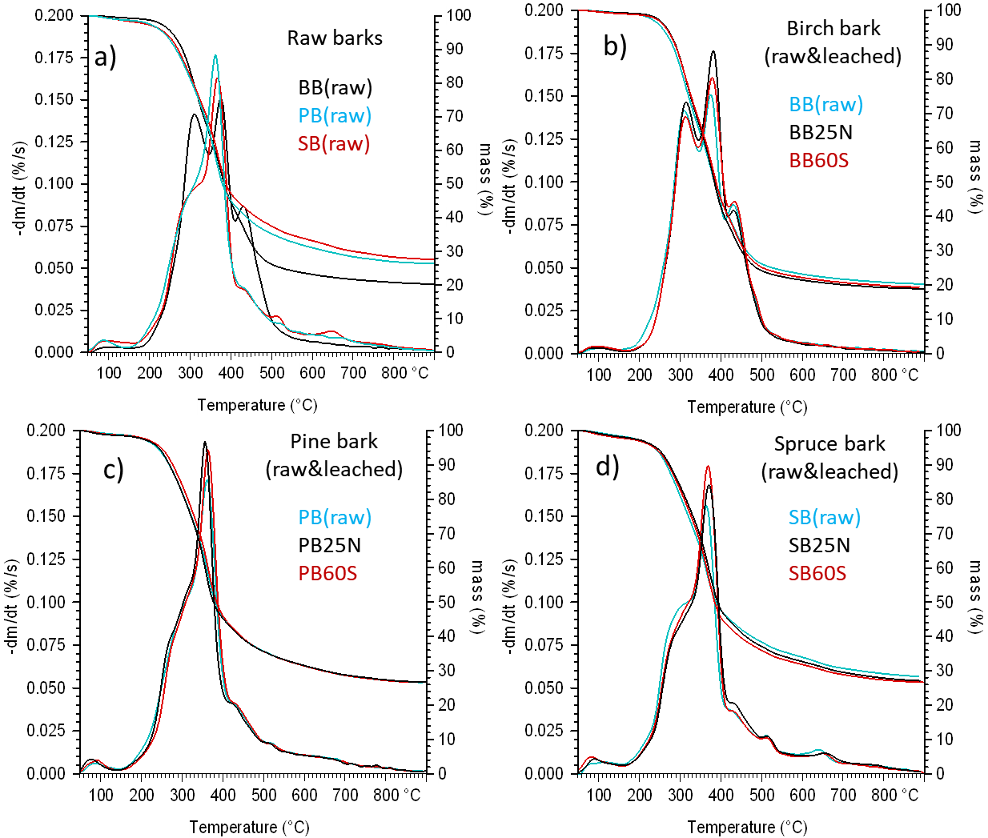

*Figure 3: Comparison of TG and DTG curves of the raw and leached bark samples in inert atmosphere.   
(a) Raw birch bark, raw pine bark, raw spruce bark, (b) raw and leached birch bark, (c) raw and leached pine bark and (d) raw and leached spruce bark samples.*

The TG and DTG curves of the raw and water-leached bark samples of the same feedstock are compared in Figures 3b–d. As described above, the water leaching process removed significant amounts of organic material together with the inorganics. Changes in the inorganic and organic composition of water-leached samples resulted in a modified thermal decomposition pattern. In the case of birch bark (Figure 3b), the effect of leaching is clearly visible at low temperatures (180–250 °C); the weight loss rate of the washed samples was lower, which is partially due to the removal of water extractable organic compounds. This difference is visible, but much less characteristic for the pine and spruce samples (Figures 3c–d). In the case of spruce bark, a similar effect was observed at around 300 °C, which indicates the removal of organic extractable materials, like mono- and oligosaccharides and water-soluble lignin (LeNormand et al., 2012). The main DTG peak at around 350°C indicates the thermal decomposition of cellulose. The height of this peak was increasing as a result of water leaching in the cases of all three types of bark samples. The reason for this effect is the relative increase of the cellulose content in the leached samples due to the removal of the water-soluble part of the biomass. The TG and DTG curves of the raw and water-leached samples are very similar above 400 °C, which indicates that the thermal decomposition of lignin was not much affected by the partial removal of inorganics. The effects of the 25 °C leaching without stirring and the 60 °C leaching with stirring were almost identical in the thermogravimetric properties of all three types of bark samples.

* 1. Conclusions

Wood bark is an abundant biomass by-product of the wood processing industry. However, the use of biocarbon produced from bark is limited for certain applications due to drawbacks of this largely available biomass material (i.e., high inorganic content). In this study, the effects of water leaching on the composition and thermal properties of birch bark, spruce bark and pine bark samples were studied.

The solid yield of the dry leached barks was around 90 % for all three bark types. Based on the results, it can be concluded that the majority of the extracted mass was organic material, further studies are needed to determine the utilization possibilities of this fraction. Although the ash contents decreased moderately, the amount of alkali elements reduced by 40-60%; to a higher extent for birch bark and pine bark comparing to spruce. The results of elemental analysis reflect the decreased C and increased O contents in the leached barks. The change was the most characteristic for birch bark. The results also indicate that elevated leaching temperature (60 vs. 25 °C) and continuous stirring facilitated the removal of Ca, K and Na to different extents. In general, the removal of the given elements by water leaching was found more effective from birch bark compared to the coniferous pine bark and spruce bark. The apparent effects of alkali elements removal and partial removal of the extractives were reflected in the thermoanalytical behaviour of the leached samples.

Acknowledgments

This work was supported by the Research Council of Norway and a number of industrial partners through the project BioCarbUpgrade (Grant No. 336309).

References

Barta-Rajnai E., Babinszki B., Sebestyén Z., Czirok I.S., May Z., Jakab E., Czégény Zs., 2018, On the significance of potassium and chlorine content of lignocellulose during torrefaction, Journal of Analytical and Applied Pyrolysis, 135, 32–43.

DeGroot WF., Shafizadeh F., 1984, The influence of exchangeable cations on the carbonization of biomass. Journal of Analytical and Applied Pyrolysis, 6, 217–232.

Fu J., Allen G., Weber S., Turn Q.S., Kusch W., 2021, Water leaching for improving fuel properties of pongamia Pod: Informing process design, Fuel, 305, 121480.

Kilpeläinen P., Liski E., Saranpää P., 2023, Optimising and scaling up hot water extraction of tannins from Norway spruce and Scots pine bark, Industrial Crops & Products, 192, 116089.

LeNormand M., Edlund., Holmborm B., Ek M., 2012, Hot-water extraction and characterisation of spruce bark non-cellulosic polysaccharides, Nordic Pulp & Paper Research Journal, 27, 18–23.

Liimatainen J., Karonen M., Sinkkonen J., Helander M., Salminen J-P., 2012, Phenolic compounds of the inner bark of Betula pendula: Seasonal and Genetic Variation and Induction by Wounding, Journal of Chemical Ecology, 38, 1410–1418.

Miranda, I., Gominho, J., Pereira, H. 2013, Fractioning and chemical characterization of barks of Betula pendula

and Eucalyptus globulus. Industrial Crops and Products, 41, 299-305

Saarela K.E., Harju L., Lill J.O., Heselius S.J., Rajander J., Lindroos A., 2005, Quantitative Elemental Analysis of Dry-ashed Bark and Wood Samples of Birch, Spruce and Pine from South-Western Finland Using PIXE, Acta Academiae Aboensis Ser. B., 65, 4.

Singhal A., Goel A., Bhatnagar A., Roslander C., Wallberg O., Konttinen J., Joronen T., 2023, Improving Inorganic Composition and Ash Fusion Behavior of Spruce Bark by Leaching with Water, Acetic Acid, and Steam Pre-Treatment Condensate, Chemical Engineering Journal, 452, 139351.

Sjöström E, 1993, Wood Chemistry: Fundamentals and Applications, Academic Press, Inc. 2nd Ed. San Diego, CA, USA.

Vassilev S.V., Vassileva C.G., 2019, Water-Soluble Fractions of Biomass and Biomass Ash and their Significance for Biofuel Application, Energy & Fuels, 33, 2763–2777.

Wang L., Skreiberg Ø., 2003, Evaluation of Water Leaching on Properties of Woody Biomass for Biocarbon Prodiction, Chemical Engineering Transactions, 105, 277–282.

Werkelin J., Skrifvars B-J., Hupa., 2005, Ash-forming elements in four Scandinavian wood species. Part 1: Summer harvest, Biomass and Bioenergy, 29, 451–466.

Werkelin J., Skrifvars B-J., Zevenhoven M, Holmbom B., Hupa M., 2010, Chemical forms of ash-forming elements in woody biomass fuels, Fuel, 89, 481–493.