|  |  |
| --- | --- |
| cetlogo ***CHEMICAL ENGINEERING TRANSACTIONS***  ***VOL. xxx, 2025*** | A publication of  aidiclogo_grande |
| The Italian Association  of Chemical Engineering  Online at www.cetjournal.it |
| Guest Editors: Fabrizio Bezzo, Flavio Manenti, Gabriele Pannocchia, Almerinda di Benedetto  Copyright © 2025, AIDIC Servizi S.r.l. **ISBN** 979-12-81206-17-5; **ISSN** 2283-9216 | |

Olive Stones as optimal precursor of activated carbons for water purification process

Rossella Girimonte\*a, Nadia Astorinoa, Maria Turanoa, Daniele Sofiaa, Andrea Katovica

aDepartment of Computer Engineering, Modeling, Electronics and Systems, University of Calabria, Via P. Bucci cubo 44/a Rende (CS), 87036, ITALY

\*rossella.girimonte@unical.it

The olive tree is a predominant crop in Mediterranean countries, accounting for approximately 95% of global olive production, with Italy being the second-largest producer after Spain. While olive oil is the main product, the olive industry also generates a significant amount of by-products, including olive stones, which constitute about 20% of the olive’s weight. These stones, rich in lignin, cellulose, and hemicellulose, are traditionally used as biofuels. However, they also offer great potential for conversion into activated carbon (AC) due to their high porosity and large surface area, making them ideal adsorbents for water and gas treatment. This study investigates the production of ACs from olive stones using both physical and chemical activation processes, evaluating key parameters such as activation method, temperature, and time. The ACs produced were analyzed for their thermal properties, structural attributes, and ability to adsorb dyes in water treatment systems. The findings revealed that the selection of the activation process and the fine-tuning of operating parameters play a crucial role in determining the adsorption efficiency of the resulting materials.

This research highlights the feasibility of utilizing olive stones as an eco-friendly and renewable raw material for manufacturing high-quality granular ACs, offering a sustainable solution for repurposing agricultural residues into effective tools for water purification and environmental protection.

* 1. Introduction

The olive tree dominates agricultural production in the Mediterranean Basin, accounting for approximately 95% of the world’s olive plantations. This is largely due to the region's warm and mild climate, which provides ideal conditions for the growth and development of olive trees. Olive trees mainly supply important olive oils, which provide the healthiest vegetable fats, but also produce by-products such as olive stones (OS), which account for roughly 20% of the olive weight (García Martín et al., 2020). Most of those recovered in olive mills have sizes larger than 1 mm, but never exceed 7 mm in length. As a lignocellulose material, they have been proposed as a source for the production of various added-value products (Lama-Muñoz et al., 2014) through thermochemical and biochemical processes, helping to address the problem of their environmental contamination. Elemental analysis shows the composition of the different elements: almost 47-51% (wt.) of carbon, 6% of hydrogen, 42-45% of oxygen, less than 2% of nitrogen, and less than 0.1% of sulphur. Ash percentages are usually lower than 2% (wt.). Like any carbonaceous waste or agricultural by-product from the food crop sector, olive stones represent an attractive precursor for activated carbon. The term ‘activated carbon’ (AC) refers to a category of amorphous carbonaceous materials with high porosity and a large internal surface area (SA). They are the most widely used adsorbents for the treatment of wastewater and gas emissions because of their low cost, exceptionally high porosity, tunable pore size, and high adsorptive capacities (Pelaez Cid et al., 2024). Ideally, an adsorbent should have a high surface area or micropore volume to achieve a high adsorption capacity; pore diameters sufficiently large to accommodate the size of the adsorbate; surface functional groups to attract the adsorbate; and a relatively large porous network providing access to the internal surface area by diffusion without great transport resistances. These characteristics depend on the precursor and the activation process carried out. The stones consist exclusively of the bones of the olives. Usually, the material is subjected to grinding by ball mills, which allows for a reduction in particle size, a condition that enables the production of AC in either powdered or granular form (Obregón-Valencia et al., 2014). The carbonaceous precursor undergoes an activation process, which can be either physical or chemical. This process is pivotal in shaping the pore structure and distribution, as well as enhancing the adsorption capacity of the resulting AC. The most influential factors include both physical and chemical activation time and temperature (Pan et al., 2021; Saleem et al., 2019). The physical activation process involves thermal treatment in the presence of an inert gas, carbon dioxide, or steam at temperatures ranging from 500 to 1000°C. Chemical activation, on the other hand, involves a chemical agent that is added to the precursor prior to the thermal treatment at the same temperature range. Thermal treatment without an activating agent develops some surface-active sites and porosity due to the presence of major constituents (cellulose, hemicellulose, and lignin). For chemical activation, a wide range of chemicals have been used with olive stones, including phosphoric acid, nitric acid, sulphuric acid, sodium hydroxide, potassium hydroxide, steam, potassium carbonate, zinc chloride, hydrochloric acid, and hydrogen peroxide. The presence of various functional groups, particularly oxygen-containing groups, enhances surface reactivity, significantly contributing to the adsorbent's uptake capacity (Saleem et al., 2019). The adsorption performance and activation efficiency of biochar depend on the material's physicochemical properties, which vary greatly depending on the raw material characteristics, synthesis methods, and production conditions. The composition of the biomass affects the yield, elemental content, and microstructure of the AC. In general, the high lignin content in plant-based raw materials results in a high biochar yield. For this reason, this study focused on Olive Stones as a cheap precursor (with a lignin content of 25-30% wt. and low inorganic content), as they are an abundant waste material in our country. An experimental investigation into the preparation of activated carbon (AC) through physical and chemical activation was carried out, aiming to identify the key parameters that affect its dye adsorption efficiency for water treatment applications. Special attention was dedicated to AC preparation in terms of granular particles, which are easy to operate in adsorption units such as fluidized bed, conventional, or confined systems.

* 1. Experimental
     1. Preparation of AC

The starting material, derived from the solid residue of olive processing, consists only of olive stones that have already been deprived of the pulp and further residues, milled with a residual humidity of 7% wt., and then made ready for use, thus obtaining granular activated carbons. The granular, rather than powdered, configuration was preferred to facilitate the separation of the treated currents from the solid material, which can then be reactivated more easily, especially if a fluidized bed application is of interest. Olive stones contain a fixed and elemental carbon content of approximately 16% and 40% wt., respectively, which is among the highest carbon values found in various stone fruits. A literature analysis (Pan et al., 2021; Saleem et al., 2019) identified a list of parameters to consider in the preparation of ACs, the ranges within which to operate in evaluating these parameters, and the most effective activating agent for preparing the sorbent for the intended application.

A first set of AC samples was produced by physical activation at 500°C, the minimum temperature required to successfully convert the lignin in the precursor, while varying the pyrolysis time (90–210 min). However, only the sample with a pyrolysis time of 150 min is included in Table 1, as it was determined to be the optimal value for both AC yield and porosity characteristics. Pyrolysis temperature is an important factor influencing the physicochemical properties and structural characteristics of biochar, particularly its C content. Specifically, the higher the pyrolysis temperature, the greater the amount of volatile components released from the raw materials and the lower the biochar yield. Increasing the pyrolysis temperature accelerates the formation of pore structures within the biochar and enhances the specific surface area (Chen et al., 2001). Meanwhile, the C content of biochar increases with rising temperature, while the H and O content gradually decreases. The hydrophilicity and polarity of the biochar surface also weaken as the pyrolysis temperature increases, while the degree of aromatization and its stability are enhanced (Zhao et al., 2018). However, biochar prepared at high temperatures (>500 °C) is generally highly aromatic and exhibits a well-organized carbon layer structure suitable for carbon sequestration, which is not the intended application of this study.

Furthermore, longer pyrolysis times lead to lower surface area but higher adsorption capacity for large molecules. Prolonged treatment transforms micropores into mesopores, reducing the surface area over time, while also modifying surface functionality by introducing more nitrogen surface groups and reducing the number of oxygen surface functional groups. For this reason, an intermediate time of 150 min was identified as optimal. For chemical activation, the activating agent selected was phosphoric acid (H₃PO₄), the most commonly used agent in the literature, as it does not pose significant separation issues (Yakout and Sharaf El-Deen, 2016). Among the several processing parameters, the activating agent-to-olive stone ratio (%) was set to 0.5, while other parameters, such as acid contact time, temperature, and pyrolysis duration, were varied. However, the sample with the same pyrolysis parameters as the physically activated AC is reported in Table 1.

The olive stones were left in contact with acid at room temperature and stirred for a period sufficient to ensure H₃PO₄ penetration into the particle interior and completion of the activation process, lasting at least 20 hours. Afterward, the sample was washed with distilled water to remove excess acid, dried in an oven for a few hours, and then subjected to the pyrolysis step. The furnace temperature was first calibrated, and the length and position of the constant-temperature zone were determined. Heating from room temperature to the maximum pyrolysis temperature was conducted in a nitrogen atmosphere (flow rate = 330 mL/min). The heating rate was set at 10°C/min, with pyrolysis temperatures ranging between 350 and 500°C, and durations varying between 20–280 min. However, the sample treated at 500°C for 150 min is included in Table 1 for direct comparison with the physically activated sample.

Table 1: Main experimental parameters for the AC preparation and some characteristics results

|  |  |  |  |  |  |  |  |
| --- | --- | --- | --- | --- | --- | --- | --- |
| Sample | H3PO4/OS ratio (%vol) | Activation T  [°C] | Contact  time [h] | Pyrolysis T  [°C] | Pyrolysis  time [min] | Particle diameter [mm] | Yield [%] |
| ACp | no | no | no | 500 | 150 | 2.25 | 19.2 |
| ACc | 0.5 | 25 | 24 | 500 | 150 | 2.56 | 30.4 |

* + 1. Characterization of AC

The prepared activated carbons were characterized for granulometric distribution using a QICPIC/Gradis (Sympatec GmbH, Germany), and the mean volume diameter was determined as indicated in Table 1. Using thermogravimetric analysis (TGA), X-ray diffraction (XRD), and FTIR analysis, a description of their physicochemical properties was provided. Thermogravimetric analysis (TGA) provides information about the structural stability of ACs by recording their mass variations as a function of temperature or time. The instrument used was a NETZSCH analyzer, model STA 409. The analysis was conducted in static air, within a temperature range of 20 to 850°C, at a heating rate of 5°C/min, with sample weights ranging from 5 to 10 mg. X-ray diffraction, a non-destructive analytical technique, was used for both qualitative and quantitative examination of crystalline and solid-state materials. This method provides insights into the sample's structure, revealing how atoms are arranged and interconnected. The measurements in this study were carried out using a Rigaku MiniFlex 600 Powder Diffractometer. Infrared spectroscopy, commonly referred to as FTIR spectroscopy, is a widely used absorption spectroscopic technique for material characterization based on chemical bonds. Since each substance has a unique combination of atoms, no two different compounds produce the same spectrum. Therefore, infrared spectroscopy can be used to identify a material as well as quantify the presence of a component within a mixture. This investigation was performed using a Nicolet iS10 IR Spectrometer (Thermo-Fisher Scientific Inc., USA). All spectra were obtained with 32 scans and a resolution of 4 cm⁻¹, covering a wavenumber range from 4000 to 450 cm⁻¹.

* + 1. Adsorption tests on ACs

The adsorptive capacity of the prepared ACs was studied for the removal of methylene blue (MB) from aqueous solutions, which was used as a model compound for high molecular weight organic contaminants, similar to the majority of water micropollutants. Methylene blue is a compound belonging to the class of aromatic heterocyclics. At room temperature, it appears as an odorless crystalline solid with a dark green color, which is stable in air and light and resistant to biodegradation. When dissolved in an aqueous solution, it takes on an intense dark blue color, which is why it is primarily known for its use as a dye. Chemical dyes are widely used in the textile, paper, plastic, food, and cosmetic industries, and the colored effluents from these industries pose a danger not only to the environment (partly because they are poorly biodegradable) but also to human health. The adsorption process on activated carbons is commonly used for the removal of organic dyes from textile wastewater (Saleem et al., 2019). The experimental adsorption tests focused on investigating the thermodynamic aspects of the adsorption process. This was carried out by determining the adsorption isotherms to assess the adsorptive capacity of the produced activated carbons. In particular, various factors such as contact time, initial solute concentration, quantity, and size of the adsorbent material used could influence the process, along with the type of activation process. The adsorption capacity of ACs was evaluated in a batch reactor by contacting different masses of AC, mAC, (10, 25, 50, 75, 100, 150, and 200 mg) with 25 ml of an MB solution at a concentration of 60 mg/l. At equilibrium, spectrophotometric measurements were performed to evaluate the concentration of MB remaining in the solution using a Shimadzu UV-1601 Spectrophotometer, which operates within a wavelength range of 320 to 1000 nm. Before the spectrophotometric analysis, a calibration curve was constructed by plotting the absorbance values, obtained at a wavelength of λ = 665 nm, for different concentrations of MB, which are not reported here.

* 1. Results
     1. Characterization results

In Table 1, the particle diameter and the AC yield (expressed as the ratio between the final weight of AC and the initial weight of the precursor) are reported as a function of the operating parameters used during their preparation. It can be observed that physical activation tends to degrade the precursor more significantly, resulting in finer granules and a lower AC yield under the same pyrolysis conditions. Thermogravimetric (TGA) analyses were used to characterize the samples by measuring the percentage of weight change as a function of temperature and to predict their thermal stability across a temperature range of 20°C to 850°C. The two prepared ACs show significant differences. The TGA curve of ACp, which was only physically activated (shown in Fig. 1a), exhibits mass losses at 70°C, 400°C, and 500°C. The first loss, occurring at 70°C, with a small percentage of weight reduction, is attributed to water vapor and low-molecular-weight volatile compounds. Between 420°C and 500°C, the maximum mass loss is observed, corresponding to the decomposition stage of cellulose and hemicellulose. At temperatures ranging from 500°C to 530°C, further mass losses likely result from the decomposition of lignin, which occurs at higher temperatures. The TGA curve of ACc, chemically activated with H₃PO₄ (see Fig. 1a again), shows a mass loss associated with moisture and volatile organic compounds up to 100°C, followed by a significant mass loss recorded between 480°C and 590°C. This broader decomposition range, compared to ACp, suggests that cellulose and hemicellulose were converted with the formation of phosphate complexes, which are more resistant to decomposition, as reported in the literature. At temperatures between 650°C and 700°C, mass losses were likely due to the degradation of both lignin and the phosphate complex. ACc exhibits superior thermal stability compared to ACp, as its structural decomposition begins at a higher temperature. Activated carbons are amorphous (microcrystalline) materials with a highly disordered porous structure. While they share similarities with graphite, ACs exhibit variable spacing between their individual layers, which are smaller in size and contain structural defects. This type of structure is commonly referred to as "turbostratic." X-ray diffraction was employed to analyze the arrangement of carbon atoms in the samples. In Fig. 1b, the prepared ACs show two significant peaks in their diffraction profiles, at approximately 23° and 43°, which correspond to the disordered graphitic planes (002) and (101), respectively. However, there are significant differences in the intensity of these peaks. The (002) peak, located at approximately 23°, is the most intense peak in the spectrum, while the (101) peak, which results from the two-dimensional arrangement of the crystal planes, appears at 43° and is less intense than the (002) peak. The type of turbostratic or graphitic arrangement in the graphite layers is determined based on the interplanar distance (d₀₀₂), calculated using Bragg’s equation. If d₀₀₂ is less than 0.335 nm, a graphitic structure dominates; if it exceeds 0.335 nm, a turbostratic structure prevails. The calculated interlayer spacing values were found to be greater than those of graphite (0.335 nm), confirming that all prepared ACs exhibit a turbostratic structure, characterized by a low degree of crystallinity, with planes laterally displaced relative to each other. The analysis of the diffractograms enabled the determination of the size of the turbostratic carbon crystallites, including their lateral diameter (Lₐ) and height (Lc), as reported in Table 2. An increase in crystallite size was observed from ACp to ACc, as commonly reported (El-Sheikh et al., 2004), confirming an improvement in structural properties, which is beneficial for its application in chemical dye removal from wastewater.

Table 2: Planes distance and crystals sizes of the ACs prepared

|  |  |  |  |  |
| --- | --- | --- | --- | --- |
| AC | d002 | d101 | Lc | La |
| ACp | 0.376 | 0.216 | 0.61 | 0.70 |
| ACc | 0.356 | 0.206 | 0.83 | 0.83 |

To identify the functional groups present on the surface of the ACs, Fourier Transform Infrared Spectroscopy (FTIR) analysis was performed. This provided a picture of their molecular structure and how it changed compared to the precursor. From the comparison of the FTIR spectra (shown in Fig. 2) of the precursor and the obtained ACs, it was observed that the starting material exhibits a higher number of transmission peaks in the region between 1700 and 500 cm⁻¹. This suggests that olive stones contain a higher concentration of functional groups compared to the ACs. The primary constituents of olive stones are hemicellulose, cellulose, and lignin; however, unlike other polymers, lignin exhibits an aromatic nature. The ACp spectrum appears more similar to that of the precursor and displays a wide absorption band around 3400-2400 cm⁻¹. In contrast, ACc exhibits a peak around 1700 cm⁻¹, which corresponds to the stretching of C=O in ketones, aldehydes, lactones, and carboxyl groups.

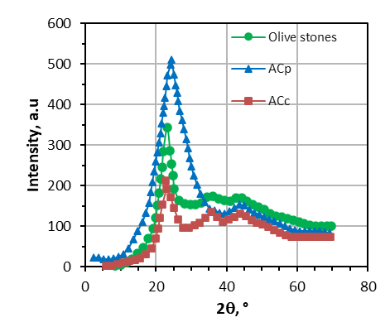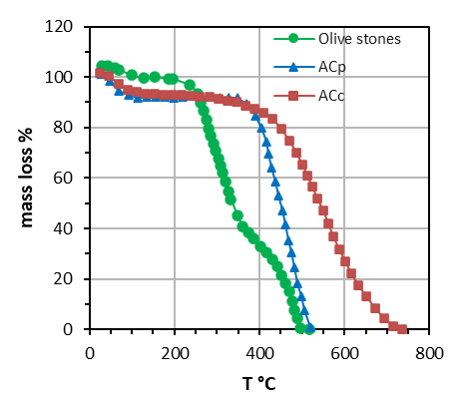

**(b)**

**(a)**

Figure 1: TGA (a) and RX curves (b) for the ACs prepared compared to precursor

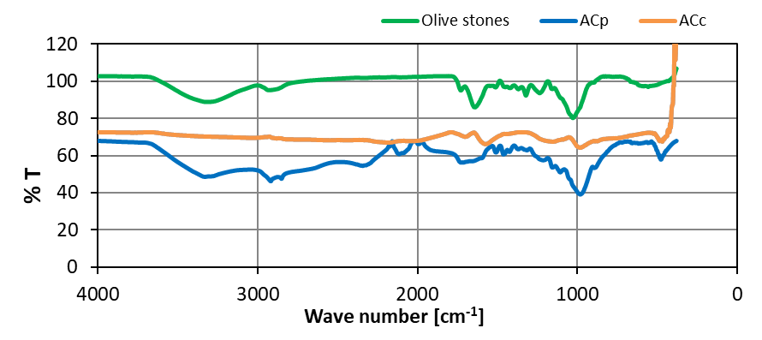

Figure 2: FTIR spectra for the ACs prepared compared to precursor

The reduction of these bands compared to those of the precursor spectrum is due to the reduction of hydrogen bonding, attributed to asymmetric stretching (C-H), and it may be due to the decomposition of these C=O groups during activation. The peak at 1590 cm⁻¹ indicates the stretching of the aromatic ring (C=C), suggesting that the structure of the AC becomes richer in aromatics. There is also a peak around 1200 cm⁻¹ attributed to the stretching of hydrogen bound to P=O, O–C in P–O–C, and P=OOH. The effect of phosphoric acid as an impregnating agent plays an important role in modifying the porosity structure, since it partially hydrolyzes the cellulose and hemicellulose of the olive stones. This leads to a widening of mesopores during pyrolysis and also a weakening of the structure. This observation is confirmed experimentally: after impregnation, not only is there an increase in particle size (due to the incorporation of acid), but also a decrease in rigidity: the particles become elastically deformable.

* + 1. Adsorption results

After the characterization of the AC, a preliminary series of adsorption tests was carried out to verify the effectiveness of AC preparation. In these tests, different masses of adsorbent granules were used for a given initial concentration of adsorbate, set at 60 mg/L. The adsorption isotherms are expressed by comparing the amount of adsorbate adsorbed per gram of adsorbent, qₑ [mg/g], with the concentration of the solution at equilibrium, Cₑ [mg/L], at a predefined temperature (see Figure 3).The performance of ACc was better than that of ACp. The results indicated that the removal rate of MB increased from 10% to 70% as the ACc amount, mAC, increased from 10 to 200 mg. However, the ACc amount needed to exceed 200 mg to reach a constant removal rate close to 100%.Considering the granular nature of the ACs and assuming a certain degree of heterogeneity in intraparticle porosity, the experimental MB adsorption data were also fitted using the Freundlich model, which is based on sorption onto a heterogeneous surface. The model equation is given in (1), where kF ((mg/g) (L/mg)¹/ⁿ) and nF are Freundlich constants related to adsorption capacity and adsorption intensity, respectively. Their values are reported in Table 3. The value of nF > 1, obtained only for ACc, confirms a favorable adsorption condition, but the kF values are significantly lower than those reported in the literature (Saleem et al., 2019; Pelaez Cid, 2024), despite using the same precursor material and chemical agent, but with activation at higher temperatures. A significant effect on the adsorption performance was attributed to the decision to maintain the granular size, which reduced the active surface immediately available for MB capture while increasing intraparticle resistance.

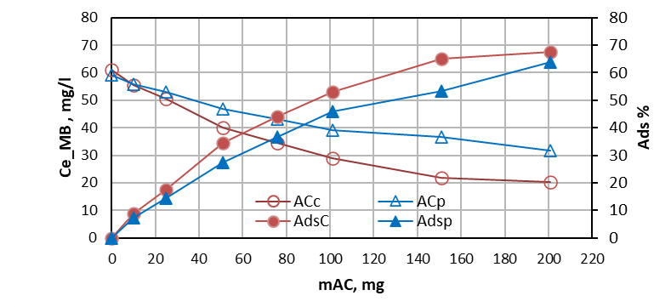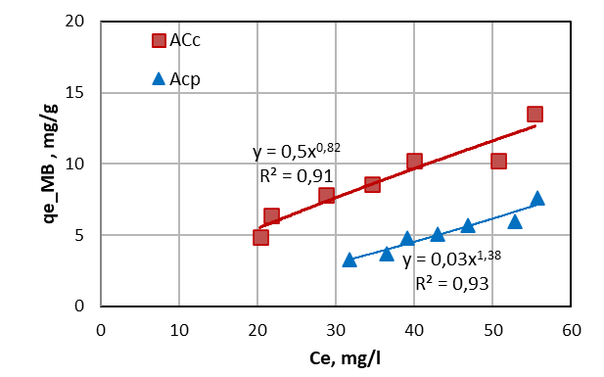

*Figure 3: MB adsorption data for the ACs prepared*

Table 3: Parameters of Freundlich isotherm

|  |  |  |  |  |
| --- | --- | --- | --- | --- |
| AC | KF | nF | R2 | (1) |
| ACp | 0.03 | 0.72 | 0.93 |
| ACc | 0.5 | 1.22 | 0.91 |

* 1. Conclusions

The solid waste generated from olive processing, primarily composed of olive stones, has proven to be an effective precursor for producing activated carbon with promising properties as an adsorbent for water pollutants. The various characterizations carried out on the AC samples revealed that the parameters that most affect the structure and material composition are the type of activation process, the pyrolysis temperature, and duration.

Despite their large particle size, the activated carbons (ACs) tested demonstrated a good adsorption capacity for removing methylene blue (MB) from aqueous solutions, achieving removal efficiencies exceeding 60%.

Key synthesis parameters, including the pyrolysis temperature and duration, as well as the composition of the phosphoric acid solution, require further investigation. Conversely, the chemical activation time with phosphoric acid appears less critical, provided it does not fall below 24 hours.

References

El-Sheikh, Amjad. “Characterization of Activated Carbon Prepared from a Single Cultivar of Jordanian Olive Stones by Chemical and Physicochemical Techniques.” J. of Anal. and Applied Pyrolysis, Elsevier BV, 2004.

García Martín J.F., Cuevas M., Feng C-H, Álvarez Mateos P., Torres García M. and Sánchez S., 2020, Energetic Valorisation of Olive Biomass: Olive-Tree Pruning, Olive Stones and Pomaces, Processes, 8, 511.

Lama-Muñoz, A., Romero-García J.M.,, Cara C.; Moya M., Castro E., 2014, Low energy-demanding recovery of antioxidants and sugars from olive stones as preliminary steps in the biorefinery context, Ind. Crops Prod., 60, 30–38.

Obregón-Valencia D., del Sun-Kou R.M., 2014, Comparative cadmium adsorption study on activated carbon prepared from aguaje (Mauritia flexuosa) and olive fruit stones (Olea europaea L.), J. Environ. Chem. Eng., 2, 2280–2288.

Pelaez Cid A.A., Lopez Hernandez D.L., Gomez Merino E., Herrera Gonzales A.M., 2024, Synthesis of activated carbons using custard apple seeds and their application in the adsorption of textile dyes, Rev. Int. Contam. Ambie. 40, 263-278. https://doi.org/10.20937/RICA.54967

Pan X., Gu Z., Chen W., Li Q., 2021, Preparation of biochar and biochar composites and their application in a Fenton-like process for wastewater decontamination: A review, Sci. of the Total Environment, 754,142104.

Saleem J., Shahid U.B., Hijab M., Mackey H., McKay G., 2019, Production and applications of activated carbons as adsorbents from olive stones, Biomass Conversion and Biorefinery, 9, 775–802.

Yakout S.M., Sharaf El-Deen G., 2016, Characterization of activated carbon prepared by phosphoric acid activation of olive stones. Arab J Chem 9:S1155–S1162. https://doi.org/10.1016/j.arabjc.2011.12.002

Zhou, J., Luo, A., & Zhao, Y., 2018, Preparation and characterisation of activated carbon from waste tea by physical activation using steam. Journal of the Air & Waste Management Association, 68(12), 1269–1277. https://doi.org/10.1080/10962247.2018.1460282