|  |  |
| --- | --- |
| cetlogo ***CHEMICAL ENGINEERING TRANSACTIONS***  ***VOL. xxx, 2025*** | A publication of  aidiclogo_grande |
| The Italian Association  of Chemical Engineering  Online at www.cetjournal.it |
| Guest Editors: Fabrizio Bezzo, Flavio Manenti, Gabriele Pannocchia, Almerinda di Benedetto  Copyright © 2025, AIDIC Servizi S.r.l. **ISBN** 979-12-81206-17-5; **ISSN** 2283-9216 | |

Estimation of carbon captured using the Walkey and Black technique by Tillandsia purpurea in the Amara hills. Ocucaje- Perú

Leidy Milady Ramos Alarcona, Juan Alberto Pisconte Vilcaa, Zanhy Leonor Valencia Reyesb\*, Fiorella Vanessa Güere Salazarb, Alex Segundino Armas Blancasb, Hellen Felicia Blancas Amayac, William Cesar Santos Tellod, Giner Emerson Díaz Dávilae

aUniversidad Nacional San Luis Gonzaga, Av de los Maestros, Ica 11004, Perú

b Universidad Nacional Mayor de San Marcos, Ciudad Universitaria, Lima 15081, Perú

cUniversidad Nacional de Educación Enrique Guzmán y Valle, Lurigancho-Chosica 15472, Perú

dUniversidad Continental, Av. Alfredo Mendiola 5210, Los Olivos 15306, Perú

eUniversidad Pontifica de Cataluña, España

\*corresponding: zvalenciar@unmsm.edu.pe

For carbon capture, various techniques are employed, such as membrane separation and chemical absorption (Girimonte et al., 2024); however, tillandsias are capable of doing it naturally. The objective was to estimate the amount of carbon and water by Tillandsia purpurea in the hills of Amara. Forty 1 m² plots were sampled, and six individuals were collected from each to determine their wet and dry weight (the samples were dried at 105 °C for 48 hours); the difference between the two allowed for the estimation of the amount of water. To obtain the %H (amount of water stored in the biomass), moisture was subtracted, and the results were subsequently extrapolated for the entire hill. To obtain carbon, 300 g of T. purpurea and 200 g of soil were extracted and processed in the Soil, Plant, Water, and Fertilizers Analysis Laboratory (LASPAF-UNALM) using the Walkley and Black technique; then the total amount for the hill was estimated through Kriging modeling using ArcGIS. An average fresh biomass of 25.2 g and 72.5% humidity was recorded; Regarding carbon capture, 35.4 Tn C/ha was estimated for aerial carbon, which is the biomass of the tillandsial, and 19.4 Tn C/ha for the soil. The sum of both was 54.8 Tn C/ha, which captures the tillandsial of the Amara hill with an area of 7,338.63 ha.

**1. Introduction.**

Anthropogenic activities from the energy supply, transportation, and industrial sectors generate emissions such as CO2, methane (CH4), nitrous oxide (N2O), and halocarbons, which produce environmental waste, increasing long-term temperature and climate effects (Diaz, 2012). Carbon sequestration is a natural process that helps regulate ambient temperature (Rojo et al., 2003). To capture CO2, various techniques are used such as membrane separation and chemical absorption (Girimonte et al., 2024); however, air plants naturally contribute to this process.

*Tillandsia purpurea "*Achupalla" is distributed in the coastal hills of the Peruvian desert, spread across small patches that connect fragile ecosystems. (Aguilar and Turkowsky, 1977). This plant has the ability to capture carbon dioxide through the photosynthetic process and store it in the form of biomass in its tissues (Rojo-Martínez et al., 2003); morphologically, it presents hairs on its leaves called trichomes that replace the roots by absorbing water, nutrients, and particles in the air (Benzing and Bennett, 2000); likewise, they maintain turgor in the tissues of the leaves and photosynthetically active stems (Schulte, 2009). Chemically, they have crassulacean acid metabolism (CAM) which allows them to fix CO2 during the night and close their stomata during the day. These attributes help regulate temperature and resilience to episodic drought (Winter et al., 1983); as is the case with *Tillandsia utriculata* L, where the water potential after two months of droughts decreased from −0.75 to −1.25 MPa (Stiles and Martin, 1996).

Estimating the amount of water that *Tillandsia purpurea* can capture, as well as carbon dioxide, is the objective of this research. The obtained value would provide the importance they have as air purifiers (Benzing, 2000), and the ecosystem service they offer; but for this, it is necessary to determine the organic carbon using the Walkley and Black technique. This involves oxidizing the organic carbon present in living matter (Tillandsia) (Eyherabide et al., 2014).

In the hills of southern Peru, eleven (11) species of the genus Tillandsias have been identified, which together form the tillandsials (Whaley et al., 2019)., however, there is a gap in information regarding the amount of carbon and water capture; therefore, these results will help reassess the ecosystem services of the tillandsial and take the necessary conservation measures by the National Forest and Wildlife Service-SERFOR.

**2. Materials and methods.**

**2.1. Area of study.**

Loma de Amara (Figure 1), located in the district of Ocucaje, province of Ica, Peru, approximately 48 kilometers away from the Panamerican South between 14°44'55" S and 75°40'9" W, at an altitude of 875 m.s.n.m. According to the Ecological Map of Peru (ONERN, 1976) is located on the zone of Desert dry warm temperate (dd-Tc), which presents vegetation with presence of winds from 21 to 36 km/h.

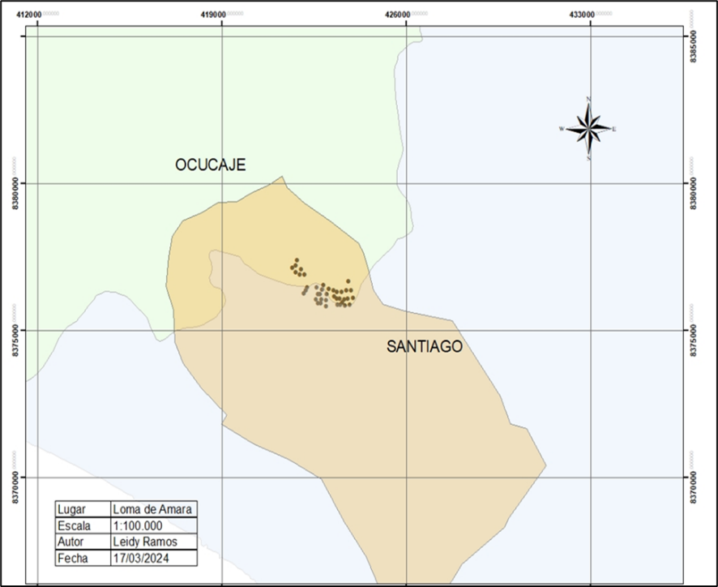

*Figure 1. Study area, Loma de Amara and georeferenced points.*

**2. Materials and methods.**

**2.2. Establishment of plots.**

40 plots of 1m2 were established, which were georrefenciados. For each sample, 6 individuals and 300 g of *Tillandsia purpurea* were extracted, plus 200 g of soil sample.

### 

**2.3. Estimate fresh biomass - dry and humid on the hill.**

Fresh biomass was determined by weighing 240 individuals in total on the 40 plots, using a digital scale and dry biomass was obtained by placing samples in a 105°C oven for 48 hours and then weighing them. The difference between wet and dry weight allowed to know the humidity.

**2.4. Determine the carbon capture in Tillandsia purpurea and soil.**

Forty samples of 300 g of Tillandsia purpurea and 200 g of soil were processed in the laboratory for Soil, Plant, Water and Fertilizer Analysis at the National Agricultural University La Molina (LASPAF-UNALM) using the Walkley and Black technique. This consists of oxidizing the organic carbon present in living matter (Tillandsia) by a solution of potassium dichromate and the reaction heat generated when it is mixed with sulphuric acid, obtaining a mixture to which phosphoric acid is added to avoid interference of Fe3+. Potassium dichromate is obtained as a residual product and is titrated with ferrous sulphate. Between 70 and 84% of the total organic carbon is detected with this procedure, so a correction factor must be introduced, which may vary per plant (Eyherabide et al., 2014). The reaction is expressed in the following reaction:

$2{Cr}_{2}0_{7}=+3C^{°}+16 H+→{4Cr}_{3}+{3Co}_{2 }+8H_{2}O$; the oxidized C is quantified by titrating the excess Cr+6; this obtained value is multiplied by the factor 1.3 to express the results in percent organic carbon (Walkey and Black, 1934 and Eyherabide et al., 2014).

**2.5. Estimation of aboveground and soil carbon per plot.**

To know the amount of aboveground carbon per plot, the following equation was used: CAP=B x %CA, where B is equal to the dry plant biomass and %CA is the percentage of carbon in the biomass per plot. Regarding soil carbon, the formula CSP=%CS x S was applied; %CS: Percentage of carbon in the soil and S: Quantity of grams of soil (Arévalo and Aponte, 2020).

The amount of soil gram was obtained by determining its bulk density. This density is determined by dividing the dry weight of the sample by the volume of the cylinder (Toledo, 2020). The soil samples were processed in the laboratory by placing them in an oven at 105 °C for 48 hours. Subsequently, they were sieved and dry weight data were taken.

**2.6. Determination of total carbon in Amara hill by spatial modeling.**

The estimation of carbon in soil and tillandsia (aerial) was found by means of the spatial inference kriging method, using ArcGIS software. This consists of calculating the values of a variable in unsampled locations (space where there were no tillandsia) using the information provided by the sample (Porras, 2017). Then, the equation $CT=CA+CS$; where:

CT: Is the total carbon in Amara hill, CA: aboveground carbon and CS: soil carbon.

**3. Results and discussions.**

**3.1. Estimation of fresh - dry biomass and humidity in the hill.**

An average fresh biomass of 25.2 g and 7 g dry weight was recorded for the 40 plots (Figure 2a). Regarding the humidity in *Tillandsia purpurea* (Figure 2b) it was 72.5% and 37.7%. This result differs from Arévalo and Aponte (2020), who worked with *Tillandsia latifolia*, with an average humidity of 83.09%. These values are due to the fact that *Tillandsia latifolia* has a larger leaf area and therefore more hairs or trichomes that allow it to capture water from the mist. Likewise, the capture and storage of water is a peculiar characteristic of these species with CAM metabolism (Crassulacean Acidic Metabolism), which causes CO2 to be stored in the form of acid before being used in photosynthesis, in addition to allowing the stomata to open during the night, which reduces water loss by evaporation (Winter et al., 1983 and Arévalo and Aponte 2020).

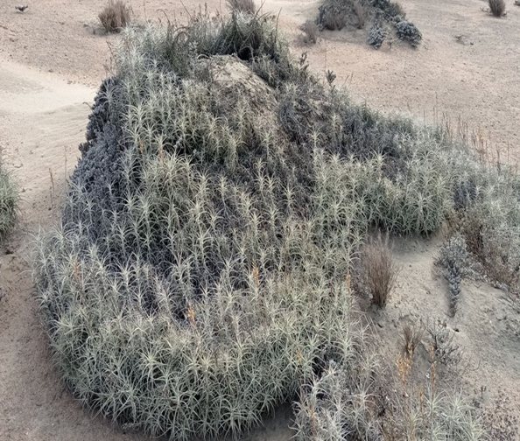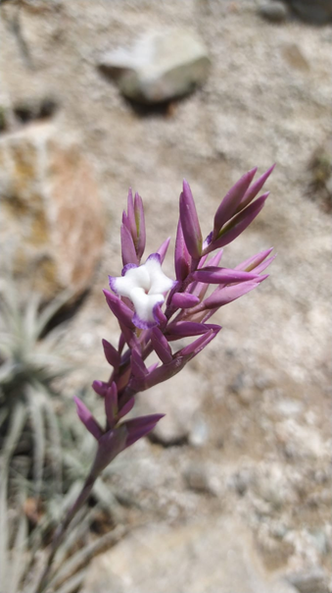

*Figure 2a. Tillandsial plot Figure 2b. Tillandsia purpurea.*

**3.2. Determination of carbon in tillandsia purpurea and soil.**

The amounts of carbon recorded in *Tillandsia purpurea* ranged from 16.84% to 51.16%. In soil, the minimum carbon percentage was 0.17%, and maximum 1.51%. These results differ with that of Arévalo and Aponte (2020), where they mention that *Tillandsia werdermannii* registered 43.13% of organic carbon content in plant tissue and *Tillandsia landbeckii* 38.40% and *Tillandsia latifolia* 52.66%. Toledo (2020) estimated that *Tillandsia werdermannii* captured 39.79% followed by *Tillandsia purpurea* with 35.35%. This last figure gives us an idea of the different amounts of carbon that *Tillandsia purpurea* can sequester. The amount of carbon stored differs for each species according to the capacity of its vegetation cover, which maintains an amount of biomass per hectare that is a function of its heterogeneity, climate and soil type (Arévalo, Alegre, & Palm 2003).

The lower amount of carbon registered in comparison with the other tillandsias is due to the size of the plant, size of the leaf and the percentage of coverage of the plant on the soil. Regarding carbon sequestration in the soil is lower compared to the other studies, due to the fact that, the transfer of carbon from the plant biomass passes to the soil where it is stored (FAO,2017), however, this plant lacks a root that allows this transfer. Likewise, the type of soil (porosity) where some have the capacity to capture a greater amount of organic matter.

**3.3. Determination of total carbon in loma de Amara by spatial modeling**

Soil and tillandsial carbon sequestration data were modeled using Kriging geostatistical interpolation, resulting in a histogram with a Gaussian bell shape (Kurtosis of 2.37) and a normal distribution. The method used was the ordinary method in logarithmic function. The semiovariogram of the model applied in the kriging methodology for aerial carbon in the study area was determined by the linear equation of first degree obtaining the equation: 0.118722746308231 \* x + 224.057987921692 and 118722746308231 \* x + 224.057987921692 for soil carbon.

With this equation it was possible to extrapolate the data.

The amount of 35.4 Tn C/ha was estimated for the aerial carbon which is the biomass of the tillandsial (Figure3b) and 19.4 Tn C/ha for the soil (Figure3a). The sum of both was 54.8 Tn C/ha stored by the Amara hill with an area of 7,338.63 ha.

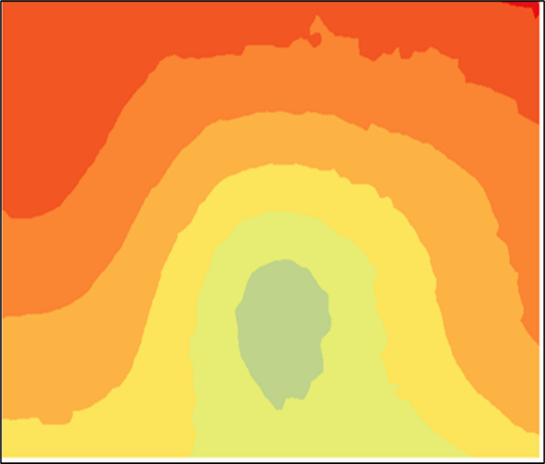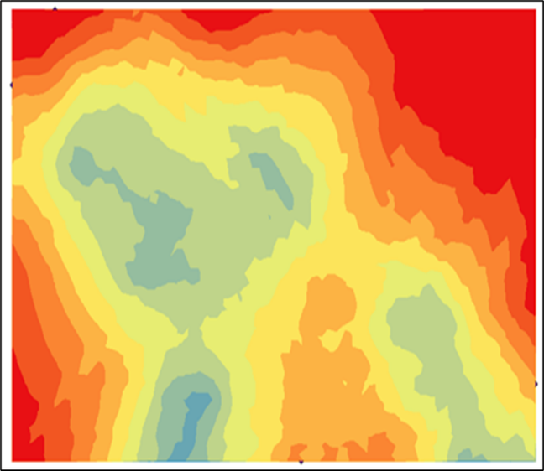

*Figure 3a. Modeling of airborne carbon. Figure 3b. Soil carbon modeling.*

Some studies related to carbon sequestration are those of Arévalo and Aponte (2020) in which they estimated 94.10 t for the Piedra Campana hill (Lima/Peru). Toledo (2020) determined that in Lomas Arrojadero in the districts of Inclán and Locumba - Tacna, *Tillandsia werdermannii* captured 1.78 t C/ha of carbon in plant biomass, while *Tillandsia purpurea* 1.66 t C/ha; the total amount of carbon stored in the living biomass and necromass of Tillandsial was 25.15 t C, representing an estimated capture of 92.30 tons of CO2. Chino (2018) found in the Tillandsial of Cerro Intiorko - Tacna 2.75 t C/ha of carbon stored in plant biomass, and the total amount of carbon stored in the area was 61 250.21 t C. The results of the investigations of the other authors differ from ours, because the species are different (leaf size) even though they belong to the same family, also due to the coverage of this and the size of the hill; however, the different species form the tillandsiales that make up the hills, so these ecosystems have a great potential to capture CO2.

There is no other soil carbon sequestration study of tillandsiales, except for Arévalo and Aponte (2020), who obtained a carbon amount of 76.5 tn, which is different from our result (19.4 Tn C/ha). This is due to the low presence of dead biomass in the spring season. Hernandez et al., (2014) mentions that “dead plant matter to the soil is the main source of carbon”. That is, where there is a higher density of living biomass there will be greater mortality and consequently a greater amount of carbon stored in the soil.

**4. Conclusions.**

An average fresh biomass of 25.2 g and 72.5 % of humidity was recorded; therefore, it is of great importance for the communities that inhabit this type of desert ecosystem. In reference to carbon sequestration it was estimated 35.4 Tn C/ha for the aerial carbon which is the biomass of the tillandsial and 19.4 Tn C/ha for the soil). The sum of both was 54.8 Tn C/ha captured by the tillandsial of the Amara hill with an area of 7,338.63 ha.

**Acknowledgments**

The authors express their gratitude to the **Universidad Nacional San Luis Gonzaga** for the support provided in the development of this research, as well as for granting access to the necessary resources for the estimation of carbon captured using the Walkley and Black technique in Tillandsia purpurea in the Amara hills, Ocucaje, Peru. We also extend our appreciation to all individuals and institutions that contributed their knowledge and technical assistance to this study.

**Reference**

Aguilar, PG. y Turkowsky, JA., 1977. Fauna Desértico-Costera Peruana. - III. Observaciones en el Tillandsial de Cajamarquilla, Lima. *Revista Peruana de Entolomogía*, 20 (1), 81-85.

Arévalo, J & Aponte, H. 2020. Carbon and water storage in *Tillandsia latifolia* Meyen in a sector of the tillandsial lomas Piedra Campana (LIMA / PERU). *Ecología Aplicada,* 19(1), DOI: <http://dx.doi.org/10.21704/rea.v19i1.1441>.

Arévalo, L, Alegre, J., y Palm, C. 2003. *“Manual de Las Reservas Totales de Carbono En Los Diferentes Sistemas de Uso de La Tierra En Perú.”* STC/CGIAR/Ministerio de agricultura.

Benzing, DH. y Bennett, B., 2000. *Bromeliaceae: Profifile of an Adaptive Radiation*. Cambridge University Press, Cambridge,U.K. ISBN0-521-43031-3.

Chino, C., y Elisban, A. 2018. Evaluación del servicio ambiental de captura y almacenamiento de carbono en la comunidad de tillandsial (Bromeliaceae) en las pampas de Cerro Intiorko en la provincia de Tacna, 2016. Tesis de Maestría Universidad Nacional Jorge Basadre Grohmann.

Eyherabide, M., Saínz, H., Barbierie, P., y Echeverria, E. 2014. Comparación de métodos para determinar carbono orgánico en suelo.  *Ciencia del suelo*, 32(1) 13-19. <https://www.scielo.org.ar/scielo.php?script=sci_arttext&pid=S185020672014000100002&lng=es&tlng=es>.

Girimonte, R., Sofia D., Agrippino S., Turano M., Testa F., 2024, The Process of CO2 Capture and Reduction: Exploring the Efficacy of Metal-Organic Frameworks (MOFs), *Chemical Engineering Transactions*, 111, 577-582. DOI:10.3303/CET24111097.

Hernández, J.E., Tirado, D. y Beltrán, I., 2014. Captura de carbono en los suelos. *Padi Boletín científico del ICBI*, Universidad Autónoma del Estado de Hidalgo. DOI: <https://doi.org/10.29057/icbi.v1i2.506>.

Organización de las Naciones Unidas para la Alimentación y la Agricultura (FAO). 2017. *Carbono Orgánico del Suelo:* el potencial oculto. Organización de las Naciones Unidas para la Alimentación y Agricultura Roma, Italia. <http://www.fao.org/soils-portal/cos>.

Porras, A. 2017. *Método Kriging de inferencia espacia*l. Disponible en: <http://centrogeo.repositorioinstitucional.mx/jspui/handle/1012/160>

Rojo-Martínez, G. E., Jasso-Mata, J., y Velásquez-Martinez, A. 2003. Las masas forestales como sumideros de CO2 ante un cambio climático global. *Revista Chapingo. Serie Ciencias Forestales y Del Ambiente*, 9(1), 57–67. <https://www.redalyc.org/articulo.oa?id=62990106>

Roulet, N.,2000. Peatlands, Carbon Storage, Greenhouse Gases, and The Kyoto Protocol: Prospects And Significance For Canada. *Wetlands*, 20: 605-615.

Schulte, P. J., 2009. Water transport processes in desert succulent plants. Perspectives in Biophysical Plant Ecophysiology: A Tribute to Park S. *Nobe*l, 39-55.

Toledo, A. 2020. *Captura de Carbono en la especie Tillandsia werdermannii y Tillandsia purpurea (siempre viva) en las Lomas Arrojadero situada entre los Distritos de Inclán y Locumba, Tacna*” Tesis para obtener el grado de bachiller en Ingeniería Ambiental. [https://repositorio.upt.edu.pe/bitstream/handle/20.500.12969/1710/Toledo-Guzma Anaiz.pdf?sequence=1&isAllowed=y](https://repositorio.upt.edu.pe/bitstream/handle/20.500.12969/1710/Toledo-Guzma%20Anaiz.pdf?sequence=1&isAllowed=y)

Whaley, O. Q., Orellana-García, A., & Pecho-Quispe, J. O., 2019. An Annotated Checklist to Vascular Flora of the Ica Region, Peru—with notes on endemic species, habitat, climate and agrobiodiversity. *Phytotaxa*, 389(1), 1-125.

Walkey, A., & Black, I., 1934. An examination of the Degtjareff method for determining soil and, and a modification of the chromic acid titration method. Soil *Science*, 37: 29-38.

Winter, K., Wallace, BJ, Stocker, GC y Roksandic, Z. (1983). Metabolismo ácido de las crasuláceas en epífitas vasculares australianas y algunas especies relacionadas. *Oecologia,* 57(1-2), 129–141. doi:10.1007/bf00379570