|  |  |
| --- | --- |
| cetlogo ***CHEMICAL ENGINEERING TRANSACTIONS***  ***VOL. xxx, 2025*** | A publication of  aidiclogo_grande |
| The Italian Association  of Chemical Engineering  Online at www.cetjournal.it |
| Guest Editors: Fabrizio Bezzo, Flavio Manenti, Gabriele Pannocchia, Almerinda di Benedetto  Copyright © 2025, AIDIC Servizi S.r.l. **ISBN** 979-12-81206-17-5; **ISSN** 2283-9216 | |

Direct carbonation of Mg2+-rich brines as alternative CO2 storage opportunity

Michela Cardella, Giuseppe Battaglia\*, Melissa Salvo, Andrea Cipollina, Alessandro Tamburini, Giorgio Micale

Università degli studi di Palermo, Dipartimento di Ingegneria, Viale delle Scienze, 90128 Palermo, Italy

[giuseppe.battaglia03@unipa.it](mailto:giuseppe.battaglia03@unipa.it)

Desalination is the leading technology that provides fresh water in arid and semi-arid regions of the world. Desalination plants, however, produce also concentrated salty solutions (brines), whose disposal has raised environmental concerns. Several authors have investigated the use of desalination brines as a potential source for CO2 mineralization, aiming at reducing CO2 emissions through indirect and direct carbonation processes. The present work deeply examines the performance of the poorly investigated direct carbonation process of Mg2+-rich solutions at room temperature and atmospheric pressure. These solutions, referred to as bitterns, are generated after a concentration process of seawater desalination brines in evaporative ponds or after the production of table salt in saltworks. Synthetic magnesium chloride solutions with a Mg2+ concentration of ~2.00 mol/L, mimicking the Mg2+ concentration in real bitterns, were adopted. Sodium hydroxide solutions were employed as alkaline reactant. For comparison, the indirect carbonation process of commercial magnesium hydroxide powders was studied. Tests were carried out in a 1 L semi-batch stirred jacketed reactor. The influence of different impellers, namely a 6-blade Rushton turbine and a marine propeller, on the crystal morphology of synthesized products was also investigated.

* 1. Introduction

Anthropogenic carbon dioxide (CO₂) emissions are the primary driver of global warming. About 40% of CO2 emissions remains for 100 years in the atmosphere, while ~20% persists for 1000 years (Sobanaa et al., 2024). Given the long-term impact of CO₂, it is crucial to reduce global CO2 emissions. In the last 30 years, several mitigation methods have been explored. Among them, direct and indirect carbonation mineralisation techniques have been proposed. These techniques exploit metallic cations, such as magnesium (Mg2+) and calcium (Ca2+), from different types of feedstocks to store CO2 in the form of stable carbonate solids. Wang et al. (2011) confirmed the possible application of concentrated seawater brines for the storage of CO2 streams. Singh et al. (2022) investigated the indirect carbonation process of seawater desalination brines through the addition of calcium oxide as the alkaline reagent and a CO2 stream. The mechanical properties of synthesized carbonated magnesium hydroxide, Mg(OH)2, solids were tested for construction materials applications. Zhang et al. (2023) proposed an easy and cost-effective method to completely transform Mg2+ via carbon dioxide (CO2) mineralization from bitterns. Synthetic bittern solutions with Mg2+ concentration of 2.2 mol/L were let to react with NaOH solutions and a CO2 stream at 70°C. With this respect, the present work deeply examines the direct carbonation process of highly concentrated Mg2+ solutions at room temperature and atmospheric pressure. The aim is the simultaneous synthesis of valuable magnesium-carbonate compounds and their applicability for CO2 capture and storage. The work has been performed within the activities of the European-granted H2020 REWAISE project. In the project, the use of evaporation ponds is foreseen to precipitate first calcium compounds and then produce table salt (NaCl) from desalination waste brines. The remaining solutions, called bitterns, are highly concentrated Mg2+ sources, free of calcium. Direct carbonation tests were carried out by using synthetic magnesium chloride solutions with a Mg2+ concentration of ~2.00 mol/L. Sodium hydroxide was the alkaline reactant. Tests were carried out in a (semi)-batch stirred reactor by injecting a highly pure CO2 gas stream (99.99 % v/v). The influence of different impellers, namely a 6-blade Rushton turbine and a marine propeller, on the morphology of synthesized crystals was also investigated. In the experimental campaign, in addition to the analysis of direct carbonation, the indirect carbonation process of commercial magnesium hydroxide powders (Magnifin®) was analysed.

* 1. Materials and methods

**2.1 Solutions**

Synthetic Mg2+-rich and NaOH solutions were employed in direct carbonation tests. Analytic grade magnesium chloride hexahydrate solids (CARLO ERBA > 99 %) and analytical grade NaOH pellets (Honeywell FlukaTM > 98 %) were dissolved in deionized water. The targeted concentrations were 2.00 M of Mg2+ and 1.00 M of OH-. The Mg2+ concentration mimicked that of a typical real saltworks bittern (Battaglia et al., 2022, 2023). 23.32 g of Mg(OH)2 solids of analytical grade (Magnifin® H-10 > 99.8 %) were suspended in 1 L of deionized water. The amount of Mg(OH)2 solids was chosen in order to have the same concentration of Mg2+,namely 0.4 mol/L,in the reaction volume during direct and indirect tests. The Mg(OH)2 suspension was used for indirect tests.

2.2 Experimental and analytical procedures

Direct carbonation tests were conducted in a 1 L semi-batch jacketed reactor. 200 mL of the synthetic Mg2+-rich solution was added dropwise through a peristaltic pump (KRONOS 50) at a flow rate of 10 mL/min into a 800 mL of NaOH solution. A pure CO2 stream(PHARGALISTM > 99.99 % v/v) was injected at a flow rate of 0.77 L/min by a cylindric sparger having 0.5 µm holes, located in the bottom part of the reactor. CO2 was injected until the suspension pH reached a value of 7.8. All experiments were performed at 30 °C. The temperature of the suspension was accurately controlled by using a thermostat system (JULABO), while the pH was recorded through a pH meter (WTW™ pH/Cond 3320). Two types of impellers were adopted, namely a six-blade Rushton turbine and a marine propeller. The rotational speed was always 300 rpm. The same experimental set-up was adopted for indirect carbonation tests. In this case the peristaltic pump was not adopted since the reactor was filled with the 23.32 g/L Mg(OH)2 suspension before the beginning of the tests. Table 1 reports the details of the tests carried out. DC and IC refer to direct and indirect carbonation tests, while RT and MP indicate the use of the Rushton turbine or the marine propeller, respectively.

Table 1 – Summary of conducted experimental tests. Tests were performed at 30 °C. CO2 flow rate was 0.77 L/min. The rotation speed was 300 rpm. The Mg2+ solution was added dropwise at 10 mL/min in a 800 mL of 1.00 M NaOH solution.

|  |  |  |  |  |
| --- | --- | --- | --- | --- |
| Test | Mg source | Mg source volume [mL] | Carbonation process | Impeller type |
| DC-RT | 2.00 M Mg2+ solution | 200 | Direct | Rushton turbine |
| DC-MP | 2.00 M Mg2+ solution | 200 | Direct | Marine propeller |
| IC-RT | Mg(OH)2 suspension  (23.3 g/L) | 1000 | Indirect | Rushton turbine |
| IC-MP | Mg(OH)2 suspension  (23.3 g/L) | 1000 | Indirect | Marine propeller |

Samples were collected over time and filtered. Mg2+ concentration was assessed in the filtrates (liquid phase) via ethylenediaminetetraacetic acid (EDTA) complexometric titration technique. Solids were dried at 40 °C in an oven for 24 h. The composition and purity of the synthesized solids were analyzed by Fourier-Transform Infrared Spectroscopy, FTIR (FT IR, Shimadzu IRTracer-100) and thermogravimetric analysis, TGA (STA 449 F1 Jupiter, NETZSCH, 20 mL/min of N2 flow rate, 10 °C/min). The morphology of the particles was assessed by adopting a scanning electronic microscope, SEM (FEI QUANTA 200), after a gold spattering on the powders. The crystalline structure of solids was analysed by X-ray diffraction, XRD, technique using the RIGAKU model D.MAX 2500 HK (CuKa radiation, 1.542° A, 40 KV, 100 mA, step size of 1°/min).

* 1. Results and discussion

Mg2+ concentration and pH profiles obtained by analysing filtrates in DC and IC tests are shown Figure 1.

**b)**

**a)**

**d)**

**c)**

Figure 1 - Mg2+ concentration and pH profiles obtained by analysing filtrates during direct (a and b), DC, and indirect (c and d), IC, tests conducted by adopting a marine propeller (a and c), MP, or a six-bladed Rushton turbine (b and d), RT. Tests were conducted at 30 °C. The CO2 flow rate was 0.77 L/min and the rotational speed was 300 rpm.

Mg2+ concentrations increased over time up to a maximum value of 0.21±0.02 mol/L at ~20 minutes due to the dissolution of Mg(OH)2 solids in IC tests (Cheng et al., 2019) and the continuous addition of the Mg2+ in DC ones, as shown in Figure 1a and 1b. Mg2+ concentrations further decreased due to the crystallization of Mg-carbonate species. Initial pH values were ~12.6 and ~10.7 in DC and IC tests (Figure 1c and 1d) due to the use of the 1.00 M sodium hydroxide solution and the Mg(OH)2 suspensions, respectively. pH values sharply decreased to a value of ~7.8 already at 20 minutes in IC tests and at 30 minutes in DC ones. In the literature, it has been reported that a pH value of 7.8 is typically reached after a total conversion of Mg2+ into Mg-carbonate species. However, in IC tests, at 20 minutes, the Mg2+ concentration was the highest, thus clearly suggesting an incomplete conversion of Mg(OH)2 solids. Based on this consideration, IC tests were conducted for additional 40 minutes, thus being the process at least two times slower than the direct carbonation one. To further elucidate the evolution of tests and the formation of solids, FT-IR spectra of powders collected over time are shown in Figure 2.

**b)**

**a)**

Figure 2. FT-IR spectra of solids synthesized in direct (a) and indirect (b) carbonation tests over time.

FT-IR spectra highlighted the synthesis of magnesium carbonate solids mainly in the form of nesquehonite, MgCO3·3H2O, compounds. In particular, bands at ~1112 cm−1 and ~859 cm−1 are related to the symmetric C–O stretching and C–O non-planar bending vibrations modes. Absorption bands observed at 1421 cm−1, ~1468 cm−1 and 1519 cm−1 are assigned to asymmetric CO32– stretching modes. The absorption bands at ~3113 cm−1, ~3322 cm−1, ~3466 cm−1 and ~3569 cm−1 are the OH stretching modes of the structural water molecules of the nesquehonite crystals (Morgan et al., 2015). FT-IR spectra also exhibited the presence of Mg(OH)2 solids as highlighted by the peak at 3700 cm-1 due to the vibrational band of OH group. This peak disappeared at 29 min in DC\_MP tests, indicating the presence of pure nesquehonite solids. On the other hand, the peak reduced over time in IC tests, although a small amount was still present even at 60 minutes. TG analyses were performed to also characterize the composition of solids. Figure 3a and 3b report thermogravimetry (TG) and derivative thermogravimetry (DTG) curves of powders synthesized in DC\_MP and DC\_RT tests, respectively.

**b)**

**a)**

*Figure 3. TG and DTG curves of solids synthesized in direct carbonation tests using the marine propeller, DC\_MP, (a) and the Rushton turbine, DC\_RT, (b).*

Solids synthesized in DC\_MP tests exhibited two main mass losses of 33 % and 35 % in temperature ranges between 25 °C – 300 °C and 300 °C – 600 °C. These mass losses were related to the release of the molecular water from nesquehonite solids and the consecutive calcination of anhydrous magnesium carbonate. The total mass loss was 68 % indicating the presence of pure nesquehonite solids (Han et al., 2014), in accordance with FT-IR spectra. Interestingly, a third mass loss was noticed in solids synthesized in the DC\_RT case between 475 °C – 525 °C, probably due to the presence of magnesium carbonate in the form of hydromagnesite or dypingite (Botha & Strydom, 2001). Figure 4a and 4b report TG and DTG curves of solids synthesized in IC\_MP and IC\_RT tests.

**b)**

**a)**

Figure 4. TG and DTG curves of solids synthesized in indirect carbonation tests using the marine propeller, IC\_MP, (a) and the Rushton turbine, IC\_RT, (b).

TG plots of IC\_MP and IC\_RT solids exhibited four mass losses: (i) a mass loss between 25 °C – 350 °C, attributed to the loss of water molecules of hydrated magnesium carbonate species; (ii) two mass losses in intervals of 350 °C – 475 °C and 525 °C – 600 °C, associated to the decomposition of anhydrous magnesium carbonate or residual Mg(OH)2 species; and (iii) a mass loss between 475 °C – 525 °C, that may be attributed to the calcination process of hydromagnesite or dypingite (Botha & Strydom, 2001). Figure 5 shows SEM images and XRD spectra of synthesized solids.

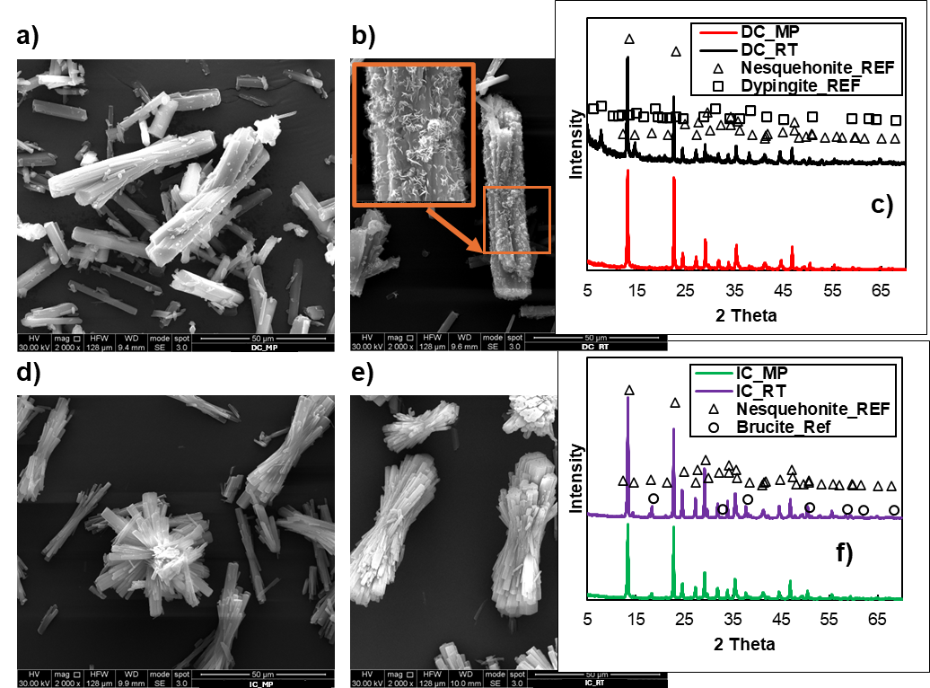

Figure 5 – SEM images of synthesized solids at a magnification of 2000 x: DC\_MP (a), DC\_RT (b), IC\_MP (d) and IC\_RT (e). XRD spectra of DC\_MP and DC\_RT (c) and IC\_MP and IC\_RT (f) samples. Reference spectra of nesquehonite and brucite, Mg(OH)2, were taken from RRUFF™ database (<https://rruff.info/>), while the spectrum of the Dypingite was taken by (Dong et al., 2019).

Rod-like nesquehonite crystals were synthesized in all tests. Crystals were significantly more aggregated in IC cases with respect to DC ones, see Figures 5d and 5e. This may be attributed to the nucleation of nesquehonite crystals from the surface of Mg(OH)2 solids, as also reported by (Cheng et al., 2019). Interestingly, small flakes of dypingite solids with a “house of cards” texture were observed on nesquehonite rods in the DC\_RT test, most likely caused by damages of the surface of the rods due to the Rushton turbine inducing secondary nucleation points. XRD data indicated that pure nesquehonite crystals were produced only in the DC\_MP case, traces of brucite were identified in IC\_RT and IC\_MP tests, while dypingite solids were found in DC\_RT one.

* 1. Conclusion

The present work investigated the direct carbonation process of Mg2+-rich solutions at room temperature and atmospheric pressure. The direct carbonation process of Mg2+ solutions was faster than the indirect carbonation of Mg(OH)2 suspensions. Highly pure rod-like nesquehonite solids were synthesized only in direct tests when adopting a marine propeller. The use of a Rushton turbine affected the crystallization process of nesquehonite solids promoting the local nucleation of dypingite compounds with a “house of cards” texture. Indirect carbonation of commercial Mg(OH)2 powders led to aggregated nesquehonite rods still containing Mg(OH)2 traces even after an ageing time of 40 minutes. Results highlighted the advantages of the direct carbonation process of Mg2+-rich solutions, thus being a promising opportunity for the simultaneous production of highly pure Mg-carbonate species and the reduction of CO2 emission.

Acknowledgements

The Authors would like to thank the European Union and the Horizon 2020 Research and Innovation Framework Programme for funding this research under the project REWAISE grant agreement No. 869496.

References

Battaglia, G., Domina, M. A., Romano, S., Tamburini, A., Cipollina, A., & Micale, G. (2022). Magnesium Hydroxide Nanoparticles Production from Natural Bitterns. *Chemical Engineering Transactions*, *96*, 43–48. https://doi.org/10.3303/CET2296008

Battaglia, G., Ventimiglia, L., Viggiano, F. P. M., Vassallo, F., Cipollina, A., Tamburini, A., & Micale, G. (2023). Mg(OH)2 Recovery from Real Bitterns: a Proof of Concept at Pilot Scale. *Chemical Engineering Transactions*, *105*, 1–6. https://doi.org/10.3303/CET23105001

Botha, A., & Strydom, C. A. (2001). Preparation of a magnesium hydroxy carbonate from magnesium hydroxide. *Hydrometallurgy*, 175–183. www.elsevier.com/locate/hydromet

Cheng, W., Fang, L., Cheng, H., Li, E., Zhang, C., & Cheng, F. (2019). Formation of MgCO 3 ·3H 2 O in the CO 2 mineralization system using Mg(OH) 2 as an intermediate at 20 °C. *Journal of Industrial and Engineering Chemistry*, *76*, 215–222. https://doi.org/10.1016/j.jiec.2019.03.043

Dong, H., Unluer, C., Yang, E. H., Jin, F., & Al-Tabbaa, A. (2019). Microstructure and carbon storage capacity of hydrated magnesium carbonates synthesized from different sources and conditions. *Journal of CO2 Utilization*, *34*, 353–361. https://doi.org/10.1016/j.jcou.2019.07.016

Han, B., Qu, H., Niemi, H., Sha, Z., & Louhi-Kultanen, M. (2014). Mechanistic study of magnesium carbonate semibatch reactive crystallization with magnesium hydroxide and CO2. *Industrial and Engineering Chemistry Research*, *53*(30), 12077–12082. https://doi.org/10.1021/ie501706j

Morgan, B., Wilson, S., Madsen, I. C., Gozukara, Y. M., & Habsuda, J. (2015). Increased thermal stability of nesquehonite (MgCO3·3H2O) in the presence of humidity and CO2: Implications for low-temperature CO2 storage. *International Journal of Greenhouse Gas Control*, *39*, 366–376. https://doi.org/10.1016/j.ijggc.2015.05.033

Singh, I., Hay, R., & Celik, K. (2022). Recovery and direct carbonation of brucite from desalination reject brine for use as a construction material. *Cement and Concrete Research*, *152*. https://doi.org/10.1016/j.cemconres.2021.106673

Sobanaa, M., Prathiviraj, R., Selvin, J., & Prathaban, M. (2024). A comprehensive review on methane’s dual role: effects in climate change and potential as a carbon–neutral energy source. *Environmental Science and Pollution Research*, *31*(7), 10379–10394. https://doi.org/10.1007/s11356-023-30601-w

Wang, W., Hu, M., Zheng, Y., Wang, P., & Ma, C. (2011). CO2 fixation in Ca2+-/Mg2+-rich aqueous solutions through enhanced carbonate precipitation. *Industrial and Engineering Chemistry Research*, *50*(13), 8333–8339. https://doi.org/10.1021/ie1025419

Zhang, D., Li, Y., & Cao, J. (2023). Efficient magnesium recovery from seawater desalination brine via CO2 mineralization to synthesize hydromagnesite for uranium extraction. *Desalination*, *559*. https://doi.org/10.1016/j.desal.2023.116629