 CHEMICAL ENGINEERING TRANSACTIONS  VOL. xxx, 2025 | A publication of  
The Italian Association
of Chemical Engineering
Online at www.cetjournal.it

Guest Editors: Fabrizio Bezzo, Gabriele Pannocchia, Almerinda di Benedetto
Copyright © 2025, AIDIC Servizi S.r.l.
ISBN 979-12-81206-17-5; ISSN 2283-9216

Modulating biochar properties through pyrolysis temperature for different applications
Martina Fazi*, Domenico Rosa, Luca Di Palma
Department of Chemical Engineering Materials Environment, Sapienza-University of Rome, Via Eudossiana 18, 00184 Rome, Italy
martina.fazi@uniroma1.it
Biochar, the solid product of biomass carbonization, is a versatile material that can be used for different applications. This material is a sustainable solution for many environment issues, like food waste treatment, greenhouse gases emission reduction and soil remediation.
In this work, slow pyrolysis was used to produce biochar from agri-food waste at three different temperatures (500, 800 and 900 °C) for 1 hour as residence time. The produced biochars were characterized through SEM and EDS analisys. Point of zero charge (pH_{ZC}) was measured, and the leaching of nutrients and anions from biochars was investigated. Results show that biochar main characteritics strongly depended on the sinthesys temperature: at increasing pyrolysis temperature point of zero charge increased, as well as the leaching of chlorides phosphates and nitrates.
Adsorption tests were then carried out to assess the adsorption properties of biochars synthesized at different temperatures. The biochar produced at 500 °C proved to be the most effective in the removal of organic dyes in water.
According to the results of the characterization study, some applications were proposed for the synthetized biochars.
  - Introduction
Biochar is the solid byproduct of the thermal treatment of biomass. It could be synthesized through torrefaction, gasification or slow and fast pyrolysis. Changing feedstock biomass, synthesis technique and related parameters it is possible to obtain biochars with different features, making it suitable for a wide range of applications. Several properties, like large surface area, high charge density, and steady porous structure, make biochar a promising additive to improve soil (Ghadirnezhad Shiade et al. 2024). Its surface area and porous structure make it also a good low cost adsorbent for both organic and inorganic contaminants (Barquilha and Braga 2021).
Understanding the correlation between the synthesis technique and operating conditions and its physiochemical properties is fundamental in the view of optimizing the production process aiming at tailoring biochar properties for specific applications.
Pyrolysis is one of the most used processes for biochar synthesis: it involves biomass thermal decomposition under oxygen-free conditions, in a wide range of temperature between 300 and 900 °C. The main process parameters include reaction temperature, heating rate and residence time. Pyrolysis processes are classified in slow and fast pyrolysis depending on temperature increasing rate. Slow pyrolysis involves low temperatures and long residence times, whilst in fast pyrolysis high temperatures and low residence times are adopted (Cha et al. 2016).
In this work grape seeds were used to synthesize biochar via slow pyrolysis at three selected temperatures, in order to assess the influence of the pyrolysis temperature on the physicochemical properties of the product. Buffer capacity was evaluated and point of zero charge was measured for the produced biochar, and morphology and elemental composition were investigated, as well as the leaching of anions, potassium and ammonia. Furthermore FTIR spectra were performed and adsorption tests on model compounds (rhodamine B and methylorange) were carried out to obtain additional information on the surface characteristics. Finally, considering the obtained characterization data, some applications are suggested for synthesized biochars.
  - Materials and methods
    - Biochar synthesis
Three samples of biochar were synthesized through slow pyrolysis, starting from agricultural waste. Grape seeds were the chosen feedstock biomass, which were previously pulverized, washed with water and then dried. The obtained powder was pressed in an autoclave to have a lacking oxygen atmosphere, and put in a muffle at three different temperatures (500, 800 and 900 °C) for 1 hour as residence time. The resulting biochars (GS_BC500, GS_BC800, GS_BC900) were finally homogenized using a mortar.
    - Biochar characterization
To evaluate biomass and temperature influence on biochar physicochemical properties, GS_BC500, GS_BC800, GS_BC900 were characterized via various techniques.

2.2.1 Point of zero charge (pH_{ZC})
0.100 g of each biochar were weighed using an analytical balance and added to 10 mL of different solutions at different initial pH values. They were laid in contact without mixing for 120 hours (until equilibrium achievement), and then final pH values were measured using a pHmeter (Crison GLP 421) (Rosa et al. 2024).

2.2.2 Morphology and elemental composition (SEM+EDS)
To describe biochar morphology and composition, a system SEM+EDS (Zeiss Auriga instrument) was used. The samples were set on stainless steel disks, and then analyzed subject to gold-plating; they were coated with ∼20 nm of Au using a Quorum Q150T ES (Quorum Technologies) and then examined at an acceleration voltage of ∼2 keV. Once SEM images were obtained, selected points or areas were studied using EDS, to obtain respective elemental compositions.

2.2.3 Relaesed anions (IC)
0.4 g of each biochar were weighed and added to 40 mL of H₂O; they were then laid there for 29 days without mixing and finally filtered to separate the liquid phase. Three solutions were thus obtained: 5 mL of each solution were collected using a syringe, and then injected into an Ionic Cromatograph (Dionex ICS-1100, Thermo Fisher Scientific). The release of fluorides, chlorides, nitrates, phosphates and sulfates was measured.

2.2.4 Hydrosoluble potassium (ICP-OES)
The three solutions, prepared as described above, were diluted with H₂O considering a 1:100 ratio, and then analyzed using an Inductively Coupled Plasma-Optical Emission Spectrometer (PerkinElmer Avio 220) to determine potassium released from each biochar.

2.2.5 Released ammonia (Nessler method)
Nessler reactive was used to evaluate ammonia amount released from biochar: when it is added to a solution, it becomes yellow proportionally to ammonia amount; employing a UV-visible spectrophotometer it is possible to devise a calibration line, that correlates sample absorbance with ammonia concentration. To reduce interferences due to Ca, Mg and chlorides some reagents were used. Considering 100 mL of each of the three solutions, 0.2 mL of a 0.014 M solution of Na₂S₂O₃⋅5H₂O were added, to remove each mg/L of Cl⁻ (doses for each sample are based on chlorides release). To remove suspended and colored particles 1.0 mL of a 0.348 M solution of ZnSO₄⋅7H₂O and ≈0.5 mL of NaOH (up to pH=10) were added to the samples; waiting few hours it was possible to separate a limpid supernatant from a precipitate, through filtration. Considering 50 mL of filtrate, two drops of an EDTA solution were added; 100 mL of this solution were prepared solubilizing 50 g of EDTA disodium salt in 60 mL of H₂O with 10 g of NaOH, and then leading to a volume of 100 mL. Then, 2.0 mL of Nessler reactive were added to the samples; after 15 minutes, samples were analyzed using a UV-visible spectrophotometer (PG Instruments T8o + UV/Vis spectrophotometer) collecting absorbances at 420 nm.

2.2.6 FTIR spectra
To appreciate biochars functional groups, Fourier Transformed Infrared spectrometer (Shimadzu FTIR-8400S) was used. GS_BC500 was analyzed as prepared, instead of GS_BC800 and GS_BC900, which were mixed with KBr, due to their high IR absorption. Measures were collected in transmittance over the range 4000-400 cm⁻¹ using a resolution of 4 cm⁻¹, 8 scans per spectrum.

2.2.7 Adsorption test
GS_BC500, GS_BC800 and GS_BC900 were tested as adsorbent materials, carrying out batch tests with rhodamine B and methyl orange as model organic contaminants. 20 mg of biochar were added to 20 mL of 5 mg/L dye solution; they were mixed for 48 hours using a magnetic stirrer at 300 rpm, therefore equilibrium was reached. At the end, samples were filtered through syringe filters with pores of 0.45 μm, using a vacuum pump and analyzed using the UV-visible spectrophotometer, collecting the absorbance respectively at 553 nm and 464 nm for rhodamine B and methyl orange.
  - Results and discussion
In the following sections results are reported: the dependence on temperature of the main biochar characteristics is discussed, in order to assess the optimal operating condition for different application of the product.
    - Point of zero charge (pH_{ZC})
In Figure 1a pH_{ZC} values for GS_BC500, GS_BC800 and GS_BC900 are reported, as the intersection points of the pH values of the solutions after contact with the produced biochars. pH_{ZC} was found to increase at increasing pyrolysis temperature. Since biochar pH_{ZC} depend on the amount of organic functional groups, soluble organic compounds and ash content, its increase at increasing temperature can be attributed to the increase of ash content (Xie et al. 2022) and the corresponding decrease of acidic functional groups (e.g. COOH, OH) (Cha et al. 2016).
Figure 1a also shows that GS_BC500, GS_BC800 and GS_BC900 had a high buffering power: both starting from acidic or neutral pH values, pH_{ZC} is always attained.
d
c
200 μm
200 μm
200 μm
b
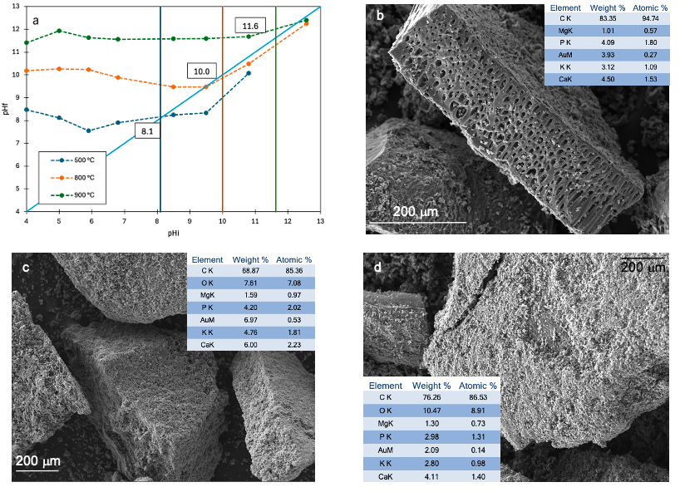
200 μm
Figure 1: point of zero charge varying pyrolysis temperature (a) and SEM images of GS_BC500 (b), GS_BC800 (c) and GS_BC900 (d) coupled with related EDS.

    - SEM and EDS
In Figure 1(b,c,d) SEM images of biochar samples are reported. The same granular structure of the feedstock biomass was observed for each biochar; a porous structure was generally observed, as shown in Figure 1. EDS spectra are also reported: in all three samples carbon, calcium, magnesium, phosphorus and potassium are revealed, while oxygen was only found GS_BC800 and GS_BC900. In all samples the presence of gold is due to the gold-plating preliminary process.
    - FTIR spectra
In Figure 2b grape seeds biochars functional groups were reported on FTIR spectra, peaks were assigned considering the following table (Table 2).
Table 2: FTIR signals
Functionality | wavenumber (cm⁻¹) | Reference
O-H stretching | 3500-3200 | (Granados et al. 2022)
N-H stretching | 3400-3300 | (Nandiyanto et al. 2019)
aliphatic C-H stretching | ∼2930 | (Granados et al. 2022)
C≡N stretching | 2300-2000 | (Leng et al. 2020)
conjugated ketones C=O stretching | ∼1600 | (Janu et al. 2021)
aromatic domains C=C stretching | ∼1400 | (Wu et al. 2012)
C-N stretching | 1300-110 | (Leng et al. 2020)
cellulose, hemicellulose and lignin C-O stretching | ∼1026 | (Liu et al. 2015)
N-H wagging | 900-660 | (Textmap)

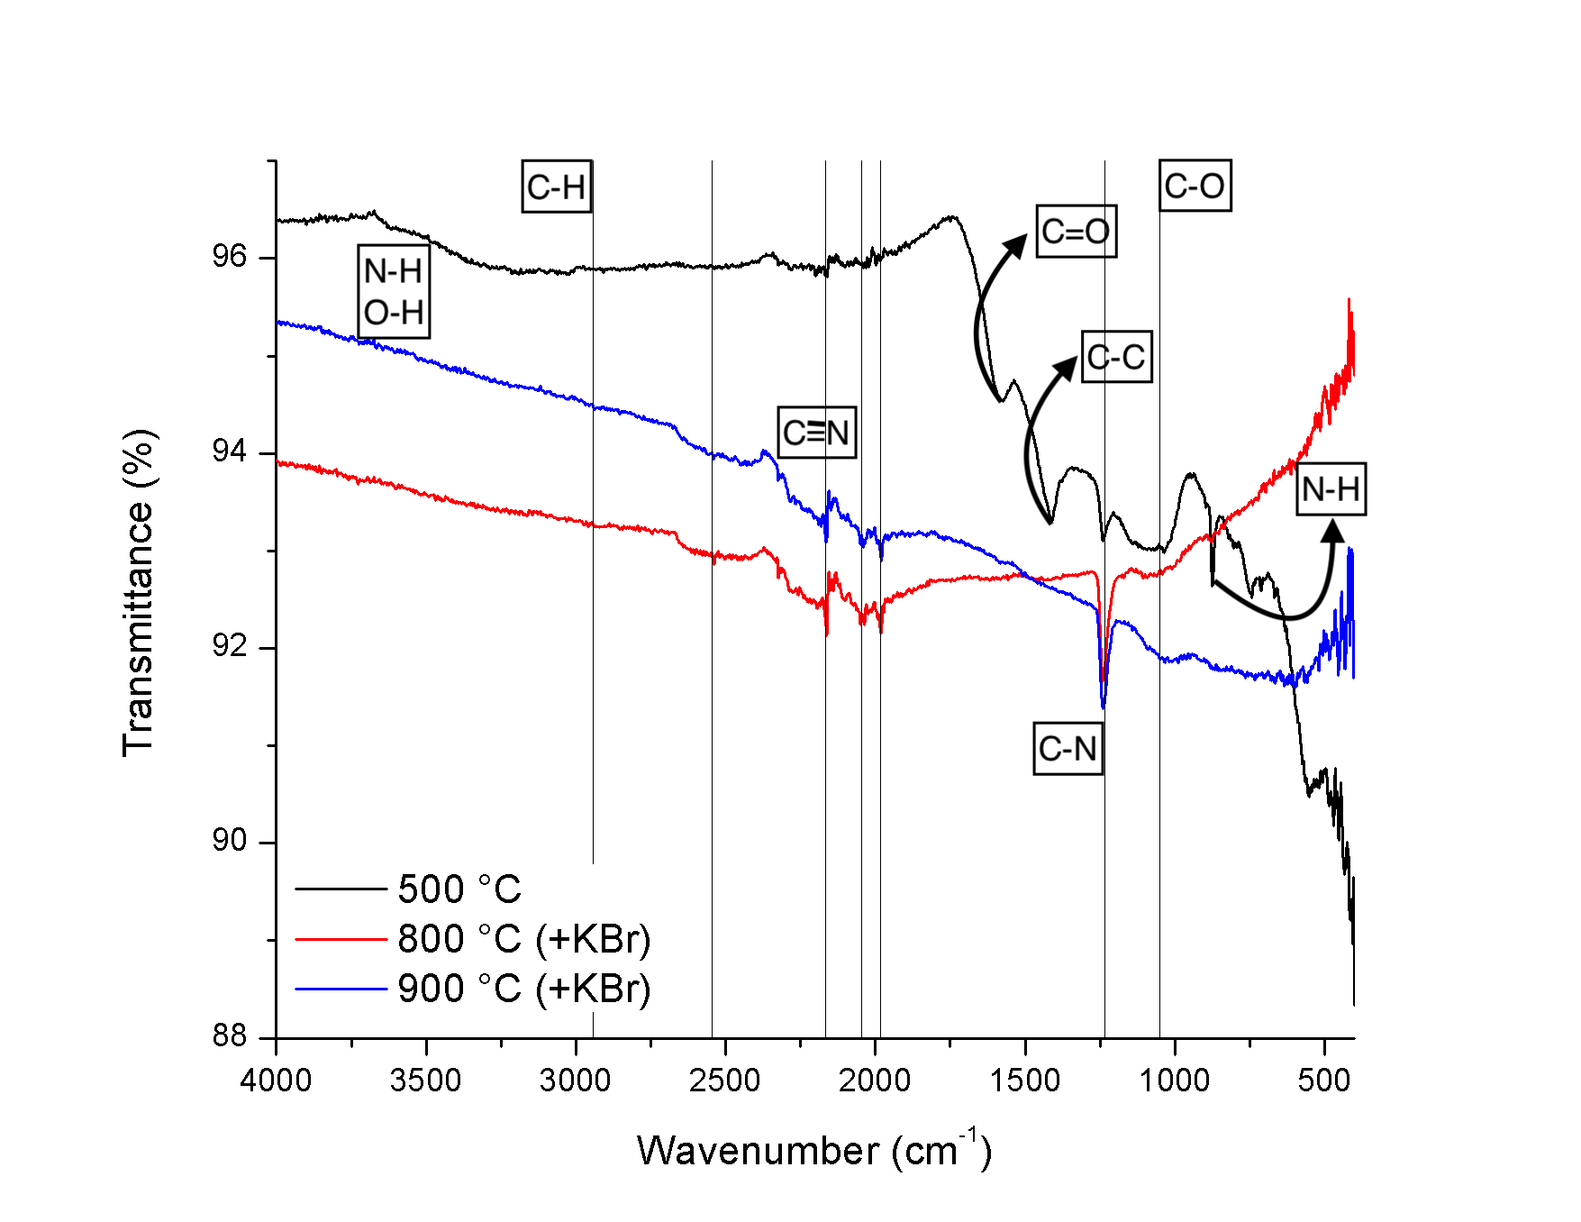
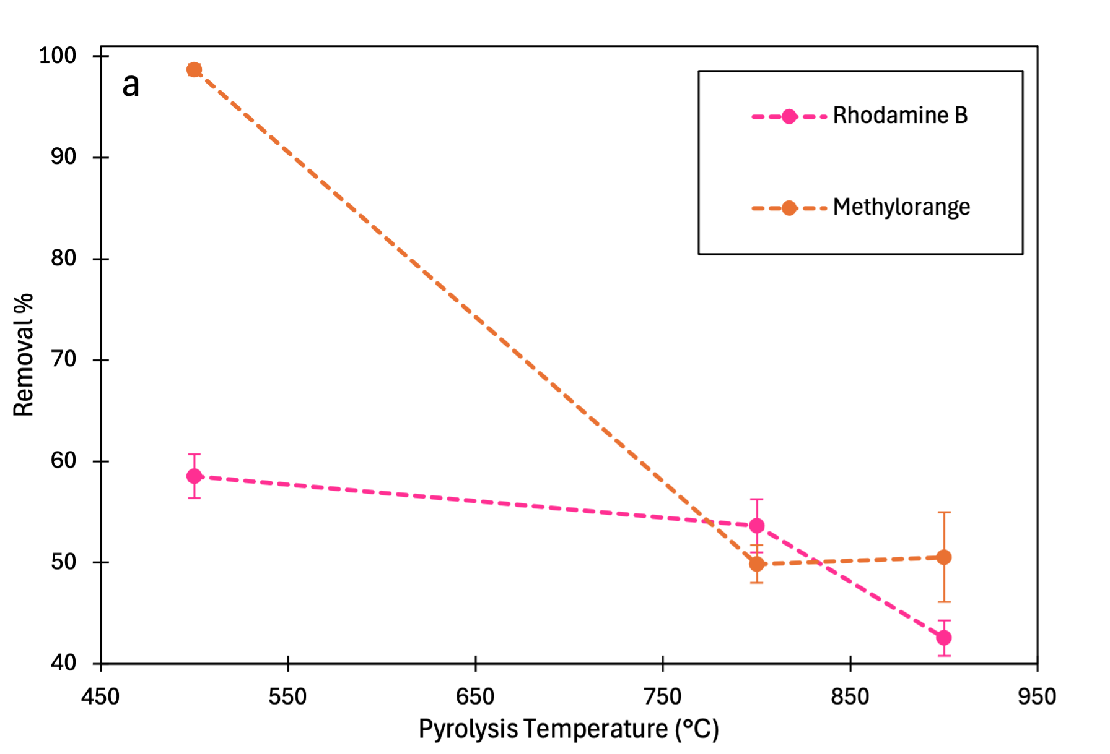
GS_BC500 revealed the higher contents in nitrogen and oxygen functional groups. Increasing pyrolysis temperature, biochar lost its functional groups as a result of the graphitization process (Liu et al. 2015), thus becoming more similar to the typical structure of an activated carbon. As regards to N, it changed its chemical nature at increasing temperature, due to the formation of double bonds that involve nitrogen, revealing signals around 2300 cm⁻¹.
b
Figure 2: Adsorption tests results (a) and FTIR spectra (b) related to GD_BC500, GS_BC800 and GS_BC900.

    - Ions leaching
In Table 1 GS_BC500, GS_BC800 and GS_BC900 leaching results are reported. An increasing leaching trend at increasing pyrolysis temperature was observed, for sulfates and fluorides. As expected, a remarkable leaching of ammonia from GS_BC900 was observed (about ten times higher than from the other produced biochars), since ammonia release is generally related to sulfur release (Amin et al. 2016).
Conversely, potassium leaching decreased at increasing pyrolysis temperature for all the tested biochars, according to literature (Bilias et al. 2023).
A decreasing leaching trend at increasing pyrolysis temperature was observed for phosphates, according to literature (Hollister et al. 2013).
Table 1: Release data (expressed in mg of substance per g of biochar) considering a time interval of 29 days.
Sample | Fluorides | Nitrates | Phospates | Sulfates | Ammonia | Potassium
GS_BC500 | <LOD | 1.78 | 4.36 | 0.41 | 0.003 | 9.07
GS_BC800 | <LOD | <LOD | 4.00 | 0.57 | 0.005 | 8.69
GS_BC900 | 0.02 | 222.20 | 0.25 | 1.10 | 0.042 | 4.46

To summarize previous data, GS_BC500 released the highest amounts of phosphorus and potassium, and the lowest amounts of sulfates and ammonia. K,P leaching decreased and ammonia leaching increased at increasing pyrolysis temperature especially between 800 and 900 °C. GS_BC900 released also the highest amounts of chlorides and nitrates.

    - Adsorption tests
In Figure 2a adsorption of the two model organic contaminants are reported. It was evident that, for both dyes, biochar GS_BC500 resulted the best adsorbent material. According to the mechanism proposed in literature, (Barquilha and Braga 2021) adsorption on biochar of charged organic molecules is driven by electrostatic interactions, hydrogen bonds, π-π stacking and pore filling. Therefore, biochar surface charges and functional groups are the most important parameter for the adsorption of investigated charged dyes (Phuong et al. 2019). According to the FTIR spectra, it was supposed that GS_BC500 surface dealt with functional groups (e.g. OH, C=O or amino-groups), that effectively could interact with dyes. Generally, biochar is more effective in cationic dyes adsorption, but from the results showed in Figure 3a, methylorange adsorption proved to be higher than rhodamine B adsorption. This behavior could reveal a higher concentration of positively (e.g. amino-groups) ionizable functional groups than negatively ones (e.g oxygen functional groups). Such groups could also contribute to rhodamine B adsorption, because of its amphoteric nature. Moreover, the carboxylic groups, characterized by a pKa∼4, also allowed electrostatic interactions between dye and GS_BC500. However, these interactions could be hindered by electrostatic repulsion of positive charge, thus explaining how a lower removal was observed for rhodamine B. Increasing pyrolysis temperature the amount of these ionizable functional groups decreased and they were replaced by graphitic domains and insaturations involving nitrogen: such new structures can interact with aromatic dyes through π-interactions, thus changing the adsorption mechanism, now based on π-π stacking (Tcheka et al. 2024).
However, these interactions are less efficient than the previous ones, occurring at lower pyrolysis temperature, and, as a consequence, a lower removal was observed for both investigated dyes at increasing pyrolysis temperature.
  - Conclusions
The results of this characterization study demonstrated that biochars with distinct physicochemical properties can be obtained from the same feedstock and synthesis method by simply varying the pyrolysis temperature.
Results show that biochar pyrolyzed at lowest temperature was the richest in oxygen and nitrogen functional groups and released also the highest amounts of potassium and phosphorus, well known as macronutrients for plants, thus suggesting its use as fertilizer. It was also the best biochar for ionizable organic dyes adsorption.
Increasing pyrolysis temperature up to 800 °C, phosphorus and potassium releases decreased, suggesting GS_BC800 use as fertilizer, especially in acidic soils thanks to its alkaline pH_{ZC}. Over 800 °C, nutrients leaching decresed a lot, making difficult GS_BC900 use as fertilizer. Considering their aromaticity GS_BC800 and GS_BC900 could be also used to adsorb not-charged aromatic organic contaminants.
Nomenclature
GS_BC500 - grape seeds biochar pyrolyzed at 500 °C
GS_BC800 - grape seeds biochar pyrolyzed at 800 °C
GS_BC900 - grape seeds biochar pyrolyzed at 900 °C
References
Amin, F.R., Huang, Y., He, Y., Zhang, R., Liu, G. and Chen, C. 2016. Biochar applications and modern techniques for characterization. Clean Technologies and Environmental Policy 18(5), pp. 1457–1473. doi: 10.1007/s10098-016-1218-8.
Barquilha, C.E.R. and Braga, M.C.B. 2021. Adsorption of organic and inorganic pollutants onto biochars: Challenges, operating conditions, and mechanisms. Bioresource Technology Reports 15. doi: 10.1016/j.biteb.2021.100728.
Bilias, F., Kalderis, D., Richardson, C., Barbayiannis, N. and Gasparatos, D. 2023. Biochar application as a soil potassium management strategy: A review. Science of the Total Environment 858. doi: 10.1016/j.scitotenv.2022.159782.
Cha, J.S., Park, S.H., Jung, S.C., Ryu, C., Jeon, J.K., Shin, M.C. and Park, Y.K. 2016. Production and utilization of biochar: A review. Journal of Industrial and Engineering Chemistry 40, pp. 1–15. doi: 10.1016/j.jiec.2016.06.002.
Ghadirnezhad Shiade, S.R., Fathi, A., Minkina, T., Wong, M.H. and Rajput, V.D. 2024. Biochar application in agroecosystems: a review of potential benefits and limitations. Environment, Development and Sustainability 26(8), pp. 19231–19255. doi: 10.1007/s10668-023-03470-z.
Granados, P., Mireles, S., Pereira, E., Cheng, C.L. and Kang, J.J. 2022. Effects of Biochar Production Methods and Biomass Types on Lead Removal from Aqueous Solution. Applied Sciences (Switzerland) 12(10). doi: 10.3390/app12105040.
Hollister, C.C., Bisogni, J.J. and Lehmann, J. 2013. Ammonium, Nitrate, and Phosphate Sorption to and Solute Leaching from Biochars Prepared from Corn Stover ( Zea mays L.) and Oak Wood ( Quercus spp.) . Journal of Environmental Quality 42(1), pp. 137–144. doi: 10.2134/jeq2012.0033.
Janu, R., Mrlik, V., Ribitsch, D., Hofman, J., Sedláček, P., Bielská, L. and Soja, G. 2021. Biochar surface functional groups as affected by biomass feedstock, biochar composition and pyrolysis temperature. Carbon Resources Conversion 4, pp. 36–46. doi: 10.1016/j.crcon.2021.01.003.
Leng, L. et al. 2020. Nitrogen containing functional groups of biochar: An overview. Bioresource Technology 298. doi: 10.1016/j.biortech.2019.122286.
Liu, Y., He, Z. and Uchimiya, M. 2015. Comparison of Biochar Formation from Various Agricultural By-Products Using FTIR Spectroscopy. Modern Applied Science 9(4). doi: 10.5539/mas.v9n4p246.
Nandiyanto, A.B.D., Oktiani, R. and Ragadhita, R. 2019. How to read and interpret ftir spectroscope of organic material. Indonesian Journal of Science and Technology 4(1), pp. 97–118. doi: 10.17509/ijost.v4i1.15806.
Phuong, D.T.M., Loc, N.X. and Miyanishi, T. 2019. Efficiency of dye adsorption by biochars produced from residues of two rice varieties, Japanese Koshihikari and Vietnamese IR50404. Desalination and Water Treatment 165, pp. 333–351. doi: 10.5004/dwt.2019.24496.
Rosa, D., Petruccelli, V., Iacobbi, M.C., Brasili, E., Badiali, C., Pasqua, G. and Di Palma, L. 2024. Functionalized biochar from waste as a slow-release nutrient source: Application on tomato plants. Heliyon 10(8). doi: 10.1016/j.heliyon.2024.e29455.
Tcheka, C., Conradie, M.M., Assinale, V.A. and Conradie, J. 2024. Mesoporous biochar derived from Egyptian doum palm (Hyphaene thebaica) shells as low-cost and biodegradable adsorbent for the removal of methyl orange dye: Characterization, kinetic and adsorption mechanism. Chemical Physics Impact 8. doi: 10.1016/j.chphi.2023.100446.
Textmap, W. [no date]. ORGANIC CHEMISTRY. Available at: https://LibreTexts.org.
Wu, W., Yang, M., Feng, Q., McGrouther, K., Wang, H., Lu, H. and Chen, Y. 2012. Chemical characterization of rice straw-derived biochar for soil amendment. Biomass and Bioenergy 47, pp. 268–276. doi: 10.1016/j.biombioe.2012.09.034.
Xie, Y. et al. 2022. A critical review on production, modification and utilization of biochar. Journal of Analytical and Applied Pyrolysis 161. doi: 10.1016/j.jaap.2021.105405.

