 CHEMICAL ENGINEERING TRANSACTIONS  VOL. xxx, 2025 | A publication of  
The Italian Association
of Chemical Engineering
Online at www.cetjournal.it

Guest Editors: Fabrizio Bezzo, Flavio Manenti, Gabriele Pannocchia, Almerinda di Benedetto
Copyright © 2025, AIDIC Servizi S.r.l.
ISBN 979-12-81206-17-5; ISSN 2283-9216

Deformable nanovesicles produced by using a supercritical technology for enhanced transdermal drug delivery
Sonia Sarnelli, Ernesto Reverchon, Lucia Baldino*
Department of Industrial Engineering, University of Salerno, Via Giovanni Paolo II, 132, 84084, Fisciano (SA), Italy
lbaldino@unisa.it
Transfersomes are promising nanocarriers for transdermal drug delivery since they are ultra-deformable liposomes constituted of phospholipids and surfactants; these latter compounds work as edge activators, allowing the deformation of the vesicle. In this work, transfersomes were produced by using SuperSomes, an innovative and continuous process assisted by supercritical carbon dioxide (SC-CO₂). Different amounts of phosphatidylcholine (PC) (i.e., 500, 1000, and 2000 mg) were tested; whereas, phosphatidylcholine/Span 80 weight ratio was maintained constant at 80:20 value. SuperSomes operating conditions were fixed at 100 bar and 40 °C. Transfersomes with nanometric size and unimodal size distribution were obtained without post-processing operations (i.e., solvent removal or filtration), which are mandatory steps for conventional production methods. The optimized formulation resulted in transfersomes of about 180 nm mean diameter, with a low polydispersity index (equal to 0.304) and a -21.00 mV Zeta-potential. Diclofenac sodium (DF) was then loaded into these transfersomes with an encapsulation efficiency of 74%; drug release tests showed a prolonged release of DF up to about four times than drug alone.
  - Introduction
Transdermal drug delivery (TDD) is proposed as a promising alternative to conventional oral drug administration, to avoid problems related to the first-pass metabolism and the clearance of drugs by the liver (Matharoo et al., 2024). TDD systems could enable direct adsorption of drugs through the skin into the bloodstream, allowing controlled drug release and minimizing side effects (Ghaferi et al., 2024).
Liposomes and niosomes can be used as delivery systems for both hydrophilic and lipophilic drugs, since they are composed of a lipid bilayer that mimics the cellular membrane structure (de A.C. Kodel et al., 2024). However, their transdermal application is hindered by the difficulty to penetrate the stratum corneum (i.e., the outermost layer of the skin) due to their rigid structure (Elron-Gross et al., 2009).
To address this challenge, deformable liposomes, named “transfersomes”, have been developed. The introduction of edge activators, typically surfactants like Tween 80 or Span 80, in the lipid bilayer composed of phosphatidylcholine, leads to the formation of largely deformable vesicles with respect to liposomes (Patel et al., 2024). This fact makes transfersomes promising candidates for transdermal drug delivery, capable of penetrating through tight intercellular spaces of the skin barrier (Prausnitz and Langer, 2008).
Several non-steroidal anti-inflammatory drugs (NSAIDs) are administered transdermally to obtain a local action, offering an alternative to traditional oral and parental administration (Li et al., 2007; Li et al., 2012). In this way, drugs can be delivered to the action site, minimizing the common side effects: i.e., gastrointestinal irritation or kidney damage. Diclofenac sodium (DF) is an anti-inflammatory drug widely used for the treatment of inflammatory and degenerative rheumatic conditions, post-traumatic painful states and inflammation (Devi et al., 2007). However, its skin permeation is limited by its poor water solubility (>1 %) and the fast clearance (Cevc and Blume, 2001). Transfersomes have been proposed by some authors (Wadher et al., 2024; Nagaich et al., 2024): more specifically, Ghanbarzadeh and Arami (2013) produced transfersomes loaded with diclofenac by rotary evaporation, using Span 80 as surfactant. The lipidic phase composed of phospholipids, surfactant and cholesterol was dissolved in a chloroform-methanol mixture with a volume ratio of 3:1. The organic solvent was removed from the lipidic solution by using rotary evaporation at 45 °C and reduced pressure. The thin film was, then, hydrated for 1 h with an aqueous solution containing the drug. The resulted transfersomes were characterized by a mean size of 426 ± 33 nm, drastically reduced to 145 ± 7 nm after several extrusion steps. The encapsulation efficiency of diclofenac loaded into transfersomes was equal to about 47%. Sultana and Krishana Sailaja (2015) prepared diclofenac sodium loaded transfersomes by thin film hydration, testing three different surfactants (i.e., Span 20, Span 60, and Span 80) as edge activators. The thin film was formed after rotary evaporation at 25 °C and 600 mmHg of pressure, using a mixture of chloroform and ethanol for the organic phase. The best formulation was obtained using soya lecithin and Span 60 with a 2:1 mass ratio, resulting in the production of vesicles with a mean size of 257 nm, a Zeta-potential of -25 mV and a drug encapsulation efficiency equal to 62%.
The analysis of the scientific literature shows that conventional methods used for transfersomes production suffer from several limitations, resulting in the production of micrometric vesicles, with low drug encapsulation efficiency and high solvent residue. Indeed, post-processing operations like extrusion and/or solvent removal were necessary to obtain nanometric vesicles with low toxicity.
An innovative and continuous process assisted by supercritical carbon dioxide (SC-CO₂), named SuperSomes, can be used to overcome these limitations (Baldino and Reverchon, 2022). This process takes advantage of using SC-CO₂ allowing the production of stable vesicles with nanometric size, unimodal size distribution, high drug encapsulation efficiency and low solvent residue (Trucillo et al., 2020).
In this work, SuperSomes was used to produce transfersomes, selecting phosphatidylcholine as phospholipid and Span 80 as edge activator (Squittieri et al., 2023). Transfersomes with an increasing amount of phosphatidylcholine (i.e., from 500 to 2000 mg) were produced to identify the best formulation to obtain stable transferosomes. Phosphatidylcholine to Span 80 weight ratio was set at 80:20, since this value allows to the production of nanometric and stable transfersomes, as reported in a previous work (Squittieri et al., 2023). The best formulation obtained for the production of empty transfersomes was, then, tested to encapsulate diclofenac sodium; analyses of drug encapsulation efficiency and drug release were carried out to understand how the encapsulation of DF affected its kinetic release.
  - Materials and Methods
    - Materials
L-α-phosphatidylcholine from egg yolk (PC, purity ≥99%), Span 80 (M_{w}= 428.60 g/mol), diclofenac sodium (DF, M_{w}= 318.13 g/mol) were purchased from Sigma Aldrich (Milan, Italy). Ethanol (anhydrous, purity ≥99%) was purchased from Carlo Erba Reagents (Cornaredo (MI), Italy). Carbon dioxide (CO₂, purity ˃99.4%) was purchased from Morlando Group Srl (Naples, Italy).
    - Transfersome formulation
A 100 mL volume of ethanolic solution containing phosphatidylcholine and Span 80 at different amounts of phosphatidylcholine (ranging from 500 to 2000 mg) was prepared by magnetic stirring at 250 rpm for 1 h and at room temperature. For all the experiments, phosphatidylcholine to Span 80 weight ratio was fixed at 80:20. The aqueous solution was obtained by dissolving 10 mg of diclofenac in 200 mL of water at a concentration of 0.05 mg/mL; this solution was stirred at 250 rpm for 1 h at room temperature.
    - SuperSomes plant description
SuperSomes is a high-pressure plant mainly composed of a static mixer (with an internal volume of 150 cm³), filled with stainless-steel packings and a formation chamber (with an internal volume of 500 cm³), both operating at 40 °C and 100 bar. Supercritical carbon dioxide and the ethanolic solution are pumped into the static mixer by using an Ecoflow® pump (mod. LDC-M-2 Lewa, Leonberg, Germany) and a Gilson pump (mod. 305, Villiers Le Bel, France), respectively. Their interaction promotes the formation of a gas-expanded liquid, which is, then, transferred through a capillary tube inside the formation chamber. The aqueous solution is pumped into the formation chamber by a Gilson pump (mod. 305, Villiers Le Bel, France) and atomized through a nozzle with an internal diameter of 80 µm. At the end of the process, the ethanol-CO₂ mixture is recovered by a separator, operating at 25 °C and 10 bar; transfersomes suspension is instead collected in a reservoir located downstream of the formation chamber and recovered by an on/off valve. Temperature is controlled by using a J-type thermocouple and regulated with PID controllers; whereas pressure is measured by using a pressure gauge. Further details about SuperSomes plant and the mechanism of transfersomes formation can be found in previous works (Baldino and Reverchon, 2022).
    - Characterization techniques
The mean hydrodynamic diameter (MHD), polydispersity index (PDI) and Zeta-potential values of transfersomes were measured by using a dynamic light scattering (DLS, mod. Zetasizer Nano S). All measurements were performed in triplicate and at different intervals of time (i.e., 15 and 30 days after the production) to study the stability of nanovesicles over time. The morphology of transfersomes was observed by a field emission scanning electron microscope (FE-SEM, Carl Zeiss, mod. Supra 35). To perform this analysis, samples were coated with gold, using a sputter coater (mod. 108 A, Agar Auto Sputter Coater) at 40 mA for 180 s. Diclofenac sodium encapsulation efficiency (EE%) was determined by using an indirect method: samples were centrifuged (centrifuge mod. IEC CL30R Thermo Scientific) at 6500 rpm for 30 min at 4 °C using Amicon® Ultra-15 with a cut-off of 30 kDa, and the absorbance of diclofenac into the supernatant was read at λ= 275 nm by using an UV-Vis spectrophotometer (mod. Cary 60 UV-Vis, Agilent Technologies). In vitro release tests were performed by introducing 5 mL of pellet into a dialysis bag with a cut-off of 14,000 Da (Merck, Darmstadt, Germany) previously activated with ethylenediaminetetraacetic acid (EDTA). The bag was, then, immersed in 80 mL of phosphate buffer saline (pH 7.4), used as release medium, and the temperature was fixed at 37 °C. The release of diclofenac from transfersomes was monitored by measuring its absorbance in the liquid medium over time (Bucci et al., 1998). Deformability tests were also performed using a perfuser (mod. NE-300, Just Infusion). In particular, the transfersomal suspension was forced through a filter with a diameter of 100 nm and the deformability parameter (P_{def}) was measured using Eq (1), where: d_{in} is the MHD of transfersomes before the deformation; d_{f} is the MHD of transfersomes after the deformation.
P_{def} = {1 – [(d_{in} – d_{f})/d_{in})]} x 100 (1)
  - Results and Discussion
All the experiments were carried out using the same parameters optimized in previous works (Baldino and Reverchon, 2023): i.e., pressure 100 bar, temperature 40 °C, aqueous solution flow rate 7 mL/min, ethanolic solution flow rate 3.5 mL/min, and CO₂ flow rate 6.5 g/min.
    - Production of empty transfersomes
The first set of experiments was performed to study the influence of different amounts of phosphatidylcholine (i.e., 500, 1000, and 2000 mg) on the vesicle size, Zeta-potential and stability of empty transfersomes. For all the experiments, the phosphatidylcholine to Span 80 weight ratio was set at 80:20. The results obtained by DLS analysis and expressed in terms of MHD, PDI and Zeta-potential, are summarized in Table 1.
Table 1: DLS results related to empty transfersomes produced at different amount of phosphatidylcholine
Sample | PC, mg | MHD, nm | PDI | Ζ-potential, mV
T1 | 500 | 154 ± 61 | Bimodal | -13.00 ± 4.11
T2 | 1000 | 183 ± 100 | 0.304 | -21.00 ± 6.03
T3 | 2000 | 172 ± 112 | 0.424 | -9.80 ± 7.51
Figure 1b shows that the formulation prepared using an amount of phosphatidylcholine equal to 1000 mg allowed the formation of transfersomes with nanometric size and unimodal size distribution. Transfersomes produced with a PC concentration of 5 mg/mL were characterized by a slightly bimodal size distribution (Figure 1a), probably due to an insufficient amount of PC to form the double layer, resulting in the formation of self-assembled micelles of about 42 nm. Transfersomes with nanometric size and unimodal size distributions were also obtained using an amount of PC equal to 2000 mg (Figure 1c); but they showed a large polydispersity index (0.424). In addition, the absolute value of T3 Zeta-potential was the lowest one (-9.80 ± 7.51 mV) compared with the values obtained for the other formulations (i.e., T1 and T2) and this result suggested less stable nanovesicles over time. Therefore, T2 was selected as the best formulation of empty transfersomes with a longer stability over time, as confirmed by the higher absolute value of Zeta-potential (-21.00 ± 6.03 mV).
(a) (b) (c)
Figure 1: Particle size distribution of empty transfersomes produced at different PC concentration values: (a) 5 mg/mL, (b) 10 mg/mL, (c) 20 mg/mL
    - Production of diclofenac-loaded transfersomes
The best formulation obtained using 1000 mg of PC was, then, tested to encapsulate diclofenac with a drug-to-lipid ratio (DLR) of 1% on a mass basis. Diclofenac-loaded transfersomes were characterized by a unimodal size distribution (Figure 2) with a mean diameter of 208 ± 98 nm, a PDI equal to 0.191 and a Zeta-potential of -15.40 ± 3.60 mV. The mean hydrodynamic diameter of loaded transferosomes was slightly larger than the one obtained for empty transfersomes, because of the presence of the drug in the internal core of nanovesicles. Diclofenac encapsulation efficiency was measured as reported in section 2.4, yielding a value of 74%; whereas the deformability parameter was equal to 74%, confirming the deformation properties of loaded transferosomes.

Figure 2: Particle size distribution of diclofenac-loaded transfersomes produced by SuperSomes at a drug-to-lipid ratio of 1% (w/w)
The morphology of transfersomes was observed by FE-SEM for empty and drug-loaded nanovesicles. In both cases, spherical vesicles were produced (Figure 3a-b), indicating that the encapsulation process did not significantly modify their morphology. Moreover, vesicles showed a nanometric size, in agreement with the results obtained by DLS analysis.
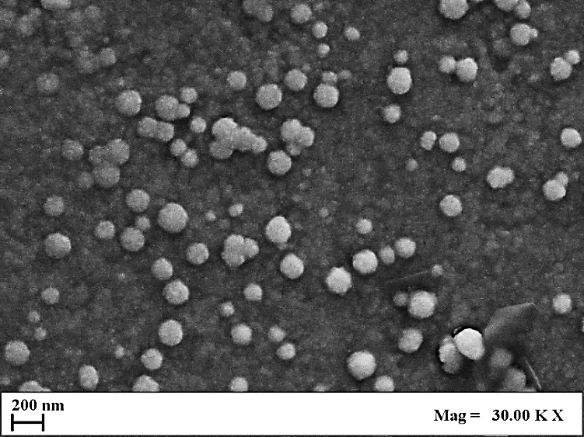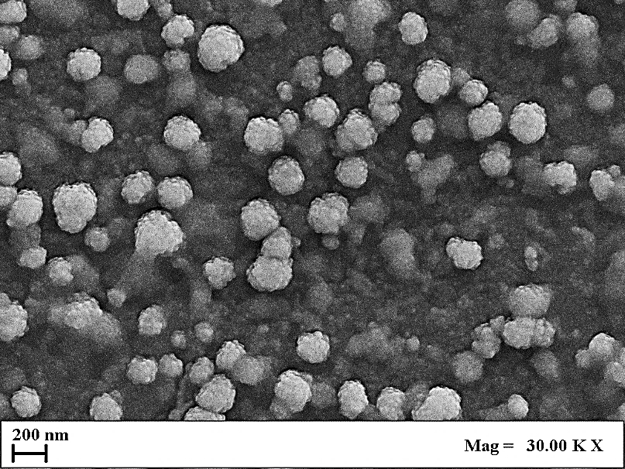
(a) (b)
Figure 2: FE-SEM images of empty transfersomes (a) and diclofenac-loaded transfersomes (b)
    - Drug release tests
Figure 3 shows release profiles of diclofenac powder and diclofenac-loaded transfersomes, expressed in terms of drug concentration (C_{t}/C_{eq}) against time (min). In particular, C_{t} is the drug concentration measured at a specific time; C_{eq} is the maximum drug concentration released.

Figure 3: Diclofenac release profiles for diclofenac powder and diclofenac-loaded into transfersomes. Lines highlight the general drug release profile.
These results show that the diclofenac powder was dissolved in the PBS release medium in about 1 day; whereas, diclofenac loaded into transfersomes was released in about 4 days. This result underlines that diclofenac encapsulated into transfersomes was released slowly compared with the drug alone, since the deformable bilayer of nanovesicles acted as a barrier, prolonging the release time of the drug and protecting it from fast degradation. Therefore, the encapsulation of diclofenac within transfersomes can improve drug bioavailability, ensuring its stability for a longer period and reducing the frequency of drug administration.
  - Conclusions
This work showed that transfersomes produced by SuperSomes process were characterized by a nanometric diameter and a unimodal size distribution, without using post-processing operations. FE-SEM analysis confirmed the spherical and regular morphology of these nanovesicles. An encapsulation efficiency of 74% was obtained when diclofenac sodium was entrapped into the optimized formulation of transfersomes.
Drug release tests also underlined that a slower release kinetic can be obtained after the encapsulation of diclofenac into nanometric transfersomes; whereas deformability tests confirmed the efficiency of SuperSomes process.
Acknowledgments
Sonia Sarnelli: Writing – review & editing, Writing – original draft, Investigation, Formal analysis. Ernesto Reverchon: Writing – review & editing, Visualization, Supervision, Resources. Lucia Baldino: Writing – review & editing, Writing – original draft, Visualization, Validation, Supervision, Methodology, Conceptualization.
References
Baldino, L., Reverchon, E., 2022, Continuous supercritical CO₂ assisted process for the production of nano-niosomes loaded with a second-generation antibiotic for ocular therapy, The Journal of Supercritical Fluids, 188, 105673.
Baldino, L., Reverchon, E., 2023, Production of nanoliposomes by a supercritical CO₂ assisted process: Application to cosmetics, Chemical Engineering Transactions, 101, 61-66.
Bucci, R., Magri, A.D., Magri, A.L., 1998, Determination of diclofenac salts in pharmaceutical formulations, Fresenius' Journal of Analytical Chemistry, 362, 577-582.
Cevc, G., Blume, G., 2001, New, highly efficient formulation of diclofenac for the topical, transdermal administration in ultradeformable drug carriers, Transfersomes. Biochimica et Biophysica Acta (BBA)-Biomembranes, 1514, 191-205.
de A.C. Kodel, H., Alizadeh, P., Ebrahimi, S.N., Machado, T.O., Oliveira, M.B.P., Fathi, F., Souto, E.B., 2024, Liposomes and niosomes: New trends and applications in the delivery of bioactive agents for cancer therapy, International Journal of Pharmaceutics, 124994.
Devi, R.S., Narayan, S., Vani, G., Devi, C.S.S., 2007, Gastroprotective effect of terminalia arjuna bark on diclofenac sodium induced gastric ulcer, Chemico-Biological Interactions, 167, 71-83.
Elron-Gross, I., Glucksam, Y., Margalit, R., 2009, Liposomal dexamethasone–diclofenac combinations for local osteoarthritis treatment, International Journal of Pharmaceutics, 376, 84-91.
Ghaferi, M., Alavi, S.E., Phan, K., Maibach, H., Mohammed, Y., 2024, Transdermal drug delivery systems (TDDS): Recent advances and failure modes, Molecular Pharmaceutics, 21, 5373-5391.
Ghanbarzadeh, S., Arami, S., 2013, Enhanced transdermal delivery of diclofenac sodium via conventional liposomes, ethosomes, and transfersomes, BioMed Research International, 2013, 616810.
Li, L., Rossoni, G., Sparatore, A., Lee, L.C., Del Soldato, P., Moore, P.K., 2007, Anti-inflammatory and gastrointestinal effects of a novel diclofenac derivative, Free Radical Biology and Medicine, 42, 706-719.
Li, X., Zhang, Z., Li, J., Sun, S., Weng, Y., Chen, H., 2012, Diclofenac/biodegradable polymer micelles for ocular applications, Nanoscale, 4, 4667-4673.
Matharoo, N., Mohd, H., Michniak‐Kohn, B., 2024, Transferosomes as a transdermal drug delivery system: Dermal kinetics and recent developments, Wiley Interdisciplinary Reviews: Nanomedicine and Nanobiotechnology, 16, e1918.
Nagaich, U., Mishra, D.K., Jain, N., 2024, Full factorial design-based development and characterization of ciclopirox olamine loaded transferosomes: An efficient approach for the management of Athlete's foot, Journal of Drug Delivery Science and Technology, 99, 105939.
Patel, S., Ismail, Y., Singh, S., Rathi, S., Shakya, S., Patil, S.S., Bumrela, S., Jain, P.C., Goswami, P., Singh, S., 2024, Recent innovations and future perspectives in transferosomes for transdermal drug delivery in therapeutic and pharmacological applications, Zhongguo Ying Yong Sheng Li Xue Za Zhi, 40, e20240031.
Prausnitz, M.R., Langer, R., 2008, Transdermal drug delivery, Nature Biotechnology, 26, 1261-1268.
Squittieri, R., Baldino, L., Reverchon, E., 2023, Production of antioxidant transfersomes by a supercritical CO₂ assisted process for transdermal delivery applications, Nanomaterials, 13, 1812.
Sultana, S.S., Krishna Sailaja, A., 2015, Formulation and evaluation of diclofenac sodium transferosomes using different surfactants by thin film hydration method, Der Pharmacia Lettre, 7, 43-53.
Trucillo, P., Cardea, S., Baldino, L., Reverchon, E., 2020, Production of liposomes loaded alginate aerogels using two supercritical CO₂ assisted techniques, Journal of CO₂ Utilization, 39, 101161.
Wadher, K., Trivedi, S., Rarokar, N., Umekar, M., 2024, Development and assessment of rutin loaded transfersomes to improve ex vivo membrane permeability and in vitro efficacy, Hybrid Advances, 5, 100144.

