|  |  |
| --- | --- |
| cetlogo ***CHEMICAL ENGINEERING TRANSACTIONS***  ***VOL. xxx, 2025*** | A publication of  aidiclogo_grande |
| The Italian Association  of Chemical Engineering  Online at www.cetjournal.it |
| Guest Editors: Fabrizio Bezzo, Flavio Manenti, Gabriele Pannocchia, Almerinda di Benedetto  Copyright © 2025, AIDIC Servizi S.r.l. **ISBN** 979-12-81206-17-5; **ISSN** 2283-9216 | |

Thermochemical Conversion of Biomass and Algae Mixtures: A Simulation Study on Co-Pyrolysis Temperature and Biomass Ratio Effects

Guilherme Iureschi, Ingrid L. Motta\*

School of Mechanical Engineering, University of Campinas, Rua Mendeleyev 200, Campinas, Brazil. Postcode: 13083-860

\*imotta@unicamp.br

Greenhouse gas (GHG) emissions from human activity have triggered serious environmental issues related to climate change. One important strategy to attenuate such effects is to reduce GHG emissions with renewable energy routes such as biomass fast pyrolysis. Biomass refers to non-fossilized and biodegradable carbonaceous materials, which have several advantages, including renewability, high carbon content, and broad worldwide availability. Some of the most promising feedstocks are lignocellulosic biomass and algae, with the former yielding products with high energy density and the latter requiring lower energy input to be pyrolyzed. Therefore, the co-pyrolysis of both feedstocks offers a compelling pathway for future bioenergy value chains. In this context, this work developed, in Aspen PlusTM, a simulation of the co-pyrolysis of lignocellulosic biomass (eucalyptus, EU) and algae (*Gelidium* *amansii*, GE, and *Ulva* *lactuca*, UL), aiming to analyze synergistic effects of combining both feedstock sources and study process parameters. The simulation was run at different temperatures (450–550 °C) and GE-EU or UL-EU blending proportions (0–100 wt%). The results show that increasing pyrolysis temperatures had small effects on the pyrolytic yields and product compositions, while the feedstock type increased bio-oil yields, higher heating values (HHV), densities, and O/C ratios in the order of UL < EU < GE. Blending EU to either GE or UL produced significant differences, as UL has much higher ash content than GE. In the GE-EU mixtures, increasing the GE proportion resulted in higher bio-oil yields, densities, HHV, and oxygen contents. In the UL-EU counterparts, higher UL proportions led to increased char yields due to the high UL ash contents. This study shows how different mixtures of algae and lignocellulosic biomass can be explored, aiming at enhancing bio-oil yields and quality.

* 1. Introduction

Human activities, particularly the emission of greenhouse gases (GHGs), are driving a significant increase in global temperatures beyond pre-industrial levels. The main strategy to halt global warming is to reduce GHG emissions, which predominantly originate from the combustion of fossil fuels to meet the ever-increasing global energy demands (UNFCCC, 2023). In this context, biomasses have great potential as renewable energy sources due to their energy-dense composition and broad worldwide availability. Biomass refers to non-fossilized, biodegradable carbonaceous materials, obtained directly or indirectly from photosynthesis. Biomass covers a variety of sources, including forestry and agricultural residues, algae, and municipal solid wastes (Brandt et al., 2013).

Lignocellulosic biomass is the most abundant plant material on Earth and, therefore, available in large quantities. It is characterized by the presence of lignocellulose, which is composed of carbohydrates, lipids, proteins, and extractives. These components form three primary polymers: cellulose (38-50%), hemicellulose (23-32%), and lignin (15-25%) (Brandt et al., 2013). On a different biological reign, algae are a highly diverse group of organisms, and their compositions are of particular interest to the bioenergy sector, especially their lipid-rich content, which may be desirable for biofuel production (Chakraborty and Dunford, 2024).

Among the possible biomass conversion routes, thermochemical processes such as fast pyrolysis (FP) have emerged as sustainable and energy-efficient technologies. FP is the thermal decomposition of biomass at high temperatures (around 500 ºC) in the absence of oxygen and at low residence times (typically less than 2 s), rendering a carbon-rich liquid called bio-oil, as well as solids (char) and gaseous products (Motta et al., 2024a). FP products are highly dependent on the feedstock. For instance, the FP of macroalgae requires lower energy input, as it undergoes pyrolysis at temperatures ranging from 300 to 550 ºC. Due to the high nitrogen content of algae (up to 10 wt%), the resulting bio-oils tend to have elevated nitrogen levels and lower oxygen content. On the other hand, the FP of lignocellulosic biomass requires higher energy input and results in bio-oils with higher outputs, greater heating values, and lower nitrogen-containing species. Therefore, considering the perks of each feedstock, combining lignocellulosic biomass and algae represents a promising strategy to reduce the energy required for pyrolysis while producing bioproducts with improved thermochemical properties: higher yields, greater heating values, and lower polluting N-species. In summary, the co-pyrolysis of algae and lignocellulosic biomass may enhance the overall pyrolysis process and overcome the limitations associated with each feedstock when used individually (Fakayode et al., 2020).

This work developed the simulation of a co-pyrolysis reactor in Aspen PlusTM, aiming to represent the phenomena involved in the co-pyrolysis of algae and lignocellulosic biomass and predict product yields and compositions. A sensitivity analysis was conducted to evaluate the effects of temperature, algae-biomass blending ratios, and algae composition on the resulting products. This work aims to be a reference for future studies on the co-pyrolysis of different algae sources and lignocellulosic feedstocks, contributing to the sustainable use of algae in bioenergy applications.

* 1. Methods
     1. Feedstock composition

The feedstocks used in this work were the lignocellulosic biomass eucalyptus (EU) and the algae *Gelidium amansii* (GE) and *Ulva lactuca* (UL). EU was selected due to its wide availability and low ash content. GE and UL are red and green algae, respectively, and these algae were chosen to evaluate the effect of different algae species. Thus, the combinations between EU and two species of algae enable the investigation of algae composition and possible synergistic effects. Table 1 shows the treated compositions of the three feedstocks.

Table 1: Compositions of the feedstocks of the study.

|  |  |  |  |  |  |  |
| --- | --- | --- | --- | --- | --- | --- |
| Eucalyptusa | | | | Algae | *Gelidium amansii* | *Ulva*  *Lactuca* |
| Proximate analysis | | | | Lignocellulosic analysis | |
| Moisture content (wt%) | 6.4 | Volatiles (wt%, db) | 80.6 | Cellulose (wt%) | 24.1c,d | 9.1g |
| Fixed carbon (wt%, db)b | 17.8 | Ash (wt%, db) | 1.6 | Hemicellulose (wt%) | 45.1c,d | 19.5g |
|  |  |  |  | Lignin (wt%) | 0c | 5.1g |
| Ultimate analysis |  |  |  | Extractives (wt%)i | 17.5c | 10.8g |
| C (wt%, db) | 49.5 | N (wt%, db) | 0.2 | Ash (wt%) | 3.2e | 45.4h |
| H (wt%, db) | 5.8 | S (wt%, db) | 0.0237 | Moisture content (wt%) | 10.0f | 7.2h |
| O (wt%, db)b | 42.8 | Cl (wt%, db) | 0.121 |  |  |  |
| Ash (wt%, db) | 1.6 |  |  |  |  |  |
| Lignocellulosic analysis | |  |  |  |  |  |
| Cellulose (wt%, daf) | 44.08 | Lignin (wt%, daf) | 24.9 |  |  |  |
| Hemicellulose (wt%, daf) | 24.02 | Extractives (wt%, daf)b | 7.0 |  |  |  |

db: dry basis; daf: dry and ash free; aPienihäkkinen et al. (2022); bby difference; cFakayode et al. (2023); dIstianah et al. (2024); eWi et al. (2009); fassumed to be 10%, as it is common value for biomass; gYaich et al. (2015); hFarobie et al. (2024); i17.29% of lipids and 0.25% of proteins, UL: 5.7% of lipids and 8.0% of proteins.

The composition of EU was reported in the work of Pienihäkkinen et al. (2022), consisting of proximate, ultimate, and lignocellulosic analysis. As for the algae, their composition is usually characterized by their carbohydrate, lipid, protein, and ash contents, as exemplified in the study of Fakayode et al. (2023). However, this approach does not adequately meet the requirements of pyrolysis kinetic equations, based on lignocellulosic components (Ranzi, Debiagi, and Frassoldati, 2017). Also, the algae composition must include ash and moisture contents. To obtain the lignocellulosic contents of the algae, several studies were evaluated, and assumptions were made to ensure the algae composition contained cellulose, hemicellulose, lignin, extractives, ash, and moisture.

In the case of GE, carbohydrate, lipid, and protein contents were collected from the work of Fakayode et al. (2023) and normalized to 100%, representing the composition on dry and ash-free bases. The carbohydrate content was then divided into cellulose and hemicellulose based on the proportion of such components reported in the work of Istianah et al. (2024). Proteins and lipids were categorized as extractives and modeled as tannins (TANN) and triglycerides (TGL), respectively, which are model compounds defined by Ranzi, Debiagi, and Frassoldati (2017). Finally, as the algae also contains ash and moisture, the composition of GE was normalized to include the ash and moisture shares in the composition. Ash content (dry basis) was collected from Wi et al. (2009) and moisture content was assumed to be 10%.

Concerning UL, cellulose, hemicellulose, lignin (assumed as the total fiber concentrate), and extractives (sum of proteins and lipids) were available in the work of Yaich et al. (2015) and normalized to 100% (dry and ash-free basis). Similar to the case of GE, ash (dry basis) and moisture were also included, collected from the work of Farobie et al. (2024).

* + 1. Simulation in Aspen PlusTM

The algae-EU co-pyrolysis simulation was built in Aspen PlusTM v.10 (see flowsheet in Figure 1) by integrating thermodynamic models and FP kinetic equations. The primary FP kinetic phenomena involve the conversion of cellulose, hemicellulose, lignin, and extractives into intermediate lignocellulosic compounds, which subsequently form products such as levoglucosan, char, C5–C6 tar, and other decomposition byproducts. All lignocellulosic species were represented by model compounds composed of carbon, hydrogen, and oxygen, with their structures defined by Ranzi, Debiagi, and Frassoldati (2017).

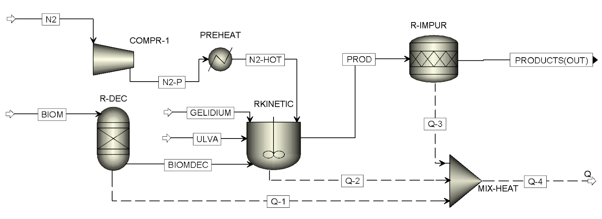

**(a)**

**(b)**

*Figure 1: Simulation flowsheets: a) fast pyrolysis; b) product recovery.*

To apply the FP kinetic models, the feedstock composition input must include cellulose, hemicellulose, three types of lignin (lignin compounds, either rich in carbon, hydrogen, or oxygen), and two extractive compounds (TANN and TGL). For EU, a SOLVER tool in MS Excel using the LP Simplex method was used to determine the contents of the lignocellulosic model compounds. The SOLVER tool performs elemental and mass balances between the ultimate and lignocellulosic analyses of Table 1, as described elsewhere (Motta et al., 2023). For the algae, the lignocellulosic contents reported in Table 1 could be directly used, being represented by the model compound of lignin rich in oxygen.

Several assumptions were made in the simulation. The pyrolyzer was modeled under steady-state and isothermal conditions, with heat losses and effects of feedstock particle size and density not considered. The thermodynamic models employed were Peng-Robinson with Boston-Mathias modifications (PR-BM) for co-pyrolysis and NRTL for product recovery, encompassing separate bio-oil, char, and gas streams.

In the co-pyrolysis flowsheet (Figure 1a), EU was inserted as a nonconventional stream (stream *BIOM*) at 25 °C and 1 atm. The GE and UL streams (streams *GELIDIUM* and *ULVA*, also at 25 °C and 1 atm) had nonconventional and conventional substreams to account for the presence of ash (nonconventional) and all other species (conventional), following the composition reported in Table 1. The RYield reactor R-DEC converts the nonconventional stream *BIOM* into its lignocellulosic analysis, generating the stream *BIOMDEC*. The latter, along with algae (either the stream GELIDIUM or ULVA) and nitrogen (stream N2-HOT), is then sent to the RCSTR reactor RKINETIC (450-550 ºC,1 atm), which performs the co-pyrolysis process using kinetic equations. The stream PROD, coming from the RKINETIC block, then enters the RStoic reactor R-IMPUR to simulate the formation of sulfur and nitrogen compounds, generating the stream PRODUCTS.

The stream PRODUCTS then are directed to the product recovery flowsheet (Figure 1b) to be separated into bio-oil, char, and gas streams. The recovery is composed of a cyclone (SEP block CYCLONE), a direct-contact condenser (QUENCH), and two condensers (CON-1 and SEP-1, CON-2 and SEP-2). The bio-oil, char, and gas yields were calculated by dividing the mass flows of streams BIO-OIL, CHAR-1, and GASES-2 (excluding nitrogen mass flow) by the mass flow of BIOM, respectively.

* + 1. Evaluated scenarios

This work evaluated the effect of temperature, algae-EU blending ratios, and algae species on product yields and quality. In the case of temperature, the simulation was run at 450 ºC, 500 ºC, and 550 ºC and using the pure feedstocks (without blends) to assess the individual effect of temperature, resulting in nine main scenarios. As for the blending ratios, different mixtures of EU and algae at different algae proportions were considered: 0.0, 0.2, 0.4, 0.6, 0.8, and 1.0, referring to feeds with 0, 20, 40, 60, 80, and 100 wt% of either GE or UL in the blend, respectively. As six blending ratios were adopted for either GE-EU or UL-EU mixtures, 12 main scenarios were run. The co-pyrolysis cases at different algae proportions enable the evaluation of potential synergistic effects between lignocellulosic biomass and algae, as well as the influence of higher lignin and ash contents, as UL has higher amounts of both components. All scenarios were run via a sensitivity analysis, set up to provide the effects of the parameters on more than 150 variables (mass flows of main streams, mole flows of bio-oil, char, and gas components), and further treated to provide yields and compositions.

* 1. Results and discussion

Table 2 presents the yields and higher heating values (HHV) of the bioproducts obtained from the FP of pure feedstocks at 450 ºC, 500 ºC, and 550 ºC. The results indicate that higher temperatures consistently enhanced the yields of bio-oil and gases, while the char yields decreased with temperature rise. This trend can be attributed to the decomposition and cracking of larger molecules at elevated temperatures, which may remain in the gas phase or condense into liquid bio-oil, decreasing the char yield. It should also be noted that higher temperatures influenced the bioproduct properties to a small extent: all properties increased slightly, except for the bio-oil moisture content.

Table 2: Yields and properties of bioproducts from the FP of the pure feedstocks

|  |  |  |  |  |  |  |  |  |  |
| --- | --- | --- | --- | --- | --- | --- | --- | --- | --- |
| Parameter | 450 ºC | | | 500 ºC | | | 550 ºC | | |
|  | EU | GE | UL | EU | GE | UL | EU | GE | UL |
| Ybio-oil (wt%) | 50.1 | 55.9 | 34.4 | 51.8 | 57.5 | 35.0 | 52.9 | 58.6 | 35.2 |
| Ychar (wt%) | 30.4 | 22.0 | 54.7 | 27.2 | 19.9 | 53.8 | 24.7 | 17.9 | 53.0 |
| Ygases (wt%) | 19.5 | 22.1 | 10.9 | 21.0 | 22.6 | 11.2 | 22.4 | 23.5 | 11.7 |
| HHVbio-oil (MJ/kg) | 33.5 | 36.2 | 30.6 | 34.0 | 36.5 | 30.9 | 34.2 | 36.7 | 31.0 |
| ρbio-oil (kg/m3) | 1094.4 | 1129.6 | 1072.1 | 1097.0 | 1132.3 | 1074.0 | 1096.8 | 1132.9 | 1074.2 |
| MCbio-oil (wt%) | 22.7 | 25.5 | 27.0 | 22.0 | 24.8 | 26.6 | 21.8 | 24.4 | 26.5 |
| H/Cbio-oil | 1.565 | 1.447 | 1.529 | 1.574 | 1.451 | 1.534 | 1.586 | 1.456 | 1.540 |
| O/Cbio-oil | 0.526 | 0.621 | 0.456 | 0.536 | 0.623 | 0.463 | 0.544 | 0.625 | 0.467 |
| HHVchar (MJ/kg) | 49.4 | 42.6 | 44.8 | 50.2 | 42.5 | 45.0 | 51.6 | 43.7 | 46.3 |

Table 2 also provides a comparative analysis of the yields and properties of bioproducts derived from each feedstock. Across all temperatures, the FP of GE yielded the highest bio-oil yields and HHV, densities, and O/C ratios, while utilizing UL as a biomass source rendered the highest char yields and bio-oil moisture contents. Conversely, the use of EU resulted in chars with the highest HHV. These results can be attributed to the feedstock compositions: EU and GE comprise ~70% of cellulose and hemicellulose, which decompose and condense into bio-oil. On the other hand, UL has the highest ash content of all feedstocks (as shown in Table 1), significantly contributing to char formation.

Figure 2 shows the product yields and bio-oil properties (density, HHV, moisture content, H/C and O/C ratios) obtained in the co-pyrolysis simulation with feedstocks containing 0–100 wt% of either GE or UL and at 500 ºC.

Figure 2a shows that increasing the GE proportion increased the bio-oil yield, while char formation decreased, which occurred due to GE not having lignin, which would decompose into char (among other molecules), as described by Ranzi, Debiagi, and Frassoldati (2017). Figure 2b, on the other hand, shows that increasing UL proportion increased char formation, which was expected due to UL having a significantly higher ash content than EU. As a result, bio-oil and gas yields decreased in the UL-EU co-pyrolysis at increasing UL contents.

Figure 2c shows that increasing the GE proportion led to a slightly denser bio-oil. This could be explained by a higher content of sugar-like molecules derived from hemicellulose, such as xylan (Motta et al., 2024b), as well as the higher bio-oil oxygen content (Motta et al., 2023), denoted by the increasing O/C ratios and decreasing H/C ratios shown in Figure 2e. The increasing HHV can be attributed to higher content of extractives in the GE-rich samples, which have been correlated to higher bio-oil HHVs (Motta et al., 2023).

Figure 2d shows that increasing UL proportion decreased density and HHV. These occurrences can be explained by the lower cellulose and hemicellulose contents in UL compared to EU, which tend to form bio-oil with fewer sugar-like molecules, decreasing O/C ratios, as shown in Figure 2f. Furthermore, Figures 2c and 2d show that increasing algae proportion increased moisture content in the resulting bio-oils, attributed to the higher moisture content of both algae when compared to EU.

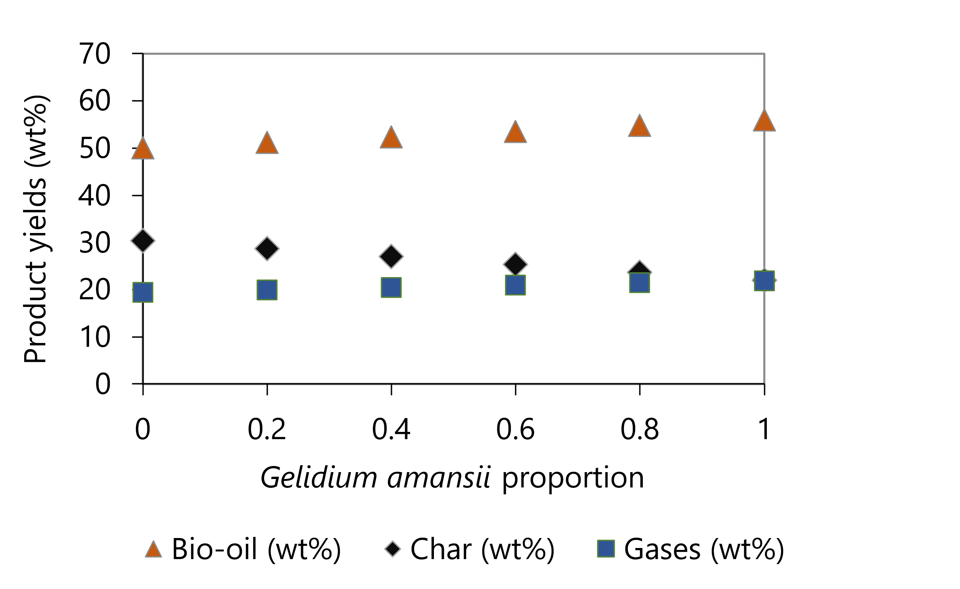 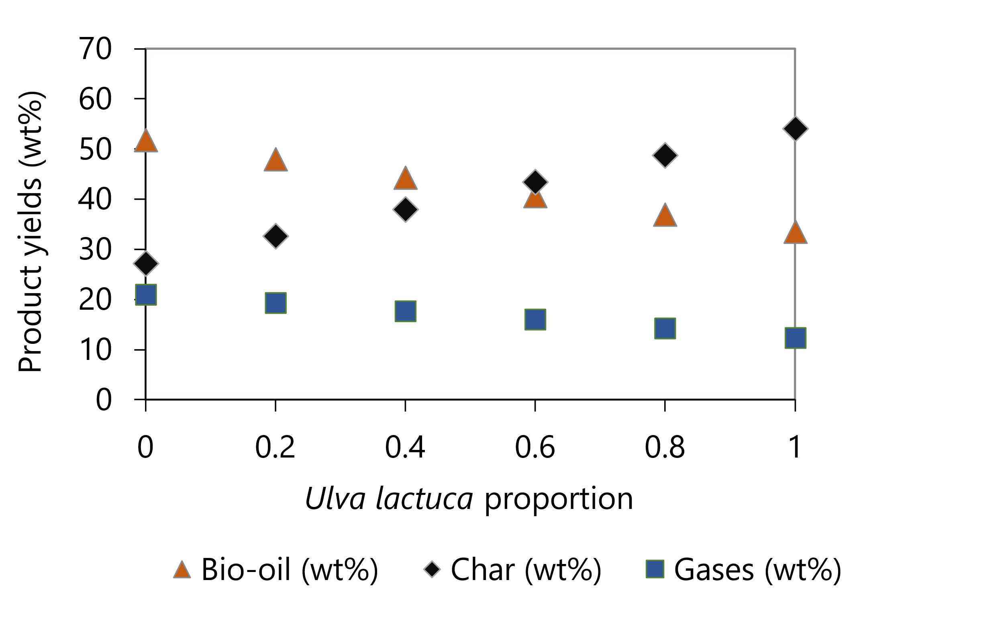

**(f)**

**(c) **

**(b)**

**(d)**

**(e)**

**(a)**

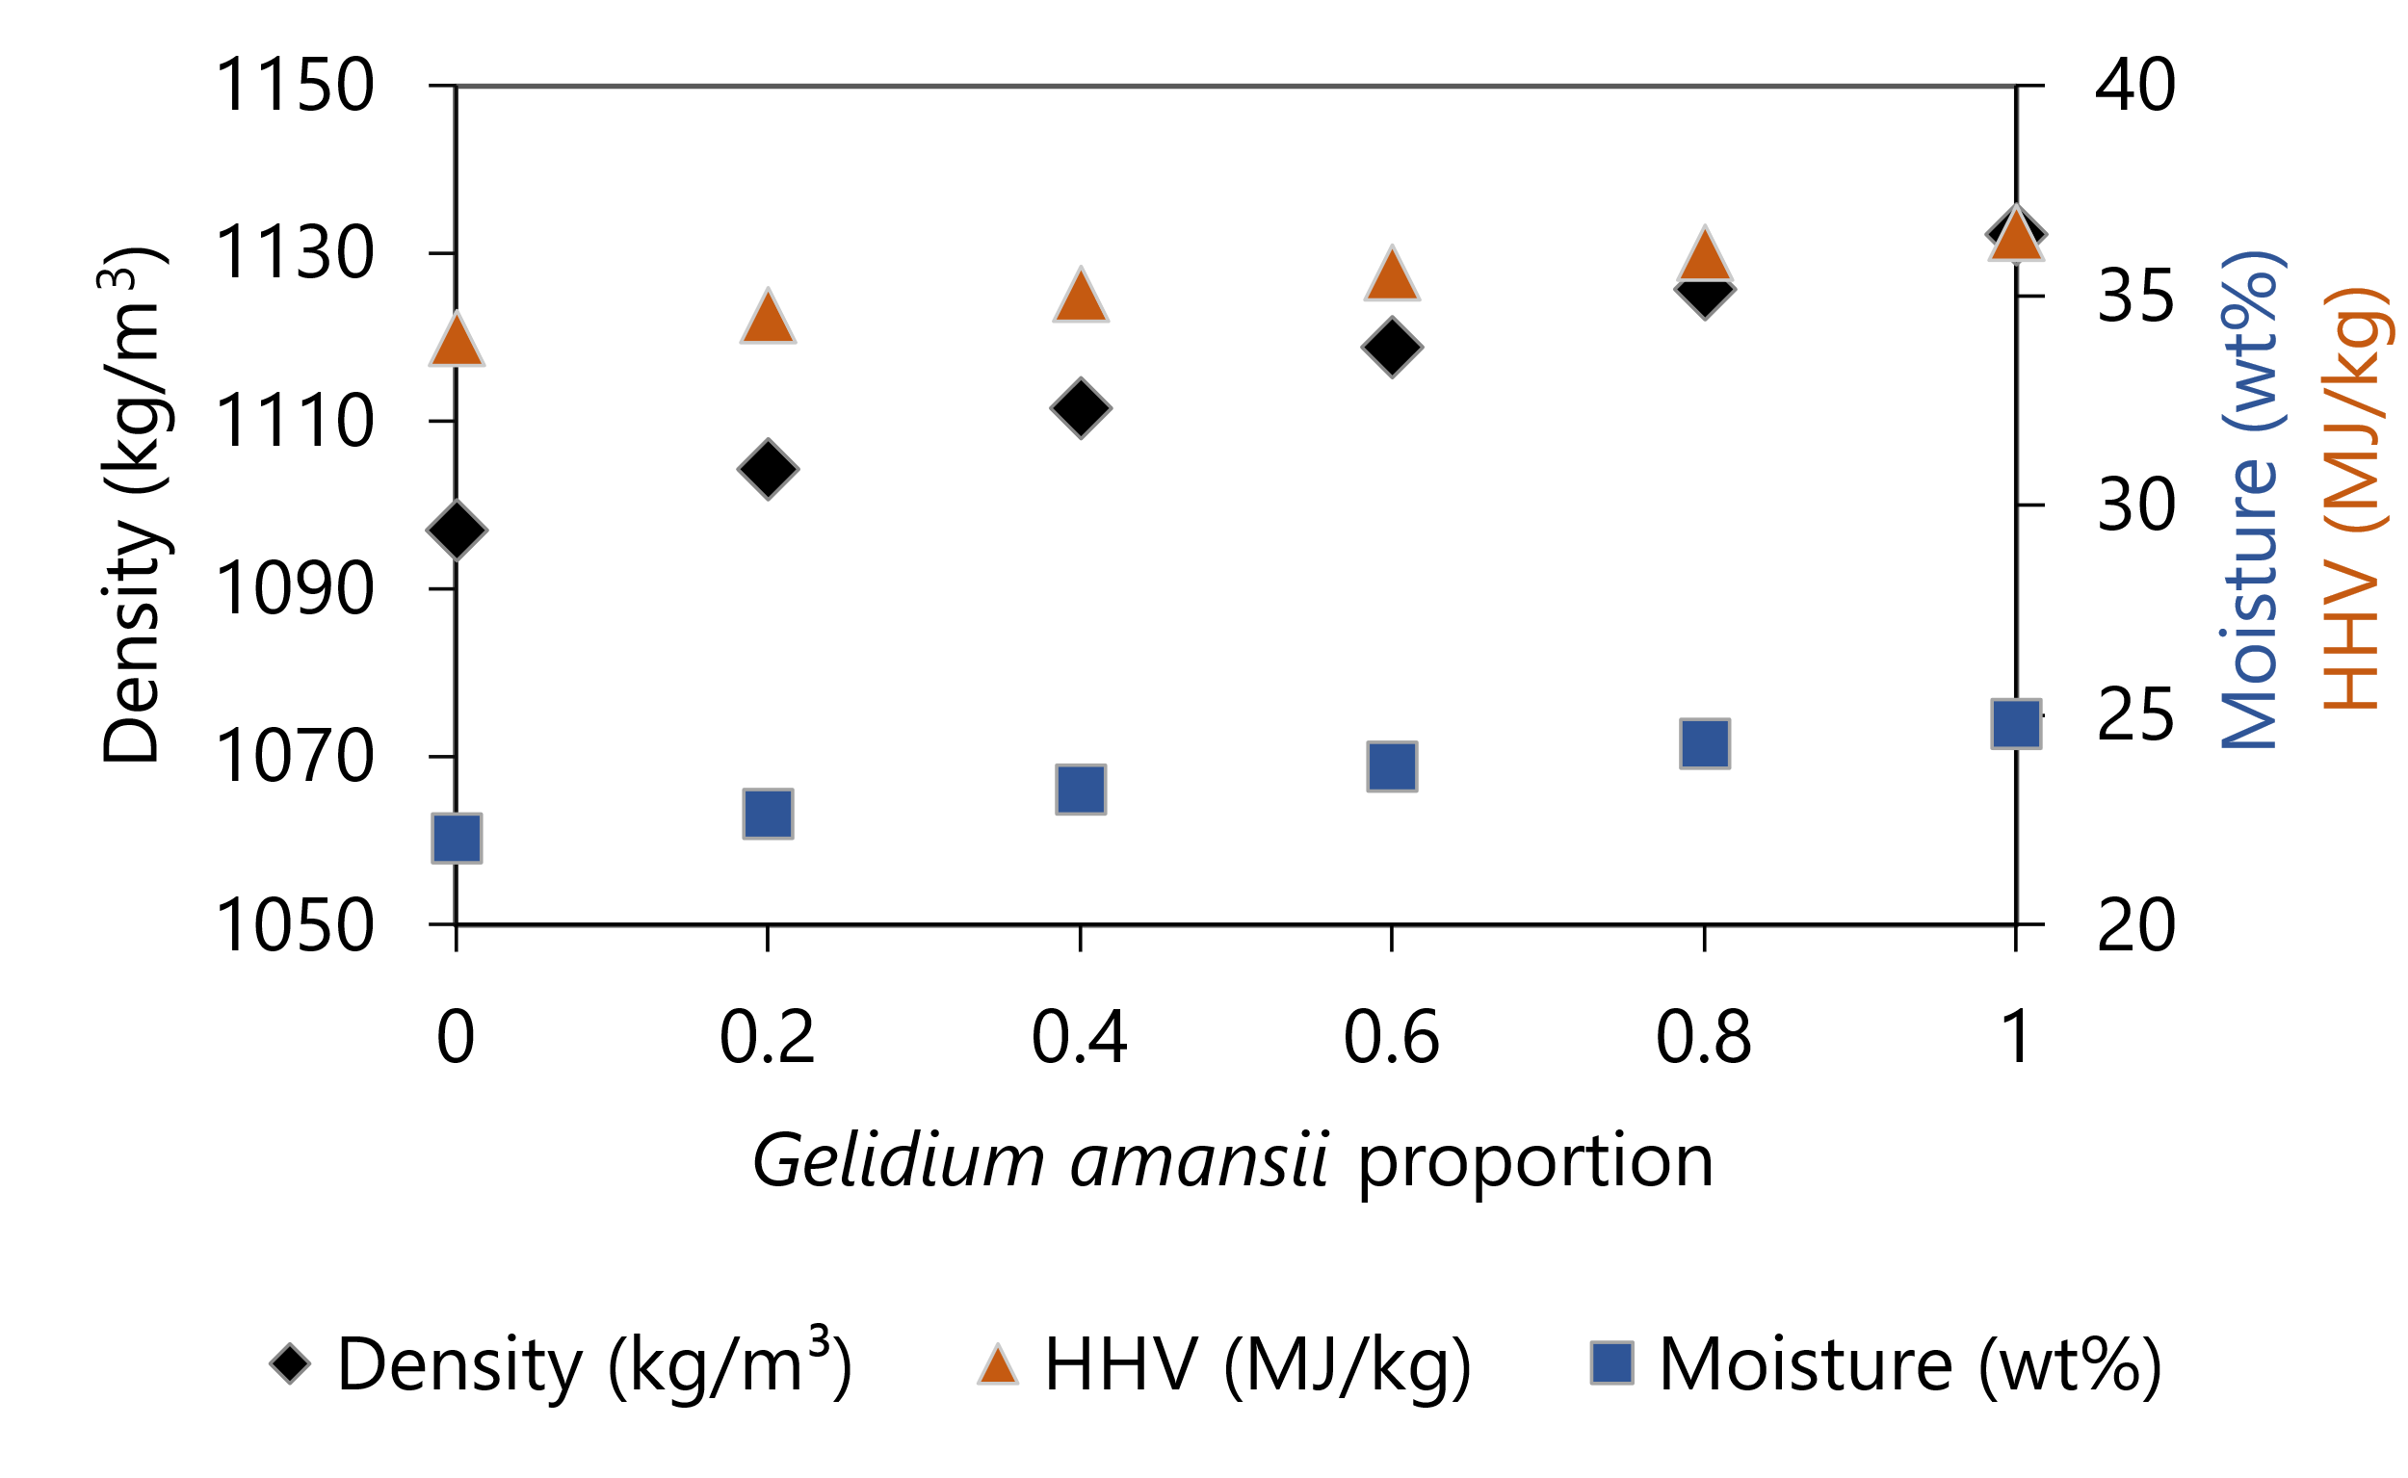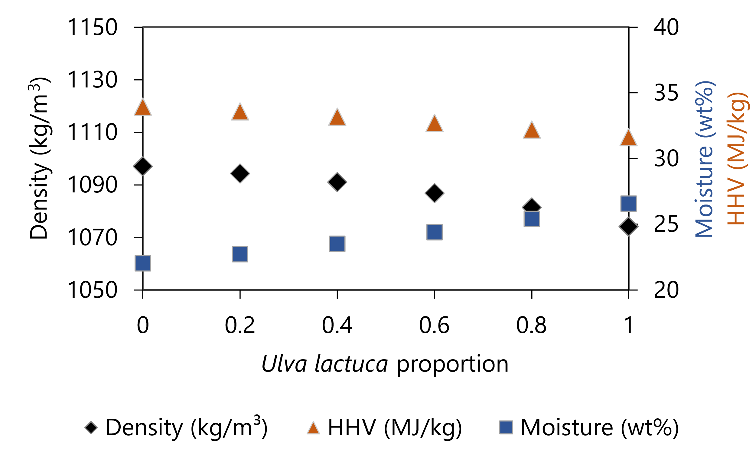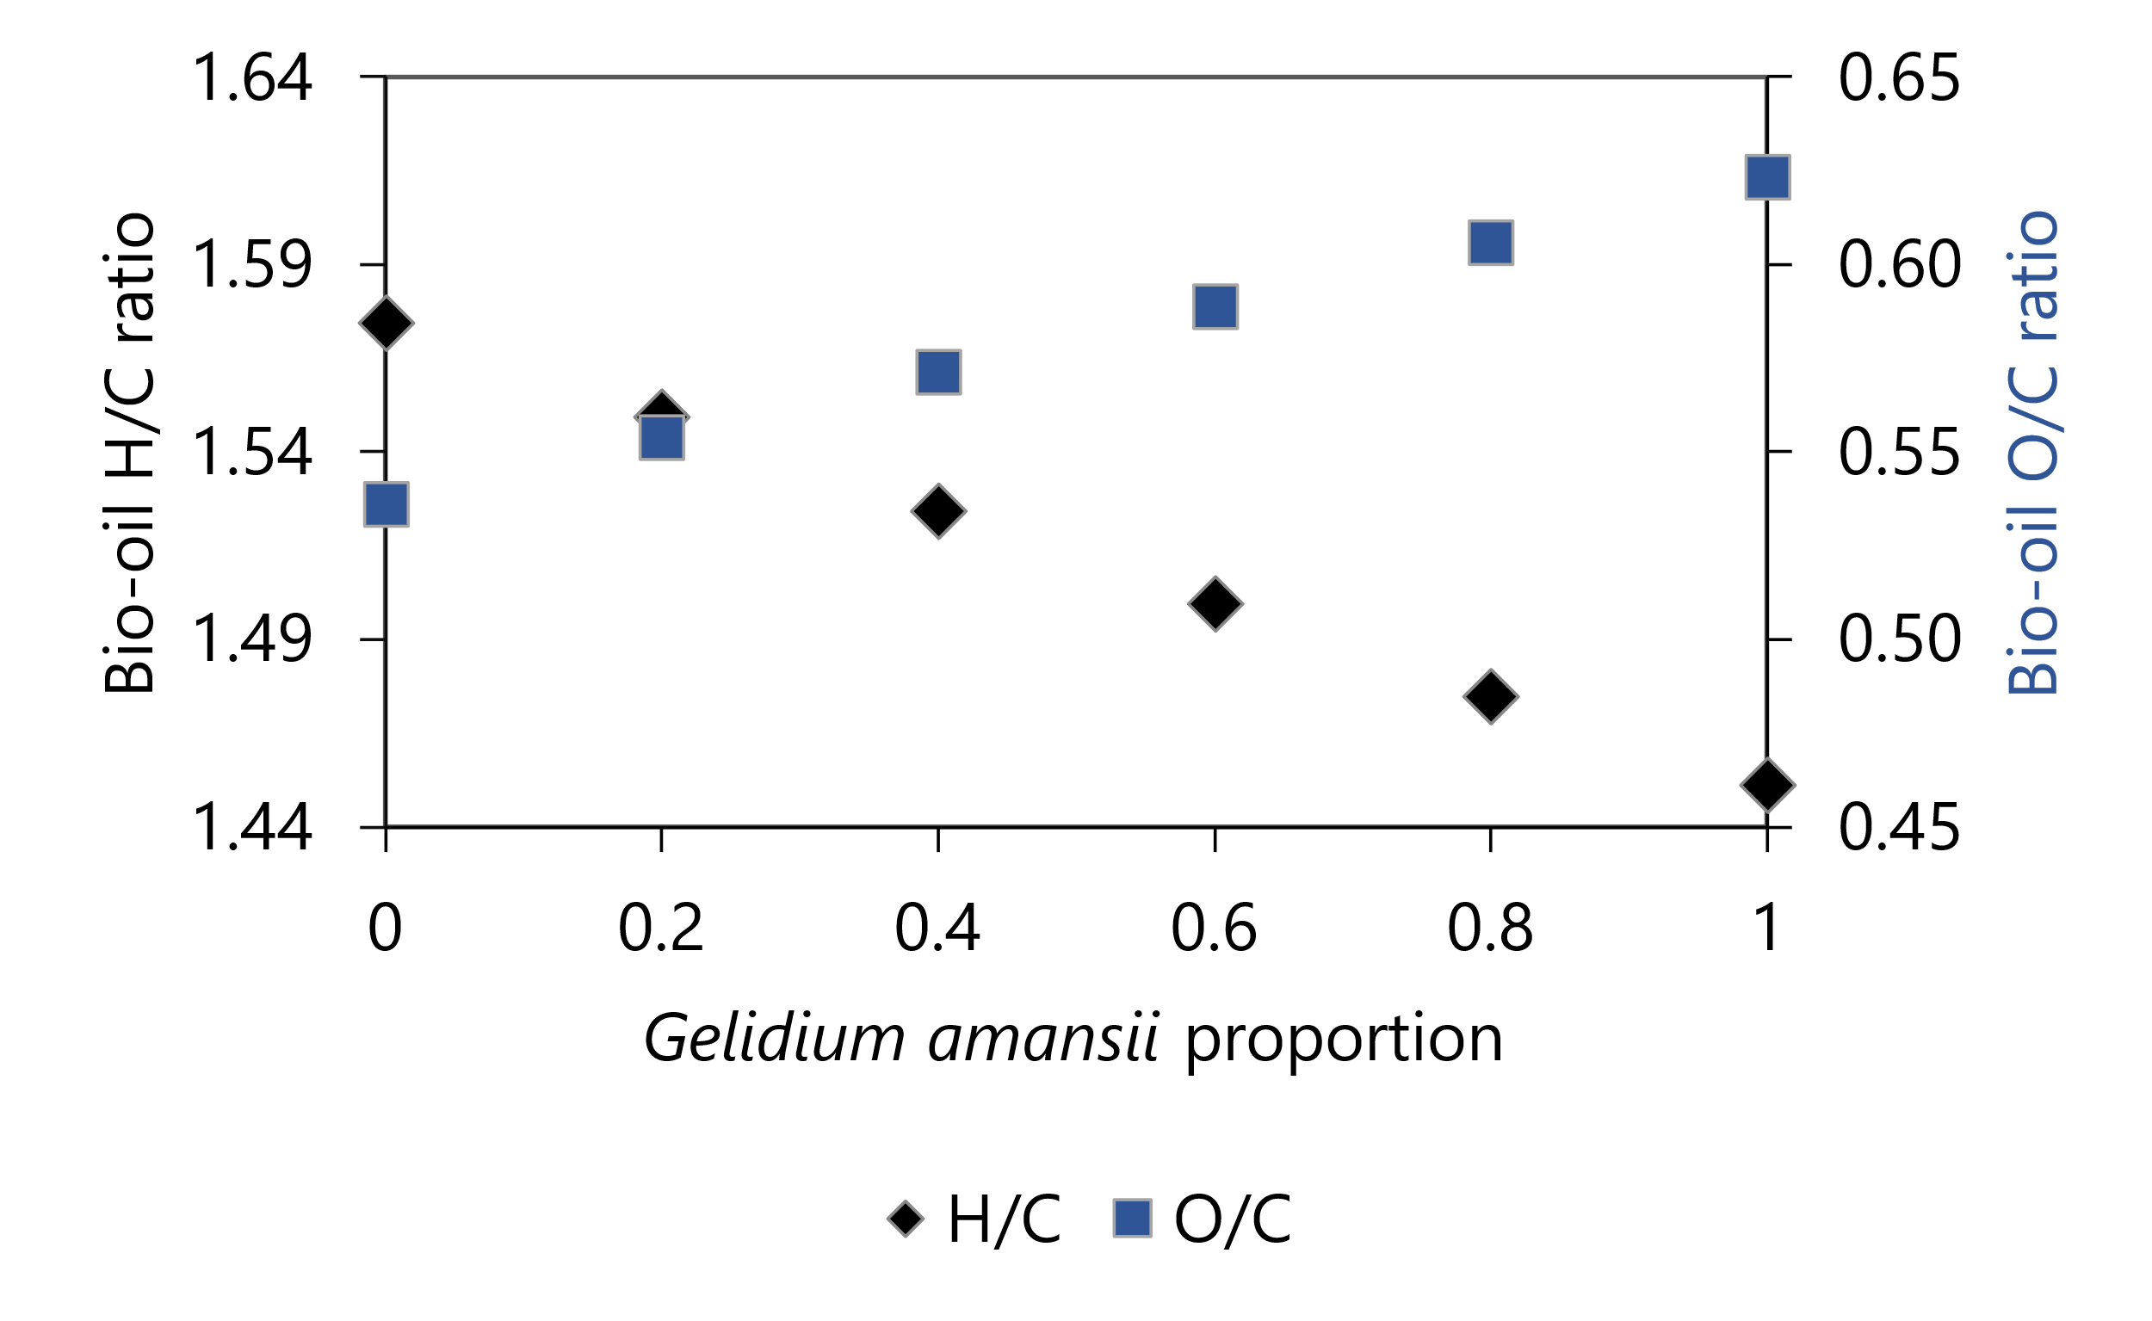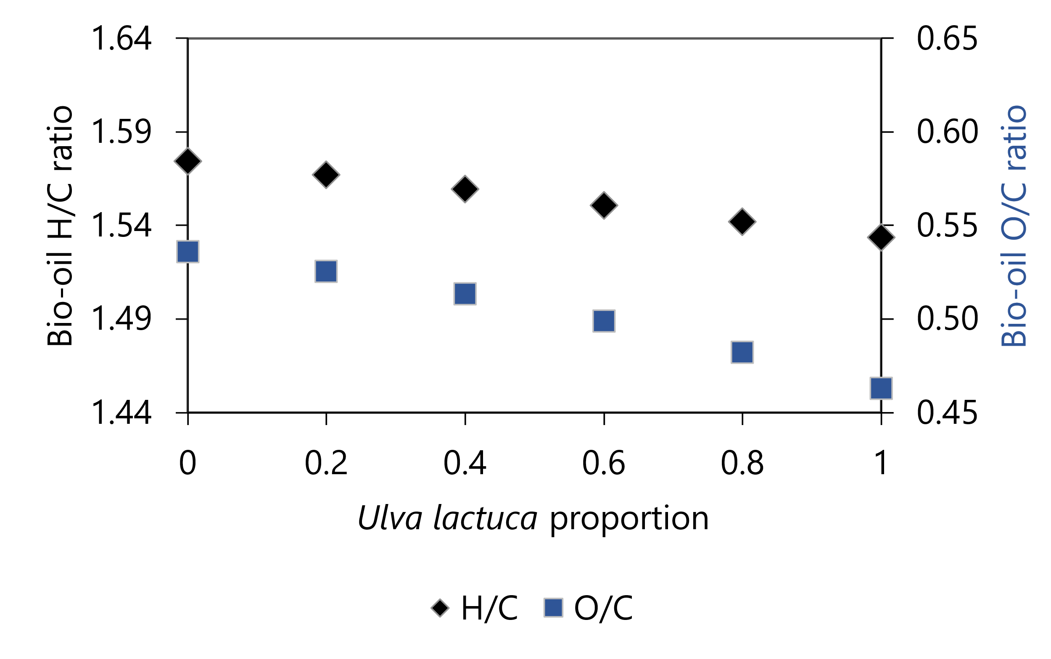*Figure 2: Simulation results by algae/EU ratio: product yields for GE (a) and UL (b); bio-oil properties for GE (c) and UL (d); bio-oil H/C and O/C ratios for GE (e) and UL (f).*

* 1. Conclusions

The present work developed a simulation of the co-pyrolysis of eucalyptus and algae (namely: *Gelidium amansii*, and *Ulva Lactuca*). The co-pyrolysis simulation was developed in Aspen PlusTM using kinetic equations to model the pyrolysis behavior of both EU and algae. A sensitivity analysis was performed to analyze the effects of co-pyrolysis temperature, algae proportion, and algae type on the pyrolytic product yields and quality. In the pyrolysis of pure feedstocks, increasing temperatures had small effects on the pyrolytic yields and product compositions. The feedstock type, on the other hand, had significant effects, increasing bio-oil yields, higher heating values (HHV), densities, and O/C ratios in the following order: UL < EU < GE. In the study of the blending ratios of the GE-EU and UL-EU mixtures, the algae type also had significant effects due to differences in the algae composition. Increasing the GE proportion resulted in higher bio-oil yields with higher density, HHV, and oxygen contents. Alternatively, increasing the proportion of UL led to higher char yields due to its high ash content, while the yield and O/C ratio of the resulting bio-oil decreased. This study showed that kinetic-based pyrolysis simulations are interesting options for studying the use of algae as a renewable energy source, serving as a starting point for the design of co-pyrolysis processes with either GE-EU or UL-EU mixtures or blends with other residues.

Acknowledgments

The authors would like to thank the funding received from São Paulo Research Foundation (FAPESP) grant #2024/05208-3, Programa de Incentivo a Novos Docentes da UNICAMP (PIND), and Coordenação de Aperfeiçoamento de Pessoal de Nível Superior - Brasil (CAPES) - Finance Code 001.

References

Brandt A., Gräsvik J., Hallett J.P., Welton T., 2013, Deconstruction of lignocellulosic biomass with ionic liquids, Green Chemistry, 15, 550-583.

Chakraborty S., Dunford, N.T., 2024, Algae: Nature’s Renewable Resource for Fuels and Chemicals, Biomass, 4(2), 329-348.

Fakayode O.A., Wahia H., Zhang L., Zhou C., Ma H., 2023, State-of-the-art co-pyrolysis of lignocellulosic and macroalgae biomass feedstocks for improved bio-oil production - A review, Fuel, 332, 126071.

Fakayode O.A., Aboagaib E.A.A., Zhou C., Ma H., 2020, Co-pyrolysis of lignocellulosic and macroalgae biomasses for the production of biochar – A review, Bioresource Technology, 297, 122408.

Farobie O., Amrullah A., Fatriasari W., Nandiyanto A.B.D., Ernawati L., Karnjanakom S., Lee S.H., Selvasembian R., Azelee N.I.W., Aziz M., 2024, Co-pyrolysis of plastic waste and macroalgae Ulva lactuca, a sustainable valorization approach towards the production of bio-oil and biochar. Results in Engineering, 24, 103098.

Istianah N., Kang H.J., Lee Y.J., Choe D., Jung S.K., Hong S.-C., Jung Y.H., 2024, Enhancing the dispersibility of Gelidium amansii-derived microfibrillated cellulose through centrifugal fractionation, International Journal of Biological Macromolecules, 262, 129909.

Motta I.L., Marchesan A.N., Guimarães H.R., Chagas M.F., Bonomi A., Wolf Maciel M.R., Maciel Filho R., 2024a, Co-Pyrolysis of Lignocellulosic Residues and Plastics: a Simulation Approach to Predict Product Yields, Chemical Engineering Transactions, 109, 139-144.

Motta I.L., Marchesan A.N., Guimarães H.R., Chagas M.F., Bonomi A., Wolf Maciel M.R., Maciel Filho R., 2024b, Exploring The Impact of Biomass Composition on High-Value Bio-Oil Components: Insights from Fast Pyrolysis Kinetic Simulation and Multivariate Analysis, Chemical Engineering Transactions, 109, 145-150.

Motta I.L., Marchesan A.N., Guimarães H.R., Chagas M.F., Bonomi A., Wolf Maciel M.R., Maciel Filho R., 2023, Fast pyrolysis simulation via kinetic approach and multivariate analysis to assess the effect of biomass properties on product yields, properties, and pyrolyzer performance, Energy Conversion and Management, 296, 117676.

Pienihäkkinen E., Leijenhorst E.J., Wolters W., Lindfors C., Lahtinen J., Ohra-aho T., Oasmaa A., 2022, Valorization of Eucalyptus, Giant Reed Arundo, Fiber Sorghum, and Sugarcane Bagasse via Fast Pyrolysis and Subsequent Bio-Oil Gasification, Energy and Fuels, 36(19), 12021–12030.

Ranzi E., Debiagi P.E.A., Frassoldati A., 2017, Mathematical Modeling of Fast Biomass Pyrolysis and Bio-Oil Formation. Note I: Kinetic Mechanism of Biomass Pyrolysis, ACS Sustainable Chemistry and Engineering, 5(4) 4, 2867–2881.

UNFCCC, 2023, Conference of the Parties serving as the meeting of the Parties to the Paris Agreement < unfccc.int/process/bodies/supreme-bodies/conference-of-the-parties-serving-as-the-meeting-of-the-parties-to-the-paris-agreement-cma> accessed 26.12.2024.

Wi S.G., Kim H.J., Mahadevan S.A., Yang D.-J., Bae H.-J., 2009, The potential value of the seaweed Ceylon moss (Gelidium amansii) as an alternative bioenergy resource, Bioresource Technology, 100(24), 6658–6660.

Yaich H., Garna H., Bchir B., Besbes S., Paquot M., Richel A., Blecker C., Attia H., 2015, Chemical composition and functional properties of dietary fibre extracted by Englyst and Prosky methods from the alga Ulva lactuca collected in Tunisia, Algal Research, 9, 65–73.