|  |  |
| --- | --- |
| cetlogo ***CHEMICAL ENGINEERING TRANSACTIONS***  ***VOL. , 2024*** | A publication of  aidiclogo_grande |
| The Italian Association  of Chemical Engineering  Online at www.cetjournal.it |
| Guest Editors:  Copyright © 2024, AIDIC Servizi S.r.l. **ISBN** 979-12-81206-XX-X; **ISSN** 2283-9216 | |

Parameterization and sensitivity analysis of an Industrial Scale Adsorption Column for the Removal of Chromium (VI) from Wastewater

Candelaria N. Tejada-Tovara,\*, Angel Villabona-Ortíza, Ángel D. González-Delgadob

aChemical Engineering Department, Process Design, and Biomass Utilization Research Group (IDAB), Universidad de Cartagena, Avenida del Consulado St. 30, Cartagena de Indias 130015, Colombia

bChemical Engineering Department, Nanomaterials and Computer-Aided Process Engineering Research Group (NIPAC), Universidad de Cartagena, Avenida del Consulado St. 30, Cartagena de Indias 130015, Colombia

ctejadat@unicartagena.edu.co

Heavy metal pollution significantly threatens aquatic ecosystems and life’s health. These have different characteristics that make them persistent, bioaccumulative, and non-biodegradable, negatively affecting the food chain of the area of influence. Hexavalent chromium is highly toxic and can cause various harmful effects on humans and ecosystems, depending on the potency and amount of exposure. This study aims to use Computer Aided Process Engineering (CAPE) to model an industrial-scale operating column for Cr (VI) adsorption in an aqueous solution, taking advantage of the biomass of *Theobroma cacao L.* For this, Aspen Adsorption software was used to perform various simulations of an industrial-scale adsorption column with different configurations to obtain a parametric sensitivity analysis. The results show that using the Langmuir-Quadratic lumped resistance (QDF) model to simulate the adsorption column for Cr (VI) removal yields up to 98% efficiencies. On the other hand, the best conditions for simulating the adsorption column were a bed height of 5 m, an initial concentration of 5000 mg/L, and an input flow of 100 m3/day. The present study is shown as a novel form of engineering prediction of the potential performance of adsorption columns packed with organic waste-based biomasses using computer-aided engineering.

* 1. Introduction

The environmental problems generated by the pollution of water bodies constitute an important challenge that directly affects the quality and availability of water resources. This phenomenon is caused by introducing pollutants into the water, which can take different forms, whether chemical, biological, or physical, generating negative impacts on the ecosystem (Saidon *et al.*, 2024). These contaminants include heavy metals originating from different polluting sources such as mining, volcanic eruptions, industrial operations, among others. The contamination generated by these creates a significant concern, as they are generally toxic, non-biodegradable, and difficult to remove (Sahoo and Goswami, 2024). Among these heavy metals is chromium, which in its hexavalent state is considered a highly toxic pollutant (Mohanty *et al.*, 2023). This metal can have different harmful effects on health, such as digestive, urinary, reproductive and immune system dysfunctions, which makes it a priority pollutant in different environmental regulations. (Murthy *et al.*, 2023). It is widely used in various industries, such as tanning, textiles, electroplating, and pigments, among others (Irshad *et al.*, 2023). The permissible limit for chromium in drinking water by the World Health Organization is 0.05 mg/L for Cr (Gupta *et al.*, 2021). Multiple biological, physical or chemical techniques have been developed to remove pollutants from water bodies. Among them is adsorption, which is a simple and economical technique due to its remarkable capacity to remove different heavy metals in water bodies (Gao *et al.*, 2024). Studies have been developed for the removal of heavy metals in solution using biomasses, among these is cocoa, in particular the shell, is an effective natural sorbent for the removal of heavy metal ions (Lara *et al.*, 2016). But most of these studies have been conducted at the laboratory level therefore, ways have been sought to predict the behavior of the adsorption process on a large scale and how this change affects the efficiency of the material used as adsorbent. Considering the above, the purpose of this study is to model at industrial scale an operational adsorption column for Cr (VI) removal packed with *Theobroma cacao L*. biomass using experimental data previously obtained by the authors combined with parametric sensitivity analysis and simulation using computer aided process engineering. Presenting this study as a novel technique for predicting the performance of an industrial scale packaged adsorption column.

* 1. Methodology
     1. Parametric study

Parametric studies identified how modifying various independent variables in the packed bed process affects adsorption performance by analyzing the rupture curve profile in detail. This research employs a 33 experimental design, where 3 factors are examined: inlet flow rate, initial concentration and bed height, where the selected values were established after a literature review and preliminary analysis to establish the limit where the parameters present significant results. The operating ranges evaluated are shown in Table 1.

Table 1. Parametric studies on the effect of five parameters and the range of values used in this study.

|  |  |  |  |
| --- | --- | --- | --- |
| Parameters | Range of values | | |
| Flow rate, m3/day | 100 | 150 | 200 |
| Initial concentration, mg/L | 2000 | 3500 | 5000 |
| Bed height, m | 3 | 4 | 5 |

* + 1. Packed bed column at industrial scale

Similar industrial-scale heavy metal adsorption columns in wastewater were used as a reference (Upadhyay *et al.*, 2021; Hameed *et al.*, 2024) for scaling the packed tower for the adsorption of Cr (VI) ions. The parameters of the industrial scale packed column for this study are presented in Table 2.

Table 2. Adsorption column parameters for simulation

|  |  |
| --- | --- |
| Parameters | Values |
| Bed diameter, m | 1 |
| Bed porosity, m3 of vacuum / m3 of bed | 0.67 |
| Total vacuum porosity m3 of vacuum / m3 of bed | 0.4 |
| Constant mass transfer coefficient, 1/s | 1.37x10-4 |
| Bulk density, g/cm3 | 0.0365 |

* + 1. Mathematical Models.

The adsorption isotherm is established by bringing an adsorbate and an adsorbent into contact, which is affected by various factors such as pH, ionic strength and temperature. It is also affected by the nature of the adsorbed species (adsorbate) and the type of adsorbent. For this study, Langmuir was selected as the isothermal model, which assumes that adsorption occurs on a single layer of the adsorbate surface making the adsorption energy constant (Pereira *et al.*, 2023). This model is described by equation 1.

|  |  |
| --- | --- |
| $q_{e}=\frac{q_{max}bC_{e}}{1+bC_{e}}$ | (1) |

Likewise, it is essential to analyze the adsorption kinetics which allows to predict the rate of contaminant removal, establish the time evolution of the adsorbate remaining in solution, showing the efficiency of the adsorbate used and the mass transfer process for this study, the Quadratic lumped resistance (QDF) kinetic model that estimates the rate of mass transfer from a single adsorbate (k) to the adsorbent particle was used (Ragadhita, Bayu and Nandiyanto, 2022). This model is described by equation 2.

|  |  |
| --- | --- |
|  | (2) |

* 1. Results and discussions
     1. Evaluation of mathematical models of kinetics and molecular adsorption isotherms using Aspen Adsorption software

Using Aspen Adsorption, a packed column was modelled by implementing the Langmuir isotherm model and the QDF kinetic model with different distributions of the parameters inlet flow rate, bed height and initial Cr (VI) concentration. Subsequent to the development of the multiple simulations, values of the time to rupture (T.R) and time to saturation (T.S) were obtained. The results are shown in Figure 1, where Figure 1.a represents the T.R and T.S values obtained for a concentration of 2000 mg/L, while Figure 1.b presents the T.R and T.S values obtained for a concentration of 3500 mg/L and finally, Figure 1.c shows the T.R and T.S values obtained for a concentration of 5000 mg/L. It should be noted that the figures show bars of different colors which represent a type of net flow configuration with bed height at that initial concentration.

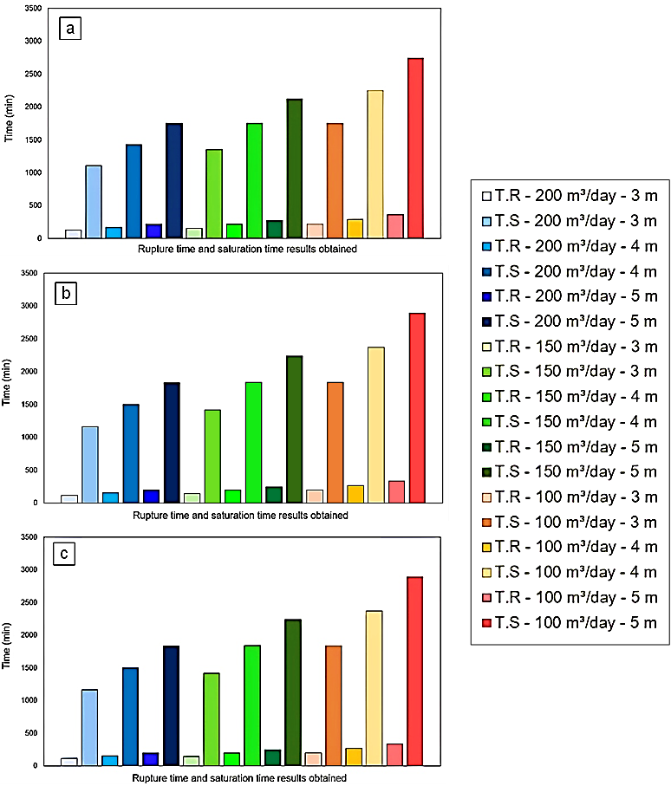

Figure 1. Results of rupture time (R.T) and saturation time (S.T) obtained from simulations for initial Cr (VI) concentrations of (a) 2000 mg/L, (b) 3500 mg/L and 5000 mg/L, with a confidence interval of ± 16.31 for R.T values and ± 143.16 for S.T values.

* + 1. Parametric sensitivity analysis

Parametric sensitivity analysis for inlet flow rate

The analysis of the alteration of the flow entering the bed was carried out, evaluating flow rates in a range of 200, 150 and 100 m3/day, maintaining the initial concentration at 5000 mg/L and the bed height at 5 m. After the simulation process, the results obtained from the breakthrough curves were taken, where the values of breakthrough time, saturation time and efficiency of the adsorption process were obtained. Figure 2 shows the breakthrough curve profile. It is observed that, as the initial flow rate into the column increases, there is a decrease in the T.R and T.S but an increase in the efficiency of the process. This behavior seems to be due to the fact that, as a greater amount of flow enters the equipment, a positive effect is generated in the mass transfer of the process, which causes an acceleration in the time it takes for the bioadsorbent to begin to lose its removal capacities, generating a decrease in the times. On the other hand, the efficiencies obtained are 96.2% for 200 m3/day, 95.5% for 150 m3/day and 93.4% for 100 m3/day (Mansa, Ting and Patrick, 2021).

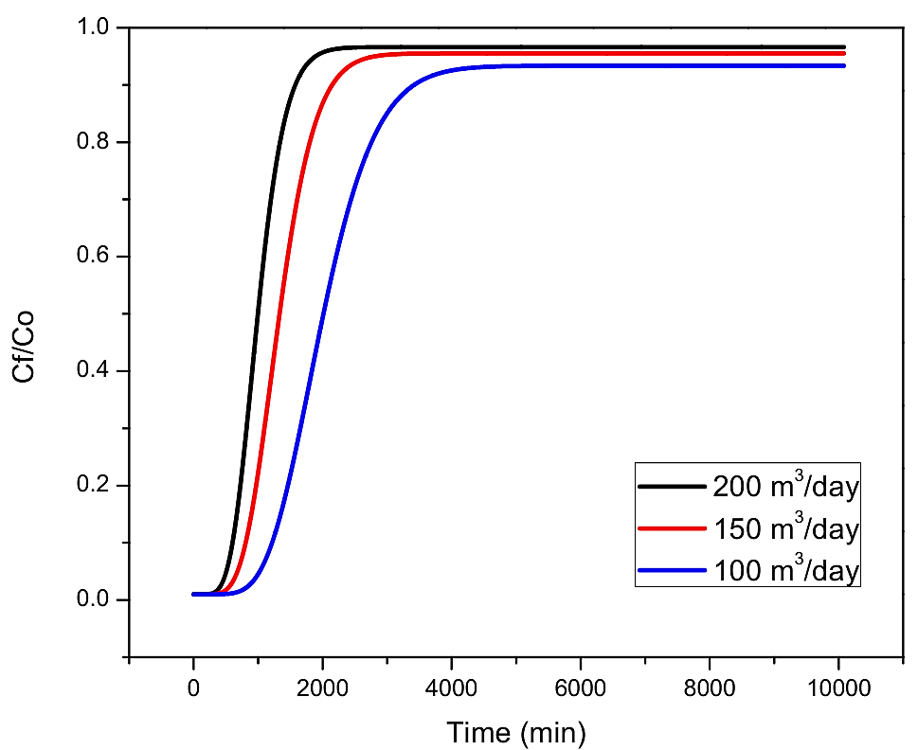

Figure 2. Rupture curves at different inlet flow rates for Langmuir - QDF.

Parametric sensitivity analysis for the initial concentration

A parametric analysis of the alteration of the initial concentration of Cr (VI) was developed. For this purpose, initial concentration of pollutant ranges of 5000, 3500 and 2000 mg/L were used, leaving the inlet flow rate and the bed height fixed at 100 m3/day and 5 m, respectively. Once the simulation process of the packed adsorption column was completed, the profiles of the breakthrough curves were obtained, where the results of T.R, T.S and efficiency of the adsorption process were taken. Figure 3 shows the breakthrough curve profile. The results show that, as the initial concentration of the contaminant increases, a decrease in T.R and T.S. is generated. This behavior may be due to the presence of a greater amount of pollutant entering the adsorption column, since the active sites of the adsorbent material used as bed filler are occupied and saturated at a higher rate, causing the biomass to lose its removal capacity at an accelerated rate, resulting in a decrease in T. R and T.S. On the other hand, the efficiency of the process for the concentrations of 5000, 3500 and 2000 mg/L was 93%, showing that the variation of this parameter does not significantly affect the efficiency of the process (Bahrun *et al.*, 2021).

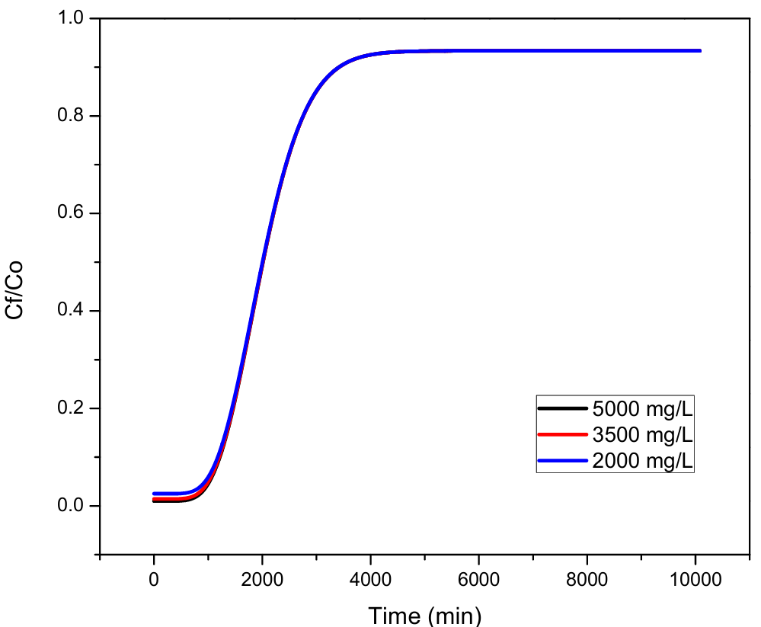

Figure 3. Rupture curves at different initial concentrations for Langmuir – QDF.

Parametric sensitivity analysis for bed height.

A parametric analysis of the alteration of the column height was developed. For this purpose, we worked with heights of 3, 4 and 5 meters, leaving the inlet flow and the initial concentration fixed at 100 m3/day and 5000 mg/L, respectively. After the development of the packed adsorption column simulation, profiles of the breakthrough curves were obtained, where the results of T.R, T.S and efficiency of the adsorption process were taken. Figure 4 shows the penetration curve profile. It is evident that, by increasing the bed height, a prolongation in T.R and T.S is generated but a decrease in the efficiency of the process. This behavior is attributed to the presence of a larger bed size, which causes the flow entering the column to take longer to leave the equipment, thus resulting in an increase in times. On the other hand, the efficiency obtained for the different bed height conditions was 96% for 3 meters, 94.6% for 4 meters and 93.4% for 5 meters (Patel, 2020).

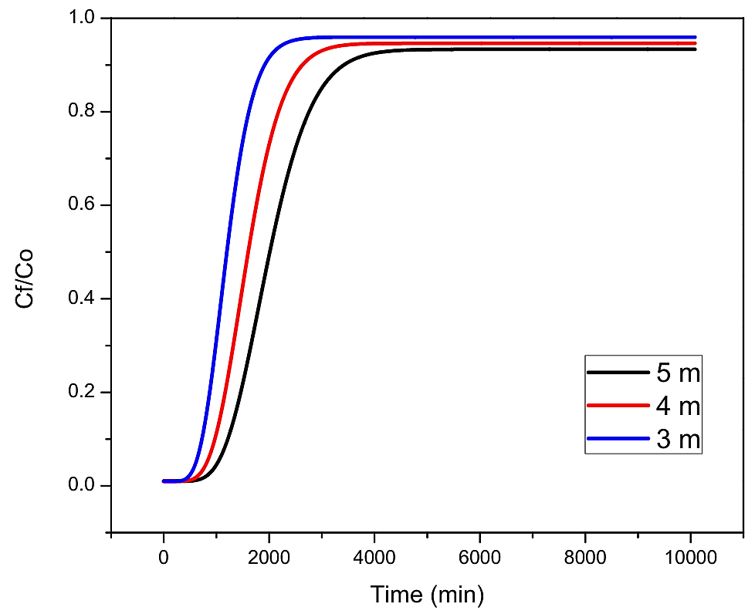

Figure 4. Rupture curves at different bed heights for Langmuir – QDF.

The results obtained from the simulation of the packed bed with *Theobroma Cacao L* at industrial scale have been compared with studies found in the literature. It should be noted that the data and comparisons reported only have relative significance because each study was carried out under different conditions of inlet flow, inlet concentration and bed height, as well as the adsorbent biomaterial used. The present study shows that *Theobroma Cacao L* in an industrial scale packed bed presents reasonable results in the removal of Cr (VI) in aqueous solutions. The comparison of the values reported in literature with this study is presented in Table 3.

Table 3. Comparison of result with literature

|  |  |  |  |
| --- | --- | --- | --- |
| Contaminant | Pb (II) | Cd (II) | Cr (VI) |
| Adsorbent | Olive tree pruning | Dolochar | *Theobroma Cacao L* |
| Initial concentration (mg/L) | 100 | 55 | 5000 |
| Inlet flow rate (m3/day) | 128.04 | 75 | 100 |
| Bed height (m) | 2.26 | 0.65 | 5 |
| Rupture time (min) | 201.6 | 666 | 315 |
| Saturation time (min) | 530 | 1140 | 2993 |
| Source | (Ronda *et al.*, 2018) | (Upadhyay *et al.*, 2021) | This study |

* 1. Conclusions

This study presents the modeling of an adsorption column packed with cocoa waste using Aspen adsorption software and how the alteration of the parameters of bed height, inlet flow rate and initial concentration of Cr (VI) affect the performance of the equipment by means of a parametric sensitivity analysis. The results showed that, for this study, increasing the inlet flow rate and decreasing the height improved the performance of the equipment, whereas, altering the initial concentration did not significantly affect the efficiency of the process. These findings provide a novel way to anticipate the possible behavior of a packed column with *Theobroma Cacao L* residues to adsorb Cr (VI) on an industrial scale.

Nomenclature

b - Langmuir parameter related to the affinity of binding sites for the contaminant, L/mg

Ce - Concentration of contaminant in solution at equilibrium, mg/L

Cf/C0 - Efficiency.

MTC - Overall mass transfer coefficient, m/s

n - Effect of initial concentration on adsorption capacity

QDF - Kinetic model of Quadratic Lumped Resistance

qmax - Maximum amount of solute in solid phase, mg/g

R.T. - Rupture Time, min

S.T. - Saturation time, min

wk - Instantaneous equilibrium loading of adsorbate on the adsorbent, mg/g

Acknowledgments

The authors thank the Universidad de Cartagena for facilitating the development of this work.

Reference

Bahrun, M.H.V. Kamin, Z., Anisuzzaman, S., & Bono, A. (2021) ‘Assessment of adsorbent for removing lead (pb) ion in an industrial-scaled packed bed column’, Journal of Engineering Science and Technology, 16(2), pp. 1213–1231.

Gao, Y., Yi, Z., Wang, J., Ding, F., Fang, Y., Du, A., Jiang, Y,. Zhao, H. and Jin, Y. (2024) ‘Interpretation of the adsorption process of toxic Cd2+ removal by modified sweet potato residue’, RSC Advances, 14(1), pp. 433–444. Available at: https://doi.org/10.1039/d3ra06855b.

Gupta, B., Mishra, A. Singh, R. and Thakur. I.S. (2021) ‘Fabrication of calcite based biocomposites for catalytic removal of heavy metals from electroplating industrial effluent’, Environmental Technology and Innovation, 21, p. 101278. Available at: https://doi.org/10.1016/j.eti.2020.101278.

Hameed, A., Hameed, B. H., Almomani, F. A., Usman, M., Ba-Abbad, M. M., and Khraisheh, M. (2024) ‘Dynamic simulation of lead (II) metal adsorption from water on activated carbons in a packed-bed column’, Biomass Conversion and Biorefinery, 14, pp. 8283–8292. Available at: https://doi.org/10.1007/s13399-022-03079-8.

Irshad, M.A., Sattar, S., Nawaz, R., Al-Hussain, S. A., Rizwan, M., Bukhari, A., Waseem, M., Ali Irfan, A., Aqil Inam, A. and Zaki, M. (2023) ‘Enhancing chromium removal and recovery from industrial wastewater using sustainable and efficient nanomaterial: A review’, Ecotoxicology and Environmental Safety, 263(July), p. 115231. Available at: https://doi.org/10.1016/j.ecoenv.2023.115231.

Lara, J., Tejada, C., Villabona, Á., Arrieta, A., and Granados Conde, C. (2016) ‘Adsorción de plomo y cadmio en sistema continuo de lecho fijo sobre residuos de cacao’, Revista ION, 29(2), pp. 113–124.

Mansa, R.F., Ting, M.L. and Patrick, A.O. (2021) ‘Simulation of Lead Removal Using Palm Kernel Shell Activated Carbon in a Packed Bed Column’, easychair.org, pp. 2–15.

Mohanty, S., Benya, A., Hota, S., Kumar, M. S., and Singh, S. (2023) ‘Eco-toxicity of hexavalent chromium and its adverse impact on environment and human health in Sukinda Valley of India: A review on pollution and prevention strategies’, Environmental Chemistry and Ecotoxicology, 5(January), pp. 46–54. Available at: https://doi.org/10.1016/j.enceco.2023.01.002.

Murthy, M.K., Khandayataray, P., Padhiary, S. and Samal, D. (2023) ‘A review on chromium health hazards and molecular mechanism of chromium bioremediation’, Reviews on Environmental Health, 38(3), pp. 461–478. Available at: https://doi.org/10.1515/reveh-2021-0139.

Patel, H. (2020) ‘Batch and continuous fixed bed adsorption of heavy metals removal using activated charcoal from neem (Azadirachta indica) leaf powder’, Scientific Reports, 10(1), pp. 1–12. Available at: https://doi.org/10.1038/s41598-020-72583-6.

Pereira, S.K., Kini, S., Prabhu, B., and Jeppu, G. P. (2023) ‘A simplified modeling procedure for adsorption at varying pH conditions using the modified Langmuir–Freundlich isotherm’, Applied Water Science, 13(1), pp. 1–13. Available at: https://doi.org/10.1007/s13201-022-01800-6.

Ragadhita, R., Bayu, A. and Nandiyanto, D. (2022) ‘Curcumin Adsorption on Zinc Imidazole Framework-8 Particles: Isotherm Adsorption Using Langmuir, Freundlich, Temkin, And Dubinin-Radushkevich Models’, Journal of Engineering Science and Technology, 17(2), pp. 1078–1089.

Ronda, A., Martín-Lara, M. A., Osegueda, O., Castillo, V., and Blázquez, G. (2018) ‘Scale-up of a packed bed column for wastewater treatment’, Water Science and Technology, 77(5), pp. 1386–1396. Available at: https://doi.org/10.2166/WST.2018.020.

Sahoo, S.K. and Goswami, S.S. (2024) ‘Theoretical framework for assessing the economic and environmental impact of water pollution: A detailed study on sustainable development of India’, Journal of Future Sustainability, 4(1), pp. 23–34. Available at: https://doi.org/10.5267/j.jfs.2024.1.003.

Saidon, N.B., Szabó, R., Budai, P., and Lehel, J. (2024) ‘Trophic transfer and biomagnification potential of environmental contaminants (heavy metals) in aquatic ecosystems’, Environmental Pollution, 340(October 2023). Available at: https://doi.org/10.1016/j.envpol.2023.122815.

Upadhyay, U., Gupta, S., Agarwal, A., Sreedhar, I., and Anitha, K. L. (2021) ‘Process Optimization at an Industrial Scale in the adsorptive removal of Cd2+ ions using Dolochar via Response Surface Methodology’, Environmental Science and Pollution Research, pp. 0–27. Available at: https://doi.org/10.1007/s11356-021-17216-9.