 CHEMICAL ENGINEERING TRANSACTIONS  VOL. xxx, 2025 | A publication of  
The Italian Association
of Chemical Engineering
Online at www.cetjournal.it

Guest Editors: Fabrizio Bezzo, Flavio Manenti, Gabriele Pannocchia, Almerinda di Benedetto
Copyright © 2025, AIDIC Servizi S.r.l.
ISBN 979-12-81206-17-5; ISSN 2283-9216

Analysis of Different Formulations of Cellulose-Grafted Hydrogels in the Dehydration of Biodiesel
Giovana Almenaraa, Bianca Estevama*, Isadora Pereza, Patrícia Fregolenteb, Maria Regina Wolf Maciela, and Leonardo Fregolentea*

ªDepartment of Process and Product Design - School of Chemical Engineering, University of Campinas (UNICAMP), 13083-852 Campinas-SP, Brazil.
^{b}Salesian University Center of São Paulo, 13075-490 Campinas, São Paulo, Brazil
*Corresponding authors e-mails: b262792@dac.unicamp.br and leovf@unicamp.br
Polymer hydrogels are promising desiccant materials for biodiesel dehydration, with performance largely determined by their monomer and polymer composition. This study investigates the swelling capacity and dehydration efficiency of hydrogels, both grafted and ungrafted onto cellulose nanocrystals (CNC), synthesized using sodium polyacrylate (PSA), polyacrylamide (PAam), hydrolyzed polyacrylamide (H-PAam), or sodium poly(acrylate-co-acrylamide) (P(SA-co-PAam)). For grafted hydrogels, 4 % CNC (by weight relative to the monomer) was incorporated. CNC addition slightly influenced hydrogel performance, with PSA-CNC and H-PAam-CNC exhibiting the highest dehydration efficiency (48 % and 42 %) and swelling capacity (285 g·g⁻¹ and 500 g·g⁻¹, respectively). FTIR and SEM analyses of these hydrogels revealed rough and non-porous surfaces with functional groups mainly originating from the crosslinked polymer. The batch dehydration process was investigated regarding the treatment time (from 30 min to 72 h), and mass of hydrogel used (0.1-1.0 g). Increasing the treatment time and the mass of hydrogel improved the water removal efficiency for both formulations, which reached 63 % using PSA-CNC and 57 % with H-PAam-CNC. These results demonstrate that hydrogels with anionic groups, particularly PSA or H-PAam, benefit the removal of water from the oil with adequate dehydration efficiencies.
  - Introduction
Biofuels are a critical energy source that must meet regulatory limits on water content. Effective water removal from biodiesel remains a significant challenge, as it absorbs moisture during production, storage, and transportation (Fregolente et al., 2023). Various technologies have been developed to overcome this hurdle, including using hydrogels as desiccants for biofuels (Arthus et al., 2024; Atadashi et al., 2012). These three-dimensional networks can absorb large amounts of water, depending on their composition. Hydrogels synthesized from synthetic polymers often achieve high water uptake at the expense of mechanical strength, limiting their practical use (Bashir et al., 2020). Adding cellulose as a reinforcing agent improves the mechanical stability of hydrogels and enhances their hydrophilicity (Bashir et al., 2020). This improvement can be achieved through grafting, a technique that generates free radicals on cellulose chains, enabling the polymerization of synthetic monomers via propagation reactions (Wohlhauser et al., 2018). The type of cellulose and monomers used are critical factors influencing the hydrogels performance. Previous work by our group identified cellulose nanocrystals (CNC) as a promising grafting material for the application proposed here. This is because CNC have high surface area and abundant hydroxyl groups (Arthus et al., 2024). This study advances the field by assessing the impact of various formulations of grafted hydrogels using synthetic monomers on the performance of the material to swell and to dehydrate biodiesel. The best-performing formulations were further analyzed for morphology, functional groups, water removal kinetics, and the effects of hydrogel dosage in batch systems. The findings offer valuable insights into how CNC-grafted hydrogels enhance biodiesel dehydration and help identify the most effective materials and optimal conditions for practical applications.
  - Methodology
    - Hydrogel syntheses
Several hydrogel formulations were prepared, including the homopolymers of sodium polyacrylate (PSA), polyacrylamide (PAam), hydrolyzed polyacrylamide (H-PAam), and the copolymer P(SA-co-Aam) from sodium acrylate and acrylamide. The monomers were dissolved in 45 mL of distilled water, using proportions optimized in previous studies, both in weight by volume (g:mL): 4 % acrylamide for PAam and H-PAam (Arthus et al., 2023b), 9.2 % sodium acrylate for PSA (Fregolente et al., 2023), and 2.5 % sodium acrylate with 3 % acrylamide for P(SA-co-Aam) (Perez et al., 2022). After monomer dissolution, 0.015 mols of crosslinker (N,N'-methylenebisacrylamide - MBAAm) per mol of monomer and 1 mL of N,N,N,N’-tetramethylethylenediamine (TEMED) at 0.57 M were added. For the grafting formulations, it was incorporated 4 %, by weight, of cellulose nanocrystals (CNC) of the total monomer weight in the hydrogel (Arthus et al., 2024). The mixtures were distributed in Falcon tubes and bubbled with nitrogen gas for 5 minutes to remove oxygen and prevent side reactions. After this period, the initiator (sodium persulfate at 0.2 g.L⁻¹) was added to the solution, that remained under nitrogen bubbling until gel formation. After these procedures, the swollen hydrogels were cut into discs of 4 mm high and 15 mm diameter. For the H-PAam, the previously synthesized PAam hydrogels underwent hydrolysis by immersion in a 0.5 mol.L⁻¹ NaOH solution at 75 °C for 18 h. The hydrogels were washed by immersion in distilled water for 24 h to remove unreacted compounds, except the PSA to preserve geometry. The prepared hydrogels were then dried in an air recirculated oven at 60 °C.
    - Evaluation of the hydrogel formulations: swelling degree and water removal from biodiesel
The effects of cellulose and type of monomers on hydrogel performance were evaluated by assessing swelling degree and water removal efficiency from biodiesel. Experiments were performed in duplicate, using both grafted and ungrafted hydrogels. Results were compared using Tukey's test, following an analysis of variance (ANOVA), to identify significant differences between group means. This test compares all possible pairs of means, assuming equal variances and normally distributed residuals, with a 95 % confidence interval set for this study.
To determine the swelling degree, 0.1 g of each hydrogel sample was immersed in 200 mL of distilled water for 24 h at 37 ºC. The weight difference of the samples was used to calculate the swelling degree of each replicate. The dehydration experiments used water-saturated biodiesel, prepared by adding 5 % (mL:mL) of distilled water to the commercial biodiesel and stirring it for 30 min at 750 rpm, followed by a gravitational separation during 72 h to allow phase settling. Then, the oil phase was centrifuged at 5,500 rpm for 10 minutes to remove any free water present. The dehydration of the biodiesel was performed in a batch system using 0.5 g of each hydrogel formulation and 25 mL of water-contaminated oil, stirred at 150 rpm for 24 h at 25 ºC. Control experiments (water-saturated biodiesel without the hydrogel) were subjected to the same conditions to identify any water losses that may not be related to the hydrogel. The water content in the oil was measured using Karl Fischer coulometric titration, following the ASTM D6304 standard.
    - Characterization of the hydrogels
The hydrogel formulations with the highest water removal efficiency (PSA and H-PAam) were characterized using Scanning Electron Microscopy (SEM) and Fourier Transform Infrared Spectroscopy (FTIR). With the FTIR analysis it was identified the functional groups of the samples, with a resolution of 2 cm⁻¹ and a spectral range of 4,000 to 400 cm⁻¹. SEM was used to examine the surface morphology and cross-sectional structure of the hydrogels, operating at 10 kV and 23 pA, with the samples coated with gold.
    - Evaluation of hydrogels dosage and treatment time on the biodiesel dehydration
The effect of hydrogel dosage and treatment time on water removal efficiency was investigated for the formulations with the highest dehydration performance (PSA and H-PAam). Treatments were conducted in a batch system with 25 mL of water-saturated biodiesel, stirred at 150 rpm under controlled conditions at 25 °C. To study the kinetics of water removal, the process was monitored over time intervals from 30 min to 72 h using 0.5 g of hydrogel. The influence of hydrogel dosage was evaluated by varying its mass from 0.1 to 1.0 g, with a fixed treatment duration of 24 h.
  - Results and discussion
    - Evaluation of the hydrogel formulations: swelling degree and water removal from biodiesel
Table 1 presents the results for water removal efficiency and swelling degree of the evaluated hydrogel formulations, along with the Tukey test results for comparing differences at a 95 % confidence level. The swelling degree of the hydrogels was primarily influenced by the type of synthetic monomer. The addition of CNC did not significantly affect swelling in most formulations, likely due to its low content (4 % of total monomer mass). However, PSA was an exception; the inclusion of CNC significantly enhanced its swelling capacity, resulting in similar swelling degrees for PSA-CNC and both P(SA-co-Aam) and P(SA-co-Aam)-CNC formulations. This improvement may be attributed to the high surface area of CNC, which could facilitate water transport into the hydrogel matrix (Al Abdallah et al., 2024). A higher effect of monomer concentration than cellulose was also reported by Rop et al. (2019) in grafting PAam onto cellulose nanofibers (CNF), achieving a swelling degree of up to 142 g.g⁻¹. The highest swelling degree (500 g·g⁻¹) was observed in the H-PAam and H-PAam-CNC hydrogels. This outcome demonstrates the interplay between the polymer's hydrophilicity and the crosslinked network's density, which promotes increased water uptake. In these formulations, hydrolysis increased the number of active hydrophilic sites, while lower monomer and crosslinker concentrations allowed greater polymer chain mobility, supporting swelling. It is important to note that the hydrogel formulations in this study were designed based on optimal conditions from the literature for water removal from oil but have different monomer concentrations. The balance between monomer content, crosslinker density, and hydrolysis effects enabled H-PAam and H-PAam-CNC to achieve superior swelling performance. Arthus et al. (2024) also reported that hydrolysis improved the performance of PAam grafted onto cellulose microfibrils (CMF) from 27 g.g⁻¹ to 714 g.g⁻¹.
The highest water removal efficiency from biodiesel was achieved with PSA, and according to the Tukey test at 95 % confidence, the addition of CNC did not significantly affect the removal efficiency. The lowest efficiency was recorded for PAam (32 %), which significantly differs from all other formulations. Notably, the addition of CNC to PAam (PAam-CNC) enhanced the material’s hydrophilicity, improving its oil dehydration performance. The H-PAam and P(SA-co-Aam) hydrogels, whether grafted onto CNC or not, demonstrated similar performance for oil dehydration, which varies between 42 and 46 %, and reached similar results to PSA-CNC. These findings suggest that combining acrylamide with anionic groups from sodium acrylate or hydrolysis yields comparable results, with minimal influence from CNC in these specific formulations. Hydrolysis also benefited biodiesel dehydration, as reported by Arthus et al. (2024), where PAam grafted onto MFC showed a 9 % increase in water removal efficiency after hydrolysis. Overall, the water removal efficiency appears to be primarily determined by the choice of monomers in the hydrogel's crosslinked network rather than including CNC. While CNC did not significantly affect dehydration efficiency, it enhanced the mechanical stability of the hydrogels and increased the use of bio-based resources, aligning with sustainable product development goals. Given that PSA achieved the highest efficiency and hydrolysis is more cost-effective than adding sodium acrylate, the PSA-CNC and H-PAam-CNC formulations were selected for further analysis.
Table 1: Swelling degree and water removal efficiency of the prepared hydrogels.
Hydrogel | Swelling degree (g.g⁻¹) | Removal efficiency (%)
PSA | 161.2±18.6 A | 53.1±0.5 A
PAam | 51.4±0.6 B | 32.7±3.3 B
P(Aam-co-SA) | 281.1±3.8 AC | 41.9±0.6 C
H-PAam | 493.1±0.5 D | 46.3±0.3 CD
PSA-CNC | 285.1±29.6 C | 48.2±2.3 AD
PAam-CNC | 60.8±12.3 B | 42.2±0.6 C
P(Aam-co-SA)-CNC | 264.8±8.2 AC | 43.2±0.3 CD
H-PAam-CNC | 500.4±33.9 D | 42.6±0.3 CD
Note: Different capital letters indicate significant differences at a 95% confidence level for the response among the types of hydrogels used.
    - Characterization of the hydrogels
The morphology of PSA, PSA-CNC, H-PAam, and H-PAam-CNC hydrogels was analysed using SEM (Figure 1). The images showed that all hydrogels had a rough surface, no pores, and cracks in the cross-section, likely resulting from the drying process that compresses the polymer matrix. Voids were observed in PSA and PSA-CNC, potentially caused by nitrogen gas entrapment during synthesis. Additionally, PSA and PSA-CNC hydrogels exhibited surface and cross-sectional granules, which are likely due to the presence of sodium, as these hydrogels were not washed to preserve their original structure.

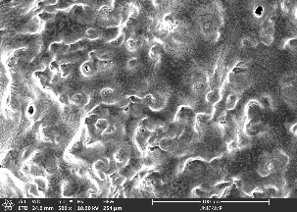  a | 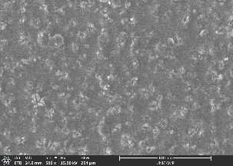  b | 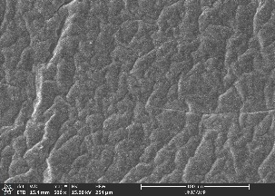  c | 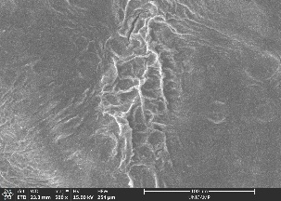  d
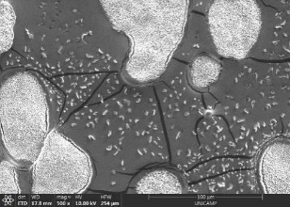  e | 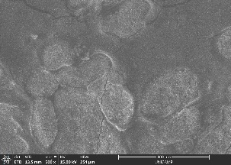  f | 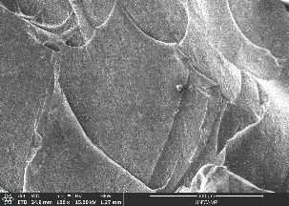  g | 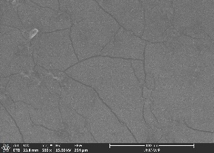  h
Figure 1: SEM of PSA (a - surface and e – cross-section), PSA-CNC (b - surface and f - cross-section), H-PAam (c - surface and g - cross-section) and H-PAam-CNC (d - surface and h - cross-section).

FTIR analysis (Figure 2) confirmed the presence of O-H groups in all hydrogels, with characteristic peaks around 3,300 cm⁻¹, 1,550 cm⁻¹, and 800 cm⁻¹. Peaks in the 1,300–1,400 cm⁻¹ range were associated with C-H bonds, while the peak near 1,600 cm⁻¹ corresponded to C-N groups. In the composite hydrogels, the functional groups of the crosslinked polymer network dominated, suppressing the CNC-specific functional groups. This is likely due to the low CNC content (4 % by weight of monomer), which may have limited its spectral influence while still reinforcing the hydrogel matrix.

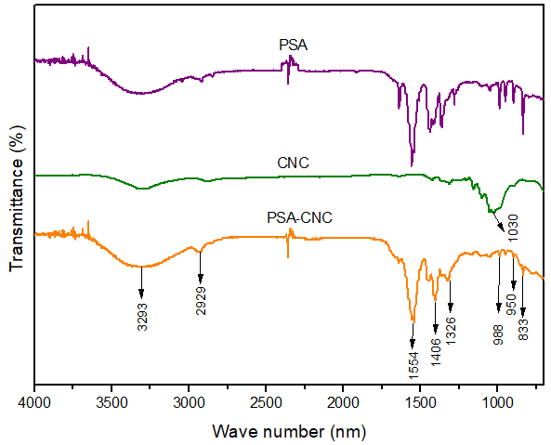  a | 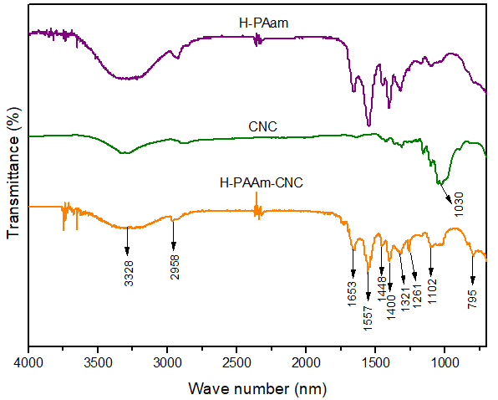  b
Figure 2: FTIR of PSA (a) and FTIR of PAam hydrogels (b).
    - Evaluation of hydrogels dosage and treatment time on the biodiesel dehydration
Figure 3 illustrates the water uptake kinetics of the PSA-CNC and H-PAam-CNC hydrogels. Both materials displayed similar behavior, with a rapid decrease in water concentration during the first 8 h of treatment, a stabilization between 24 and 48 h, and a further reduction in water content after 72 h. The water removal efficiency followed the same trend, reaching its maximum after 72 h of treatment. At this point, PSA-CNC achieved a dehydration efficiency of 62.43±0.18 %, while H-PAam-CNC removed 52.98±0.18 % of the water from the biodiesel. It is important to note that efficiency was calculated based on the difference in water concentration between control and treatment samples at each time. The slight reduction in efficiency after 24 h is attributed to the gradual decrease in water concentration in the control samples over time due to moisture exchange with the air. The initial water content in the saturated biodiesel was 1,749 mg·kg⁻¹, with control samples ranging from 1,752 mg·kg⁻¹ to 1,550 mg·kg⁻¹ during the experiment. By the end of the 72 h, the water content in biodiesel was reduced to 706.98±3.0 mg·kg⁻¹ and 816.71±8.92 mg·kg⁻¹ for the treatment using PSA-CNC and H-PAam-CNC, respectively. Although these results demonstrate a significant reduction in water content, they do not meet the international standard for water concentration in biodiesel, which is set at 500 mg·kg⁻¹. Consequently, additional experiments were conducted using a higher hydrogel mass to further reduce water content aiming to meet the standard regulations.

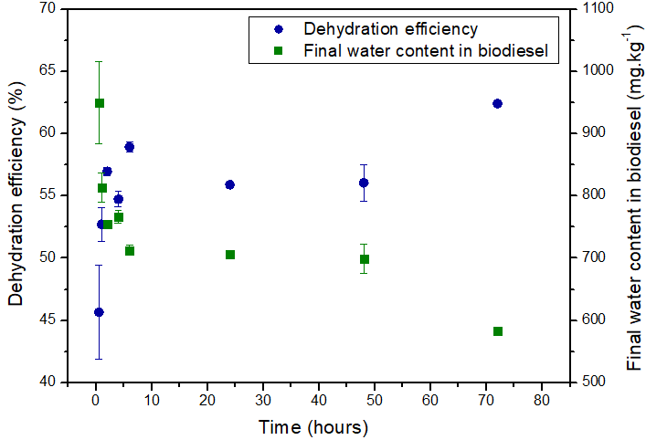  a) PSA-CNC | 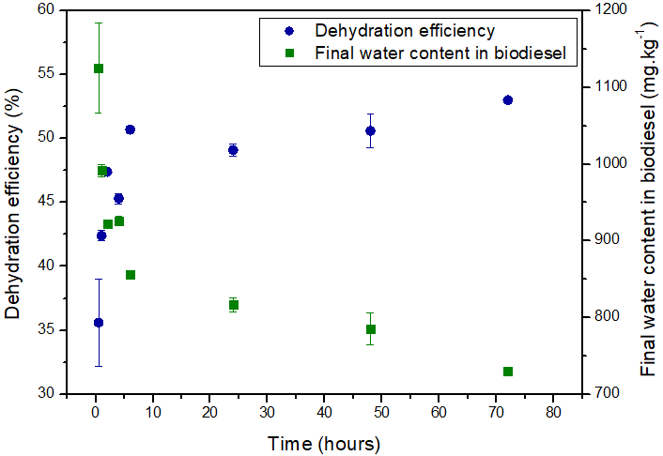  b) H-PAam-CNC
Figure 3: Kinetics of water removal from biodiesel using PSA-CNC (a) and H-PAam-CNC (b).

Figure 4 shows the impact of hydrogel dosage on water removal efficiency and sorption capacity for biodiesel treatment. As the hydrogel dosage increased, both PSA-CNC and H-PAam-CNC hydrogels demonstrated higher water removal efficiency, reaching 64 % and 57 %, respectively. This improvement can be attributed to an increase in the mass transfer area and the number of active sites available for interaction with water. However, as hydrogel mass increased, a higher proportion of internally activated sites remained unoccupied, resulting in a reduction in sorption capacity. PSA-CNC exhibited sorption capacities ranging from 25 to 111 g·g⁻¹, while H-PAam-CNC ranged from 23 to 128 g·g⁻¹. In this set of experiments the initial water concentration in the biodiesel was set as 1,787 mg·kg⁻¹, the control samples reduced it to 1,603 mg·kg⁻¹ and at the end of the treatment with the hydrogel the final water content in the biodiesel was reduced to 578 mg·kg⁻¹ with PSA-CNC and 677 mg·kg⁻¹ with H-PAam-CNC. While these results approach the international standard for water content in biodiesel 500 mg·kg⁻¹ (ASTM D6751-20a, 2020; European Standard for Biodiesel, 2008), further optimization is required. Future research could focus on using freeze-dried hydrogels for faster kinetics or applying hydrogels to treat biodiesel with lower initial water content. Despite PSA-CNC's superior performance, sodium acrylate's cost is up to 150 times higher than acrylamide at the laboratory scale. Scale-up studies and cost analyses are necessary, but preliminary investigations suggest that H-PAam-CNC may offer a more economically viable solution for the proposed treatment due to its lower material cost and competitive performance.

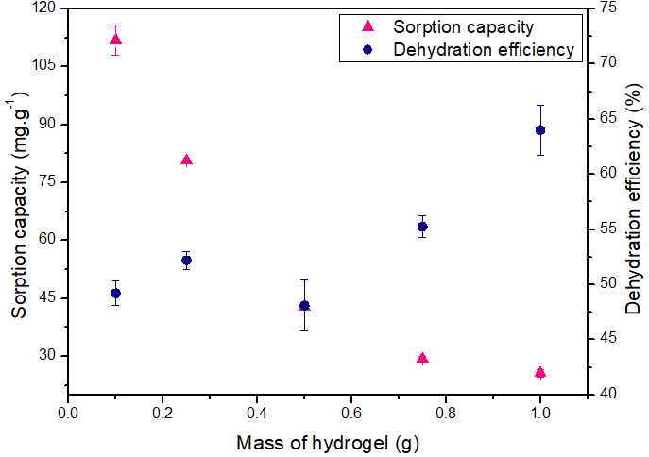  a) PSA-CNC | 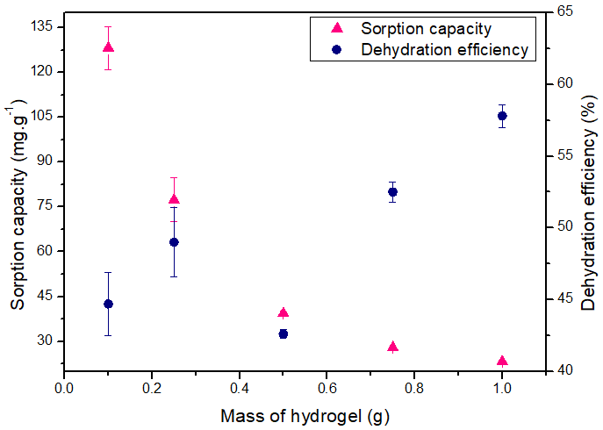  b) H-PAam-CNC
Figure 4: Effect of the mass variation of PSA-CNC (a) and H-PAam-CNC (b) for the biodiesel dehydration.
  - Conclusions

This research demonstrated that the choice of monomers for hydrogel synthesis has a more significant influence on water removal efficiency from biodiesel and the swelling degree of the materials than the addition of cellulose nanocrystals (CNC). The grafted hydrogels PSA-CNC and H-PAam-CNC exhibited high swelling capacities (285 and 500 g.g⁻¹, respectively) and higher water removal efficiencies from biodiesel (48 % and 42 %, respectively). Morphological analysis revealed rough surfaces with voids and cracks in the cross-sections of these hydrogels, while their functional groups were predominantly derived from the synthetic crosslinked network. The water uptake kinetics showed rapid absorption during the first 8 hours, with maximum efficiency achieved after 72 h. Increasing the hydrogel mass further improved the efficiency of the treatment, removing 64 % and 57 % of the water using PSA-CNC and H-PAam-CNC, respectively. The treatment enabled the reduction in the water concentration in biodiesel from 1,787 mg·kg⁻¹ to 578 mg·kg⁻¹ with PSA-CNC and 677 mg·kg⁻¹ with H-PAam-CNC. These findings highlight the potential of these hydrogels for biodiesel treatment and provides valuable insights for optimizing hydrogel formulations and treatment conditions, contributing to advancements in oil dehydration technologies and the development of hydrophilic materials for biodiesel purification. Future research should investigate the performance of these materials under lower initial water content in biodiesel at batch and continuous flow systems, in addition to assessing the economic feasibility of their application on an industrial scale.
Acknowledgments
The authors acknowledge the funding provided by the ANP'S Human Resources Program for the Oil and Gas Sector (PRH-23/ANP-finep) grand number 043919; the São Paulo Research Foundation (FAPESP), grant number 2021/03472-7; the Coordination for the Improvement of Higher Education Personnel (CAPES), Financing Code 001, through Institutional Internationalization Program (CAPES- PrInt) grant number 88887.936650/2024-00; the National Council for Scientific and Technological Development (CNPq) grant number 302888/2023-3 and the Program of Academic Excellence (PROEX), grant number 33003017034p8.
References
Al Abdallah, H., Tannous, J. H., Abu-Jdayil, B., 2024, Cellulose and nanocellulose aerogels, their preparation methods, and potential applications: a review, Cellulose, 31, 2001–2029.
Arthus, L., Estevam, B. R., Maciel, M. R. W., Fregolente, L. V., 2024, Design of mechanically stable polyacrylamide/cellulose hydrogel with high performance for biodiesel dehydration, Industrial Crops and Products, 218, 118859.
Atadashi, I. M., Aroua, M. K., Abdul Aziz, A. R., Sulaiman, N. M. N., 2012, The effects of water on biodiesel production and refining technologies: A review, Renewable and Sustainable Energy Reviews, 16, 3456–3470.
Bashir, S., Hina, M., Iqbal, J., Rajpar, A. H., Mujtaba, M. A., Alghamdi, N. A., Wageh, S., Ramesh, K., Ramesh, S., 2020, Fundamental Concepts of Hydrogels: Synthesis, Properties, and Their Applications, Polymers, 12, 2702.
Fregolente, L. V., Gonçalves, H. L., Fregolente, P. B. L., Maciel, M. R. W., Soares, J. B. P., 2023, Sodium polyacrylate hydrogel fixed bed to treat Water-Contaminated cloudy diesel, Fuel, 332, 125953.
Perez, I. D., dos Santos, F. B., Miranda, N. T., Vieira, M. G. A., Fregolente, L. V., 2022, Polymer hydrogel for water removal from naphthenic insulating oil and marine diesel, Fuel, 324, 124702.
Rop, K., Mbui, D., Njomo, N., Karuku, G. N., Michira, I., Ajayi, R. F., 2019, Biodegradable water hyacinth cellulose-graft-poly(ammonium acrylate-co-acrylic acid) polymer hydrogel for potential agricultural application, Heliyon, 5, 1416.
Wohlhauser, S., Delepierre, G., Labet, M., Morandi, G., Thielemans, W., Weder, C., Zoppe, J. O, 2018, Grafting Polymers from Cellulose Nanocrystals: Synthesis, Properties, and Applications, Macromolecules, 51, 6157–6189.

