|  |  |
| --- | --- |
| cetlogo ***CHEMICAL ENGINEERING TRANSACTIONS***  ***VOL. xxx, 2025*** | A publication of  aidiclogo_grande |
| The Italian Association  of Chemical Engineering  Online at www.cetjournal.it |
| Guest Editors: Fabrizio Bezzo, Flavio Manenti, Gabriele Pannocchia, Almerinda di Benedetto  Copyright © 2025, AIDIC Servizi S.r.l. **ISBN** 979-12-81206-17-5; **ISSN** 2283-9216 | |

Environmental impact assessment of the RESTORE prototype

Alessandra-Diana Selejan-Ciubancan\*, Stefan-Cristian Galusnyak, Letitia Petrescu, Calin-Cristian Cormos

Faculty of Chemistry and Chemical Engineering, Babes-Bolyai University, 11 Arany Janos Street, RO-400028, Cluj-Napoca, Romania

alessandra.selejan@ubbcluj.ro

The RESTORE concept aims to store energy by dehydrating copper sulphate when renewable electricity is available (e.g., in the summer when solar power is abundant) and rehydrating it when energy demand is higher (e.g., during winter when consumption rises and energy supplies are scarce). This study is focused on the RESTORE prototype, which combines the Organic Rankine Cycle (ORC)/Heat Pump (HP) with Thermochemical Energy Storage (TCES) technology. Life Cycle Assessment (LCA) was used to evaluate the environmental impact of this setup across specific spatial and temporal limits. Eight environmental KPIs were identified using the ReCiPe 2016 impact assessment method, with the LCA for Experts v.10.8 software utilized for the analysis. The generation of 30 kWh of thermal energy was set as the functional unit (FU) for the current study, with the system boundaries including the following: i) upstream processes—raw materials supply chains including Novec 649, CuSO4, oil production, as well as construction materials for the RESTORE components; ii) main processes—thermal energy charging and discharging cycles; and iii) downstream processes— wastewater treatment, recycling of CuSO4, Novec 649 and oil. The main impact categories were strongly affected by several subsystems, namely the production of copper that was utilized for producing CuSO4 and for the materials used in the RESTORE prototype construction. For example, HTPnon-cancer reached 75.48 kg 1.4-DB eq./h, while TETP summed 726.93 kg 1.4-DB eq./h. Regarding GWP, which stood at 12.15 kg CO2 eq./h, the most significant contributors were Novec 649 production and the energy charging cycle.

* 1. Introduction

Global efforts to combat climate change are intensifying due to the alarming rate at which global temperatures are rising—currently increasing by 0.2°C every decade. The international community acknowledges the urgent need to keep global warming well below 2°C, with an aim to limit the increase to 1.5°C. Exceeding 2°C above pre-industrial levels poses severe risks both to human health and the environment, leading to potentially catastrophic changes such as extreme heat events, severe weather patterns, flooding, and ecological disasters (European Commission, 2024). Improving energy efficiency and switching to low-carbon energy sources are essential strategies to lower greenhouse gas emissions and lessen these effects.

The domestic heating sector, which accounted for 78% of the total energy consumed by EU-27 households in 2020, is a major target for emission reduction. About 42% of the energy used in this sector comes from fossil fuels, mostly natural gas, prompting a need to replace these systems with more efficient, sustainable, and environmentally friendly alternatives (European Union, 2020). In response, the European Commission promotes the use of renewable energy sources (RES), including biomass, solar, wind, and geothermal energy. However, due to the cyclical nature of these sources, efficient energy storage systems must be developed (Cormos et al., 2022). Thermal energy storage technologies are particularly suited to this task, as they can help balance energy supply and demand over time and space (Bian, 2020).

Recent research has highlighted TCES as a promising technology due to its high energy storage density and capacity to retain energy for long periods with minimal losses (Kalita et al., 2021). TCES systems can function both in residential and industrial settings, storing and releasing heat through reversible chemical reactions, which transform thermal energy into chemical potential energy (Behzadi et al., 2022). When combined with ORC technology, TCES enables a robust integration of RES, facilitating year-round energy utilization and reducing waste (Eyidogan et al., 2016).

The ORC is a reliable and efficient method for generating electricity, particularly from waste heat, biomass, solar, or geothermal sources. Its ability to leverage various low-temperature heat sources for small to medium power generation is one of its standout features, especially since traditional power generation methods struggle with low-grade heat (Wei et al., 2007). As fossil fuel resources dwindle and environmental concerns mount, sustainable and reliable energy generation becomes increasingly important (Cormos et al., 2019).

The RESTORE project, which stands for “Renewable Energy based Seasonal Storage Technology to Raise Economic and Environmental Sustainability,” aims to develop a system that integrates a variety of RES into District Heating and Cooling (DHC) networks. This system will leverage the complementary technologies of TCES and ORC/HP to create a more efficient and flexible energy infrastructure. There are LCA studies done for sections (e.g., ORC or HP) that are included in RESTORE, but not for the whole concept, and the boundary conditions taken into account are different.

The novelty of this paper is the environmental impact assessment, using the LCA methodology, of the integrated technology featured in the RESTORE project. This comprehensive methodology assesses the environmental consequences of combined ORC/HP and TCES technologies over their lifetime. The LCA systematically quantifies emissions and resource use over the life cycle of a product, providing valuable information on the environmental friendliness of these technologies. The assessment helps to identify areas for improvement in design and implementation (Galusnyak et al., 2021).

* 1. Methodology

To assess the environmental footprint of a process, LCA serves as an essential tool that follows well-established steps outlined in ISO 14040:2006 (principles and framework) and ISO 14044:2006 (requirements and guidelines). These steps include: defining the Goal and scope, conducting a Life Cycle Inventory (LCI), performing a Life Cycle Impact Assessment (LCIA), and Interpreting the results. (Klüppel, 2005).

By combining two highly innovative technologies, TCES and ORC/HP, the current study aims to quantify and evaluate the environmental impact of a completely novel approach to decarbonizing the heating and cooling sector. By integrating a variety of RESs with appropriate seasonal storage, the concept enables DHC networks to become completely sustainable and greatly enhance their environmental footprint. The process makes use of TCES and ORC/HP, which will serve as a standard for evaluating the RESTORE technology. The study's target audience includes members of DHC networks, and its findings may be useful to decision makers dealing with heating and cooling systems.

The RESTORE system generated thermal energy to increase the reliability and availability of energy distribution in supply networks. Since the FU for this investigation is 30 kWh of thermal power output, all environmental indicators are reported to it.

As shown in Figure 1, the cradle-to-gate LCA of this study covers every stage of production, from the supply of raw materials (Novec 649, mineral oil, copper sulphate, etc.) and manufacture of plant equipment up to the final product (heat and energy).

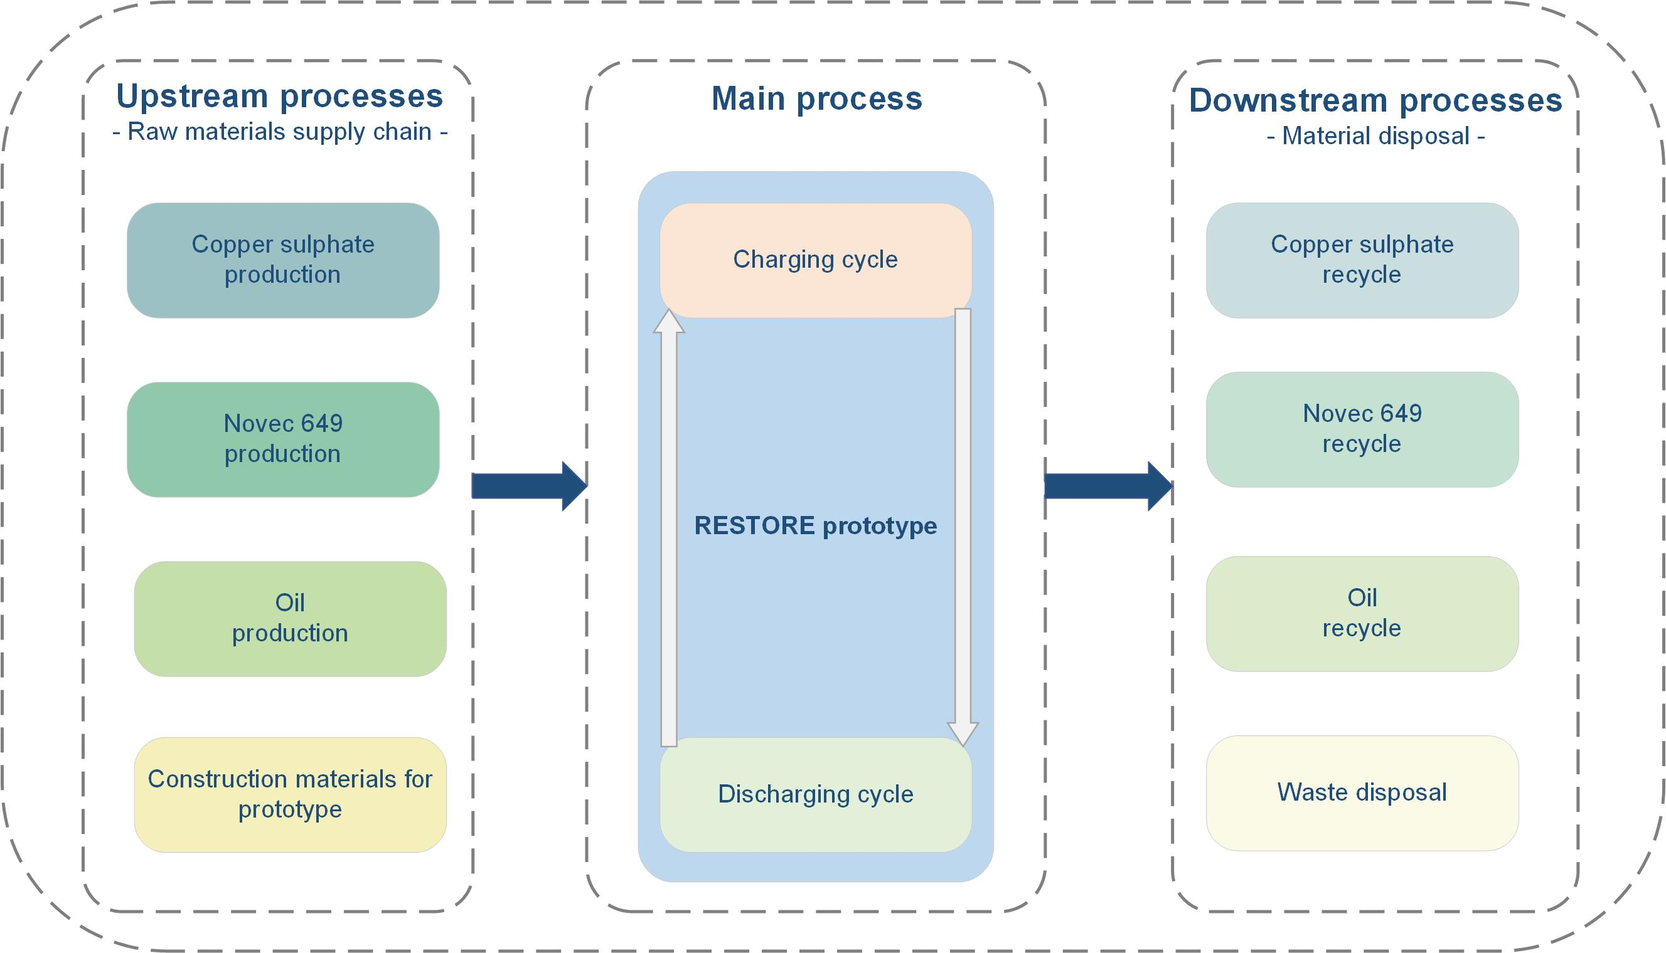

Figure 1: System boundaries for the RESTORE prototype

Given that environmental conditions, resource availability, and technology improvements may alter spatially and over time, thus it is crucial to identify both spatial and temporal limitations (Curran, 2017). Geographically and chronologically, the parameters of the system under investigation assume that there are six distinct configurations for potential placements where the plant is located in Denmark, Austria, Italy (with two locations, one near Milan and another close to a steel plant in the country's north), Slovakia, Germany, and all of them have a 25-year lifespan.

The ReCiPe 2016 impact assessment approach was used to perform the environmental analysis while keeping in mind the objective of the current investigation. The ability to calculate midpoint and endpoint impact categories, via a cause-and-effect chain, makes the ReCiPe method an improved version of both Eco-Indicator 99 and CML. The Dutch National Institute for Public Health and the Environment (RIVM), the Dutch Institute of Environmental Sciences (CML) at Leiden University, PRé Sustainability, Radboud University of Nijmegen, and CE Delft collaborated to build ReCiPe impact assessment method (Huijbregts, 2017).

The quantities presented in Table 1 were used for the reference case scenario. Each compound comes from a specific location (Europe or USA) and has a known production route.

Table 1: Assumptions considered in all chemical compounds supply chains

|  |  |  |  |
| --- | --- | --- | --- |
| Assumption | Value of the LCA model | | |
|  |  | Unit | Reference case |
| 1.01 kg of Novec 649 | Methane | kg | 30.80·10-2 |
| Chlorine | kg | 4.09 |
| Hydrofluoric acid | kg | 77.00·10-2 |
| Oxygen | kg | 5.10·10-2 |
| 2.85·10-1 kg of Copper sulphate pentahydrate | Copper | kg | 13.30·10-2 |
| Sulphuric acid | kg | 17.50·10-2 |
| 4.55 kg of Oil (90% rapeseed oil and 10% mineral oil) | Oil | kg | 4.55 |
| Construction of the RESTORE pilot plant | Platinum | kg | 8.10 |
|  | Stainless steel | kg | 1837.58 |
|  | Polyethylene | kg | 112.75 |
|  | Copper | kg | 918.40 |
|  | Brass | kg | 12.50·10-2 |

For the present LCA study, the following limitations were considered: the plant decommissioning; the maintenance and repair activities; the construction of needed infrastructure, as well as the one for means of transport; installation of unloading facilities; human activities associated with labor tasks; low-frequency, high magnitude, non-predictable events.

Table 2: Assumptions considered in all chemical compounds supply chains

|  |  |  |  |
| --- | --- | --- | --- |
| Process | Inputs | Value | Unit |
| Novec 649 supply chain | Diesel for transportation | 2.40·10-2 | kg/h |
| Methane for production | 30.80·10-2 | kg/h |
| Chlorine for production | 4.02 | kg/h |
| Hydrofluoric acid for production | 76.90·10-2 | kg/h |
| Oxygen for production | 5.10·10-2 | kg/h |
| Copper Sulphate | Diesel for transportation | 10-3 | kg/h |
| Copper for production | 11.30·10-2 | kg/h |
| Sulphuric acid for production | 17.50·10-2 | kg/h |
| Oil | Diesel for transportation | 6·10-3 | kg/h |
| Rapeseed oil | 4.55 | kg/h |
| Prototype construction | Stainless steel | 8.39·10-3 | kg/h |
| Coper | 4.19·10-3 | kg/h |
| High density Polypropylene | 5.15·10-4 | kg/h |
| Platinum | 3.70·10-5 | kg/h |
| Red brass | 5.71·10-7 | kg/h |

In LCI analysis, unit processes serve as the smallest elements for quantifying material exchanges, including resources and emissions, between a system and the environment (Hauschild and Huijbregts, 2015). These unit processes act as "black boxes", transforming a set of inputs—such as materials and natural resources—into various outputs, including products, waste, and environmental pollutants (Nuss, 2014). Data from these exchanges are organized in Table 2. This study relies exclusively on secondary data, derived from simulations conducted by means of IPSE GO, using a dedicated model library (RESTORE\_Lib) with newly created and customized components for the RESTORE project (SimTech GmbH, 2024). For Novec 649, CuSO4, and oil production, data from available literature was used.

The LCIA phase translates system flows into environmental impact categories to assess potential effects, using reference flows from the LCI. For this study, LCA for Experts software was chosen, offering access to diverse environmental databases to model material, energy use, and waste treatment. The tool also supports a variety of life cycle analyses, including ISO-compliant LCA, Life Cycle Costing, Environmental Product Declarations, and sustainability assessments.

* 1. Results and discussions

The primary goal of the interpretation stage is to derive conclusions, study limitations, and recommendations based on the concerns identified in the LCI and LCIA results, and in line with the objectives and limitations of the research. The study’s target audience should be able to easily comprehend the evaluation results once they are presented. Considering the limitations and presumptions of the study, Table 3 displays the LCA results for the investigated scenario.

Table 3: LCA results for the reference case according to ReCiPe 2016 method

|  |  |  |
| --- | --- | --- |
| KPI | Units | Reference case |
| GWP | kg CO2 eq./h | 12.15 |
| ODP·10-4 | kg CFC-11 eq./h | 1.30 |
| FEP·10-3 | kg P eq./h | 2.13 |
| FETP | kg 1.4-DB eq./h | 15.40·10-2 |
| HTPnon-cancer | kg 1.4-DB eq./h | 75.48 |
| HTPcancer | kg 1.4-DB eq./h | 18·10-2 |
| MDP | kg Cu eq./h | 67.20·10-2 |
| TETP | kg 1.4-DB eq./h | 726.93 |

* + 1. Human toxicity potential non-cancer (HTPnon-cancer)

The HTPnon-cancer evaluates the effects of toxic chemicals on human health without inducing cancer, considering factors such as environmental persistence, food chain accumulation, and toxicity (Huijbregts, 2017). The evaluation chain begins with chemical emissions that harm species, cause diseases (based on toxicity data from animals and humans), and ultimately threaten human health. In the RESTORE system, the total human toxicity potential is 75.48 kg 1.4-DB eq./h, with significant contributions from the prototype construction (85.32%) and Charging cycle (13.27%), particularly due to the oil production process. The primary environmental impacts associated with the construction of the RESTORE prototype stem not from the process itself but from the upstream production of materials such as copper and stainless steel. Hydrofluoric acid production is the main contributor in Novec 649 manufacturing, while copper production is a key factor in the toxicity of the RESTORE prototype’s construction, as can be observed in Figure 2a. Upstream manufacturing stages for materials such for example copper, stainless steel, and platinum in the prototype subsystem are highlighted as primary health risks, emphasizing the need to manage toxicity impacts from these early stages.

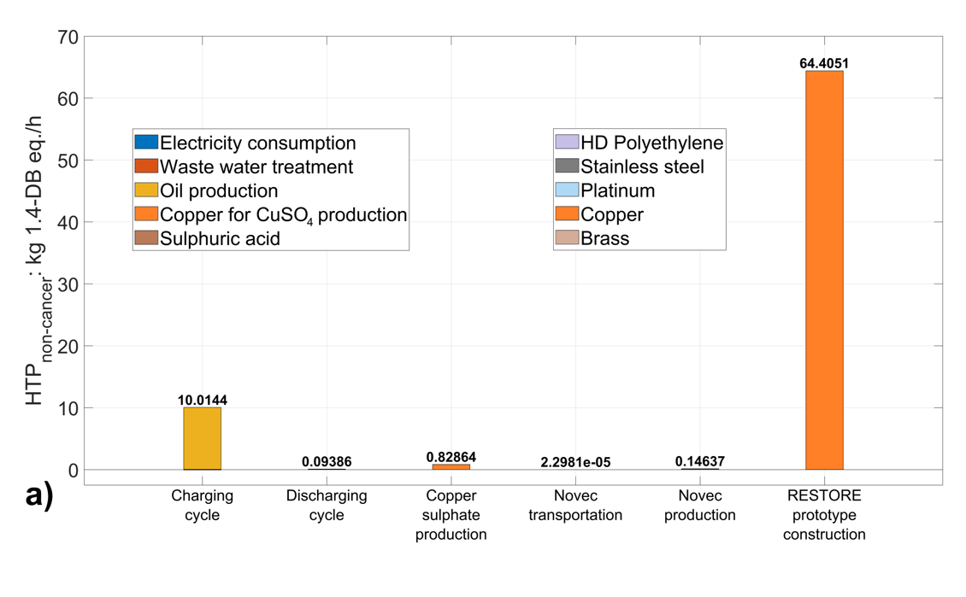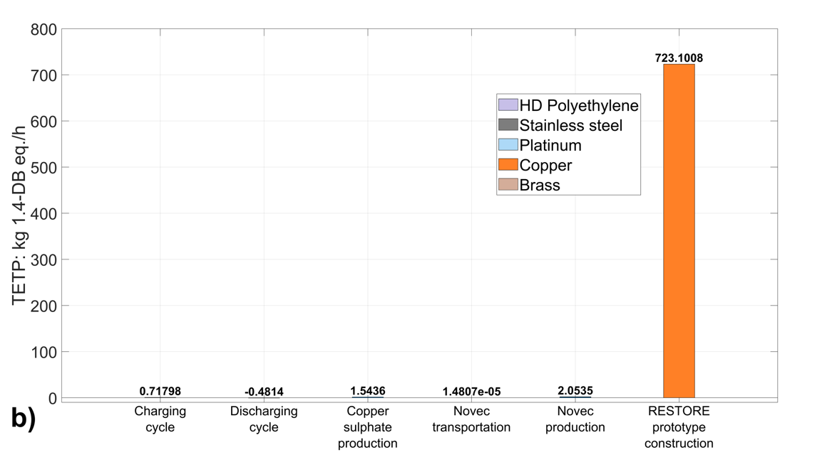

Figure 2: HTPnon-cancer distribution for the overall system

* + 1. Terrestrial ecotoxicity potential (TETP)

The TETP category reflects species loss due to elevated environmental chemical concentrations, totaling 726.93 kg 1.4-DB eq./h, with over 99% attributed to materials for the prototype construction, as can be observed in Figure 2b. TETP’s conservative estimate results from calculation methods that highlight significant contributors, including steam and sulfuric acid used in conversion processes, along with pesticide emissions into agricultural soils

* + 1. Global warming potential (GWP)

The GWP indicator, measured in kg CO₂-equivalents, assesses the climate impact of greenhouse gases in the RESTORE system, with a total GWP impact of 12.15 kg CO₂-eq./h. Key contributors to this GWP are the Charging cycle and Novec 649 production, accounting for 9.51 kg CO₂-eq./h and 5.43 kg CO₂-eq./h, respectively. The manufacturing and transportation of copper sulphate, oil, and Novec 649, along with the construction of the RESTORE prototype, have a much lower effect on the overall GWP due to their extended lifespans, as can be seen in Figure 3. The Discharging cycle counteracts emissions with a negative GWP of -3.41 kg CO₂-eq./h, largely due to its heat and electricity production, which reduces net emissions. Oil production within the Charging cycle emerges as a major GWP contributor because of its energy-intensive processes, including pre-processing, purification, and extraction steps.

Although the wastewater treatment process introduces some positive GWP, the combined impact of energy-generating subsystems ultimately creates a negative balance. Furthermore, regarding Novec 649 production, the main contributors to GWP are chlorine and hydrofluoric acid manufacturing. With an estimated 25-year lifespan, the RESTORE prototype’s construction has a relatively minor impact. This GWP breakdown identifies significant emission sources within the RESTORE system, enabling targeted strategies to mitigate climate impact, especially within high-emission subsystems like the Charging cycle and Novec 649 production.

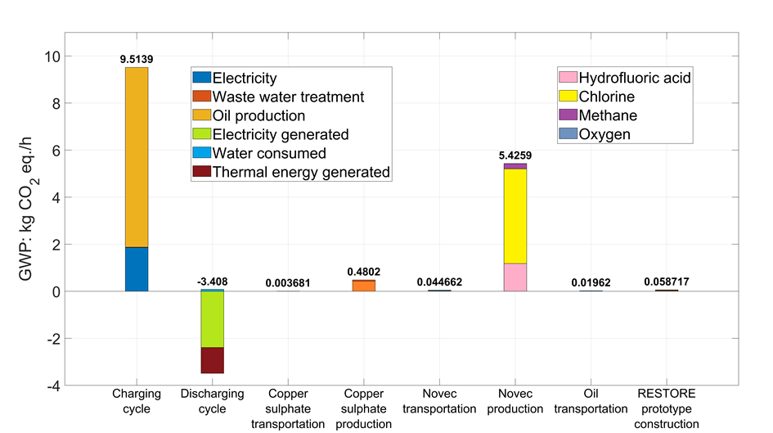

Figure 3: GWP distribution for the overall system

* 1. Conclusions

This study presents the environmental evaluation of the RESTORE prototype, as a reference case, using LCA methodology. RESTORE integrates a novel TCES system with an ORC and an HP to provide cost-effective and sustainable solutions for heating and cooling, reducing greenhouse gas emissions, air pollutants, and fossil fuel use. This approach also supports the transition to district heating and cooling powered by renewable energy.

The LCA study relies on material and energy balances acquired from modelling activities and literature data, considering upstream processes such for example raw material supply chains (i.e., Novec 649, copper sulphate, oil production), thermal energy charging and discharging cycles, and downstream processes including recycling and wastewater treatment. The traditional LCA methodology is applied across four stages: goal definition, input-output inventory, environmental impact assessment, and result analysis with suggestions for achieving further improvements.

To model the processes and evaluate the environmental effects, LCA for Experts software v.10.8 was utilized. Eight environmental key performance indicators were calculated using the ReCiPe 2016 method. GWP, HTPnon-cancer, and TETP were the most significant impact indicators found. The production of copper for the RESTORE prototype, which accounts for about 85% of the HTPnon-cancer score, and the oil supply chain, which accounts for more than 80% of the GWP impact in the charging cycle, are two important areas where improvements might greatly lessen the impacts on the environment. In addition, the investigation highlights the primary source of environmental concerns related to the RESTORE prototype as upstream material manufacturing.

Nomenclature

DHC – district heating and cooling

FEP – freshwater eutrophication potential

FETP – freshwater ecotoxicity potential

FU – functional unit

GWP – global warming potential

HTPcancer – human toxicity potential cancer

HTPnon-cancer – human toxicity potential non-cancer

LCA – life cycle assessment

LCI – life cycle inventory

LCIA – life cycle impact assessment

MDP – metal depletion potential

ODP – ozone depletion potential

ORC – organic Rankine cycle

RES – renewable energy storage

TCES – thermochemical energy storage

TETP – terrestrial ecotoxicity potential

Acknowledgments

The current work has received funding from the European Union’s Horizon 2020 research and innovation program under grant agreement No. 101036766.

References

Behzadi A., Holmberg S., Duwig C., Haghighat F., Ooka R., Sadrizadeh S., 2022, Smart design and control of thermal energy storage in low-temperature heating and high-temperature cooling systems: A comprehensive review, Renewable and Sustainable Energy Reviews, 166, 112625, 1-20.

Bian Q., 2020, Waste heat: the dominating root cause of current global warming, Environmental Systems Research, 9, 8.

Cormos A.M., Dragan S., Petrescu L., Chisalita D.A., Szima S., Sandu V.C., Cormos C.C., 2019, Reducing carbon footprint of energy-intensive applications by CO2 capture technologies: An integrated technical and environmental assessment, Chemical Engineering Transactions, 76, 1033–1038.

Cormos C.C., Dragan S., Cormos A.M., Petrescu L., 2022, Assessment of Flexible Thermochemical Energy Conversion and Storage System based on Chemical Looping Combustion, Chemical Engineering Transactions, 94, 25–30.

Curran M.A., 2017, Goal and Scope Definition in Life Cycle Assessment, Springer Netherlands, Dordrecht.

European Commission, 2024, Causes of climate change <climate.ec.europa.eu/climate-change/causes-climate-change\_en> accessed 08.09.2024.

European Union, 2020, Global and European temperatures <eea.europa.eu/en/analysis/indicators/global-and-european-temperatures> accessed 08.09.2024.

Eyidogan M., Canka Kilic F., Kaya D., Coban V., Cagman S., 2016, Investigation of Organic Rankine Cycle (ORC) technologies in Turkey from the technical and economic point of view, Renewable and Sustainable Energy Reviews, 58, 885–895.

Galusnyak S.C., Petrescu L., Chisalita D.A., Cormos C.C., 2021, Life cycle assessment of bio-methanol derived from various raw-materials, Chemical Engineering Transactions, 86, 667–672.

Hauschild M.Z., Huijbregts M.A.J., 2015, Introducing Life Cycle Impact Assessment, Springer,1–16.

Huijbregts M.A.J., 2017, ReCiPe 2016 A harmonized life cycle impact assessment method at midpoint and endpoint level Report I: Characterization, Springer.

Kalita P., Kashyap D., Bordoloi U., 2021, Thermal Energy Storage Systems for Cooling and Heating Applications. In: Photoconductivity and Photoconductive Materials: Fundamentals, Energy Storage, Wiley, 149–199.

Klüppel H.-J., 2005, The Revision of ISO Standards 14040-3 - ISO 14040: Environmental management – Life cycle assessment – Principles and framework - ISO 14044: Environmental management – Life cycle assessment – Requirements and guidelines, International Journal of Life Cycle Assessment 10, 165.

Nuss P., 2014, Life Cycle Assessment Handbook: A Guide for Environmentally Sustainable Products, John Wiley & Sons, Inc., USA.

SimTech GmbH, 2024, IPSE GO: a web-based platform for process simulations.

Wei D., Lu X., Lu Z., Gu J., 2007, Performance analysis and optimization of organic Rankine cycle (ORC) for waste heat recovery, Energy Conversion and Management, 48, 1113–1119.