|  |  |
| --- | --- |
| cetlogo ***CHEMICAL ENGINEERING TRANSACTIONS***  ***VOL. xxx, 2025*** | A publication of  aidiclogo_grande |
| The Italian Association  of Chemical Engineering  Online at www.cetjournal.it |
| Guest Editors: Fabrizio Bezzo, Flavio Manenti, Gabriele Pannocchia, Almerinda di Benedetto  Copyright © 2025, AIDIC Servizi S.r.l. **ISBN** 979-12-81206-17-5; **ISSN** 2283-9216 | |

Tribocharging and electrostatic interactions of polarisable particles in fluidised beds: a computational analysis

Maria Giordanoa, Giovanni Iozzia, Francesca O. Alfanoa, Francesco P. Di Maioa , Alberto Di Renzoa,\*

a University of Calabria, DIMES Department, Via P. Bucci, Cubo 41A, 87036 Rende (CS), Italy

alberto.direnzo@unical.it

Gas-solid fluidization is widely used in the chemical industry due to the high mass and heat transfer rates. The continuous particle-particle and particle-wall collisions cause electric charge transfer (tribocharging) and electrostatic interactions. Electrostatic charge accumulation can lead to particle agglomeration and the formation of particle layers sticking on the walls, resulting in severe operational issues. The mechanisms underlying these effects remain not completely understood: phenomena like surface charge polarisation, possibly inducing attraction between like-charged particles and between a charged particle and a neutral one, still raise debate. Simulations can help tracking macroscopic manifestations down to the individual particle scale. Current Discrete Element Method (DEM) models of tribocharging and electrostatic interactions neglect polarisation effects, limiting their predictive accuracy. In this contribution, a new model is presented, in which interactions including both net and polarisation-induced charges are accounted for. The model’s formalism is discussed and a strategy for the evaluation of electric field is presented. Then, results from CFD-DEM simulations incorporating these features are presented and discussed for a fluidized system, demonstrating its effectiveness in accurately capturing the electrostatic forces between polarisable particles.

* 1. Introduction

Fluidized bed technology is employed in a range of applications, including heterogeneous gas-solid reactions, drying, mixing, and coating. However, when no specific precautions are in place, the frequent collisions between particles and between particles and the column walls can lead to electrostatic charge transfer, resulting in a gradual build-up of charge. This accumulation can lead to significant issues, including agglomeration, wall adhesion, and, in more severe cases, sparks and explosions. For instance, in gas-solid polymerization reactors, particle agglomeration is the main cause of the solids fouling (Giffin and Mehrani, 2010; Lacks and Shinbrot, 2019; Sowinski et al., 2010). As charge builds up, particles accumulate on the walls and, because of the exothermic reaction, tend to melt in growing layers. Eventually, such accumulated layers dislodge, leading to downtime, production losses, and increased maintenance costs (Kazemi et al., 2021).

At the individual particle level, the widely used “condenser model” (Matsusaka et al., 2010), suggests that charges transfer between contacting materials based on their work function difference. So, in theory, particles in a fluidized bed should charge with one polarity and the walls with the opposite polarity. According to Coulomb’s law, this should cause the particles to repel each other, preventing agglomeration. However, experimental observations contradict this hypothesis. Some researchers related the attractive nature of such contacts to the “bipolar charging” phenomenon (Konopka et al., 2020). Another factor influencing charge behaviour in fluidized beds is induced polarisation, especially with polarisable, insulating or dielectric particles. Such phenomenon, which can occur from close interactions between charged particles or from an external electric field, has important implications. Attractive forces even between particles carrying the same charge or between charged and neutral particles, contrary to the predictions of the Coulomb’s point-charge approximation, may be present. Recent developments in CFD-DEM simulations have been extended to include tribocharging and electrostatic interactions in a variety of systems, including fluidized beds (Kazemi et al., 2021; Pei et al., 2016, 2013), aerodisperion devices (Alfano et al., 2021), pneumatic conveying lines (Grosshans and Jantač, 2023). However, none of these models accounts for surface polarisation effects. In the present work, a new model for DEM taking charged surface polarisation into account is presented and applied to a fluidized bed.

* 1. Computational model

The simulations carried out are based on a combined computational technique: DEM approach for the solid phase and a local average CFD approach for the fluid phase. For DEM the Lagrangian approach is followed:

|  |  |
| --- | --- |
| $$m_{i}\frac{{dv}_{i}}{dt}=\sum_{j=1}^{Nc}{f_{c,ij}}+f_{d,i}+f_{b,i}+f_{L,i}+f_{g,i}+f_{k,i}+\sum_{j=1}^{Mc}{f_{e,ij }}$$ $$I_{i}\frac{dω_{i}}{dt}=\sum_{j=1}^{Nc}{T_{c,ij}}+T_{r,i}$$ | (1)  (2) |

where $m_{i}$, $v_{i}$, $I_{i}$ and $ω_{i}$ are the mass, velocity, moment of inertia and angular velocity of the i-th particle respectively. The summation of external actions includes contact forces, $\sum_{j=1}^{Nc}{f_{c,ij}}$, the gas drag and pressure gradient forces, $f_{d,i}$ and $f_{b,i}$ respectively, the drag force $f_{L,i}$, the gravitational force $f_{g,i}$ and the fictitious forces $f_{k,i}$. Electrostatic forces ($f_{e,ij }$) in Equation 1 are determined by Coulomb’s law. In Equation 2 the torques considered are the contact torque $\sum_{j=1}^{Nc}{T_{c,ij}}$ and the rolling resistance ($T_{r,i}$). The fluid phase is solved by Eulerian local-average continuity and Navier-Stokes equation:

|  |  |
| --- | --- |
| $$\frac{∂ερ_{f}}{∂t}+∇⋅\left(ερ_{f}u\right)=0$$ $$\frac{Dερ_{f}u}{Dt}=-∇p+∇⋅τ+F_{fp}+ερ_{f}g$$ | (3)  (4) |

The charging dynamic is described by the condenser model (Matsusaka et al., 2000): each particle is assigned a charge which evolves according to the particle-particle and the particle-wall contacts experienced during its motion. When particles of the same material get in contact, they exchange charge only if they have different surface charge density, in the direction of equalizing it. The equations for the charge exchange between two particles (Equation 5) and between a particle and the wall (Equation 6) are presented below:

|  |  |
| --- | --- |
| $$Δq_{p-p}=kS_{m}\left(\frac{Φ_{i}-Φ_{j}}{e}+ξ\frac{z_{p}}{4πε_{0}}\left(\frac{q_{i}}{r_{i}^{2}}-\frac{q_{j}}{r_{j}^{2}}\right)\right)$$ $$Δq_{p-w}=kS_{m}\left(\frac{Φ_{i}-Φ_{s}}{e}+ξ\frac{z_{s}}{4πε_{0}}\frac{q_{i}}{r_{i}^{2}}\right)$$ | (5)  (6) |

where $k$ is the charging efficiency, $S_{m}$ is the maximum contact area during the impact, $Φ_{i}$, $Φ_{j}$ and $Φ_{s}$ are the work function of particle i, particle j and the wall respectively, $e$ is he elementary charge $ξ$ is the image correction factor, $z_{p}$ and $z_{s}$ are the cut-off distance for particle-wall and particle-particle charge transfer; $ε_{0}$ is the vacuum permittivity; $q_{i}$ and $q_{j}$ are the charges before the impact while $r_{i}$ and $r_{j}$ are particles radius.

* + 1. Novel model for electrostatic interactions

A new strategy is adopted for evaluating electrostatic interactions, considering two distinct contributions: one associated with the polarisation effect (short-range) and the other with the electric field (long-range) generated by the charged particles. For the short-range contribution, the conventional point-charge approximation is limited by its inability to represent the attraction between like-charged particles or with a neutral one. Accurate modelling of these interactions requires a more rigorous approach to charge distributions on particle surfaces, addressing local inhomogeneities with advanced mathematical methods. A novel approach based on the effective dipole has been recently proposed by Chan (Chan, 2020) for polarisable ions. In the present contribution, an extension of such approach is proposed for solid particles, where the ion volume polarisability is replaced by a function of the material dielectric constant $k_{i}$. A detailed derivation of the model is available in (Giordano et al., 2025). The effective dipole provides a means to describe the non-uniform distribution of charge and is defined as:

|  |  |
| --- | --- |
| $$p_{i}=4πε_{0}\frac{k_{i}-1}{3}r_{i}^{3}E_{i}$$ | (7) |

where $r_{i}$ is the particle’s radius and $E_{i}$ is the electric field. In the model, each particle-particle or particle-wall interaction gives rise to a temporary dipole, which represents the effect of polarisation. The short-range electrostatic force $F_{SR}$ between two interacting spheres can then be expressed in a compact form by:

|  |  |
| --- | --- |
| $$F_{SR}=K\frac{q_{i}q_{j}}{h^{2}} \frac{1-2\left(f_{ij}+f_{ji}\right)\left(1+2y\right)+2y(3+4y)}{{\left(1-4y\right)}^{2}}$$ with $f_{ij}=\frac{k_{i}-1}{3}{\left(\frac{r_{i}}{h}\right)}^{3}\frac{q_{j}}{q_{i}}$, $y=f_{ij}f_{ji}=\frac{\left(k_{i}-1\right)\left(k_{j}-1\right)}{9}{\left(\frac{r_{i}r_{j}}{h^{2}}\right)}^{3}$ and $K$ as the Coulomb constant. | (8) |

Figure 1: Absolute electrostatic force (positive is repulsive) as a function of the surface-to-surface separating distance calculated using Coulomb and Dipole models for like-charged spheres: $r_{i}=200 μm$; $r_{j}=50 μm$; $q_{i}=+0.5 pC$; $q_{j}=+5 pC$; $k_{i}=k_{j}=3$.

InFigure 1, the electrostatic force for a pair of like-charged particles with different sizes is described. As well-known, the behaviour obtained by Coulomb’s law consistently shows a repulsion: as the separation distance decreases, the repulsive force increases. For large distances, the effective dipole model displays a similar trend, indicating that the influence of surface polarisation is minimal. However, for separation distances below 225 µm, the electrostatic force turns negative, suggesting an attractive interaction between the particles. Notably, at very short distances, the attractive force becomes significantly stronger than the Coulombic repulsion. The proposed model is capable to capture the force sign inversion and the attraction between like-charged particles. Quantitative comparisons with detailed multipole expansion methods show reasonable agreement, see (Giordano et al., 2025). The approach presented for the polarisation contribution of the electrostatic force at short range is compact and integral, and it can be easily implemented in DEM-based codes.

* + 1. Evaluation of far field contributions

The second component involves modelling long-range interactions, taking the electric field generated by distant particles and walls into account. The computational strategy involves dividing the system into a grid, in which each cell is assigned a total charge $Q_{tot}$ corresponding to the sum of the charges of the particles and walls:

|  |  |
| --- | --- |
| $Q_{tot,j}=\sum_{i=1}^{n}{q_{i}}$ | (9) |

In theory, each cell interacts with all the others. To limit the computational load, a cut-off distance from each reference cell is considered, after which further contributions are neglected. The electric field in each reference cell (rc) is calculated as the sum of contributions of all surrounding cells:

|  |  |
| --- | --- |
| $E_{rc←j}=\frac{1}{4πε_{0}}\sum_{j=1}^{n}{\frac{Q_{tot, j}}{{d_{rc, j}}^{2}}}$ | (10) |

where $d_{rc,j}$ is the distance between the reference cell and the *j*-*th* cell. So, the force contribution due to long-range interaction, $F_{LR}$ is expressed as:

|  |  |
| --- | --- |
| $F_{LR}={-q}_{j}\sum_{j=1}^{m}{\overline{E_{rc←j}}}$ | (11) |

The same procedure is repeated for all the particles present in the system. The total electrostatic force on each particle is the sum of the short-range contribution from the charge and polarisation (effective dipole) effects (Equation 8) and the long-range contribution of the distant particles and walls (Equations 11).

* 1. Results
     1. Simulation of fluidized bed of polarisable particles

The charge dynamics in a small-scale fluidized bed containing polyethylene particles were simulated using the open-source CFD-DEM software MFIX (<https://mfix.netl.doe.gov>), developed by the Multiphase Flow Science group at NETL (DoE), USA (Garg et al., 2012). Custom modules implementing the point-charge and effective dipole approximations were integrated into the framework. The simulation setup replicates the geometry of the lab-scale system previously studied experimentally and through simulations by Sippola (Sippola et al., 2018). Key parameters are provided in Table 1.

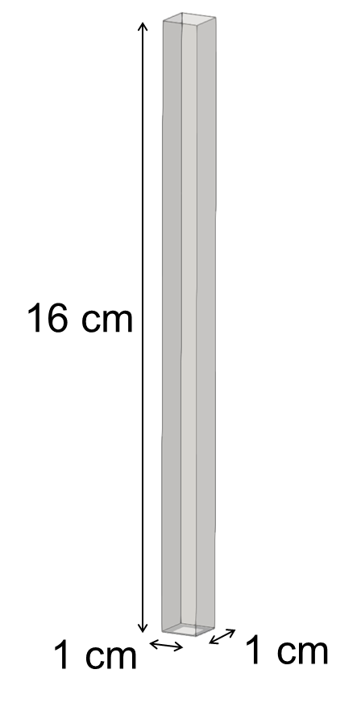

*Table 1: Simulated system parameters*

*Figure 2: Simulated geometry.*

|  |  |
| --- | --- |
| Particle diameter | 276 mm |
| Particle density (polyethylene) | 960 kg/m3 |
| Number of particles | 140400 |
| Young’s modulus | 0.063 MPa |
| Restitution coefficient | 0.9 |
| Dielectric constant | 2.25 |
| Work function difference | 1.43 eV |
| Grid size | 1 x 1 x 1 mm3 |
| Inlet air velocity | 1.50 m/s |
| Bulk superficial air velocity | 0.54 m/s |

The fluidized particles are initially neutral. They are then allowed to charge as a result of collisions with the walls and with other particles, according to the tribocharging model . In the computational code MFIX, the condenser model for charge transfer during contacts between particles (Equation 5) and with the walls (Equation 6) was implemented, see (Alfano et al., 2021) for the details. The charge evolution under three different conditions is investigated: (i) using the point-charge Coulomb’s law to evaluate electrostatic interactions, (ii) using the short-range Dipole model and (iii) considering the short-range Dipole model and the long-range far-field contribution (Dipole+LR). In Figure 3a, screenshots corresponding to the three previously described conditions are shown. As observed, the fluid dynamic regime changes significantly depending on the model used. Using Coulomb's law and the dipole model does not seem to result in dramatic differences, but when long-range interactions are included, the formation of wall multilayers, as observed in the experiments of Sippola et al. (Sippola et al., 2018), becomes evident. Figure 3b reports the trend of the averaged charge with respect to time. It is worth noting that after a certain time a plateau is reached with all the models, but the charging rate is different, with the Dipole+LR model leading to a higher charging rate and a lower saturation charge compared to the other ones. Considering that the walls are also charged and the system size is very small, only 1 cm wide (Figure 2), the presence of the walls is thought to be responsible for the accumulation of particles which, in turn, repel other particles at relatively long distances, causing the central region of the bed to be nearly emptied.

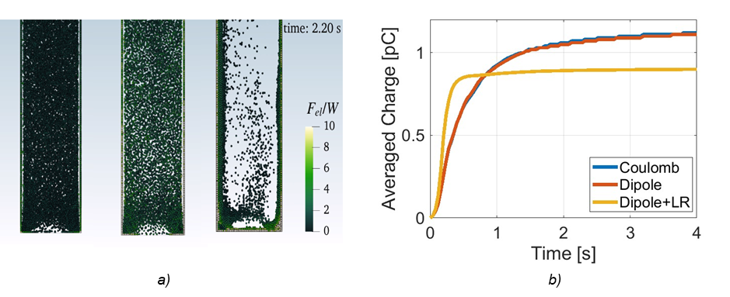

*Figure 3: a) Screenshot from simulations, from left to right: Coulomb model, Dipole model and Dipole+LR, respectively; b) Averaged charge vs. time, using the Coulomb model, the Dipole model and the Dipole+LR.*

Despite a similar behaviour in the definition of the charge dynamics, a totally different behaviour is detected in terms of electrostatic interactions. In Figure 4a, the electrostatic force divided by the particle weight averaged over all the particles over time is shown.

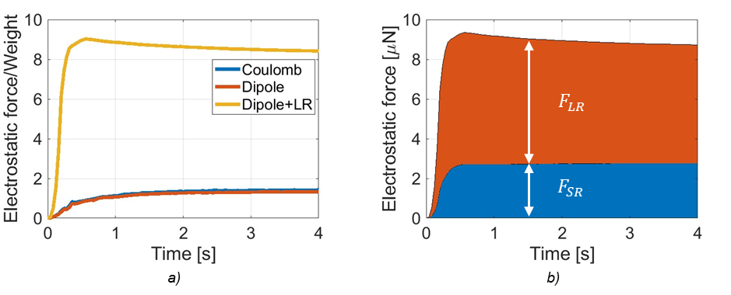

*Figure 4: a) Dimensionless electrostatic force divided by the particle weight over time. The force is averaged over all particles in the system. Electrostatic interactions are evaluated with the Coulomb model (blu), the Dipole model (red) and the Dipole model+LR (yellow). b) Quantitative analysis of individual short range and long-range contributions in the Dipole+LR model in terms of absolute force over time.*

With the Coulomb and the Dipole models, such ratio is slightly larger than 1, i.e. on average the electrostatic force slightly overcomes the particle weight. This means that the particles, primarily affected by gravity, settle at the bottom of the fluidized bed column. The Dipole+LR model predictions suggest that, after a short time, the ratio between these two forces rises much higher and very quickly, eventually reaching a plateau value above 8. In this case, particles are subjected to very high electrostatic forces, which are responsible for the formation of particle multi-layers on the column walls. For the Dipole+LR model, the relative importance of the two contributions is shown in Figure 4b: the blue area represents the averaged short-range contribution of the charge and dipole (polarisation), while the red area depicts the long-range one on account of the presence of the far electric field. As it is possible to notice, the red area has a bigger extension compared to the blue one, a demonstration that the far electric field is not negligible in the evaluation of the force. The results shown in *Figure 4* indicate that the polarization effect, which at short distances can cause significant differences compared to the point-charge approximation, does not have a noticeable impact on the fluid dynamic behaviour of the system. Far-field interactions can exert profound repulsion between the particles, eventually leading to a completely different behaviour. In particular, with the Dipole+LR model it is possible to capture the formation of the wall multilayers observed experimentally (Sippola et al., 2018), an effect that cannot be captured with either the point-charge approximation or the dipole-alone model. It is worth noting that given the small dimensions of the system, particles tend to adhere to the inner wall of the column, both due to attractive electrostatic forces between the walls and the particles, and due to the repulsive interactions among the particles themselves.

* 1. Conclusions

A new model based on the concept of effective dipole, accounting for the charge polarisation on the particle surface, is described and implemented into a CFD-DEM code, for the analysis of fluidized bed behaviour. The proposed model is compared against the point charge approximation (Coulomb’s law) emphasizing how important the role of polarisation is in detecting the attractive force in two-particles interaction. A new strategy is defined to take into account the presence of the far electric field in the evaluation of the electrostatic force.

Then, a fluidised bed is considered, where the dynamic results obtained with Coulomb’s law are compared with those of the Dipole model with and without the long-range contribution. Qualitatively, there is no striking difference in the charge dynamics. On the other hand, the Dipole model plus long-range interactions, under comparable conditions, yields a lower charging characteristic time. With regard to electrostatic forces, it has been demonstrated that their assessment requires consideration of both polarisation effects and long-range electric field contributions. The influence of particles located far from the reference cell cannot be overlooked, as it significantly affects the evaluation of electrostatic interactions. It has been demonstrated that the long-range contribution is even more important than the short-range one and it is responsible of a higher value of the electrostic force compared with the ones obtained with the other two models. This reflects in the formation of multi-layers. Overall, the proposed model effectively captures interactions at the particle level, demonstrating good agreement between simulations and experimental results. Further tests on larger units are necessary to validate the computational strategy.

Acknowledgments

This research was supported by the project ICSC National Center for High-Performance Scientific Computing, funded by the European Union – NextGenerationEU (grant number CN00000013, CUP: H23C22000360005), which is gratefully acknowledged.

References

Alfano F.O., Di Renzo A., Di Maio F.P., Ghadiri M., 2021. Computational analysis of triboelectrification due to aerodynamic powder dispersion. Powder Technology 382, 491–504. https://doi.org/10.1016/j.powtec.2021.01.011

Chan H.K., 2020. A theory for like-charge attraction of polarizable ions. Journal of Electrostatics 105. https://doi.org/10.1016/j.elstat.2020.103435

Garg R., Li T., Pannala S., Galvin J., 2012. Documentation of open-source MFIX-DEM software for gas-solids flows 1. https://mfix.netl.doe.gov/doc/mfix-archive/mfix\_current\_documentation/dem\_doc\_2012-1.pdf

Giffin A., Mehrani P., 2010. Comparison of influence of fluidization time on electrostatic charge build-up in the bubbling vs. slugging flow regimes in gas-solid fluidized beds. Journal of Electrostatics 68, 492–502. https://doi.org/10.1016/j.elstat.2010.06.013

Giordano M., Alfano F.O., Di Maio F.P., Di Renzo A., 2025. Effective dipole model for electrostatic interactions between polarizable spherical particles in particle scale simulations. Scientific Reports 15, 3121. https://doi.org/10.1038/s41598-025-86181-x

Grosshans H., Jantač S., 2023. Recent progress in CFD modeling of powder flow charging during pneumatic conveying. Chemical Engineering Journal, 455. https://doi.org/10.1016/j.cej.2022.140918

Kazemi S., Zarghami R., Mostoufi N., Sotudeh-Gharebagh R., 2021. CFD-DEM simulation of wall sheeting and particles charge in fluidized beds. Canadian Journal of Chemical Engineering 99, 1582–1594. https://doi.org/10.1002/cjce.24007

Konopka L., Jantač S., Vrzáček M., Svoboda M., Kosek J., 2020. Triboelectric charging of polyethylene powders: Comparison of same-material and different-material contributions to the charge build-up. Powder Technology 367, 713–723. https://doi.org/10.1016/j.powtec.2020.04.029

Lacks D.J., Shinbrot T., 2019. Long-standing and unresolved issues in triboelectric charging. Nature Reviews Chemistry, 8, 465-476. https://doi.org/10.1038/s41570-019-0115-1

Matsusaka S., Ghadiri M., Masuda H., 2000. Electriﬁcation of an elastic sphere by repeated impacts on a metal plate, Journal of Physics, 2311-2319. [doi:10.1016/j.ces.2005.05.001](https://dx.doi.org/10.1016/j.ces.2005.05.001)

Matsusaka S., Maruyama H., Matsuyama T., Ghadiri M., 2010. Triboelectric charging of powders: A review. Chemical Engineering Science. https://doi.org/10.1016/j.ces.2010.07.005

Pei C., Wu C.Y., Adams M., 2016. DEM-CFD analysis of contact electrification and electrostatic interactions during fluidization. Powder Technology 304, 208–217. https://doi.org/10.1016/j.powtec.2016.08.030

Pei C., Wu C.Y., England D., Byard S., Berchtold H., Adams M., 2013. Numerical analysis of contact electrification using DEM-CFD. Powder Technology 248, 34–43. https://doi.org/10.1016/j.powtec.2013.04.014

Sippola P., Kolehmainen J., Ozel A., Liu X., Saarenrinne P., Sundaresan S., 2018. Experimental and numerical study of wall layer development in a tribocharged fluidized bed. Journal of Fluid Mechanics 849, 860–884. https://doi.org/10.1017/jfm.2018.412

Sowinski A., Miller L., Mehrani P., 2010. Investigation of electrostatic charge distribution in gas-solid fluidized beds. Chemical Engineering Science 65, 2771–2781. https://doi.org/10.1016/j.ces.2010.01.008