|  |  |
| --- | --- |
| cetlogo ***CHEMICAL ENGINEERING TRANSACTIONS***  ***VOL. xxx, 2025*** | A publication of  aidiclogo_grande |
| The Italian Association  of Chemical Engineering  Online at www.cetjournal.it |
| Guest Editors: Fabrizio Bezzo, Flavio Manenti, Gabriele Pannocchia, Almerinda di Benedetto  Copyright © 2025, AIDIC Servizi S.r.l. **ISBN** 979-12-81206-17-5; **ISSN** 2283-9216 | |

Predictive Modeling of Phenolic Adsorption from Yerba Mate Extract on Commercial Activated Carbon

Marina L. Kienteca\*; Matheus S. T. Arantes; Myriam Lorena N. Cerutti; Vitor R. Silva

Department of Chemical Engineering, Federal University of Paraná (UFPR)

marinakienteca@ufpr.br

Phenolic compounds are valued for their antioxidant properties, essential in reducing oxidative stress linked to chronic diseases. Rich in these compounds, yerba mate shows promise for antioxidant extraction. Adsorption techniques, particularly using commercial activated carbon (CAC) with high surface area and porosity, are critical for isolating such compounds. This study explores the adsorption of phenolic compounds from yerba mate extract onto activated carbon, employing batch kinetic analysis and predictive modeling. Using the three-factor-three-level Box-Behnken experimental design, variables such as temperature (25, 35, 45 ºC), initial phenolic concentration (25, 50, 75 mg TPC/L), and adsorbent mass-to-liquid volume ratio (0.5, 1, 1.5) were examined. Unlike single-variable studies, this approach offers a multifactorial model to optimize adsorption. Results showed a 93.3% fit to the pseudo-second order kinetic model, indicating surface-mediated adsorption reliant on active site availability. This validates the efficacy of commercial activated carbon in such applications, suggesting future studies on qeq generalized models to enhance accuracy and efficiency in antioxidant recovery.

* 1. Introduction

Yerba mate (Ilex paraguariensis) is a plant whose tea is a traditional South American beverage, particularly celebrated in Brazil, Argentina, Paraguay, and Uruguay, where it has been consumed for centuries (Heck & De Mejia, 2007). Its rich cultural heritage and health benefits made yerba mate globally popular and its high concentration of bioactive compounds, especially phenolic compounds, exhibit strong antioxidant properties (Vieira et al., 2010) which are useful in mitigating oxidative stress, a contributor to numerous chronic health conditions (Lorigooini et al., 2020). The extraction and isolation of these phenolic compounds are crucial for applications in pharmaceuticals, food, and cosmetics, where natural antioxidants are increasingly in demand (Maximize Market Research, 2023).

Adsorption techniques are widely used to isolate phenolic compounds from plant extracts due to their efficiency in selectively capturing molecules from complex mixtures (Bibi et al., 2023). Additionally, commercial activated carbon (CAC) is cost-effective and widely available (Hoseinzadeh Hesas et al., 2015, Bosh et al., 2021). Its proven efficacy in adsorbing organic compounds further justifies its use in this study and while adsorption processes for phenolic compounds in plant extracts have been extensively studied (XU et al., 2017), limited research has focused specifically on optimizing this process for yerba mate using CAC.

Many existing studies evaluate individual variables—such as temperature, concentration, or adsorbent mass—in isolation, without fully capturing the interactive effects between these factors on adsorption efficiency (Ahmed et al., 2024; Melo et al., 2024; Sellaoui et al., 2019). This gap suggests a need for a more comprehensive approach that accounts for multiple variables simultaneously, enhancing our understanding of the adsorption kinetics and improving predictive accuracy. The objective of this study is to address this gap by examining the adsorption of phenolic compounds from yerba mate extract onto CAC through a batch kinetic analysis and multifactorial predictive modelling. By applying the Box-Behnken design, this research aims to develop a robust model that considers variable interactions, optimizing adsorption conditions and advancing the practical application of CAC in phenolic compound recovery.

* 1. Materials and Methods

This section is intended to describe the materials used as well as the methodology for preparing the yerba mate extract, phenolic adsorption and data processing, summarized in Figure 1.

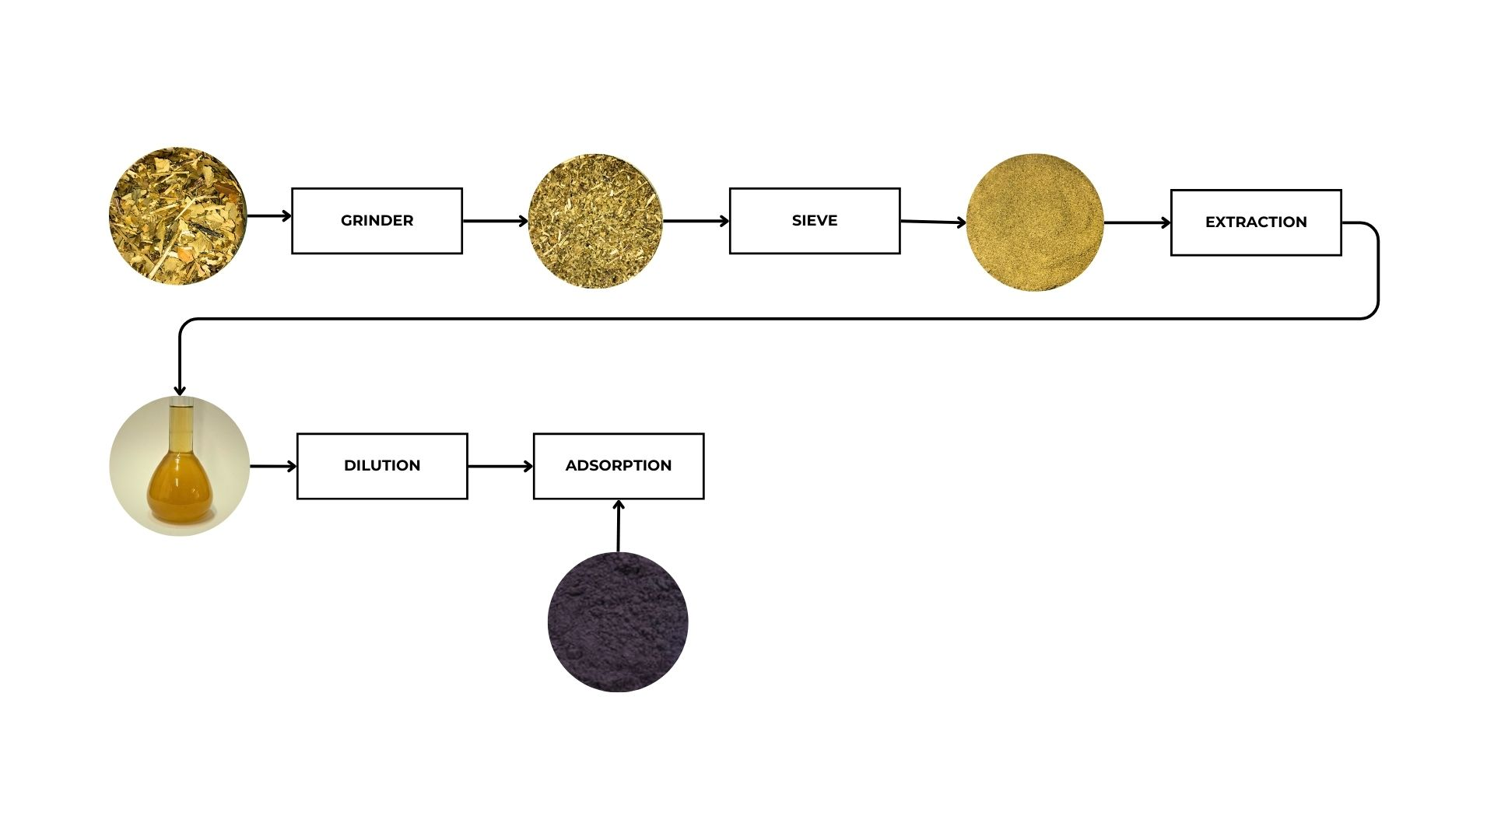

Figure 1: Steps in the yerba mate preparation, phenolic compounds extraction and adsorption

* + 1. Materials

The yerba mate used for extraction was milled and sieved *canchada* yerba mate (40 mesh). The gallic acid solutions used to construct the standard curve for total phenolic content analysis were prepared by diluting monohydrated gallic acid ((HO)₃C₆H₂CO₂H·H₂O, Sigma Aldrich, 99% purity). For the quantification of total phenolics, expressed as gallic acid equivalents by spectrophotometry, the following reagents were used: Folin-Ciocalteu reagent (2 N, Sigma Aldrich) and calcium carbonate (analytical grade, Sigma Aldrich). All chemicals used were of analytical grade. The powdered activated carbon used in this study was a donation from the company ACT. It was physically activated using steam and has a surface area of 1002 m²/g, as specified by the supplier.

* + 1. Yerba Mate extract and characterization

The preparation of the yerba mate extract is described by a systematic process, summarized in Fig. 1 and extensively described by the following text.

First, the *canchada* yerba mate is ground to a fine powder and selected through a 40-mesh sieve to ensure uniform particle size. The batch extraction, using a method adapted from Jensen & Zanoelo (2013) De Carvalho Rodrigues et al. (2015) was carried out in 1000 g of deionized water with 70 g of yerba mate leaves with constant agitation at 200 rpm for 1 hour. This process facilitates the release of phenolic compounds into the solvent. After the extraction, a concentrated yerba mate extract is obtained, which is characterized by the total phenolic content. This concentrated extract can then be used for further analysis or adsorption studies.

The total phenolic concentration (TPC) of the aqueous extract and the remaining phenolic content after the adsorption process was calculated by the Folin-Ciocalteau method Singleton et al. (1999). The absorbance is measured using a SHIMADZU 1800 UV-Vis spectrophotometer. The results are expressed as gallic acid equivalents (GAE).

* + 1. Adsorption kinetics experiments

In this study, adsorption is employed to separate phenolic compounds from yerba mate, with commercial activated carbon (CAC) chosen as the adsorbent material. The experimental design for the kinetics study of the adsorption process was based on the three-factor-three-level Box & Behnken (1960) experimental design using the software Statistica (v 10.0), which allowed for the simultaneous evaluation of multiple factors influencing the adsorption of phenolic compounds from yerba mate extract onto commercial activated carbon. The three factors examined were temperature, initial phenolic concentration, and the adsorbent mass-to-liquid volume ratio.

The temperature was varied at three levels: 25, 35, and 45ºC. The initial phenolic concentration in the extract was tested at three different concentrations: 25, 50, and 75 mg TPC/L. Additionally, the adsorbent mass-to-liquid volume ratio was adjusted to 0.5, 1, and 1.5. These values were selected to explore a wide range of conditions under which the adsorption process might vary in terms of efficiency.

The kinetics of batch adsorption (Lin & Wang, 2009) were analysed by taking samples at specific time intervals: 2, 5, 10, 30, 60, and 120 minutes. These time points were chosen to capture the dynamics of the adsorption process and monitor the reduction in phenolic concentration as a function of time. The final phenolic concentration in the liquid phase after adsorption was measured, and (Ho & Mckay, 1999)this data was used to model the kinetics and optimize the conditions for maximal adsorption efficiency. The study was run in an NT735 Orbital Incubator Shaker at 150 rpm, using the appropriate mass of activated carbon and the volume of extract placed in 125 mL Erlenmeyer flasks.

* + 1. Data and statistical modeling

This work introduces a generalized mode, as Eq(1), to describe the batch adsorption process, derived from Lagergren's models Eq(2) and Eq(3) (Ho & Mckay, 1999). The pseudo-first-order (PFO) and pseudo-second-order (PSO) models, originally proposed by Lagergren, are adapted to better represent the dynamics of adsorption by integrating their features into a unified mathematical model.

The model developed to describe the adsorption process depends on four variables: initial concentration C0, solid-liquid ratio SLR, temperature T and time t. The overall adsorption capacity qov is represented as:

|  |  |
| --- | --- |
| $$q_{ov}=q(k_{i},q_{eq},t)=q(C_{0},SLR,T,t)$$ | (1) |

Table 1: Lagergren kinetics models evaluated in the phenolics adsorption onto CAC

|  |  |  |
| --- | --- | --- |
| Model | Kinetics equation |  |
| Pseudo-first order (PFO) | $$q\left(t\right)=q_{eq}\left[1-\exp\left(-k_{1}t\right)\right]$$ | (2) |
| Pseudo-second order (PSO) | $$q\left(t\right)=\frac{q_{eq}^{2}k_{2}t}{1+q_{eq}^{2}k_{2}t}$$ | (3) |

Parameters q(t) and qeq (mg g-1) are the concentration of sorbed solute per mass of sorbent at time t (min) and at equilibrium, respectively, k1 (min-1), k2 (g mg−1 min−1), are the kinetics parameters for the PFO, PSO, kinetics models.

The rate constant ki follows the Arrhenius equation Eq(4):

|  |  |
| --- | --- |
| $$k_{i}=k_{i,0}(C_{0},SLR)⋅exp\left[-\frac{{Ea}_{i}}{R}\left(\frac{1}{T}-\frac{1}{T_{ref}}\right)\right]$$ | (4) |

This equation describes how temperature affects the adsorption, with Eai being the activation energy, the reference temperature being 298,15 K and ki,0(C0, SLR). It describes how the adsorption capacity changes based on the initial concentration of the compound and the solid-liquid ratio. These are modelled as Eq(5):

|  |  |
| --- | --- |
| $$k_{i,0}\left(C_{0},SLR\right)=a+b⋅ C_{0}+c⋅ C_{0}^{2}+d⋅SLR+e⋅{SLR}^{2}+f⋅C_{0}⋅SLR$$ | (5) |

In both the PFO and PSO models, the equilibrium adsorption capacity qeq is utilized. Its values were determined using Eq(6), derived from the relationship between the mass balance at equilibrium conditions and a linear equilibrium model:

|  |  |
| --- | --- |
| $$q_{eq}=\frac{K_{eq}⋅C_{0}}{{1+SLR⋅K}_{eq}}$$ | (6) |

The Keq constant is the equilibrium constant, which follows the Arrhenius equation Eq(7):

|  |  |
| --- | --- |
| $$K_{eq}=K_{0,i}(C_{0},SLR)⋅exp⁡\left(-\frac{E_{i}}{RT}\right)$$ | (7) |

This equation describes how temperature affects the adsorption equilibrium, with Ei​ being the activation energy. K0,i(C0, SLR) describing how the equilibrium adsorption capacity changes based on C0 and SLR. These are modelled as a linear equation Eq(8):

|  |  |
| --- | --- |
| $$K_{0,i}(C_{0},SLR)=A_{1}+A_{2}⋅C_{0}+A_{3}⋅SLR+A_{4}⋅C_{0}⋅SLR$$ | (8) |

Where the constants a, b, c, d, e, f, A1, A2, A3, A4, Eai​ and Ei​ vary depending on whether the model is PFO or PSO. By changing the parameters, two models were created to predict the adsorption behavior under different conditions, as long as the values for T, C0, and SLR are known.

The mean relative percentage error (MPE) was calculated as follows in Eq(9) using a simple mass balance from the concentrations calculated post adsorption and characterization (qexp) and the overall adsorption capacity qov calculated by Eq(1).

|  |  |
| --- | --- |
|  | (9) |

* 1. Results

The adsorption study evaluated the equilibrium adsorption capacity (qeq) for PFO and PSO models across various experimental conditions as shown in Table 2. The Keq​ values varied, with notable ranges such as 0.89–4.38 L/mg for PFO and 1.44–5.48 L/mg for PSO. The central point in the experimental design (13) was used to validate the models.

*Table 2 - Keq​ for Pseudo-First and Pseudo-Second Order Models and conditions*

|  |  |  |  |  |  |  |  |  |  |  |  |  |
| --- | --- | --- | --- | --- | --- | --- | --- | --- | --- | --- | --- | --- |
| Run | 1 | 2 | 3 | 4 | 5 | 6 | 7 | 8 | 9 | 10 | 11 | 12 |
| T (°C) | 25 | 45 | 25 | 45 | 25 | 45 | 25 | 45 | 35 | 35 | 35 | 35 |
| C0 (TPC, expressed as mg GAE/L) | 25 | 25 | 75 | 75 | 50 | 50 | 75 | 75 | 25 | 75 | 25 | 75 |
| SLR (mg of CAC/mL) | 1.0 | 1.0 | 1.0 | 1.0 | 2.0 | 2.0 | 0.67 | 0.67 | 2.0 | 2.0 | 0.67 | 0.67 |
| Keq (PFO) (L/mg) | 2.7 | 3.53 | 1.24 | 1.56 | 3.05 | 3.89 | 0.89 | 1.13 | 4.38 | 2.5 | 2.79 | 1.0 |
| Keq (PSO) (L/mg) | 3.36 | 3.88 | 2.01 | 2.25 | 4.39 | 4.97 | 1.44 | 1.63 | 5.48 | 3.84 | 3.09 | 1.53 |

* + 1. Kinetic model fit

The PFO model demonstrated a higher average error (10.4%) compared to the PSO model (6.7%) with the adjusted parameters (Table 3 and 4).

*Table 3 - Adjusted parameters for* ki,0 *for the PFO and PSO general models*

|  |  |  |  |  |  |  |  |
| --- | --- | --- | --- | --- | --- | --- | --- |
| Model | a | b | c | d | e | f | Ea |
| PFO | 9.99 10-4 | 1.95 10-3 | 1.07 10-3 | 2.01 10-3 | 2.04 10-3 | 2.36 10-3 | 100 |
| PSO | 1.03 10-3 | 5.03 10-3 | -6.96 10-3 | 2.32 10-3 | 2.96 10-3 | 3.44 10-4 | 100 |

*Table 4 - Adjusted parameters for* K0,i *for the PFO and PSO general models*

|  |  |  |  |  |  |
| --- | --- | --- | --- | --- | --- |
| Model | A1 | A2 | A3 | A4 | E |
| PFO | 2.5241 | -0.0310 | 1.0869 | -0.0008 | 9,220.2 |
| PSO | 2.4807 | -0.0286 | 1.7171 | -0.0007 | 4,688.9 |

After analysing 84 data points from the adsorption kinetics, errors were calculated for each model with Eq(10). The histogram in Figure 2a reveals that PSO model has a higher concentration of errors in the 0–5% range, signifying superior accuracy compared to the PFO model. Although both models exhibit similar distributions in the 5–20% error range, the PFO model shows a larger proportion of errors exceeding 20%. This observation underscores that, while both models are applicable, the PSO model demonstrates greater reliability and precision for describing the adsorption process under the studied conditions.

The most significant deviations in kinetic measurements occur in the initial stages (2 to 10 minutes), as shown in Figure 2b, primarily due to filtration delays after adsorption. These delays impact short-time measurements, causing higher relative errors. As the process progresses, this effect diminishes, and the errors become less significant in later stages.

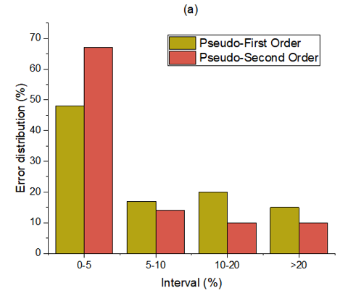 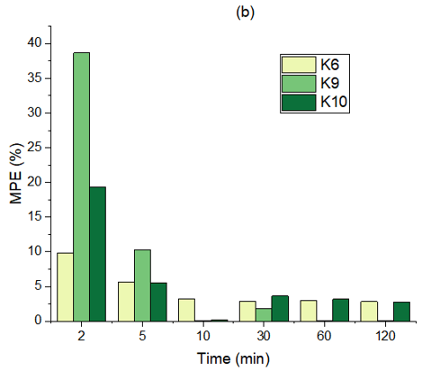

Figure 2: Histograms of the error distribution among all data (84 points) on (a) and through time for the 6, 9 and 10 kinetic datasets on PSO model (b)

The highest equilibrium adsorption capacity (qeq​) was observed in kinetic dataset 8, as shown in Figure 3a, under conditions of C0= 75 mg/L, SLR = 1.5, and 45 °C, reaching 58.42 mg/g. This dataset achieved a PSO model fit of 92.7%, which, while high, was not the highest among the datasets. Kinetic datasets 6 and 10 demonstrated the strongest adherence to the PSO model, with correlation coefficients of 98.8% and 98.5%, respectively, reflecting the model's predictive robustness (Figure 3b). Conversely, dataset 12 (Figure 3a) gathered the highest experimental adsorption capacities (86.21 mg/g after 120 min) had the lowest fit, with a correlation coefficient of 67.8%, highlighting variability in performance under certain experimental conditions.

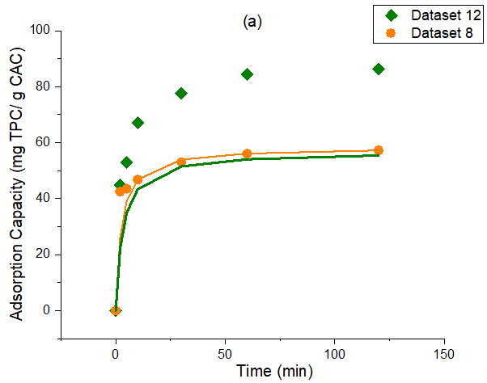 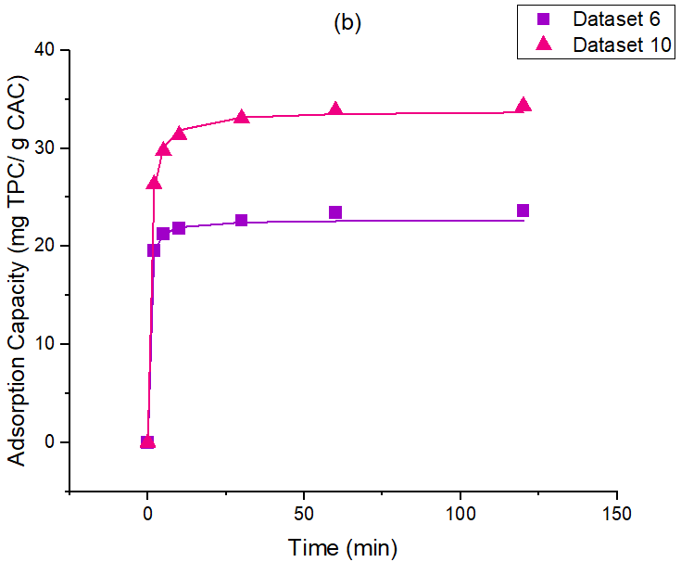

*Figure 3: Adsorption capacities. Highest values of experimental data vs. PSO model (a), and datasets 6 and 10, the best fits (b)*

* 1. Conclusions

The study demonstrated the efficacy of both PFO and PSO models in predicting adsorption kinetics (89.6% and 93.3%). However, the PSO model provided better reliability and lower average errors under most conditions. The interaction of variables such as temperature, concentration, and adsorbent ratio significantly influenced adsorption efficiency, emphasizing the importance of multifactorial approaches in process optimization The highest equilibrium adsorption capacity (qeq​) was achieved in kinetic dataset 8 under the conditions of an initial concentration (Co) of 75 mg/L, a solid-liquid ratio (SLR) of 1.5, and a temperature of 45 °C, reaching a value of 58.42 mg/g. Experimental errors at early stages due to filtration delays highlight the need for improved short-time kinetic methodologies. The study's generalized kinetic model predicts adsorption rates based on equilibrium capacity (qeq), reducing extensive experimental work by relying on minimal inputs for accurate results.

Acknowledgments

Acknowledgment is extended to the Coordination for the Improvement of Higher Education Personnel (CAPES) for providing financial support, which was fundamental to the progress and completion of this research.

References

Ahmed, S., Gogina, E., Makisha, N. & Gulshin, I., 2024. Date palm branches-based activated carbon: Synthesis via H3PO4 activation, response surface methodology, application for phenol adsorption, kinetics, and isotherm modeling. Journal of Water Process Engineering, 68. Available at: <https://doi.org/10.1016/j.jwpe.2024.106305>.

Bibi, A., Bibi, S., Abu-Dieyeh, M. & Al-Ghouti, M. A., 2023. Towards sustainable physiochemical and biological techniques for the remediation of phenol from wastewater: A review on current applications and removal mechanisms. *Journal of Cleaner Production*, 417. Available at: <https://doi.org/10.1016/j.jclepro.2023.137810>.

Bosch, D., Rendl, L., Plangger, F., Hofmann, A., & Langergraber, G. (2021). Chemical activation of biochar with H3PO4 – A comparison between two reactor types. *Chemical Engineering Transactions, 86*, 7–12. <https://doi.org/10.3303/CET2186002>

Box, G. E. P. & Behnken, D. W., 1960. Some new three-level designs for the study of quantitative variables. *Technometrics*, 2(4), pp. 455–475. Available at: <https://doi.org/10.1080/00401706.1960.10489912>.

De Carvalho Rodrigues, V., Da Silva, M. V., Dos Santos, A. R., Zielinski, A. A. F. & Haminiuk, C. W. I., 2015. Evaluation of hot and cold extraction of bioactive compounds in teas. *International Journal of Food Science and Technology*, 50(9), pp. 2038–2045. Available at: <https://doi.org/10.1111/ijfs.12858>.

Heck, C. I. & De Mejia, E. G., 2007. Yerba mate tea (Ilex paraguariensis): A comprehensive review on chemistry, health implications, and technological considerations. *Journal of Food Science*, 72(9). Available at: <https://doi.org/10.1111/j.1750-3841.2007.00535.x>.

Ho, Y. S. & Mckay, G., 1999. Pseudo-second order model for sorption processes. *Process Biochemistry*, 34.

Hoseinzadeh Hesas, R., Arami-Niya, A., Wan Daud, W. M. A. & Sahu, J. N., 2015. Microwave-assisted production of activated carbons from oil palm shell in the presence of CO2 or N2 for CO2 adsorption. *Journal of Industrial and Engineering Chemistry*, 24, pp. 196–205. Available at: <https://doi.org/10.1016/j.jiec.2014.09.029>.

Jensen, S. & Zanoelo, É. F., 2013. Kinetics of aqueous extraction of mate (Ilex paraguariensis) leaves. *Journal of Food Process Engineering*, 36(2), pp. 220–227. Available at: <https://doi.org/10.1111/j.1745-4530.2012.00675.x>.

Lin, J. & Wang, L., 2009. Comparison between linear and non-linear forms of pseudo-first-order and pseudo-second-order adsorption kinetic models for the removal of methylene blue by activated carbon. *Frontiers of Environmental Science and Engineering in China*, 3(3), pp. 320–324. Available at: <https://doi.org/10.1007/s11783-009-0030-7>.

Lorigooini, Z., Jamshidi-Kia, F. & Hosseini, Z., 2020. Analysis of aromatic acids (phenolic acids and hydroxycinnamic acids). In *Recent Advances in Natural Products Analysis*. Elsevier, pp. 199–219. Available at: <https://doi.org/10.1016/B978-0-12-816455-6.00004-4>.

MAXIMIZE MARKET RESEARCH, 2023. Phenolic Antioxidant Market – *Global Industry Analysis and Forecast* (2024-2030). Available at: <https://www.maximizemarketresearch.com/market-report/global-phenolic-antioxidant-market/25444/>.

Melo, J. M., Lütke, S. F., Igansi, A. V., Franco, D. S. P., Vicenti, J. R. M., Dotto, G. L., Pinto, L. A. A., Cadaval, T. R. S. & Felipe, C. A. S., 2024. Mass transfer and equilibrium modelings of phenol adsorption on activated carbon from olive stone. *Colloids and Surfaces A: Physicochemical and Engineering Aspects*, 680. Available at: <https://doi.org/10.1016/j.colsurfa.2023.132628>.

Sellaoui, L., Kehili, M., Lima, E. C., Thue, P. S., Bonilla-Petriciolet, A., Lamine, A. Ben, Dotto, G. L. & Erto, A., 2019. Adsorption of phenol on microwave-assisted activated carbons: Modelling and interpretation. *Journal of Molecular Liquids*, 274, pp. 309–314. Available at: <https://doi.org/10.1016/j.molliq.2018.10.098>.

Singleton, V. L., Orthofer, R. & Lamuela-Raventós, R. M., 1999. Analysis of total phenols and other oxidation substrates and antioxidants by means of Folin-Ciocalteu reagent. *Methods in Enzymology*, 299, pp. 152–178.

Vieira, M. A., Maraschin, M., Pagliosa, C. M., Podestá, R., de Simas, K. N., Rockenbach, I. I., Amboni, R. D. de M. C. & Amante, E. R., 2010. Phenolic acids and methylxanthines composition and antioxidant properties of mate (Ilex paraguariensis) residue. *Journal of Food Science*, 75(3). Available at: <https://doi.org/10.1111/j.1750-3841.2010.01548.x>.

Xu, C. C., Wang, B., Pu, Y. Q., Tao, J. S. & Zhang, T., 2017. Advances in extraction and analysis of phenolic compounds from plant materials. *Chinese Journal of Natural Medicines*, 15(10), pp. 721–731. Available at: <https://doi.org/10.1016/S1875-5364(17)30103-6>.