|  |  |
| --- | --- |
| cetlogo ***CHEMICAL ENGINEERING TRANSACTIONS***  ***VOL. xxx, 2025*** | A publication of  aidiclogo_grande |
| The Italian Association  of Chemical Engineering  Online at www.cetjournal.it |
| Guest Editors: Fabrizio Bezzo, Flavio Manenti, Gabriele Pannocchia, Almerinda di Benedetto  Copyright © 2025, AIDIC Servizi S.r.l. **ISBN** 979-12-81206-17-5; **ISSN** 2283-9216 | |

The role of hydrochar as Anaerobic Digestion process additive and CO2 adsorbent

A. Caponea\*, A. Panicoa, A. Travaglinob, L. Zaccariellob, H. Ageorgesc, B. Morronea

aDepartment of Ingegneria, University of Campania “L. Vanvitelli”, Aversa (Caserta), Italy

bDepartment of Scienze del Farmaco per l'Ambiente e la Salute, University of Campania “L. Vanvitelli”, Caserta, Italy cCNRS, IRCER, Université de Limoges, UMR 7315, F-87000 Limoges, France

annalinda.capone@unicampania.it

Hydrothermal Carbonization (HTC) is a thermochemical process that converts wet biomass into three main products: gas, liquid, and solid phase. The solid phase, hydrochar, can act as an accelerator of methane production. This article focuses on the sequential integration of HTC with Anaerobic Digestion (AD) utilizing HTC products as a boost to the AD process and CO2 capture. This study investigates the sequential integration of HTC and AD, evaluating the effect of hydrochar addition on methane production from sewage sludge under mesophilic (35°C) conditions. Various hydrochar dosages (0.5 g, 2 g, 5 g, and 8 g) were tested in batch reactors. The main outcomes indicate that hydrochar addition increased cumulative methane production in AD by up to 1100 mL under mesophilic conditions (35°C) with a 5 g hydrochar dosage, representing the optimal enhancement.

In addition, the study assesses the influence of different operational parameters, such as temperature, pressure, and hydrochar feedstock, on CO2 adsorption efficiency. By examining these variables, the study also aims to identify optimal conditions for maximizing CO2 capture, considering that chemical activation can enhance the adsorption properties of hydrochar. Comparing the effects of hydrochar in improving the performance of both AD and CO2 capture processes with those of existing materials provides a benchmark for evaluating the practical applicability of hydrochar in industrial activities.

* 1. Introduction

Hydrothermal Carbonization (HTC) has gained attention as a sustainable method for processing wet biomass, particularly problematic waste materials like sewage sludge. With its high moisture content and rich organic composition, sewage sludge presents challenges in disposal and treatment, making it a suitable raw material for HTC. This process converts the sludge into hydrochar, a carbon-rich solid with applications in bioenergy and environmental management (Wang et al., 2017).

Hydrochar enhances anaerobic digestion (AD) by improving the breakdown of organic matter and supporting microbial activity, leading to increased methane production. Beyond AD, hydrochar can be chemically modified to function as an efficient CO₂ adsorbent. These two key applications make hydrochar an important material for advancing renewable energy production and carbon capture technologies (Goel et al., 2021).

This study examines the integration of HTC and AD, evaluating the effects of hydrochar derived from sewage sludge on methane production. The research provides insights into enhancing AD performance by exploring different hydrochar dosages under mesophilic and thermophilic conditions. Additionally, it investigates the impact of operational parameters on hydrochar’s CO2 adsorption capabilities, focusing on maximizing efficiency through activation and tailored process conditions.

* + 1. HTC and AD processes

Hydrothermal carbonization (HTC) is a thermochemical process that takes place under subcritical water conditions, with temperatures ranging from 180°C to 250°C and autogenous pressures of 10–50 bar. Through dehydration, decarboxylation, and polymerization reactions, HTC transforms wet biomass into three main components: hydrochar, a liquid phase containing dissolved organic compounds and nutrients, and a minor gaseous phase primarily composed of CO₂. This method accelerates the conversion of organic matter into a stable solid form, mimicking the natural carbonization of biomass but within a much shorter timespan (Zaccariello et al., 2022a). In this study, HTC was applied to sewage sludge residues, utilizing their high moisture content to enable efficient conversion without the need for energy-intensive drying pretreatments.

AD is a microbial process that decomposes organic material in an oxygen-free environment, producing biogas and digestate. Biogas, composed primarily of methane (CH4) and carbon dioxide (CO2), is generated during methanogenesis, while the digestate contains stabilized organic material and nutrients. For this study, batch reactors were operated under mesophilic and ambient temperature conditions to evaluate the impact of HTC-derived hydrochar on methane production. Hydrochar was introduced at different dosages to analyze its potential as a process additive.

* 1. Materials and Methods

This study uses sewage sludge as the primary biomass feedstock to integrate Hydrothermal Carbonization and Anaerobic Digestion processes. Detailed characterization was performed on the raw sewage sludge and the hydrochar produced through HTC to assess their properties and potential applications.

Hydrochar was evaluated under varying dosages and operational conditions to determine its effectiveness as an additive in AD. Additionally, hydrochar underwent chemical and/or thermal activation to enhance its CO2 adsorption capacity.

* + 1. Sewage Sludge Characterization

The sewage sludge used in this study was collected from a wastewater treatment plant operated by G.O.R.I. S.p.A. near Naples, Italy. The sludge consisted of primary sludge and secondary sludge, mixed in equal proportions (50:50) for experimental purposes. This mixture was selected to represent a realistic composition of sewage sludge typically treated in wastewater facilities and served as the primary feedstock for both the Hydrothermal Carbonization and Anaerobic Digestion processes.

Characterization of the sludge included measurements of moisture content, and volatile solids (VS), conducted using standard gravimetric methods. Proximate and ultimate analyses (CHNS) were performed to assess the elemental composition of the sludge. These analyses allowed to establish baseline properties of the feedstock and evaluate its suitability for both HTC and AD processes.

All measurements were carried out in triplicate to ensure reliability and reproducibility of the results, which are discussed in detail in the Results section. This comprehensive characterization provided the necessary data to guide the experimental design and assess the potential of sludge-derived hydrochar in enhancing anaerobic digestion performance.

* + 1. Experimental Apparatus

The experimental setup for the HTC and AD processes included both pilot-scale and laboratory-scale systems, designed to replicate real operational conditions for HTC and to precisely monitor biogas production and composition during AD.

The HTC experiments were conducted using a pilot-scale reactor with a volume of 0.1 m³, constructed from AISI 316L stainless steel to ensure durability under high-pressure (2–10 MPa) and high-temperature (180–250°C) conditions (Zaccariello et al., 2022b). The reactor was designed to operate in a closed-loop system, incorporating a condenser to capture and recycle process vapors into the HTC liquor. Feedstocks were processed without the need for additional water, as sewage sludge already contained a naturally high moisture content. In this study, the water-to-dry mass ratio (𝑅) was calculated as 15.1, indicating that for every unit of dry biomass, approximately 15.1 units of water were present in the mixture. The HTC process was set to 240°C and residence times of 4 hours for sewage sludge, balancing hydrochar yield and process efficiency.

The reactor was equipped with continuous monitoring systems for temperature and pressure, along with safety features such as pressure relief valves. This setup facilitated precise control over the HTC process and systematic characterization of hydrochar properties.

The AD experiments were conducted in laboratory-scale batch reactors consisting of 500 mL glass bottles. Each bottle was fitted with a cap containing ports for sampling and gas monitoring. Gas production was measured using a syringe-based system connected to the reactors. As biogas accumulated, it displaced the syringe piston, enabling direct measurement of gas volume using the syringe's graduated scale. A valve allowed for periodic detachment of the syringe for gas analysis using a portable biogas analyzer (Nanosense DP-27 BIO). After the AD experiments, digestate samples were centrifuged and filtered for further analysis. The liquid phase was examined via GC/MS to identify volatile fatty acids (VFAs) and other metabolic by-products, providing insight into the digestion dynamics and the impact of hydrochar on biogas production.

* + 1. HTC and AD Integration

The integration of HTC and AD was studied under mesophilic conditions (35°C) using batch reactors and a setup designed to evaluate biogas production and composition accurately.

The AD experiments were conducted in 500 mL glass bottles, each loaded with 100 g of inoculum and 60 g of sewage sludge, maintaining a 1:1 volatile solid ratio between inoculum and substrate. The sewage sludge consisted of a mixture of primary and secondary sludge, prepared to ensure a balanced substrate. Hydrochar was added in four different dosages: 0.5 g, 2 g, 5 g, and 8 g, labeled respectively as HY-1, HY-2, HY-3, and HY-4. A control reactor (BLANK), without hydrochar, was included for baseline comparison.

The reactors were placed in thermostatically controlled ovens set at 35°C to maintain stable mesophilic conditions. The experiment duration generally varied between 26 and 34 days, depending on the stabilization of gas production. Gas production was monitored using a water displacement system connected to each reactor, allowing for regular measurement of cumulative biogas volumes. The composition of the biogas, specifically the concentrations of methane (CH₄) and carbon dioxide (CO₂), was analyzed using a portable biogas analyzer (Nanosense DP-27 BIO). This device measured the volume percentages of CH₄, CO₂, and trace gases such as hydrogen sulfide (H₂S) and oxygen (O₂).

The pH of the digestate was measured at the start and end of the experiments to assess the conditions for methanogenesis. Duplicate reactors were prepared for each hydrochar dosage and the control to ensure the reproducibility of the results.

This setup provided a robust framework for assessing the effects of hydrochar addition on methane production, enabling a detailed evaluation of its impact across different dosages under mesophilic conditions.

2.4 Hydrochar Activation

To enhance CO2 adsorption properties, hydrochar produced via Hydrothermal Carbonization was chemically activated using potassium hydroxide (KOH) (Jedynak and Charmas, 2024). This process aimed to increase the porosity and specific surface area of the material, optimizing it for CO2 capture.

The hydrochar was impregnated with a KOH solution prepared in ethanol to ensure even distribution of the activating agent. The mixture was stirred magnetically for one hour at room temperature, followed by thermal treatment at 600°C for two hours in a nitrogen atmosphere. This procedure facilitated the development of micropores and increased surface functionality. After activation, the hydrochar was rinsed with hydrochloric acid (HCl) and distilled water to remove residual chemicals and impurities. The activated hydrochar was then dried at 105°C for 12 hours to ensure stability.

The adsorption properties of the activated hydrochar were assessed using a thermogravimetric analyzer (TGA). The tests involved exposing hydrochar samples to a CO₂ flow under controlled temperature conditions while monitoring weight changes over time. TGA analysis was conducted through multiple adsorption-desorption cycles to evaluate both adsorption capacity and stability of the material. The results demonstrated the material's ability to consistently adsorb CO₂ while maintaining its structural integrity over repeated cycles, as presented in Section 3.3.

This activation and testing methodology emphasizing the potential of hydrochar as a cost-effective and reusable material for industrial CO₂ capture systems, addressing key requirements for performance and durability.

* 1. Results and Discussions

In this section, the results obtained from the experimental activities are presented and discussed, stressing the effects of hydrochar on anaerobic digestion (AD) performance and its behavior as a CO₂ adsorbent. The findings are divided into product characterization, influence on methane production, and CO₂ adsorption capabilities.

* + 1. Products Characterization

The sewage sludge used in this study, sourced from the wastewater treatment plant, demonstrated a high moisture content (ww) and a balanced composition of primary and secondary sludge. Proximate and ultimate analyses confirmed its high organic matter content and suitability as a feedstock for HTC and AD. The volatile solids and elemental composition of the sludge stressed its potential for transformation into valuable products.

The hydrochar produced by HTC process at 240°C for 4 hours exhibited significant alterations in its chemical and physical properties compared to raw sludge. Proximate analysis showed reduced volatile matter and an increased proportion of fixed carbon, indicating the conversion of organic matter into a more stable, carbon-rich material (Table 1). Ultimate analysis revealed an elevated carbon-to-oxygen ratio, a characteristic linked to the material's suitability for bioenergy and adsorption applications.

Table 1: Characterization Parameters for Sewage Sludge and Hydrochar

|  |  |  |  |  |  |  |  |
| --- | --- | --- | --- | --- | --- | --- | --- |
| Sample | ww [%] | VS [%] | C [%] | H [%] | N [%] | S [%] | pH |
| Sewage Sludge | 93.8±0.26 | 3.5±0.003 | 38.4±0.40 | 5.9± 0.97 | 6.56±0.03 | 0.70± 0.20 | 7.2± 0.10 |
| Hydrochar | *dried* | 16.8±0.271 | 79.4±0.11 | 5.3±0.17 | 0.43±0.05 | 0.59±0.02 |  |

SEM imaging of the hydrochar demonstrated its porous and heterogeneous structure, with particle sizes ranging from 5 to 100 µm. EDS analysis identified carbon and oxygen as the dominant elements, along with minor quantities of calcium, silicon, and other trace elements. These features enhance its functionality in processes like AD, where surface interactions are critical, and in CO2 capture when activated.

Hydrochar’s physical characteristics, such as surface area and porosity, were influenced by the HTC process conditions. The inactivated hydrochar exhibited a moderate surface area, which supports its role in enhancing microbial activity during AD. These properties were further enhanced through chemical activation, improving its adsorption capacity for CO2, as detailed in Section 3.3.

* + 1. Influence of Hydrochar on AD of Sewage Sludge

The trends observed in methane production under mesophilic conditions are presented in Figure 1. Adding hydrochar in different dosages improved cumulative methane production compared to the control reactor (BLANK). Four dosages of hydrochar were tested, labeled HY-1, HY-2, HY-3, and HY-4, corresponding to increasing amounts of hydrochar (as specified in Section 2.3).

Among the four different conditions in substrates, the system showed the highest methane production when the highest dosages of hydrochar were added with a final value of 620 mL, corresponding to an increment of 8.77% compared to the control (BLANK, 570 mL). This condition overpassed the methane production of the BLANK conditions with the HY-1 condition, which also showed an elevated value (590 mL) of methane production, with an increment of 3.51% compared to the control. These two conditions showing a superiority concerning BLANK, demonstrate differences in behavior: the HY-1 condition follows a similar trend to the control reactor, with an elevated production of methane and proficient stability. In the case of the HY-4 condition, it is possible to observe a late increase in methane production, starting from day 5 to day 15 with a plateau that stabilizes at about day 20, maintaining the most superior value compared with the other conditions.

In contrast to the HY-1 and HY-4 dosages, the dosages of 2 g and 5 g of hydrochar added to sewage sludge showed negative results as methane production compared to the control reactor. The HY-2 experiment produced 550 mL of methane, less than the control reactor by 3.51% while the HY-3 condition produced the lowest methane value (530 mL) with a decrement of 7.02% compared to the control. These trends demonstrated that adding hydrochar to the sludge in anaerobic digestion processes can improve the efficiency of the process only if added in optimal amounts.

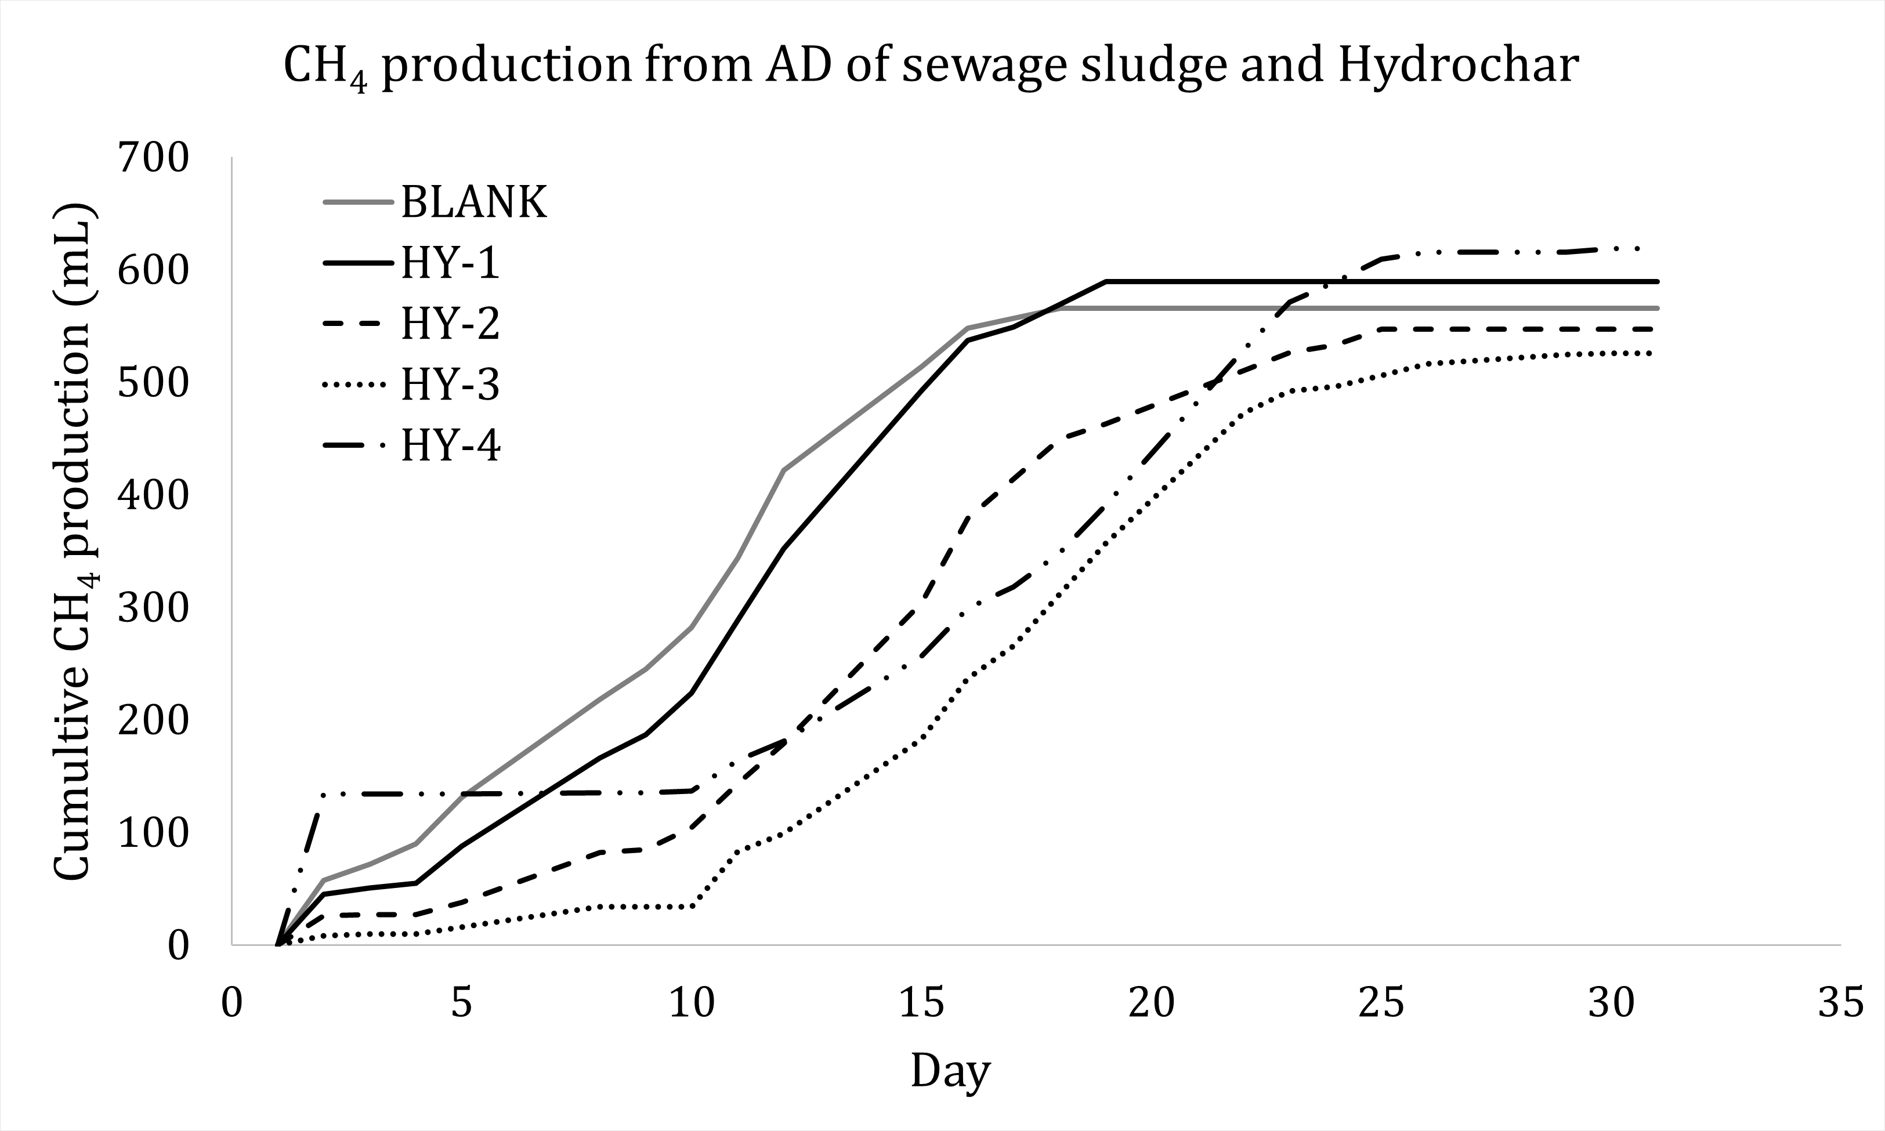

Figure 1: Cumulative methane production from AD of sewage sludge and hydrochar under mesophilic conditions

The increment of methane production when a certain amount of hydrochar was added, like for the HY-4 condition (which means 8 g added to the sludge), can be due to several mechanisms that occurred during the process. The bacteria that regulate and guide the anaerobic digestion process reactions probably used hydrochar particles as a support in the availability of organic matter to decompose (Cao et al., 2025). Furthermore, hydrochar can modulate the pH of digestate and prevent accumulation of volatile fatty acids (VFA), which in high concentrations could inhibit methanogenesis as well as act as an adsorbent for anaerobic digestion inhibitors such as toxic compounds such as ammonia or heavy metals, reducing their inhibitory effect on methanogenic bacteria (Harirchi et al., 2022). In addition, hydrochar, thanks to its carbonaceous structure and the presence of redox-active functional groups, could promote inter-species electronic transfer (DIET, Direct Interspecies Electron Transfer), facilitating methanogenic metabolism.

The worse performance of HY-2 and HY-3 could be explained by an inhibitory effect on the amount of hydrochar used, potentially due to a competition for nutrients between bacterial consortia and hydrochar, excessive adsorption of compounds useful for digestion, or a possible alteration of the microbial population as a result of changes in the digestive ecosystem.

This result suggests that the use of hydrochar has influenced methane production in varying ways. HY-1 (590 mL, +3.51%) showed a slight increase without altering the production profile, suggesting that low doses can improve the process without adverse effects. HY-4 (620 mL, +8.77%) had the highest yield, with a delayed start followed by faster growth, indicating a possible stimulant effect at high doses. In contrast, HY-2 (550 mL, - 3.51%) and HY-3 (530 mL, -7.02%) showed a decrease in productivity, suggesting an inhibitory influence at intermediate doses. Further studies will explore higher dosages to define the optimal hydrochar trend in anaerobic digestion.

* + 1. CO₂ Adsorption of Activated Hydrochar

The cyclic performance of KOH-activated hydrochar for CO₂ adsorption was evaluated using thermogravimetric analysis (TGA), as shown in Figure 3. The weight variation over time was monitored during consecutive adsorption and desorption cycles, providing insights into the stability and reusability of the material.

Figure 3 shows that during the adsorption phase, the weight of the material increases systematically from approximately 6.43 mg to 6.49 mg, corresponding to the uptake of CO₂. This increase of about 0.06 mg demonstrates the effective adsorption capacity of the activated hydrochar. During the desorption phase, the weight decreases back to the baseline values, confirming the successful release of CO₂ and the material’s regenerative behavior.

The initial rapid weight gain observed in the first adsorption cycle occurs within the first 20 minutes, where the weight rises from 6.43 mg to 6.48 mg. This increase of approximately 0.05 mg emphasizes the high affinity of the material for CO₂. In subsequent cycles, the weight variations remain consistent, with adsorption peaks stabilizing around 6.47–6.49 mg and desorption returning to approximately 6.43–6.45 mg, demonstrating the stability and structural integrity of the activated hydrochar over repeated cycles.

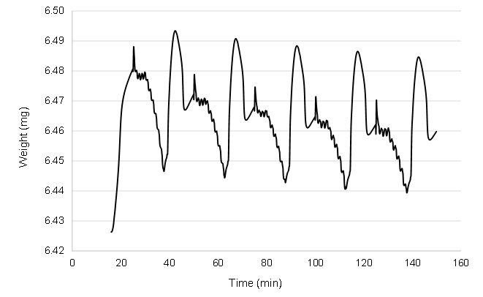

Figure 3: Cyclic CO₂ adsorption-desorption performance of KOH-activated hydrochar

These results confirm that the KOH activation process enhances the hydrochar’s capacity for CO₂ adsorption by increasing the availability of microporous structures and functional groups. Interestingly, the material exhibits excellent cyclic stability, with negligible loss in performance after five adsorption-desorption cycles. Such stability and reusability are critical for practical applications in industrial carbon capture systems.

The combination of high adsorption capacity (0.06 mg CO₂ uptake) and stable cyclic performance underscores the viability of KOH-activated hydrochar as a sustainable and efficient solution for CO₂ sequestration.

* 1. Conclusions

This study demonstrates the potential of hydrochar, produced through Hydrothermal Carbonization (HTC) of sewage sludge, as a versatile material to improve anaerobic digestion (AD) performance and promote effective capture of CO2. By integrating HTC with AD, the environmental and operational benefits of hydrochar in reusing waste, generating renewable energy, and sequestrating carbon are highlighted.

In anaerobic digestion, the addition of hydrochar has shown variable effects on methane production. HY-1 (0.5 g) increased methane production by 3.51% (590 mL) without significantly altering the process, suggesting that low doses may be beneficial with no inhibitory effects. HY-4 (8 g) achieved the highest increase (+8.77%, 620 mL), with a delayed start followed by faster growth, indicating a potential stimulus for high-dose methanogenesis. In contrast, HY-2 (2 g, 550 mL, -3.51%) and HY-3 (5 g, 530 mL, -7.02%) showed a decrease in productivity, suggesting an inhibitory influence at intermediate doses.

Hydrochar activated with KOH has shown excellent CO2 adsorption capabilities, with a constant value of about 0.06 mg CO2 per cycle, measured by thermogravimetric analysis (TGA). Even after five adsorption-desorption cycles, the material maintained its capacity with negligible losses, confirming its stability and re-usability for long-term carbon capture.

Overall, the results confirm that hydrochar is a promising material for improving anaerobic digestion and CO2 sequestration. Increasing methane production at optimal doses and stability in carbon adsorption make it a sustainable and scalable solution for waste management, renewable energy production and greenhouse gas mitigation.

Acknowledgments

The authors would like to thank Ing. Simona Scarfoglio from GORI S.p.A. for providing the sewage sludge samples and for her valuable technical support during the study. This research was carried out within the framework of the CIBUS Project, to promote innovative solutions for sustainable waste management and energy recovery, project identification number CUP: B27G22000290002.

References

Cao X., Li S., Liu C., 2025, Effect of lysozyme combined with hydrothermal pretreatment on excess sludge and anaerobic digestion. Journal of Environmental Sciences, 147, 36-49.

Goel C., Mohan S., Dinesha, P., 2021, CO2 capture by adsorption on biomass-derived activated char: a review. Science of the Total Environment, 798, 149296.

Harirchi S., Wainaina S., Sar T., Nojoumi S. A., Parchami M., Parchami M., Varjani S., Khanal S. K., Wong J., Awasthi M. K., Taherzadeh M. J., 2022, Microbiological insights into anaerobic digestion for biogas, hydrogen or volatile fatty acids (VFAs): a review. Bioengineered, 13, 6521-6557.

Jedynak K., Charmas B., 2024, Adsorption properties of biochars obtained by KOH activation. Adsorption, 30, 167-183.

Wang W., Zhao Z., Yang Q., Sun J., Peng C., Chen F., Xu Q., Wang S., Wang D., Li X., Zeng G., 2017, Evaluating the potential impact of hydrochar on the production of short-chain fatty acid from sludge anaerobic digestion, Bioresource Technology, 246, 234-241.

Zaccariello L., Battaglia D., Morrone B., Mastellone, M., 2022a, Hydrothermal carbonization: a pilot-scale reactor design for bio-waste and sludge pre-treatment. Waste and Biomass Valorization, 13, 3865-3876.

Zaccariello L., Battaglia D., Catauro M. Morrone B., Mastellone M., 2022b, Hydrothermal Carbonization of Oat in a Lab-Scale Batch Reactor, Chemical Engineering Transactions, 92, 307-312.