|  |  |
| --- | --- |
| cetlogo ***CHEMICAL ENGINEERING TRANSACTIONS***  ***VOL. xxx, 2025*** | A publication of  aidiclogo_grande |
| The Italian Association  of Chemical Engineering  Online at www.cetjournal.it |
| Guest Editors: Sauro Pierucci, Jiří Jaromír Klemeš  Copyright © 2025, AIDIC Servizi S.r.l. **ISBN** 979-12-81-206-17-5; **ISSN** 2283-9216 | |

Enhancement of gas and hydrogen yield with mechanochemically activated catalysts

Alex Kis-Ivána, Csilla Őzeb, Viktória Zsinkaa\*, Nobert Miskolczia

aDepartment of MOL Hydrocarbon and Coal Processing, Research Centre for Biochemical, Environmental and Chemical Engineering, University of Pannonia, Egyetem utca 10. Veszprém, Hungary

bDepartment of Materials Engineering, Technical Sciences Research and Development Center, University of Pannonia, Egyetem utca 10. Veszprém, Hungary

[zsinka.viktoria@mk.uni-pannon.hu](mailto:zsinka.viktoria@mk.uni-pannon.hu)

Mechanochemical activation of kaolin proved to be a promising method for enhancing hydrogen production during the thermochemical conversion of biomass. Kaolin is a naturally occurring aluminosilicate mineral in large quantities, generally exhibits low reactivity in its raw form. However, its activation by combined mechanical and chemical treatments transforms into a catalytically active material capable of promoting the production of hydrogen-rich gas. This process involves grinding and often coupled with chemical additives, which induces structural deformations and increases the specific surface area, effectively improving the reactivity of kaolin in thermal reactions. The resulting mechanochemically activated kaolin provides an improved catalytic surface for hydrogen production in processes such as pyrolysis and gasification. Mechanically induced lattice defects and increased amorphization improve the catalytic efficiency of kaolin by exposing more active sites. At the same time, chemical treatments change the acidity of the kaolin and induce cation exchange, which promotes the breaking of hydrocarbon bonds. Studies have shown that mechanochemically activated kaolin promotes water-gas shift and reforming reactions, optimizing conditions for higher hydrogen selectivity and yield by improving reaction kinetics and reducing the formation of tar byproducts. This study highlights the potential application of mechanochemically activated kaolin to promote biomass thermochemical processes for sustainable hydrogen production.

**Keywords**: mechanochemical activation, kaolin, hydrogen production, biomass gasification, catalyst

* 1. Introduction

Kaolin is a naturally occurring mineral, one of the main constituents of which is kaolinite, an aqueous aluminium silicate (M. Parades, H. Murray, 1991). In terms of structure, it is composed of octahedral sheets of alumina and tetrahedral sheets of silica. The OH groups present in the structure are converted into gel water during mechanochemical activation. Its composition is 46.54% SiO2, 39.50% Al2O3 and 13.96% water (M. Parades and H. Murray, 1991). Its first use was in porcelain production (P. A. Schroeder, 2018). The kaolin reserves of the World are currently estimated at 32 billion tons, accounting for the largest share with Brazil, US, UK and Ukraine, which equals of 78% of world’s production (J. He et al., 2019). The kaolin market has an increment tendency in the next few years, based on the statistics. It is forecasted to grow to 14.67 billion USD by 2028 with a compound annual growth rate (CAGR) of nearly 9%. In terms of use, more and more sectors are starting to utilize it. In the past, it was most widely applied in ceramics and paper production, but agriculture, cosmetics, bioceramics and medical applications have also become important markets (H. H. Murray, 2006, P. A. Alaba et al., 2015). Agglomerates have been used as catalysts since the 1930s, but several obstacles have inhibited their widespread use (P. A. Alaba et al., 2015). Kaolin has been used in many industrial processes, such as photocatalysis (P. Hu, H. Yang, 2013), ion exchange (K. G. Bhattacharrya, S. S. Gupta, 2011) or even adsorption (Q. Zhuo et al., 2007), but there are limitations that make its use difficult, such as impurities, porosity and low surface area (A. K. Panda and RK Singh, 2011, A. Vaccari, 1999). To improve these properties, various modifications are required, such as thermal activation (L. A. S. do Nacimento et al., 2011, E. Horváth et al., 2003), mechanochemical activation (E. Horváth et al., 2003, V. Vágvölgyi et al., 2008) or chemical activation (alkaline or organic or inorganic acid treatment) (L. A. S. do Nacimento et al., 2011). During thermal treatment, the water content of the kaolin, which is present as physically bounded water, is removed between 55°C and 80°C. A further change in the structure occurs at 450-600°C, when the dehydroxylation of the kaolinite particles takes place according to the following reaction, resulting in metakaolinite (V. Vágvölgyi et. al, 2008, H. Cheng et al., 2012, E. Gasparini et al., 2013).

$$Al_{2}Si_{2}O_{5}{\left(OH\right)}_{4}→Al_{2}O_{3}∙2 SiO_{2}+2 H_{2}O$$

In contrary, during mechanochemical activation, the O-H, Al-OH, Al-O-Si and Si-O bonds are broken, the formation of water occurred owing to the released OH groups and proton, which then remains in the system as gel water, as the following equation (É. Makó et al., 2001).

$$OH^{-}→H^{+}+O^{2-};H^{+}+OH^{-} ⟷H_{2}O$$

Vahiddin et al (2022) reported that grinding time does not necessarily cause a reduction in sample particle size, but it does reduce the specific surface area and turns it into an amorphous material (Vahiddin et al., 2022). Mechanical activation increases the surface activity of kaolin and results in higher ion exchange capacity (L. A. S. do Nacimento et al., 2011, F. Dellisanti, G. Valdré, 2012). The ratio of silica to aluminium in the structure of kaolin can be modified by acids and alkalines, resulting in change of the Si/Al ratio. Alkaline treatment decreases this ratio, causing a desilication of the structure. Dellisanti et al. (2012) observed that treatment at 110°C with 3M sodium hydroxide increased the surface area from 23 m2/g to 76 m2/g (F. Dellisanti, G. Valdré, 2012). Belver et al. (2002) used a solution of potassium hydroxide at 5 mol/dm3, treated the material at 90°C, calcined at 600°C for 6h and obtained results which showed the decrement surface are by more than a quarter (from 18 to 4.1 m2/g), while the Si/Al ratio changed minimally (from 1.783 to 1.74) (C. Belver et al., 2002). During acid treatment, the dealumination reaction takes place and Al3+ ions are removed from the system. Metals are applied to the surface of the catalysts to increase the hydrogen yield. An economic option could be the nickel, which can also have a positive effect on the increment of the amount of hydrogen in the gaseous product. In a study, various rare earth elements and nickel were investigated to increase the hydrogen yields on a fly ash-based zeolite substrate while lignocellulosic biomass was used as feedstock. The combination of lanthanum and nickel was found to be the most effective combination and the most resistant to coking (R. Ryczkowski et al., 2021).

The aim of this research work is to produce zeolite-type catalysts from natural feedstock (kaolin) with different procedures that can be resulted in high synthesis gas yields. Currently the production of zeolite catalysts from kaolin in biomass gasification reaction is a research gap. In our work, the effect of mechanochemical and thermal activation was investigated, also the effects on morphological changes caused by acidic and alkaline treatment, and the hydrogen generation capacity of nickel added during impregnation.

* 1. Materials & methods
     1. Raw material

Zettlitz kaolinite (Zettlitz, Czech Republic, 91% kaolinite, 7% muscovite, 2% quartz) was used in this work. The kaolin was grounded for 30 min in a planetary mill (Fritsch Pulverisette 5/4, 500 cm3 volume, stainless steel jar, 10 mm diameter stainless steel ball), after which it was modified. For reference, kaolin without mechanochemical activation was used. To impregnate the kaolin, nickel (II) nitrate (Thermo Scientific, Ni(NO3)2∙6H2O, 98%) was used in a 1 M solution. For the alkaline and acidic treatment, sodium hydroxide (VWR Prolabo Chemicals, 99%) and hydrochloric acid (Gruppo Montedison, Farmitalia Carlo Ebra S.r.l., 37%) at a concentration of 2 M were used. The applicability of the natural sourced catalysts in gasification processes using maize agricultural biomass waste has been investigated. The biomass composition was determined by CHNS-O analysis. It contains significant amounts of carbon (48.5%), oxygen (44.7%), hydrogen (6.3%) and less nitrogen (0.5%) and sulphur (1.0%). The volatile organic matter content was 75.0% with 6.5% moisture content, while the fix carbon was 16.2% and the ash content was 2.3%. Its heating value was close to 20 MJ/kg.

* + 1. Catalyst production

The process of catalyst production is illustrated in Figure 1, where 30 min grinding time was tested and modifications were carried out. Grinding was necessary due to mechano-chemical activation. Then it was calcined at 800°C in an oven for 2 hours. The purpose of the preliminary calcination is to form the metakaolinite structure. After calcination, the material was placed in the apparatus shown in Figure 2 and stirred in nickel (II) nitrate solution at 85°C for 2 hours to transfer nickel to the surface, owing to its positive effect on hydrogen production. Eventually, the kaolin was divided into three parts (Figure 1).

*Figure 1: the methods of the catalyst production*



*Figure 2: Equipment used for impregnation and acid/alkali treatment*

The acid/alkali treatment was carried out with different solutions (HCl and NaOH) with a concentration of 2 mol/dm3 and stirred at 80°C for 4 hours, to change the Si/Al ratio. After impregnation and acid/alkaline treatments, the kaolin was always filtered on filter paper and dried in a drying oven at 110°C until constant weight. Calcination after impregnation was carried out at 700°C for 3 hours, which is necessary for thermal reduction of nickel.

* + 1. Gasification and pyrolysis process

The gasification process was carried out in a two-zone tubular reactor as Figure 3 depicts. 5 g of raw material was placed in the first zone at 800°C and 2.5 g of catalyst in the second zone at 700°C. The obtained gases were passed through silica gel to bind the moisture content of the gas and then the sample was collected in a gas bag. The experiment was carried out in a nitrogen atmosphere. Peristaltic pump was used to add steam to the reaction, with water flow rate 5 g/h.

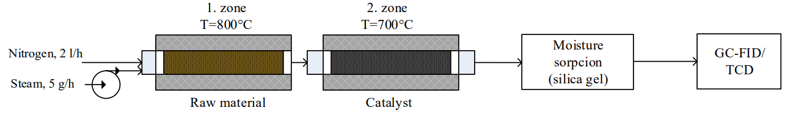

*Figure 3: Schematic drawing of the equipment*

* + 1. Product analysis

DANI gas chromatograph was used to determine the results. The chromatograph is equipped with TCD and FID detectors. The instrument is equipped with Rtx-1 PONA column of 100 m length and 0.25 mm diameter, with a stationary phase film of 0.5 μm thickness on the inner surface of the column. The measurements were carried out under isothermal conditions at 35°C. The detector and injector temperature were 230°C, while the TCD was 120°C with a heating rate of 15°C/min. Clarity software was used to evaluate the chromatograms.

The morphology of the applied catalysts and adsorbents was examined using an FEI/ThermoFisher Apreo S LoVac scanning electron microscope, while their elemental composition was determined with an EDAX AMETEK Octane Elect Plus energy-dispersive X-ray analyzer.

* 1. Results & discussion
     1. Gas analysis

Figure 4 shows the composition of the gases. It was noted that CO was the main component in all cases. As it shown in the Figure 4(b) highest amount produced with the acidic catalyst (42.7%) and the lowest with the reference (32.9%). In addition, as the Figure 4(a) shows, the experiments with the reference catalyst with steam produced the most CO2 (28.4%) and the acidic catalyst the least (7.2%) with steam. Furthermore, significant amounts of methane, 29.4% were produced with the acidic catalyst without steam. The reference catalyst proved to be the best in terms of hydrogen yield, with almost 14% hydrogen produced without steam and 21.0% hydrogen produced in the presence of steam. In contrary, the acid-treated kaolin yielded 11.9% hydrogen without steam and 17.1% hydrogen with steam. The alkali modified catalyst produced 12.5% hydrogen without and 16.8% hydrogen with steam.

Figure 5 illustrates the product yields and the H2/CO ratio. In all cases, the products were consistently produced in almost the same amount – the char was between 19.1-19.5%, the liquid phase was between 22.3-22.7% while the gas yield was about 58% – as the reactions were carried out under the same parameters in all cases.

|  |  |  |  |  |
| --- | --- | --- | --- | --- |
|  | |  |  | |
| (a) | (b) | | | (c) |
| Figure 4: Gas compositions: (a) reference, (b) acidic, (c) alkaline | | | | |

The concentration of syngas was the highest with the acidic catalyst, more than 60%. The H2/CO ratio was outstanding during the steam measurement with the reference catalyst. While in the other cases this ratio was between 0.3-0.4. It was 0.63 for the reference catalyst. Regarding the CO/CO2 ratio, it can be observed that there was no significant difference between the reference and the alkaline catalyst in the steam and steam-free measurements, but the acidic catalyst had a significantly higher ratio in (6.08) with steam.

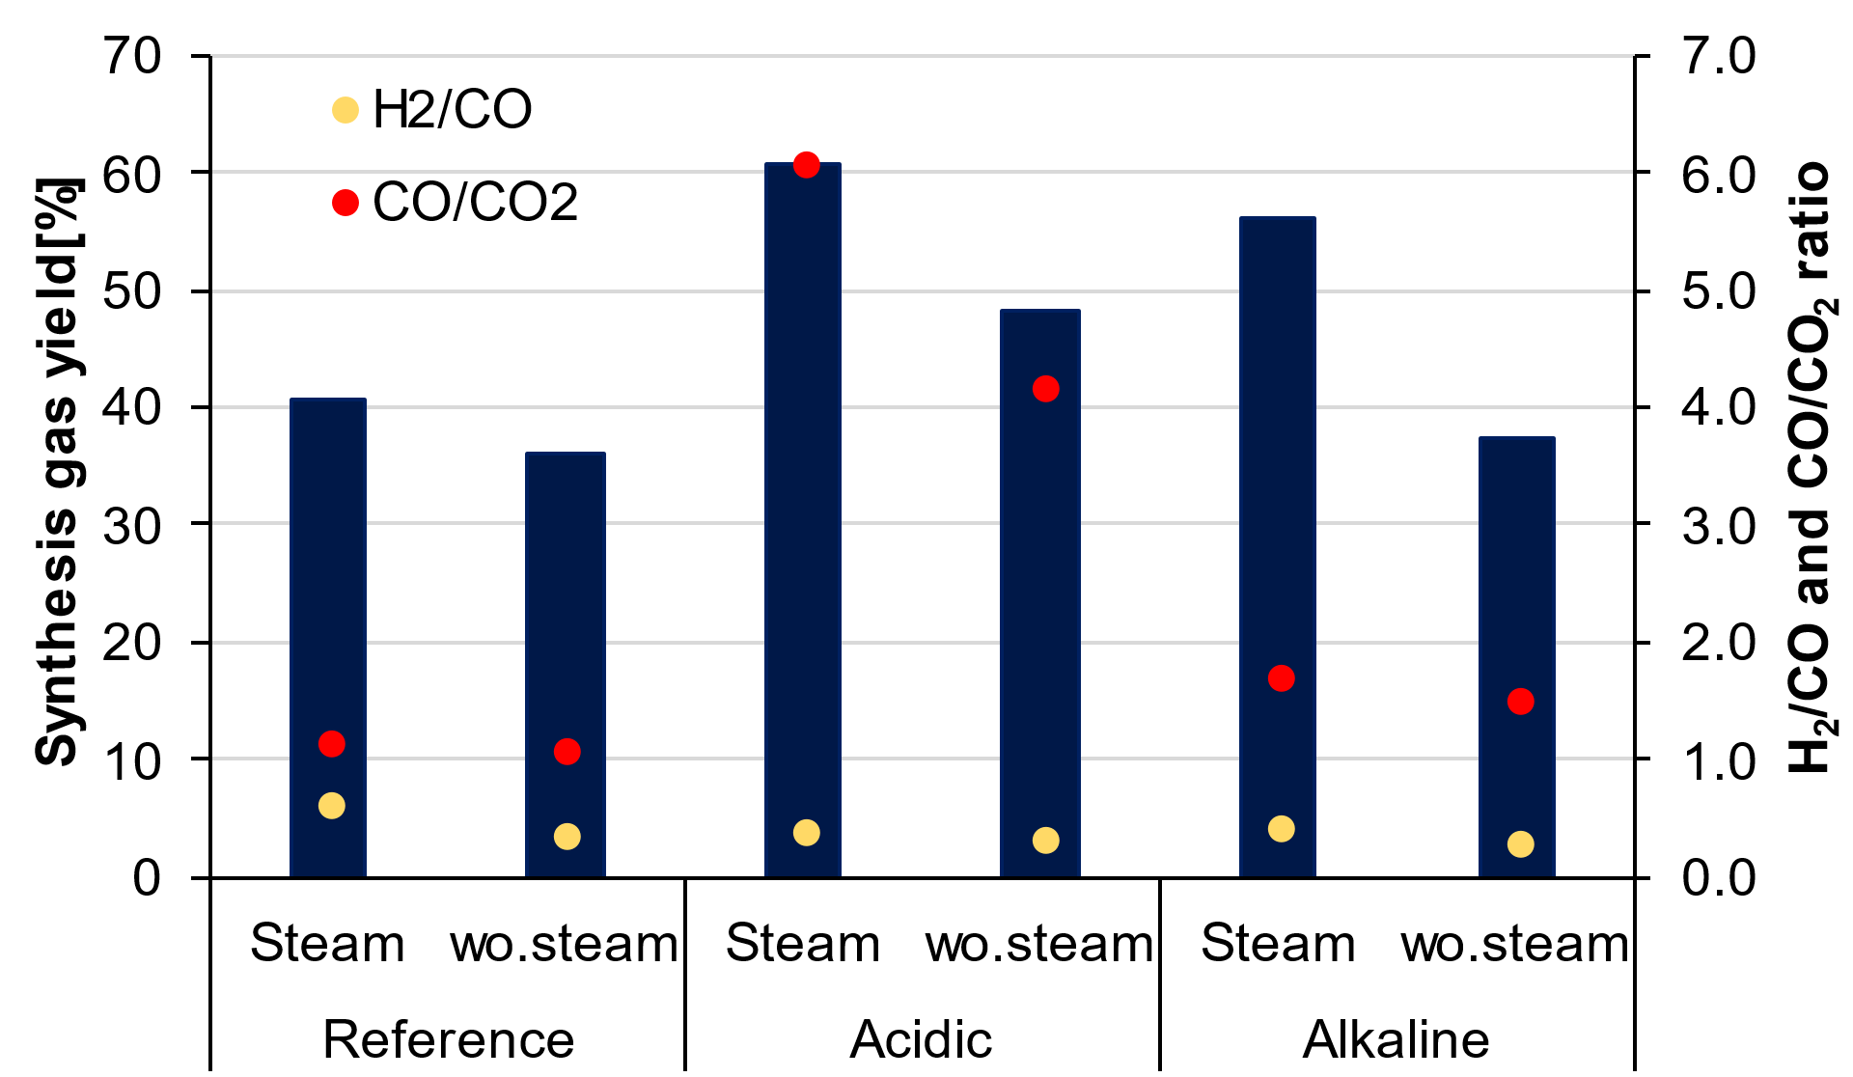

Figure 5: H2/CO and CO/CO2 ratio in the gas product

* + 1. Elemental composition

Table 1 shows the elemental composition of the produced catalysts. The catalysts prepared by alkaline treatment have the highest Na content (9.35%), which suggests a Na-zeolite structure. The Si/Al ratio for the acidic catalysts was 1.61, which is respectively the highest since a dealumination reaction took place. There is no significant difference in the ratio between the reference and the alkaline catalyst, but a decrease in the amount of Si (19.03%) can be seen compared to the reference (24.33%), due to the desilication that occurs during the alkaline treatment. These results show that the treatments after the impregnation step reduce the amount of metal added by impregnation, suggesting that the solutions actually washing off the added nickel.

Table 1: Elemental composition of catalysts (weight %)

|  |  |  |  |
| --- | --- | --- | --- |
|  | **Reference** | **Acidic** | **Alkaline** |
| **Na** | - | 0.04 | 9.35 |
| **Mg** | 0.19 | 0.27 | 0.40 |
| **Al** | 22.44 | 17.46 | 17.85 |
| **Si** | 24.33 | 28.02 | 19.03 |
| **K** | 0.65 | 0.66 | 0.53 |
| **Ca** | 0.16 | - | - |
| **Fe** | 0.77 | 0.77 | 0.68 |
| **Ni** | 2.45 | 0.85 | 1.17 |
| **O** | 49.01 | 51.82 | 50.99 |

* + 1. Morphology

The plate structure of the kaolin disappeared after 30 minutes of mechanochemical activation (Figure 6(a)). The morphology of the kaolinite samples was not influenced by the acid treatment, neither after reaction wo. steam after nor after steam gasification. Figure 6(g) shows the appearance of spherical particles on the surface of the amorphous kaolin grains, which shows the formation of poorly crystallized Na-zeolite from the reaction of amorphized kaolin and NaOH. After reaction wo. steam and steam gasification (Figure 6(h) and Figure 6(i)), poorly crystallized Na-zeolite grains can still be observed.

|  |  |  |
| --- | --- | --- |
|  |  |  |
| (a) | (b) | (c) |
|  |  |  |
| (d) | (e) | (f) |
|  |  |  |
| (g) | (h) | (i) |
| Figure 6: SEM images of the catalysts: reference: (a) before reaction, (b) after reaction wo. steam, (c) after steam gasification, acidic: (d) before reaction, (e) after reaction wo. steam, (f) after steam gasification, alkaline: (g) before reaction, (h) after reaction wo. steam, (i) after steam gasification, alkaline | | |

Conclusion

In this research, modified kaolin with a grinding time of 30 min was used as catalysts. The processes involved pre-calcination of the kaolin and wet impregnation of nickel onto the surface to increase the hydrogen yield. Then the samples were divided into three groups: one part was treated with acid, another part with alkaline to modify the Si/Al ratio, while a part was left unchanged for reference. In the last step, they were calcined in a furnace to reduce the nickel. The highest amount of hydrogen was found with the reference catalyst both with and without steam. The change in the Si/Al ratio was reflected in the less amount of CO2 and CH4, while the reaction with the acid catalyst produced a more significant amount of methane and the alkaline catalyst produced a larger amount of CO2. The amount of nickel cannot be correlated with the amount of hydrogen yield, as while most of the nickel was found on the alkaline catalyst. The composition of the gases may be more influenced by the structure formed than by the elemental composition. Most hydrogen is produced using reference catalyst with steam. Acid and alkaline catalysts produced almost identical results.

Acknowledgments

Project no. RRF-2.3.1-21-2022-00009, titled National Laboratory for Renewable Energy has been implemented with the support provided by the Recovery and Resilience Facility of the Europian Union within the framework of Programme Széchenyi Plan Plus.

**References**

Achyut K. Panda, RK Singh, 2011, Catalytic performances of kaoline and silica alumina in the thermal degradation of polypropylene, Journal of Fuel Chemistry and Technology, Vol. 39, 198-202.

A. Vaccari, 1999, Clays and catalysis: a promising future, Applied Clay Science, Vol. 14, 161-198.

Carolina Belver, Miguel Angel Banares Munoz, Miguel Angel, Vincente, 2002, Chemical Activation of a Kaolinite under Acid and Alkaline Conditions, Chemistry of Materials, Vol. 14, 2033-2043.

Erzsébet Horváth, Ray L. Frost, Éva Makó, János Kristóf, Tamás Cseh, 2003, Thermal treatment of mechanochemically activated kaolinite, Thermochimica Acta, Vol. 404, 227-234.

Éva Makó, Ray L. Frost, János Kristóf, Erzsébet Horváth, 2001, The Effect of Quartz Content on the Mechanochemical Activation of Kaolinite, Journal of Colloid and Interface Science, 359-364.

Francesco Dellisanti, Giovanni Valdré, 2012, The role of microstrain on the thermostructural behaviour of industrial kaolin deformed by ball milling at low mechanical load, International Journal of Mineral Processing, Vol. 102-103, 69-77.

Gasparini, E., Tarantino, S. C., Ghigna, P., Riccardi, M. P., Cedillo-González, E. I., Siligardi, C., Zema, M., 2013, Thermal Dehydroxylation of Kaolinite under Isothermal Conditions, Applied Clay Science, 417-425.

Haydn H. Murray, 2006, Chapter 5 Kaolin Application, Developments in Clay Science 2, Vol. 2, 85-109.

Hongfei Cheng, Qinfu Liu, Jing Yang, Songjiang Ma, Ray L. Frost, 2012, The thermal behavior of kaolinite intercalation complexes-A review, Thermochimica Acta, Vol. 545, 1-13.

Jingfeng He, Yake Yao, Wang Lu, Guanghui Long, Quiang Bai, Haifeng Wang, 2019, Cleaning and upgrading of coal-series kaolin fines via decarbonization using triboelectric separation, Journal of Cleaner Production, Vol. 228, 956-964.

Kaolin Global Market Report 2024; The Business Research Company; ID: 5769468

Krishna G. Bhattacharyya, Susmita Sen Gupta, 2011, Removal of Cu(II) by natural and acid-activated clays: An insight of adsorption isotherm, kinetic and thermodynamics, Vol. 272, 66-75.

Luís Adriano S do Nascimento, Laura MZ Tito, Romulo S Angélica, Carlos EF Da Costa, José R Zamian, Geraldo N da Rocha Filho, 2011, Esterification of oleic acid over solid acid catalysts prepared from Amazon flint kaolin, Applied Catalysis B: Environmental, Vol. 101, 495-503.

M. Paradas, K. Reid, H. Murray, 1991, Kaolin: processing, properties and applications, Applied Clay Science Vol. 6, 87-119.

Paul A. Schroeder, Kaolin, 2018, University of Georgia.

Peiwei Hu, Huaming Yang, 2013, Insight into the physicochemical aspects of kaolins with different morphologies, Applied Clay Science, Vol. 7458-65.

Peter Adeniyi Alaba, Yahaya Muhammad Sani, Wan Mohd Ashri Wan Daud, 2015, Kaolinite Properties and Advances for Solid Acid and Basic Catalyst Synthesis, RCS Advances.

Qiongfang Zhuo, Hongzhu Ma, Bo Wang, Lin Gu, 2007, Catalytic decolorization of azo-stuff with electro-coagulation method assisted by cobalt phosphomolybdate modified kaolin, Journal of Hazardous Materials, Vol. 142, 81-87.

Robert Ryczkowski, Joanna Goscianska, Rafał Panek, Wojciech Franus, Kamila Przybysz, Jacek Grams, 2021, Sustainable nickel catalyst for the conversion of lignocellulosic biomass to H2-rich gas, International Journal of Hydrogen Energy, Vol. 46, 956-964.

Vahiddin Alperen Baki, Xinyuan Ke, Andrew Heath, Juliana Calabria-Holley, Cemalettin Terzi, Murat Sirin, 2022, The impact of mechanochemical activation on the physicochemical properties and pozzolanic reactivity of kaolinite, muscovite and montmorillonite, Cement and Concrete Research; Vol. 162, 106962

Veronika Vágvölgyi, József Kovács, Erzsébet Horváth, János Kristóf, Éva Makó, 2008, Investigation of mechanochemically modified kaolinite surfaces by thermoanalytical and spectroscopic methods, Journal of Colloid and Interface Science, Vol. 317, 523-529.