|  |  |
| --- | --- |
| cetlogo ***CHEMICAL ENGINEERING TRANSACTIONS***  ***VOL. xxx, 2025*** | A publication of  aidiclogo_grande |
| The Italian Association  of Chemical Engineering  Online at www.cetjournal.it |
| Guest Editors: Fabrizio Bezzo, Flavio Manenti, Gabriele Pannocchia, Almerinda di Benedetto  Copyright © 2025, AIDIC Servizi S.r.l. **ISBN** 979-12-81206-17-5; **ISSN** 2283-9216 | |

Effect of the supercritical extraction parameters on lavender essential oil yield and composition

Sára Preiner\*, Dóra Pethő, Norbert Miskolczi

University of Pannonia, Department of MOL Hydrocarbon and Coal Processing, Egyetem street 10, H-8200 Veszprém, Hungary

preiner.sara@mk.uni-pannon.hu

The aromatic plants, also called herbs and species contain significant high amounts of essential oils which produced from different parts of the plant. Lavender essential oil is one of the most popular volatile oil. It is known for its complex chemical composition which contributes to its exceptional fragrance and aromatherapeutic properties. The extraction of lavender oil using supercritical fluid extraction is a promising alternative to conventional methods. Carbon dioxide is the most often used supercritical fluid solvent. Its solution efficiency can be influenced by the parameters (pressure, temperature). the addition of cosolvents to the supercritical fluid can enhance the solubility of non-volatile compounds and improve the extraction of complex essential oils. This work explores the influence of the cosolvent amount and CO2 flowrate on the yield and chemical composition of lavender essential oil. The *Lavandula angustifolia* type lavender was dried and milled before use. Absolute ethanol cosolvent was used in different amounts (1-3 V/V %) in the solvent which flowrate was changed between 4-8 ml/min. According to the extraction yield the increasing of the cosolvent and flowrate resulted higher amount of essential oil. The samples were analysed by GC-MS to see the effect of the parameters on the main components.

* 1. Introduction

Essential oils (EO) derived from herbs play a significant role in everyday life. Due to their numerous beneficial properties various industries including cosmetics, food and pharmaceuticals use them. One of the most commonly used EO is extracted from *Lavandula angustifolia*, also known as true lavender which also can be utilized for several applications due to its calming effect and antimicrobial and antioxidant properties (Kıvrak, 2018). The quality requirements for lavender essential oil extracted from *Lavandula angustifolia* type lavender are defined by the European Pharmacopoeia and also ISO 3515:2002. According to the standards the main components of the essential oil are as follows: limonene, 1,8-cineole, β-fellandrene, β -cis-ocimene, β -trans-ocimene, 3-octanol, camphor, linalool, linalyl acetate, 4-terpineol, lavandulyl acetate, lavandulol, and α-terpineol of which the two most abundant are linalool and linalyl acetate with their ratio in the essential oil varying between 20-45 % and 25-46 % respectively (Pokajewicz et al., 2021).

The unique composition of the essential oil can be influenced by the different extraction methods. Conventional methods including hydrodistillation, steam distillation and solvent extraction have low efficiency and yield while the time of the extraction is quite high. On the other hand, non-conventional extraction methods such as microwave-assisted or ultrasound-assisted extraction and supercritical extraction can produce high extraction yield in a short time increasing this way the efficiency (Kant and Kumar, 2022). These new methods for extracting essential oils are promising. Currently, the steam distillation technology is still the most often used in the industry since near the economic reasons. The European Pharmacopoeia defines their quality requirements for lavender oil extracted by steam distillation.

To extract lavender oil, supercritical extraction technology promises to be one of the most effective way. The extraction time can be easily reduced, while the low operating temperature prevents the degradation of the heat sensitive components. The application of it results high yield and good quality of the product. Carbon-dioxide is the most often used supercritical solvent due to its advantageous properties. The solvency of the supercritical fluid can be influenced by changing the extraction parameters. The density of the solvent can be increased by the rising of the pressure resulting better solubility of many components. The operating temperature has different effect on the solvency. While the increasing of the temperature decreases the density of the supercritical fluid the vapor pressure of the components increases. This results an opposite effect on the process. Additionally, the quality of the raw material, the amount of the used solvent (flowrate) and also the usage of any cosolvents can affect the process (Ibáñez et al., 2016). As an apolar compound, the effectiveness of the carbon-dioxide to dissolve some components of lavender oil is not high enough. Several cosolvents can be applied to increase the extraction efficiency by dissolving more components (Capuzzo et al., 2013).

Agkün et al. (2000) near the extraction pressure and temperature investigated the effect of the solvent flowrate but no significant effect was attributed to it. Adaşoğlu et al. (1994) also investigated the effect of flowrate but significant effect was not observed. The effect of the flowrate was also investigated on *Andrographis paniculate* extraction where the extraction yield increased by the rising of the flowrate (Kumoro and Hasan, 2007). It can be seen that the influence of raw material Is not negligible, while the flowrate effect on the lavender extraction is not obvious.

The investigation of several cosolvents such as ethanol, methanol, water and ethyl acetate were investigated on the extraction of the phenolic compound of different type of plants (Tyśkiewicz et al., 2018). Also, the amount of ethanol cosolvent was examined to fractionate microalgae extracts (Cejudo et al., 2022). In the case of the lavender extraction, ethanol cosolvent were used and determined that small amount of it affected the increase of the extraction yield (Cruz-Sánchez et al., 2024).

The effect of several parameters such as pressure, temperature and extraction time were investigated in case of lavender oil extraction. Near these parameters, the flowrate and the addition of cosolvents were also examined although not as deep as the pressure and temperature. The aim of this study is to examine the effect of changing the amount of cosolvent while varying the solvent flowrate. The impact of these parameter changes on the lavender oil was observed and ranked on the yield and composition.

* 1. Materials and methods

*Lavandula angustifolia* plant was collected in Tihany (46.90891°N,17.87923°E), Hungary in the harvesting season of 2023. The plants were dried after the harvest at room temperature until constant mass. For the supercritical extraction measurements, the flower part of the plant was used which moisture content was below 5 m/m %. The solvent used for the extraction was 4.5 purity CO2 (Messer) and absolute ethanol (99.8 % G.R., ISO reagent, Lach-Ner s.r.o.) as cosolvent. The supercritical extraction apparatus can be seen on Figure 1.



Figure 1 Schematic figure of the supercritical extraction apparatus 1: CO2 flask, 2: EtOH tank, 3: Degasser, 4: CO2 delivery pump, 5: Cosolvent pump, 6: Dynamic mixer, 7: Thermostat, 8: Extraction vessel, 9: Back pressure regulator, 10: Sample container

The equipment consists of a CO2 tank and a cosolvent tank. The rest of the elements are the CO2 delivery pump and the cosolvent pump, extraction vessel, thermostat and the back-pressure regulator which ensures the appropriate pressure through the experiments. The lavender flowers were grounded before use and the particle size was between 0.8-2 mm. The extraction vessel was filled with the flower and placed in the thermostat. Through the experimental work 18 measurements were performed where the pressure and the time of the extraction were constant, 100 bar and 1 h respectively. The investigation of the flowrate and the cosolvent amount on the extraction yield and composition was executed on two different temperature values. The parameter combinations were performed with three flowrate (4,6,8 ml/min) and three cosolvent amount (1,2,3 V/V %) on two different temperatures (40,50 °C).

The performance of the supercritical extraction was analysed by the extraction yield and the composition of the lavender oil. The extraction yield was calculated by the ratio of extracted lavender oil to measured flower based on Eq. (1).

|  |  |
| --- | --- |
| $$Yield \left(\frac{m}{m}\%\right)=\frac{Extracted lavender oil (g)}{Weight of measured lavender (g)}$$ | (1) |

To define the effect of the variables on the composition, the extracted lavender oils were analysed by gas chromatography. Shimadzu GC 2010 (Shimadzu, Kyoto Japan) type of gas chromatograph was used with an Equity-1-column (30.0 m × 0.25 mm; film thickness 0.25 µm) and FID detector. The injector and detector temperatures were set on 280 °C and 1 µL of sample was injected on the column. The heating rate started at 50 °C and was programmed at 10 °C/min until 280 °C.

* 1. Results and discussion

In the following sections the effect of the above-mentioned parameters will be showcased on the extraction yield and composition.

* + 1. Extraction yield

The measurements were performed at 40 °C and 50 °C since the supercritical state is ensured at 40 °C at this pressure and it is advisable to use low temperature to avoid the degradation of volatile components. For this purpose, the examination of the temperature effect was performed on as low value as possible. After the calculation of the extraction yield in this study the lowest value was 2.15 m/m % while the highest reached yield was 7.27 m/m %. It is evident from these two values, that the variability of the result is significant due to the changes in the parameters. In Figure 2 the effect of the cosolvent amount and flowrate are presented in case of the 40 °C extraction temperature.



Figure 2 Effect of the flowrate and cosolvent amount on the extraction yield at 40 °C

Figure 2 shows that on 40 °C extraction temperature, the increasing of the cosolvent amount has a positive effect on the extraction yield. At 4 ml/min flowrate nearly identical extraction yields at around 3 m/m % could have been achieved. In case of 6 ml/min flowrate the amount of cosolvent had a more significant impact. The extraction yields developed as 3.41 and 3.7 m/m % in case of 1 or 2 V/V % applied cosolvent respectively, while the highest amount of it resulted 5 m/m % yield. At the highest flowrate the yield values were 3.49, 5.38 and 7.14 m/m % for the 1,2 and 3 V/V % cosolvent amounts respectively. Overall, increasing both parameters positively impacted the recoverable essential oil yield. As mentioned above the measurements were performed also at 50 °C. The yield results obtained at higher temperature are shown on Figure 3.



Figure 3 Effect of the flowrate and cosolvent amount on the extraction yield at 50 °C

In case of the measurements completed at 50 °C the amount of the yield has a maximum value at 6 ml/min, 4.59, 6.21 and 7.27 m/m % at different cosolvent amounts, while the effect of the cosolvent amount was the same as at 40 °C. By rising the temperature, the density of the supercritical fluid and also the solvency decreases but in parallel the vapor pressure of the compounds grows which helps their solubility in the fluid. This effect is valid at lower flowrates since higher amount of oil could have extracted at higher temperature, while at 8 ml/min the decreased density is determinate. Overall, by rising the temperature higher amount of oil can be extracted than at 40 °C but because of the decreased density of the fluid the solvency of many components significantly decreases by rising the flowrate.

* + 1. Chemical composition

In the compositional analysis of the samples 19 different components were identified. The variation ranges of these compounds are summarized in Table 1.

Table 1 The variation ranges in the compositions of 18 samples

|  |  |  |  |
| --- | --- | --- | --- |
| Component | Variation range (m/m %) | Component | Variation range (m/m %) |
| α-pinene | 0.41-3.79 | hexyl butyrate | 0.3-1.13 |
| 1,8-cineole | 0.17-1.61 | linalyl acetate | 26.29-50.65 |
| β-trans-ocimene | 0.43-3.52 | lavandulyl acetate | 0.84-10.89 |
| γ-terpinene | 0.34-4.44 | geranyl acetate | 0.65-3.4 |
| p-menthan-1-ol | 0.66-3.39 | β -caryophyllene | 0.28-1.89 |
| linalool | 7.39-22.69 | santalene | 0.70-5.64 |
| 2-hexenyl acetate | 1.19-2.68 | α -caryophyllene | 0.50-3.90 |
| lavandulol | 0.61-2.40 | germacrene-D | 0.43-2.76 |
| camphor | 1.02-2.37 | caryophyllene oxide | 1.32-12.74 |
| 4-terpineol | 1.61-13.88 | other | 3.81-45.61 |

The high variation range of the components can be seen in Table 1. In general, the essential oils contain the highest amount of the two main components. Additionally, in certain cases there are notable amount of 4-terpineol, lavandulyl acetate and caryophyllene oxide. The objective was not to identify the optimal parameter combination, but rather to examine the effect of the parameters on both composition and yield. A pairplot was utilized to demonstrate the existence of linear relationships between the parameters. To explore the impact of variables, Pearson correlation study was conducted based on the experimental data (Sedgwick, 2012). The Pearson correlation coefficients shows the relationship between the variables while a significance test was made to specify the p-values of the coefficients. In consideration of better transparency and the requirements of the ISO standard, the analysis of the correlation study focuses on the components defined in the standard and also in Table 1. The results of the correlation coefficients and the p-values are represented on Figure 4 and Figure 5 respectively.

Figure 4 shows the effect of the temperature with a lightly positive correlation for the extraction yield is observed. In contrast, temperature has a greater impact in terms of chemical composition. Mild negative correlation values can be seen with β-trans-ocimene (-0.17), while strongly negative effect is observed with linalool (-0.9), 4-terpineol (-0.75), linalyl-acetate (-0.42) and lavandulyl acetate (-0.55). The proportion of these components decreases with rising temperature while the ratio of lavandulol and camphor slightly increased in these experiments performed at 100 bar. A strong positive correlation is observed for the other components which means that with increasing temperature more components, which are not listed in the standard are extracted from the plant.

In case of the flowrate positive correlation coefficient belongs to the extraction yield (0.45) and also lighter positive effect can be seen with linalool (0.18), linalyl acetate (0.16) and lavandulyl acetate (0.23). Negative effects are shown with β-trans ocimene (-0.25), lavandulol (-0.41) and camphor (-0.37) while there is no significant effect with 4-terpineol and other components.

Among the examined parameters cosolvent amount effects the most positively the extraction yield (0.49) but it has lighter effect on the chemical composition. For each component the negative or positive correlation coefficients are smaller corresponded to the other two parameters.

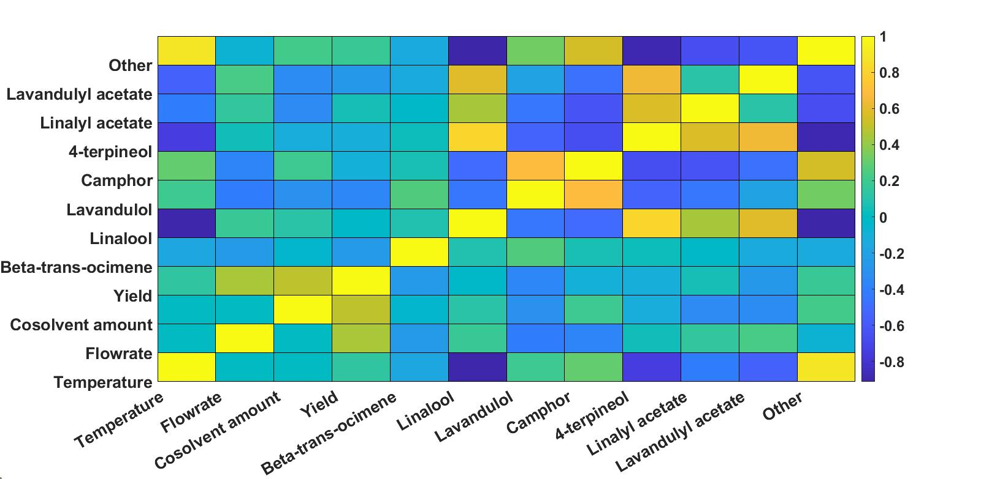

Figure 4 Pearson correlation coefficients of the yield, composition and the investigated parameters

Regarding p-values zero value were observed between temperature and linalool and others. Almost zero p-value was performed by 4-terpineol (0.0003), lavandulyl acetate (0.017) and linalyl acetate (0.09). The flowrate received low value for yield (0.06) while in case of the components, lavandulol and camphor reached the lowest values of 0.09 and 0.12 respectively. For the cosolvent quantity also the yield received the lowest value (0.04) while among the components lavandulol, linalyl acetate and lavandulyl acetate can be highlighted with the p-vales of 0.22, 0.16 and 0.17 respectively.

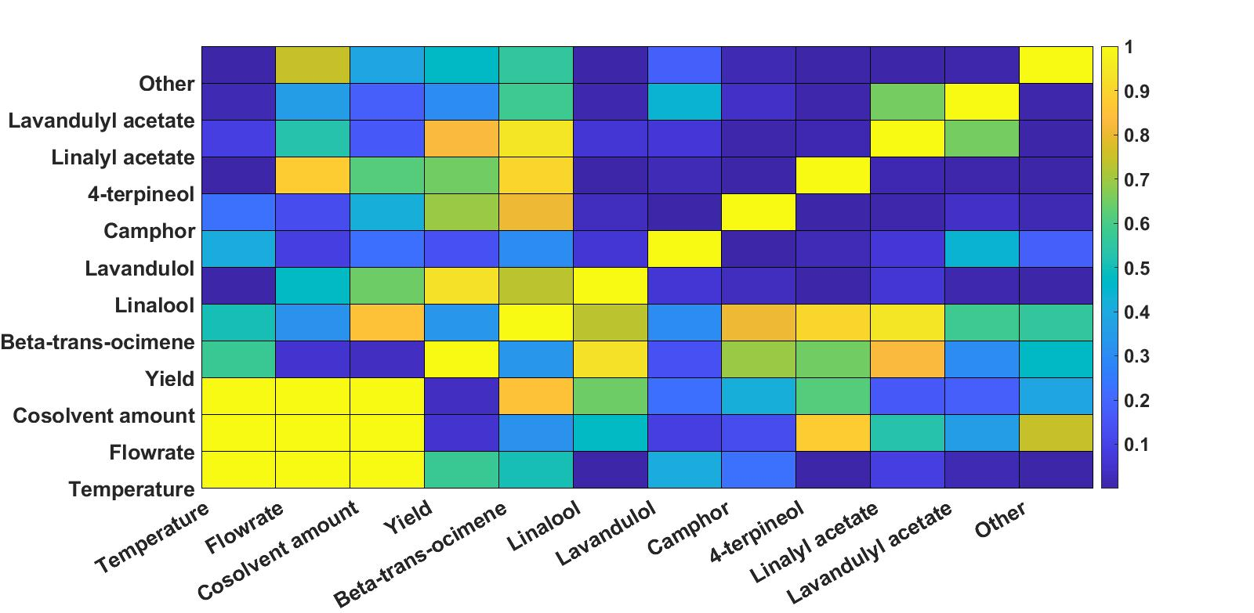

Figure 5 P-values of the yield, composition and the investigated parameters

The correlation study was performed to observe the effect of the parameters on yield and composition. It showed that in terms of yield the flowrate and the cosolvent amount are the most determining factors according to the Pearson correlation and p-vales. While the impact of these parameters on the chemical composition is also not negligible, it is not as significant as the extraction temperature.

* 1. Conclusion

In this study lavender essential oil was obtained from *Lavandula angustifolia* type lavender using the supercritical extraction method. The solvent consisted of CO2 with different amount (1-3 V/V %) of absolute EtOH as cosolvent. During the experiments near the cosolvent amount, the effect of the changing flowrate (4-8 ml/min) and the extraction temperature (40-50 °C) were investigated on the essential oil yield and composition. Based on the results in case of the extraction yield the increasing of the cosolvent amount and the flowrate resulted higher amount of essential oil, while exact effect of the temperature on the extraction yield was not clear. The compositional analysis of the samples was performed using gas chromatography and the main components of the oil were defined. Among these the components contained in the ISO standard were given particular emphasis in the further investigations. A Pearson correlation analysis was conducted to examine the significance of the parameters on the variables. The study confirmed that the flowrate and cosolvent amount have high impact on yield which is also confirmed by the p-values. However, in terms of lavender oil composition the effect of extraction temperature is more pronounced for many components than the other two parameters. These results enable to define the appropriate parameter combinations to influence the composition or maximize the yield.

References

Adaşoğlu N., Dinçer S., & Bolat E., 1994, Supercritical-fluid extraction of essential oil from Turkish lavender flowers, The Journal of Supercritical Fluids, 7(2), 93-99.

Akgün M., Akgün N. A., & Dinçer S., 2000, Extraction and modeling of lavender flower essential oil using supercritical carbon dioxide, Industrial & engineering chemistry research, 39(2), 473-477.

Capuzzo A., Maffei M. E., & Occhipinti A.,2013, Supercritical fluid extraction of plant flavors and fragrances, Molecules, 18(6), 7194-7238.

Cejudo Bastante C., Ramirez Tizon S., Casas Cardoso L., Macias Sanchez M.D., Mantell Serrano C., Martinez De La Ossa E.J., 2022, Fractionation of Marine Microalgae Extract Using Supercritical CO2 with Progressive Addition of Co-solvent for the Recovering of High-valuable Compounds, Chemical Engineering Transactions, 93, 259-264.

Cruz-Sánchez E., García-Vargas J. M., Gracia I., Rodriguez J. F., & García M. T., 2024, Supercritical CO2 extraction of lavender flower with antioxidant activity: Laboratory to a large scale optimization process, Journal of the Taiwan Institute of Chemical Engineers, 157, 105404.

Ibáñez E., Mendiola J.A., Castro-Puyana M., 2016, Supercritical Fluid Extraction, Encyclopedia of Food and Health, Academic Press, 227-233.

Kant R., & Kumar A.,2022, Review on essential oil extraction from aromatic and medicinal plants: techniques, performance and economic analysis, Sustainable Chemistry and Pharmacy 30: 100829.

Kıvrak Ş., 2018, Essential oil composition and antioxidant activities of eight cultivars of Lavender and Lavandin from western Anatolia, Industrial Crops and Products, 117, 88-96.

Kumoro A. C., & Hasan M., 2007, Supercritical carbon dioxide extraction of andrographolide from Andrographis paniculata: Effect of the solvent flow rate, pressure, and temperature, Chinese Journal of Chemical Engineering, 15(6), 877-883.

Pokajewicz K., Białoń M., Svydenko L., Fedin R., & Hudz N., 2021, Chemical composition of the essential oil of the new cultivars of Lavandula angustifolia Mill. Bred in Ukraine, Molecules, 26, 5681.

Sedgwick P., 2012, Pearson’s correlation coefficient, Bmj, 345.

Tyśkiewicz K., Konkol M., & Rój E., 2018, The application of supercritical fluid extraction in phenolic compounds isolation from natural plant materials, Molecules, 23, 2625.