 CHEMICAL ENGINEERING TRANSACTIONS  VOL. xxx, 2025 | A publication of  
The Italian Association
of Chemical Engineering
Online at www.cetjournal.it

Guest Editors: Fabrizio Bezzo, Flavio Manenti, Gabriele Pannocchia, Almerinda di Benedetto
Copyright © 2025, AIDIC Servizi S.r.l.
ISBN 979-12-81206-17-5; ISSN 2283-9216

Shaping Zn foam electrodes for CO₂ reduction by bubbling electrodeposition: potentiostatic versus galvanostatic control
Silvia Iacobelli*, Olga Russina, Pier G. Schiavi, Francesca Pagnanelli, Pietro Altimari
Department of Chemistry, Sapienza University of Rome, Piazzale Aldo Moro 5, 00185, Rome
s.iacobelli@uniroma1.it
Catalytic zinc foam electrodes for the electrochemical reduction of carbon dioxide to carbon monoxide were synthesized by bubbling electrodeposition. The analysis was focused on analyzing the effect of the employed substrate and of the electrodeposition regime. To this purpose, electrodepositions under galvanostatic and potentiostatic conditions were separately carried out on carbon paper and copper foil. Under galvanostatic conditions, no significant change in the foam pore size (50 µm) was observed by varying the support. In contrast, electrodeposition under potentiostatic conditions resulted in an increase in the pore size with the carbon paper (150 µm) compared to that attained with the copper foil (70 µm). The experimental analysis indicates that this result could be explained by the reduced evolution of hydrogen bubbles and by the decreased number of nucleation sites achieved under the potentiostatic conditions. The catalytic activity of the fabricated electrodes towards the electrochemical reduction of CO₂ was evaluated by chronoamperometric tests in an H-cell. Notably, while the efficiency of zinc deposited on the carbon paper electrodes was greater under potentiostatic conditions, the highest Faradaic Efficiency for carbon monoxide production was achieved under galvanostatic conditions (~ 60 % at -1.7 V relative to Ag/AgCl). This discrepancy may be explained by the increased surface area of the electrodes deposited under galvanostatic conditions.
  - Introduction
The urgent need to reduce carbon dioxide emissions and decrease reliance on fossil fuels (Zhang et al., 2024) has accelerated the adoption of technologies to produce electric energy from renewable sources, such as solar, wind, and geothermal (Deshmukh et al., 2023). However, the intermittent nature of these renewable sources necessitates the use of batteries for energy storage, which often do not provide the necessary autonomy for many applications (Gray et al., 2021). In recent years, new strategies to reduce CO₂ emissions have been extensively investigated, such as the use of photoelectric energy or electricity, which are used to convert CO₂ into high value-added chemicals. In this framework, the electroreduction of carbon dioxide (ERC) is considered a competitive technology to reduce carbon dioxide emissions and store the energy from renewable sources. This process converts CO₂ into fuels/chemicals (e.g. carbon monoxide, formic acid, methanol) at the cathode of an electrochemical cell by using different metals as catalysts (Feng et al., 2021). Major limitations of ERC are high costs and/or unsatisfactory selectivity of available electrocatalysts. The formation of C-C bonds is enabled by the application of Cu catalysts, but the synthesis of different products observed under these conditions makes it difficult the downstream separation. One of the most desired ERC reaction products is CO, which is used as a feedstock precursor for the chemical synthesis of hydrocarbons and liquid fuels such as alcohols (Moreno-García et al., 2018). Experimental studies have reported achieving Faradaic Efficiencies for CO exceeding 90 % using gold and silver electrodes (Moura de Salles Pupo et al., 2019). However, the high cost of these metals has prompted the exploration of more abundant alternatives, such as zinc (Rosen et al., 2015). Zinc has demonstrated comparable Faradaic Efficiencies for CO relative to silver but operates at significantly higher cathodic potentials, potentially increasing the energy consumption required to maintain a specified current density per unit area (Li et al., 2023). The use of porous zinc electrodes can help mitigate this issue by increasing the specific surface area, thereby lowering the overpotential necessary to sustain the target current density (Zhang et al., 2024). A facile method to fabricate high-surface metal electrodes is bubbling electrodeposition. In this method, metal electrodeposition is carried out by applying sufficiently high cathodic potentials. This not only reduces the precursor metal ions but also leads to the generation of hydrogen bubbles through the reduction of water. These bubbles act as templates for the growth of zinc deposits, resulting in a foam with a hierarchical porous structure that has a high specific surface area. The thickness of this structure can be adjusted by changing the amount of electric charge transferred during the electrodeposition process. This unique morphology can be used both in liquid-fed electrolyze configurations, where carbon dioxide is supplied by dissolution in the liquid phase (Zhang et al., 2024), or to produce gas-diffusion electrodes for vapor-fed systems.
Previous studies have explored the use of zinc foams created through bubbling electrodeposition to catalyze the electrochemical reduction of carbon dioxide (Lamaison et al., 2015). However, moderate attention has been devoted to investigating how the electrodeposition parameters and the electrodeposition regime (galvanostatic or potentiostatic) influence the foam's structure and morphology, which in turn affects its catalytic activity.
In this study, we aim to fill these gaps by conducting an experimental analysis of galvanostatic and potentiostatic bubbling electrodeposition of zinc foams to better understand the properties of the system. We analyze how deposition parameters and different substrates (carbon paper, copper foil) can impact the electrode morphology and evaluate the catalytic activity of the fabricated foam electrodes.
  - Experimental section
    - Catalyst preparation
The copper electrodes used as the support copper foil (1.0 mm (0.04 in) thick, 99.99 % (metals basis), Thermo Scientific Chemicals) were electropolished in phosphoric acid 1.7 M (H₃PO₄, 85 %, Sigma Aldrich) for two minutes at 2.0 V vs Ag/AgCl to generate clean surfaces. Carbon paper (39 BC Sigracet, Fuel Cell Store) was used as another support for the electrodes. All electrodes were masked with insulating tape, leaving an exposed area of 4 cm². The substrates were employed as working electrodes for galvanostatic and potentiostatic electrodeposition. For all depositions, a potentiostat (Ivium OctoStat 5000) was used, along with a three-electrode cell configuration: the working electrode, a reference electrode Ag/AgCl (3 M KCl, Fluka Analytical), and copper foil (1.0 mm (0.04 in) thick, 99.99 % (metals basis), Thermo Scientific Chemicals) as the counter electrode in galvanostatic conditions, while a platinum mesh (100 Mesh woven from 0.0762mm (0.003 in) wire, 99.9 % (metal basis), Thermo Scientific Chemicals) was used in potentiostatic conditions. All the potentials reported in the text refer to Ag/AgCl. The deposition bath used consists of sulfuric acid 1.5 M (H₂SO₄, 96 %, Carlo Erba Reagents), zinc sulphate heptahydrate 0.2 M (ZnSO₄ · 7 H₂O, EMSURE®, Merk), and copper sulphate pentahydrate 0.006 M (CuSO₄ · 5 H₂O, VWR Chemicals) for all analyzed samples. Copper was added to the deposition bath to promote the growth with a high specific surface area, providing sites for hydrogen evolution. After deposition, the samples were washed with Milli-Q distilled water and subsequently tested in a hydrogen cell for electrocatalytic performance. The two electrodes deposited in galvanostatic conditions at 1 A/cm² and 60 C/cm² on copper foil and carbon paper are called ZnCuG and ZnCPG respectively, the two electrodes deposited in potentiostatic conditions on copper foil and carbon paper at -1.5 V and 60 C/cm² are called ZnCuP and ZnCPP respectively.
    - Characterization Methods
To evaluate the morphology of the surface, Scanning Electron Microscopy (SEM) analyses were performed using a Tescan SEM. The amount of metal deposited on the electrodes was quantified using atomic absorption spectrophotometer (AAS - ContraAA 300 - Analytik Jena AG) after acid digestions of electrodes in aqua regia using nitric acid (HNO₃, 65 %, AnalaR NORMAPUR®, VWR) and hydrochloric acid (HCl, 37 %, EMSURE®, Merk). The efficiency of zinc electrodeposition was then determined as the ratio of the charge associated with the mass of deposited zinc, calculated using Faraday's law, to the total transferred charge.
    - Electrochemical Reduction Reaction of CO₂ (ERC)
CO₂ electrolysis experiments were carried out under potentiostatic conditions in a gas-tight glass H-cell. A three-electrode configuration was used with an Ag/AgCl reference electrode, a graphite sheet serving as a counter electrode, and zinc foams acting as working electrodes. The catholyte and anolyte were separated by a proton exchange membrane (Nafion 117, Sigma-Aldrich). Prior to CO₂ electrolysis, both the cathodic and anodic compartments were filled with 200 mL of potassium bicarbonate0.5 M (KHCO₃, ≥ 99.5 % AnalaR NORMAPUR®, VWR) electrolyte solution. At the beginning of each test, the electrolyte in the cathodic compartment was saturated with CO₂ gas (99.95 %, SOL Spa) for 20 minutes, via bubbling at ambient temperature and pressure. During this bubbling process, the electrode was maintained at a fixed potential of -1.3 V as cathodic protection to prevent any oxidation of the electrodeposited metal that constitutes the catalyst. Throughout the duration of the experiment, the cathodic compartment was kept under constant magnetic stirring. Following saturation, a CO₂ flow of 10 mL/min was imposed, measured with a PerkinElmer FlowMeter Plus. A fresh and distinct electrode was used for each applied potential. Two replicates were carried out for each applied potential, and three different potentials were selected: -1.5 V, -1.7 V, and -1.9 V vs Ag/AgCl.
    - Gas Chromatography (GC)
The gaseous reaction products, hydrogen (H₂) and carbon monoxide (CO), were transported from the headspace of the H cell to the gas chromatograph sampling loop via a continuous flow of CO₂. For this analysis, the Clarus 590 gas chromatograph manufactured by PerkinElmer was utilized. The chromatograph is equipped with a 500 μL sampling loop with a 6-way injection valve, a thermal conductivity detector (TCD), and a Shincarbon ST Micropacked column, 2 meters in length, produced by Restek. Argon (Ar, 99.99 %, SOL Spa) was employed as the carrier gas. To quantify the produced gases, calibration was performed using a standard gas mixture produced by Sol Group, consisting of 1.0 % H₂ and 5.0 % CO in Ar.

To calculate the Faradaic Efficiency (FE) of the reaction, the following formula was used:
η_{x} = (ϕ_{tot}· t· V_{x}· Z_{e}· F· P) · (ΔQ· R· T· V_{tot})⁻¹ | (1)

where:
- t – sampling time for the electric charge (1 minute)
- ϕ_{tot} – total gas flow exiting the electrochemical cell;
- V_{x} – volume of the x-th gas analysed by the gas chromatograph during the sampling period;
- Z_{e} – number of electrons exchanged during the reduction process (this number is equal to 2 for CO and H₂);
- F – Faraday constant, equal to 96485 C mol⁻¹
- P – gas sampling pressure (1 atm);
- ΔQ – charge passed through the cell measured during the sampling;
- R – ideal gas constant (0.0822 L atm K⁻¹ mol⁻¹);
- T – ambient temperature (298 K);
- V_{tot} – total volume of gas introduced into the loop (500 μL).

The chronoamperometric analyses lasted 1 h for each electrode.
  - Results
    - Galvanostatic deposition
Zinc foams were separately deposited under galvanostatic conditions on copper foil and carbon paper, respectively. Carbon paper is structured in two different layers: a macro-porous layer, composed of carbon fibers, and a micro-porous layer made of carbon particles bonded together by polytetrafluoroethylene. Deposition on the microporous layer yields a gas diffusion electrode that can be employed in vapor-fed configurations (e.g., membrane electrode assembly cells), which are of technological interest for the upscale of the ERC process.
The selected electrodeposition parameters are reported in Table 1.
Table 1: Galvanostatic parameters of electrodeposition method.
Support | Current Density (A/cm²) | Transferred Charge density (C/cm²)
Cu Foil, Carbon Paper | 1 | 60

SEM images presented in Figure 1, show that, by changing the support, no significant change was observed in the morphology (hierarchical porous structure formed by dendrites, as seen at 10 μm zoom). This is somehow unexpected in what the rate of the hydrogen evolution reaction (HER), and thus rate of bubbles formation which dictates the foam structure, should be larger on copper than on carbon paper. Indeed, copper can sustain the HER more effectively than carbon paper can do. A possible explanation is that, by increasing the cathodic potential, hydrogen evolution on the growing zinc surface becomes the prevalent mechanism of bubble formation, whereas a progressively lower contribution can be imputed to the underlying support.

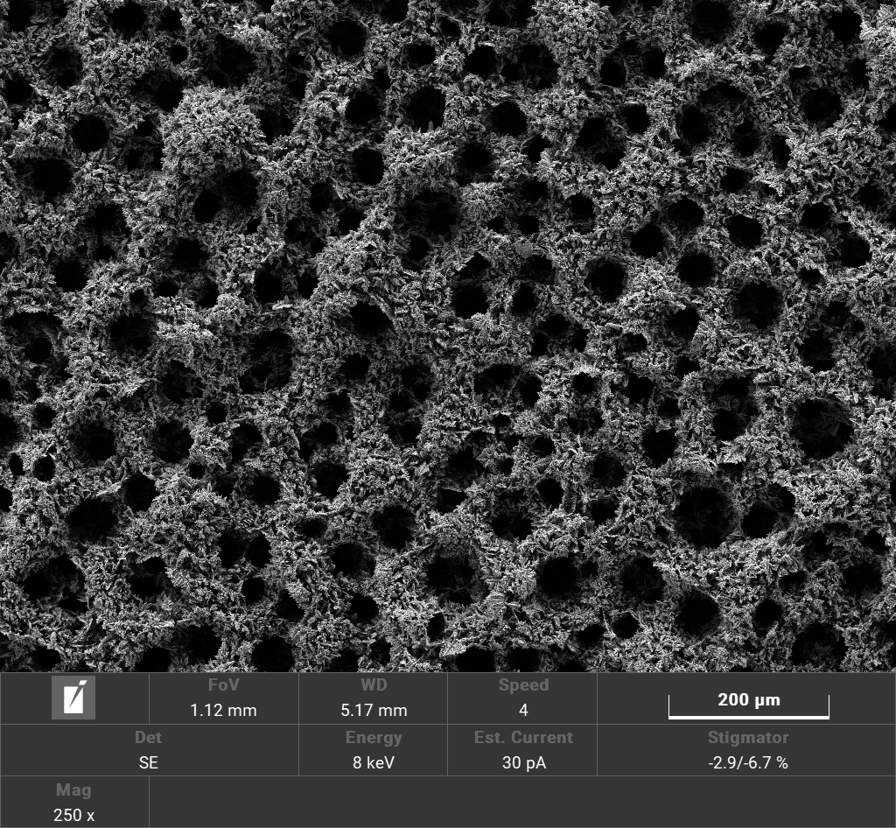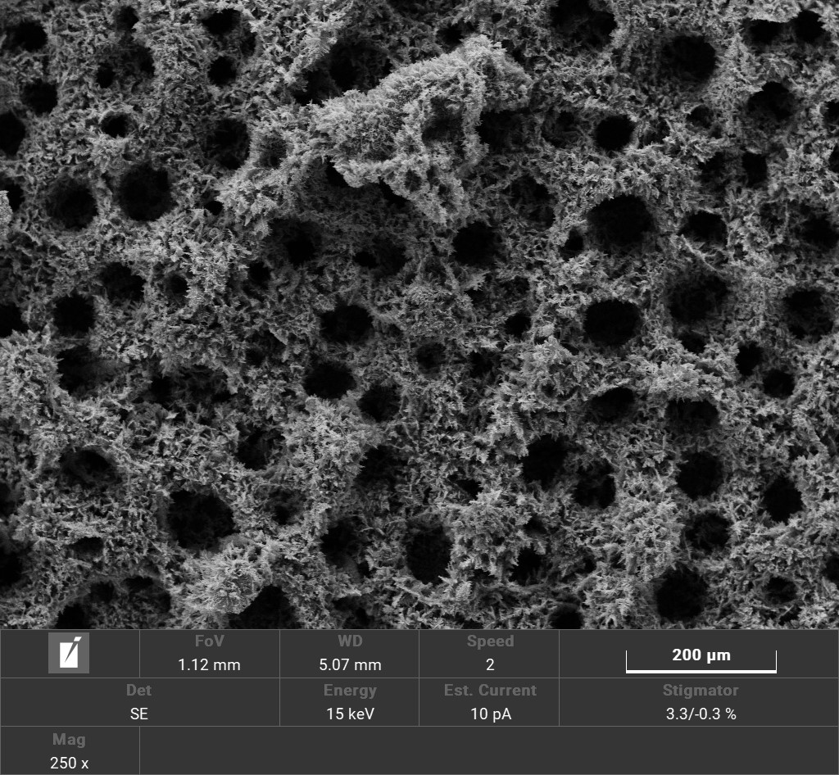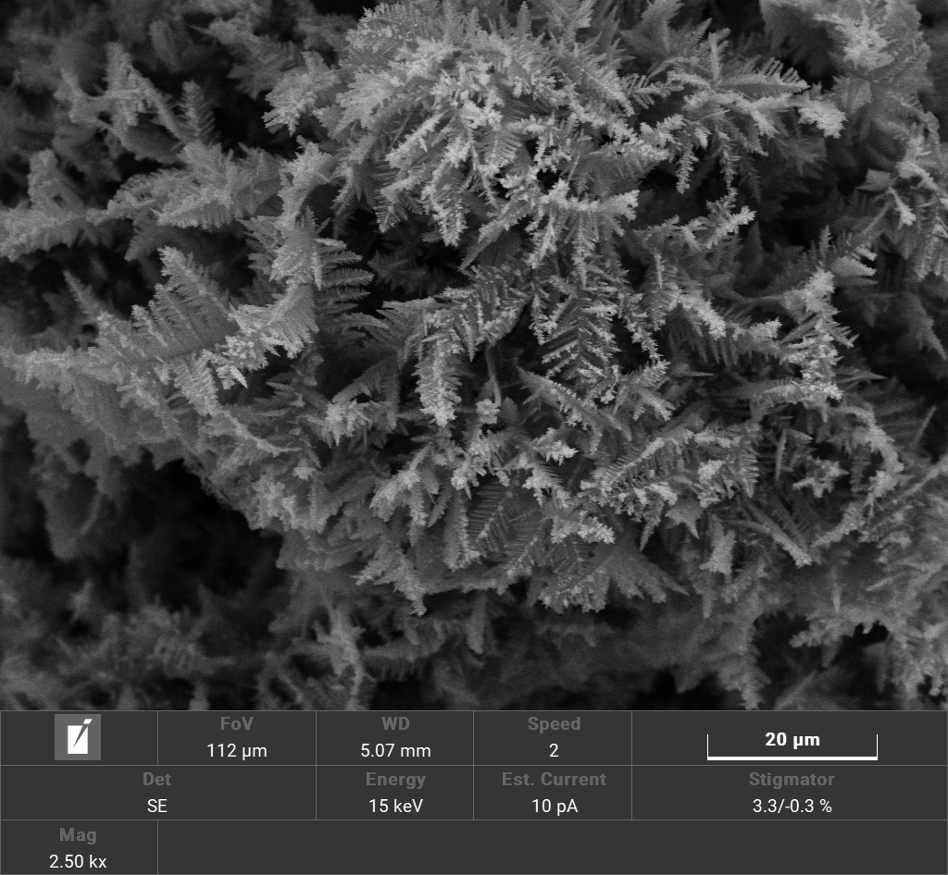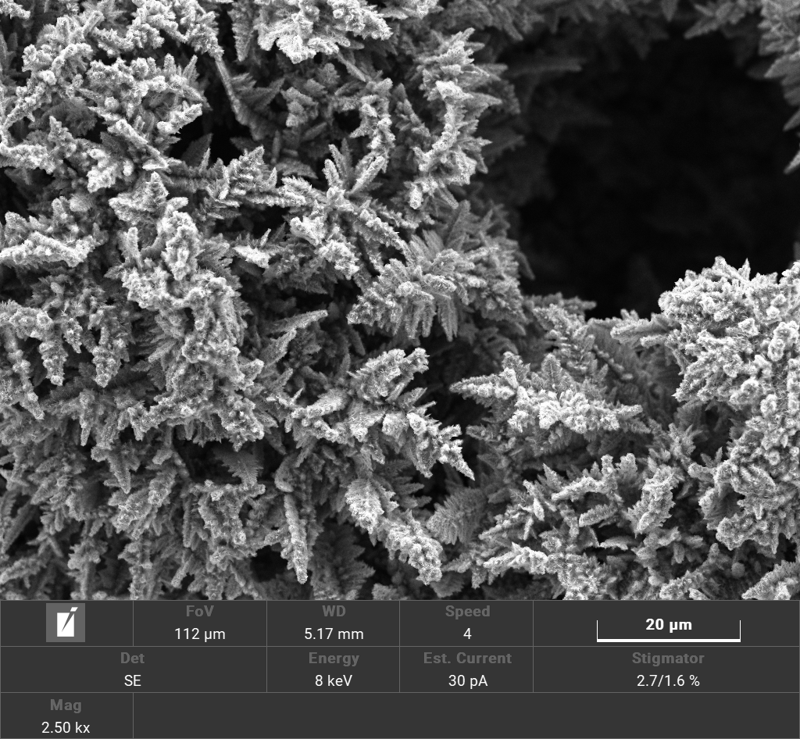
a
200 μm
b
200 μm
10 μm
10 μm
Figure 1: SEM images of zinc foams electrodeposited under galvanostatic conditions: a) deposition on cu foil 1 A/cm² 60 C/cm² (ZnCuG), b) deposition on carbon paper 1 A/cm² 60 C/cm² (ZnCPG).
This hypothesis is corroborated by the analysis of the zinc mass deposited on the electrodes. As it is ​​reported in Table 2, the efficiency of zinc deposition is the same (i.e., absence of statistically significant variations) with the copper and the carbon paper support. This confirms that the ratio between the rates of HER and zinc electrodeposition did not vary significantly by changing the support from copper to carbon paper.
Table 2: Zinc deposition efficiency after galvanostatic electrodeposition.
Electrodes | Zn (%)
a  b | 36.2 % ± 9.00 %  25.0 % ± 3.70 %
    - Potentiostatic deposition
The electrodes were deposited on copper foil and carbon paper using a cathodic potential of -1.5 V maintaining the same charge density used in galvanostatic electrodeposition (60 C/cm²). It should be remarked that this cathodic potential is lower (i.e., the potential is less negative) than that attained at the beginning of the galvanostatic electrodeposition tests. This is confirmed by the achievement of a current density at the beginning of any potentiostatic test lower than that maintained during the galvanostatic tests (data not shown). On the other hand, the choice to decrease the cathodic potential to -1.5 V is here needed to ensure that the current density increases to prohibitively large values after the formation of the foam. Indeed, under potentiostatic conditions, the current density progressively increases with increasing the zinc surface.
SEM images reported in Figure 2 show that the hierarchical porous structure of the foam was maintained as in galvanostatic electrodeposition. In contrast to what observed under galvanostatic conditions, as the support is changed from copper foil to carbon paper, the size of the pores increases significantly (from ~ 70 μm to ~ 150 μm, respectively).

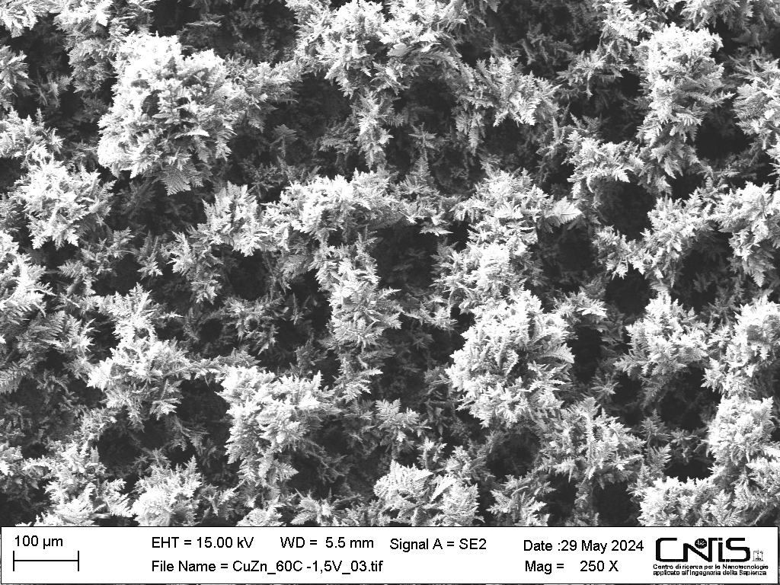
a
100 μm
b
100 μm
10 μm
10 μm
Figure 2: SEM images of zinc foams deposited under potentiostatic conditions: a) deposition on copper foil at -1.5 V (ZnCuP), b) deposition on carbon paper at -1.5 V (ZnCPP).
To identify the mechanisms responsible for this result, the efficiency of zinc electrodeposition achieved with the two supports can be considered. The results of this analysis are reported in Table 3. It is apparent that the amount of zinc deposited on carbon paper is two-fold larger compared to that deposited on copper foil. A possible explanation for this difference is that the rate of HER on carbon paper is lower than on copper. This effect, not yielding morphological differences under galvanostatic conditions, had probably a more significant impact under the potentiostatic conditions due to the application of a lower cathodic potential during the early electrodeposition stage. Indeed, decreasing the cathodic potential can increase the contribution of hydrogen bubbles formation at the underlying substrate. Accordingly, an increased hydrogen evolution is attained with copper. Further, it should be considered that the decreased cathodic potential can determine, at the same time, a reduced number of zinc nuclei. This effect is expected to be significantly more pronounced with carbon paper and could thus contribute to explaining the increased zinc pore observed on carbon paper.
Table 3: Zinc deposition efficiency after potentiostatic electrodeposition.
Electrodes | Zn (%)
a  b | 28.0 % ± 7.00 %  54.0 % ± 1.00 %
    - Chronoamperometric tests
The electrodes deposited both using galvanostatic and potentiostatic methods were tested in an H cell, applying three different cathodic potential: -1.5 V, -1.7 V -1.9 V. Faradaic Efficiencies (FEs) towards carbon monoxide are reported in Figure 3. The highest Faradaic Efficiency (~ 60 %) was obtained for the electrode deposited at 1 A/cm² on carbon paper (ZnCPG) and tested at -1.7 V. This electrode, deposited under galvanostatic conditions, has improved performance compared to the electrode deposited under potentiostatic conditions on carbon paper (ZnCPP) tested at -1.7 V, likely due to its smaller pore size and larger surface area. Indeed, by decreasing the pore size, the pH within the pores is expected to increase during the ERC test, which can decrease the rate of the HER (Luo et al., 2019). Increasing the cathodic potential from -1.7 V to –1.9 V, a decrease in the FE towards carbon monoxide is observed. This can be explained by observing that, with increasing the cathodic potential, the HER rate continuously increases while the ERC becomes limited by mass transfer.

Figure 3: Faradaic Efficiency (FE%) towards carbon monoxide for all electrodes tested.
This is confirmed by the analysis of the partial current densities reported in Figure 4. Here, it is apparent that, for all electrodes, the CO synthesis rate increases when the potential is increased from -1.5 V to -1.7 V. However, by modifying the potential from -1.7 V to -1.9 V, an increase in the current density of H₂ is observed compared to that found for CO, evidencing that the water reduction becomes dominant.
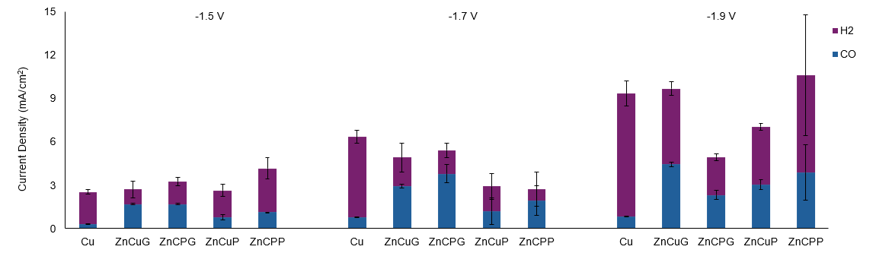
Figure 4: Current Density towards CO and H₂ for all electrodes tested.
  - Conclusions
Zinc foam electrodes were synthesized by the bubbling electrodeposition method on carbon paper and copper foil. Under galvanostatic conditions, no significant change was observed between the morphologies generated with the two substrates, while an increased pore size was achieved, under potentiostatic conditions, by employing the copper substrate. It is proposed that the different influence of the substrate observed under galvanostatic and potentiostatic conditions could be explained by the lower cathodic potential achieved during the early stage of potentiostatic electrodeposition. This can increase the contribution of the hydrogen bubbles generated at the substrate and, thus, the reduced HER rate on carbon paper can yield decreased pore size. To evaluate the catalytic activity of the fabricated electrodes, chronoamperometric ERC tests at three different potentials were carried. The highest Faradaic Efficiency toward carbon monoxide (~ 60 %) was achieved with the electrode deposited at 1 A/cm², 60 C/cm² at -1.7 V. This electrode is characterized by the lowest pore size, which can yield increased pH inside the pores and thus decrease the rate of the HER.
Acknowledgments
The research was funded by the European Union - NextGenerationEU under the National Recovery and Resilience Plan (NRRP), Mission 4 Component 2 Investment 1.3 - Call for tender No. 1561 of 11.10.2022 of Ministero dell’Università e della Ricerca (MUR), Project code PE0000021, CUP B53C22004070006, Project title “Network 4 Energy Sustainable Transition – NEST”.
References
Deshmukh M.K.G., Sameeroddin M., Abdul D., Abdul Sattar M., 2023, Renewable energy in the 21st century: A review, Materials Today Proceedings,1756–1759.
Feng L., Kaiwen Z., Lei Z., Yingjie Z., Yong L., Xueliang S., 2021, Recent Development of Electrocatalytic CO₂ Reduction Application to Energy Conversion Small, 17, 2100323.
Gray N., McDonagh S., O’Shea R., Smyth B., Murphy J.D., 2021, Decarbonising ships, planes and trucks: An analysis of suitable low-carbon fuels for the maritime, aviation and haulage sectors, Advances in Applied Energy 1,100008.
Lamaison S., Wakerley D., Montero D., Rousse G., Taverna D., Giaume D., Mercier D., Blanchard J., Tran H. N., Fontecave M., Mougel V., 2019, High-Current-Density CO₂-to-CO Electroreduction on Ag-Alloyed Zn Dendrites at Elevated Pressure, ChemSusChem,12, 511 – 517.
Li M., Hu Y., Dong G., Wu T., Geng D., 2023, Achieving Tunable Selectivity and Activity of CO₂ Electroreduction to CO via Bimetallic Silver–Copper Electronic Engineering, Small, 19, 2207242.
Luo W., Zhang J., Li M., Züttel A., 2019, Boosting CO Production in Electrocatalytic CO2 Reduction on Highly Porous Zn Catalysts, ACS Catalysis, 9, 3783-3791.
Moreno-García P., Schlegel N., Zanetti A., López A. C., Gálvez-Vázquez M., Dutta A., Rahaman M., Broekmann P., 2018, Selective Electrochemical Reduction of CO₂ to CO on Zn-Based Foams Produced by Cu²⁺ and Template-Assisted Electrodeposition, Applied Materials & Interfaces, 10, 31355−31365.
Moura de Salles Pupo M., Kortlever R., 2019, Electrolyte Effects on the Electrochemical Reduction of CO₂ ChemPhysChem, 20, 2926–2935.
Rosen J., Hutchings G.S., Lu Q., Forest R. V., Moore A., Jiao F., 2015, Electrodeposited Zn Dendrites with Enhanced CO Selectivity for Electrocatalytic CO₂ Reduction, ACS Catalysis, 5, 4586−4591.
Zhang Z., Li S., Rao Y., Yang L., Yan W., Xu H., 2024, Three-dimension porous Zn-Cu alloy: An inexpensive electrocatalyst for highly selective CO₂ reduction to CO in non-aqueous electrolyte, Chemical Engineering Journal, 479, 147376.

