 CHEMICAL ENGINEERING TRANSACTIONS  VOL. xxx, 2025 | A publication of  
The Italian Association
of Chemical Engineering
Online at www.cetjournal.it

Guest Editors: Fabrizio Bezzo, Flavio Manenti, Gabriele Pannocchia, Almerinda di Benedetto
Copyright © 2025, AIDIC Servizi S.r.l.
ISBN 979-12-81206-17-5; ISSN 2283-9216

Exploring a bicarbonate-based carbon capture approach applicability to industrially relevant marine microalgae
Danilo Marchese^{a,}*, Alessandro Rosengart^{b}, Elena Barberaª, Eleonora Sforzaª
ª Department of Industrial Engineering DII, University of Padova, Via Marzolo 9, 35131 Padova (PD), Italy
^{b} VTU Engineering, Via della Vittoria 90, 30035 Mirano (Ve), Italy
danilo.marchese@phd.unipd.it

Microalgae represent the primary producers of valuable molecules in the marine ecosystems, such as essential fatty acids and antioxidants, that can be exploited as nutritive supplements in animal feeds and human food, as well as in nutraceuticals. However, their industrial massive production is currently limited by high cultivation costs. CO₂ insufflation and management as well as mixing and cooling operations require an important energetic investment, decreasing the overall profitability of the process. The recently theorized BICCAPSO (Bicarbonate-based Induced Carbon Capture and Algae Production System on Ocean) approach aims at addressing these limitations by coupling the exploitation of alternative inorganic carbon sources, such as sodium bicarbonate, with the use of cheaper sea-powered floating photobioreactors. Although the promising potential, some challenges must be faced when applying such a cultivation rationale. The use of bicarbonate as sole carbon source, for instance, leads to a progressive pH increase in the cultivation environment, affecting both microalgae growth and carbon availability. For this reason, most of the literature regarding bicarbonate-based cultivation is limited to alkaliphilic microalgae species, eventually excluding industrially-relevant strains. In this work both alkaliphilic and mesophilic microalgae were cultivated in batch mode applying the BICCAPSO approach. Results suggest that this strategy can be extended also to mesophilic strains when carbon concentration is well-balanced, reaching a maximum biomass productivity of 0.35 g L⁻¹ d⁻¹ with the model diatom Phaeodactylum tricornutum. Moreover, we focused also on pH management, by trying diverse strategies to stabilize this operative variable with the aim of further increasing biomass productivity without affecting process economics.

  - Introduction
Marine microalgae have been elected as a promising sustainable source of different valuable commodities to be integrated in food, feed and nutraceuticals. To expand this novel market, current efforts must focus on reducing energy investment and, hence, overall cultivation costs. For instance, carbon dioxide management, i.e. its transportation, storage and insufflation, accounts for a significant share of the capital and operating costs in microalgae processes (Llamas et al. 2021). Furthermore, the efficiency of CO₂ conversion to microalgal biomass through carbon fixation is still quite low, with 65-90% of the sparged gas lost in the atmosphere (Llamas et al. 2021). Therefore, the substitution of this gas with alternative sources of inorganic carbon could be beneficial for future algae farmers to enter the market. Chi et al. (2011) more than ten years ago theorized the concrete possibility of cultivating microalgae exclusively with sodium bicarbonate (NaHCO₃) derived from a circular CO₂ capture process, based on carbonate (CO₃²⁻) exploitation, in an innovative cultivation approach named BICCAPS (Bicarbonate-based Induced Carbon Capture and Algae Production System). Applying this approach to microalgae cultivation processes offers advantages over conventional ones, including higher carbon utilization efficiency (CUE) due to bicarbonate’s greater solubility in water than CO₂ (Latagan et al. 2024). Nevertheless, carbon fixation in microalgal metabolism leads to progressive alkalinization of the environment if no buffer systems are provided, such as CO₂ sparging (Price et al. 2008). Hence, despite good results to date obtained with alkaliphilic strains, such as Euhalothece sp. and Dunaliella tertiolecta, BICCAPS approach seems incompatible to other mesophilic commercially relevant strains (Roy et al. 2021). However, the ability of several interesting species to grow on well-balanced concentration of bicarbonate as sole carbon source has been reported several times in literature. Kim et al. (2019), for instance, observed such a result in nine different species, although a loss in biomass productivity was recorded with respect to CO₂-based cultures. This issue could be addressed by coupling this strategy with innovative technologies, such as floating bag photobioreactors, which reduce energy input by harnessing sea wave power. The so-called BICCAPSO approach (Bicarbonate-based Induced Carbon Capture and Algae Production System on Ocean) has been already presented as effective but, still, only restricted to alkaliphilic species cultivation, reducing its impact in the next-generation microalgae cultivation systems (Zhu et al. 2018).
In this work, we aimed at optimizing carbon concentration supply to five microalgal strains by using a BICCAPSO cultivation approach. Specifically, an alkaliphilic strain, Dunaliella tertiolecta, was used as a reference while mesophilic marine microalgae Tetraselmis chuii, Nannochloropsis gaditana, Tisochrysis lutea and Phaeodactylum tricornutum were used due to their commercial relevance as potential food and feed supplements. Moreover, we tried to mitigate culture alkalinization by supplying inorganic carbon in excess in batch mode and in fed-batch mode. To our knowledge this is the first attempt to successfully extend BICCAPSO approach application to commercially relevant microalgae with the aim of reducing cultivation costs.
  - Materials and Methods
    - Microalgae species and cultivation conditions
Five marine microalgae species were used in laboratory scale experiments. In all the culture medium used the concentration of macro and micronutrients was doubled to avoid nutrients deficiency. The alkaliphilic microalgae Dunaliella tertiolecta CCAP 19/30 was cultivated in Modified Johnson Medium (Sathasivam and Juntawong 2013). The mesophilic strains tested, i.e. Tisochrysis lutea CCAP 927/14, Nannochloropsis gaditana CCAP 849/5, Tetraselmis chuii CCAP 8/6 and Phaeodactylum tricornutum CCAP 1055/1 were cultivated in f/2 medium (Guillard 1975). Culture media pH was adjusted to ~8 by using 1M NaOH and then autoclaved at 121°C for 20 minutes prior to their utilization. Sodium bicarbonate (NaHCO₃) was added once the medium was autoclaved and cooled to avoid formation of insoluble carbonate precipitates. In the screening phase microalgae were cultivated at three different concentrations of NaHCO₃ (1, 2.5 and 5 g L⁻¹) in batch mode in 250 mL Erlenmeyer flasks constantly illuminated at 100±10 µmol m⁻² s⁻¹ by means of a warm white LED lamp. The batch duration was set to seven days. To simulate the environment inside a floating photobioreactor, cultures were not insufflated with any gaseous stream and mixing was guaranteed by orbital shaking at 100 rpm at a temperature of 22±2 °C. Sampling was performed daily and pH was measured immediately after using a pH meter (Hanna – HI 9124).
    - Bicarbonate supply management and pH control experiments
pH management experiments were carried out with Phaeodactylum tricornutum CCAP 1055/1. Two different strategies of bicarbonate supply were applied to stabilize pH in the BICCAPS cultivation of this diatom. First, an excess of NaHCO₃ was supplied (8 and 12 g L⁻¹) at the beginning of the batch experiments to verify the buffer power of an excess of bicarbonate ions (HCO₃⁻) inside the culture medium. Fed-batch experiments were performed through daily addition of known amounts of NaHCO₃ to the batch growth of microalgae for nine days. Specifically, in the first fed-batch experiment (FB₁) 0.25 g L⁻¹ of NaHCO₃ were added daily and 0.75 g L⁻¹ were added at the fourth day of cultivation for a total of 1.75 g L⁻¹ of bicarbonate. In the second experiment (FB₂) 0.50 g L⁻¹ of sodium bicarbonate were added daily and 1.50 g L⁻¹ were added at the fourth day of cultivation for a total of 3.50 g L⁻¹ NaHCO₃.
    - Biomass quantification, specific growth rate and mass balance
Biomass concentration was quantified by daily dry weight (DW) measurements. A known volume of the culture was filtered through a vacuum pump on a pre-weighed 0.45 µm nitrocellulose filter. Biomass was washed at least two times with deionized water to dissolve eventual salts residuals. Filter was then dried in a laboratory oven for at least 2h at 105°C and after that weighed by means of a precision balance. DW was calculated by subtracting the weight of the empty filter to the gross weight and dividing for the filtered volume.
Biomass concentration measurements were used to calculate specific growth rate, µ (day⁻¹), according to:

$μ=\frac{{ln⁡(C}_{2}/C_{1})}{t_{2}-t_{1}}$ (Eq.1)
where C₂ and C₁ represent, respectively, biomass concentration at the end and at the beginning of exponential growth phase and t₂ and t₁ represent the end and the start of the cultivation, respectively.
Biomass volumetric productivity (P_{X,V}) in batch mode was calculated through the following equation:
$P_{X,V}=\frac{C_{SP}-C_{i}}{t_{SP}-t_{i}}$ (Eq. 2)
Where C_{SP} and C_{i} represent the biomass concentration (g_{X} L⁻¹) at the beginning of the stationary phase and at the beginning of the experiment, respectively; t_{SP} and t_{i} represent the time (days) to reach the stationary phase of growth and the time zero, respectively.
  - Results and Discussion
    - Effect of bicarbonate concentration on microalgae growth
Three different concentrations of sodium bicarbonate (1, 2.5 and 5 g L⁻¹) were supplied at the beginning of the batch growth to investigate how performances of the selected strains were affected.
Table 1: Summary of calculated specific growth rates (µ, day⁻¹), pH and biomass concentration (C_{x,SP}, g L⁻¹) measured at stationary phase in batch cultivation of different species grown at different bicarbonate concentrations.
 |  |  | Bicarbonate concentration [g L⁻¹]
 | 1 |  |  |  | 2.5 |  |  | 5
Species | C_{x,SP}  [g L⁻¹] | pH_{SP} |  | µ  [d⁻¹] | C_{x,SP}  [g L⁻¹] | pH_{SP} | µ  [d⁻¹] | C_{x,SP}  [g L⁻¹] | pH_{SP} | µ  [d⁻¹]
D. tertiolecta | 0.71 | 9.01 |  | 0.30 | 0.54 | 9.12 | 0.31 | 1.04 | 9.46 | 0.20
T. chuii | 0.33 | 8.63 |  | 0.18 | 0.94 | 9.63 | 0.11 | 0.60 | 8.83 | 0.19
N. gaditana | 0.77 | 8.90 |  | 0.24 | 0.75 | 8.97 | 0.42 | 0.57 | 9.09 | 0.13
T. lutea | 0.70 | 8.95 |  | 0.29 | 0.66 | 9.24 | 0.74 | 0.55 | 9.48 | 0.17
P. tricornutum | 0.75 | 9.02 |  | 0.75 | 1.12 | 9.16 | 0.87 | 0.85 | 9.75 | 0.43

As shown in Table 1, all species were able to grow without insufflation of any gaseous stream for at least four days, after which most of the species entered the stationary phase. D. tertiolecta, representing the reference alkaliphilic species, was able to grow up to 1.04 g L⁻¹ at the highest concentration of sodium bicarbonate (5 g L⁻¹), recording a biomass productivity of 0.16 g L⁻¹ d⁻¹ (Table 2). At lower carbon concentrations its growth performance decreased, reaching 0.11 and 0.06 g L⁻¹ d⁻¹ of biomass productivity, accordingly. These results are consistent with the alkaliphilic behavior of this microalga and its ability to thrive at extreme concentrations of sodium bicarbonate as sole carbon source. Roy et al. (2021), indeed, found that maximum biomass concentration (1.68 g_{X} L⁻¹) for D. tertiolecta is obtained at 20-40 g L⁻¹ of bicarbonate, with lower concentrations being limiting for its growth. Considering 50% carbon into microalgal biomass, in our case the final biomass yield on total inorganic carbon supplied was about 70% (data not shown). In the same study, at a concentration of 20 g L⁻¹ NaHCO₃ the yield was slightly lower (~60%) due to carbonate ions accumulation (almost 50% of the initial carbon pool) (Roy et al. 2021). Accordingly, our results indicate that whenever alkaliphilic species are cultivated, although their tolerance to alkalinity, efficient carbon conversion occurs as long as carbon supplied is reasonably balanced.
Considering the stationary phase of growth, both N. gaditana and T. lutea showed similar performances, reaching around 0.70 g_{X} L⁻¹ at the lowest NaHCO₃ concentration (Table 1). Biomass productivity, anyway, ranged between 0.07 and 0.08 g_{X} L⁻¹ d⁻¹ (Table 2) for both species in all the conditions, suggesting a scarce efficiency in exploiting HCO₃⁻ for carbon fixation as well as a poor resistance to alkaline environments. Despite its ability to uptake HCO₃⁻ has been previously demonstrated, growth performances of N. gaditana do not seem to be improved by bicarbonate supply. Similar outcomes are reported in literature: Pedersen et al. (2018) showed no significant increase in biomass productivity when N. gaditana was cultivated with 0.42 g L⁻¹ of NaHCO₃ and growth was impaired at 4.2 g L⁻¹. Similarly, Kim et al. (2019) found 1.0 g L⁻¹ as optimal NaHCO₃ concentration for this species, even though growth rate was negatively affected with respect to control condition (with CO₂ insufflation). In this case a major role can be played by pH increase in the culture (data not shown) since it is known that optimal pH for this microalga is around 8-8.3 (Moraes et al. 2020). Correspondingly, T. lutea best performances were recorded at lowest concentrations of sodium bicarbonate. The same species cultivated in a range of 60-150 µmol m⁻² s⁻¹ light intensity in CO₂-based cultivation resulted in higher productivity (0.26-0.29 g_{X} L⁻¹ d⁻¹) with respect to our results (0.07 g_{X} L⁻1 d⁻¹), suggesting a scarce efficiency in bicarbonate uptake (Gao et al. 2020). Also, the pH recorded at the stationary phase was 8.95, 9.24 and 9.48 at, respectively, 1, 2.5 and 5 g L⁻¹ NaHCO₃. These values are higher than the optimal range reported for this haptophyte species (6.9-8.0) (Mohamadnia et al. 2020).
Best performances in this screening phase were recorded for T. chuii and P. tricornutum. Both reached the highest cell concentration at 2.5 g L⁻¹ of NaHCO₃, i.e. 0.94 and 1.12 g_{X} L⁻¹, respectively. In the same condition, the diatom reached the highest specific growth rate (0.87 d⁻¹). Anyway, by doubling bicarbonate concentration (5 g L⁻¹) negative effects on cell growth can be observed in both cases, probably due to the increase in the ion strength of the culture medium. The results obtained for T. chuii are discordant with respect to the work of Kim et al. (2019), where a NaHCO₃ concentration of 0.1 g L⁻¹ was found optimal for its growth. On the contrary, remarkable performances of the diatom P. tricornutum in bicarbonate-based cultivation have been reported previously. Nunez and Quigg (2016) found that P. tricornutum growth is enhanced when a range from 0.5 to 2 g L⁻¹ of bicarbonate is supplied in batch mode. Comparable results were reported by Kusi et al. (2024) who achieved a productivity of 0.125 g_{X} L⁻¹ d⁻¹ by supplying 1 g L⁻¹ of sodium bicarbonate. These results are close to what was found in the present study under the same growth conditions (0.130 g_{X} L⁻¹ d⁻¹). Remarkably, the biomass productivity obtained at 2.5 g L⁻¹ was even higher than that recorded in CO₂-based cultivation (~0.20 g_{X} L⁻¹ d⁻¹- data not shown). At 5 g L⁻¹ the growth rate decreases to 0.43 d⁻¹ and, subsequently, final biomass concentration decreases to 0.85 g_{X} L⁻¹. This results suggest that, even though growth is not impaired, higher bicarbonate concentrations can be stressful for this species, as stated in previous works (Kusi et al. 2024; Nunez and Quigg 2016). Moreover, pH recorded at stationary phase (Table 1) was very high (9.75). Although little is known about optimal conditions from an industrial perspective, the versatility of this species to thrive in bicarbonate-based systems is demonstrated and seems to be due to high efficiency in active HCO₃⁻ transportation both from the external environment as well as between the cells organelles (Hopkinson et al. 2016).
Table 2: Biomass volumetric productivity (g_{X} L⁻¹ d⁻¹) calculated according to Equation 2 for different species grown at different bicarbonate concentrations.
 | Bicarbonate concentration [g L⁻¹]
Species | 1 | 2.5 | 5
D. tertiolecta | 0.06 | 0.11 | 0.16
T. chuii | 0.04 | 0.09 | 0.17
N. gaditana | 0.08 | 0.08 | 0.07
T. lutea | 0.07 | 0.19 | 0.08
P. tricornutum | 0.13 | 0.35 | 0.12

Eventually, growth validation of the species used in the screening phase was addressed in pilot-scale floating bag photobioreactors. By supplying the species-specific optimal NaHCO₃ concentration, biomass productivities ranging between 0.04 and 0.25 g_{X} L⁻¹ d⁻¹ (precise data not shown for confidentiality reasons) were obtained. Although further scale-up validation is requested, these results provide promising evidence on the BICCAPSO approach feasibility at an industrial scale.

    - Alkalinization mitigation by bicarbonate supply management
In the screening phase experiments, microalgae growth was probably strongly influenced by the quick shift of the pH to values higher than 9, as expected for BICCAPS-based processes. We focused, hence, on trying to stabilize P. tricornutum cultivation environment by managing the bicarbonate dosage by first increasing bicarbonate concentration supplied at the beginning of the batch cultivation (8 and 12 g L⁻¹) (Figure 1).
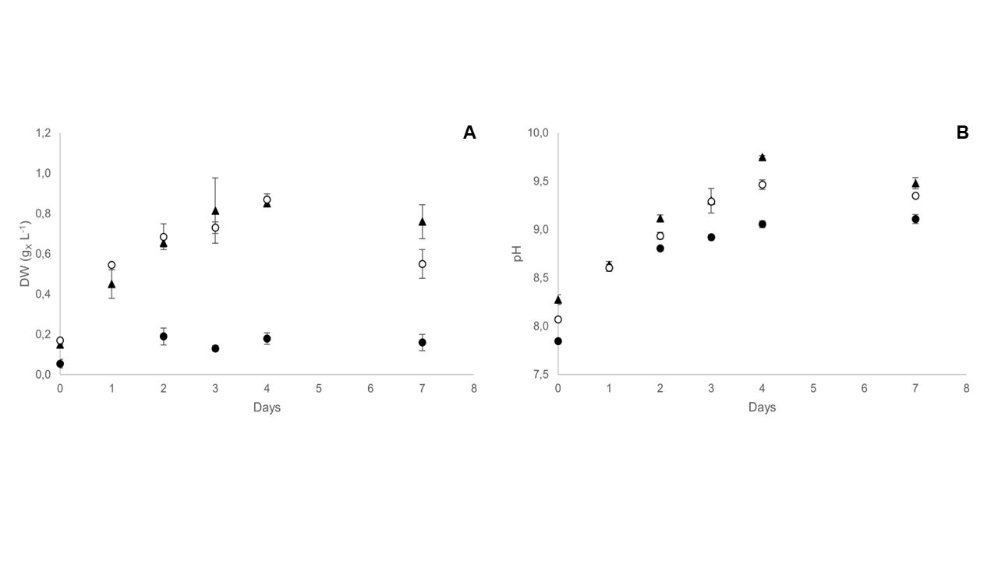
Figure 1: (A) Biomass concentration (g_{X} L⁻¹) and (B) pH measured in P. tricornutum batch culture at 5 g L⁻¹ (black triangles), 8 g L⁻¹ (empty circles) and 12 g L⁻¹ (black filled circles) of NaHCO₃.

Increasing NaHCO₃ concentration up to 8 g L⁻¹ did not exert a strong influence on P. tricornutum biomass concentration at the stationary phase of growth (0.87 g_{X} L⁻¹) being similar to that obtained with 5 g L⁻¹ of bicarbonate (Figure 1A). Growth is evidently impaired in any case when NaHCO₃ concentration is increased to 12 g L⁻¹, probably due to the higher concentration of Na⁺ and, subsequently, ion strength of the culture (Chi et al. 2014).
However, small differences can be seen in pH evolution over time (Figure 1B). Control culture (5 g L⁻¹) reached a pH of 9.75 at stationary phase, while at higher bicarbonate concentrations the final value established at 9.47. This result, as expected, is due to the higher buffer power exerted by an excess of HCO₃⁻ in the culture. At 12 g L⁻¹ pH evolution rate over time is lower but is probably due to the lack of cellular activity.
Faster bicarbonate uptake and intracellular accumulation could be reasonably the main cause of the quick pH increase observed. Hence, a fed batch protocol based on the daily supply of small amounts of bicarbonate in batch cultures was applied to verify this hypothesis (Figure 2).

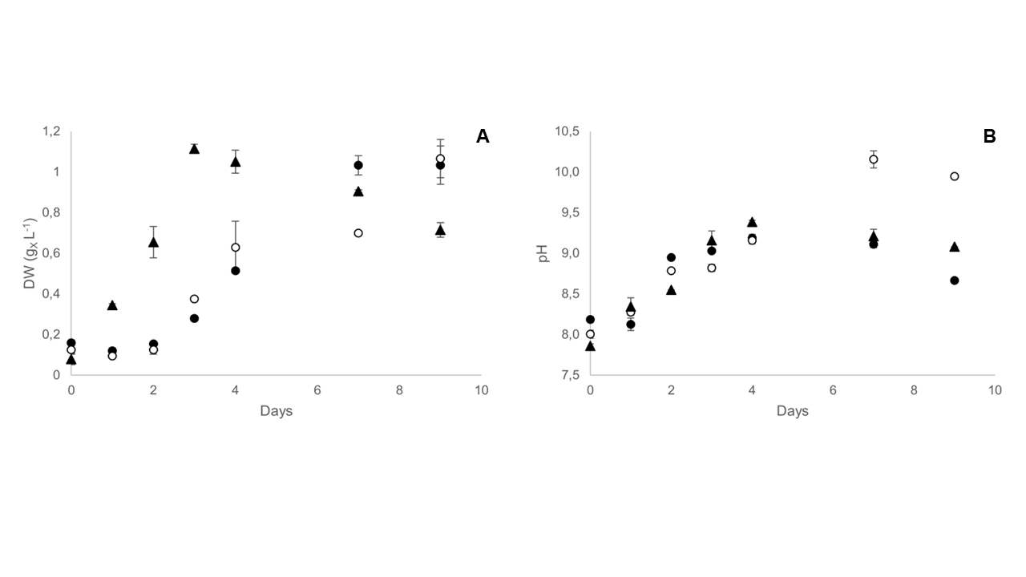
Figure 2: (A) Biomass concentration (g_{X} L⁻¹) and (B) pH measured in batch cultivation with 2.5 g L⁻¹ NaHCO₃ (black triangles), daily addition of 0.25 g L⁻¹ of NaHCO₃ (FB₁) (empty circles) and daily addition of 0.50 g L⁻¹ of NaHCO₃ (FB₂) (filled black circles).

Small amounts of bicarbonate (0.25 and 0.50 g L⁻¹ daily for, respectively, FB₁ and FB₂) were supplied to avoid its fast uptaking and, subsequently, pH increase. FB₁ trials resulted in a maximum biomass concentration of 1.03 g_{X} L⁻¹ at the stationary phase, while higher daily addition of NaHCO₃ (FB₂) led to lower values (0.70 g_{X} L⁻¹) (Figure 2A). With respect to the control culture (2.5 g L⁻¹ of NaHCO₃ in batch mode), hence, maximum biomass concentration was comparable when adding 0.25 g L⁻¹ of bicarbonate daily. Anyway, productivity is significantly different. Considering the stationary phase, fed-batch supply of bicarbonate resulted in a biomass productivity of 0.125 g_{X} L⁻¹ d⁻¹, three times lower than that reached in batch mode (0.345 g_{X} L⁻¹ d⁻¹). This difference is due to the longer lag-phase through which P. tricornutum underwent in both FB₁ and FB₂. As a comparison, a similar behavior was never recorded in previous batch cultivation for this species (see also Figure 1A). Efficient external HCO₃⁻ uptake by means of carbonic anhydrases is strongly dependent on substrate affinity. Hence, these results suggest that for a fast growing a certain initial carbon pool must be available from the beginning of the cultivation.
The study of pH increase during cellular growth shows small differences between fed-batch and batch addition of bicarbonate (Figure 2B). Still, it should be noticed that in FB₁ trials pH was buffered at about 9.0 from day 4 to day 7. As mentioned in section 2.2, increased doses of NaHCO₃ were fed on day four. In the same days, P. tricornutum continued its growth trend consuming the whole carbon pool (data not shown here). It is reasonable to think that spike addition of excess bicarbonate during cellular active growth possibly contributed to pH buffering, neutralizing OH⁻ released by the cells to generate carbonate (CO₃²⁻) and water (H₂O). The same result cannot be seen in FB₂, where biomass concentration remained steady in the same period, while pH increased to values up to 10.
  - Conclusions
Bicarbonate-based batch cultivation of different commercially-relevant microalgal strains was addressed in this study. Significant biomass concentrations were reached at different bicarbonate concentrations. Tetraselmis chuii (0.94 g_{X} L⁻¹) and Phaeodactylum tricornutum (1.12 g_{X} L⁻¹) performed the best when supplying 2.5 g L⁻¹ of NaHCO₃. The latter one resulted in the highest specific growth rate (0.85 d⁻¹) and, hence, in the highest biomass productivity (0.345 g_{X} L⁻¹ d⁻¹), comparable to that reached in CO₂-based cultivations for this species. Moreover, the diatom was able to grow at bicarbonate concentrations up to 8.0 g L⁻¹. When addressing pH stabilization by alternative bicarbonate supply modes, we found that no significant improvements in pH mitigation can be seen when an excess of bicarbonate is supplied. The daily fed-batch addition of inorganic carbon, instead, showed a negative impact on biomass growth rate and overall process productivity. Nevertheless, some pH mitigation occurred when spikes of inorganic carbon were supplied during linear growth of P. tricornutum. This result suggests that culture alkalinization could be reduced when delaying bicarbonate fed-batch addition to the active growth phase of culture. However, to overcome smaller growth rate issues observed, the initial carbon concentration should be finely balanced to avoid both carbon limitation as well as growth inhibition.
Finally, our work poses the basis for further experimentations aimed at stabilizing the cultivation of environment to enhance biomass productivity, extend the application to several other mesophilic strains and characterize biomass composition to validate the industrial feasibility of BICCAPSO.

References
Almutairi, Adel W., Abo El Khair B. El-Sayed, and Marwa M. Reda. 2020. “Combined Effect of Salinity and pH on Lipid Content and Fatty Acid Composition of Tisochrysis Lutea.” Saudi Journal of Biological Sciences 27(12): 3553–58.
Chi, Zhanyou et al. 2014. “Selection of Microalgae and Cyanobacteria Strains for Bicarbonate-Based Integrated Carbon Capture and Algae Production System.” Applied Biochemistry and Biotechnology 172(1): 447–57.
Chi, Zhanyou, James V. O’Fallon, and Shulin Chen. 2011. “Bicarbonate Produced from Carbon Capture for Algae Culture.” Trends in Biotechnology 29(11): 537–41.
Gao, Fengzheng, Iago Teles (Cabanelas, ITD), René H. Wijffels, and Maria J. Barbosa. 2020. “Process Optimization of Fucoxanthin Production with Tisochrysis Lutea.” Bioresource Technology 315.
Guillard, Robert RL. 1975. “Culture of Phytoplankton for Feeding Marine Invertebrates.” In Culture of Marine Invertebrate Animals: Proceedings—1st Conference on Culture of Marine Invertebrate Animals Greenport, Springer, 29–30.
Hopkinson, Brian M., Christopher L. Dupont, and Yusuke Matsuda. 2016. “The Physiology and Genetics of CO2 Concentrating Mechanisms in Model Diatoms.” Current Opinion in Plant Biology 31: 51–57.
Kim, Ga Yeong, Kosan Roh, and Jong In Han. 2019. “The Use of Bicarbonate for Microalgae Cultivation and Its Carbon Footprint Analysis.” Green Chemistry 21(18): 5053–62.
Kusi, Philip Asare, Donal McGee, Shamas Tabraiz, and Asma Ahmed. 2024. “Bicarbonate Concentration Influences Carbon Utilization Rates and Biochemical Profiles of Freshwater and Marine Microalgae.” Biotechnology Journal 19(8): 1–12.
Latagan, Mary Joy D. et al. 2024. “Bicarbonate-Based Microalgal Cultivation Technologies: Mechanisms, Critical Strategies, and Future Perspectives.” Chemical Engineering Journal 502(September).
Llamas, Bernardo et al. 2021. “Techno-Economic Analysis of Microalgae Related Processes for CO₂ Bio-Fixation.” Algal Research 57(December 2020).
Mohamadnia, Sonia, Omid Tavakoli, Mohammad Ali Faramarzi, and Zahra Shamsollahi. 2020. “Production of Fucoxanthin by the Microalga Tisochrysis Lutea: A Review of Recent Developments.” Aquaculture 516(September 2019): 734637.
Moraes, L. et al. 2020. “Bioprocess Strategies for Enhancing the Outdoor Production of Nannochloropsis Gaditana: An Evaluation of the Effects of PH on Culture Performance in Tubular Photobioreactors.” Bioprocess and Biosystems Engineering 43(10): 1823–32.
Nunez, Marcella, and Antonietta Quigg. 2016. “Changes in Growth and Composition of the Marine Microalgae Phaeodactylum Tricornutum and Nannochloropsis Salina in Response to Changing Sodium Bicarbonate Concentrations.” Journal of Applied Phycology 28(4): 2123–38.
Pedersen, Todd C., Robert D. Gardner, Robin Gerlach, and Brent M. Peyton. 2018. “Assessment of Nannochloropsis Gaditana Growth and Lipid Accumulation with Increased Inorganic Carbon Delivery.” Journal of Applied Phycology 30(4): 2155–66.
Price, G. Dean, Murray R. Badger, Fiona J. Woodger, and Ben M. Long. 2008. “Advances in Understanding the Cyanobacterial CO2-Concentrating- Mechanism (CCM): Functional Components, Ci Transporters, Diversity, Genetic Regulation and Prospects for Engineering into Plants.” Journal of Experimental Botany 59(7): 1441–61.
Roy, Uttam K., Tanja Radu, and Jonathan L. Wagner. 2021. “Carbon-Negative Biomethane Fuel Production: Integrating Anaerobic Digestion with Algae-Assisted Biogas Purification and Hydrothermal Carbonisation of Digestate.” Biomass and Bioenergy 148(September 2020): 106029.
Sathasivam, Ramaraj, and Niran Juntawong. 2013. “Modified Medium for Enhanced Growth of Dunaliella Strains.” Int J Curr Sci 5(January): 67–73.
Zhu, Chenba, He Zhu, Longyan Cheng, and Zhanyou Chi. 2018. “Bicarbonate-Based Carbon Capture and Algal Production System on Ocean with Floating Inflatable-Membrane Photobioreactor.” Journal of Applied Phycology 30(2): 875–85.

