|  |  |
| --- | --- |
| cetlogo ***CHEMICAL ENGINEERING TRANSACTIONS***  ***VOL. , 2024*** | A publication of  aidiclogo_grande |
| The Italian Association  of Chemical Engineering  Online at www.cetjournal.it |
| Guest Editors:  Copyright © 2024, AIDIC Servizi S.r.l. **ISBN** 979-12-81206-XX-X; **ISSN** 2283-9216 | |

Process Simulation-Driven Optimization of Acetic Acid Recovery: Azeotropic Distillation with n-Propyl Acetate

Alessio Ferlina,\*, Giulia Tonsib, Cristiano Maesanic, Giuseppe Burgioc, Stefano Alinic, Carlo Pirolab

aUniversità degli Studi della Campania Luigi Vanvitelli, Dipartimento di Architettura e Disegno Industriale - via San Lorenzo, 31, 81031 Aversa (NA), Italy

bUniversità degli Studi di Milano, Dipartimento di Chimica – via Golgi, 19, 20133 Milano (MI), Italy

bRadici InNova S.c.a.r.l. – via Fauser, 50, 28100 Novara (NO), Italy

alessio.ferlin@unicampania.it

The recovery of acetic acid is essential for various industries, but aqueous acetic acid solutions are particularly challenging to separate at high purity due to the presence of a pinch point at water molar fractions greater than 0.9. Simple binary distillation faces significant limitations in achieving high-purity separation, prompting the exploration of heterogeneous azeotropic distillation using n-propyl acetate as an entrainer to improve separation efficiency. This study focuses on optimizing the azeotropic distillation process and comparing it with simple binary distillation for the separation of water/acetic acid mixtures. Cross-validation between simulated and experimental data was performed to ensure the accuracy of the results. Additionally, a Life Cycle Assessment was conducted to assess and compare the environmental impact of both distillation methods, along with an evaluation of the differences in their energy demand.

1. Introduction

The recovery of acetic acid (AcOH) from aqueous solutions (water, W) represents a crucial problem in the efficiency of wastewater treatment, laboratory procedures, and in several industrial processes. Some of the most common industrial processes where acetic acid and water solutions are used are manufacturing of cellulose acetate, terephthalic, and isophthalic acids.

The application of the simple binary distillation on acetic acid and water solutions faces several limitations and, more importantly, is very expensive, from both fixed costs and operational costs point of view. For this reason, the employment of a third component called entrainer to perform heterogenous azeotropic distillation is mandatory to decrease these costs by enhancing significantly the separation between the two initial components. Water from the initial solution undergoes mass and heat transfer when it meets the n-propyl acetate (PrOAc) generating an azeotrope with a boiling point at around 82 °C and mass fraction composition of 0.124 in water (Toikka and Toikka, 2006). The azeotrope, being the component with the lowest boiling point, is vaporized and raises through all the column to be recovered as the distillate, meanwhile the remaining water and the acetic acid remain liquid and flow through all the column to the reboiler.

Acetates such as ethyl acetate, n-propyl acetate (Wang et al., 2007), n-butyl acetate (Wang et al., 2016) and iso-butyl acetate (Zhang et al., 2011) for heterogenous azeotropic distillation are reported in several articles and offer a fundamental advantage: acetates and water are only partially miscible, so it is possible to recover the entrainer with a simple decantation operational unit without the need for a second distillation tower.

The study will focus on n-propyl acetate as entrainer because it’s reported being the one with the lowest Total Annual Costs (TAC) (Galli et al., 2017).

To correctly investigate and predict the water and acetic acid entrainer assisted separation, the AVEVA Pro/II simulation software was employed. After a thermodynamic investigation on the most common thermodynamic models, azeotropic distillations were simulated. A comparative study respect to the binary method was performed. Experimental tests were conducted both on batch and continuous setups: the results were used to validate the result obtained on the AVEVA Pro/II software.

It was determined the target of the distillation were AcOH/W solutions in a range between 60 and 90 %wt of AcOH, due to the preference to store this chemical in a diluted form to avoid the expense of heated storage tanks, otherwise required for glacial acetic acid (> 99.5 %) (Eastman, 2025) especially in application in which it is employed as an additive. Moreover, the AcOH loss in the distillate was limited at 1 %wt or less.

1. Experimental

In this section the setups for the experimental tests are described.

* 1. Batch Claisen distillation

The batch distillation setup consisted of a Claisen condenser, cooled with cold running water, connected at one end to a three-necked flask. The flask contained the solution to be distilled along with the entrainer. At the other end of the condenser, tubes were installed to collect the distillate. The vapor temperature within the three-necked flask was monitored using a digital thermometer, while the solution was heated using a heating mantle to control the distillation process.

* 1. Continuous distillation column

Experimental tests were conducted using a distillation column with a height of 5 meters, equipped with 15 bubble cap trays. The column was designed with an on-off solenoid valve as an actuator, enabling precise control of the reflux ratio.

Temperature profiles along the column were monitored using multiple thermocouples strategically placed at various plates. Heat was supplied to the reboiler with two quartz rods inserted directly into the system. A flowmeter was installed to ensure continuous monitoring of the water flow rate through the condenser.

The feed points for the AcOH/W solution and PrOAc (used in azeotropic distillation) were located between trays 10 and 11 (Figure 1).

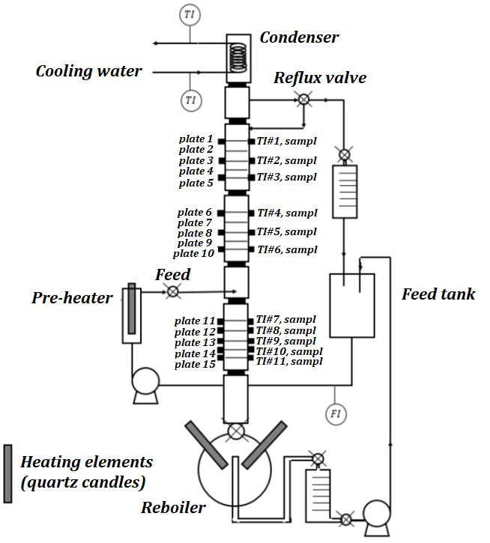

Figure 1: Schematic representation of the experimental tray column.

1. Simulation setup

In this section the simulative study of the separation process is presented.

* 1. Thermodynamic model selection

To accurately predict the experimental behaviour using AVEVA Pro/II simulation software, a preliminary analysis of the thermodynamic model was conducted.

The thermodynamic approach was selected by comparing experimental data from the literature with predictions generated by the simulator’s ELV tools across various thermodynamic models. This comparison ensured the reliability of the chosen model. In the case of the ternary mixture AcOH/W/PrOAc, this study presented several challenges: the formation of both organic and aqueous phases leads to a vapor-liquid-liquid equilibrium (VLLE) scenario. Furthermore, data on these equilibria are scarcely present in the literature. To address this issue, the predictive UNIFAC thermodynamic model was employed. To validate the AVEVA Pro/II simulation, small-scale batch tests were performed and the experimental data from these tests were used to assess the accuracy of the simulation results, ensuring their reliability and alignment with the observed behaviours.

A similar approach was used also for the binary mixture, to build the simulation setup for the following comparative study. In this case the evaluation was simpler for the presence of a big amount of literature data (Pirola et al., 2013).

* 1. Azeotropic distillation simulation

In AVEVA Pro/II software, after the selection of the UNIFAC temperature dependent (Fredenslund et al., 1975), an initial study was conducted employing the shortcut distillation unit. This step provided a first estimation of the number of trays and the reflux ratio required. The obtained values were rounded up to the nearest whole number and subsequently applied to the rigorous distillation column model.

The primary objectives of the simulation were to concentrate a 30 %wt acetic acid-water (AcOH/W) solution to 60 %wt in the first case and 90 %wt in the second case, while maintaining an acceptable reflux ratio (6 or less) and minimizing acetic acid losses in the overhead product to 1 %wt or less.

Additional details, such as tray efficiency and packing characteristics, were incorporated into the model. The Murphree efficiency was set at 70 % for every tray not affected by PrOAc, based on prior studies involving the AcOH/W system, while it was reduced to a value of 50 % for every tray in which a double liquid phase was present. Raschig ceramic rings, with a diameter of 1 inch, were selected as packing material.

Following this initial setup, the simulation was subjected to further optimization through several case studies. Key variables evaluated included the feed tray location, the reflux ratio, and the total number of trays, allowing for fine-tuning of the main column's performance to meet the specified objectives.

To maximize the recovery of PrOAc and minimize its loss, a second sensibly smaller distillation unit was incorporated into the process and the key variables mentioned above were optimized through case studies.

To facilitate the separation of phases, a flash unit was introduced, functioning as a decanter. To not create additional power demand the unit was set at 20 °C. The decanter enabled the settling of the aqueous and organic phases. The aqueous phase was directed to the second distillation unit, while the organic phase was recycled back into the main distillation column. The flow rate of the recycled organic phase was adjusted using a controller unit to ensure the appropriate concentration of n-propyl acetate. Through case studies, for the 30 to 60 %wt case it was determined that a weight fraction of 0.708 of entrainer in the whole solution fed into the column was required to achieve effective separation, while for the 30 to 90 %wt concentration the entrainer weight fraction required was 0.751. This setup allowed for precise control and optimization of the overall process, ensuring high recovery rates and minimal losses of n-propyl acetate.

In the case of the second method considered, the binary distillation, the model adopted was the UNIQUAC-HOC. The steps followed for the optimization of the model were the same described for the azeotropic main distillation column.

* 1. Energy consumption and Life Cycle Assessment (LCA) analysis

To evaluate the difference of the environmental impact respect to the binary distillation method, a Life Cycle Assessment (LCA) was conducted using SimaPro v. 9.4.0.3. The analysis is based on the Ecoinvent 3.8 (cut-off, S) database and apply the IPCC 2021 GWP100 (incl. CO2 uptake) V1.01 for the evaluation of the Global Warming Potential (GWP). Inventory data for the study were derived from simulations conducted using AVEVA Pro/II for the 30 to 60 % case. For comparison purposes, the aqueous acetic acid feed was not considered in the material inputs because it was the same in the two distillations. The secondary data required were obtained from the Ecoinvent database (Table 1). The functional unit considered in the study was 1 kg of recovered mixture.

Table 1: Selected Ecoinvent processes (for propyl acetate, an additional 100 km of transportation was included to comprehensively account for all environmental impacts.)

|  |  |  |
| --- | --- | --- |
|  | **ECOINVENT PROCESS** | **Region** |
| **Propyl Acetate** | Propyl acetate production | RER |
| **Cooling water** | Water, cooling, unspecified natural origin | IT |
| **Electricity (medium voltage)** | Market for electricity, medium voltage | IT |
| **Steam (heat)** | Heat and power co-generation, natural gas, combined cycle power plant, 400MW electrical | IT |
| **Wastewater treatment** | treatment of wastewater, average wastewater treatment | Europe without Switzerland |

1. Results

The selection of the thermodynamic models was based on a detailed comparison between Vapor-Liquid equilibrium (VLE) and Liquid-Liquid Equilibrium (LLE) curves from the literature and simulated data.

For the ternary mixture comprising water, acetic acid, and n-propyl acetate, the UNIFAC temperature dependent model was deemed as suitable. Although this model slightly overestimated the acetic acid concentration in the aqueous phase, its performance was considered conservative and acceptable. This choice was further justified by the agreement in the slope of the tie lines between the simulated ternary plot and literature data (Toikka et al., 2020), indicating consistent phase behaviour (Figure 2). The UNIQUAC model, coupled with the Hayden-O’Connell correction for the vapor phase (UNIQUAC-HOC), was instead identified as the most accurate for the binary water-acetic acid (W/AcOH) system, with the binary interaction parameters finely tuned for this pair.

Figure 2: Ternary plot for the n-PrOAc/AcOH/W solution and miscibility gap comparison between literature and UNIFAC Temperature Dependent data.

The accuracy of the thermodynamic models and simulations was further validated by comparing the distillate mass fractions obtained experimentally with those predicted by the simulation. The results showed excellent agreement, demonstrating that the selected thermodynamic models accurately predicted the real behaviour of the mixtures (Figure 3).

Figure 3: Comparison between experimental data (EXP) and simulated data (SIM) of the various components in a) binary distillation and b) azeotropic distillation in batch runs. Each cut represents the mixture with its specific composition distilled in function of time

After optimization, each design for the azeotropic distillation process yielded two distinct columns with different configurations to achieve the desired separation specifications (Figure 4a). Considering the concentration from 30/70 %wt AcOH/W solution to 60/40 %wt, the first distillation column, referred as T1, consists of 9 stages. The reflux ratio was set to 1, and the feed was introduced at the 5th stage. The second distillation unit features a column with 5 stages, while the reflux ratio was similarly set to 1, with the feed introduced at the 3rd stage. The optimal setup for the binary distillation instead consists of a single column composed by 33 stages with the reflux ratio set at 6, and the feed was introduced at the 23rd stage (Figure 4b).

Focusing on the concentration to 10/90 %wt AcOH/W solution, the specifications changed accordingly: in the azeotropic distillation the T1 unit consisted of 15 stages column fed at the 8th plate with reflux ratio set at 1, while the T2 unit was 7 stages column fed at the 4th plate with the same reflux ratio as T1. For the binary distillation setup, it comprises a single unit consisting in 37 stages fed at 23rd stage with reflux ratio set as 6.

In Table 2 the specifications reached with the two configurations are reported and it can be seen the initial goals set were reached.

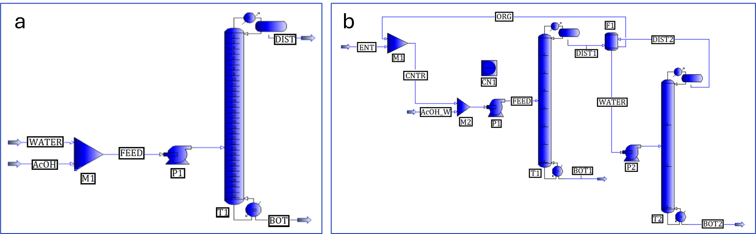

Figure 4: Overall spreadsheets of the (a) binary (b) azeotropic distillation columns.

Table 2: Specifications obtained with the simulation software AVEVA Pro/II for the optimized azeotropic distillation for the concentration to 60 and 90 %wt, respectively.

|  |  |  |  |  |  |  |  |
| --- | --- | --- | --- | --- | --- | --- | --- |
| *Azeotropic distillation simulation (30 to 60 %wt AcOH)* | | | | | | | |
| *STREAM NAME* |  | *AcOH/W STREAM* | *FEED* | *BOTTOM1* | *DISTILLATE1* | *BOTTOM2* | *ENTRAINER* |
| Total mass rate | kg/h | 2000 | 7311 | 998 | 6313 | 1012 | 9 |
| Weight component fraction | | | | | | | |
| Water |  | 0.700 | 0.209 | 0.399 | 0.179 | 0..990 | 0.000 |
| Acetic acid |  | 0.300 | 0.083 | 0.600 | 0.001 | 0.001 | 0.000 |
| n-propyl acetate |  | 0.000 | 0.708 | 0.001 | 0.820 | 0.009 | 1.000 |
| *Azeotropic distillation simulation (30 to 90 %wt AcOH)* | | | | | | | |
| Total mass rate | kg/h | 2000 | 8925 | 647 | 8278 | 1353 | 12 |
| Weight component fraction | | | | | | | |
| Water |  | 0.700 | 0.177 | 0.100 | 0.183 | 0.990 | 0.000 |
| Acetic acid |  | 0.300 | 0.072 | 0.900 | 0.007 | 0.001 | 0.000 |
| n-propyl acetate |  | 0.000 | 0.751 | 0.000 | 0.810 | 0.009 | 1.000 |

Experimental trials were conducted using a 15-tray distillation column and the results demonstrated the impossibility to achieve the desired separation efficiency without the entrainer addition. Table 3 shows the data obtained through the different tests performed with acetic acid feeds and entrainers at mid-column, as the reflux ratio and flowrate of the input streams varies. As it can be observed, the n-propyl acetate mass fraction/feed used (0.708 based on simulation) was sufficient to achieve the desired specifications for both the distillate and the residue at the bottom of the column. Unlike the binary distillation of acetic acid and water, the distillate had a very low percentage of acetic acid (0.3 %).

|  |  |  |  |  |  |  |  |  |
| --- | --- | --- | --- | --- | --- | --- | --- | --- |
| **Trial** | **Working mode** | **Pressure (atm)** | **Reflux ratio** | **Initial AcOH reboiler wt%** | **Feed flowrate (mL/min)** | **PrOAc flowrate** | **Bottom AcOH wt%** | **Distillate AcOH wt%** |
| 1 | Continuous | 1 | 1 | 60 | 6 | 14 | 63.1 | 0.02 |
| 2 | Continuous | 1 | 0.7 | 60 | 4 | 14 | 62.8 | 0.02 |
| 3 | Continuous | 1 | 0.5 | 60 | 6 | 13 | 62.2 | 0.04 |

*Table 3: Experimental trials conducted using a 15-tray distillation column results.*

By LCA analysis, it was concluded that azeotropic distillation again demonstrates advantages over binary distillation, since the Global Warming Potential impact category is lower: in fact, the GWP for the binary distillation accounts for 0.43 kg CO2 eq, while for the azeotropic distillation accounts for just 0.32 kg CO2 eq. A detailed analysis of the contribution of this indicator shows that most of the environmental impact comes from the thermal energy required by the reboiler and that it is essential to minimize the loss of propyl acetate along the process (Table 4).

Table 4: Contribution analysis for the GWP impact category (green =<5 %, red =>10 %).

|  |  |  |  |  |  |  |  |
| --- | --- | --- | --- | --- | --- | --- | --- |
| ***CONTRIBUTION ANALYSIS FOR BINARY DISTILLATION*** | | | | | | | |
|  |  | | **Cooling Water** | | **Steam** | **Waste water treatment** | **Electric Energy** |
| **WP total** | kg CO2eq | | 0.31 % | | 99.53 % | 0.16 % | 0.00 % |
| **CONTRIBUTION ANALYSIS FOR AZEOTROPIC DISTILLATION** | | | | | | | |
|  |  | **Cooling Water** | | **PrOAc** | **Steam** | **Waste water treatment** | **Electric Energy** |
| **GWP total** | kg CO2eq | 0.235 % | | 16.02 % | 83.92 % | 0.22 % | 0.01 % |

As it can be seen in the inventory data table (Table 5), the amount of steam is notably higher for binary distillation, which demands a greater amount of thermal work for the separation process. Despite its increased engineering complexity, in fact, azeotropic distillation benefits from a lower reflux ratio, leading to reduced heat requirements and consequently a smaller environmental impact, especially in terms of energy consumption and associated emissions. So, although the entrainer could represent a greater contribution to the environmental impact, the minimization of its loss leads to a negligible impact on the GWP compared to the reduction in the energetic demand. making azeotropic distillation a more sustainable option overall.

Table 5: Inventory data for the two processes.

|  |  |  |  |
| --- | --- | --- | --- |
| **BINARY DISTILLATION** | | **AZEOTROPIC DISTILLATION** | |
| Cooling Water (m3) | 7.96 ∙ 10-3 | Cooling Water (m3) | 4.54 ∙ 10-3 m3 | |
| Steam (kg) | 5.73 kg | Steam (kg) | 3.67 kg | |
| Electric Energy (kWh) | 7.92 ∙ 10-6 kWh | Electric Energy (kWh) | 4.79 ∙ 10-5 kWh | |
| Waste water treatment (m3) | 1.02 ∙ 10-3 m3 | Waste water treatment (m3) | 1.03 ∙ 10-3 m3 | |
|  |  | Propyl Acetate-PrOAc (kg) | 5.10∙ 10-3 kg | |

1. Conclusions

The use of azeotropic distillation with n-propyl acetate overcomes the limitations of binary distillation for AcOH/W separation caused by the pinch point in the liquid-vapor equilibrium near pure water. Simulations with AVEVA Pro/II software, using the UNIFAC temperature dependent model and experimentally validated, optimized the process and enabled energy demand and environmental impact analysis. The study revealed significant steam savings and improved overall sustainability for the azeotropic distillation system with n-propyl acetate as the entrainer, to bring acetic acid from 30 % to 60 % and from 30 % to 90 %wt.

References

Eastman, 2025. Acetic Acid - 60% Diluted [WWW Document]. URL https://www.eastman.com/en/products/product-detail/71001182/ (accessed 3.3.25).

Fredenslund A., Jones R.L., Prausnitz J.M., 1975. Group-contribution estimation of activity coefficients in nonideal liquid mixtures. AIChe Journal 21, 1086–1099.

Galli F., Previtali D., Casagrande S., Pirola C., Manenti F., Boffito D.C., 2017. Simulation of the water-acetic acid separation via distillation using different entrainers: An economic comparison. Chem Eng Trans 57, 1159–1164.

Pirola C., Galli F., Bianchi C.L., Carvoli G., 2013. Heterogeneous Distillation of the System Water-Acetic Acid-p-Xylene: Study of its Fluid Phase Equilibria, Micro-Pilot Column Experimental Results and Computer Simulation. Chem Eng Trans 32, 1897–1902.

Toikka A., Toikka M., 2006. Phase transitions and azeotropic properties of acetic acid–n-propanol–water–n-propyl acetate system. Fluid Phase Equilib 250, 93–98.

Toikka M., Sadaev A., Lobacheva O., Golikova A., 2020. Experimental Liquid-Liquid Equilibrium and Solubility Study of an Acetic Acid- n-Propyl Alcohol- n-Propyl Acetate-Water System at 323.15 and 333.15 K. J Chem Eng Data 65, 5352–5359.

Wang B., Rong M., Wang P., Chen S., 2016. Liquid-Liquid Equilibria for the Ternary System n-Butyl Acetate + Pyrocatechol + Water at Different Temperatures at 101.3 kPa. J Chem Eng Data 61, 3184–3189.

Wang L., Cheng Y., Xiao X., Li X., 2007. Liquid-liquid equilibria for the ternary systems acetic acid + water + butyl acetate and acetic acid + water + 2-methyl propyl acetate at 304.15 K, 332.15 K, and 366.15 K. J Chem Eng Data 52, 1255–1257.

Zhang C., Wan H., Xue L., Guan G., 2011. Investigation on isobaric vapor liquid equilibrium for acetic acid + water + (n-propyl acetate or iso-butyl acetate). Fluid Phase Equilib 305, 68–75.