|  |  |
| --- | --- |
| cetlogo ***CHEMICAL ENGINEERING TRANSACTIONS***  ***VOL. xxx, 2025*** | A publication of  aidiclogo_grande |
| The Italian Association  of Chemical Engineering  Online at www.cetjournal.it |
| Guest Editors: Fabrizio Bezzo, Flavio Manenti, Gabriele Pannocchia, Almerinda di Benedetto  Copyright © 2025, AIDIC Servizi S.r.l. **ISBN** 979-12-81206-17-5; **ISSN** 2283-9216 | |

Evaluating the Wettability of Hydrophobized Granular Solids via Rheological Analysis of Surfactant-Induced Modifications

Ronald Mercado\*, Arlex Chaves-Guerrero,

Grupo de Investigación en Fenómenos Interfaciales, Reología y Simulación de Transporte – FIRST. Universidad Industrial de Santander, Bucaramanga – Colombia

ramerca@uis.edu.co

The wettability of granular solids plays a critical role in multiple industrial applications, including enhanced oil recovery, advanced material coatings, and nanotechnology. Despite its significance, traditional methods of assessing wettability, such as contact angle measurements, encounter challenges when applied to heterogeneous and porous solids. This study introduces a rheological methodology as an alternative approach for determining the wettability of granular solids, specifically bentonite clay, modified by sodium dodecylbenzene sulfonate adsorption. Aqueous suspensions of bentonite with varying degrees of hydrophobicity were evaluated through viscosity measurements, oscillatory amplitude sweeps, and thixotropic recovery tests. Results revealed distinct correlations between surface coverage and rheological behavior, including reduced viscosity and viscoelasticity with increasing hydrophobicity in aqueous systems. The proposed rheological methodology not only addresses the limitations of conventional wettability assessments but also provides a comprehensive framework for characterizing and tailoring the interfacial properties of particulate systems. This work has implications for a range of industries, from petroleum and coatings to material science, offering a new avenue for designing systems with optimized wettability and flow properties.

* 1. Introduction

The degree of hydrophobicity of a solid is a highly relevant property because of its wide range of applications in various fields. Modifying the wettability of solid surfaces has significant implications in areas ranging from the petroleum industry, where enhanced oil recovery is requested, to the textile industry, as well as in the protection of infrastructure such as solar panels and satellites, and in coatings for the materials industry (Cuevas Becerra, 2006; Dos Santos and Goncalves, 2016).

The study of wettability and its modulation remains a vibrant area of research due to its relevance in both fundamental science and technological applications. Recent advances in surface science have provided insight into the molecular-level interactions driving wettability, particularly in systems involving surfactants and mixed-phase media. However, the intricate interplay between surface roughness, chemical heterogeneity, and interfacial energy continues to pose significant challenges in achieving precise wettability characterization (Tadros, 2011). These complexities are magnified in granular and porous solids, where conventional methods often fail to capture the nuanced behavior of such systems under real-world conditions.

Despite numerous studies on the phenomena that affect wettability, it has been challenging to establish unequivocal rules that relate it to various variables such as temperature, the type of solid, the chemical composition, and the presence of surfactants. For example, in enhanced oil recovery (EOR) processes, alteration of rock wettability is a critical factor (Deng et al., 2021). Surfactants are often used to modify the surface interaction between oil, water, and mineral surfaces, significantly impacting the efficiency of oil recovery (Pu et al., 2016). The determination of the degree of wettability in particulate solids and non-ideal surfaces, such as those found in oil reservoirs, is particularly relevant due to the roughness and heterogeneity of minerals like clay, silica, and limestone. This variability makes it difficult to obtain a precise contact angle, which in turn complicates the reliable estimation of the solid's hydrophobicity.

Understanding the rheological properties of suspensions formed with granular solids is crucial for optimizing processes in the petroleum, coatings, and materials industries. The rheology of these systems is strongly influenced by the wettability of the suspended particles, which affects particle-particle interactions, aggregation, and dispersion stability. For instance, clay suspensions with varying degrees of hydrophobicity exhibit distinct flow behaviors, ranging from Newtonian to highly shear-thinning or viscoelastic responses(Abrougui et al., 2018; Pal, 2024). However, the quantitative relationship between hydrophobicity and rheological behavior remains an underexplored area, limiting the predictive capabilities required for industrial applications.

Beyond traditional applications, this research has implications for designing advanced materials with tailored surface properties. For instance, hydrophobically modified clay particles could serve as templates for developing functionalized coatings, or as additives in nanocomposites to enhance mechanical and barrier properties. Therefore, the objective of this work is to propose a methodology to determine the wettability degree of a granular solid, using clay suspended in an aqueous continuous phase to form a suspension. Wettability can be then assessed by the rheological response in terms of viscosity or viscoelasticity. This approach not only aims to improve the understanding of hydrophobicity in granular solids, but also provides practical applications in various industries, including petroleum recovery, surface coatings, and advanced material engineering.

* 1. Experimental procedures

**2.1 Materials**. Sodium dodecylbenzene sulfonate (SDBS) of 99.9 purity (supplied by ALDRICH) was used as an amphiphilic molecule. This molecule can absorb electromagnetic radiation in the ultraviolet (UV) range, offering a maximum absorbance wavelength of 224 nm. This property is useful for quantifying its concentration in solution by UV spectroscopy. The critical micellar concentration (CMC) was determined at 0.1 % wt/v (0.001 g/ml) using the surface tension method.

A bentonite mineral (provided by Acofarma S.A), a montmorillonite-type clay with hydrophilic properties was the solid used in this study. This clay has a high capacity to adsorb anionic compounds due to its structure. Its surface area (BET) was determined at 65.26 m²/g. The average particle diameter was measured to be about 1.06 m, exhibiting a narrow monomodal size distribution. The clay was washed several times with distilled water and dried for further use.

**2.2. Formulation of suspensions**. In this study, an aqueous slurry was first formulated. This step allowed the determination of the most suitable solid/liquid ratio through rheological tests. Suspensions of bentonite in distilled water were prepared at several weight/volume concentrations. The suspensions were stirred at 20 rpm for 45 minutes to ensure uniform distribution before being characterized by rheological assessments.

**2.3. Rheological characterizations**. Rheological data were obtained using an Anton Paar MCR-302 rheometer with RheoCompass software. Tests were carried out in a Couette geometry formed by an outer static cup of 40 mL volume and an inner double-helix spindle (ST24-2HR-37/120, Anton Paar) that is able to mix the solution and measure the rheological properties. This geometry was used in order to ensure a good dispersion of solid particles since it is highly recommended for measuring suspensions (Bbosa et al., 2017; Kapur and Meloy, 1999). The temperature was kept constant at 25 °C in all rheological tests.

For viscosity curves, a shear rate sweep was performed from 100 to 0.1 s⁻¹ using a logarithmic ramp. Moreover, oscillatory amplitude sweeps were performed from 0.01% to 100% strain at a constant angular frequency of 10 rad/s. To evaluate thixotropy of the suspensions, an oscillatory-rotational-oscillatory (ORO) test was carried out. The initial and final step were conducted at 10 rad/s and 0.1% strain (constant parameters), since the rotational step was developed at 1000 s⁻¹. All steps in the ORO tests were conducted during 300 s.

**2.4. Quantification of surfactant concentration**. The SDBS concentration in aqueous solutions was estimated through spectrometry measurements using a Mapada P5 spectrophotometer, at the wavelength of the maximum absorbance for SDBS, i.e. at 224 nm.

**2.5 SDBS isotherm on bentonite.**

The adsorption of the surfactant onto bentonite was also quantified at 25 °C. Samples were stirred using a Thermo Scientific roller agitation system (model 8881003), to improve the system homogenization at 20 rpm. Every sample was composed of bentonite and SDBS solution at a constant 1g/10mL ratio. After an equilibration time of 24 h, solids were separated from the solution using a centrifuge system (Dathan Scientific, model Cef-50.6) at 3400 rpm for 20 minutes. The amount of adsorbed surfactant was then calculated from the mass balances (Amran et al., 2022). In all cases, the temperature was maintained constant at 25 °C.

* 1. Results and discussion
     1. Determination of the more suitable solid concentration in suspensions

Four aqueous dispersions with varying bentonite concentrations (4%, 6%, 8%, and 10% wt./v) were analyzed; the resulting viscosity curves are illustrated in Figure 1a. It can be observed that as solid content is augmented, the viscosity profile also increases (Figure 1a). A shear-thinning behavior can be observed for all suspensions except for 4 %. Shear-thinning is typically exhibited in highly concentrated bentonite suspensions, which means that resistance to flow decreases with increasing deformation rate due to interactions between particles, such as interparticle double-layer repulsions (Luckham and Rossi, 1999).

Suspension with 4% of bentonite does not show deviation from Newtonian behavior. This is probably due to negligible interactions between particles. This fact let us discard this concentration in the study. Important deviations from ideal behavior are suitable for further tests because different particle´s hydrophobic degrees are expected to show more important differences in rheological assessments. This is more likely to be exhibited if the behavior is not Newtonian.

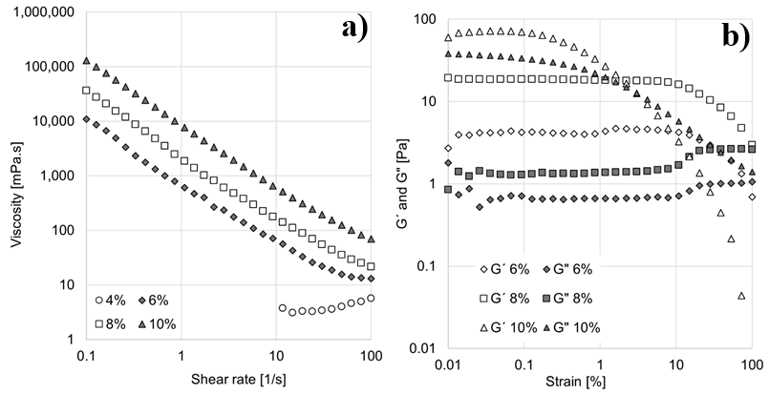

*Figure 1. a) Viscosity curves as a function of solids content. b) Amplitude sweeps as a function of solids content at 10 rad/s.*

The interactions between particles depend on their hydrophilicity. The aim of this study is to note these interactions from rheological characterizations. The viscosity curves for the suspensions depend on these interactions. To provide confirmatory test to viscosity curve, amplitude sweeps were performed, and the results are shown in Figure 1b. It can be observed that at low strains, the elastic modulus (G') is greater than the viscous modulus (G''), indicating that the system is predominantly elastic (solid structure) and can store energy at low strains; see Figure 1b. As strain increases, the network collapse results in greater energy dissipation; both moduli decrease continuously, but the elastic component drop is more important than the viscous one, consequently suspensions behave as a viscous liquid at high strains. Now, for 10% aqueous suspension, the elastic and viscous moduli are above 10 Pa, but a crossover point between G´ and G″ is obtained at 2.2%. However, 8% and 6% suspensions exhibit lower modulus, but they start to drop at higher strains. This is a very interesting behavior, because the solid structure remains at high shear strains and the crossover point is reached at about 100% strain in both suspensions. In the case of the suspension of 4%, results are not shown in Figure 1b since no important viscoelasticity is obtained. This behavior is consistent with the Newtonian behavior seen in the viscosity curve (Figure 1a).

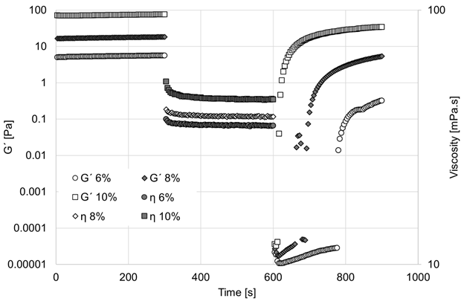

*Figure 2. ORO tests for suspension at several bentonite concentrations.*

To determine the most appropriate solids concentration to continue the study, the recovery kinetics of the suspensions must be studied. This is necessary, since several studies have demonstrated the thixotropic behavior of bentonite suspensions (Ren et al., 2021). Thixotropy describes the gradual decrease in viscosity of fluids when subjected to a constant shear force over time, with partial or full recovery of its initial structure when the force is removed. The ORO (Oscillatory-Rotational-Oscillatory) tests allow determination of recovery speed and rheological behavior characterization. The results are shown in Figure 2. In this figure, it can be observed that all suspensions exhibit similar rheological behavior and that a rapid recovery of the elastic modulus after rotational shear is removed. The value used for rotational speed is very high (1000 s-1) to ensure the complete structure´s breakup, then after 300 seconds of rest, the 10% suspension achieves 45% recovery, while the 8% suspension recovers 29.4% and the 6% suspension recovers 5.8%.

* + 1. Effect of bentonite hydrophobicity degree on the rheological behavior of suspensions

The CMC of SDBS was determined from surface tension assessments. At 25°C, the CMC is reported to be 0.1% wt./v (2.87 mM). This value is in line with other values calculated by conductivity (Hait et al., 2003; Sood and Aggarwal, 2018). The Gibbs isotherm equation was used to determine the specific surface area of the surfactant molecules, see Eq (1), (8.68×10-10 moles/cm2). This parameter is very important since the adsorption isotherm can be expressed in terms of surface coverage instead of traditional moles of surfactant adsorbed per solid mass ratio.

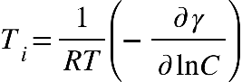 (1)

In the latter equation, Ti represents the excess interface concentration [moles/cm2], R is the Universal gas constant, and T is the Absolute Temperature, [K].

Adsorption Isotherm Calculation

The adsorption isotherm was determined by quantifying the amount of SDBS adsorbed onto the solid while varying its initial concentration at a constant temperature of 25 °C. This step provides insight into the different surface coverage levels exhibited by the solid as a function of the equilibrium surfactant concentration/CMC ratio.

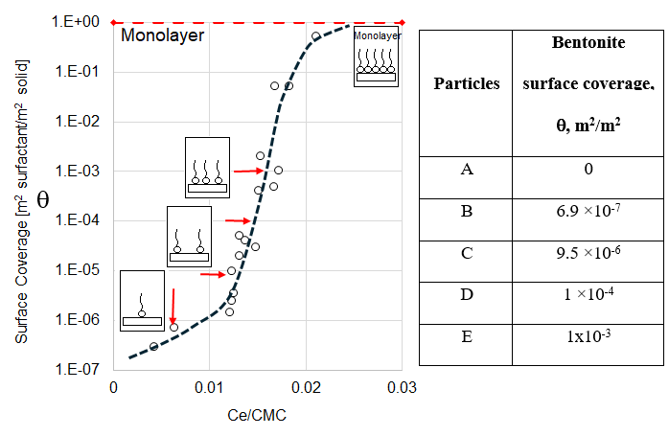

*Figure 3. Adsorption Isotherm of SDBS on bentonite at 25°C.*

The surface coverage is presented as a function of equilibrium concentration

In Figure 3, the isotherm is represented using a normal-log scale to easily observe the whole range of solid surface coverage. Upon evaluating the isotherm, the behavior aligns closely with an S-type isotherm (Kalam et al., 2021). The dotted line describes the general behavior of the adsorption. Some authors suggest that the adsorption of surfactants on solid surfaces in simple systems or those with a single surfactant can be described using a four region or two step models (Schramm, 2000). However, in this study, the x-axis range is limited to basically one order of magnitude. The goal is to control the hydrophobization of the bentonite surface avoiding the formation of hemi-micelles structures. A monomolecular adsorption quasi-vertical step is observed and consequently the surface coverage increases with the concentration of surfactant (see Figure 3). Beyond the maximum concentration value used in this study (0.021), a plateau-step is expected followed by a second increase in surfactant adsorption, the latter characterized by the appearance of hemi-micelles when the surface coverage is higher than one ( >1). This behavior is typically associated with a two-step model, as explained by Cases et al., for systems with strong normal adsorbate-adsorbent bonds (Cases et al., 2002). In the range of surfactant concentration used in this work, only a surfactant monolayer is able to be formed. This is very convenient in view of the application of the study since bentonite particles can become hydrophilic again if a partial bilayer is produced on its surface. In line with this behavior, it is appropriate to state that, for this analysis, the data aligns with a single step adsorption isotherm. In the first region, between 0.004 and 0.012 on the x-axis, only a few molecules adsorb onto the bentonite surface. Then adsorption increases and the surface coverage rises several orders of magnitudes between 0.012 and 0.018. This behavior continues until 0.021, wherein the surface of the solid is half saturated ( = 0.51), marked by a change in the slope. Beyond this concentration, no additional data were obtained, first because there is no particular interest in reaching higher surface coverages and second, because of the high adsorption capacity of bentonite, characterized by an extremely large surface area (65.3 m2/g). In fact, a surfactant concentration close to the solution saturation was used to obtain the last point of the curve.

The different surface coverages exhibited by the solid are defined as a function of the equilibrium surfactant concentration. These concentrations are marked with a red arrow on the isotherm, see Figure 3.

Effect of the Surface Coverage on Rheological Behavior

In the case of aqueous suspensions, a clear trend can be observed in Figure 4a. The higher the coverage of the sold surface, the lower the viscosity. The suspension containing completely hydrophilic solids (bentonite without adsorbed SDBS molecules) exhibits the highest viscosity, although it is very similar to the curve corresponding to suspensions with particles B ( = 6.9 ×10-7). This behavior is due to the negative surface charge of bentonite particles, which generates a strong electrostatic repulsion between them, increasing the system's viscosity. The adsorption of DBSS mitigates this repulsion, as the surfactant concentration increases, the surface coverage rises, enhancing interparticle lubrication. This effect occurs because the hydrophobic tails of the surfactant partially cover the particle surfaces, reducing direct interactions between them. Consequently, electrostatic repulsions are attenuated, and the attractive forces between the hydrophobic tails become dominant (Luckham and Rossi, 1999). As a result, a decrease in viscosity is observed.

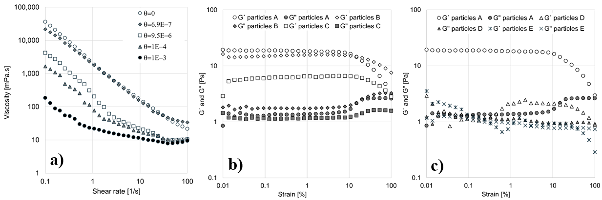

*Figure 4. a) Viscosity curves as a function of particles coverage. b) Oscillatory amplitude strain sweeps as a function of particles A, B and C coverage. c) Oscillatory amplitude strain sweeps as a function of particles A, D and E coverage.*

It is important to note that when hydrophobized particles are used, a plateau appears at high shear rates. That is, the behavior changes with respect to uncoated particles ( = 0). The surface coverage evaluated in this study is less than one ( < 1), hence, the results are aligned with expectations. Now, if the coverage is increased and hemimicellar structures are formed, the solid not only becomes hydrophilic again, but the apparent size of the particles would also increase as well as the apparent solids concentration. This would lead to an increase in viscosity and again we would observe significant deviations from Newton's Law. This fact can be a disadvantage from the point of view of the purpose of the technique, so it is advisable to have a well-defined calibration system where the surface coverage of the solid is between 0 and 1 (0 ≤  ≤ 1).

Moreover, oscillatory amplitude sweep tests were performed at a constant frequency (10 rad/s) on the same aqueous suspensions, see Figure 4. Similarly, fully hydrophilic particles exhibit the highest viscoelasticity in aqueous suspensions (Figure 4b), the elastic modulus reaches values above 10 Pa. As discussed before, this structured system is dominated by electrostatic repulsions. Nevertheless, as the surface coverage increases, the elastic modulus (G’) progressively decreases (see Figures 4b and 4c). At surface coverages of 9.47x10-6 and 1.01x10-4 (particles B and C), the magnitudes of the viscous and elastic moduli are comparable, around 1 Pa, see Figure 4b. For these two systems, viscoelasticity of the formed structures is reduced, and the elastic component is no longer greater than the viscous modulus. In the shear strain range studied, the crossover points between G' and G” are not observed. This point is known as the yield stress and could eventually be used as a calibration parameter for particles with different surface coverages. Another interesting point to be highlighted in the oscillatory tests is that the fact that viscous modulus exhibits an increase in magnitude from 10% strain. This increase is clearly observed in suspensions with more hydrophilic particles (particles A, B and C in Figure 4b) and is usually associated with the formation of microcracks within the conformation of the suspension structure. On the other hand, suspensions with higher surface coverage, particles exhibit a decrease in this parameter from 10% strain onwards (particles D and E in Figure 4c).

* 1. Conclusions

According to the findings of this research, the degree of hydrophobicity, modulated by surfactant adsorption, significantly impacts the rheological properties of bentonite suspensions. The aqueous suspensions showed a progressive reduction in viscosity and viscoelastic modulus with increasing surface coverage, attributed to the attenuation of electrostatic repulsions and enhanced interparticle lubrication.

Hydrophobic modifications led to a marked transition from shear-thinning to near-Newtonian behavior, with a decrease in structural rigidity reflected in lower elastic (G') and viscous (G'') moduli. Thixotropic recovery tests demonstrated that higher solid concentrations (e.g., 8% wt./v) recover their structure more efficiently, confirming their suitability for studying hydrophobic modifications. Faster recovery ensures reliable rheological behavior during repeated deformation cycles.

This study establishes rheology as a sensitive quantitative tool for assessing the wettability of particulate solids, overcoming the limitations of conventional methods on heterogeneous and porous materials. The methodology enables fine-tuning of solid-liquid systems to meet specific application requirements in industries such as oil recovery, coatings, and advanced materials.

Finally, this research lays the foundation for broader applications, suggesting that similar approaches could be extended to more complex systems, including composite materials, oilfield rocks, or modified particles with multiple surfactants. Further investigations will explore the interplay between surface chemistry, interfacial forces, and rheological properties to enhance predictive capabilities.

Acknowledgments

The authors express their gratitude to the “Ministerio de Ciencia y Tecnología (MINCIENCIAS)” and the “Agencia Nacional de Hidrocarburos (ANH)” for the financial support. This work was financially supported by Project 1102-1035-92931 contract 036 2023.

References

Abrougui, M.M., Bonhome-Espinosa, A.B., Bahri, D., López-López, M.T., Durán, J.D.G., Srasra, E., 2018. Rheological Properties of Clay Suspensions Treated by Hydrocyclone Process. Journal of Nanofluids 7, 258–268. https://doi.org/10.1166/jon.2018.1460

Amran, T., Mohd, T., Bohairah, T.A., Jaafar, M.Z., 2022. Characterization of Quartz Sand as an Adsorbent for Anionic Surfactant Adsorption with Presences of Alkaline and Polymer. Chemical Engineering Transactions 95, 283–288. https://doi.org/10.3303/CET2295048

Bbosa, B., DelleCase, E., Volk, M., Ozbayoglu, E., 2017. Development of a mixer-viscometer for studying rheological behavior of settling and non-settling slurries. J Petrol Explor Prod Technol 7, 511–520. https://doi.org/10.1007/s13202-016-0270-6

Cases, J.M., Villiéras, F., Michot, L.J., Bersillon, J.L., 2002. Long chain ionic surfactants: the understanding of adsorption mechanisms from the resolution of adsorption isotherms. Colloids and Surfaces A: Physicochemical and Engineering Aspects 205, 85–99. https://doi.org/10.1016/S0927-7757(01)01151-7

Cuevas Becerra, J., 2006. Organic matter and management effect over hydrophobicity in volcanic ash soils. Revista de la ciencia del suelo y nutrición vegetal 6, 13–27. https://doi.org/10.4067/S0718-27912006000200002

Deng, X., Tariq, Z., Murtaza, M., Patil, S., Mahmoud, M., Kamal, M.S., 2021. Relative contribution of wettability Alteration and interfacial tension reduction in EOR: A critical review. Journal of Molecular Liquids 325, 115175. https://doi.org/10.1016/j.molliq.2020.115175

Dos Santos, S.N.C., Goncalves, D., 2016. Variations in wettability on heat-treated wood surfaces: Contact angles and surface free energy. Maderas. Ciencia y tecnología 18, 383–394. https://doi.org/10.4067/S0718-221X2016005000035

Hait, S.K., Majhi, P.R., Blume, A., Moulik, S.P., 2003. A Critical Assessment of Micellization of Sodium Dodecyl Benzene Sulfonate (SDBS) and Its Interaction with Poly(vinyl pyrrolidone) and Hydrophobically Modified Polymers, JR 400 and LM 200. J. Phys. Chem. B 107, 3650–3658. https://doi.org/10.1021/jp027379r

Kalam, S., Abu-Khamsin, S.A., Kamal, M.S., Patil, S., 2021. Surfactant Adsorption Isotherms: A Review. ACS Omega 6, 32342–32348. https://doi.org/10.1021/acsomega.1c04661

Kapur, P.C., Meloy, T.P., 1999. Industrial modeling of spirals for optimal configuration and design: spiral geometry, fluid flow and forces on particles. Powder Technology 102, 244–252. https://doi.org/10.1016/S0032-5910(98)00214-9

Luckham, P.F., Rossi, S., 1999. The colloidal and rheological properties of bentonite suspensions. Advances in Colloid and Interface Science 82, 43–92. https://doi.org/10.1016/S0001-8686(99)00005-6

Pal, R., 2024. Non-Newtonian behaviour of suspensions and emulsions: Review of different mechanisms. Advances in Colloid and Interface Science 333, 103299. https://doi.org/10.1016/j.cis.2024.103299

Pu, W.-F., Yuan, C.-D., Wang, X., Sun, L., Zhao, R., Song, W., Li, X., 2016. The Wettability Alteration and the Effect of Initial Rock Wettability on Oil Recovery in Surfactant-based Enhanced Oil Recovery Processes. Journal of Dispersion Science and Technology 37, 602–611. https://doi.org/10.1080/01932691.2015.1053144

Ren, J., Deshun, Y., Zhai, R., 2021. Rheological behavior of bentonite-water suspension at various temperatures: Effect of solution salinity. Engineering Geology 295, 106435. https://doi.org/10.1016/j.enggeo.2021.106435

Schramm, L.L. (Ed.), 2000. Surfactants: Fundamentals and Applications in the Petroleum Industry, 1st edition. ed. Cambridge University Press, Cambridge.

Sood, A.K., Aggarwal, M., 2018. Evaluation of micellar properties of sodium dodecylbenzene sulphonate in the presence of some salts. J Chem Sci 130, 39. https://doi.org/10.1007/s12039-018-1446-z

Tadros, T.F., 2011. Rheology of Dispersions: Principles and Applications. John Wiley & Sons.