|  |  |
| --- | --- |
| cetlogo ***CHEMICAL ENGINEERING TRANSACTIONS***  ***VOL. xxx, 2025*** | A publication of  aidiclogo_grande |
| The Italian Association  of Chemical Engineering  Online at www.cetjournal.it |
| Guest Editors: Fabrizio Bezzo, Flavio Manenti, Gabriele Pannocchia, Almerinda di Benedetto  Copyright © 2025, AIDIC Servizi S.r.l. **ISBN** 979-12-81206-17-5; **ISSN** 2283-9216 | |

Polymer composites fabricated with calcium carbonate recovered from Acid Mine Drainage of the Witwatersrand Eastern basin

Recardo D.S. Khumaloa\*, Raymond S. Mohlamonyaneb, Washington Mhikeb, Liezl Matthewsc, Xandri van Niekerkc, Hendrik G. Brinka, Evans M.N. Chirwaa

aWater Utilisation and Environmental Engineering Division, Department of Chemical Engineering, University of Pretoria, Hatfield Campus, Pretoria, 0002, South Africa

bDepartment of Chemical, Metallurgical and Materials Engineering (Polymer Technology Division), Tshwane University of Technology, Pretoria, 0183, South Africa

cNelson Mandela University, eNtsa North Campus, Summerstrand, Gqeberha, 6001, South Africa

rds.khumalo@outlook.com

An environmentally benign hydrothermal urea hydrolysis method for treating acid mine drainage has been developed, enabling the recovery of the aragonite polymorph of calcium carbonate from the three basins in the Witwatersrand region (Gauteng, South Africa). Of the three basins investigated, the calcium carbonate recovered from the Eastern basin displayed the highest crystallinity and average aspect ratio when compared to the other basins. This made it an interesting candidate for the preparation of polymer composites. In this preliminary study, the aragonite particles recovered from the Eastern basin acid mine drainage (with and without the suspended solids) were incorporated at 5 wt.% into an ethylene propylene copolymer via melt compounding. The resulting composites were then investigated for their morphologies, thermal and mechanical properties to establish the influence of particles on the polymer matrix. The results showed that the particles had a heterogeneous nucleating effect on the polymer matrix. The particles imparted a good balance between the toughness and stiffness of the ethylene propylene copolymer. The study demonstrated the possible industrial utility of the calcium carbonate recovered from the acid mine drainage, thus the self-sustaining viability of the treatment method.

* 1. Introduction

Particulate fillers in polymers have been used for a variety of reasons ranging from cost reduction to functional fillers, tailoring the matrix for specific performances (Rothon & DeArmitt, 2017). That is, the final performance of the polymer composite (e.g. optical, thermal, mechanical properties, etc.) is governed by the filler’s chemical composition, particle size, shape and surface characteristics, concentration as well as its dispersion in the polymer matrix (Liang, 2013). The filler also has a significant impact on the polymer composite’s processing parameters like viscosity, heat transfer, etc. (Mallick, 2018). On the other hand, polypropylene (PP) has seen tremendous growth in demanding applications especially where light weighting and high strengths are required, like automotive applications and others. This has continued stimulate research in developing PP composites in search of novel properties (Murariu et al., 2023). Calcium carbonate (${CaCO}_{3}$) has been extensively employed as a discontinuous phase in the polypropylene (PP) matrix, with the resulting composites showing a variety of enhanced properties like improved impact strength (Chan et al., 2002; Chafidz et al., 2016; do Nascimento et al., 2016), fracture toughness (Afshar et al., 2010), elastic modulus (Eiras & Pessan, 2009), have a synergistic effect with carbon nanotubes (CNTs) to enhance electrical conductivity of PP (Li et al., 2017), and recently, environmental saving by reducing the global warming potential by reducing the fossil fuel based component of the composite (Webb et al., 2024), to name but a few. Property enhancements have been showed to be facilitated by the method of composite preparation such as the treatment of the ${CaCO}_{3}$ particle surface (Li & Dou, 2011); processing technique (Faud et al., 2010) and the level of dispersion of the particles (Lin et al., 2008; Zhu et al., 2014), in the polymer matrix. These factors are critical as composite preparation is a balancing act where one or more matrix properties can be degraded while improving on another (Ezenkwa et al., 2021). The bulk of the reported literature on PP/ ${CaCO}_{3}$ composites are based on ground and/or precipitated ${CaCO}_{3}$, predominantly the calcite polymorph (Thenepalli et al., 2015; Jimoh et al., 2018). However, in this work we focused on the aragonite polymorph of the mineral, not only because of its unique morphology (high aspect ratio) and highest density when compared to the other polymorphs. This was mainly because a method was developed to recover aragonite from acid mine drainage (AMD) of the three goldfields of the Witwatersrand basin (Gauteng, South Africa) using an environmentally benign synthesis method. The preliminary study demonstrated that of the three basins evaluated, the Eastern basin AMD gave the particles with the highest aspect ratio and these particles were selected to evaluate the utility of the recovered mineral in polymer composite applications (Khumalo et al., submitted). The use of aragonite for PP reinforcement has been reported where it imparted better composite performance when compared to conventional calcite (Jing et al., 2018a). However, PP reinforced with aragonite recovered from AMD has not been published and this is endeavored here.

In this study, we present the results of ethylene polypropylene composites prepared using two aragonite samples recovered from the Eastern basin mine wastewater under slightly different method conditions. That is, one method (proprietary), which involves the pretreatment of the AMD to determine if this would have an impact on the morphology and purity of the resulting particles while the other method does not, the AMD was reacted as received as reported previously (Khumalo & Chirwa, 2024).

* 1. Experimental
     1. Materials

A natural ethylene propylene copolymer (*Safron*®C765-15NA), a commercial product (Safripol Pty Ltd, Sasolburg, South Africa) with a melt flow rate 15 g/10min (230 °C/2.16 kg) and density 0.9 g/cm3 was supplied and used to preparer the composites. The calcium stearate (CaSt) and urea, analytical reagents were purchased from Sigma-Aldrich South Africa. The AMD was collected in Springs (EB) from the shaft pump before it enters the treatment plant. The aragonite samples were recovered using the highest urea-to-metal ratio (concentration) as previously reported (Khumalo & Chirwa, 2024). The main difference was that for one sample (Eastern basin no-sludge – EBNS), the AMD was pretreated using a proprietary method to remove the suspended solids before the reaction, while the other sample (Eastern basin with-sludge – EBWS) was reacted without any pretreatment. The recovery reactions were performed in triplicates.

* + 1. Composite preparation

The composites were premixed as 500 g batches and dried overnight in an oven at 60 °C prior to melt mixing (see Table 1 for compositions). The ${CaCO}_{3}$ was loaded at 5 wt.% in the composites, firstly to evaluate the effect of the filler as a preliminary study. Secondly, in another study, this level of loading was reported to give the highest tensile and flexural strength values of the composites (Jing et al., 2018a). The control sample was subjected to the same processing as the PP/ ${CaCO}_{3}$ composites. The samples were extruded using a Ninjing Giant A SHJ-20 co-rotating twin screw (China), screw L/D ratio of 40. A screw speed of 20 rpm was used with a temperature profile starting at 140 °C in the feeder zone, going up to 180 °C at the die. The resulting extrudates, were granulated and dried in the oven at 60 °C overnight prior to injection moulding for tensile test specimen preparation. The test specimens were injection moulded using a TMC-30H injection moulding machine (China) with a temperature profile between 190 and 240 °C, as well as the mould temperature between 50 and 60 °C.

Table 1: Composite formulations

|  |  |  |  |  |
| --- | --- | --- | --- | --- |
| Sample | PP (wt.%) | CaSt (wt.%) | ${CaCO}_{3}$ (wt.%) |  |
| PP | 99.7 | 0.3 | 0 |  |
| PP-EBNS | 94.7 | 0.3 | 5 |  |
| PP-EBWS | 94.7 | 0.3 | 5 |  |

* + 1. Sample characterization

The morphologies of the obtained precipitates and the fractured surfaces of the composites were determined using images taken on the Joel JSM-IT100 InTouchScope™ Scanning Electron Microscope (SEM) (Japan) at different magnifications. The elemental mapping of the composites’ fractured surfaces was performed on the Thermo Fischer Scientific energy dispersive X-Ray (EDS) (United States). The crystalline phase determinations of the composites were measured on the PANalytical Aeris Research XRD system (United Kingdom), using Cobalt radiation at 36 kV/36 mA. The melting and crystallization properties of the composites were measured on the TA Instruments Q2000 differential scanning colorimeter (DSC) (United States) after removing their thermal history using a heating and cooling rate of 10 °C/min under nitrogen atmosphere. The decomposition profiles of the composites were measured using a TA Instruments thermogravimetric analyzer (TGA) Q5500 (United States) at a heating rate of 10 °C/min under nitrogen atmosphere from ambient temperature to 700 °C. The flexural modulus and impact properties of the composites were determined according to ISO 178 and ISO 179 standard test methods, respectively.

* 1. Results and discussion
     1. Morphology and thermal properties

The images of the precipitates, EBNS and EBWS are shown in Figure 1. The dimensions of the particles were measured using the image analysis software, ImageJ2, where ten particles were measured from a minimum of two different SEM images of each sample (Rueden et al., 2017). The samples were found to have slightly different aspect ratios with the EBNS being higher on average than that of EBWS, 8.7 vs. 7.2, respectively. The EBNS sample was characterized by uniform thin particles while the EBWS sample had wide range of particle thickness and some irregular/spherical particles (Figure 1b). The observed differences could be attributed to the

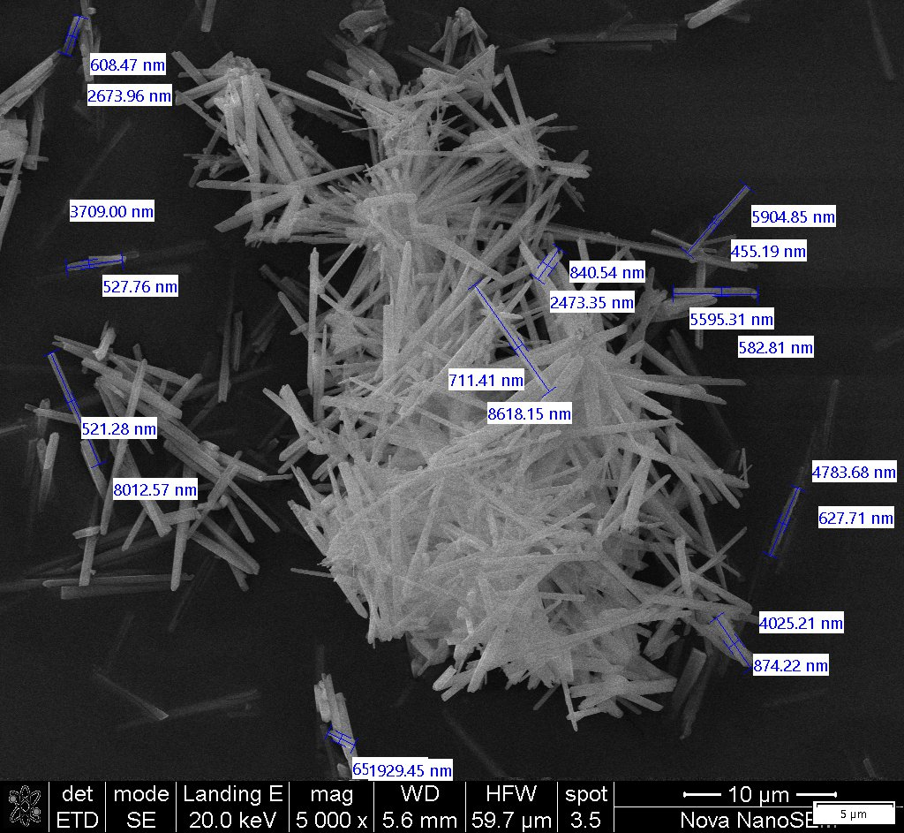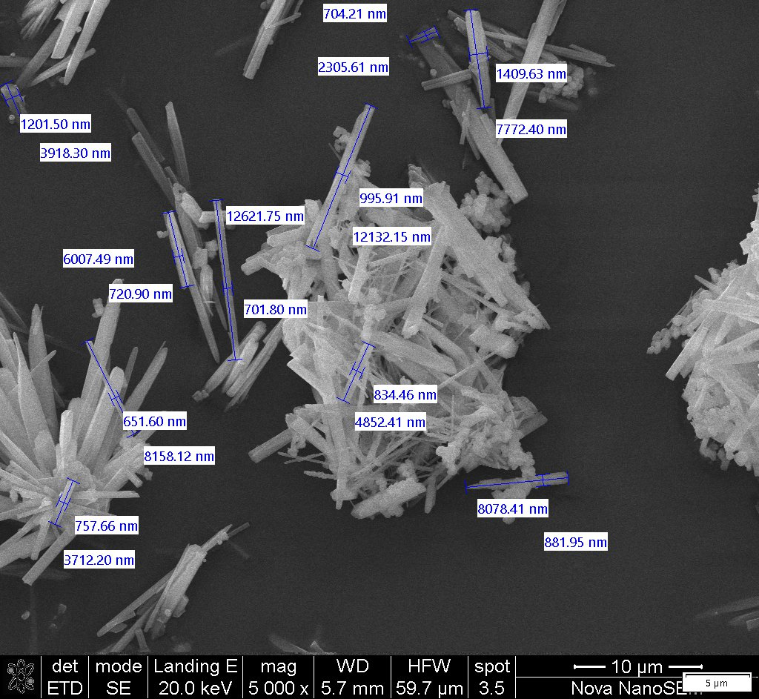

**(b)**

**(a)**

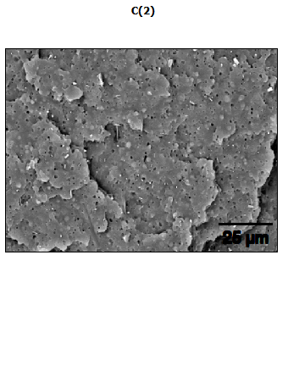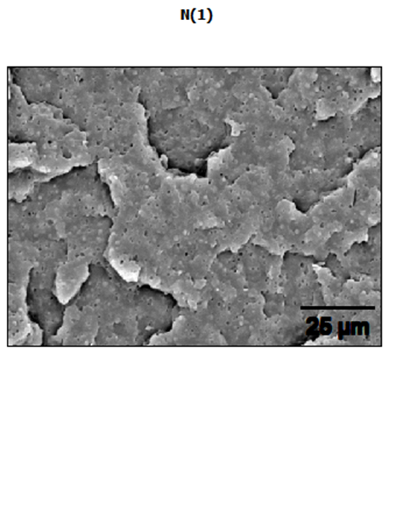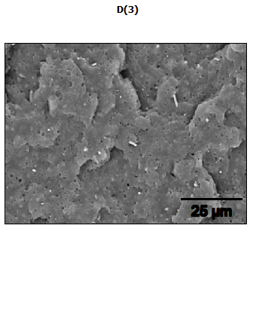*Figure 1: SEM images of the particles recovered from the Eastern basin AMD (a) EBNS and (b) EBWS*

**(b)**

**(a)**

**(c)**

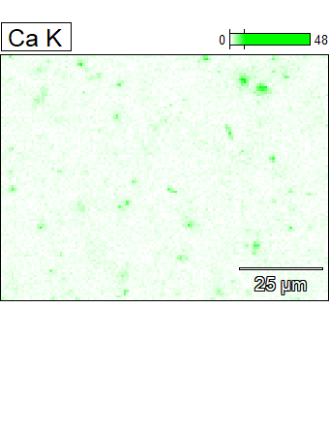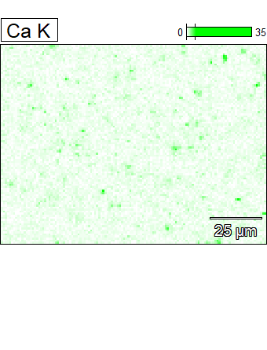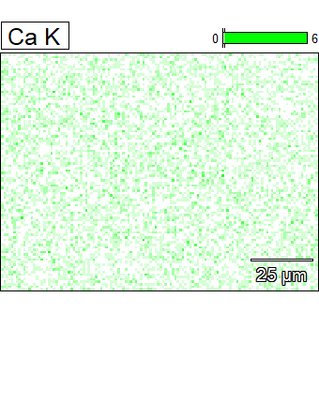

Figure 2: SEM images of the composites fractured surfaces and elemental mapping for calcium (a) PP, (b) PP-EBNS, and (c) PP-EBWS

pretreatment of the EB AMD where the other constituents (e.g. sulphate ions, ferric irons, etc.) were systematically removed for the EBNS sample, while the EBWS sample would contain other precipitates than aragonite. The particle purity is a subject of an ongoing investigation. The presence of sulphate and other ions has been shown to inhibit and/or retard the growth of ${CaCO}_{3}$ crystals (Goetschl et al., 2019). While the spherical particles observed in the EBWS sample have been reported previously when urea hydrolysis was used to treat AMD as amorphous and low crystalline minerals of iron (Subrt et al., 2011). The images of the composites’ fractured surfaces are shown in Figure 2. The calcium detected in the neat sample (Figure 2a) was from the calcium stearate used in all composites. The composites are characterized by uniformly dispersed aragonite particles as shown by the darker green spots for PP-EBNS and PP-EBWS mapping (Figure 2b and 2c), respectively confirming the effectiveness of the composite preparation method.

The XRD reflection patterns of the composites are presented in Figure 3. The composites displayed similar reflection patterns as the neat polymer, all dominated by the α-crystalline form of polypropylene with Miller indices (110), (040), (130), (111), (131) and (060). The presence of small amounts of the β-crystalline form could not be completely ruled out as its indices, (300), (301) and (041), overlap with those of the α-crystalline form as shown (Zhang et al., 2012; Lanyi et al., 2020). The results indicated that the incorporation of aragonite did not have an influence on the matrix crystalline phase.

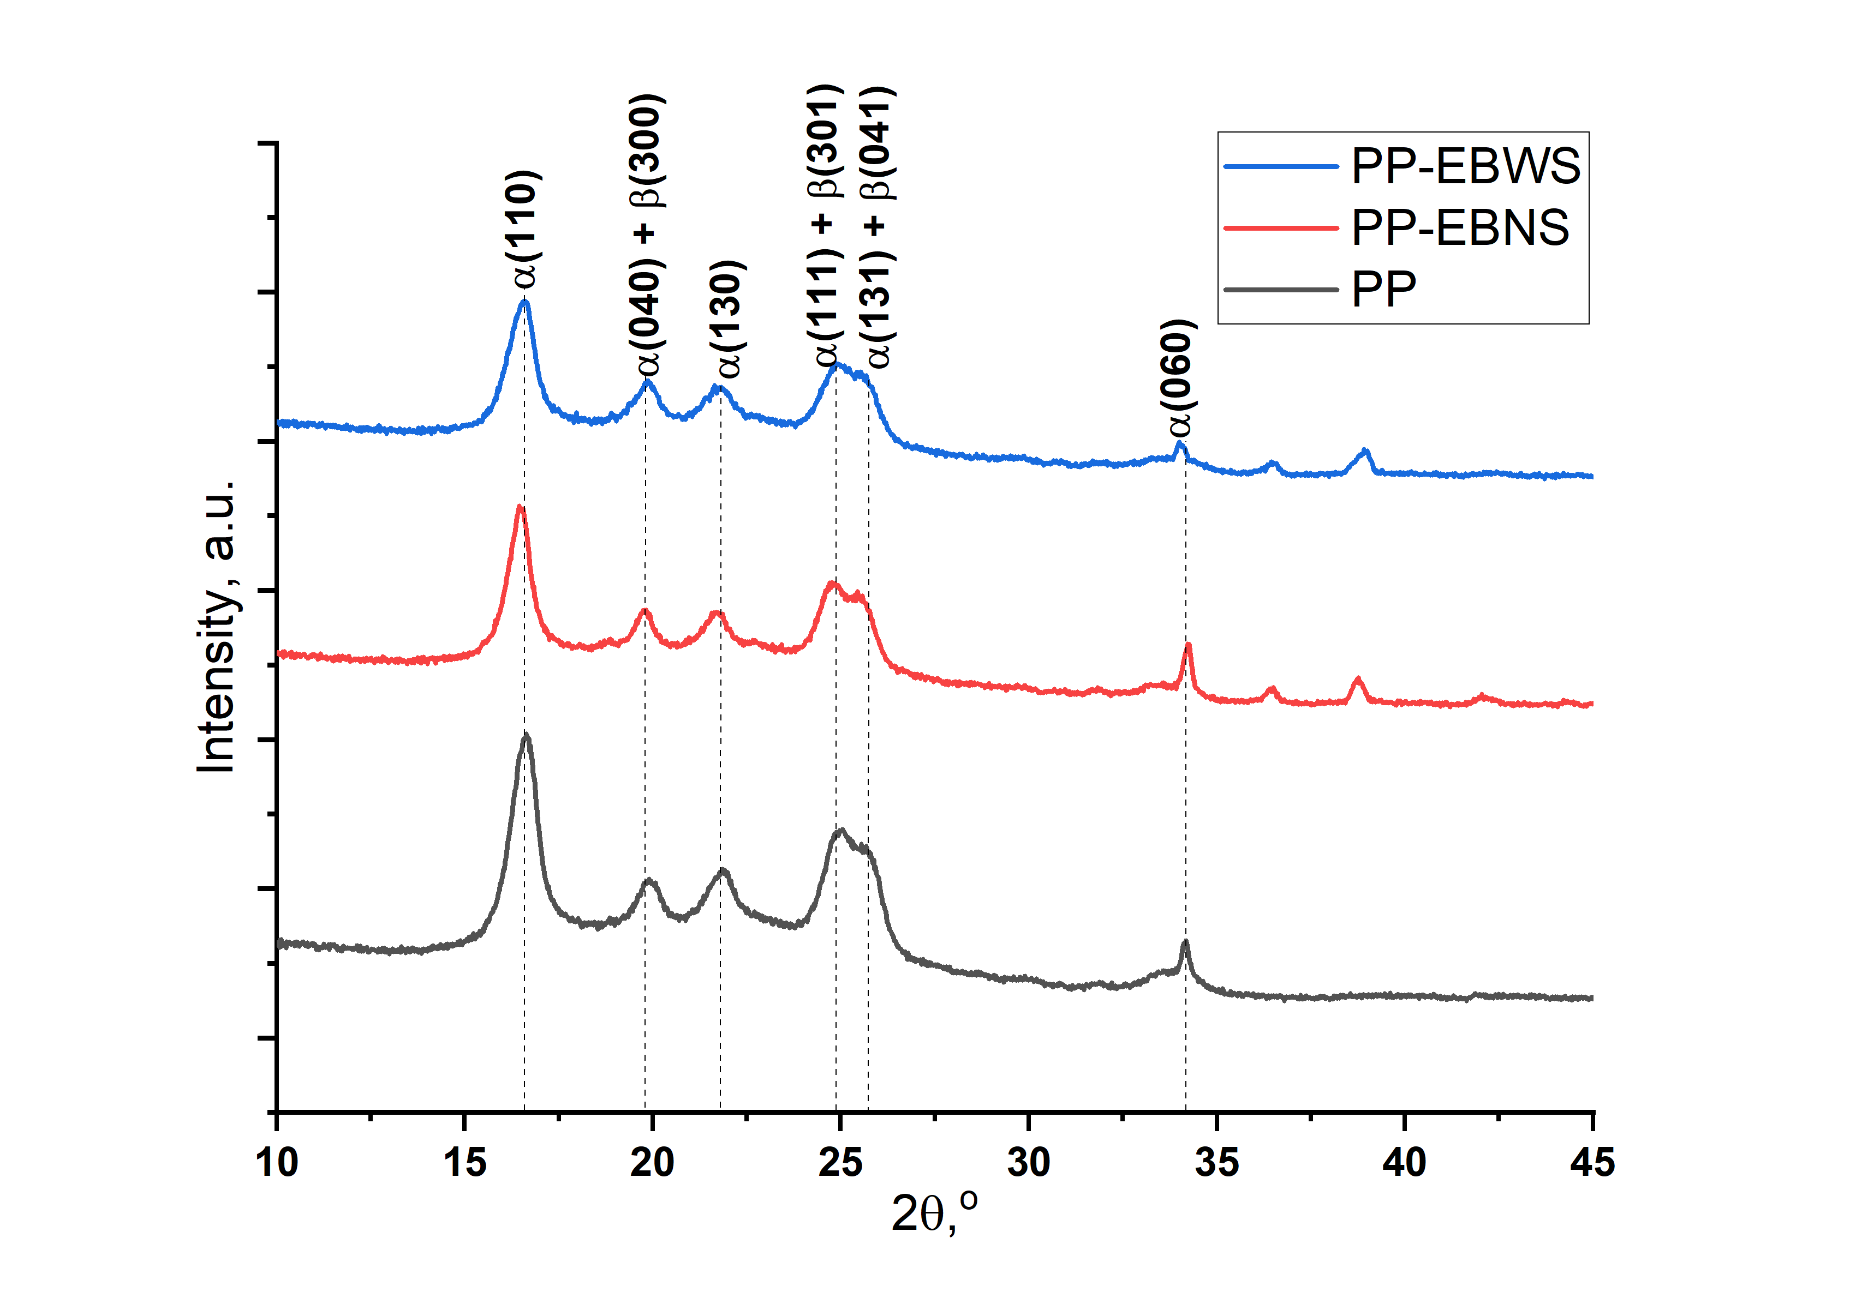

Figure 3: XRD reflection patterns of the composites

The overlay of the DSC crystallization curves is shown in Figure 4a. The aragonite had a heterogenous nucleating effect on the PP matrix as shown by slightly higher crystallization peaks of PP-EBNS and PP-EBWS when compared to that of neat PP (121.4 and 122.1 °C vs. 120.8 °C, respectively). The EBWS displayed a slightly better nucleation performance compared to EBNS, this was proposed to be due to the wide range of particle sizes as observed from the SEM images of the particles (Figure 1).

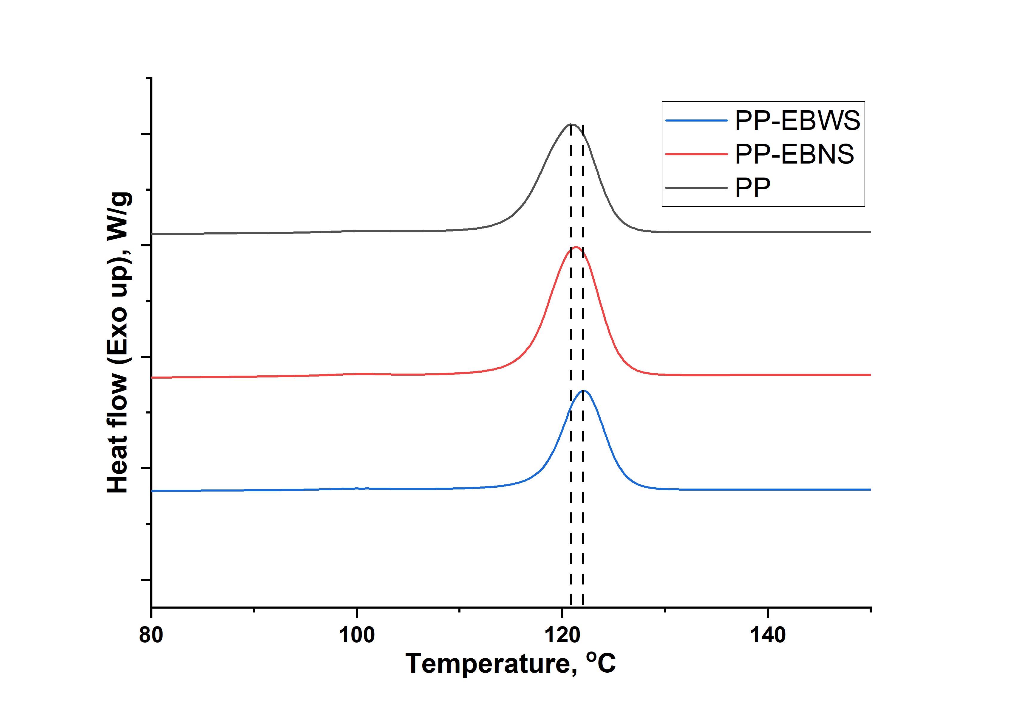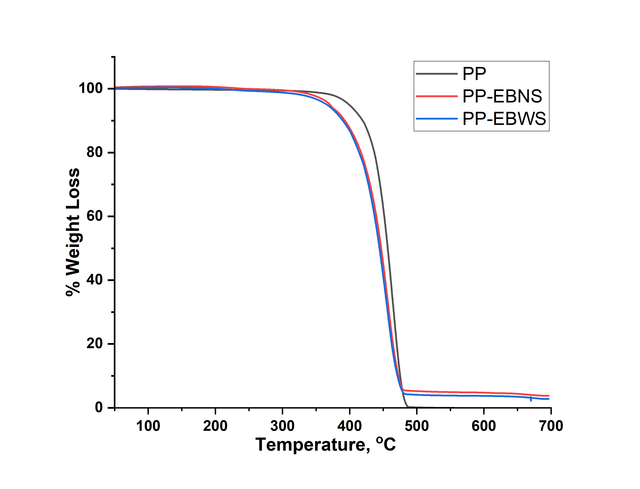

**(b)**

**(a)**

Figure 4: Overlay of the (a) DSC crystallization curves, and (b) TGA decomposition profiles of the composites

The decomposition profiles of the samples are shown in Figure 4b. The incorporation of the aragonite particles recovered from the AMD had a negative impact on the thermal stability of the PP matrix. The composites’ onset temperature of decomposition was found to be 368 °C when compared to 394 °C for the neat PP. The negative impact of ${CaCO}_{3}$ on PP thermal stability has been reported, and it was attributed to poor dispersion of the filler and poor interaction with the matrix (Jing et al., 2018b). In this study, it could be attributed to the presence of other metallic impurities precipitated with the aragonite from the mine wastewaters. This could be countered by incorporating some metal deactivating additives that form stable complexes with the impurities, thus rendering them unreactive with the matrix (Fitaroni et al., 2016). However, that is beyond the scope of this work.

* + 1. Mechanical properties

The mechanical properties of the composites are shown in Figure 5. The composites displayed a slight decrease on the impact strength (toughness), when compared to the virgin material (Figure 5a). The PP-EBNS sample displayed a 12 % decrease while the PP-EBWS sample only decreased 3 %. This was attributed to poor interfacial interaction between the matrix and ${CaCO}_{3}$ particles since their surfaces were not individually treated with a surfactant (Moczo & Pukanszky, 2019). At 5 wt.% loading, the aragonite increased the flexural modulus (stiffness) of PP by 7 and 5 % for PP-EBNS and PP-EBWS, respectively (Figure 5b). These results agreed with previously reported observations especially the incorporation of aragonite in relation to the neat PP matrix (Jing et al., 2018a). The overall differences between the PP-EBNS and PP-EBWS composites could be attributed to the incorporated particle’s aspect ratios as well as their particle size distributions (Moczo & Pukanszky, 2019). This was interesting to observe as it demonstrated balanced material properties of the composites as desired to increase the stiffness of the polymer matrix without negatively affecting its toughness (Zhang et al., 2012). The incorporation of commercial ${CaCO}_{3}$ into PP matrix to compare with aragonite recovered from the mine wastewater is a subject of ongoing investigations.

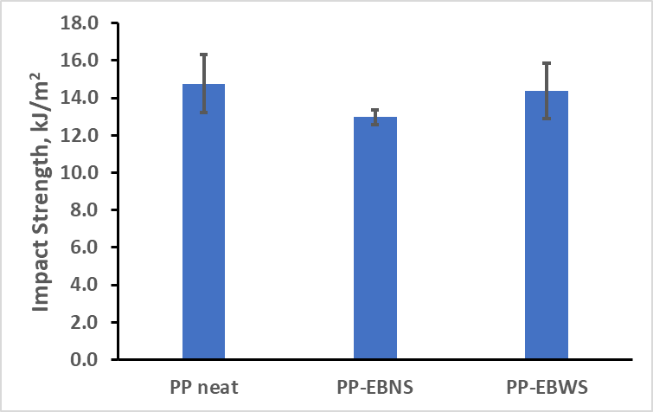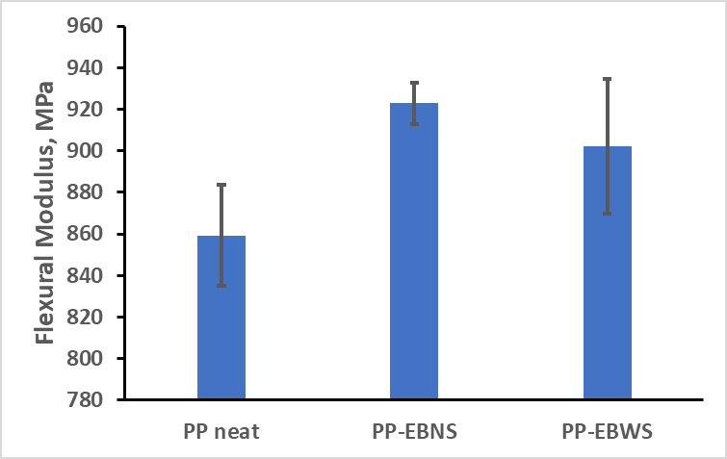

Figure 5: Mechanical properties of the composites (a) Impact strength, and (b) Flexural Modulus

* 1. Conclusions

The results showed that the aragonite calcium carbonate was recovered from the AMD of the Eastern basin in Gauteng, South Africa. The removal of suspended solids had an impact on the resulting particle’s morphology and size distribution, consequently, different aspect ratios (8.7 vs. 7.2 for EBNS and EBWS, respectively). The particles did not have any influence on the polymer matrix crystalline phase. However, they did have a heterogenous nucleating effect, with PP-EBWS having the highest cooling crystallization peak at 122.1 °C vs. 120.8 °C for the virgin polymer. The particles also had a negative influence on the thermal stability of the matrix with the onset temperature of degradation reduced from 394 °C for the virgin polymer to 368 °C for the composites. The aragonite particles imparted a good balance to the impact strength (decreased by 12 and 3 % for the PP-EBNS and PP-EBWS, respectively) and flexural modulus of the ethylene propylene copolymer (increased by 7 and 5 % for the PP-EBNS and PP-EBWS, respectively), thus demonstrating the industrial utility of the mineral recovered from the acid mine drainage.

Acknowledgments

Authors would like to extend their gratitude to Ms Zandile Xulu and Mr Ashville Damans (Xuba Compounders Pty. Ltd.) with their assistance on mechanical analysis of the composites.

# References

Afshar, A., Massoumi, I., Khosh, R. L., & Bagheri, R. (2010). Fracture behavior dependence on load-bearing capacity of filler in nano- and microcomposites of polypropylene containing calcium carbonate. *Materials and Design, 31*, 802-807. https://doi.org/10.1016/j.matdes.2009.07.054

Chafidz, A., Kaavessina, M., Al-Zahrani, S., & Al-Otaibi, M. N. (2016). Rheological and mechanical properties of polypropylene/calcium carbonate nanocomposites prepared from masterbatch. *Journal of Thermoplastic Composite Materials, 29*(5), 593-622. https://doi.org/10.1177/0892705714530747

Chan, C.-M., Wu, J., Li, J.-X., & Cheung, Y.-K. (2002). Polypropylene/calcium carbonate nanocomposites. *Polymer, 43*(10), 2981-2992. https://doi.org/10.1016/S0032-3861(02)00120-9

do Nascimento, E. M., Eiras, D., & Pessan, L. A. (2016). Effect of thermal treatment on impact resistance and mechanical properties of polypropylene/calcium carbonate nanocomposites. *Composites Part B, 91*, 228-234. https://doi.org/10.1016/j.compositesb.2015.12.040

Eiras, D., & Pessan, L. A. (2009). Mechanical Properties of Polypropylene/Calcium Carbonate Nanocomposites. *Materials Research, 12*(4), 517-522. https://doi.org/10.1590/S1516-14392009000400023

Ezenkwa, O. E., Hassan, A., & Samsudin, S. A. (2021). Tensile and Impact Properties of Rice Husk Filled Ethylene-Acrylic Ester Maleic Anhydride Compatibilized Polypropylene Composites. *Chemical Engineering Transactions, 83*, 511-516. https://doi.org/10.3303/CET2183086

Faud, M., Hanim, H., Zarina, R., Mohd. Ishak, Z., & Hassan, A. (2010). Polypropylene/calcium carbonate nanocomposites - effects of processing techniques and maleated propylene compatibiliser. *eXPRESS Polymer Letters, 4*(10), 611-620. https://doi.org/10.3144/expresspolymlett.2010.76

Fitaroni, L. B., de Lima, J., Cruz, S. A., & Waldman, W. R. (2016). Effect of compatibilizer and Irganox MD 1024 on the thermo-oxidative stability of PP/PP-g-MA/OMMT nanocomposites. *Polymer Testing, 53*, 165-173. https://doi.org/10.1016/j.polymertesting.2016.05.016

Goetschl, K. E., Purgstaller, B., Dietzel, M., & Mavromatis, V. (2019). Effect of sulfate on magnesium incorporation in low-magnesium calcite. *Geochimica et Cosmochimica Acta, 265*, 505-519. https://doi.org/10.1016/j.gca.2019.07.024

Jimoh, O. A., Ariffin, K. S., Hussin, H. B., & Temitope, A. E. (2018). Synthesis of precipitated calcium carbonate: a review. *Carbonate Evaporites, 33*, 331-346. https://doi.org/10.1007/s13146-017-0341-x

Jing, X., Gong, W., Feng, Z., Zhang, M., Meng, X., & Zheng, B. (2018b). Novel Comb-Like Copolymer Dispersant for Polypropylene/CaCO3 Composites and Its Influence on Dispersion, Crystallization, Mechanical, and Thermal Properties. *Polymer-Plastics Technology and Engineering, 57*(10), 986-996. https://doi.org/10.1080/03602559.2017.1370105

Jing, Y., Nai, X., DAng, L., Zhu, D., Wang, Y., Dong, Y., & Li, W. (2018a). Reinforcing polypropylene with calcium carbonate of different morphologies and polymorphs. *Science and Engineering of Composites, 25*(4), 745-751. https://doi.org/10.1515/secm-2015-0307

Khumalo, R., & Chirwa, E. (2024). Witwatersrand Basin Acid Mine Drainage (AMD) Softening via Urea Hydrolysis: Part 1 Experimental. *Chemical Engineering Transactions, 110*, 463-468. https://doi.org/10.3303/CET24110078

Khumalo, R., Brink, H., & Chirwa, E. (submitted). Hydrothermal synthesis of Aragonte from Acid Mine Drainage of the Witwatersrand basin in Gauteng, South Africa: A preliminary study. *Mine Water and the Environment*.

Lanyi, F. J., Wenzke, N., Kaschta, J., & Schubert, D. W. (2020). On the Determination of the Enthalpy of Fusion of a-Crystalline Isotactic Polypropylene Using Differential Scanning Calorimetry, X-Ray Diffreaction, and Fourier-Transfrom Infrared Spectroscopy: An Old Story Revisited. *Advanced Engineering Materials, 22*, 1900796 (1 - 8). https://doi.org/10.1002/adem.201900796

Li, L., & Dou, Q. (2011). Effect of Malonic Acid Treatment on Crystal Structure, Melting Behavior, Morphology, and Mechanical Properties of Isotactic Polypropylene/Nano-CaCO3 Composites. *Journal of Macromolecular Science, Part B: Physics, 50*, 831-845. https://doi.org/10.1080/00222348.2010.483392

Li, X.-H., He, Y., Li, X., An, F., Yang, D., & Yu, Z.-Z. (2017). Simultaneous Enhancements in Toughness and Electrical Conductivity of Polypropylene/Carbon Nanotube Nanocomposites by Incorporation of Electrically Inert Calcium Carbonate Nanoparticles. *Industrial & Engineering Chemistry Research, 56*, 2783-2788. https://doi.org/10.1021/acs.iecr.7b00446

Liang, J.-Z. (2013). Reinforcement and qauntitative description of inorganic particulate-filled polymer composites. *Composites: Part B, 51*, 224-232. https://doi.org/10.1016/j.compositesb.2013.03.019

Lin, y., Chen, H., Chan, C.-M., & Wu, J. (2008). High Impact Toughness Polypropylene/CaCO3 Nanocomposites and the Toughening Mechanism. *Macromolecules, 41*(23), 9204-9213. https://doi.org/10.1021/ma801095d

Mallick, P. (2018). Particulate Filled and Short Fiber Reinforced Polymer Composites. In P. W. Beaumont, & C. H. Zweben, *Comprehensive Composite Materials II* (Vol. 2, pp. 360-400). Elsevier Ltd. https://doi.org/10.1016/B978-0-12-803581-8.03837-6

Moczo, J., & Pukanszky, B. (2019). Particulate Filled Polypropylene: Structure and Properties. In J. Karger-Kocsis, & T. Barany, *Polypropylene Handbook* (pp. 357-417). Springer, Cham. https://doi.org/10.1007/978-3-030-12903-3\_7

Murariu, M., Laoutid, F., Paint, Y., Murariu, O., & Raquez, J.-M. (2023). Balancing the Sthrength-Impact Relationship and Other Key Properties in Polypropylene Copolymer-Natural CaSO4 (Anhydite)-Filled Composites. *International Journal of Molecular Sciences, 24*, 12659. https://doi.org/10.3390/ijms241612659

Rothon, R., & DeArmitt, C. (2017). Fillers (Including Fiber Reinforcements). In M. Gilbert, *Brydson's Plastics Materials* (8th ed., pp. 169-204). Elsevier Ltd. https://doi.org/10.1016/B978-0-323-35824-8.00008-6

Rueden, C. T., Schindelin, J., Hiner, M. C., DeZonia, B. E., Walter, A. E., Arena, E. T., & Eliceiri, K. W. (2017). ImageJ2: ImageJ for the next generation of scientific image data. *BMC Bioinformatics, 18:529*, 1-26. https://doi.org/10.1186/s12859-017-1934-z

Subrt, J., Michalkova, E., Bohacek, J., Lukac, Jozef, Ganovska, Z., & Masa, B. (2011). Uniform particles formed by hydrolysis of acid mine drainage with urea. *Hydrometallurgy, 106*, 12-18. https://doi.org/10.1016/j.hydromet.2010.11.012

Thenepalli, T., Jun, A. Y., Han, C., Ramakrishna, C., & Ahn, J. W. (2015). A stretegy of precipitated calcium carbonate (CaCO3) fillers for enhancing the mechanical properties of polypropylene polymers. *Korean Journal of CHemical Engineering, 32*(2), 1009-1022. https://doi.org/10.1007/s11814-015-0057-3

Webb, C., Qi, K., Anguilano, L., & Rivera, X. S. (2024). Mechanical and environmental evaluation of ground calcium carbonate (CaCO3) filled polypropylene composites as a sustainable alternative to virgin polypropylene. *Results in Materials, 22*, 100562. https://doi.org/10.1016/j.rinma.2024.100562

Zhang, Z., Wang, C., Meng, Y., & Mai, K. (2012). Synergistic effects of toughening of nano-CaCO3 and toughness of b-polypropylene. *Composites: Part A, 43*, 189-197. https://doi.org/10.1016/j.compositesa.2011.10.008

Zhu, Y., Allen, G., Jones, P., Adams, J., Gittins, D., Heard, P., & Skuse, D. (2014). Dispersion characterisation of CaCO3 particles in PP/CaCO3 composites. *Composites: Part A, 60*, 38-43. https://doi.org/10.1016/j.compositesa.2014.01.012